目录

环境: 2

一.安装docker-engine(所有节点) 2

二.获取elasticsearch docker镜像(所有节点) 2

三.创建elasticsearch配置文件(所有节点) 3

四.运行elasticsearch容器(所有节点) 3

五.确认集群状态 3

**Docker部署Elasticsearch集群**

# 环境:

**CentOS 7.2.1511**

**docker-engine-1.12.0**

**elasticsearch-2.3.4**

172.25.155.51 (master,data)

172.25.155.52 (master,data)

172.25.155.53 (master,data)

elasticsearch 根目录为/mnt/data/elasticsearch

# 一.安装docker-engine(所有节点)

cat >/etc/yum.repos.d/docker.repo <<'EOF'

[dockerrepo]

name=Docker Repository

baseurl=https://yum.dockerproject.org/repo/main/centos/$releasever/

enabled=1

gpgcheck=1

gpgkey=https://yum.dockerproject.org/gpg

EOF

yum -y install docker-engine

systemctl start docker

systemctl enable docker

# 二.获取elasticsearch docker镜像(所有节点)

docker pull elasticsearch:2.3.4

docker tag elasticsearch:2.3.4 elasticsearch

# 三.创建elasticsearch配置文件(所有节点)

mkdir -p /mnt/data/elasticsearch/{data,logs,config, plugins}

cat >/mnt/data/elasticsearch/config/elasticsearch.yml <<'EOF'

cluster.name: edf_cluster

node.name: **service-node-1**

threadpool.bulk.queue_size: 100

node.master: true

node.data: true

path.data: /usr/share/elasticsearch/data

path.logs: /usr/share/elasticsearch/logs

bootstrap.mlockall: true

network.host: 0.0.0.0

network.publish_host: **172.25.155.51**

transport.tcp.port: 9300

http.port: 9200

index.refresh_interval: 5s

script.inline: true

script.indexed: true

discovery.zen.ping.timeout: 100s

discovery.zen.fd.ping_timeout: 100s

discovery.zen.ping.multicast.enabled: false

discovery.zen.ping.unicast.hosts: ["172.25.155.51:9300", "172.25.155.52:9300", "172.25.155.53:9300"]

discovery.zen.minimum_master_nodes: 2

gateway.recover_after_nodes: 2

EOF

**说明:** 节点配置文件只需修改标红部分(node.name集群内唯一, 这里分别叫service-node-1,service-node-2,service-node-3)

# 四.运行elasticsearch容器(所有节点)

docker run -tid --restart=always \

-e **ES_HEAP_SIZE="32g"** \

-p 9200:9200 \

-p 9300:9300 \

-v /mnt/data/elasticsearch/data:/usr/share/elasticsearch/data \

-v /mnt/data/elasticsearch/logs:/usr/share/elasticsearch/logs \

-v /mnt/data/elasticsearch/plugins:/usr/share/elasticsearch/plugins \

-v /mnt/data/elasticsearch/config/elasticsearch.yml:/usr/share/elasticsearch/config/elasticsearch.yml \

--name=**rz15551** \

elasticsearch

**说明:** 最好起个有标识意义的容器名，这里分别叫rz15551,rz15552,rz15553

# 五.确认集群状态

curl 'localhost:9200/_cat/nodes?v'

curl 'http://localhost:9200/_cat/health?v'

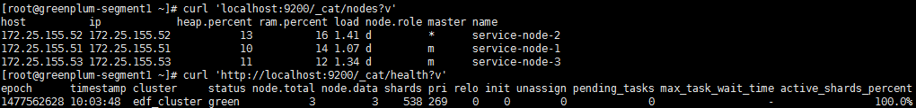

在elasticsearch集群节点上执行该命令，status为green时说明集群工作正常