#define MOTORLATCH 12

#define MOTORCLK 4

#define MOTORENABLE 7

#define MOTORDATA 8

AFMotor.cpp (af_motor): pinMode(MOTORLATCH, OUTPUT);

AFMotor.cpp (af_motor): pinMode(MOTORENABLE, OUTPUT);

AFMotor.cpp (af_motor): pinMode(MOTORDATA, OUTPUT);

AFMotor.cpp (af_motor): pinMode(MOTORCLK, OUTPUT);

AFMotor.cpp (af_motor): pinMode(11, OUTPUT);

AFMotor.cpp (af_motor): pinMode(3, OUTPUT);

AFMotor.cpp (af_motor): pinMode(6, OUTPUT);

AFMotor.cpp (af_motor): pinMode(5, OUTPUT);

All 6 analog input pins are available. They can also be used as digital pins (pins #14 thru

19)

Digital pin 2, and 13 are not used.

The following pins are in use only if the DC/Stepper noted is in use:

Digital pin 11: DC Motor #1 / Stepper #1 (activation/speed control)

Digital pin 3: DC Motor #2 / Stepper #1 (activation/speed control)

Digital pin 5: DC Motor #3 / Stepper #2 (activation/speed control)

Digital pin 6: DC Motor #4 / Stepper #2 (activation/speed control)

The following pins are in use if any DC/steppers are used

Digital pin 4, 7, 8 and 12 are used to drive the DC/Stepper motors via the 74HC595 serial-toparallel latch

The following pins are used only if that particular servo is in use:

Digitals pin 9: Servo #1 control

Digital pin 10: Servo #2 control

/////////////////////////////////////////////////////////////////////////////////////////////////////

IRremote.cpp (irremote): pinMode(TIMER_PWM_PIN, OUTPUT);

IRremote.cpp (irremote): pinMode(irparams.recvpin, INPUT);

IRremote.cpp (irremote): pinMode(BLINKLED, OUTPUT);

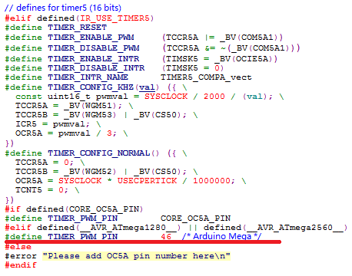

在IRremoteInt.h

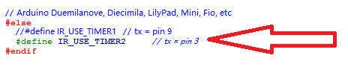

在Uno硬件和motor冲突

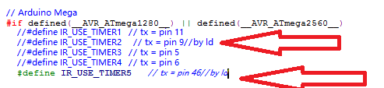

在mega中注释掉TIMER2而打开TIMER5