1.安裝SQL SERVER

<https://www.microsoft.com/zh-tw/sql-server/sql-server-downloads>

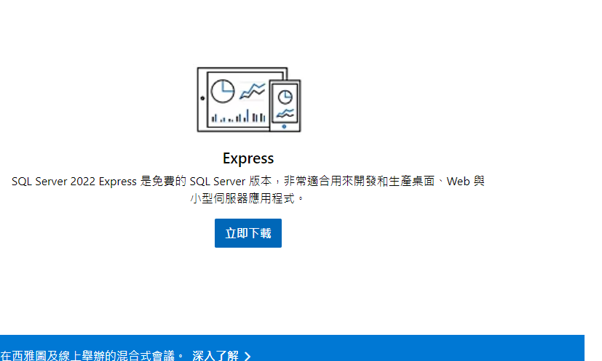

2.安裝 SSMS

<https://learn.microsoft.com/zh-tw/sql/ssms/download-sql-server-management-studio-ssms?view=sql-server-ver16>

