source code: https://github.com/coolzoom/nodemcu-ino-like-debugger
follow GPL, free to use, please send me a free copy if you use it for commerical
File:
- New
-Open
- Save
- Examples, Some examples for nodemcu
Tools
- Port, Available port
-Time to wait, when there have multiple lines and commands, it will need wait some time for the serial port to resonse.
Help
open help documents.

Upload current Lines to init.lua of NodeMCU

Execute Current Lines

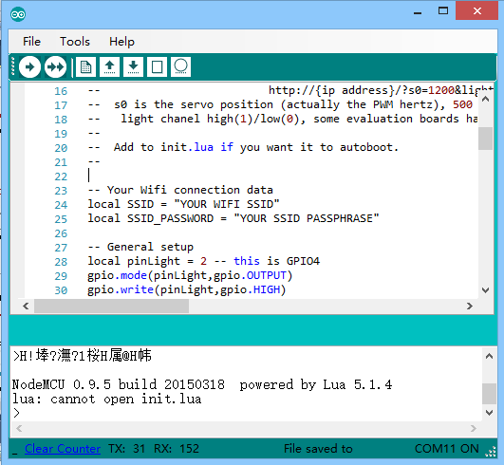
New Window
Open File
Save File
Erase NodeMCU lua file
node.restart

