Nightingale_Coxcomb

coop711

2021-05-26

# 자료와 배경

나이팅게일(Florence Nightingale, 1820-1910)은 크림전쟁(1854-1856) 당시 38명의 잉글랜드 성공회 수녀들의 도움을 받으며 슈코더르(Scutari)의 야전 병원에서 유능한 보건행정가로서의 역량을 발휘하여 병원에서 쓰는 물건을 세심하게 관리하고 무질서한 병원에 규율을 세웠다. 환자의 사망율을 42%에서 2%로 낮추고 집중치료실(ICU)을 설치하여 상태가 중한 환자를 격리하여 집중관리하는 등 근대적인 간호체계를 수립하는 데 기여하였다. 관료주의에 물든 군의 관리들을 설득하기 위하여 사용한 다음 도표는 Rose Diagram, 혹은 Coxcomb plot 등으로 불린다.

knitr::include_graphics("../pics/Nightingale_Coxcomb.jpg")

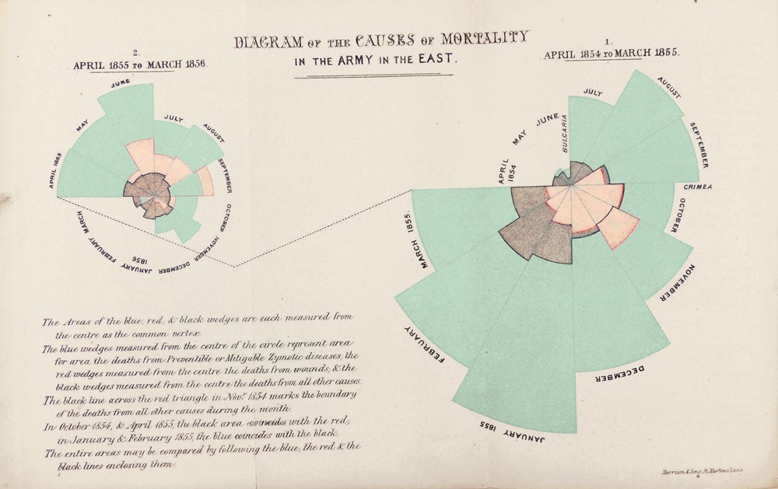

# 데이터

library(knitr)  
library(HistData)  
library(tidyverse)  
library(magrittr)  
library(grid)  
library(gridExtra)  
kable(Nightingale)

|  |  |  |  |  |  |  |  |  |  |
| --- | --- | --- | --- | --- | --- | --- | --- | --- | --- |
| Date | Month | Year | Army | Disease | Wounds | Other | Disease.rate | Wounds.rate | Other.rate |
| 1854-04-01 | Apr | 1854 | 8571 | 1 | 0 | 5 | 1.4 | 0.0 | 7.0 |
| 1854-05-01 | May | 1854 | 23333 | 12 | 0 | 9 | 6.2 | 0.0 | 4.6 |
| 1854-06-01 | Jun | 1854 | 28333 | 11 | 0 | 6 | 4.7 | 0.0 | 2.5 |
| 1854-07-01 | Jul | 1854 | 28722 | 359 | 0 | 23 | 150.0 | 0.0 | 9.6 |
| 1854-08-01 | Aug | 1854 | 30246 | 828 | 1 | 30 | 328.5 | 0.4 | 11.9 |
| 1854-09-01 | Sep | 1854 | 30290 | 788 | 81 | 70 | 312.2 | 32.1 | 27.7 |
| 1854-10-01 | Oct | 1854 | 30643 | 503 | 132 | 128 | 197.0 | 51.7 | 50.1 |
| 1854-11-01 | Nov | 1854 | 29736 | 844 | 287 | 106 | 340.6 | 115.8 | 42.8 |
| 1854-12-01 | Dec | 1854 | 32779 | 1725 | 114 | 131 | 631.5 | 41.7 | 48.0 |
| 1855-01-01 | Jan | 1855 | 32393 | 2761 | 83 | 324 | 1022.8 | 30.7 | 120.0 |
| 1855-02-01 | Feb | 1855 | 30919 | 2120 | 42 | 361 | 822.8 | 16.3 | 140.1 |
| 1855-03-01 | Mar | 1855 | 30107 | 1205 | 32 | 172 | 480.3 | 12.8 | 68.6 |
| 1855-04-01 | Apr | 1855 | 32252 | 477 | 48 | 57 | 177.5 | 17.9 | 21.2 |
| 1855-05-01 | May | 1855 | 35473 | 508 | 49 | 37 | 171.8 | 16.6 | 12.5 |
| 1855-06-01 | Jun | 1855 | 38863 | 802 | 209 | 31 | 247.6 | 64.5 | 9.6 |
| 1855-07-01 | Jul | 1855 | 42647 | 382 | 134 | 33 | 107.5 | 37.7 | 9.3 |
| 1855-08-01 | Aug | 1855 | 44614 | 483 | 164 | 25 | 129.9 | 44.1 | 6.7 |
| 1855-09-01 | Sep | 1855 | 47751 | 189 | 276 | 20 | 47.5 | 69.4 | 5.0 |
| 1855-10-01 | Oct | 1855 | 46852 | 128 | 53 | 18 | 32.8 | 13.6 | 4.6 |
| 1855-11-01 | Nov | 1855 | 37853 | 178 | 33 | 32 | 56.4 | 10.5 | 10.1 |
| 1855-12-01 | Dec | 1855 | 43217 | 91 | 18 | 28 | 25.3 | 5.0 | 7.8 |
| 1856-01-01 | Jan | 1856 | 44212 | 42 | 2 | 48 | 11.4 | 0.5 | 13.0 |
| 1856-02-01 | Feb | 1856 | 43485 | 24 | 0 | 19 | 6.6 | 0.0 | 5.2 |
| 1856-03-01 | Mar | 1856 | 46140 | 15 | 0 | 35 | 3.9 | 0.0 | 9.1 |

Night <- Nightingale %>%  
 as_tibble %>%  
 subset(select = c(1, 8:10))  
kable(Night)

|  |  |  |  |
| --- | --- | --- | --- |
| Date | Disease.rate | Wounds.rate | Other.rate |
| 1854-04-01 | 1.4 | 0.0 | 7.0 |
| 1854-05-01 | 6.2 | 0.0 | 4.6 |
| 1854-06-01 | 4.7 | 0.0 | 2.5 |
| 1854-07-01 | 150.0 | 0.0 | 9.6 |
| 1854-08-01 | 328.5 | 0.4 | 11.9 |
| 1854-09-01 | 312.2 | 32.1 | 27.7 |
| 1854-10-01 | 197.0 | 51.7 | 50.1 |
| 1854-11-01 | 340.6 | 115.8 | 42.8 |
| 1854-12-01 | 631.5 | 41.7 | 48.0 |
| 1855-01-01 | 1022.8 | 30.7 | 120.0 |
| 1855-02-01 | 822.8 | 16.3 | 140.1 |
| 1855-03-01 | 480.3 | 12.8 | 68.6 |
| 1855-04-01 | 177.5 | 17.9 | 21.2 |
| 1855-05-01 | 171.8 | 16.6 | 12.5 |
| 1855-06-01 | 247.6 | 64.5 | 9.6 |
| 1855-07-01 | 107.5 | 37.7 | 9.3 |
| 1855-08-01 | 129.9 | 44.1 | 6.7 |
| 1855-09-01 | 47.5 | 69.4 | 5.0 |
| 1855-10-01 | 32.8 | 13.6 | 4.6 |
| 1855-11-01 | 56.4 | 10.5 | 10.1 |
| 1855-12-01 | 25.3 | 5.0 | 7.8 |
| 1856-01-01 | 11.4 | 0.5 | 13.0 |
| 1856-02-01 | 6.6 | 0.0 | 5.2 |
| 1856-03-01 | 3.9 | 0.0 | 9.1 |

Night %<>%  
 gather(key = "Cause", value = "Deaths", -Date) %>%  
 mutate(Month = gl(12, 1, 72, labels = month.name[c(4:12, 1:3)])) %>%  
 mutate(Regime = gl(2, 12, 72, labels = c("Before", "After"), ordered = TRUE))   
kable(Night)

|  |  |  |  |  |
| --- | --- | --- | --- | --- |
| Date | Cause | Deaths | Month | Regime |
| 1854-04-01 | Disease.rate | 1.4 | April | Before |
| 1854-05-01 | Disease.rate | 6.2 | May | Before |
| 1854-06-01 | Disease.rate | 4.7 | June | Before |
| 1854-07-01 | Disease.rate | 150.0 | July | Before |
| 1854-08-01 | Disease.rate | 328.5 | August | Before |
| 1854-09-01 | Disease.rate | 312.2 | September | Before |
| 1854-10-01 | Disease.rate | 197.0 | October | Before |
| 1854-11-01 | Disease.rate | 340.6 | November | Before |
| 1854-12-01 | Disease.rate | 631.5 | December | Before |
| 1855-01-01 | Disease.rate | 1022.8 | January | Before |
| 1855-02-01 | Disease.rate | 822.8 | February | Before |
| 1855-03-01 | Disease.rate | 480.3 | March | Before |
| 1855-04-01 | Disease.rate | 177.5 | April | After |
| 1855-05-01 | Disease.rate | 171.8 | May | After |
| 1855-06-01 | Disease.rate | 247.6 | June | After |
| 1855-07-01 | Disease.rate | 107.5 | July | After |
| 1855-08-01 | Disease.rate | 129.9 | August | After |
| 1855-09-01 | Disease.rate | 47.5 | September | After |
| 1855-10-01 | Disease.rate | 32.8 | October | After |
| 1855-11-01 | Disease.rate | 56.4 | November | After |
| 1855-12-01 | Disease.rate | 25.3 | December | After |
| 1856-01-01 | Disease.rate | 11.4 | January | After |
| 1856-02-01 | Disease.rate | 6.6 | February | After |
| 1856-03-01 | Disease.rate | 3.9 | March | After |
| 1854-04-01 | Wounds.rate | 0.0 | April | Before |
| 1854-05-01 | Wounds.rate | 0.0 | May | Before |
| 1854-06-01 | Wounds.rate | 0.0 | June | Before |
| 1854-07-01 | Wounds.rate | 0.0 | July | Before |
| 1854-08-01 | Wounds.rate | 0.4 | August | Before |
| 1854-09-01 | Wounds.rate | 32.1 | September | Before |
| 1854-10-01 | Wounds.rate | 51.7 | October | Before |
| 1854-11-01 | Wounds.rate | 115.8 | November | Before |
| 1854-12-01 | Wounds.rate | 41.7 | December | Before |
| 1855-01-01 | Wounds.rate | 30.7 | January | Before |
| 1855-02-01 | Wounds.rate | 16.3 | February | Before |
| 1855-03-01 | Wounds.rate | 12.8 | March | Before |
| 1855-04-01 | Wounds.rate | 17.9 | April | After |
| 1855-05-01 | Wounds.rate | 16.6 | May | After |
| 1855-06-01 | Wounds.rate | 64.5 | June | After |
| 1855-07-01 | Wounds.rate | 37.7 | July | After |
| 1855-08-01 | Wounds.rate | 44.1 | August | After |
| 1855-09-01 | Wounds.rate | 69.4 | September | After |
| 1855-10-01 | Wounds.rate | 13.6 | October | After |
| 1855-11-01 | Wounds.rate | 10.5 | November | After |
| 1855-12-01 | Wounds.rate | 5.0 | December | After |
| 1856-01-01 | Wounds.rate | 0.5 | January | After |
| 1856-02-01 | Wounds.rate | 0.0 | February | After |
| 1856-03-01 | Wounds.rate | 0.0 | March | After |
| 1854-04-01 | Other.rate | 7.0 | April | Before |
| 1854-05-01 | Other.rate | 4.6 | May | Before |
| 1854-06-01 | Other.rate | 2.5 | June | Before |
| 1854-07-01 | Other.rate | 9.6 | July | Before |
| 1854-08-01 | Other.rate | 11.9 | August | Before |
| 1854-09-01 | Other.rate | 27.7 | September | Before |
| 1854-10-01 | Other.rate | 50.1 | October | Before |
| 1854-11-01 | Other.rate | 42.8 | November | Before |
| 1854-12-01 | Other.rate | 48.0 | December | Before |
| 1855-01-01 | Other.rate | 120.0 | January | Before |
| 1855-02-01 | Other.rate | 140.1 | February | Before |
| 1855-03-01 | Other.rate | 68.6 | March | Before |
| 1855-04-01 | Other.rate | 21.2 | April | After |
| 1855-05-01 | Other.rate | 12.5 | May | After |
| 1855-06-01 | Other.rate | 9.6 | June | After |
| 1855-07-01 | Other.rate | 9.3 | July | After |
| 1855-08-01 | Other.rate | 6.7 | August | After |
| 1855-09-01 | Other.rate | 5.0 | September | After |
| 1855-10-01 | Other.rate | 4.6 | October | After |
| 1855-11-01 | Other.rate | 10.1 | November | After |
| 1855-12-01 | Other.rate | 7.8 | December | After |
| 1856-01-01 | Other.rate | 13.0 | January | After |
| 1856-02-01 | Other.rate | 5.2 | February | After |
| 1856-03-01 | Other.rate | 9.1 | March | After |

str(Night)

## tibble [72 × 5] (S3: tbl_df/tbl/data.frame)  
## $ Date : Date[1:72], format: "1854-04-01" "1854-05-01" ...  
## $ Cause : chr [1:72] "Disease.rate" "Disease.rate" "Disease.rate" "Disease.rate" ...  
## $ Deaths: num [1:72] 1.4 6.2 4.7 150 328.5 ...  
## $ Month : Factor w/ 12 levels "April","May",..: 1 2 3 4 5 6 7 8 9 10 ...  
## $ Regime: Ord.factor w/ 2 levels "Before"<"After": 1 1 1 1 1 1 1 1 1 1 ...

Night$Cause %<>%   
 sub("\\.rate", "", .)  
Night$Cause %<>%   
 factor(levels = c("Disease", "Wounds", "Other"))  
Night %>%  
 kable(align = c("c", "c", "r", "c", "c"))

|  |  |  |  |  |
| --- | --- | --- | --- | --- |
| Date | Cause | Deaths | Month | Regime |
| 1854-04-01 | Disease | 1.4 | April | Before |
| 1854-05-01 | Disease | 6.2 | May | Before |
| 1854-06-01 | Disease | 4.7 | June | Before |
| 1854-07-01 | Disease | 150.0 | July | Before |
| 1854-08-01 | Disease | 328.5 | August | Before |
| 1854-09-01 | Disease | 312.2 | September | Before |
| 1854-10-01 | Disease | 197.0 | October | Before |
| 1854-11-01 | Disease | 340.6 | November | Before |
| 1854-12-01 | Disease | 631.5 | December | Before |
| 1855-01-01 | Disease | 1022.8 | January | Before |
| 1855-02-01 | Disease | 822.8 | February | Before |
| 1855-03-01 | Disease | 480.3 | March | Before |
| 1855-04-01 | Disease | 177.5 | April | After |
| 1855-05-01 | Disease | 171.8 | May | After |
| 1855-06-01 | Disease | 247.6 | June | After |
| 1855-07-01 | Disease | 107.5 | July | After |
| 1855-08-01 | Disease | 129.9 | August | After |
| 1855-09-01 | Disease | 47.5 | September | After |
| 1855-10-01 | Disease | 32.8 | October | After |
| 1855-11-01 | Disease | 56.4 | November | After |
| 1855-12-01 | Disease | 25.3 | December | After |
| 1856-01-01 | Disease | 11.4 | January | After |
| 1856-02-01 | Disease | 6.6 | February | After |
| 1856-03-01 | Disease | 3.9 | March | After |
| 1854-04-01 | Wounds | 0.0 | April | Before |
| 1854-05-01 | Wounds | 0.0 | May | Before |
| 1854-06-01 | Wounds | 0.0 | June | Before |
| 1854-07-01 | Wounds | 0.0 | July | Before |
| 1854-08-01 | Wounds | 0.4 | August | Before |
| 1854-09-01 | Wounds | 32.1 | September | Before |
| 1854-10-01 | Wounds | 51.7 | October | Before |
| 1854-11-01 | Wounds | 115.8 | November | Before |
| 1854-12-01 | Wounds | 41.7 | December | Before |
| 1855-01-01 | Wounds | 30.7 | January | Before |
| 1855-02-01 | Wounds | 16.3 | February | Before |
| 1855-03-01 | Wounds | 12.8 | March | Before |
| 1855-04-01 | Wounds | 17.9 | April | After |
| 1855-05-01 | Wounds | 16.6 | May | After |
| 1855-06-01 | Wounds | 64.5 | June | After |
| 1855-07-01 | Wounds | 37.7 | July | After |
| 1855-08-01 | Wounds | 44.1 | August | After |
| 1855-09-01 | Wounds | 69.4 | September | After |
| 1855-10-01 | Wounds | 13.6 | October | After |
| 1855-11-01 | Wounds | 10.5 | November | After |
| 1855-12-01 | Wounds | 5.0 | December | After |
| 1856-01-01 | Wounds | 0.5 | January | After |
| 1856-02-01 | Wounds | 0.0 | February | After |
| 1856-03-01 | Wounds | 0.0 | March | After |
| 1854-04-01 | Other | 7.0 | April | Before |
| 1854-05-01 | Other | 4.6 | May | Before |
| 1854-06-01 | Other | 2.5 | June | Before |
| 1854-07-01 | Other | 9.6 | July | Before |
| 1854-08-01 | Other | 11.9 | August | Before |
| 1854-09-01 | Other | 27.7 | September | Before |
| 1854-10-01 | Other | 50.1 | October | Before |
| 1854-11-01 | Other | 42.8 | November | Before |
| 1854-12-01 | Other | 48.0 | December | Before |
| 1855-01-01 | Other | 120.0 | January | Before |
| 1855-02-01 | Other | 140.1 | February | Before |
| 1855-03-01 | Other | 68.6 | March | Before |
| 1855-04-01 | Other | 21.2 | April | After |
| 1855-05-01 | Other | 12.5 | May | After |
| 1855-06-01 | Other | 9.6 | June | After |
| 1855-07-01 | Other | 9.3 | July | After |
| 1855-08-01 | Other | 6.7 | August | After |
| 1855-09-01 | Other | 5.0 | September | After |
| 1855-10-01 | Other | 4.6 | October | After |
| 1855-11-01 | Other | 10.1 | November | After |
| 1855-12-01 | Other | 7.8 | December | After |
| 1856-01-01 | Other | 13.0 | January | After |
| 1856-02-01 | Other | 5.2 | February | After |
| 1856-03-01 | Other | 9.1 | March | After |

# Plot

## barplot

cxc_b <-   
 ggplot(data = Night,  
 mapping = aes(x = factor(Date),   
 y = Deaths,   
 fill = Cause)) +  
 geom_bar(width = 0.8,   
 stat = "identity",   
 position = "stack",   
 colour = "black") +  
 theme(axis.text.x = element_text(angle = 90, hjust = 1),  
 axis.ticks.x = element_blank(),  
 legend.position = c(0.8, 0.8)) +  
 scale_fill_brewer(type = "qual",   
 palette = "Pastel1")  
cxc_b

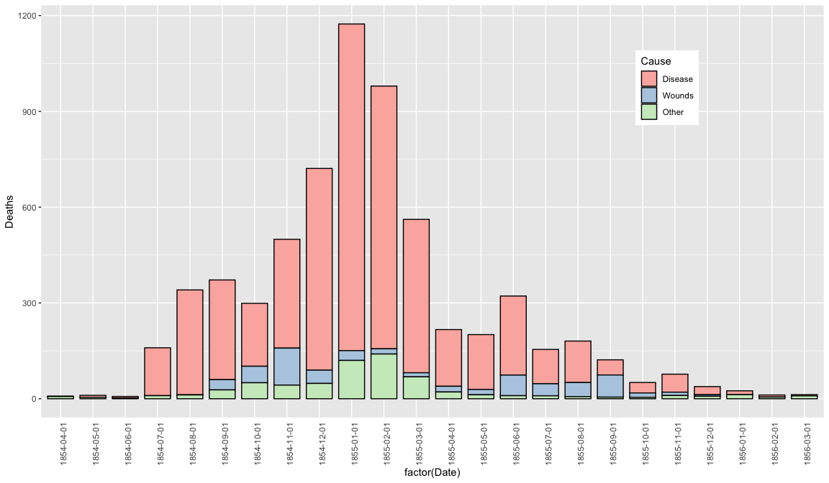

ggsave(cxc_b, file = "../pics/cxc_b.png", width = 12, height = 7)

## Coxcomb Plot

cxc1 <-   
 ggplot(data = Night %>% subset(Regime == "Before"),  
 aes(x = Month,   
 y = Deaths,   
 fill = Cause)) +  
 geom_bar(width = 1,   
 stat = "identity",   
 position = "stack",   
 colour = "black") +  
 scale_y_sqrt() +  
 coord_polar(start = 3 * pi / 2)  
cxc1

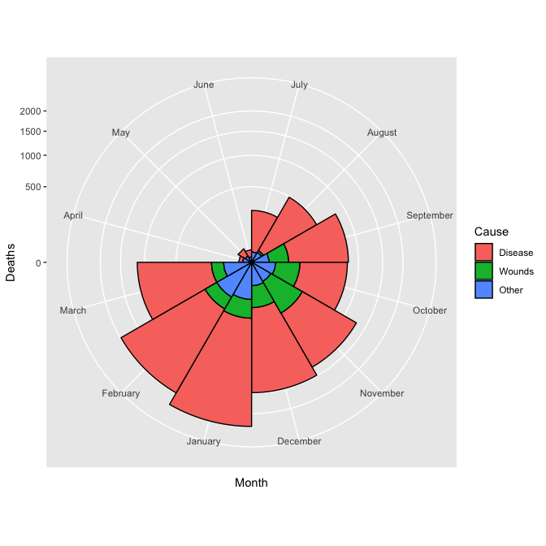

cxc2 <-   
 ggplot(data = Night %>% subset(Regime == "After"),  
 aes(x = Month,   
 y = Deaths,   
 fill = Cause)) +  
 geom_bar(width = 1,   
 stat = "identity",   
 position = "stack",   
 colour = "black") +  
 scale_y_sqrt() +  
 coord_polar(start = 3 * pi / 2)  
cxc2

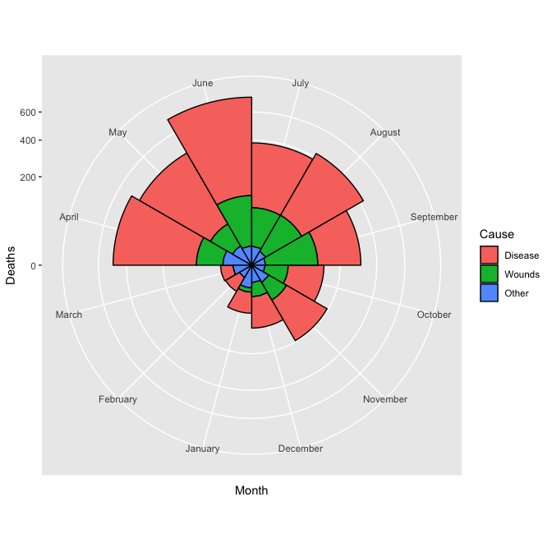

## facet

Regime_lab <- c("Before", "After")  
names(Regime_lab) <- c("Before", "After")  
cxc_f <-   
 ggplot(data = Night,  
 aes(x = Month,   
 y = Deaths,   
 fill = Cause)) +  
 geom_bar(width = 1,   
 stat = "identity",   
 position = "stack",   
 colour = "black") +  
 scale_y_sqrt() +  
 scale_fill_brewer(type = "qual", palette = "Pastel2") +  
 facet_grid(. ~ Regime,   
 scales = "fixed",   
 labeller = labeller(Regime = Regime_lab)) +  
 coord_polar(start = 3 * pi / 2)  
cxc_f

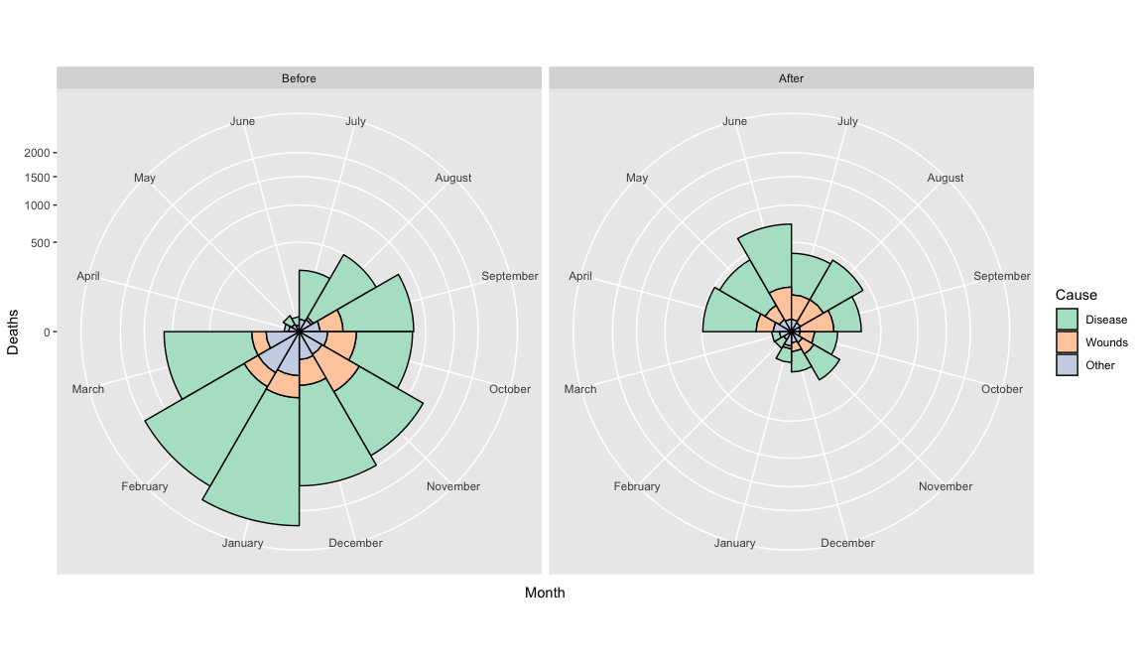

ggsave(cxc_f, file = "../pics/cxc_f.png", width = 12, height = 7)