The original CSV files were messy, with duplicates (for example, Valve appeared as “Valve,” “VALVE CORP,” etc.), inconsistent references (sometimes by ID, sometimes by name), and mixed date formats. This made reliable analysis—like calculating total revenue per publisher—very difficult.
To address this, I normalized the data into a clean relational model following 3rd Normal Form. This eliminates redundancy, ensures referential integrity, and makes queries reliable and consistent. All publisher and game names were cleaned and standardized to maintain consistent references across tables.
Data Model Overview:
I created the data model in Notepad++ for readability, then took a screenshot to include in this document for easier reference.
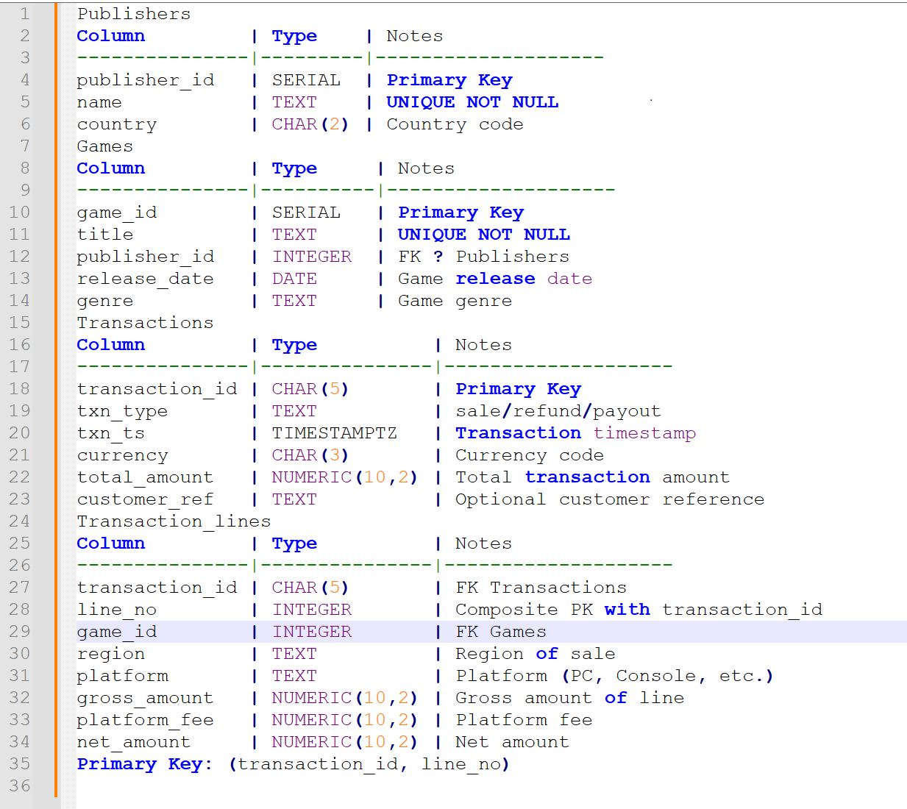

Walkthrough of the Model:

Publishers: Single source of truth for publisher information. Each publisher has a unique publisher_id, name, and country. Deduplication and standardization were applied to avoid inconsistent entries.
Games: Each publisher can have many games. The Games table stores deduplicated titles linked to their publisher via publisher_id, along with release_date and genre. This ensures every game has a consistent reference to its publisher.
Transactions: Captures header-level data for each sale, refund, or payout. Each transaction includes transaction_id, type (sale, refund, or payout), timestamp, currency, total amount, and an optional customer reference.
Transaction_Lines: Each line links a transaction to a specific game. This table supports multi-platform purchases and bundles, and includes region, platform, gross_amount, platform_fee, and net_amount. The primary key is a composite of transaction_id and line_no to ensure uniqueness within each transaction.
Relationships:
One Publisher → many Games
One Game → many Transaction_Lines
One Transaction → many Transaction_Lines
This normalized structure ensures all entities in the ERD map cleanly to real-world concepts. It eliminates redundancy, enforces referential integrity, and maintains consistent IDs and names. It also makes querying straightforward, allowing accurate revenue calculations by publisher, platform, or region, while the composite key and foreign key constraints maintain data integrity and optimize performance.Relationships:
Redshift Provisioning
I provisioned an Amazon Redshift Serverless workgroup in the same region as the RDS instance (us-east-2). Key configuration choices included starting with a low base capacity (32 RPU) to control costs during testing, and enabling public access after creation, which required allocating an Elastic IP and configuring the security group to allow inbound access on port 5439. I used the default VPC and security settings, restricting inbound rules to my IP range. This setup provides an auto-scaling analytics environment ideal for running complex queries on the normalized dataset.
Schema Creation in Redshift Serverless
I connected to the development database in the Redshift Serverless workgroup using Query Editor v2 and recreated the normalized schema with Redshift-compatible data types and constraints. All four tables, publishers, games, transactions, and transaction_lines were successfully created. Adjustments for Serverless compatibility included using IDENTITY for primary keys, DECIMAL for monetary fields, and omitting foreign keys and explicit DISTKEY/SORTKEY, since Redshift Serverless handles distribution and sorting automatically. The schema is now fully staged and ready for analytics workloads.
ETL / Data Migration Plan from PostgreSQL RDS to Redshift Serverless
To move the data from RDS PostgreSQL to Redshift, my preferred method is a simple, native AWS pipeline using S3 as an intermediary:
- Create an S3 bucket in the same region.
- Export the normalized tables from RDS to CSVs in S3 using the built-in aws_s3 extension (aws_s3.table_export_to_s3).
- Attach an IAM role with S3 read access to the Redshift Serverless workgroup.
- Load the data using Redshift COPY commands from S3 (CSV format with automatic timestamp handling).
This approach is fast, secure, serverless-friendly, and cost-efficient. Due to time constraints in the assessment, I focused on provisioning Redshift Serverless and validating the schema, but the full data load can be executed quickly in a follow-up.
Automation of Mock Data Generation and Continuous Population (Optional)
Given time constraints, I’m outlining my preferred approach rather than implementing it fully. This method leverages Fivetran (or AWS Glue) for automated, scheduled ingestion, combined with DBT-based data generation, orchestrated via Airflow (MWAA) or other applications.
High-level design:
- Create a lightweight “mock source” schema in PostgreSQL mimicking the original denormalized structure.
- Use DBT seeds and models with PostgreSQL random functions to generate realistic new transactions daily or hourly, referencing existing games, realistic bundles, and refunds.
- Schedule DBT jobs via Airflow DAGs or other applications.
- Use Fivetran (PostgreSQL connector with CDC) or Glue to sync changes into the normalized schema, or have DBT transform directly into the clean tables.
- Extend the existing S3 export + Redshift COPY process into a scheduled Airflow or Glue job to keep Redshift current.
Benefits: This approach is fully managed, observable, and scalable. It aligns with modern data stack practices I’ve successfully implemented in prior roles and ensures consistent data integrity while scaling from test to production volumes.
Summary
I analyzed the messy source data, designed and implemented a normalized 3NF schema in PostgreSQL RDS, and populated it with cleaned records. I provisioned Redshift Serverless, recreated the schema with adjustments for Serverless, and validated the environment. It’s now ready for analytics workloads and scalable ETL processes.
For reference, I’ve included a Notepad++ document in github with details on the PostgreSQL RDS instance (configuration, schema, etc.) and the Redshift Serverless instance (workgroup settings, schema adjustments, etc.).
Thank you again for the opportunity.

