SUDOKU Solver
By Dan Cooperstock – Release 1.0
I created this program in September and October 2026. I was written in the Delphi programming environment, as a port (translation / re-write) of a previous version written in the PowerBuilder programming environment.
This program lets you play Sudoku puzzles, and solve them manually, or let the computer do it for you. As far as I can tell, it can solve all solvable Sudoku puzzles, though to solve fairly hard ones, it needs to use techniques that aren’t realistic to be done manually. (See Techniques Used by the Program for Automated Solving below for details.)
This help topic assumes you already know how to play Sudoku, but in brief, you solve a Sudoku puzzle by filling the digits 1 to 9, with no repetitions, in each of the rows, each of the columns, and each of the 3x3 blocks (indicated by the thicker borders). So the same digit cannot appear twice in any row, column or block.
The program can also solve 6x6 puzzles that appear in some places (such as the daily Toronto Star newspaper).
In the rest of this Help document, I will refer to digits that cannot be entered, because the same digit already occurs in the same row, column or block, as “impossible” or incorrect entries. Possible entries are all others. The program helps you (even with manual play) by not allowing impossible entries. In that regard, using it for manual play is different from solving a puzzle on paper, where you can in fact make mistakes (impossible plays) that can leave you unable to solve it, if you can’t figure out and reverse that mistake!

Initial Setup
When you first start the program, you will see an empty puzzle:
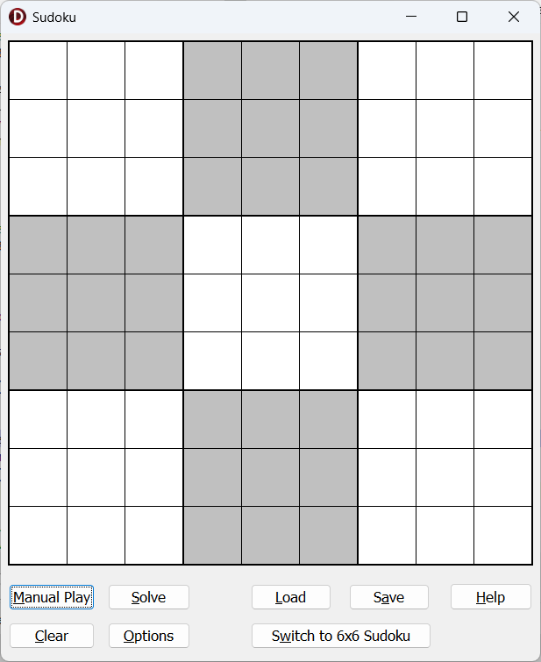
You can start by clicking into cells and filling in the initial digits of the puzzle (for instance, if you got it from a newspaper or online source). As you click in a cell, it turns light green, and you just press any key from 1 to 9 to insert it into that highlighted square. To delete an entered number, press Backspace or Del. To change a number, just press a different key from 1 to 9.
You can also navigate around the puzzle, once there is a highlighted square, with various keys:
- The 4 arrow keys (Left, Right, Up, Down) do the obvious things, stopping at each end of a row or column.
- Tab moves forward across a row (like Right arrow) but also skips from the end of one row to the start of the next, or from the end of the last row to the start of the first row.
- Shift-Tab does the opposite of Tab, moving backwards.
- Home and End move to the start or end of a row.
- PageUp and PageDown move to the top or bottom of a column.
Alternatively, you can use the Load button to load a puzzle that you have previously saved with the Save button (details below).
Then you will have your puzzle specified, such as the following:
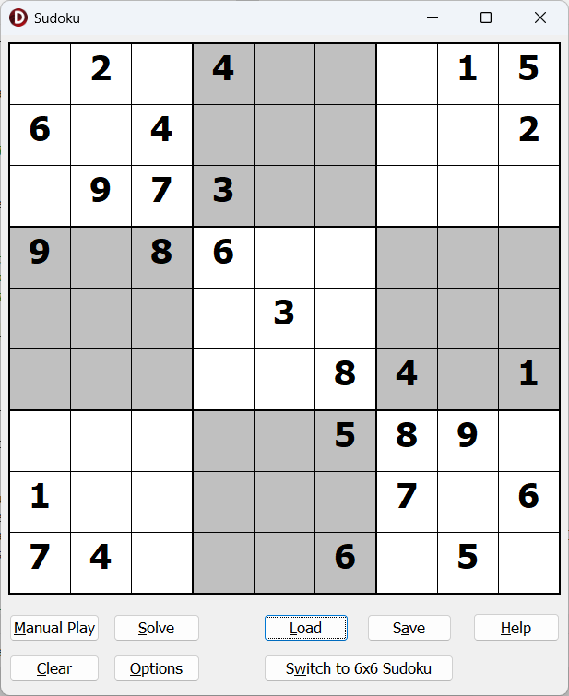
To start working on the puzzle manually, click the Manual Play button. That will give you a display such as the following:
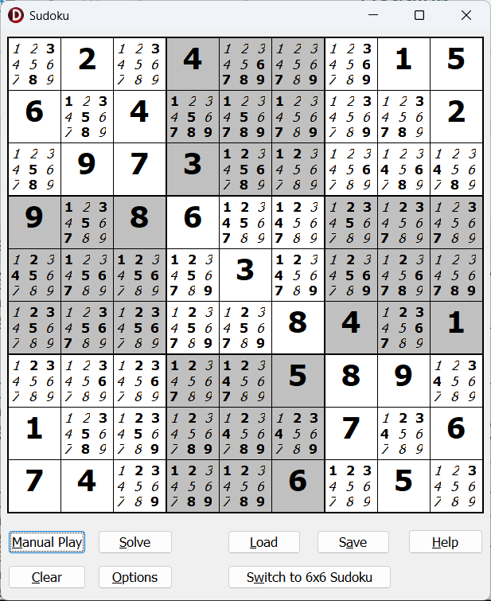
As you can see, each square that didn't yet have a puzzle digit in it gets a display with small numbers 1 to 9 displayed in it. The numbers in boldface in this small display of 1 to 9 are the possible ones. The impossible numbers are not bold, and are italic. (The program has identified and marked the impossible ones by eliminating numbers that appear in the original puzzle on the same row or column, or in the same box.)
(There is actually an Option you can set where the small numbers are not shown – that will be explained later.)
Note that once you press Manual Play, you cannot change the original puzzle numbers you entered or loaded. This prevents you from accidentally changing the original puzzle so that it cannot be solved!
You could actually work without clicking Manual Play, just filling in further digits manually, though they will then appear as if they were original puzzle digits. (Original puzzle digits are bold; if you use Manual Play, then squares you solve after that, either manually or with the Solve button, are not bold.)

Manual Play
You can click on one of those small 1 to 9 digits in a square to turn it from being bold, to not bold and italic, or vice-versa. As mentioned above, non-bold means impossible or not an option. Leaving a digit bold indicates you think that digit is still an option for that square.
The program actually won't let you take impossible actions based on what is already solved, including making a small digit bold if it’s not possible in that position. If you try to do that, you will get an error message and not be allowed to turn it back bold.
If you think you have figured out which digit goes into a square, double-click it to put that digit into the puzzle as a solved digit. (You can also click anywhere in the square to highlight it, then just press any of the 1 to 9 keys on your keyboard to enter that as a solved digit, without double-clicking.) It will then show up just like the original puzzle digits (removing the small 1 to 9 numbers) except it will not be bold. When a full-size digit is not bold, that indicates it is part of what you have solved (or the computer has solved), rather than part of the original puzzle. Again, the program won't allow you to make impossible moves based on what is already solved.
The program's prevention of impossible moves does not mean that all of your moves will be forced to be correct moves toward the solution! You can make possible moves that still aren't part of the correct unique solution of each properly designed puzzle.
If you have double-clicked a digit to turn it into a solved square, and decide it is incorrect, just double-click it again, or press Backspace or Del, to bring back the small 1 to 9 digits in the square.
Any time you solve a digit, the instances of that same number on the same row, column and 3 x 3 block that are in the small 1 to 9 digits are all marked as not being an option (i.e. not bold, and italic). If you change that solved digit to a different digit, or clear the selection by double-clicking, those markings of other squares in the same row, column or block not allowing that number are not cleared – i.e. they may then be incorrect.
So to be clear, no small 1 to 9 digit that is bold can be incorrect (not actually possible), but ones that are not bold can be incorrect (still actually possible).
Because of that problem, you may want to have the program re-calculate and re-display which digits are possible (and so bold) and impossible (and so not bold) at some point in your manual play, based on the digits you have solved so far and the original puzzle. You can do that by re-clicking the Manual Play button.

Computer Solving
Clicking the Solve button at any point, whether immediately after manually entering or loading the puzzle, after pressing Manual Play, or after some manual play, will make the program solve the puzzle. Very short pauses are optionally (depending on Options) inserted between displaying each solved digit in turn, to help you see what it is doing. Assuming it is completely successful, you will see the puzzle finished, and receive a message saying it was successful.
The program has been designed to be able to solve all Sudoku puzzles, though it may need to take a complex, potentially slow approach to very hard ones. In the unlikely case that there is a programming error leading to a program not being solved completely, you can try working on it manually.
If that complex, potentially slow approach is needed to complete the solution, depending on your Options, you may be asked whether you want the program to do that, before it continues.

Other Buttons
As mentioned above, you can use the Save button to save an entered puzzle for later re-loading. Only the filled-in digits (not your work on the small 1 to 9 digits in unsolved squares) are saved. Both original filled-in digits (from before you clicked Manual Play) and digits you have solved after that are saved.
Puzzles are saved with a “.sud” file extension (short for “sudoku”!)
You can then re-load that with the Load button. Loading maintains the distinction between original (bold) digits and subsequently solved (not bold) digits, if there were any of both types.
When you install this program with the installation program SudukuSetup.exe, there are actually a few sample saved files you can use, from different days’ Sudoku puzzles in the Toronto Star, and others. You can load them with the Load button. Most of them can be entirely solved by the initial simple steps in the program.
The Saturday puzzle (saturday.sud) is an exception. This is how far it gets on that Saturday puzzle before asking you whether you want it to use the slower method to complete it:
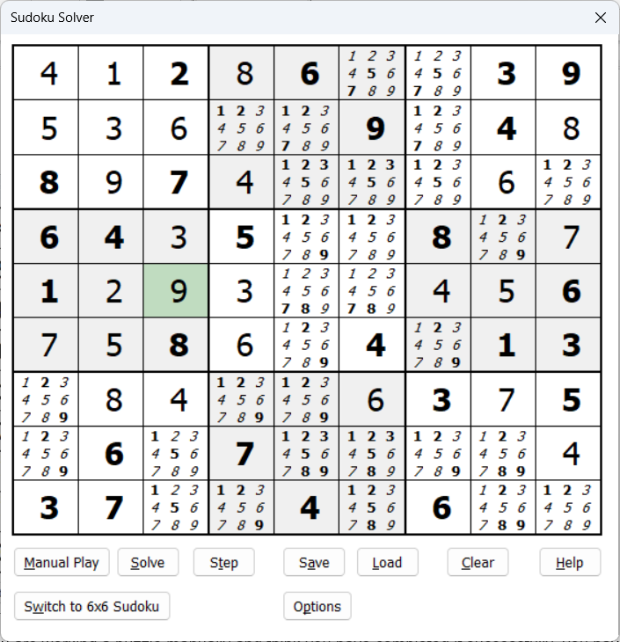
If you are working a puzzle manually and think you have completed it successfully, you have! Because the program won't let you make illegal moves (that put the same number twice in any row, column or 3x3 block), and because published sudokus only ever have a single possible solution, it should be impossible to have a fully filled-in puzzle that is not correct.
The Clear button clears the entire puzzle and lets you start again with an empty one.
The Help button displays this help file.
Power-User Tip: You see the underlined letters on the buttons in the screenshot about (like on “Start”)? If they aren’t showing up, press and release the Alt key and they will appear. You can then “click” any of the buttons by just pressing that underlined letter, or using Alt with it, like pressing either “S” or “Alt+S” for Start.

Switching between Sizes of Sudoku
On the initial 9x9 Sudoku window, if you click the Switch to 6x6 Sudoku button, it switches to that size of Sudoku, which looks like this:
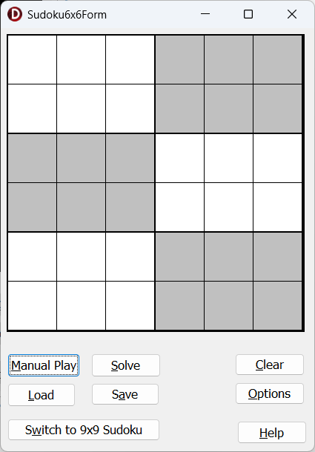
As you can see, in this puzzle there are 6 rows, 6 columns, and 6 boxes (each consisting of 3 rows and 2 columns). Play is basically identical. There are a couple of loadable samples (with “6x6” in their names) included in the installation.
The button for switching on this window changes to be named Switch to 9x9 Sudoku, and switches back to the normal larger size.

Techniques Used by the Program for Automated Solving
The program uses three simple techniques and one complex technique to solve the puzzle when you click Solve. You don’t have to understand this; it’s just interesting to know how it works, and how a few simple rules can solve most easy to moderately difficult sudokus!
Here is what it does:
1) For each digit that is already solved in the puzzle (whether an original puzzle number, that is bold, or one you have solved, that is not bold) the program un-bolds that in the small 1 to 9 digits in all unsolved squares in the same row, the same column, and the same 3x3 block. That indicates it is not possible in those squares. (I call this “bubbling out” that digit.)
2) In each square where only one of the small 1 to 9 digits is still bold (still considered to be possible), the program chooses that bold number as the answer. Having done the solve of that digit, the program bubbles it out as in (1).
3) In each row, each column, and each block, look for any bold digit in the small 1 to 9 digits in the unsolved squares that is only bold in one of those unsolved squares. That square must contain that digit, so the program chooses it there. Having done that solve of that digit, the program bubbles it out as in (1).
(4) Repeat the pair of steps (2) and (3) until neither of them solves any further squares.
If the puzzle is not solved after that, it then optionally goes on to the complex, potentially show method. Unlike the previous methods, this method is really not very suitable for manual use by people – it is only realistic for a computer program to do it.
5) Essentially this method is that the program tries each possible digit in each so-far unsolved square in turn, sees what effect that has (applying method (1) after each digit it tries), until it finds a solution. On a hard Sudoku, you will see it apparently making some progress, then going back and repeatedly starting over earlier in the puzzle.
The name of this type of algorithm (rule for solving a problem) is a “backtracking” algorithm. I adapted this from the “Simple Solving Algorithm” on the web page https://pi.math.cornell.edu/~mec/Summer2009/meerkamp/Site/Solving_any_Sudoku_I.html.

Options
If you click the Options button, a window such as the following comes up:
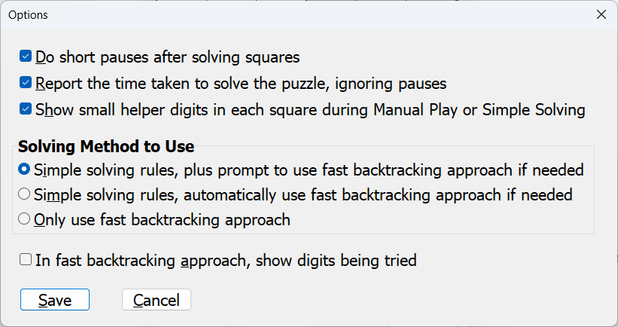
Here is a description of each option:
- Do short pauses after solving squares: If this is checked (the initial default before you change anything in this window), there is a short pause after solving each square when you use the Solve button, so you can better see what it is doing. However, pauses are never used if the potentially slow backtracking approach is used – that would make the process unreasonably slow!
- Report the time taken to solve the puzzle, ignoring pauses: If this is checked (which is not the initial default) you get a message saying how many seconds (and hundredths of a second) it took to solve the puzzle with the Solve button, excluding any pauses and also excluding any time taken if the program asks you a question in the process of solving, before you answer that question.
- Show small helper digits in each square during Manual Play or Simple Solving: If this is checked (the initial default), the small 1-9 digits are shown after you click Manual Play or Solve in the main window. If it is unchecked, you have to play without them. Even without the small digits, impossible moves are still not allowed if you are playing manually. If the backtracking method needs to be used, the small helper digits are not shown.
- Solving Method to Use: This has three alternatives:
  - Simple solving rules, plus prompt to use fast backtracking approach if needed: This is the initial default. Use the basic solving rules. If they aren’t enough to solve the prompt, you will be asked whether to then switch to the backtracking approach to do the rest of the solving.
  - Simple solving rules, automatically use fast backtracking approach if needed: Use the basic solving rules. If they aren’t enough to solve the prompt, the program will automatically switch to the backtracking approach to do the rest of the solving.
  - Only use fast backtracking approach: This never uses the basic solving rules, but rather immediately uses the backtracking approach to do the solving.
- In fast backtracking approach, show digits being tried: The initial default is that this is unchecked.
If this is checked (and backtracking solving is done), the small 1-9 digits are shown and updated as the program works through the solution by backtracking. While this is somewhat informative as you watch it, it will be 10 or more times slower than if you uncheck this and those digits are not displayed during backtracking!

License
This program is freeware - you are free to use it, share it and redistribute it as you wish, but please do not change this part of this help file. The program was created by Dan Cooperstock.

