Floppy-80 M1 Connections

Power
The 2.5mm socket and cable provided connects to a standard USB connector, this is suitable for connection to a 5-volt (approx 500ma max) USB power supply. The type that connects to a phone or firestick etc. Do not use any other voltage!

The power supply transformer is not provided due to local country mains connecter differences etc.

40 Ribbon cable
The cable is long enough for the main unit to sit to the left hand side of a TRS80-Model 1, as illustrated below. Note the bends in the cable to accommodate the polarity of the expansion edge connector on the TRS-80

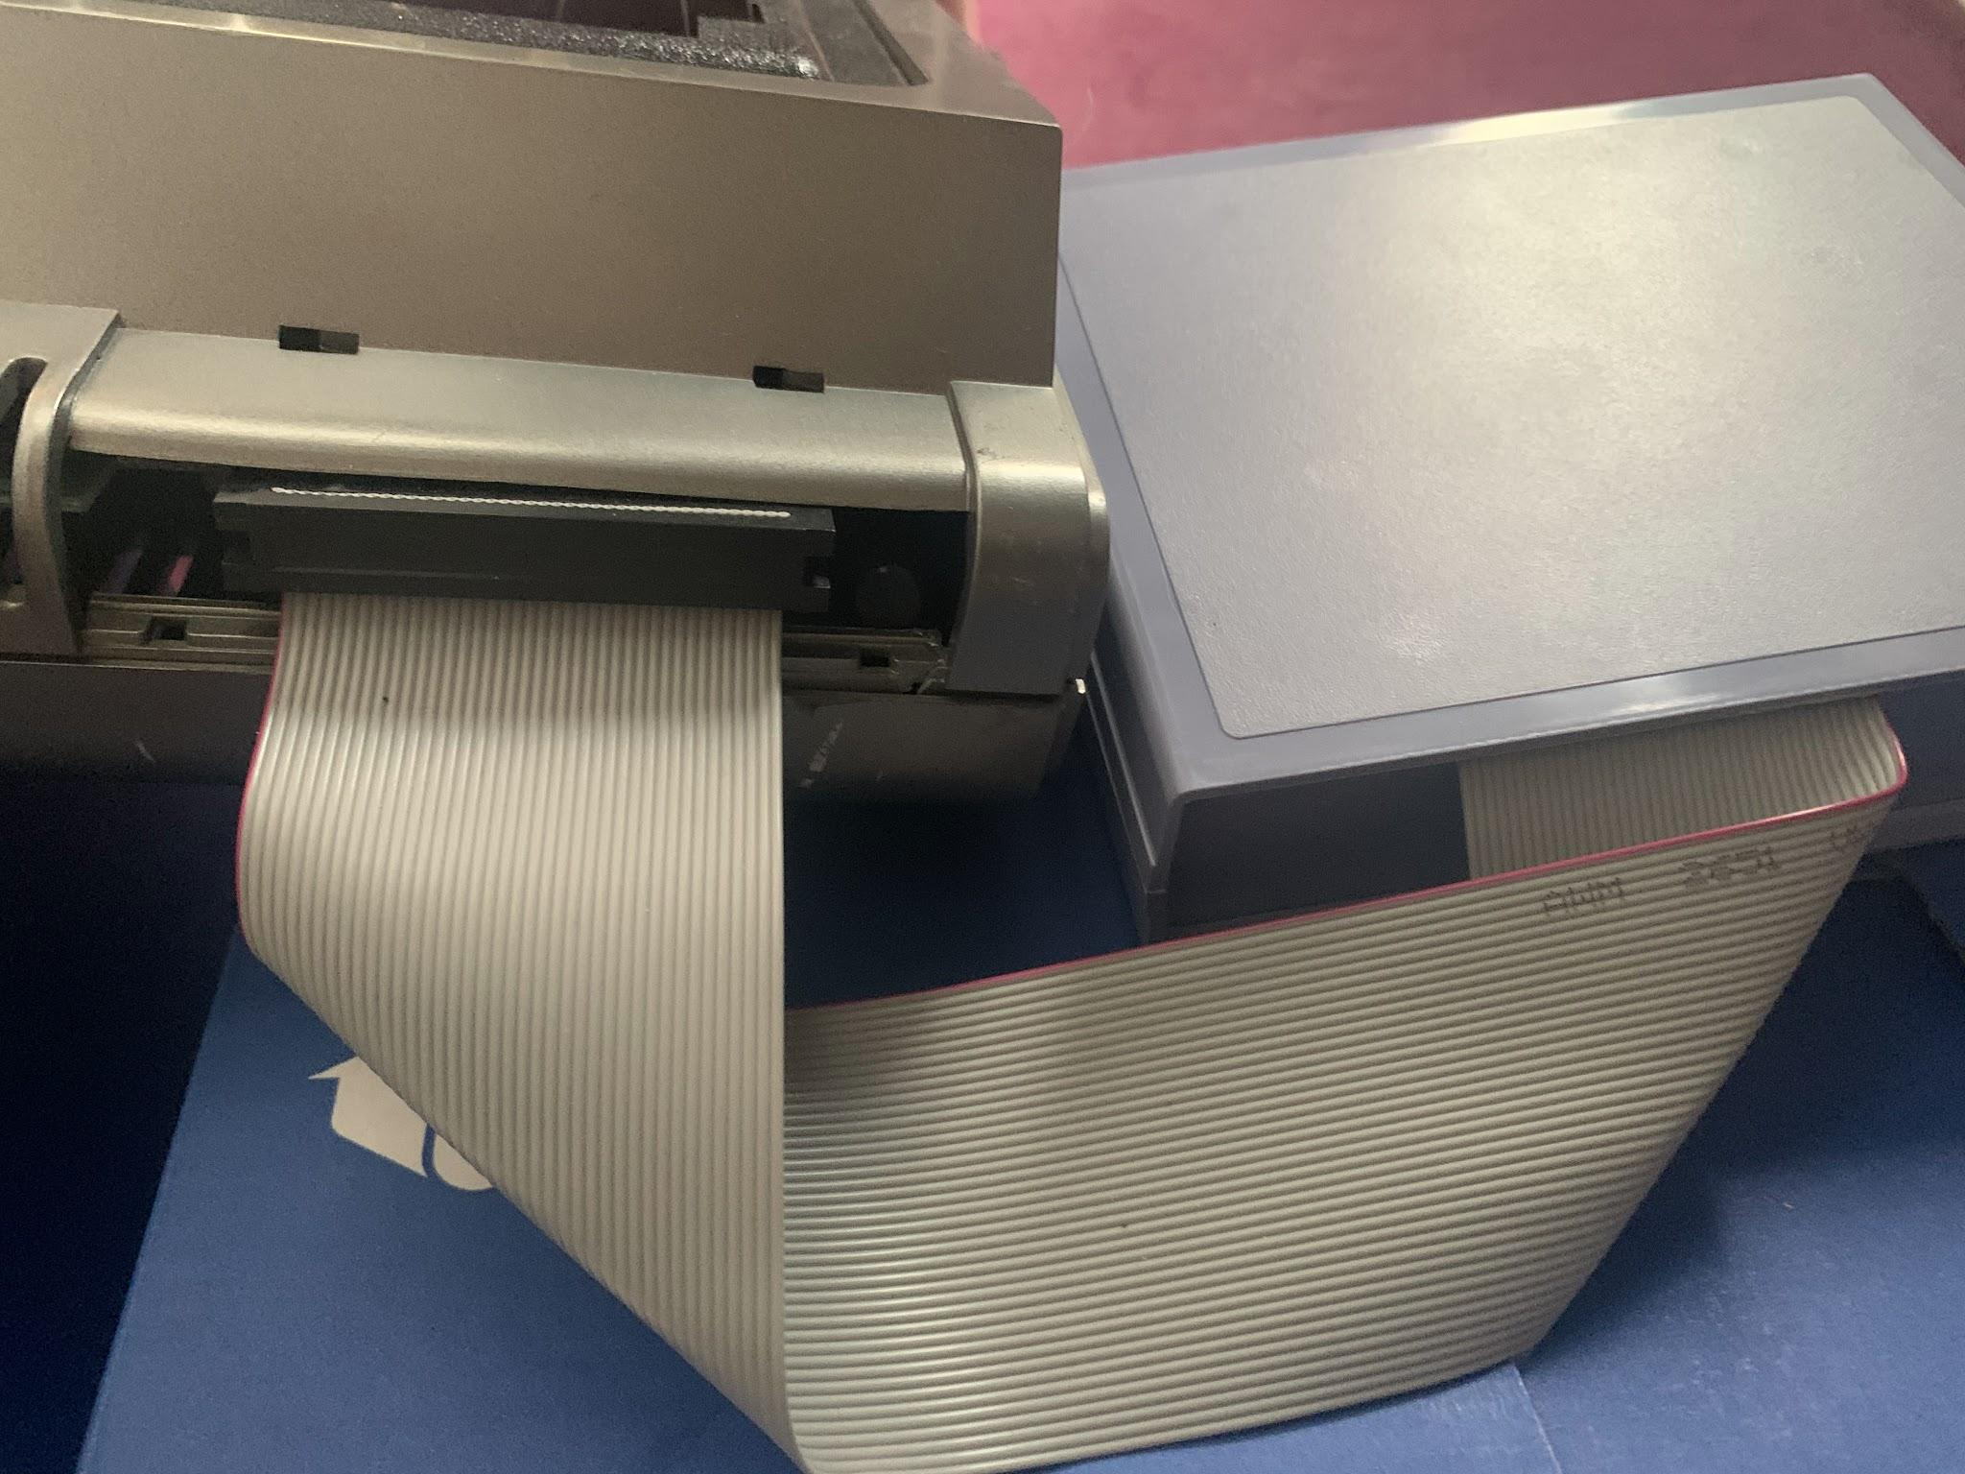Note: position of the red line on side of cable.
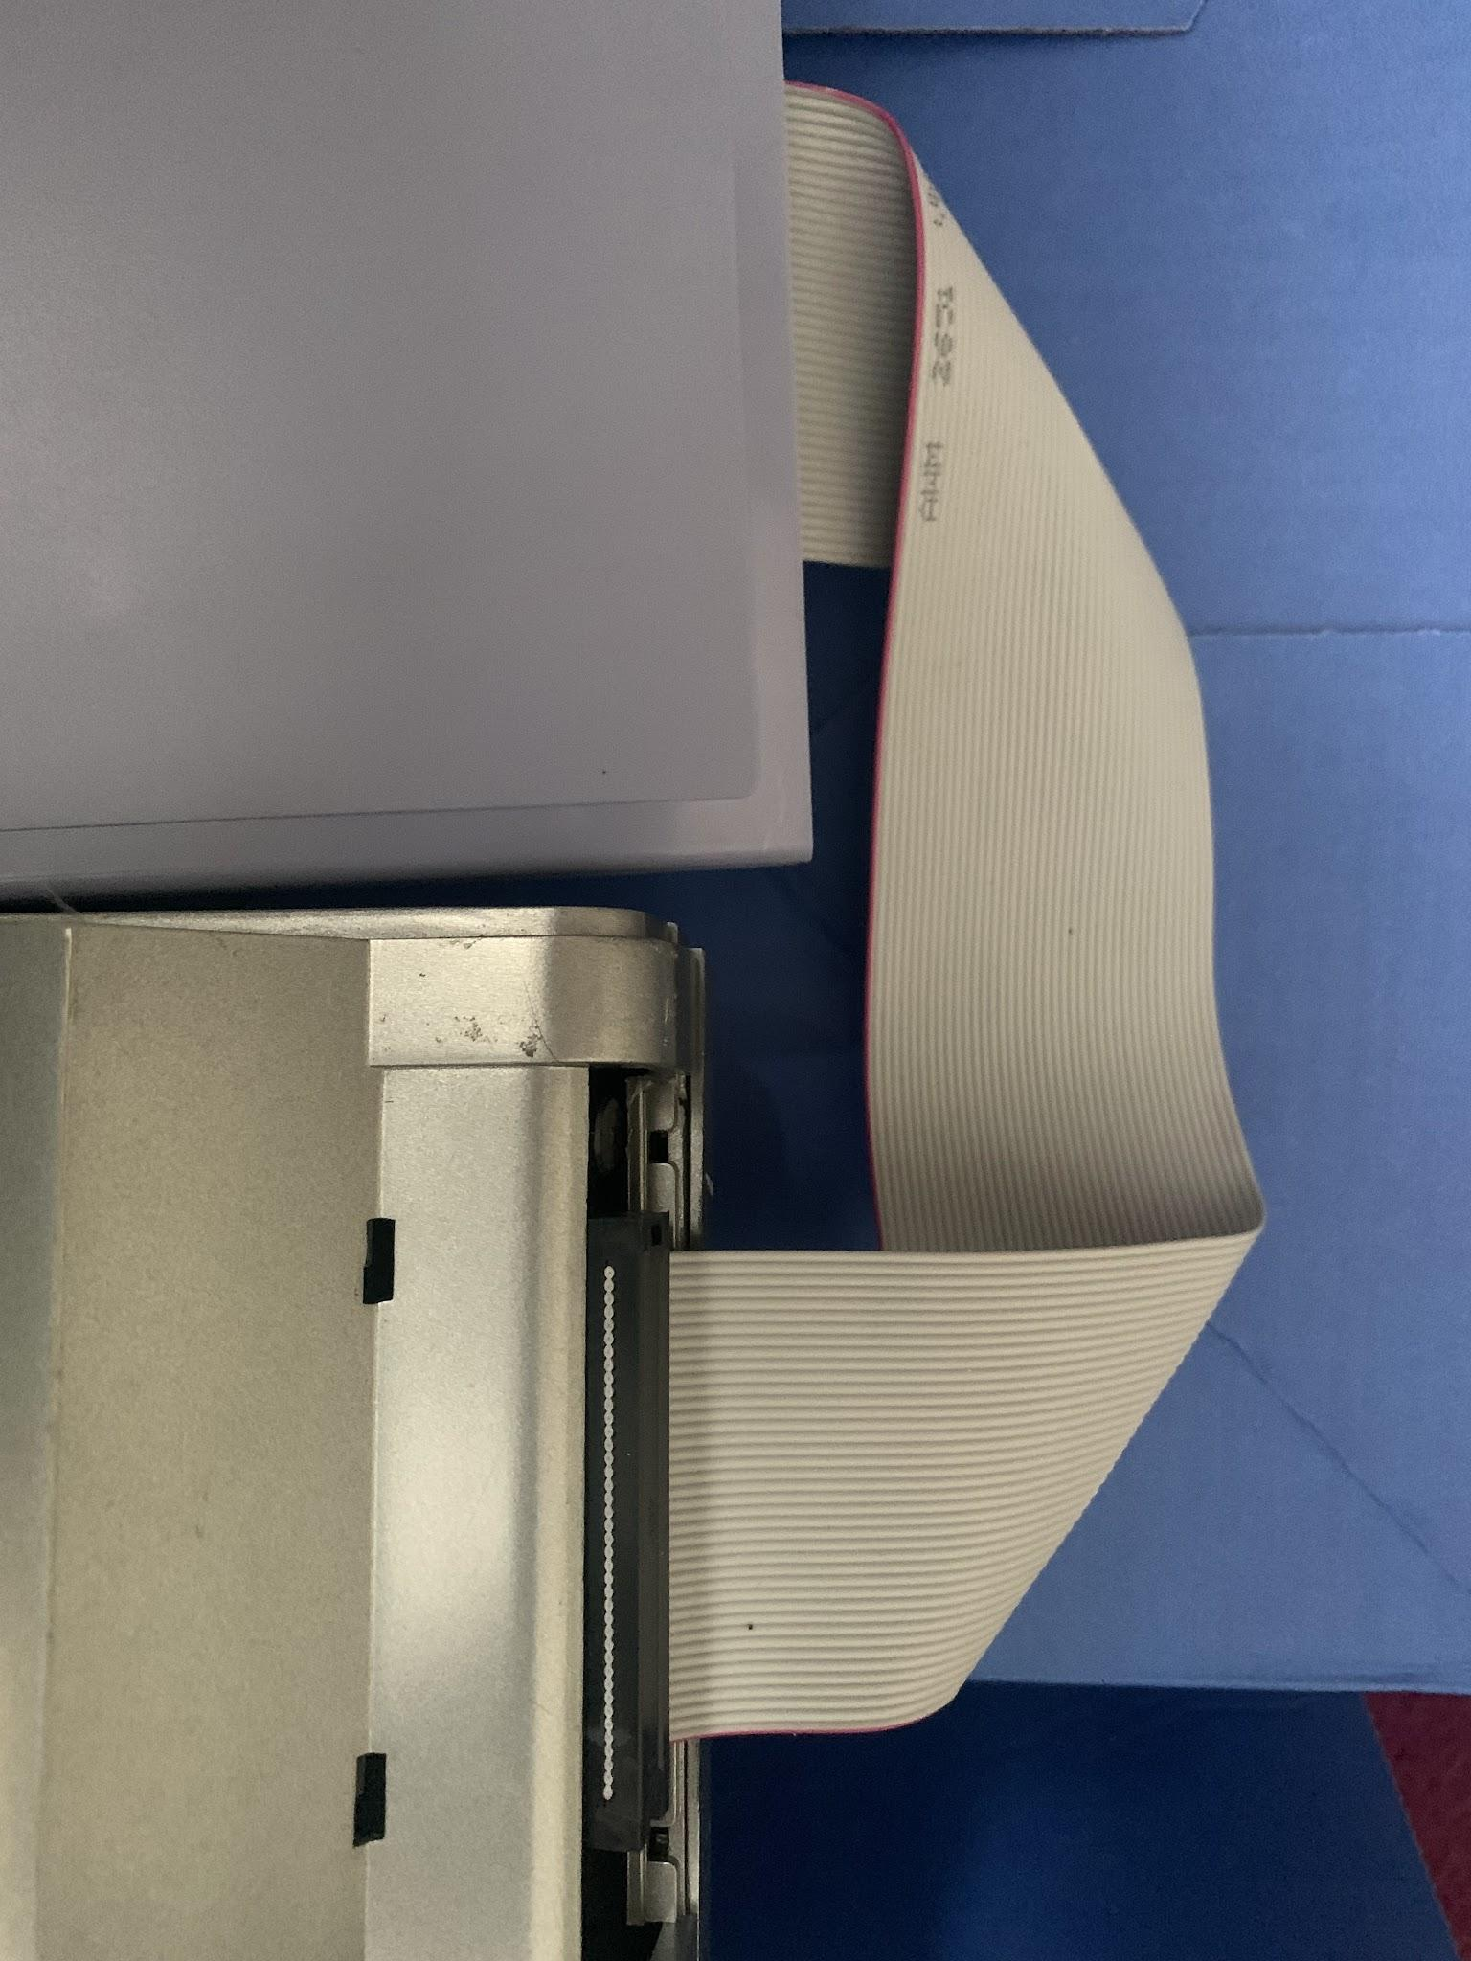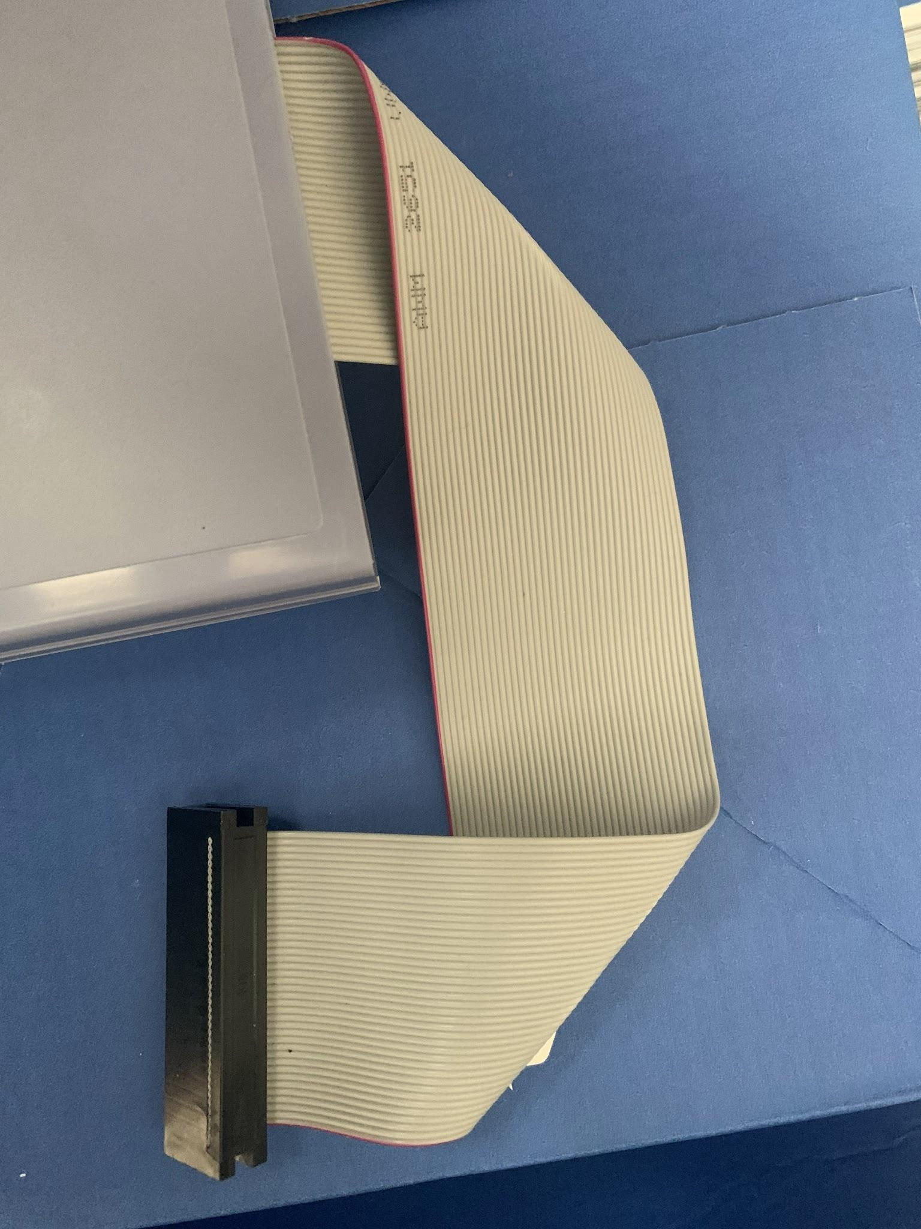
NOTE: The edge connecter on the TRS80 can be problematic, if it is not clean. If your unit misbehaves please clean the 40-pin plug and edge connector with contact cleaner.

Floppy 80 (M1) User Guide
Welcome to the Floppy 80 (M1) User Guide. This document will walk you through configuring, operating, and debugging your Floppy 80 emulation system.

Configuration
The Floppy 80 (M1) requires a FAT-formatted SD card to store disk images and configuration files. The maximum size supported is 32Mb

All configuration files must be placed in the Root folder of the SD card. Subfolders are restricted in use, for example /FMT directory. It is possible to put the image files in folders but the config files (INI) for them must be in the root folder.

1. system.cfg
This optional file defines global hardware settings. If a setting is omitted, its default value is used.
- MEM: Enables or disables the onboard 32KB RAM expansion. (1 = Enabled [Default], 0 = Disabled)
- VHD: Enables or disables Virtual Hard Disk support. (1 = Enabled [Default], 0 = Disabled)
- WAIT: Enables or disables CPU wait states. (1 = Enabled, 0 = Disabled [Default])

Example system.cfg:
MEM=1
VHD=1
WAIT=0
A Note on Wait States: Wait states slow down the Z80 CPU to ensure it waits for the floppy disk controller emulation to complete. While generally unnecessary for standard systems, they can help with overclocked CPUs where the processor outpaces the emulation. Note that wait states are known to disrupt critical, tightly timed native operations like formatting a physical floppy disk.

2. boot.cfg
This file tells the Floppy 80 which configuration profile (.INI) to load automatically when the device boots or resets. It must contain only the exact filename of your chosen INI file.

Example boot.cfg:
LD531.INI

3. .INI Files
These files define which virtual disk images map to your floppy and hard drives upon boot.
- Drive0 to Drive2: Specifies the .dmk floppy image for drives :0, :1, and :2.
- HD0 / HD1: Specifies the .hdv image for the primary and secondary virtual hard drives.
- Doubler: Enables or disables double-density floppy support. (1 = Enabled, 0 = Disabled)

Example .INI file:
Drive0=LD531-0.dmk
Drive1=LD531-1.dmk
Drive2=LD531-2.dmk
HD0=hard0.hdv
Doubler=1

File Types & Folders
- .DMK Files: Virtual floppy disk images using a standardized format compatible with common TRS-80 emulators. For example trs80gp and trs80tools.
- .HDV Files: Virtual hard drive images using the same standard format as FreHD and trs80gp.
- /FMT Folder: A dedicated root-level directory used strictly to hold blank, unmountable floppy images. These act as templates for the FDC FMT utility.

Operation
Important Power Sequence: Always power on the Floppy 80 before turning on the main TRS-80 computer. Power is supplied via the 2.5mm socket and USB adapter cable. It is also possible to use micro-USB port on the Pi Pico microcontroller, mainly if you need to debug anything - normally not accessible.. A built-in LED on the Floppy 80 indicates disk read/write activity.

The FDC Utility
The FDC command-line program allows you to interact with the Floppy 80 directly from inside the TRS-80 operating system. Versions are available for CP/M (Lifeboat and FMG) as well as most major TRSDOS-based environments.
- FDC STA — Displays the current system status and lists the contents of the active boot INI file.
- FDC DIR [filter] — Lists files in the SD card's root folder. Adding an optional text filter narrows down the results.
- FDC INI [filename.ini] — Switches the system to a new INI profile. If you omit the filename, a selectable menu of available INI files will appear, and your choice will be written to boot.cfg file.
- FDC DMK [filename.dmk] [0/1/2] — Mounts a specific floppy image to drive :0, :1, or :2. Running FDC DMK without arguments opens an interactive selection menu.
  - Example: FDC DMK LDOS-DATA.DMK 2 mounts that file to drive :2.
- FDC FOR — An emergency backup formatting utility. It lets you select a blank template from the /FMT folder to overwrite and clear a currently mounted drive image if native OS formatting fails.
- FDC IMP [filename.ext] :n — Imports a raw file from the root of the SD card directly into virtual floppy drive n.
- You can also use tools like trs80tools, to import and export files from the disk image files.

Operating System Compatibility
The following matrix details how various TRS-80 Model I operating systems interact with the Floppy 80 emulation layer.
Operating System | Native Formatting | Backup Utility | Notes / Special Requirements
CP/M 1.4.1 (Lifeboat) | Works | Works | Stable
CP/M 1.5 (FMG) | Works | Works | Stable
Double DOS 4.2.4 | Works | Works | Stable
DOS Plus 3.50 | Works | Conditional | Requires a double-sided .dmk template to format. BACKUP requires Doubler=0.
LDOS 5.3.1 | Conditional | Works | Currently supports single-density only. Requires a system reboot after formatting a drive.
MultiDOS 4.01 | Works | Conditional | BACKUP requires Doubler=0.
NEWDOS 3.0 / 80 V2.0 | Works | Works | Stable
TRSDOS 2.3 | Works | Works | Stable
UltraDOS 4.2.0 | Works | Works | Stable
VTDOS 3.0.0 | Works | Issue | BACKUP encounters "Different Pack IDs" warning.
VTDOS 4.0.1 | Works | Conditional | BACKUP requires Doubler=0.

Advanced use Debugging & Serial Interface
The Floppy 80 provides a Command Line Interface (CLI) over its USB connection for advanced diagnostics. This is only available by connecting a USB connector directly to the PI Pico2, do not power it from both the 2.5mm jack and USB at the same time!

To access it, connect the Pi Pico to a host computer via USB and launch any standard serial communication application (such as PuTTY, Tera Term, Minicom, or Serial). On macOS, the device usually initializes as a port named like /dev/cu.usbmodem000000. Because this is a virtualized serial bridge, baud rate and parity settings do not matter—just open the port and press Enter to see the help menu.

CLI Command Summary
Serial Command | Matching FDC Command | Description
boot [file.ini] | FDC INI | Sets the default INI configuration for boot or reset.
disks | None | Displays detailed geometry and mount status for all virtual drives.
dir [filter] | FDC DIR | Displays the SD card directory layout.
dump [n] | None | Performs a complete, raw sector-by-sector hexadecimal dump of drive n.
hdc | None | Formats/creates a virtual hard disk structure.
help | None | Displays the built-time CLI help menu.
logon | None | Enables real-time FDC transaction logging to the terminal screen.
logoff | None | Mutes real-time FDC transaction logging.
status | FDC STA | Returns the current global state of the device.

Advanced: Setting Up a Virtual Hard Disk (Beta)
This brief walk through uses LDOS as an example.

Prerequisites
- A working, bootable Drive 0 floppy image containing the standard RSHARD drivers (e.g., RSHARD5 for LDOS). These drivers can be found in the download section of Tim Mann's TRS-80 archive.
- A blank .hdv hard disk image. The most reliable way to generate a fresh image container is using an emulator like trs80gp.

Hard Disk Partitioning
Because traditional standard configurations (like 309 tracks, 4 heads) are to large to be supported as a single drive on a trs80, you should subdivide the drive into smaller sizes for example 4-partitions split into 38 cylinders per partition. It works best to disregard the last track, If you try to push the last partition to 39 cylinders, the LDOS formatter will drop the drive down to a 35-track default layout. Some other combinations also cause this issue, I think it’s a bug in the LDOS drivers.

Follow these configuration steps carefully inside your emulator before copying the file over to your physical Floppy 80 hardware:

- Initialize the Driver for Partition 1 (Drive :4)
Boot your LDOS 5.3.1 image in the emulator. Execute the driver initialization command and provide the geometry values below when prompted:
- SYSTEM (DRIVE=4,DISABLE,DRIVER="RSHARD5")
Enter drive address <1-2> and F/R: 1F
Enter the STEP RATE: [Press Enter for default]
Enter the physical TRACKS per surface: 153
Enter the total number of HEADS: 8
Enter partition's number of heads: 8
Enter partition's number of cylinders: 38
Initialize Partition 2 (Drive :5)
Bind the second virtual drive slice using the remaining available head allocation:
SYSTEM (DRIVE=5,DISABLE,DRIVER="RSHARD5")
Enter partition's number of heads: 8
Enter partition's number of cylinders: 38
- Initialize Partition 3 (Drive :6)
Bind the third virtual drive slice:

SYSTEM (DRIVE=6,DISABLE,DRIVER="RSHARD5")
Enter drive address <1-2> and F/R: 1F
Enter partition's number of heads: 8
Enter partition's number of cylinders: 38
- Initialize Partition 4 (Drive :7)
Bind the final virtual partition slice:
SYSTEM (DRIVE=7,DISABLE,DRIVER="RSHARD5")
Enter drive address <1-2> and F/R: 1F
Enter partition's number of heads: 8
Enter partition's number of cylinders: 38
- Format the New Partitions
Run the Western Digital high-level formatter utility on each allocated drive. Repeat this process for drives :5, :6, and :7.
RSFORM5 :4
Disk Pack name? HD04
Master password? PASSWORD
Are you sure you want to format it <Y,N>? Y
Lock out track manually <Y/N>? N
Repeat for each partition 4,5,6,7

- Commit Configuration via Sysgen
Save your newly assigned drive mappings so they survive system restarts by running:
SYSTEM (SYSGEN)

Copy to the Floppy 80
Once configured via the emulator, move your files onto the physical SD card and ensure your configuration parameters match the layout below:

Create an INI profile (e.g., ldosboothd.ini):
Drive0=ldosboot2s.dmk
HD0=ldosboothd.hdv
Ensure that VHD=1 is specified within your global system.cfg, and check that your boot.cfg points directly to your newly created hard disk .ini profile. Once booted, typing FREE or DEVICES at the LDOS prompt will verify your active virtual hard disk sub-systems.

