VIEWS / URLS / MODELS

1. HomeView(TemplateView)

Inherits Django generic TemplateView.

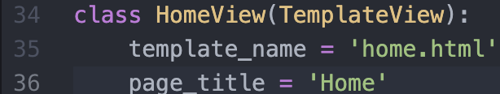

Overwrite the attribute “template_name=’home.html’”

**CSS**

**FILE:** baseN.css   
**Location:** (~/html5up/css/)

|  |  |
| --- | --- |
| **Name:** | header |
| **Type:** | Built-in HTML Tag |
| **Used In:** | baseN.html |
| **Purpose:** | *It encloses the navigation bar and keeps its position to remain on top of all other components when the page is scrolled down.* |

|  |  |
| --- | --- |
| **Name:** | navbar-light |
| **Type:** | Class |
| **Used In:** | baseN.html |
| **Purpose:** | *This is a Bootstrap class of navigation bar. It defines the styling of navigation bar.* |

|  |  |
| --- | --- |
| **Name:** | container |
| **Type:** | Class |
| **Used In:** | baseN.html |
| **Purpose:** | *This is a Bootstrap class to keep the data at the center of page. The minimum width of the content size is set to 69em (em refers to the CSS unit. 69em means means 69 times the current value).* |

|  |  |
| --- | --- |
| **Name:** | banner |
| **Type:** | ID |
| **Used In:** | homeN.html |
| **Purpose:** | It includes styling of the banner image (cloud image) display on the homeN.html page. The image is retrieved from ~/html5up/static/images/ directory.  *Styling for h1 and h3 are done separately.* |

|  |  |
| --- | --- |
| **Name:** | features |
| **Type:** | Class |
| **Used In:** | homeN.html |
| **Purpose:** | *This block includes the styling of three main features mentioned at the home page, between the cloud copasi banner and the description.* |

|  |  |
| --- | --- |
| **Name:** | description |
| **Type:** | Class |
| **Used In:** | homeN.html |
| **Purpose:** | *This block includes the styling of cloud copasi description mentioned at the homepage.* |

|  |  |
| --- | --- |
| **Name:** | footer |
| **Type:** | Class |
| **Used In:** | homeN.html |
| **Purpose:** | *This block includes the styling of cloud copasi description mentioned at the homepage.* |