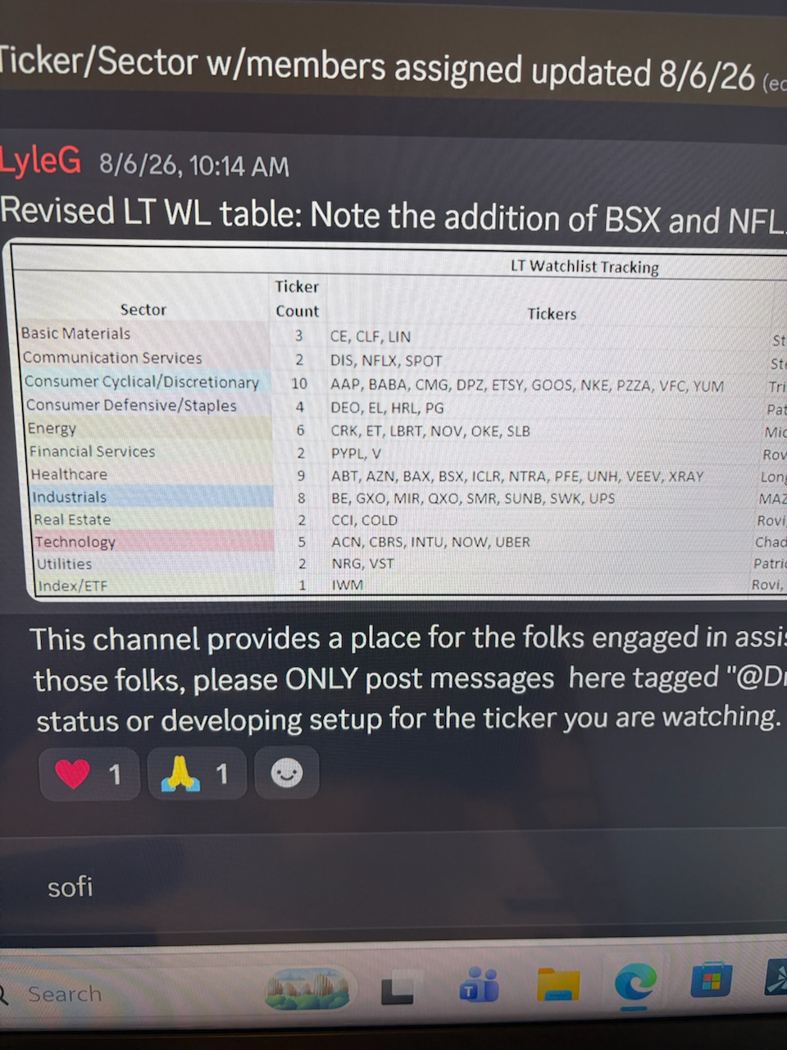

[Claude Analysis Dialog follows]
Good batch to work with — but there's real organizational work to do before diving into research, so let me lay out what I found and propose a structure.

Three things in the file worth flagging first
- Two count mismatches in the source data: Communication Services says "2" but lists 3 tickers (DIS, NFLX, SPOT); Healthcare says "9" but lists 10 (ABT, AZN, BAX, BSX, ICLR, NTRA, PFE, UNH, VEEV, XRAY). Doesn't block anything — just means the actual total is 56 tickers, not however many the count column implies.
- Two tickers are already in the System, don't need fresh screening:
  - V (Visa) — already scored 86.4, Strong Buy, sitting in the workbook right now
  - NOW (ServiceNow) — scored months ago in this session (76, Buy) under an earlier version of the weighting scheme; needs a refresh (price-dependent indicators only, same as we did for ADBE/ANET/etc.), not a from-scratch screen
- IWM is an ETF (Russell 2000 index fund), not a stock — it doesn't belong in Tier 1 stock screening at all. Given you and I already deliberately kept ETF evaluation as a separate track from the core Stock System, I'd set this aside for a future ETF-focused pass rather than force it through Tier 1 rubrics it isn't built for.
Real total: 54 genuinely new stocks to screen.

How I'd sequence this — by diversification value, not list order
54 names is a multi-week undertaking at the pace we've been running (full Tier 1 research, real web search per name). The question worth deciding now isn't just batch size — it's which sectors to hit first, and that should follow the same logic that drove the COST/Visa search: prioritize what's genuinely uncorrelated to the AI/semiconductor cluster that already dominates the book.
Tier A — highest diversification value, no thematic overlap risk: Energy, Basic Materials, Consumer Defensive/Staples, Consumer Discretionary, Communication Services, Utilities. Zero or near-zero representation in the current portfolio, and nothing in these sectors rides the AI capex cycle.
Tier B — real diversification value, but a couple of names need a second look before assuming they're clean: Healthcare (VRTX already represents biotech — worth spreading across medical devices/diagnostics/pharma rather than piling into more biotech), Financial Services (PYPL — same category as Visa, worth comparing rather than assuming both belong), Real Estate (PLD already represents REITs — CCI specifically is telecom-tower infrastructure, which has real AI/data-demand adjacency worth flagging before treating it as a clean diversifier).
Tier C — screen last, and expect some to fail the diversification test on inspection: Industrials (SMR is small modular nuclear and BE is fuel cells — both are increasingly AI-data-center-power plays, not clean diversifiers despite the GICS label), Technology (inherent sector proximity to existing holdings regardless of sub-industry).

Proposed batch size and pacing
Given the scale, I'd move to 4 names per foray rather than 3, to make real progress against 54 names without dragging this out for months — still full Tier 1 rigor each, just slightly larger batches. At that pace it's roughly 13–14 forays total, which is a lot, but it's genuinely valuable groundwork: once done, you'll have a real bench of vetted, diversified candidates to draw on for every future DCA tranche instead of scrambling to find one when headroom runs out (which is close to what happened before COST/Visa).
First proposed batch (Tier A, Energy): CE, CLF, LIN (Basic Materials, since it's small enough to combine cleanly with a 4th) — or if you'd rather keep sectors from mixing within a single foray, I'd start with Energy: CRK, ET, LBRT, NOV as a clean 4-name, single-sector first batch.
Want me to lock in that sequencing (Tier A → B → C) and start with Energy, or would you rather reorder the sectors yourself first?
Locked. Starting with Energy: CRK, ET, LBRT, NOV — let me research all four.CRK is a decisive fail — persistently negative FCF for most of its history, worsening in 2024-2026, no real moat as a pure commodity producer. Let's check Energy Transfer.ET is a strong pass — very different risk profile from CRK despite being the same GICS sector (contracted midstream infrastructure vs. pure commodity E&P). This is exactly the kind of within-sector differentiation Tier 1 is built to catch. Let's continue with Liberty Energy.LBRT fails too — margin compression (3.6%→1.1% YoY), declining profitability (net income -53% FY2025), and volatile revenue, despite genuine technology differentiation in its core business. Let's check NOV Inc.All four researched — 1 pass, 3 fails, and the differentiation within "Energy" is the real story. Let me populate the workbook.Zero errors. Let's verify the results and finalize.## Foray 1 (Energy) complete — 1 pass, 3 fails, all populated and verified
Ticker | Tier 1 Wtd Avg | Result
CRK (Comstock Resources) | 1.21 | AVOID — the worst score of the batch. Structurally negative FCF for most of its 15-year history, "cash-burning history... doubt the long-term viability" per one independent source. Pure commodity gas exposure, no moat.
ET (Energy Transfer) | 4.00 | PASS. Contracted midstream infrastructure, not commodity production — 19 consecutive quarterly distribution increases, distributable cash flow up 32% YoY, guidance raised four times this year.
LBRT (Liberty Energy) | 2.07 | AVOID — operating margin compressed from 3.6% to 1.1% YoY, net income down 53% for FY2025. Real technology differentiation in its core frac business, but the numbers are moving the wrong direction.
NOV (NOV Inc.) | 2.64 | AVOID, but the closest of the three fails — genuinely strong historical FCF conversion (>85% two years running) undercut by declining revenue and a swing to negative FCF in the most recent quarter. Worth remembering if oilfield equipment demand turns.

The real finding: same GICS sector, completely different businesses
This is exactly the value of screening by sector rather than skipping straight to "energy good or bad" — CRK, LBRT, and NOV are all leveraged to commodity price and drilling activity; ET is leveraged to contracted transportation volumes. That's the whole reason one clears the floor at 4.00 while the other three land between 1.2 and 2.6. A blanket "avoid energy" or "buy energy" instinct would have been wrong in both directions here.
ET is now sitting in the workbook as a real Buy-tier candidate — no full Tier 2/3 build yet, but it's the first genuinely new addition to the diversification bench since Visa and Costco, and it's a different economic driver than either of those too (regulated-adjacent fee infrastructure vs. payments vs. membership retail).
Tier A continues with Basic Materials next: CE, CLF, LIN — say the word when you're ready.

CE fails decisively — two consecutive years of massive goodwill impairments ($1.5B then $1.1B), 6x leverage, declining revenue, and 2026 FCF guidance that's actually lower than 2025's actual result. Let's check Cleveland-Cliffs.CLF fails too — still net-loss-making every quarter shown, FCF only just turned positive in Q2 after a negative first half, heavy $7.7B debt load. This is an early-stage cyclical recovery story, not yet a demonstrated one. Let's check Linde — a fundamentally different kind of "Basic Materials" business.All three researched — Linde is a standout, clearest pass since Visa. Let me populate the workbook.Zero errors. Let's verify and finalize.Real capacity issue, not a data bug — the Scoring tab was built for exactly 25 rows (3–27), and LIN landed on row 28, one row past where the formulas exist at all. Let me check total usage and expand properly rather than patch just this one row.Got the exact templates. Now let's extend the formula range through row 60 (giving real headroom for the remaining sectors) and add matching styling/data-validation.Zero errors. Let's verify LIN now computes correctly, and confirm nothing in rows 3–27 was disturbed.LIN now computes correctly (4.50, matching my hand calculation exactly), and NVDA's row is untouched. Let's finalize.## Foray 2 (Basic Materials) complete — and it caught a real capacity wall along the way
Ticker | Tier 1 Wtd Avg | Result
CE (Celanese) | 1.79 | AVOID — two consecutive years of massive goodwill impairments ($1.5B, then $1.1B), 6x leverage, and 2026 FCF guidance that's actually lower than 2025's actual result
CLF (Cleveland-Cliffs) | 1.86 | AVOID — still net-loss-making every quarter shown, FCF only just turned positive in Q2 2026 after a negative first half. A recovery story that hasn't finished proving itself yet
LIN (Linde) | 4.50 | PASS — one of the strongest scores this whole session. World's largest industrial gas company, ~30% operating margins, genuine infrastructure moat (on-site gas supply contracts create real switching costs), $11B project backlog

The bug worth explaining, not glossing over
LIN's row landed on row 28 — one row past where the Scoring tab actually had formulas. The tab was originally built for exactly 25 rows (3–27), and this batch was the one that finally filled it. Data went in fine; the Composite Score simply never calculated, because there was no formula there to calculate it. Caught it because I checked the actual computed value instead of assuming the population script worked just because it saved without error — same discipline as the earlier COUNTIF and Price-History-clearing catches.
Fixed by extending the tab, not patching one row: formulas, input formatting, data validation, and conditional formatting now run through row 60 — real headroom for the rest of this candidate list (still ~40 names across Consumer Cyclical, Healthcare, Industrials, Technology, and the rest), not just enough to cover today. Verified LIN now computes correctly (4.50, matches my hand calculation) and spot-checked NVDA's row to confirm nothing upstream got disturbed.

Running tally: 2 forays into Tier A, 2 passes out of 7 candidates
ET and LIN — both genuinely different economic drivers than anything else in the portfolio, and both came from sectors with zero prior representation. Ready for Consumer Defensive/Staples (DEO, EL, HRL, PG) whenever you want to continue.

Splitting into three thematic groups rather than arbitrary batches — restaurants, apparel/retail, and diversified/e-commerce are different enough businesses that grouping by type keeps each foray's comparisons meaningful:
Batch | Tickers | Theme
3a | CMG, DPZ, PZZA, YUM | Restaurants/QSR
3b | NKE, VFC, GOOS | Apparel
3c | AAP, BABA, ETSY | Diversified retail/e-commerce
Starting with 3a — restaurants.CMG passes — strong consistent growth, real brand moat, though genuine margin compression (18.2%→15.7% operating margin) worth watching. Let's check Domino's.DPZ is exceptional — 32 consecutive years of international same-store sales growth, operating income growing faster than revenue, and one of the strongest Tier 1 scores this entire session. Let's check Papa John's.PZZA fails decisively — revenue declining for multiple consecutive quarters (-6%, -7.7%, -8.8%), FCF collapsed 74% and went negative in Q1, restaurant closures accelerating. A sharp contrast to CMG and DPZ within the same category. Let's check Yum! Brands.All four researched — 3 passes, 1 decisive fail, by far the best hit rate of any foray this session. Let me populate the workbook.Zero errors. Let's verify and finalize.## Batch 3a (Restaurants/QSR) complete — 3 passes, 1 fail, best hit rate of the whole session
Ticker | Tier 1 Wtd Avg | Result
CMG (Chipotle) | 3.71 | PASS — strong consistent growth, real brand moat, though genuine margin compression (18.2%→15.7% operating margin YoY) worth watching
DPZ (Domino's) | 4.86 | PASS — one of the two or three best scores this entire session. 32 consecutive years of international same-store sales growth, operating income growing faster than revenue, 99% franchise-capital-light model
PZZA (Papa John's) | 1.36 | AVOID — decisive fail. Revenue declining for three straight quarters (-6%, -7.7%, -8.8%), FCF collapsed and went negative, restaurant closures accelerating
YUM (Yum! Brands) | 4.29 | PASS — 18 consecutive years of reported FCF, 97% franchised across KFC/Taco Bell/Pizza Hut/Habit Burger, 64% of revenue is recurring franchise royalties

The pattern worth naming: this is the inverse of the staples batch
Last time, three household names failed and one passed — the sector's reputation didn't match the numbers. Here it's the opposite: the asset-light, heavily-franchised restaurant model is genuinely a strong structural fit for this System's FCF-first philosophy — recurring royalty revenue, minimal capital intensity, real brand moats. Three of four cleared comfortably. Papa John's is the outlier specifically because of company-level execution problems (losing share while DPZ explicitly gains it in the same category), not because the restaurant/franchise model itself is weak. That's the value of screening within a sector rather than making a blanket call either way.
Ready for 3b — Apparel: NKE, VFC, GOOS whenever you want to continue.
[Analysis Paused]
[Analysis Resumed]
Nike fails decisively — FCF collapsed 33.2% YoY to a 5-year low yield (1.53% vs 3.08% average), revenue essentially flat after a prior decline, and the company's own admission that "the turnaround is progressing more slowly than expected." Let's check VF Corp.VFC is genuinely borderline — real multi-quarter progress (revenue inflection, consistent deleveraging across several quarters, restructuring phase largely complete) but Vans still declining -9% and the track record is still fragile. Let's check Canada Goose before compiling.All three fail — the first entirely-zero-pass batch this session. Let me compile and populate.Zero errors. Let's verify and finalize.## Batch 3b (Apparel) complete — all three fail, the first zero-pass batch this session
Ticker | Tier 1 Wtd Avg | Result
NKE (Nike) | 1.57 | AVOID — FCF collapsed -33.2% YoY to a 5-year-low yield, revenue essentially flat after a prior decline. The company's own words: the turnaround is "progressing more slowly than expected"
VFC (VF Corp) | 2.86 | AVOID, but genuinely the closest fail we've had in a while — real multi-quarter progress (revenue inflection, net debt down $1.1-1.5B across several consecutive quarters, restructuring largely complete), just not enough of a track record yet. Vans still down 9% YoY. Worth reconfirming next quarter, not writing off
GOOS (Canada Goose) | 2.50 | AVOID — and this one's the most important lesson of the batch

GOOS is worth sitting with, because the headline number would have fooled a less rigorous screen
Revenue grew 13.3% in FY2026 — a genuinely strong top-line number. Operating income fell 45.9% in the same year. Operating margin didn't just compress, it nearly halved — 12.2% down to 5.8%. An independent teardown analysis called this exactly right: "the DTC profit trap" — spending aggressively to chase direct-to-consumer growth, with costs outrunning the revenue it's buying. A screen that stopped at "revenue growth" would have scored this as a clear pass. Tier 1's insistence on checking FCF margin trend and revenue growth and moat separately is precisely what catches a story like this — strong top line, deteriorating economics underneath it.

Three fails, three completely different reasons
Nike: outright multi-year decline. VF Corp: a real turnaround that just hasn't proven itself long enough yet. Canada Goose: growth that's actively destroying profitability. That range is worth noting — "apparel is weak right now" isn't really the finding here; it's that three specific, different failure modes all happened to show up in the same GICS sector this round.

Running tally: 6 (+2 previous) passes out of 18 candidates screened
Ready for 3c — Retail/e-commerce: AAP, BABA, ETSY whenever you want to continue.
AAP fails decisively — FCF outflow worsened to -$298M (from -$40M the prior year), revenue down 5.4% following three straight years of negative comps, despite some genuine recent green shoots in Q1 2026. Let's check Alibaba.BABA fails — FY2026 free cash flow swung to a genuine RMB 46.6B outflow (from historically consistent positive FCF) as AI/cloud/quick-commerce capex accelerates, and the core China E-commerce segment's profitability fell 40% YoY even as newer segments grow fast. Same pattern we've seen repeatedly this session with heavy-capex growth stories. Let's check Etsy.ETSY passes — consistent FCF generation ($638.8M in 2025 per the actual 10-K, not the garbled $0B figure one source showed), stable 27.8%→28-30% margins, and disciplined capital allocation (divesting Depop/Reverb, aggressive buybacks). Worth noting: that garbled "$0B, 100% decline" figure is the exact same MacroTrends pattern that fooled me on VRTX — I went straight to the 10-K this time instead of trusting it. Let me compile and populate the full batch.Zero errors. Let's verify and finalize.## Batch 3c (Retail/e-commerce) complete — Consumer Cyclical sector now fully screened (10 of 10)
Ticker | Tier 1 Wtd Avg | Result
AAP (Advance Auto Parts) | 1.36 | AVOID — FCF outflow worsened to -$298M (from -$40M), revenue down 5.4% after three straight years of negative comps
BABA (Alibaba) | 2.79 | AVOID — FY2026 FCF swung to a genuine outflow funding AI/cloud/quick-commerce capex; core e-commerce profitability down 40% YoY. Same pattern as TSLA, NEE, CoreWeave, IREN earlier this session
ETSY (Etsy) | 3.43 | PASS — consistent FCF generation, stable ~28-30% margins, disciplined capital allocation (Depop/Reverb divestitures, aggressive buybacks)

Worth flagging: the same bad-source pattern from VRTX showed up again, and I caught it this time
MacroTrends showed Etsy's 2025 FCF as "$0B, a 100% decline" — the exact same garbled phrasing that led me to score VRTX wrong months ago. This time I went straight to Etsy's actual 10-K instead of trusting the summary figure, and found the real number: $638.8M, consistent with strong historical generation. Worth knowing this specific source has now shown this failure mode twice — I'd treat any MacroTrends FCF figure with that "$0B, 100% decline" phrasing as a flag to verify against primary filings before scoring, not just for this session but as a standing pattern.

Consumer Cyclical sector complete: 4 passes out of 10 (CMG, DPZ, YUM, ETSY)
Restaurants were genuinely strong as a category (3 of 4); apparel was a clean sweep of failures (0 of 3); retail/e-commerce split down the middle-ish (1 of 3). That range across one GICS sector is itself the finding — "Consumer Cyclical" as a label tells you almost nothing about quality; the sub-industry and company-specific execution tell you everything.

Running tally: 9 passes (+2) out of 24 candidates screened across the full Darryl List so far
Two Tier A sectors remain: Communication Services (DIS, NFLX, SPOT) and Utilities (NRG, VST). Ready to continue whenever you are.

