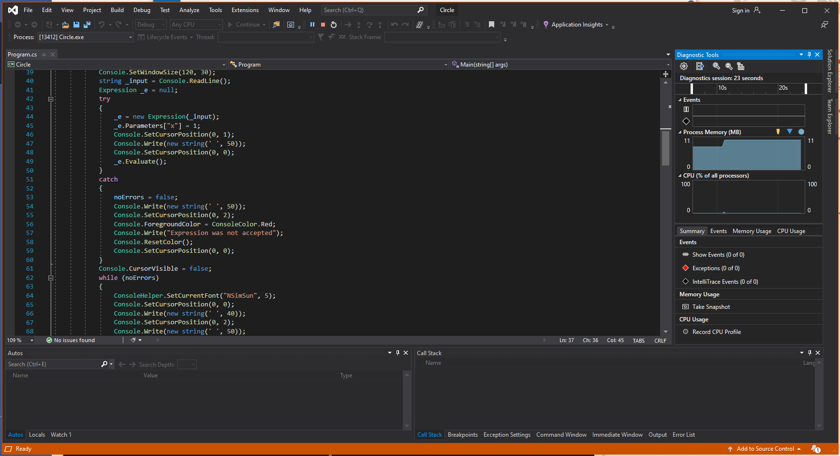**1) Run the Debugger**

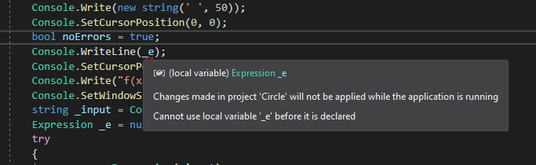**2) Describe 3 different compiler errors**

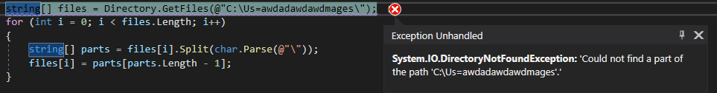Error: I called a variable that was not declared until later

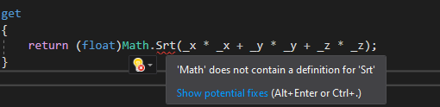 Error: Directory.GetFiles requires a path to a file within the computer, and gives an error when the given directory is not real

Error: Srt is not a function within the Math class and thus it prompted an error

**3) List websites that help with the understanding of C#**

* www.w3schools.com
* docs.microsoft.com
* stackoverflow.com

**4) Show parts of the debugger**

Breakpoint:



Variable Watch:

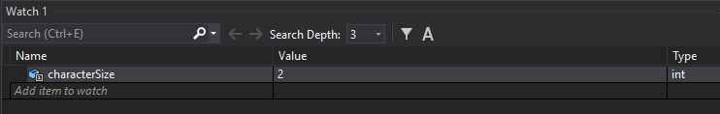

The Call Stack:

