Sanctuary Mini Expansions
Competitive Conservation Board and Refresh Display Board Jokers

DISCLAIMER: This is not an official Expansion for Sanctuary!

Competitive Conservation Board

To play with the Competitive Conservation Board, first place it on top of the original conservation board, aligning it so that the end-game conditions remain visible underneath. Then place five random conservation objectives on the designated spaces. The rules for supporting a conservation objective remain unchanged, with one important modification: for each objective, only one of each multiplier value (x2, x3, x4, x5) may be used. If a spot where you intend to place your marker is already occupied, you may not place a marker there. As before, each player may support any given objective only once.

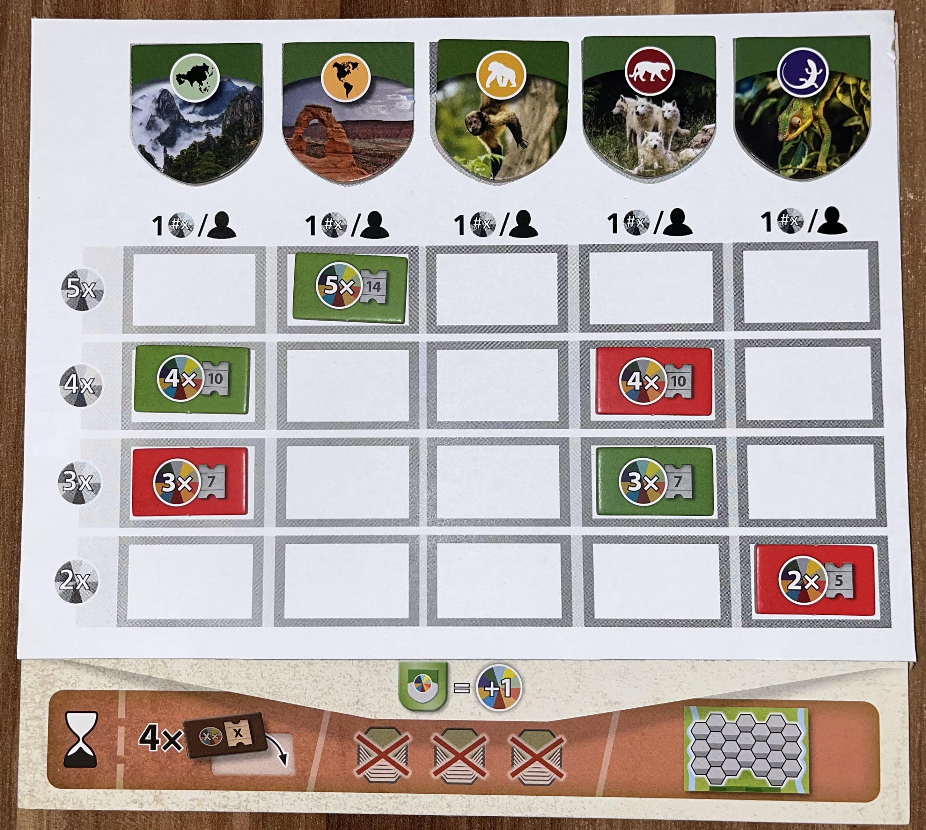

Refresh Display Board Jokers

During setup, decide whether each player will receive one or two jokers, and distribute them accordingly. At the start of a player’s turn—specifically before taking the first action in which a tile is drawn from the display—they may spend a joker to clear all tiles currently shown and refresh the display with new ones, after which the turn continues as normal. Jokers are permanently discarded when used and cannot be regained later in the game. If players begin with two jokers, they may only use one per turn.

View project on GitHub

