Theory of Computation

Coursework 1

C1527380

# Question 1

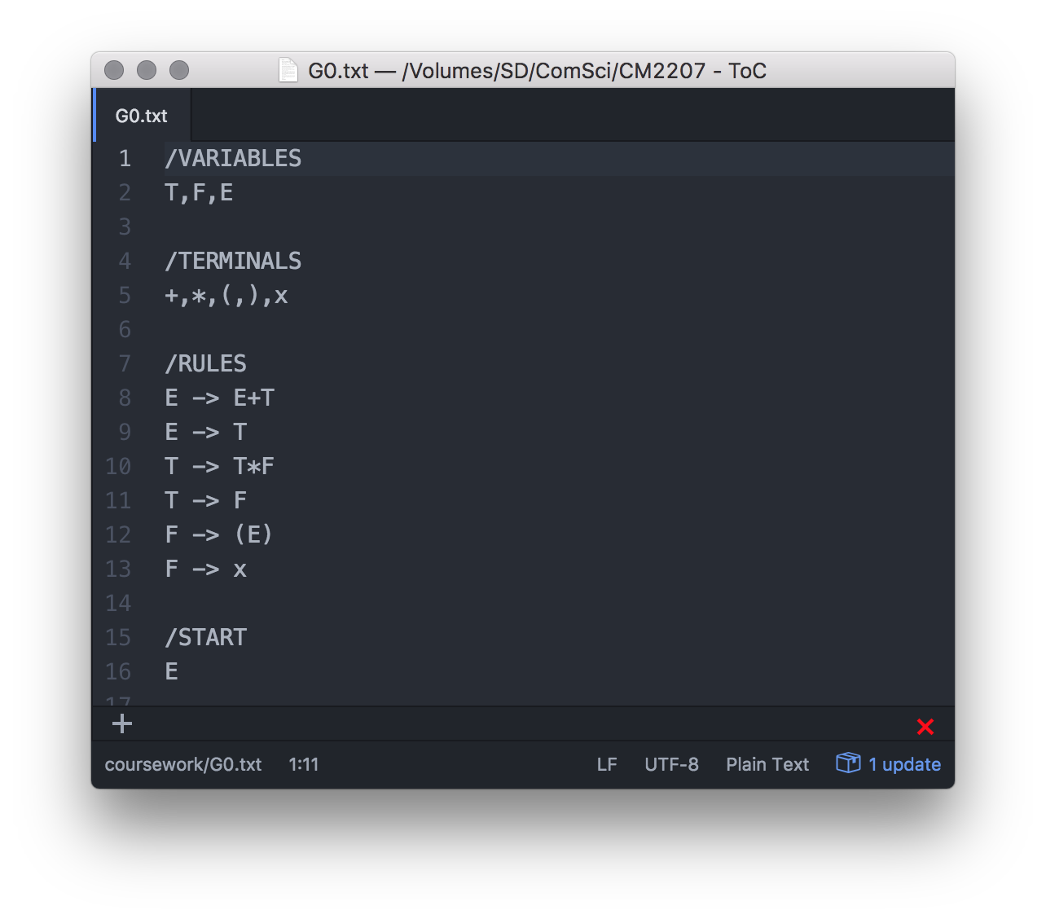

Figure 1: CFG G0 text file

Figure 1 describes my encoding of the CFG G0.

A key aim of my encoding was to maximise readability, therefore I will describe the key features which achieve this:

* **Tuple declaration**:
  + Each set of tuples is separated into their respective sections, each section is headed by a “/” followed by the type of tuples contained below
  + The “/” is there for clarity to the user to aid in differentiating the heading from the tuple content
  + The section name follows the “/” in capital letters, again to differentiate from the content below.
  + All the declarations must be written below the headings for each and follow the respective ruled for each type.
* **Variable declarations:**
  + Variables are declared on a single line, separated by commas
* **Terminal declarations:**
  + Terminals are also declared on a single line, separated by commas
* **Rule declarations:**
  + Each rule is declared on a separate line
  + Each rule
* **Start variable**
  + The start variable must be a single character

# Task 3

As instructed by the coursework specification, I constructed a derivation tree with a maximum depth of 2n-1, and if any of the productions matched the input string, the string is accepted.

The issue with this method is that it runs in exponential time; which will significantly slow down the parser for longer input strings. An alternate approach is to use the CYK algorithm which uses Dynamic Programming to store the intermediate results so that the parser can operate in polynomial time.

<https://en.wikipedia.org/wiki/CYK_algorithm>