Document Management System

**Vision (Small Project)**

**Version 1.**1

**Revision History**

|  |  |  |  |
| --- | --- | --- | --- |
| **Date** | **Version** | **Description** | **Author** |
| 28/01/2015 | 1.0 | Initial draft | Pipat, Harshani |
| 29/01/2015 | 1.0 | updates | Pipat, Sanindra, Harshani, Jonathan |
| 05/02/2015 | 1.1 | - Update alternatives multi criteria analysis  - Update Users | Pipat, Sanindra, Harshani, Jonathan |
|  |  |  |  |

**Table of Contents**

1. Introduction

1.1 References

2. Positioning

2.1 Problem Statement

2.2 Product Position Statement

3. Stakeholder and User Descriptions

3.1 Stakeholder Summary

3.2 User Summary

3.3 User Environment

3.4 Summary of Key Stakeholder or User Needs

3.5 Alternatives and Competition

4. Product Overview

4.1 Product Perspective

4.2 Assumptions and Dependencies

5. Product Features

6. Other Product Requirements

**Vision (Small Project)**

# **Introduction**

The purpose of this document is to collect, analyze, and define high-level needs and features of the Document Management System. It focuses on the capabilities needed by the stakeholders and the target users, and why these needs exist. The details of how the Document Management System fulfills these needs are detailed in the use-case and supplementary specifications.

The introduction of the Vision document provides an overview of the entire document. It includes the purpose and references of this Vision document.

## **References**

* Use case realization specification - Appendix 1

# **Positioning**

## **Problem Statement**

|  |  |
| --- | --- |
| The problem of | Managing documents for projects |
| affects | Project teams and project management |
| the impact of which is | provide a standardized and reliable way to manage documents related to entire project cycle |
| a successful solution would be | a complete Document Management System which provides a better version control, facilitate collaboration between stakeholders, increase document security and control, lower the document management and archiving costs and provide more consistent contents. |

## 

## **Product Position Statement**

|  |  |
| --- | --- |
| For | Project team members |
| Who | face problem in managing project documents |
| The Document management system | is a web based system |
| That | provides a better version control, facilitate collaboration between stakeholders, increase document security and control, lower the document management and archiving costs and provide more consistence contents. |
| Unlike | Google drive, Git, Jira, Assembla etc. |
| Our product | on the basis of PMBoK. |

# **Stakeholder and User Descriptions**

## **Stakeholder Summary**

|  |  |  |
| --- | --- | --- |
| **Name** | **Description** | **Responsibilities** |
| Dr. Paul Janecek | Lecturer in ISDM subject | - monitor students’ project progress  - check and approve students’ project |
| Company | Companies that want to use this system to manage the documents for their own projects. | - use the system for controlling the documentation in their own project |

## 

## **User Summary**

|  |  |  |  |
| --- | --- | --- | --- |
| **Name** | **Description** | **Responsibilities** | **Stakeholder** |
| Team / Project Manager | Person who monitor and manage the project. | - Review the document  - Monitor each project’s progress  - Manage every things in the project | Self-represented |
| Team developer and staff | Person who work in the project. | - Develop a software  - Make documents for projects  - Share the documents to shared folder  - Stay tune with the projects  - Communicate and discuss with team members | Self-represented |
| System admin | Person who take care about the system | - take care the system is failure  - can also control and manage everything except assign the permission to members on each project | Self-represented |

## **User Environment**

* Devices that can access to this system via Internet by using web browser.
* Web browser should be the latest version as possible to make sure that system will work properly
* Account for authentication

## **Summary of Key Stakeholder or User Needs**

|  |  |  |  |  |  |
| --- | --- | --- | --- | --- | --- |
| **Need** | **Priority** | **Concerns** | **Current Solution** | **Proposed Solutions** | |
| Version control | High | To manage previous version of the documents | Having in the same folder previous version with just name modified (time and date of last modified) | | Only lastest version of one document is displayed. When you open it, you can choose between lastest or previous versions. |
| Document locking | High | access controlling | The user saving at the end is referred as the final document. | | User who needs to edit the document should obtain the lock and others cant edit it but can access and read the document. |
| Manage old version document | Medium | Database space | Delete by users manually. | | Once the document is finalized, then older version will be archived. |

## **Alternatives and Competition**

|  |  |  |  |  |  |  |  |  |  |  |  |
| --- | --- | --- | --- | --- | --- | --- | --- | --- | --- | --- | --- |
| **Criterias** | **Weight** | **Google Drive** | | **DropBox** | | **Jira** | | **Git** | | **Bit Bucket** | |
| Cost | 12 | 5 | 60 | 3 | 36 | 1 | 12 | 2 | 24 | 2 | 24 |
| Versioning | 20 | 2 | 40 | 2 | 40 | 3 | 60 | 4 | 80 | 4 | 80 |
| Editing online | 15 | 5 | 75 | 1 | 15 | 3 | 45 | 3 | 45 | 1 | 15 |
| PMBok templates | 25 | 1 | 25 | 1 | 25 | 1 | 25 | 1 | 25 | 1 | 25 |
| Security | 15 | 4 | 60 | 4 | 60 | 4 | 60 | 2 | 30 | 3 | 45 |
| Easy to use | 8 | 4 | 32 | 5 | 40 | 2 | 16 | 3 | 24 | 3 | 24 |
| Mobility | 5 | 4 | 20 | 4 | 20 | 2 | 10 | 3 | 15 | 2 | 10 |
|  |  |  |  |  |  |  |  |  |  |  |  |
| Total | 100 |  | 62.4 |  | 47.2 |  | 45.6 |  | 48.6 |  | 44.6 |

# **Product Overview**

This section provides a high level view of the product capabilities, interfaces to other applications, and system configurations.

## **Product Perspective**

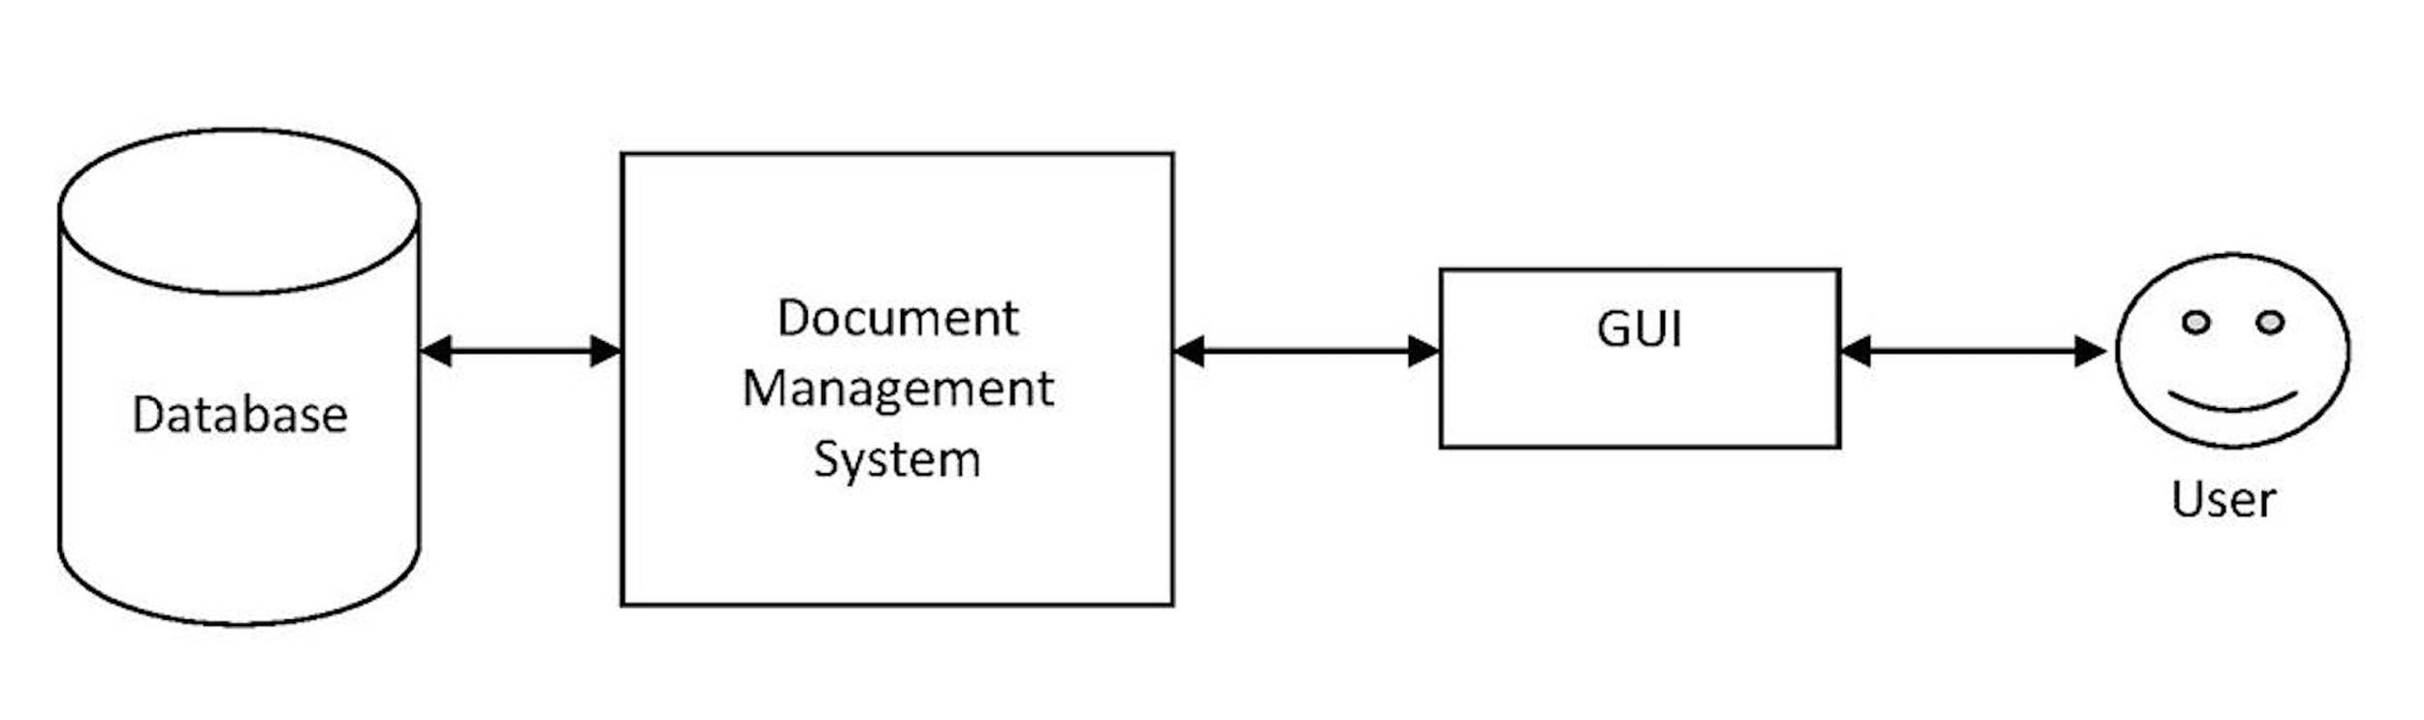

## **Assumptions and Dependencies**

* Assume that users have device that have web browser and Internet connection for accessing our system
* Assume that users have their own email account to register out system

# **Product Features**

* Upload/ Download documents
* View/edit documents online
* Document locking for editing
* Version control
* Document approval
* View history for each document/user
* Authentication

# **Other Product Requirements**

* Email for register
* Lastest version of web browser
* CSIM server that support Ruby on Rails web application and relational database.