Neighbour_Pleaser - Technical Documentation

Overview
v1 lights an LED when the averaged sound level at the mic reaches 75 dB SPL. It runs from a single +12 V rail and uses two DIP-8 chips (NE5532, LM393) plus one trimmer.
Signal chain: electret capsule MK1 → ×100 preamp → filter slot ×14.08 precision averaging detector → comparator with 75 dB trim → LED D4.

Schematic Image:
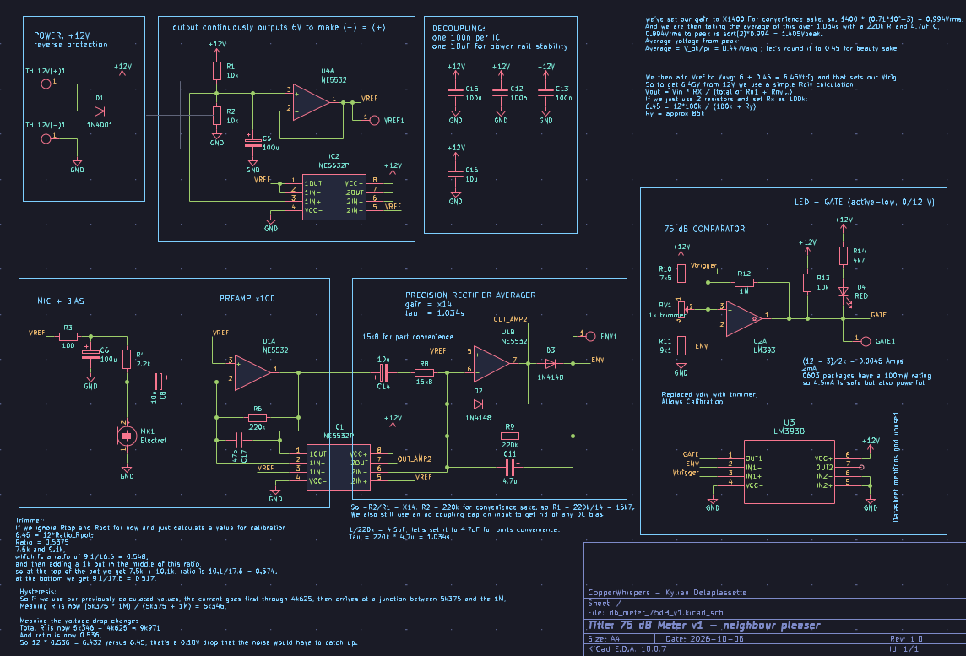

Technical Terms:
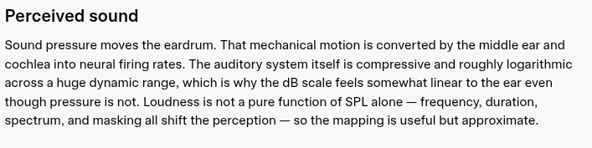

dB:
Ratio on a Log scale, mapping the voltage ratio to the exponential relationship of the sound scale so that it fits on a graph.
The loudest bearable sound has 10^6 times the pressure of the quietest.

Power ratio:
dB = 10log10(P2/P1)

Voltage/Pressure ratio:
10log10(V^2) becomes: dB = 20log10(V2/V1)

Voltage = dB:
X2 = +6
X10 = +20
X100 = +40
X1 = 0

SPL:
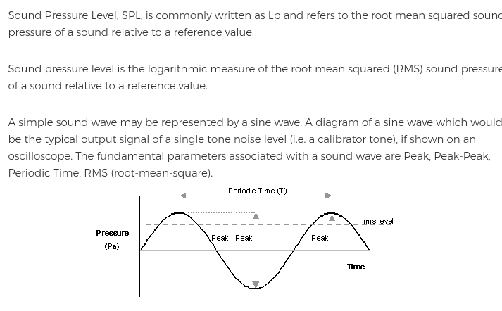
Sound Pressure Level, it is dB with the reference fixed at 20uPa:
SPL = 20log10(Pa_rms / 20*uPa)
So if SPL = 30dB, meaning rms pressure is 0.63mPa, that would correspond to a quiet room,
SPL = 120dB would be a painfully loud sound.

Rule of thumb from this is that + 6dB doubles the pressure and +10dB sounds about twice as loud.
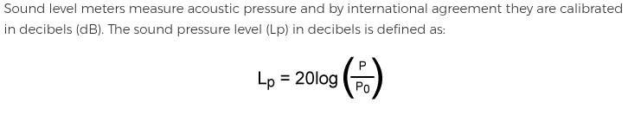
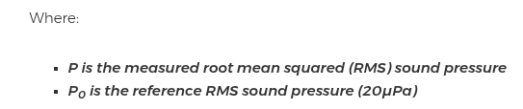
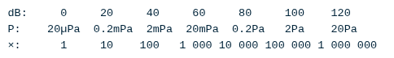

Worth noting as well that this reference comes from being about the quietest sound a newborn ear can hear at 1kHz, interesting that this 1kHz is the reference.
Also, Acoustic Intensity, which is power per area, is proportional to power squared, (I =8 P^2) .
Intensity level is Li = 10log(I/I0),

So if we substitute I = P^2 we get:
Li = 10log((p/p0)^2)
Where the two can be brought down to:
Li = 20log(p/p0)

Because of the log, the pattern is as follows:
+6dB = multiplies pressure by 2x
+10dB = multiplies pressure by 3.16x
+20dB = multiplies by x10
+40dB = multiplies by x100

Sensitivity:
https://www.analog.com/en/resources/analog-dialogue/articles/understanding-microphone-sensitivity.html
Voltage per unit of sound. Measured in negative dB.
The closer to 0 the more sensitive the microphone.

Using the equation:
dB = 20log10(V2/V1)
For mic sensitivity V1, which is V_ref is 1V per 1Pa of pressure.
V_ref = 1V/Pa.

At -44 dB the mic gives 6.3mV per pascal.
75dB is 0.11Pa which gives 0.71mV.

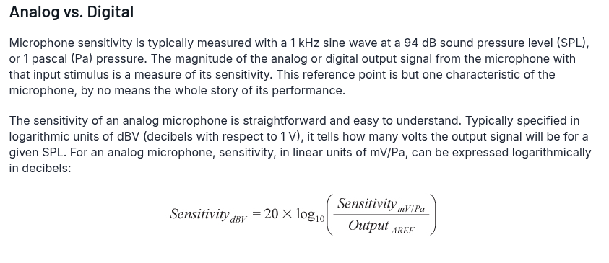
where Output_{AREF} is the 1000 mV/Pa (1 V/Pa) reference output ratio.

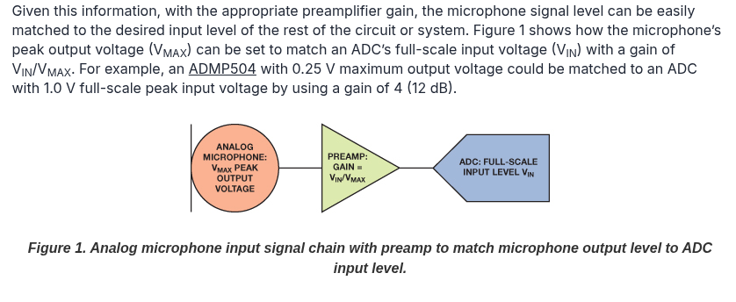

Digital Microphones:
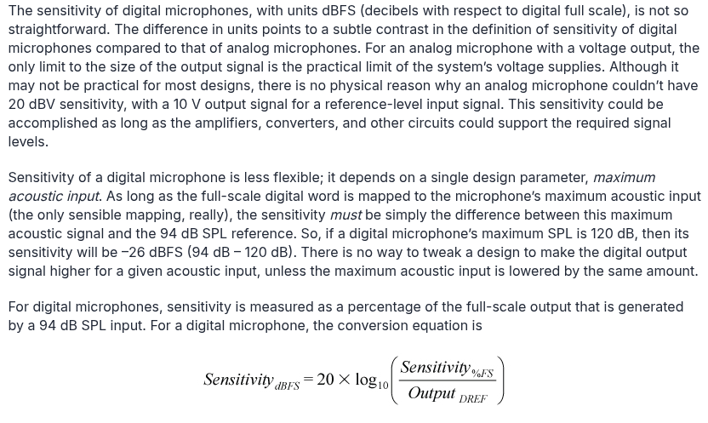

Analog Microphones:
They use rms.
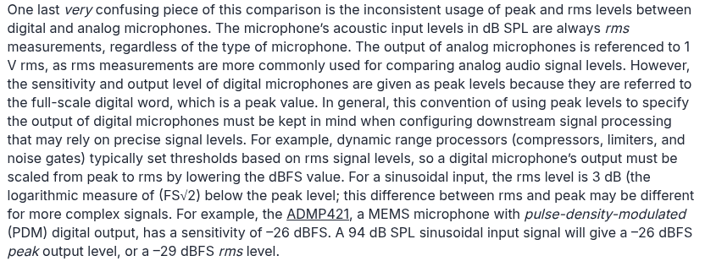

SPL is a common measurement benchmark from the acoustic domain:
SPL -> Sound pressure level,
SNR -> Signal to noise ratio , the difference between a 94dB SPL reference and the noise level,
The maximum acoustic input and SNR are the only things that can be directly compared across microphone inputs.
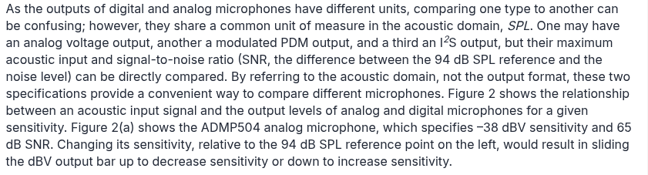
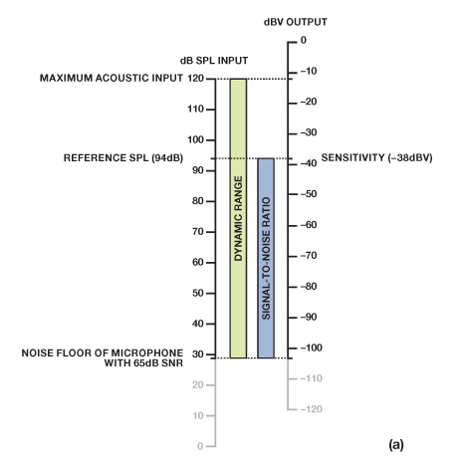
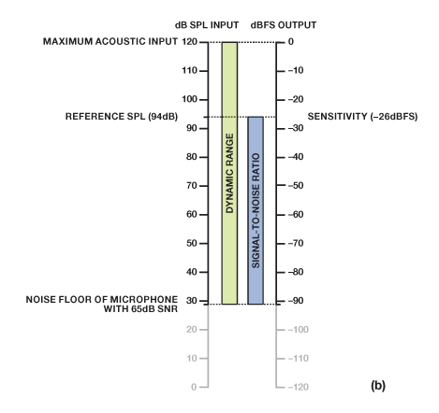
Figure 2. Mapping acoustic input level to (a) voltage output level for an analog microphone; (b) digital output level for a digital microphone.

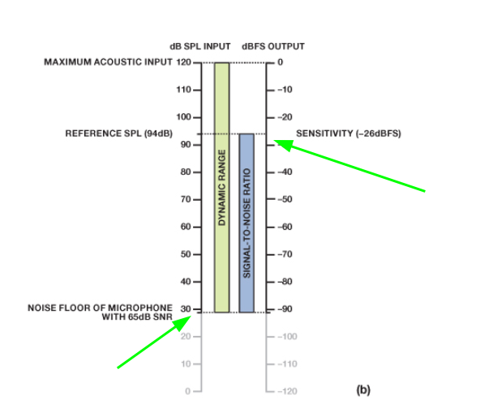

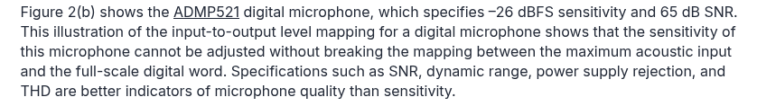

Sensitivity seems to be the difference between the maximum dBFS output which is 0 and the SNR top value. But I don’t really understand this graph.
It seems that the sensitivity is determined by the SNR and other similar factors rather than something that is adjusted by itself, which I think makes sense.

A more sensitive microphone can more easily distort and clip out, so it isn’t always the most desired, which makes sense:
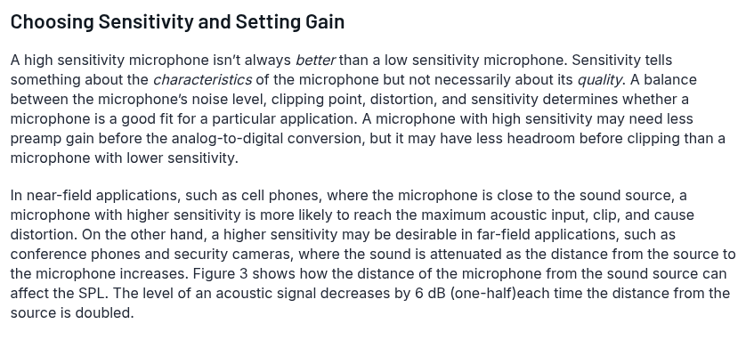

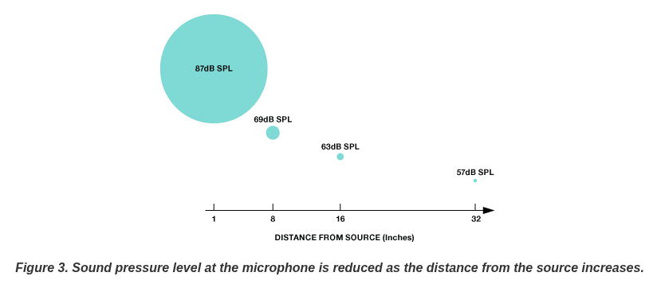

Sons and Phons:
This shit’s too complicated but it seems like this is involving frequency in the equation which sounds very interesting.
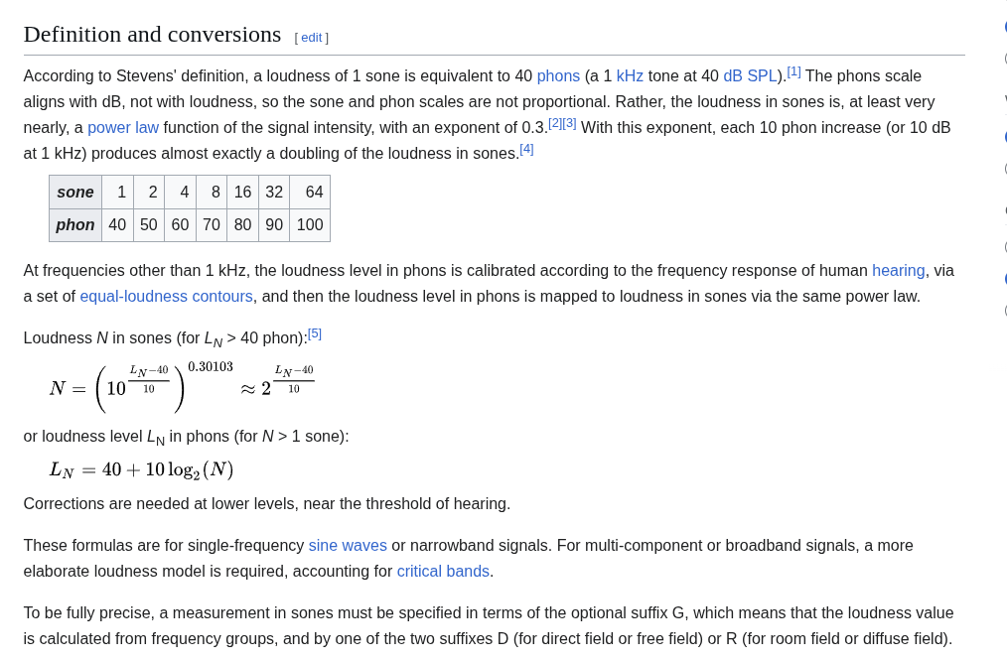

Microphone:
I will be using a simple analog microphone.
Example Microphone:
AOM-4544P-2-R

https://puiaudio.com/file/specs-AOM-4544P-2-R.pdf

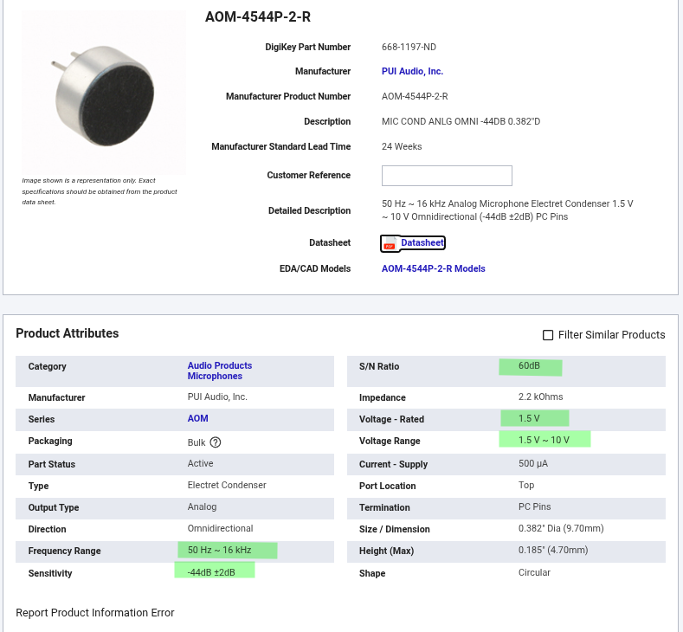

S/N Ratio:

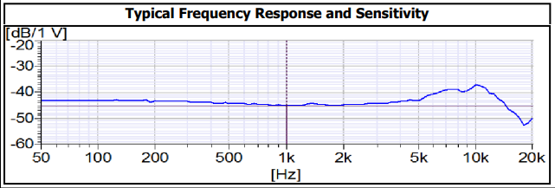

Typical Application:

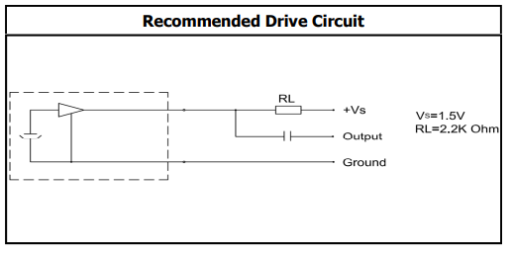

Seems a 1.5V supply is required, The part symbolizing the microphone is a JFET, sound moves a diaphragm which changes the JFET gate voltage and so its drain current.
However as mentioned above the mic can work from 1.5V to 10V.
Then the Load resistor transforms that current into a voltage drop, V = IR, higher current leads to a higher voltage drop which is what passes to the output as a sound wave.

The capacitor is an AC coupling cap to pass only the audio wave, for this I chose a typical 1uF value..

In which case I suspect the next stage would be a unity gain amp followed by a comparator that triggers a logic for an LED to turn on or not.

Expected Output:
120dB = 126mV

100dB = 12.6mV

75dB, = 0.71mV

60dB, = 0.126mV

40dB, = 0.0126mV

20dB, = 0.00126mV

Amplifier:
NE5532
https://www.digikey.co.uk/en/products/detail/texas-instruments/NE5532P/277056

https://www.ti.com/lit/ds/symlink/ne5532.pdf?ts=1784120200154&ref_url=https%253A%252F%252Fwww.ti.com%252Fproduct%252FNE5532
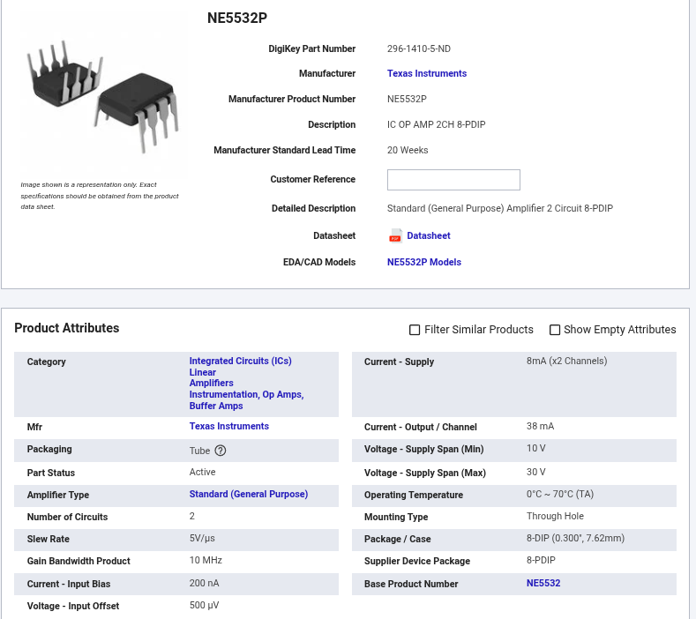

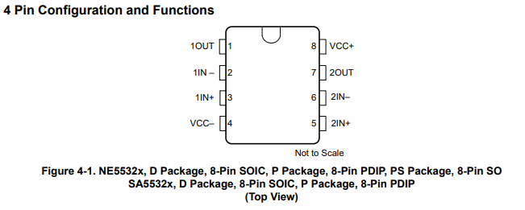
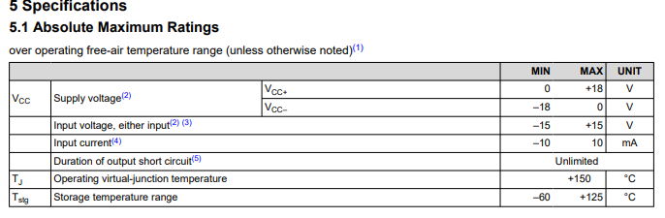
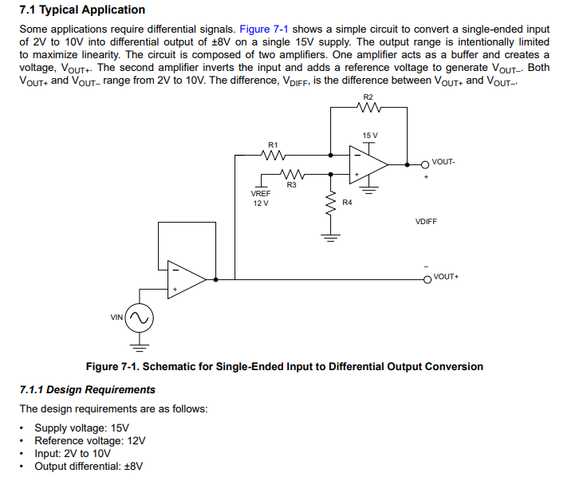

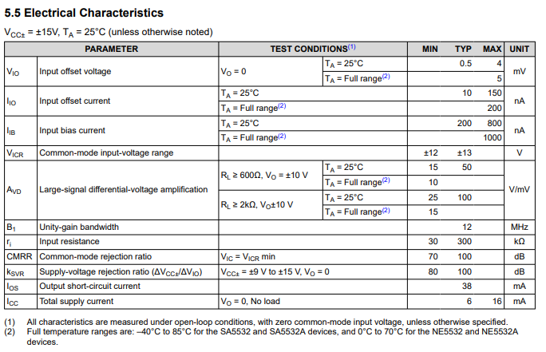

Gain Bandwidth:
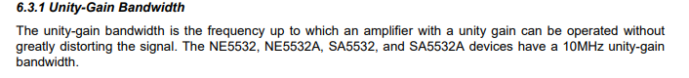
The NE5532 Amplifier chip states a 10MHz Gain Bandwidth,
This means that the amplifier acts as a low pass filter which cuts off the gain towards 1 as the Frequency increases to 10MHz,

To calculate it you look at the frequency of the wave you want to amplify ie 20kHz for maximum audible and then look at whether the cut off allows it,

The cutoff can be calculated by the fact that the gain falls 10x per 10x rise in frequency.

So 10Mhz / 1400 for a gain of 1400 means the cutoff is at 7kHz.

DC Offset:
The NE5532 states a max 5mV offset, which gets amplified along with the imputed signal.
This can be fixed by using a suitably sized cap in series with Rg to block the DC offset by acting like an open circuit for DC.

Amplification Setup:

So since our supply is 12V and the comparator voltage offset is 5mV, I think we should amplify the 0.71mV to 1Vrms, this way 5mV is a negligible uncertainty and we can have the amplified signal oscillate around 6V cleanly with some margin for extra additions.

So we now need a gain of 1/(0.71*10^-3) = X1408

And the signal also has to be biased around 6V as the supply is 12V so anything below zero will clip.

Now the NE5532 States a maximum amplification of 100V/mV,

That’s an amplification of 100,000X,

and I just need 1408 so it seems it will be fine.

However the Gain bandwidth becomes a potential limiter with a cutoff of 7kHz at a 1400 gain, and the rectifier is also an opamp configuration, so we can simply spread the amplification in two stages, this stage can do x100 and the rectifier x14.08.

10Mhz / 100 = 100kHz cutoff.

Looking at the datasheets typical application:
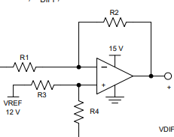
Signal in “-” means inverting input, gain is thus -R2/R1, this equation can be understood from the following:
https://www.analog.com/en/resources/glossary/non-inverting-op-amp.html

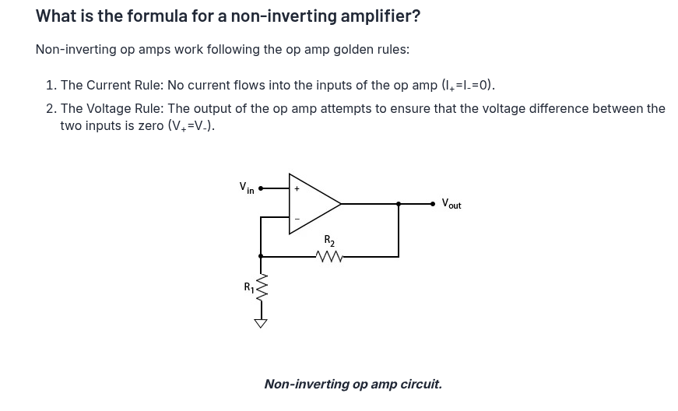
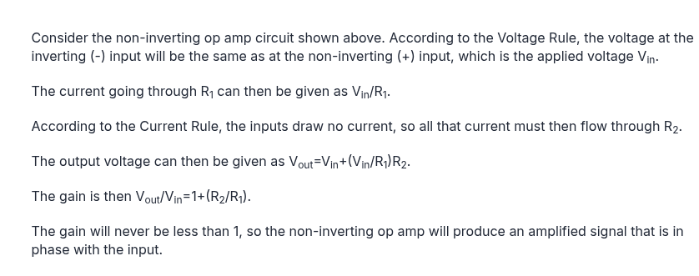
Now for an inverting configuration, which is what we have from the typical application:
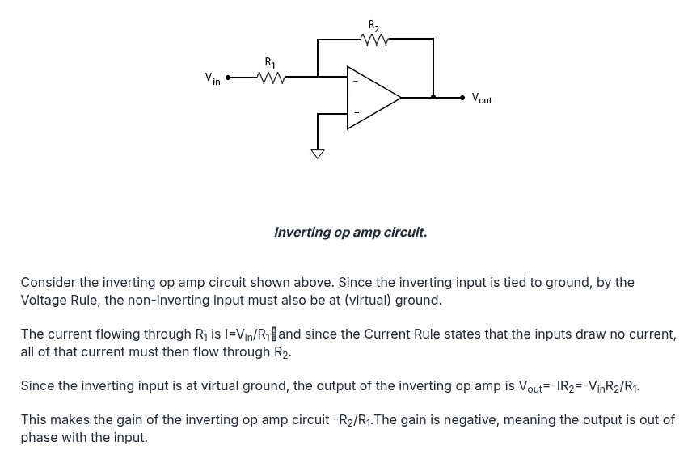

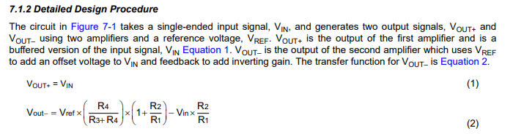
And since we know that Vout is simply (the voltage through the non-inverting pin) - (the signal entering through the inverting pin).

So we can simply view the gain as being set by the (R2/R1) ratio from the voltage divider, since we know we want a gain of 100X, then 100X = R2/R1

We set some resistors for reference:
R1 = 100k, R3 = 100k.

We first solve for the voltage divider as we know we want a reference of 6V:
Vout = Vin * Rbot / (Rtop + Rbot) and this is simply another 100k as we are wanting half the supply so a half ratio.

So R4 is 100k, we then solve the gain equation:
100 = 100k/R1), And thus R1 = 1000 ;

So:
R1 = 1k, R2 = 100k, R3 = 100k, R4 = 100k.

We also want a 10uF decoupling cap on the voltage divider point to ensure it keeps stable and doesn't mess with the output.

And an AC Coupling Cap in series with R1 to get rid of the voltage offset, we want it to preserve a good amount of low frequencies, (ac coupling caps act as high pass filters).

1/(2pi * 1k * F) = C, so if we want say a 1Hz cutoff, then that’s 1 / (2pi * 1k * 1Hz) = 159*10^-4, or roughly 159uF, that’s too big so changing cutoff to 10Hz:

1 / (2pi * 1k * 10Hz) = 159*10^-5 = 15.9uF, so we can fit a 22uF for simplicity sake.

Impedance:
The mic has a 2k2 output impedance, and if using the above opamp configuration we would then have a 1k R1 resistor being the input impedance of the opamp, and that would have to be considered in the gain, so we’d get:
-R2 / (R1 +2k2) as the gain factor, making 2k2 affect the gain significantly when R1 is only 1k, if R1 was 100k then it would be insignificant but R2 would have to be 10M, so I think best solution is to delete R1 from the Opamp, then the mic load R becomes R1,

Then R2 just has to be 220k to keep gain at x100.

Biasing:
Now OpAmp Biasing, you can inject a DC bias as shown in the typical application by simply raising the non inverting point to the desired bias with a voltage divider, the audio signal then goes into the inverting input, and the opamp tries to make the inverting input -
noninv = 0 with its output, so it naturally raises the audio input to the dc bias injected in the non inv input whilst also outputting the inverse of the audio signal around this dc bias.

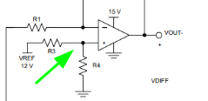

So we simply inject the PSU’s 12V into the non-inverting pin’s voltage divider circuit set to output 6V.

Precision Rectifier:
Firstly, a rectifier is needed to obtain a positive only signal, so that we can average it without getting 0, true RMS calculation would require a more complicated circuitry, but we can get close by estimating the relationship between the average of a half wave and the full wave’s rms voltage, then setting the comparator to trigger at that averaged voltage.

And we use a precision rectifier rather than just a rectifier as we also still need a x14 gain stage as we couldn’t get x1400 from a single stage.

https://www.ecircuitcenter.com/Circuits/op_HW_recitifier/Op_HW_Rectifier.htm
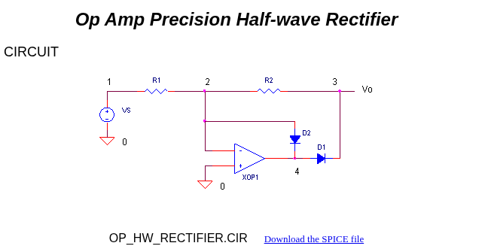
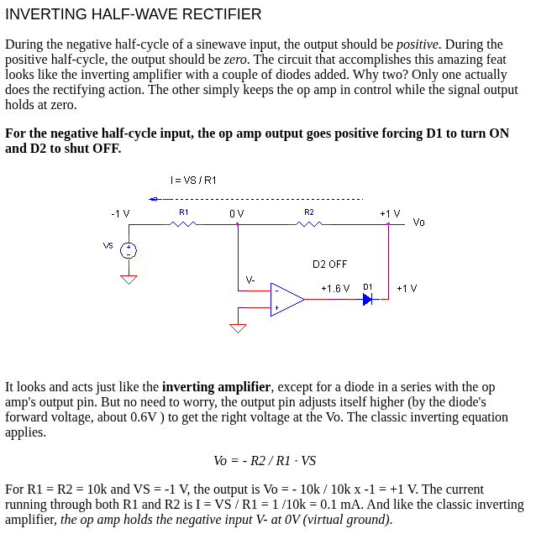
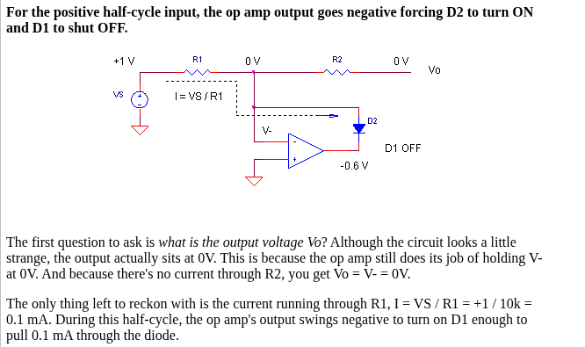
Figure Note: D1 is a typo for D2*

For this we use the second opamp available in the NE5532 package and can use the same configuration as before, except we are aiming for a gain of x14 and do have a R1 in this case,
So -R2/R1 = X14, R2 = 220k for convenience sake, so R1 = 220k/14 = 15k7.
We also still use an ac coupling cap on input to get rid of any DC bias.

We also need to average that signal so that we can get a dc level out of it so the comparator doesn’t just trigger at the signal’s frequency but instead gives a solid ON/OFF answer.
We use a simple RC filter to average the signal’s loudness over a certain time window, tie window which is set by the time constant RC.

https://blog.prosig.com/2024/01/30/data-smoothing-rc-filtering-and-exponential-averaging/
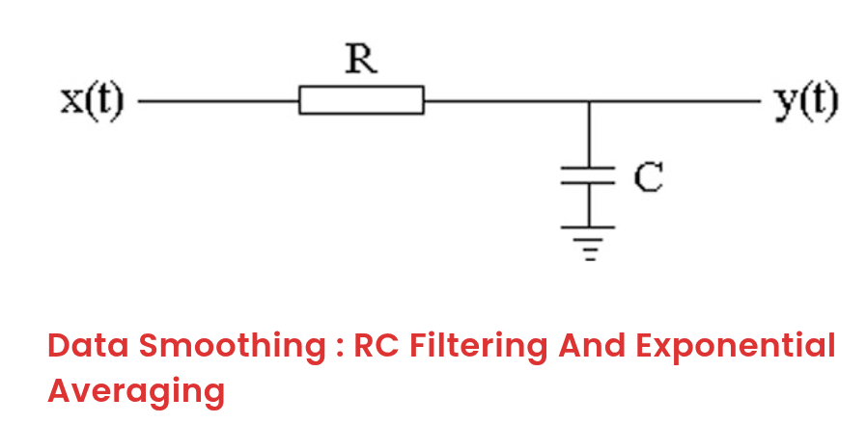
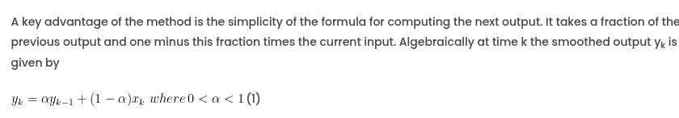
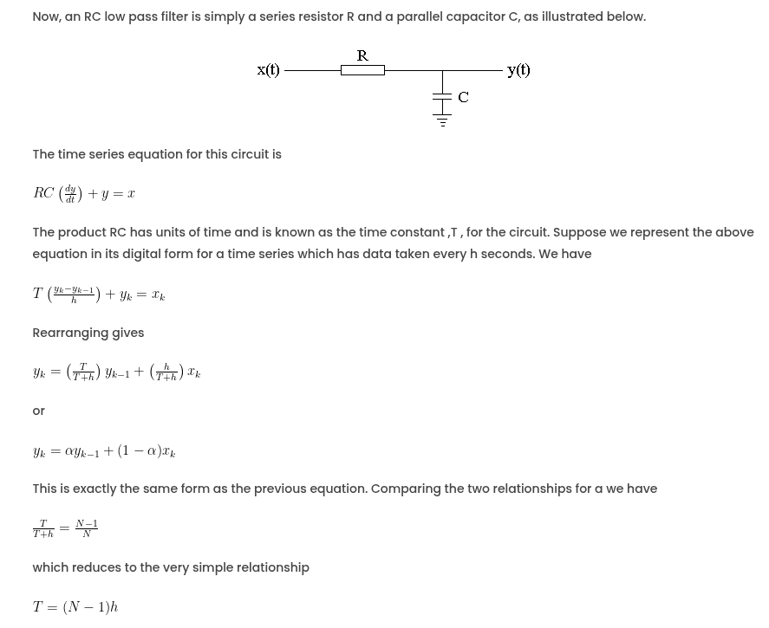

The average loudness of a sound in the synth world is called its envelope, hence I will refer to the output of this precision rectifier averager as the ENV signal.

So if we want say an averaging over 1 second, then we consider R2 = 220k,

1/220k = 4.5uF, let’s set it to 4.7uF for parts convenience.
Tau = 220k * 4.7u = 1.034s

We can also look at this in term of frequencies filtering:
F = 1/(2pi * 220k * 4.7uF) = approx 0.154Hz

Comparator:
So now we have a half wave rectified signal of desired amplitude for us to work with,
It now needs averaging so that we can get a DC level to trigger the comparator with,

LM393
https://mm.digikey.com/Volume0/opasdata/d220001/medias/docus/6808/LM393%20SOP-8.PDF

https://www.digikey.co.uk/en/products/detail/shenzhen-slkormicro-semicon-co-ltd/LM393/26601007
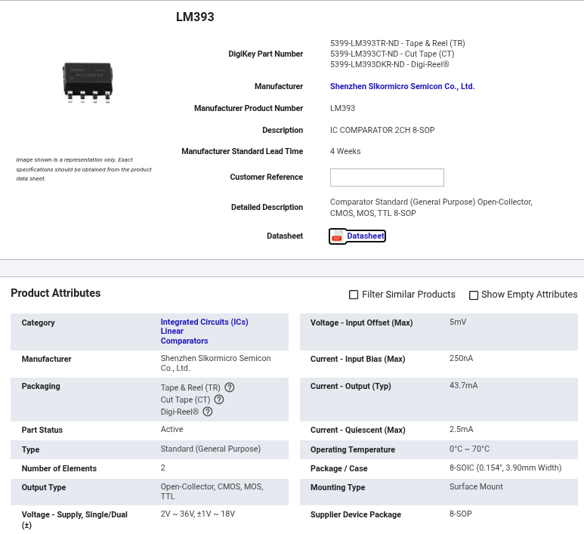

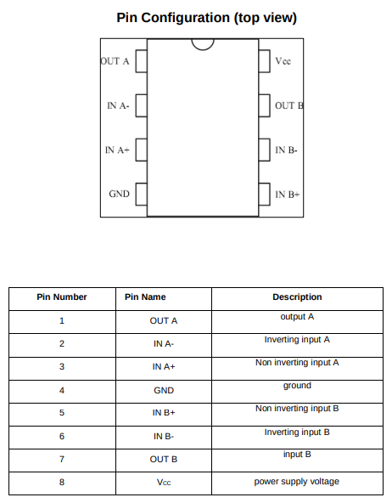
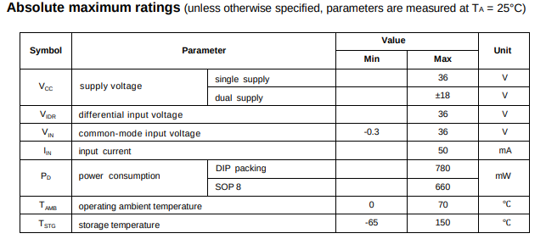

Typical Application:
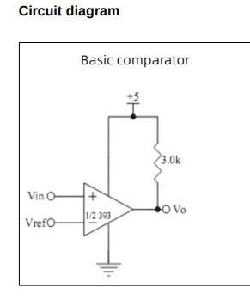
So if I supply 12V, then calculate the peak voltage that leads to 75dB SPL, then set that as my reference, the comparator then has output held high until Vref is crossed where it then outputs LOW,

I can then simply put an LEDs cathode onto the Comparator output so that it turns on when the comparator is triggered.

So if we calculate the output that we should get, not forgetting that it is biased to mid rail 6V, for this we just refer to our previous amplification section:
“
So since our supply is 12V and the comparator voltage offset is 5mV, I think we should amplify the 0.71mV to 1Vrms, this way 5mV is a negligible uncertainty and we can have the amplified signal oscillate around 6V cleanly with some margin for extra additions.
So we now need a gain of 1/(0.71*10^-3) = X1408
“

Except we’ve set our gain to X1400 For convenience sake, so, 1400 * (0.71*10^-3) = 0.994Vrms,

And we are then taking the average of this over 1.034s with a 220k R and 4.7uF C,

0.994Vrms to peak is sqrt(2)*0.994 = 1.405Vpeak.

Average voltage from peak:
Average = V_pk/pi = 0.447Vavg ; let’s round it to 0.45 for beauty sake.

We then add Vref to Vavg: 6 + 0.45 = 6.45Vtrig and that sets our Vtrig.

So to get 6.45V from 12V we use a simple Rdiv calculation:
Vout = Vin * RX / (total of Rn1 + Rny…)

If we just use 2 resistors and set Rx as 100k:
6.45 = 12*100k / (100k + Ry);
Ry = approx 86k.

Trimmer:
Instead of a fixed 86k and 100k voltage divider setup for voltage trigger, it makes more sense to use a trimmer than can be calibrated,

We refer to: CCV2_PROBLEM_SOLVING from the V2 Chess clock for this:
“
Max output voltage we want into speaker reminder:
6 = I * 4 ; I = 6/4 = 1.5, P=IV ; 1.5 * 6V = 9W.
We know the inputted voltage is 2.5V, the max output we want is 6Vpeak, the gain is 10x,
So the attenuated input needs to be = Vatt * 10 = 6 ; so Vatt needs to be 0.6V peak.

The voltage that goes into the input is taken at Rpot2 and thus needs to be 0.6Vpeak.

The parallel block resistance in the loop is:
(10k + 330) || 40k = ((10k + 330) * 40k) / ((10k + 330) + 40k) = 8k210.

VRpot2 = (2.5 * 8k21) / (Rtop + 8k21 )

0.6 = (2.5 * 8k21) / (Rtop + 8k21 )

Rtop = ((2.5 * 8k21) / 0.6) - 8k21

Rtop = 26k
”
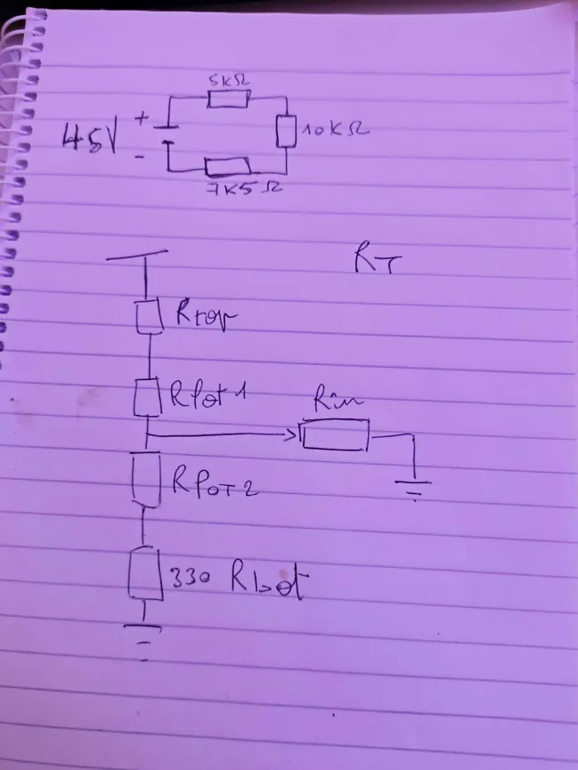

So to get 6.45V from 12V we use a simple Rdiv calculation:
Vout = Vin * RX / (total of Rn1 + Rny…)

If we ignore Rtop and Rbot for now and just calculate a value for calibration:
6.45 = 12*Ratio_Rpot;
Ratio = 0.5375
So 10k * 0.5375 = 5k375
And the other side of the pot will be 4k625

Now the guardrails will have some effect on this setup of course, but since we will have to calibrate to account for tolerances etc anyways, then there’s no need for it to be super precise at this stage.

Hysteresis:

https://www.analog.com/en/resources/analog-dialogue/articles/curing-comparator-instability-with-hysteresis.html

We place a resistor on the output path to non inv of the comparator so that when the output goes low the trigger point changes significantly enough to avoid the comparator getting retriggered multiple times due to oscillation on flick.

If for example we select a 1M resistor as the hysteresis resistor, then when output is high no current flows as there is no difference between output and non inv, but then when output goes low, the current path sees 12V, the Vdiv network to GND, in parallel with 1M to gnd,

So if we use our previously calculated values, the current goes first through 4k625, then arrives at a junction between 5k375 and the 1M,
Meaning R is now (5k375 * 1M) / (5k375 + 1M) = 5k346,

Meaning the voltage drop changes:
Total R is now 5k346 + 4k625 = 9k971
And ratio is now 0.536,
So 12 * 0.536 = 6.432 versus 6.45, that’s a 0.18V drop that the noise would have to catch up.

However, the issue with using such a big potentiometer is that we are targeting a small VREF window which make the potentiometer useless, a better idea is to setup an already set ratio with a smaller margin of change, ie:
7.5k and 9.1k, which is a ratio of 9.1/16.6 = 0.548, and then adding a 1k pot in the middle of this ratio, so at the top of the pot we get 7.5k + 10.1k, ratio is 10.1/17.6 = 0.574, at the bottom we get 9.1/17.6 = 0.517.

Finding: The trimmer range is too wide. 330 Ω / 10 k / 330 Ω lets pin 3 swing from VREF − 5.3 V to VREF + 5.3 V, but every unit’s 75 dB point lies between VREF + 0.40 and + 0.74 V: 3 % of the travel. 1 dB is about 1.4° of rotation on a 300° pot, and the lower half of the travel leaves the LED stuck on.
Action: Use R10 = 7.5 k, RV1 = 1 k, R11 = 9.1 k (window VREF + 0.19 to + 0.84 V, 7.6 % of travel per dB). R12 = 1 M then gives about 1 dB of hysteresis. Keeping the 10 k pot would need 75 k / 91 k guardrails and R12 ≈ 10 M, which breaks onsemi’s <10 k input-resistance advice.

APE BRAIN LOG:

STUFF TO FIX:
- Understanding of why I = Pa^2, what intensity actually is,
- What coherence is.
- Quick mental trick for adding dB values.
- Wording of what sensitivity actually is.
- P0 isn’t actually a newborn but just regular human.
So grok AI helped me understand this by showing me that:
I, the intensity, is directly proportional to Pa^2,
Intensity is the power per area, W/m^2
And Pressure is force per area, N/m^2

And SPL, which is the sound pressure level, or can be called acoustic INTENSITY, can be measured in terms of both the pressure or the intensity, as long as you account for the square factor,

The Acoustic intensity Li, is equal to:
Li = 10*log10(I/I0), so the logarithmic behaviour of the intensity ratio translates linearly to the acoustic intensity!!!!!!

And using the relationship I = Pa^2, we can then transform the equation into:
Li = 10*log10((P/P0)^2), which can be transformed into Li = 20*log10(P/P0)

Let’s also change Li for SPL to make it more clear (we’re going to repeat this concept a few times):

SPL = 20*Log10(P/P0)

This means that you can calculate a dB value, which is the unit for acoustic INTENSITY or sound PRESSURE level,

Now if you want to calculate a pressure level from the dB value, you simply rearrange:

10^(SPL/20) = P/P0,

Oh yeah by the way, P0 is roughly the quietest sound a newborn ear can hear at 1kHz, so that’s somewhat of an established reference at 20uPa.

P = (10^(SPL/20) ) * P0.

Beautiful.

It goes deeeeeeeprrrrrrrreeerererer.

Say you get two sounds, one at 70dB and one at 76dB,

If the sound waves are coherent and perfectly in phase, (no idea what this means.)

Then you convert the dB to pascals using the formula above (spiderman grab copy paste)
P = (10^(SPL/20) ) * P0.

Sub in the 70 and 76.

P = (10^(76/20) ) * P0 = 0.126Pa

P = (10^(70/20) ) * P0 = 0.063 Pa

Oh yeah by the way 6 dB is doubling in the world of pascal.

And now you can add the pascal values together,
You get 0.189Pa,

Then you can bring that back to the dB world so it’s easier to see as in pascals the values easily go from microscopic to macrogigantic.

SPL = 20*Log10(P/P0),
Sub in 0.189Pa
SPL = 20*Log10(0.189/P0),

And you get 79.5dB

If the sound waves are incoherent then apparently you should talk in terms of intensity which I guess makes sense as intensity is the pressure per area or something like that so it doesn't matter where they land maybe, I don’t know, I'm tired and want to go play some music.

So I guess talking about intensity you’d do:

I = P^2

I = 0.189^2 = 0.0357

Li = 10 * Log10(0.0357/I0)

Where I0 I guess is 20uPa but squared: (20*10^(-6))^2 I want to say you time the powers but that seems a little crazy and when I do it on a calculator it just gives me 4*10^-10 so fuck knows.

Guess it’s 4*10^-10, now I don’t know what tf this means anymore so let’s just get tf outta here.

Think I’d need to dig into the actual formulas of intensity and pascals but I ain't got time at the moment:
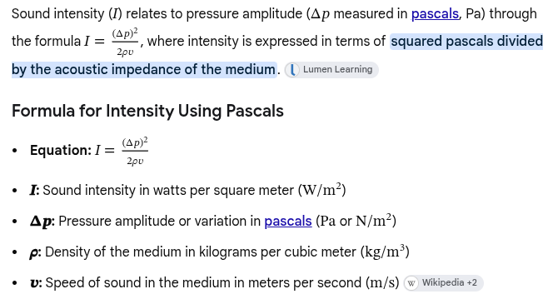

So going back to our easily and probably misimplified abstraction of pascals.

Let’s now see how that relates to voltages,

Worth mentioning that in New Caledonia there is “coutume” and British culture is the same thing, we just don’t think about it this way, using an example of someone liking a popular band, in the intro and somehow linking it with this.

We like to think that we are civilized and relationships are actually a sign of god or something greater, but everything operates in this way, perhaps AI does too.

This tribal coutume is a display of respect, you spend the time to understand and acknowledge the human that occupies this space, this is a foundational element for trust, now that we trust each other let’s communicate and see where we stand, if we disagree then, you know the story.

And money is just about trusting that someone owns something, but if everyone turns that down then it's worthless.

Sensitivity is given in dBV/Pa, example microphone:
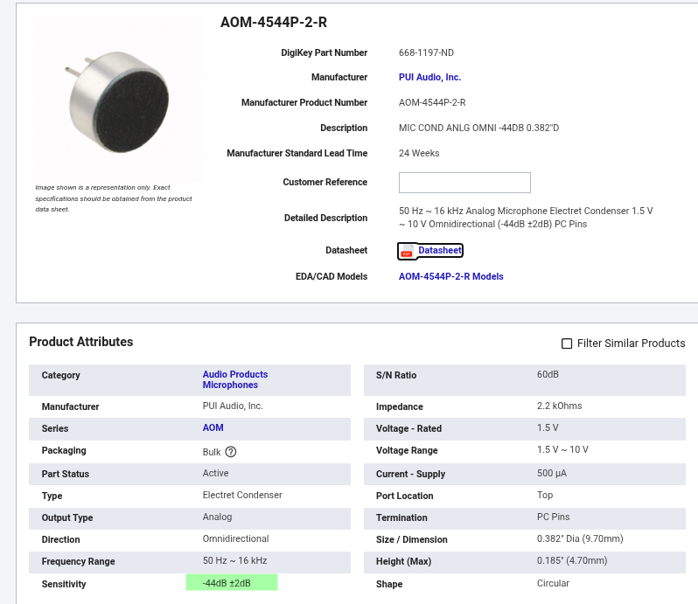

If we take our two equations from earlier:
SPL = 20*Log10(P/P0)

P = (10^(SPL/20) ) * P0.

Remember P0 is quietest newborn ear 1kHz sound and is 20uPa

And we now are talking about voltage per pascals instead of Pascals alone,

So 1V = 1Pa, thus the equation doesn’t change as we are mapping pressure straight to voltage.

Replace with voltage we get:

DbV/Pa = 20Log10(outV/VPa)

Where DbV/Pa is sensitivity, outV is the voltage out the microphone and VPa is the Voltage per Pascal ratio and we agreed the ratio to be 1.

So our example microphone claims, -44dB,

So to calculate the expected voltage output at that sensitivity we rearrange as earlier:

outV = (10^(Sensi/20) ) * VPa.

outV = (10^(-44/20) ) * 1.

Which equals 6.31mV,

So we now know that per Pascal, we expect 6.31mV.

So now, we calculate the Pascals expected for our trigger point of 75dB:

P = (10^(75/20) ) * 20uPa.

That gives us 0.112Pa

So 6.31mV * 0.112Pa = 0.71mV is the expected voltage at that Sound Pressure Level, that is when my comparator should trigger.

Now if we just get an idea of the range expected by repeating for values of 120dB, 100dB, 60dB, 40dB, 20dB:

120dB,
Vout = 6.31*10^-3 * (10^(120/20) ) * 20uPa.
= 126mV

100dB,
Vout = 6.31*10^-3 * (10^(100/20) ) * 20uPa.
= 12.6mV

60dB,
Vout = 6.31*10^-3 * (10^(60/20) ) * 20uPa.
= 0.126mV

40dB,
Vout = 6.31*10^-3 * (10^(40/20) ) * 20uPa.
= 0.0126mV

20dB,
Vout = 6.31*10^-3 * (10^(20/20) ) * 20uPa.
= 0.00126mV

So let’s say max expected voltage is 126mV and lowest is 0.00126mV

Which sounds quite tricky as you then have a 10^5 range, or X100,000 Gain range.

Now, the amplifier:
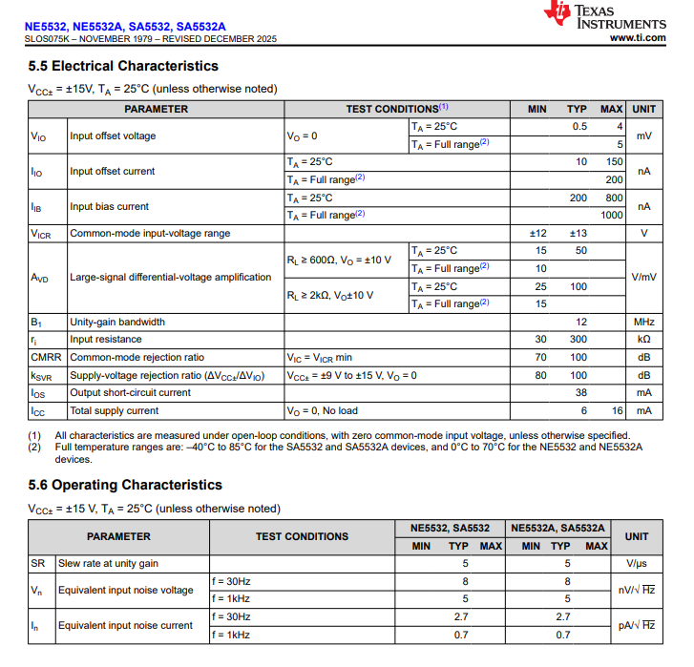

And the comparator has a voltage offset that can reach 5mV:
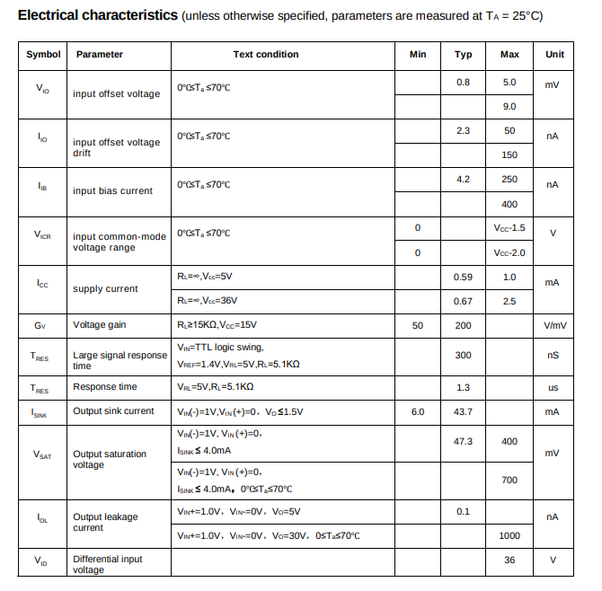

So the amplifier needs to amplify the mic signal so that the offset voltage of the comparator becomes meaningless in terms of uncertainty.

I also need an AC to DC rectifier so that the comparator gets a steady voltage level rather peaks and throughs which could cause a lot of bouncing on and Off,

The microphone has a SNR of 60dB,

Ok, Now I need to keep this simple for this first build, so plan is:

Microphone -> Amplifier -> Rectifier -> Comparator -> LED.

So based on the microphone’s -44dB sensitivity we calculated the following SPL to Voltage conversions:

120dB = 126mV

100dB = 12.6mV

75dB, = 0.71mV

60dB, = 0.126mV

40dB, = 0.0126mV

20dB, = 0.00126mV

So now we should just focus on the 0.71mV, anything above will have the comparator be triggered and if amplified past the amplifier’s power rails it will just clip anyways so nothing to worry about,

And anything lower will just not trigger anything.

So since our supply is 12V and the comparator voltage offset is 5mV, I think we should amplify the 0.71mV to 1Vrms, this way 5mV is a negligible uncertainty and we can have the amplified signal oscillate around 6V cleanly with some margin for extra additions.

So we now need a gain of 1/(0.71*10^-3) = X1408

And the signal also has to be biased around 6V as the supply is 12V so anything below zero will clip.

