Rules and Goals
Document History:
2020-10-28 Roland Hughes initial creation.

Every successful project has to have both rules and goals. If it doesn’t the project implodes. Everybody hates rules, especially in the OpenSource world. These are rules with reasons behind them. Goals are important so this project doesn’t end up 5,000 square miles in size yet only one nanometer deep. The Internet is flooded with editors that do tons of things yet none of them well.
Note: This is a “living” document. As goals are achieved they will be moved into some “Achievements” section. Goal order may change as well as the goals themselves.

Rules

1. One Class One source file
One of the worst practices in the IT industry is spreading the methods of a single class across multiple source files trying to “group them by” something in an effort to shorten some files. If you don’t want to see a 10,000 line source file don’t put that much in a single class. When methods are scattered about multiple source files it makes it difficult for developers to find and increases the chances someone will re-invent the wheel.
There are times in the business world, especially when converting/expanding indexed files with COBOL/BASIC/FORTRAN, that you will need to create source files exceeding 10,000 lines. The programs won’t even be overly complex. You will have multiple record types and need to perform field by field moves into the new record in the new file. There will just be thousands of fields. It happens.
There is nothing inherently wrong with a large source file. If you don’t like large source files make smaller classes, don’t try to shorten the file by squirreling the methods away in other source files.

2. No Plug-ins - ever
Yes a great many OpenSource projects garner lots of interest claiming their project is “the most hackable” or whatever because of support for plug-ins. Here’s what happens, the plug-ins don’t get maintained. Someone cranks out a plug-in to do something they think is neat and it gets tossed into the plug-in repo. Come the next release the plug-in no longer works, prevents the application from loading, or does something worse.
Take a really good look at Atom and Eclipse if you want to understand where this rule comes from. Atom has a long history of releases that either fail to install or fail to load after update. Much of that problem is due to thousands of plug-ins making it physically impossible to test anything. Eclipse has what feels like a mountain of plug-ins that are still in various repositories yet fail to install or install and fail to run. Other times people take a plug-in and the OpenSource project and suddenly pull it from the “free” universe to commercialize it. Read up on Eclipse COBOL support for one example.
http://www.eclipse.org/forums/index.php/t/279050/825fc773e9f675387815c44c19068b87

This project may not grow as fast as a project where everyone under the sun can hurl a poorly tested JavaScript plug-in they don’t maintain into it, but it will be more stable.

3. BARR group standard
https://barrgroup.com/embedded-systems/books/embedded-c-coding-standard

Granted that standard is developed mostly for Embedded C and requires a bit of jiggering to fit C++, but it is the most widely adopted standard in the embedded system world. The code base currently doesn’t meet the standard. In particular “no variable name shorter than three characters” really needs to be addressed.
Most shops widen the maximum line length rule to 130 from less-than-80. There are many reasons to strive for less-than-80, but it becomes almost impossible in C++ when one of the values you need on the line is

Overlord::getInstance()->openedFilesContains( tempFile )

and you still need to adhere to indentation rules as well as actually do something with that value.

Don’t worry, the formatting is easy. In the root project directory you will find astyle-diamond.sh. Run it before final build and commit. You must have Artistic Style installed on your system. If your platform cannot run a Linux shell script then create a platform appropriate one and add it to the project. There is only one real line in that file.

astyle -n src/*.cpp src/*.h

There is a “hidden” file named .astylerc in the project root directory. This has as many BARR group rules coded in it as Artistic Style can enforce.

The others have to be enforced via diligence and code reviews. The most import of those are:
- Minimum variable name length 3 characters
- Constants are ALL_UPPER_CASE using underscore for spacing/word separation
- Class names are FullCamelCase
- Method names are trailingCamelCase

The link provided has a free PDF download link that you cannot post on the Internet. It’s only 80 pages and a rather quick read. Most of the developers do the last two automatically. It’s the first two that are the biggest hurdle. Too many of us learned to code

for (int i=0; i < k; i++)

You really need to read the free PDF because it does a very good job of explaining why most of the rules exist.

4. All repository documentation in either .txt or .rtf format
Again, these formats play well with source code control. This document was created with LibreOffice. Avoid Microsoft products, especially Word because they have a tendency to insert hidden Microsoft-only control sequences in the files.

Be very careful creating documentation on Ubuntu. The Liberation font family has issues on Ubuntu 18.04 and they may well exist on 20.04 as well. Theoretically Debian fixed one of the problems with Liberation fonts.

https://bugs.debian.org/cgi-bin/bugreport.cgi?bug=898116

The Linux Libertine font family has issues as well. The issue is the Ubuntu world installed the wrong half of the font families. The font has “O” and “G” versions. Ubuntu chose one version and everybody else installed the other. When you attempt to open a Ubuntu created LibreOffice document on Windows or any other platform using the same version of LibreOffice the document is all messed up.

How-to documents and tutorials will need screen shots. They need to be kept in source control in a source control friendly file format.

6. All help within the application
We currently do not meet this standard at all. The project currently has a tiny bit of built in help and generally throws the user to a Web site for everything.

One of the goals is to create a highly functional editor that can be used in a secure environment. Secure environments are more common that you think. We aren’t talking about military “black sites” here. Many medical device companies have all development machines trapped on a local network or private VPN. They cannot get to the Internet. In many cases they aren’t supposed to apply any patches or updates. A developer may or may not have another machine on their desk which can get to the Internet, but the development machine can’t.

Intellectual property theft is a multi-billion dollar industry. Closed loop networks are going to be more and more common given this reality. People will need editors that have the help built in.

Goals

G-1. Full EDT keypad support
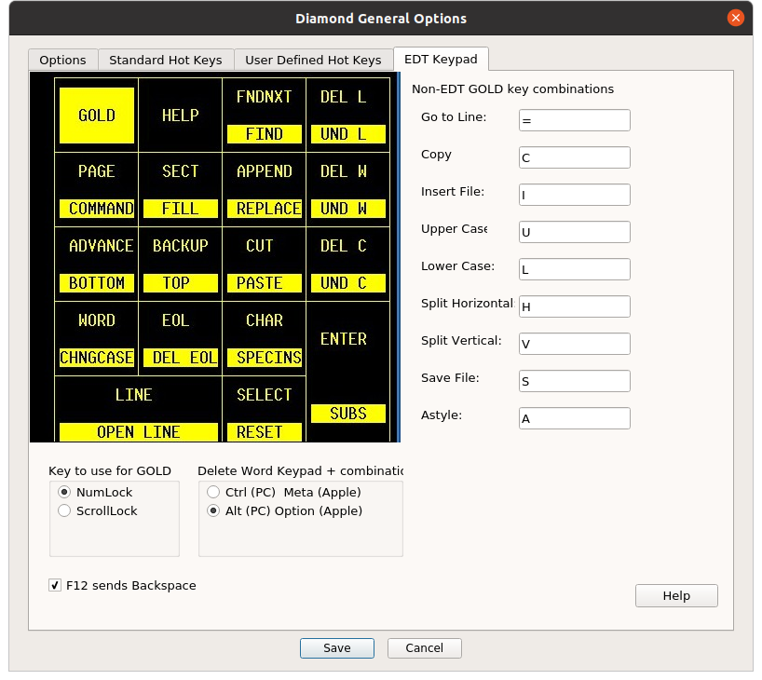
This wasn’t one of Barb’s goals when she first wrote Diamond. It was one of Roland’s goals when he decided to do some coding on Diamond.

Barb wanted to create something along the lines of Crimson and Emerald editors which are abandoned Windows only programs. Many people, including Roland, have fond memories of those editors as well. They didn’t try to do too much, just do well what they did do.

You’ve never heard of EDT and that is fine. You can run diamond and click the Help button on the bottom of the EDT Keypad Options tab. There is a bit of an explanation along with quite a bit of help there.

Bottom line is there are thousands of developers who came from the Digital Equipment Company world of computers who are incredibly frustrated by editors on PCs. Yes, I’m one of them. The only PC editors even attempting to offer support for this are Emacs and Jed. Their support kinda-sorta-works, but Roland wants better. In particular the ability to use NumLock as the GOLD key without having to modmap a terminal definition.

Diamond still needs to get a range of EDT commands implemented, but this release implements the bulk of the keypad navigation. No more having to remember several thousand <Ctrl><Alt><Whatever> key combinations to edit files and no more having to keep reaching for the mouse to do everything.

G-2 Make it faster
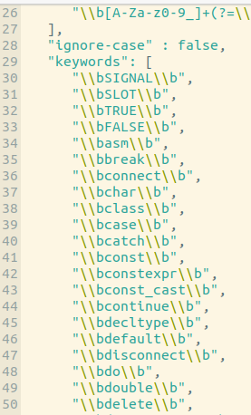
For tiny source files Diamond rocks. When you start loading 5000+ line source files (common in the midrange and mainframe computer world) it can crawl. It was taking sixteen seconds to highlight a 5000+ line .cpp file. Other editors can do it instantaneously. (Working theory: They only bother to highlight what you can see and get around to the rest during some “idle” period.)

Part of the speed increase can be easily achieved. Just changing the .json file for the language syntax dropped that load time down to around four seconds. Yes, it is very human friendly to have keywords be a long list like this. Sadly each line means the highlighter has to make yet another pass through the document. When considering a 5000+ line document it shouldn’t take long to see how this really adds up.

Thankfully you can eliminate a whole lot of passes through the document by making the .json file less human friendly.

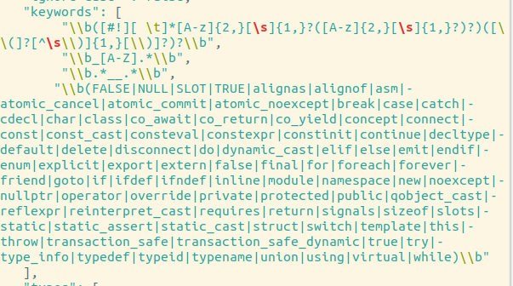
As you can see now the keyword portion of highlighting is now four passes through the document instead of numerous.

The rest of the syntax highlighting files need similar cleanup.

Both Emacs and FeatherPad (a Qt based editor using QPlainTextEdit from 5.x) have much more accurate syntax highlighting that happens much faster. We should be able to make this both better and faster.

G-3 Package creation scripts for maintainers
A script has been created and tested on Ubuntu 20.04 LTS and 18.04 LTS for creating a .DEB file. We need to have RPM, Snap, and MSYS at a minimum. Someone should probably create an Apple package if they cannot use a Snap directly.

Once the scripts are created and tested, someone will need to step up as a “maintainer” for one or more given distros. That means they become responsible for the care and feeding of the package in that distro.

G-4 Full set of developer doc
One of the decisions Roland made when he decided to write all of this doc and scripts was to make this OpenSource project not expert friendly. Far too many OpenSource projects expect developers to be “one with a a language standard” sleeping with the manuals on audio book playing in their ears at night. Just because you aren’t “one with the C++ language standard” doesn’t mean you cannot contribute in a meaningful way. Refer to “Getting-Started.rtf” for information on how even non-programmers can contribute in significant ways.

The biggest method of making this project more appealing and inclusive is by creating step-by-step developer documentation. Showing how to create a development environment for each of the supported platforms. How to set up virtual machines to test the various packages once they are created. Basically any general configuration or maintenance.

Such a set of documentation allows many new and junior developers to make meaningful contributions to the project both testing and debugging. They may know nothing about CopperSpice and less about C++, but if they know how to step through an application in a debugger, they can help identify where something is broke. Knowing where is a major chunk of the battle.

When you look at the Fedora Docs site for creating RPM packages;

https://docs.fedoraproject.org/en-US/quick-docs/creating-rpm-packages/

It even sounds like some of this documentation is required by that distro before an RPM can be accepted.

G-5 Non-Internet friendly
This goal goes hand in hand with the Rule of including all Help within the application. Ever worked in a shop using QtCreator or some other IDE that was configured to look for Help/documentation on the Internet first? It’s great when you get put on a local-only network for security purposes and hit one of the Help keys. You get to sit there for 20-80-whatever seconds waiting for a network time-out error before the IDE will look locally for Help information and documentation.
Another major pain are editors that take it upon themselves to “check for update” in background. When there is no Internet connection this usually hangs the editor because the developer couldn’t imagine a world without an Internet connection.

Very few editors in use today can exist entirely without an Internet connection. Even Emacs wants an Internet connection to reach out to ELPA and MELPA for packages and updates.

G-6 Robust support for legacy/heritage languages
Too many PC editors only pay lip service to the languages from a time before the first PC. Lots of shops are trying to use PC editors to maintain production code and the programmers are suffering pretty bad. Lots of editors claim support for COBOL. Every one of them sucks at it. Oh, they may do a passable job with ANSI COBOL 72-column card format, but they fall apart when free form COBOL-85 is loaded. They don’t have a clue when it comes to DEC (and a few other midrange vendor’s) pre-COBOL-85 free format standards.

FORTRAN is another language many claim to support and most suck at. FORTRAN-IV had a fixed format and funky rules. FORTRAN-77 was a tad better but more funky rules. FORTRAN-90 was a completely different language for all intents and purposes. They all had different formatting and by extension syntax highlighting rules.

To bring in even more of the EDT user base we need accurate support of these and other languages. Our current C/C++ support isn’t “accurate” as both C and C++ are in the same syntax file. C doesn’t have the exact same set of keyword. There are differing keywords between C++11, C++98, C++14, C++17 and most likely C++20.

The editor needs good support for COBOL, DIBOL, FORTRAN, HP/VAX BASIC, PICK BASIC, and Mumps (also called M).

Before anyone Makes fun of Mumps, it is the language used to create the medical records system for Veterans Affairs. They are the largest healthcare provider in America. The VA released a version of their system before we had the term “OpenSource” and it became the basis of the two largest medical records systems sold commercially in America, if not the world. That’s an awful lot of developers “just toughing it out.” You can read more about Mumps and the OpenHealth project here:

https://opensource.com/health/12/2/join-m-revolution

G-7 Robust Tabstop support
If you want to read a good rant on this visit:

https://www.logikalsolutions.com/wordpress/information-technology/most-text-editors-get-tabs-wrong/

This goes hand in hand with Robust legacy/heritage language support. AREA-A in ANSI-COBOL starts in column 8. The reason behind this relates back to physical typewriters and the fact modified versions of them were the keypunch machines used to create punched cards. Physical terminals continued this tradition. A tabstop of 8 meant the cursor stopped in 8. There were exactly 7 spaces in front of the cursor. If you set the tabstop to 8 across the screen (the default) there were 7 spaces between the left edge of the screen and where the cursor landed after hitting the TAB key.

Today, when you set your TAB spacing (they call it spacing instead of tabstops) to 4, your cursor lands in 5, not 4 where it should. When you set it to 8 the cursor lands in 9.

FORTRAN-IV has its own interesting card format.

http://www.math-cs.gordon.edu/courses/cs323/FORTRAN/fortran.html

G-8 Replace QPlainTextEdit with completely custom class
QPlainTextEdit wasn’t designed to be easily modified from the outside. Adding support for additional keystrokes to do some of the same things became a bit of a kludge. In particular the Page Up/Down logic is hidden inside of a private class so when EDT keypad support is enabled the SECT key and the Page Up/Down keys all have to move 16 lines because there is no way (sans the bigger kludge of queuing key events) to give SECT access to the internal Up/Down logic. The derived class currently is keeping track of if a select range is active and it doesn’t always know when it should clear it because of some mouse or control key operation.
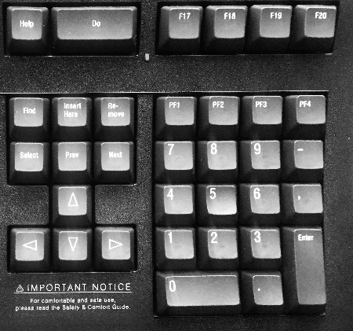Figure 1: image courtesy of Gerry Czadowski
The obvious solution is to create a completely custom EDTPlainTextEdit starting with the QPlainTextEdit and private class source. Move all of the hard mapped EDT keypad key logic into this class. Add configuration methods that allow for a key sequence to be passed in to map that pesky “Keypad Minus” key that is missing from the PC keyboard.
This new class can then emit signals for any actions our DiamondTextEdit class must take based on EDT being enabled and the keystroke(s) a user typed.
The new class also needs ability to show FormFeed characters in files.
Note: Need to have someone with a DEC/HP LK series keyboard plugged into a Linux or Windows box see if they can actually map key minus key. Don’t think Qt had a constant for that key. Might just get a raw key scan.

G-9 Get edit tabs to drag to desktop and between instances
Achieving this requires basically gutting the MainWindow class. One must create a singleton instance of a class derived from QApplication and that must have much of the functionality currently contained in MainWindow. Will need to have socket level communication between tab entities. Need to do better job of this than FeatherPad did (code wise). The ability they have to drag a tab widget to the desktop, drop it, and have a shiny new MainWindow appear around it is pretty slick. How they did the singleton and locking needs a bit of improvement.
The other reason for doing this is to clean up the startup sequence. There is far too much coordination that has to happen during application startup when autoloading. Too many things spread across too many objects have to happen in a certain order. The load time is too slow when loading several large files requiring syntax highlighting. Splitting much of this off into a higher level object should clean this up considerable.

G-10 Remove “Window” menu option
Some of the startup complexity is caused by the care and feeding of this menu option. It will need to go away before G-9 can be achieved or at least go away with it. The “server” singleton running the entire application will be the one keeping track of which tab has what file in which specific MainWindow. Worst case the “Window” menu option gets dynamically created before the menu is displayed by user activation.

G-11 Add a Persistent configuration option
What diamond is right now is a semi-persistent “safety” editor. When you attempt to close in an orderly fashion it checks for any files that need saving and prompts you. There is now also Emacs style “backups” that can be enabled and configured so that every time you save the previous version of the file is written to the backup directory with a mangled name. The mangling is required so that main.cpp from one project doesn’t overwrite the main.cpp backup from another project. The editor can be configured to automatically load all previously opened files at startup.
A persistent editor doesn’t bother checking when you exit. It also doesn’t force save over the original file. A persistent editor has some hidden data directory where it saves, under names it can figure out, the contents, tab specific settings, and cursor position of all open tabs, including those not associated with files. When you start back up it starts back up right where you left off. Sublime Text 3 does a really good job of this. KATE can sometimes do a good job of this until it gets confused about what session it should use. Notepadqq and several other editors also achieve this to varying degrees.

A persistent editor entices a user to actually close the editor before closing the lid on their laptop and driving home. They don’t have the patience to wade through all of those “do you want to save?” prompts and many of the tabs are “scratch” tabs they can’t lose and don’t want to save. They get stuck in traffic and the laptop battery gives out; thus losing those tabs they didn’t want to save and couldn’t lose not to mention all of those unsaved changes.
That’s a “good” persistent editor.
A really fantastic persistent editor has a user configurable time interval where the editor saves to some place other than the original file all unsaved changes so very little can be lost during a crash. At start up, while loading last known files and tabs, it then looks for “interval backups” with a newer timestamp than the one on the actual file and prompts the user about “recovery.”
The path to least resistance here would be to leverage the already existing backup routines.
Some editors, notably TPU on OpenVMS, “journal keystrokes.” This worked well in the era before the mouse. It was also entertaining to type
TPU/RECOVER MY_PROGRAM.COB

and watch the editor load the file then apply all of the keystrokes. If you had been editing for over an hour the more the code bounced around on the screen. The current QPlainTextEdit already has an Undo with a history so the new EDTTextEdit class could simply leverage that, dumping it to a hidden file somewhere and deleting that file with each save.
Note: One would have to process in the correct order. (i.e. the last edit written to the file also needs to be the last edit applied to the document.)

G-12 Make this solid and robust enough it can be forked into an IDE project

