Before Use:
It is better erase the whole flash with XDB first[If you first time use SWDownloader, please erase the whole flash]; or
Then go to the same step of next section.

NOTE: this guide is for DKB3.0 board with TD Y0/Y1/Y2/A0/A or with TTC A0/A1/A2;

Normal Use – Single Target Download (Default Mode):
- Make sure the USB cable is NOT plugged in.

- Open release package of SWD,see picture 1
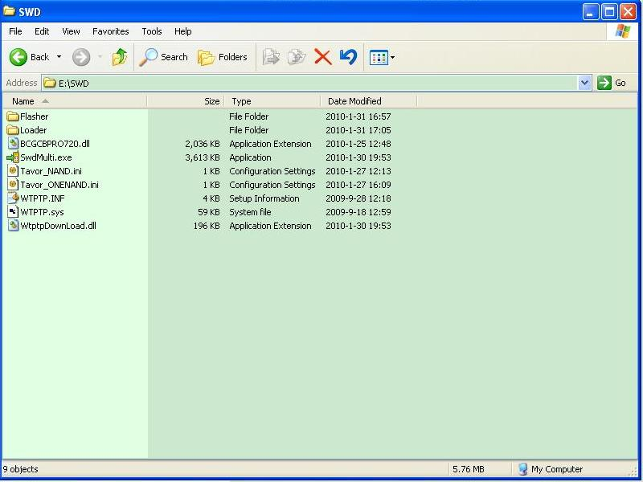

Picture 1
- Copy all necessary images to the folder: Loader\TTC_Ax\DKB3_0\Android
See picture 2 below

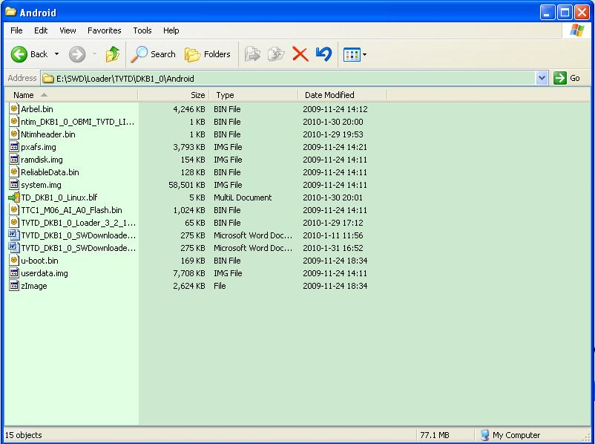

Picture 2
- Double click SwdMulti.exe and wait until picture 3 shows:
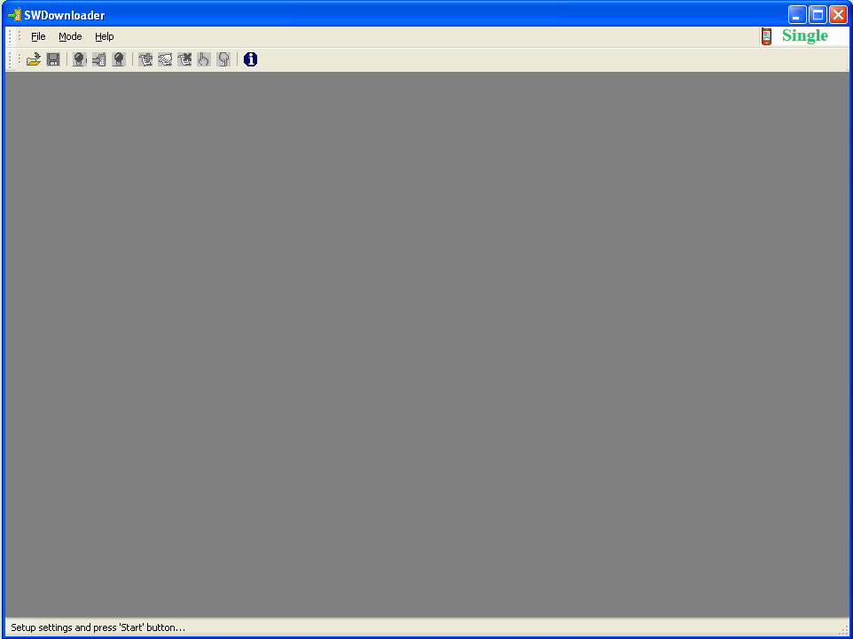
Picture 3

- Click button in toolbar or choose File->Open in menu to open Loader\TTC_Ax\DKB3_0\Android\TTC2_DKB3_0_Linux.blf, see picture 4
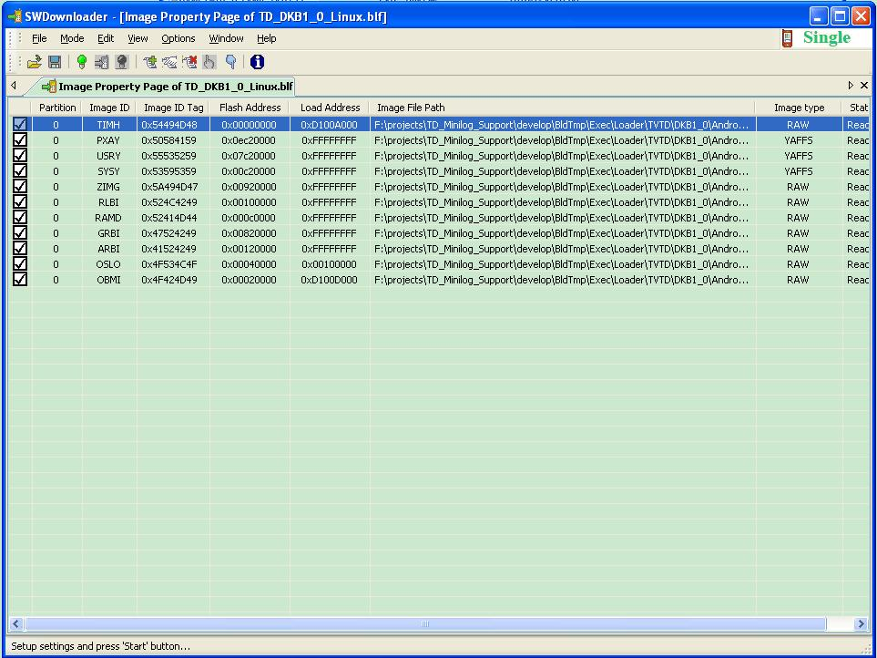
Picture 4
(Please check every image file enable to show , it will pop up message box if file not exist when you open blf file)

- Click to start preparing for downloading until see picture 5

Picture 5

- Do the following operations:
- Plug out the USB cable;
- Turn off the power;
- Press “BACK” key on DKB and hold on for several seconds(see Note a), at the same time go to next step;
- Turn on the power;
- Connect the USB cable;
- The system will give directions: install driver, see step 9; or download images, see step 8.
  - Note: this is because OBM will enter UPDATE mode when detect key pressed. However, due to BootRom bug, the boot time could be up to 7 seconds. To be safe, hold the key (not RESET key) for 10 seconds.
Until you see Marvell(R) WTP: Tools package USB Driver for PXA920
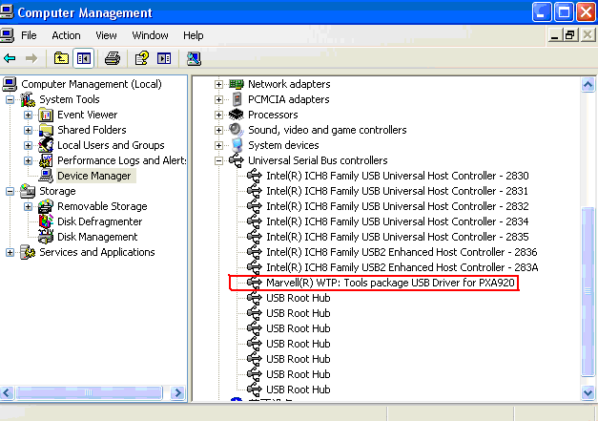

- The download will start and wait for it finishes. You can see download status and progress in download process, see picture 6
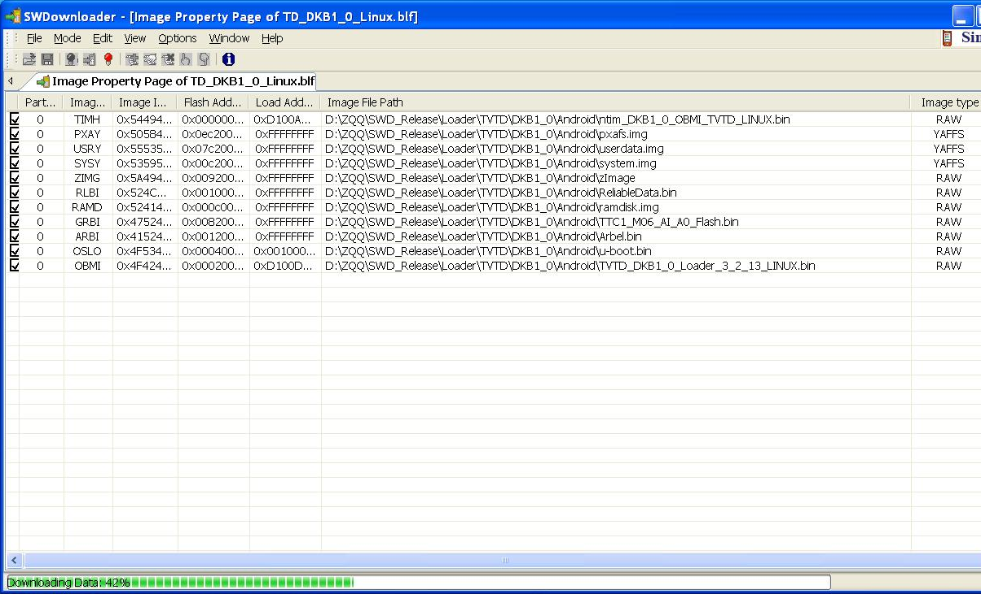
Picture 6

- It may prompt to install drivers, the drivers are located in: \SWD \WTPTP.inf and \SWD \WTPTP.sys.
- Please wait until download complete, it will pop up a message box telling the download time.

Partial download
- Copy all image files to\Loader \TVTD\DKB1_0\Andrioid\ directory, although you don’t need all image files, but they are must be existed in this directory. See
Picture 2.2.1
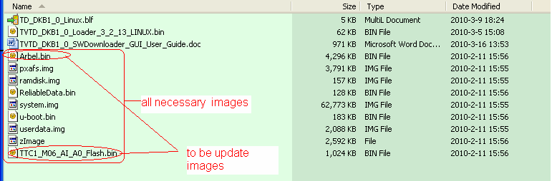
Picture 2.2.1

- Enable images to be update in view list and disable others, but please note that:TIMH is must to partial download and user can’t disable it ,see picture
2.2.2

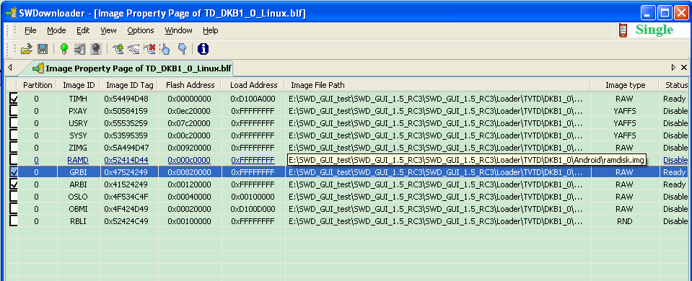
Picture 2.2.2

- Click to start preparing and wait its icon become gray
- Plug into USB,RESET the board, Press ANY key and hold until see device appeared
- Wait download until partial download completed.

Normal Use – Multiple Target Download:
- Choose Multi mode in Menu like picture 7
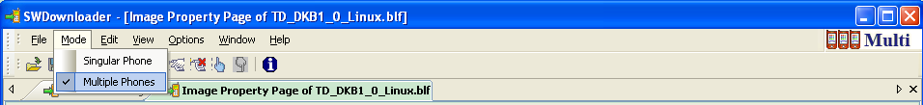

Picture 7

- Click to start preparing for downloading until see picture 8

Picture 8

- Open tab of File Transfer page of blf ,you can see download progress of every target ,see picture 9
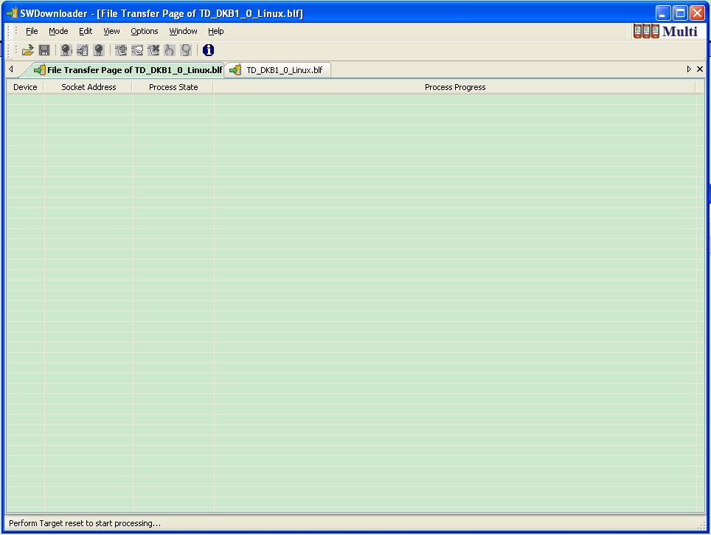

Picture 9

- Reset all Targets and download will start and wait for it finishes, see picture 10 and 11, and when you see picture 11, it finishes multi download. If you see picture 12, please check Target is connected or not in downloading process.

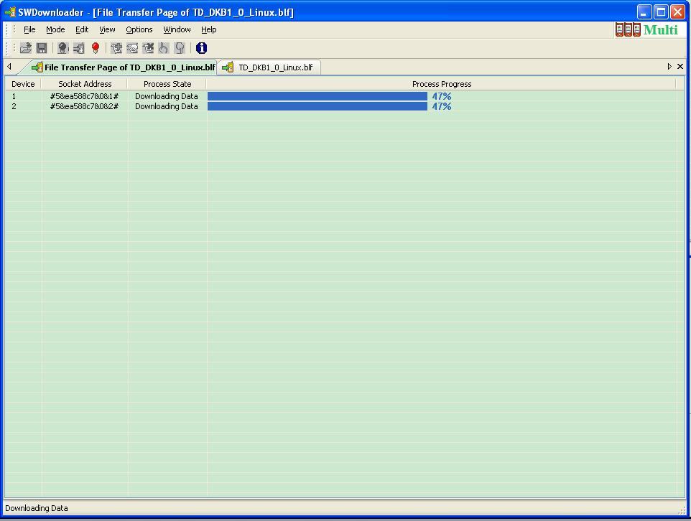

Picture 10

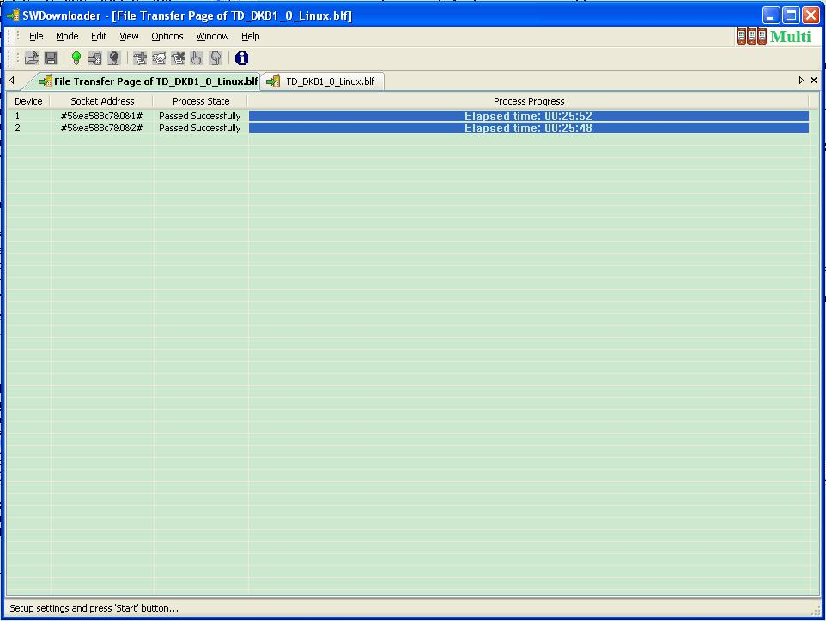

Picture 11

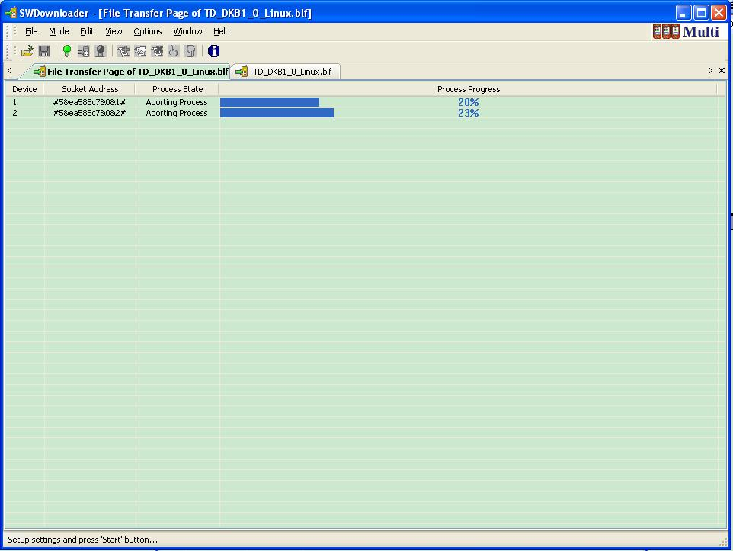

Picture 12

Notes
There are some notes during the download process:
- The name of the android version files which used to be burn must be the same to the file listed in Image File Path in SWD, or you can modify image file name to match your image file name in view;
a) Right click on the image you want to modify ,like picture 4.1
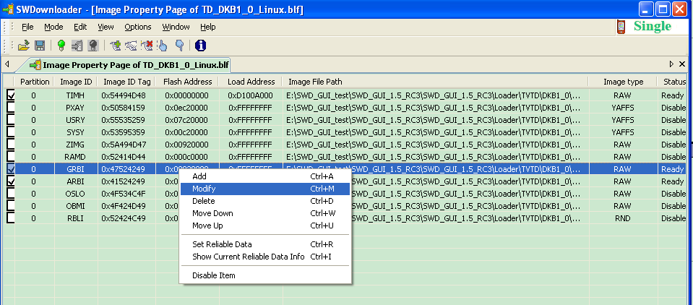

Picture 4.1
  - Click on Modify in pop up menu, then SWD will pop up a dialog like picture 4.2, you can click to browse object image file.
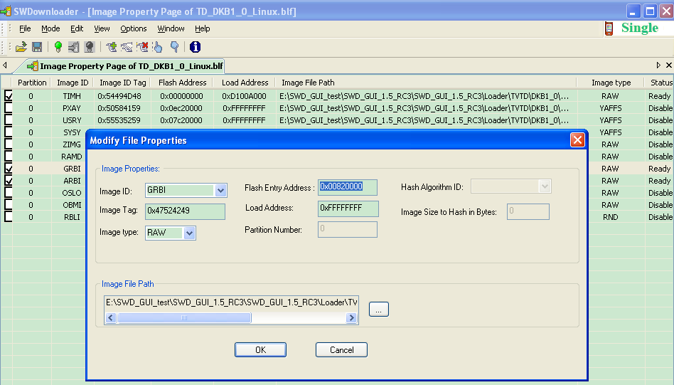

If they are different, the SWD will give error report and refused to download
- When burn software version, you should follow below steps:
- Plug out the USB cable;
- Turn on the power;
- Connect the USB cable;
- The system will give directions: install driver;

