5 Chemin des Presses, 4 allée Technopolis
06800 Cagnes sur Mer
FRANCE

IQN2 LLD

Software Design Specification (SDS)

Revision A

Document License

This work is licensed under the Creative Commons Attribution-NoDerivs 3.0 Unported License. To view a copy of this license, visit http://creativecommons.org/licenses/by-nd/3.0/ or send a letter to Creative Commons, 171 Second Street, Suite 300, San Francisco, California, 94105, USA.

Contributors to this document

Copyright (C) 2012 Texas Instruments Incorporated - http://www.ti.com/

Revision Record
Document Title: Software Design Specification

Revision | Description of Change
A | - Initial Release – Code drop 1.0.0.0
Note: Be sure the Revision of this document matches the Approval record Revision letter. The revision letter increments only upon approval via the Quality Record System.

TABLE OF CONTENTS

1 Scope 2
2 References 2
3 Definitions 2
4 Overview 4
4.1 Hardware Overview 4
4.2 Software Overview 6
4.3 Key Features 6
5 Design 7
5.1 Architecture 7
5.2 Complexity abstraction and flexibility 8
5.3 IQN2 Driver configuration object 8
5.4 IQN2 Driver initialization sequence 10
5.5 IQN2 Driver External Interface (Public APIs) 10
6 Implementation 12
6.1 Protocol 12
6.1.1 Definition 12
6.2 Antenna Containers (AxCs) 12
6.2.1 Definition 12
6.2.2 Properties 12
6.2.3 First AxC and number of AxCs 14
6.3 Radio standards 15
6.3.1 Definition 15
6.3.2 Properties 15
6.3.3 Grouping 16
6.3.4 LTE specifics 17
6.3.4.1 MBSFN 17
6.4 Radio timers 17
6.4.1 Definition 17
6.4.2 Properties 17
6.4.3 Egress/Ingress radio timers 18
6.4.4 LTE specifics 19
6.4.5 WCDMA specifics 20
6.5 AT2 events 20
6.5.1 Definition 20
6.5.2 Properties 21
6.5.3 Initialization of AT2 events 22
6.6 CPRI/OBSAI AIL 22
6.6.1 Definition 22
6.6.2 Properties 22
6.6.3 Tx wait delay 24
6.6.4 Cpri packing mode 25
6.6.5 AIL physical Timing parameters 25
6.6.5.1 Pi value 26
6.6.6 Data trace 26
6.7 DFE AID2 26
6.7.1 Definition 26
6.7.2 Properties 26
6.8 DirectIO engines (DIO2) 28
6.8.1 Definition 28
6.8.2 Ingress and Egress parameters 28
6.8.3 Properties 29
6.8.4 Duplicate feature 30
6.8.5 RAC use case 30
6.8.6 TAC use case 30
6.8.7 DIO reconfiguration using IQN2 Functional Layer 31
6.9 Control channels 31
6.9.1 Definition 31
6.9.2 Properties 31
6.10 Synchronization process 32
6.10.1 Mechanism 32
6.10.2 SW support 32
6.11 Runtime configuration 33
6.11.1 AIL Enable/Disable 33
6.11.2 AxC Enable/Disable 33
6.11.3 AT2 event Enable/Disable 33
6.12 Exception counters 33

LIST OF FIGURES

Figure 1: IQN2 Hardware Block Diagram 4
Figure 2: IQN2 LLD Software Overview 6
Figure 3: IQN2 LLD Architecture 7
Figure 4: IQN2 Driver data structures 9
Figure 5: IQN2 Driver Initialization Sequence 10

Scope
This document describes the IQN2 Low Level Driver design. Also, the data types, data structures and application programming interfaces (APIs) provided by the IQN2 driver are explained in this document.

References
The following references are related to the feature described in this document and shall be consulted as necessary.

No | Referenced Document | Control Number | Description
1 | IQN2 User Guide | SPRUxxx | KeyStone II Architecture IQN2 User Guide
2 | IQN2 LLD API  Documentation | Version 1.0.0.0 | DOXYGEN generated API  documentation located in the package under the “docs” directory in CHM  format.
Table 1. Referenced Materials

Definitions
Acronym | Description
AID | Antenna Interface for DFE
AIF | Antenna Interface
AIL | Antenna Interface Link
API | Application Programming Interface
AT | Antenna Timer
CSL | Chip Support Library
CPRI | Common Public Radio Interface
CPU | Central Processing Unit
C&M | Control and Management
DFE | Digital Front End
DIO | Direct I/O
DMA | Direct Memory Access
DRFE | Digital Radio Front End
DSP | Digital Signal Processor
EDC | Egress DMA Controller
EE | Error/Exception Event
EFE | Egress Framing Engine
FIFO | First In First Out
FFTC | Fast Fourier Transform Coprocessor
IDC | Ingress DMA Controller
IFE | Ingress Framing Engine
IP | Intellectual Property
IQ | In-phase and Quadrature data
IQN2 | In-phase and Quadrature Net v2
IQS | IQ Switch Infrastructure
ISR | Interrupt Service Routine
LLD | Low Level Driver
MCSDK | Multi-Core Software Development Kit
MMR | Memory Mapped Register
NetCP | Network Co-Processor
OBSAI | Open Base Station Architecture Initiative
OSAL | Operating System Abstraction Layer
PA | Packet Accelerator
PktDMA | Packet Direct Memory Access
PSI | Packet Streaming Interface
QMSS | Queue Manager Sub-System
RAC | Receive Accelerator Coprocessor
RAT | Radio Access Technology
SDK | Software Development Kit
SI | IQN System Interface
SOC | System On Chip
TAC | Transmit Accelerator Coprocessor
TI | Texas Instruments Inc.
Table 2. Definitions

Overview
IQN2 is intended to communicate with FFTC, RAC, TAC, PA/NetCP sub-systems without the need of constant supervision or control from application software. It is envisioned that application software would initially configure the interaction between IQN2 and these sub-systems, but that in steady state, no or very minimal CPU interventions are required for this data interchange.

IQN2 LLD is designed to provide a set of low level APIs which can be used for IQN2 IP hardware setup, control and status determination for different radio standard protocols over link layer and DFE. The LLD sets several IQN2 registers to default values based on the configuration provided by the application software.

IQN2 LLD also provides IQN2-FL (Functional Layer) APIs which allow setting up and configuration of individual IQN2 sub-module registers.

Hardware Overview
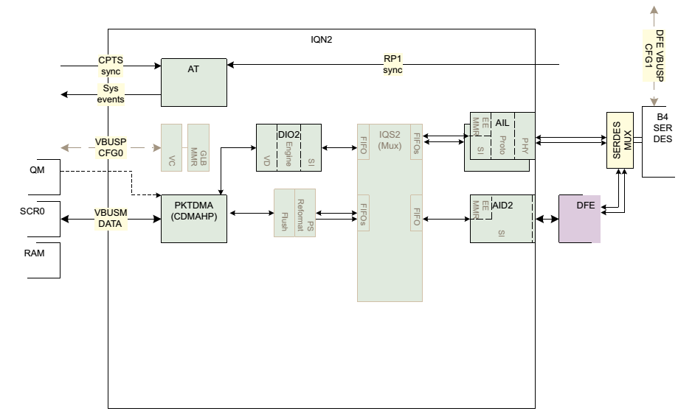

Figure 1: IQN2 Hardware Block Diagram

The Figure 1: IQN2 Hardware Block Diagram above shows the hardware overview of the IQN2 peripheral. The IQN2 consists of:
- A VBUSM DATA connection (128 bit Master) for PktDMA
- A VBUSP CFG connection (32 bit Slave) for IQN2 register access
- A PktDMA module with:
  - 48 ingress/egress channels
  - 48 quadword buffer per channel
  - 48 QPEND signals, 32 for AxC channels, 16 for control channels
  - The allocation between control and AxC is soft/flexible
- A DIO2 module with:
  - 16 ingress/egress channels
  - 3 DIO engines within DIO2
  - Up to 3-way Ingress multi-cast
  - Each engine independently programmed DMA profile
  - Each engine can have different burst length and SOC addressing scheme
- A AID2 module to interface the new Digital Front End (DFE) module with:
  - 32 ingress/egress AxC channels
  - 16 ingress/egress Control channels
- Two AIL instances to handle CPRI and OBSAI protocol with
  - OBSAI
    - Up to 32 ingress/egress AxC/Ctrl mixture channels
    - link rates {2x, 4x, 8x}
  - CPRI
    - Up to 32 ingress/egress AxC channels
    - Up to 4 ingress/egress control channels
    - Link rates {2x, 4x, 5x, 8x, 10x, 16x}
  - Link-to-link PHY level forwarding (defined in OBSAI/CPRI)
  - PHY reset isolation
- An AT2 module with:
  - 24 System Events
  - 1 BCN counter
  - 8 complex RADT (radio Timers)
  - Timing Sync Sources {RP1, generic input pins, CPTS(10gE), SW}
- Power Islands for AIL modules
- CPTS with clock synchronization circuit
- A PSR/Flush Controller with peer requested flush support
- A EE module to aggregate Alarm and Exception information and generate SoC level interrupts
The muxing of SERDES lanes between AIL (CPRI/OBSAI) and DFE (JESD) is performed at SoC level.

Software Overview
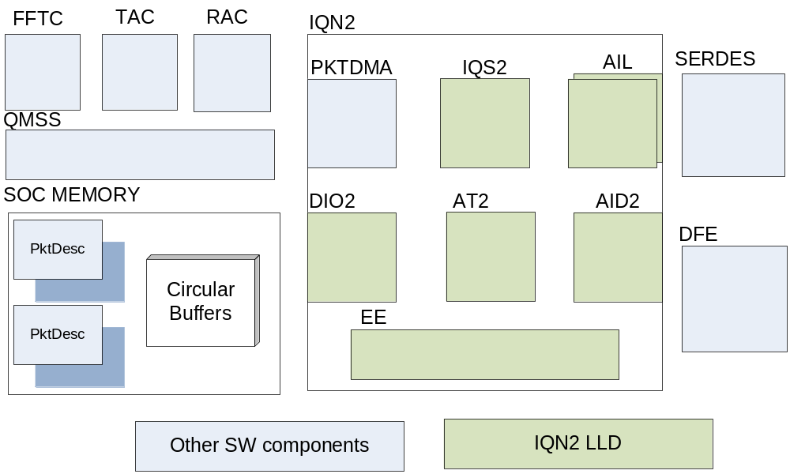
Figure 2: IQN2 LLD Software Overview
The Figure 2: IQN2 LLD Software Overview depicts the various components involved in the transfer of IQ and control data when the IQN2 driver runs on the SoC. The green boxes are the IQN2 modules that the LLD configures for the different mode of operations (LTE/WCDMA, DFE/CPRI/OBSAI). The IQN2 configuration can be run from ARM or DSP. The IQN2LLD is single instance.
The other SW components in light blue are either CSL (SERDES), LLDs (CPPI, DFE, FFTC, QMSS), or FLs (RAC, TAC).
Even though IQN2 HW includes a PktDMA instance, the PktDMA configuration and the associated Rx/Tx descriptor queues and free descriptor queues is not owned by IQN2 LLD. This allows, for instance, to have multiple SW entities running on ARM or DSP to push or pop packets to/from IQN2, each SW entity being in charge of configuring its separate Rx/Tx PktDMA channels.

Key Features
Following are the key features of IQN2 LLD software:
- IQN2 Functional Layer on top of CSLR (register layer) for IQN2 sub-modules (AIL, Top, AID2, IQS2, DIO2, AT2, and all EEs)
- Single instance LLD driver for DSP and ARM (user mode) with several mode of operations, including:
  - LTE, WCDMA, Dual mode, and Generic Packet mode
  - CPRI over AIL, including CPRI control words
  - OBSAI over AIL
  - DFE over AID2 (AxC/CTL)

Design

Architecture
This section explains the overall architecture of IQN2 LLD:

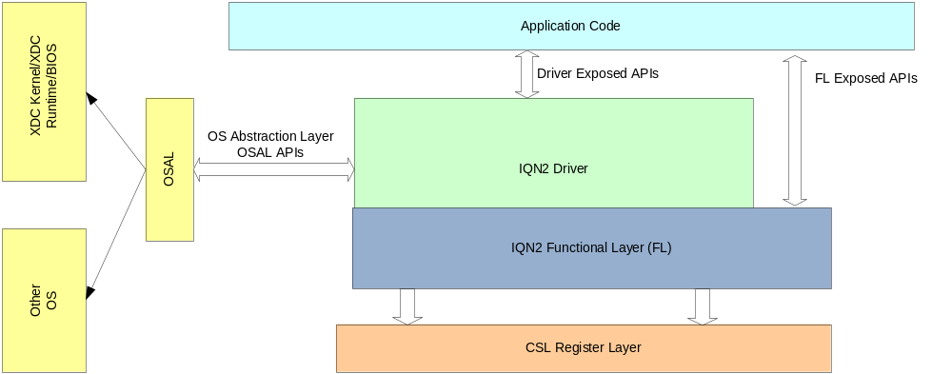
Figure 3: IQN2 LLD Architecture
The Figure 3: IQN2 LLD Architecture illustrates the following key components:
- IQN2 Driver
This is the core IQN2 driver. The driver exposes a set of APIs which are used by the application layer to configure, monitor, reconfigure and reset the IQN2 peripheral module. The driver also exposes a set of OS abstraction APIs which are used to ensure that the driver is OS independent and portable. The IQN2 driver uses its IQN2 functional layer for all IQN2 MMR access.
- Application Code
This is the user of the driver and its interface with the driver is through the APIs set. Application users use the driver APIs to configure, monitor, reconfigure and reset the IQN2 module.
- Operating System Abstraction Layer (OSAL)
The IQN2 LLD is OS independent and exposes all the operating system callouts via this OSAL layer.
- IQN2 Functional Layer
The IQN2 Functional Layer is used to setup IQN2 HW via a top-level FL configuration structure which exposes all the IQN2 low-level fields. It also offers a set of specific commands and queries for each IQN2 sub-modules (AIL, Top, AID2, IQS2, DIO2, AT2, and all EEs).
- CSL Register Layer
The CSL register layer is the IP block memory mapped registers which are generated by the IP owner. CSLR names are matching the IP HW specification. The IQN2 FL accesses the MMR registers via CSLR.

Complexity abstraction and flexibility
This IQN2 LLD aims at generalizing the configuration of IQN2 for different high-level scenarios. Only a single instance of the driver can be run from only one of the KeyStone-II SOC ARM or DSP cores. So the LLD should be seen as an abstraction of the IQN2 configuration complexity. That means that within a short amount of configuration parameters / API calls, the application code can configure IQN2 for a specific high level scenario. Enough flexibility is put in the LLD at this point to achieve that goal. The LLD implementation actually won’t prevent the application code from overriding the “pre-defined” parameters. APIs have been split in such a way that first, the FL high level setup structure (Iqn2Fl_Setup) of the IQN2 driver instance gets populated (IQN2_initHw):

// initialization function for the IQN2 H/W FL structure
IQN2_initHw(&iqn2Obj);

And then the Iqn2Fl_Setup configuration is applied to IQN2 HW registers in a separate API call.

IQN2_startHw(&iqn2Obj);

That means iqn2Obj.hIqn2Setup can still be altered in between with the “end user” very specific needs by using a set of LLD APIs.

IQN2 Driver configuration object
The IQN2 LLD defines a structure called IQN2_ConfigObj. It exposes high level parameters to allow users to configure IQN2 with a general understanding of how IQN2 HW works. IQN2_ConfigObj fields are, for instance, the type of antenna traffic, the number of links, the protocol, the data width, the DMA mode etc…
IQN2 LLD is then in charge of translating these parameters into IQN2 FL setup parameters, and then call the appropriate FL APIs to setup IQN2 registers.
The Driver configuration object, besides its own properties, contains configuration objects for IQN2 modules such as AIL, DIO2, or AID. It also contains objects with each Antenna Container (AxC) and each Radio Timer (RADT). IQN2_ConfigObj has also pointer references to an Iqn2Fl object instance and the Iqn2Fl setup structure which is used to configure IQN2 HW from IQN2_startHw() API call.

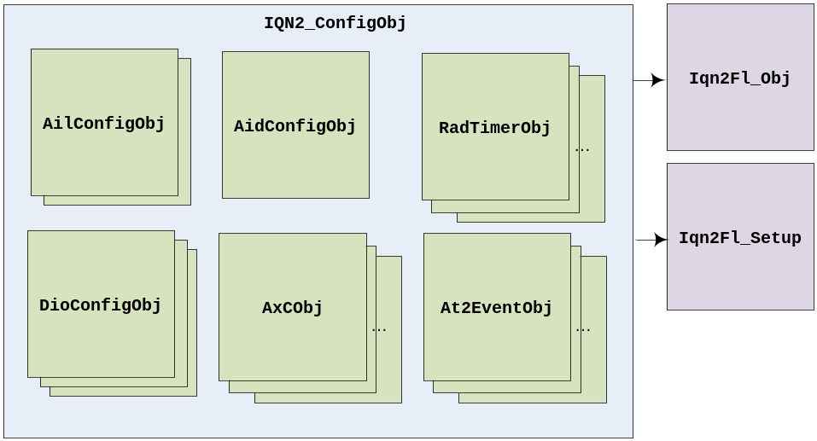
Figure 4: IQN2 Driver data structures

IQN2 Driver initialization sequence
The IQN2 driver provides a sequence which initializes the IQN2 IP block.

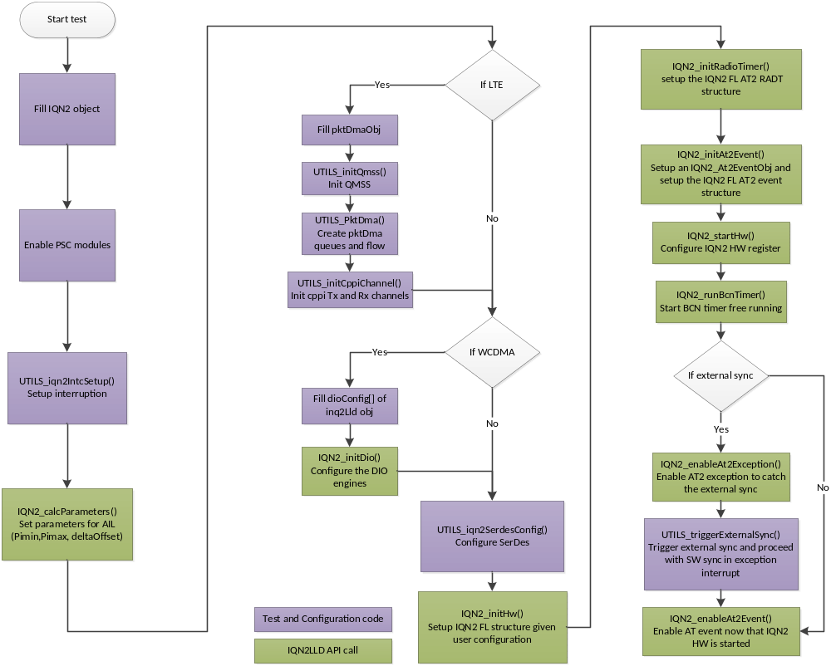Figure 5: IQN2 Driver Initialization Sequence
The Figure 5: IQN2 Driver Initialization Sequence depicts the typical control flow during the initialization of the IQN2.

IQN2 Driver External Interface (Public APIs)
The following table outlines the basic interfaces provided by IQN2 LLD. Please note that this list is not exhaustive. For complete list of APIs, there is doxygen documentation associated with each release of IQN2LLD.

IQN2 Functional Layer | Description
Iqn2Fl_init | Peripheral specific initialization function
Iqn2Fl_open | Opens an instance of iqn2 fl
Iqn2Fl_hwSetup | Initializes the device registers
Iqn2Fl_hwControl | Controls IQN2 operation based on the control command
Iqn2Fl_getHwStatus | Gets IQN2 status values based on the status query command
Iqn2Fl_close | Closing an instance of iqn2 fl

IQN2 Driver | Description
IQN2_calcParameters | Calculates IQN2 timing and delay parameters according to the pre-set parameters in IQN2_ConfigObj.
IQN2_initDio | Sets up the dio configuration structure given the application parameters.
IQN2_initHw | Sets up the IQN2 FL setup structures given the IQN2_ConfigObj instance
IQN2_startHw | Configures IQN2 HW registers given user IQN2 configuration. HW is then started, waiting for the selected synchronization
IQN2_runBcnTimer | Starts the BCN Timer free running. SW writes are not precise so it is expected in real case system, the application SW will correct the timer value with an offset. IQN2_resyncProcedure is used up on a resync external event.
IQN2_initRadioTimer | Sets up the IQN2 FL setup Radio Timer structures given the IQN2_ConfigObj instance, and the egress/ingress radio standards configured during IQN2_initHw().
IQN2_initAt2Event | Sets up the IQN2 FL setup AT2 event structures given the IQN2_At2Eventobj instance. This instance is also registered in IQN2_ConfigObj instance.
IQN2_enableAt2Event | Enables a given AT2 event, assuming this event was already initialized
IQN2_disableAt2Event | Disables a given AT2 event
IQN2_getIngressRadioStandardId | Returns the ingress radio standard ID associated with the AxC
IQN2_getEgressRadioStandardId | Returns the egress radio standard ID associated with the AxC. Used for dynamic control of MBSFN in LTE
IQN2_getIngressRadioTimerId | Returns the ingress radio timer ID associated with the AxC number. Ingress radio timer id is equal to Ingress radio standard id + max number of populated radio standards. Application may need to have separate radio timers for downlink and uplink. Following call to IQN2_initHw(), with this function, the application can get a radio timer ID and pass user-specified parameters for radio timers in IQN2_ConfigObj
IQN2_getEgressRadioTimerId | Returns the egress radio timer ID associated with the AxC number. Egress radio timer id is equal to Egress radio standard id. Application may need to have separate radio timers for downlink and uplink. Following call to IQN2_initHw(), with this function, the application can get a radio timer ID and pass user-specified parameters for radio timers in IQN2_ConfigObj.
IQN2_enableException | Configures IQN2 HW registers to enable errors at alarms at IQN2 level
IQN2_resetException | Resets IQN2LLD exception counters
IQN2_captureException | Captures the exception counts into a supplied destination storage
IQN2_resetIqn2 | Used to reset IQN2 to its default state

Implementation

Protocol

Definition
This is a high level parameter that defines whether the IQN2 driver is used for CPRI, OBSAI, or DFE modes. This parameter is used to select AIL0/1 versus AID2 module usage, and to compute the timing and framing values for the IQN2 modules. While it is envisioned to use AIL and AID2 simultaneously, the current scope of IQN2 driver does not comprehend that scenario.

Antenna Containers (AxCs)

Definition
IQN2 was designed to support flexible combinations of antenna containers (AxCs). IQN2 can support up to eight radio standards, which can result on eight different modes of operation. Each AxC can be mapped to one of these. A radio standard groups AxCs with similar properties. IQN2 LLD is allocating groups of AxCs per radio standard on its own and user application can query the radio standard id for a given AxC.
The IQN2 LLD instantiates IQN2_AxCObj structure objects, which holds information, for instance, about is egress or ingress data width and offset.

Properties

IQN2_AxCObj

sampleRate
cpriPackMode
lteCpType
egressLteCellId
ingressLteCellId
egressAxCOffset
ingressAxCOffset
inboundDataWidth
outboundDataWidth
customSampleRate
packetSize

sampleRate: this property is used to create a group or assigned the AxC to a specific radio standard. Each AxC of the same group holds the same sample rate. IQN2_SRATE_CUSTOM can be used in conjunction with customSampleRate to specify a sampling rate not part of sampleRate enumeration.

cpriPackMode: used for CPRI only. Depending on the sample rate, the antenna containers are interleaved in different order to handle the CPRI frame format.

lteCpType: LTE cyclic prefix description. The application can use normal cyclic prefix or extended cyclic prefix for each AxC. IQN2 LLD creates a different group for extended cyclic prefix if already one group is defined with the same sampling rate but normal cyclic prefix. IQN2_LTE_CPTYPE_NONE can be used to implement a non-LTE framing over a 10ms radio frame. In that case, the packet size is the same over a 10ms radio frame, and packetSize needs to be specified for this AxC.

egressLteCellId: used for LTE for group creation to facilitate MBSFN operation. An egress group is required to be created for a unique combination of sampling rate and cpType. On top of this, for different Lte cell ids, different groups will be created even if their sampling rates and cptypes are identical.

ingressLteCellId: used for LTE for group creation to facilitate multi strobe with the same rate. An ingress group is required to be created for a unique combination of sampling rate and cpType. On top of this, for different Lte cell ids, different groups will be created even if their sampling rates and cptypes are identical.

egressAxCOffset: IQN2 supports per-channel AxC offsets with sample granularity except AIL in OBSAI mode where IQN2 supports per-channel AxC offsets with clock granularity. AIL allows every AxC within a group to be offset relative to the Radio Standard Offset.

ingressAxCOffset: IQN2 supports per-channel AxC offsets with sample granularity except AIL in OBSAI mode where IQN2 supports per-channel AxC offsets with clock granularity. AIL allows every AxC within a group to be offset relative to the Radio Standard Offset.

inboundDataWidth: used to specify DL/UL data formats for IQN2

outboundDataWidth: used to specify DL/UL data formats for IQN2

customSampleRate: this field can be used to specify a custom sampling rate if sampleRate=IQN2_SRATE_CUSTOM. It is expressed in KHz and the DFE PLL clock (2457600 or 3686400) needs to be a multiple of the custom sampling rate.

packetSize: this field can be used to pass a custom packet size if sampleRate=IQN2_SRATE_CUSTOM, customSampleRate is set, and teCpType=IQN2_CPTYPE_NONE. It is expressed in number of samples (IQ). The associated custom sampling rate over 10ms needs to be an integer multiple of the custom packet size. Example: 92160*10/4096=225 for a sampling rate of 92.16 and a packet size of 4096 IQ samples.

First AxC and number of AxCs
There are restrictions introduced by the IQN2 LLD on the AxC mapping. IQN2 LLD support multiple modes of operation at the same time and on the same module (AIL/AID). The supported list of modes includes WCDMA and LTE (LTE 5, LTE 10, LTE 15 and LTE 20).

For each mode, the user application provides the numbers of AxCs to configure. The IQN2 LLD has restrictions on the order each AxC is allocated.
IQN2_AilConfigObj and IQN2_AidConfigObj structure objects contain, for instance, in AID2 case, a firstLteAxC and numLteEgressAxC/numLteIngressAxC parameters.

The user application needs to make sure that AxC numbers for different modes do not collide. For instance, if Wcdma AxCs are configured first, that means:
firstLteAxC = firstWcdmaAxC + max(numWcdmaEgressAxC, numWcdmaIngressAxC)

For scenarios with a mix, for instance, of lte5, lte10, and lte20, the user application needs to try and group same types of AxCs in contiguous entries of AxCconfig[] array. That will minimize unnecessary creation of new radio standard group ids, knowing IQN2 allows up to 8 simultaneous radio standards. The LLD internally browses AxCconfig[] array and creates new groups of contiguous AxCs objects with the same properties.

So let’s illustrate with an example:
User application:
// Suppose the following AIL0 configuration (numAil=0)
// numWcdmaAxC = 16, firstWcdmaAxC = 0, numLte20AxC = 2, firstLteAxC = 16
hIqn2->ailConfig[numAil].numWcdmaPeAxC = numWcdmaAxC;
hIqn2->ailConfig[numAil].numWcdmaPdAxC = numWcdmaAxC;
hIqn2->ailConfig[numAil].numLtePeAxC = numLte20AxC;
hIqn2->ailConfig[numAil].numLtePdAxC = numLte20AxC;
hIqn2->ailConfig[numAil].firstWcdmaAxC = 0;
hIqn2->ailConfig[numAil].firstLteAxC = hIqn2->ailConfig[numAil].firstWcdmaAxC + numWcdmaAxC;
// Corresponding AxC array configuration, note AxC with same properties are contiguous to each other
AxCOffset = hIqn2->ailConfig[numAil].firstWcdmaAxC;
for(i=0; i< numWcdmaAxC; i++)
{
hIqn2->AxCconfig[AxCOffset].sampleRate = IQN2_SRATE_3P84MHZ;
hIqn2->AxCconfig[AxCOffset].inboundDataWidth = IQN2FL_DATA_WIDTH_8_BIT;
hIqn2->AxCconfig[AxCOffset].outboundDataWidth = IQN2FL_DATA_WIDTH_8_BIT;
AxCOffset++;
}
AxCOffset = hIqn2->ailConfig[numAil].firstLteAxC;
for(i=0; i < numLte20AxC; i++)
{
hIqn2->AxCconfig[AxCOffset].sampleRate = IQN2_SRATE_30P72MHZ;
hIqn2->AxCconfig[AxCOffset].cpriPackMode =IQN2_LTE_CPRI_8b8;
hIqn2->AxCconfig[AxCOffset].inboundDataWidth = IQN2FL_DATA_WIDTH_15_BIT;
hIqn2->AxCconfig[AxCOffset].outboundDataWidth = IQN2FL_DATA_WIDTH_15_BIT;
AxCOffset++;
}
IQN2LLD allocation:
Egress radio standard 0: 16 Wcdma AxC, index 0 to 15
Ingress radio standard 0: 16 Wcdma AxC, index 0 to 15
Egress radio standard 1: 2 LTE20 AxC, index 16 to 17
Ingress radio standard 1: 2 LTE20 AxC, index 16 to 17}

Radio standards

Definition
IQN2 supports the grouping of similar antenna containers (AxCs) in radio standards. Because simultaneous modes of operation (Wcdma, Lte) have different sampling rates, for instance, IQN2 needs to be able to manage several framing configurations at once. This is what the radio standards are made for. A radio standard is defined by four parameters: {INDEX_START, INDEX_CNT, SYMBOL_TC and SAMPLE_TC}. The radio standards share the same common sample Terminal Count (TC) LUT (256 entries), which the IQN2 LLD allocates based on each radio standard needs. This way, each radio standard has access to its own framing configuration values.
The allocation of radio standards is done within the LLD and is based on the description of each AxC in the AxCconfig[] array. The user application can make use of LLD APIs to get the information about the egress or ingress group id for a given AxC.

Properties
Each Radio standards are defined by four parameters that configure their sample framing. The LLD stores these parameters in internal variables:
- egrRadStdInfo[IQN2_MAX_NUM_RADIO_STANDARD]
- ingrRadStdInfo[IQN2_MAX_NUM_RADIO_STANDARD].

radioStandardInfo_t
(internal to LLD)

indexSc
indexTc
symbolTc

The radioStandardInfo structure holds the information relative to the radio framing. In IQN2 hardware implementation, all the radio standards share a common Sample Terminal Count Look Up Table of 256 entries. In order to properly allocate a radio standard, IQN2 need the first index of that LUT (indexSc), the number of entries (indexTc), and the number of symbol in one frame (symbolTc). The IQN2 LLD uses different entries for all the radio standards that it creates.

Grouping

The IQN2 LLD internally groups AxCs for a given radio standard. It automatically fills the groups based on the AxC parameters provided by the user application. The LLD stores each group parameters in private structure arrays:
- egrGroupInfo[IQN2_MAX_NUM_RADIO_STANDARD]
- ingrGroupInfo[IQN2_MAX_NUM_RADIO_STANDARD]
baseGroupInfo_t
(internal to LLD)

samplingRate
cpType
startAxC
endAxC
isPopulated
isLte

Note that the egress group info also has a “cellId” property, used to create different groups in Lte case for proper handling of MBSFN. The ingress group has one too for multi strobe case.

The groupInfo is used by the LLD to define the characteristics of each group. It holds the number of AxCs mapped on the group from the first to the last (every AxCs in a group must be contiguous). A group is created with four parameters: sampling rate, cpType, cellId and isLte. The LLD checks every AxCs to configure for IQN2, and it creates a group for every different combination of these three parameters. AxC with the same parameters will be mapped on the same group.

LTE specifics

MBSFN
For groups of Lte AxCs with normal cyclic prefix, IQN2 LLD defines a “MBSFN factor” of 2 to use twice the number of entries in the common Sample Terminal Count Look Up Table. This allows SW to carefully modify the framing parameters. These need to be modified at runtime on transition between Normal and MBSFN Sub-Frames. To support this mechanism (described in this presentation, http://e2e.ti.com/cfs-file.ashx/__key/communityserver-discussions-components-files/439/2772.MBSFN-support-on-AIF2.ppt ), IQN2 LLD implements the following API:

Iqn2Fl_updateEgressAilRadioStandardTc (hIqn2, radioStdId, symbolSize, symbolIndex);

Radio timers

Definition
Radio Timers (8 RADT instances in IQN2) have the ability to count radio symbols and frames and to generate AT2 events. Each radio timer is used for a given radio access type and direction, LTE or WCDMA, Downlink or Uplink. There is no hard mapping between a radio timer and a radio standard, but the LLD will do a one to one mapping between egress radio standards and radio timers. The LLD, for each mode, has default parameters as applied in IQN2_initRadioTimer() as described in the below table. The LLD offers to override these parameters and the radio timers can be configured with user-defined parameters. In the specific case of LTE, the number of LTE symbols per symbol strobe is configurable as well as the number of LTE symbols per frame strobe. That allows an LTE application to work at 1-symbol pace, or 2-symbol pace, etc …
In the IQN2 hardware, the different symbols of a frame are described in a common 256 entry LUT, which give a clock count length per symbol. The LLD fills this LUT based on each radio timer parameters

Radio timers are slaves to BCN timer (equivalent of PHY timer in AIF2) and are synchronized to it. BCN is expected to be started in a free-running mode by IQN2_runBcnTimer().For enabled RADTs, they will start running once the compare value equals the BCN timer value.

Properties
IQN2_RadTimerObj

mode
userSpecified
initFrameLsbNum
initFrameMsbNum
frameTerminalCount
bcnCompValue
lte
wcdma

mode: IQN2 radio timer application mode, egress, ingress or unused. The LLD sets the RADT mode to egress based on the number of egress radio standards allocated during call to IQN2_initHw()

userSpecified: used to indicate that the user application wants to override the default parameters.

initFrameLsbNum: initial frame low 32-bit number value for this radio timer.

initFrameMsbNum: initial frame high 32-bit number value for this radio timer.

frameTerminalCount: RAD timer frame terminal count (value at which frame count wraps)

bcnCompValue: BCN timer compare value used to start this RAD timer

lte: object for the userSpecified and lte specific parameters used to configure this RAD timer.

wcdma: object for the userSpecified and wcdma specific parameters used to configure this RAD timer.

List of default RAD timer parameters applied during IQN2_initRadioTimer() when userSpecified is reset.

RADT parameters | Default values
initFrameLsbNum | 1
initFrameMsbNum | 0
frameTerminalCount | 4096
bcnCompValue | 0
Frame strobe | Every 10ms, so:  LTE: 140 symbols (default is normal CP)  WCDMA: 15 slots
Symbol strobe | Every symbol, so:  LTE: every symbol with normal CP  WCDMA: every slot (2560 chips)

Egress/Ingress radio timers
It is expected that DL applications and UL applications make use of a different radio timer. For this matter, it is important to understand how the LLD allocated radio timers for the current number of identified simultaneous radio standards:
For DL applications, the Egress radio timer id is equal to Egress radio standard id.
For UL applications, the Ingress radio timer id is equal to Ingress radio standard id + max number of simultaneous radio standards.
For the user application to find out about the allocated radio timer id, the LLD features 2 APIs, which take the egress or ingress AxC number as parameter and return the radio timer id: IQN2_getEgressRadioTimerId(AxC), and IQN2_getIngressRadioTimerId(AxC)

LTE specifics
IQN2_LteRadTimerObj

cpType
numSymbolsForSymbolStrobe
startSymbolsForSymbolStrobe
numSymbolStrobesForFrameStrobe

cpType: Lte cyclic prefix type, normal or extended, used to generate right number and frequency of the symbol strobes to the Lte applications.

numSymbolsForSymbolStrobe: This determines the terminal count array values and number of entries (lutindex). The valid range for this is 1 through 7 or 6 depending on CP type.

startSymbolsForSymbolStrobe: This parameter in unused at the moment.

numSymbolStrobesForFrameStrobe: This determines the symbol terminal count, so number of symbols per frame. So IQN2 hardware will loop thru the number of entries assigned in the common 256 entry LUT for this RAD timer and issue a frame strobe once the symbol terminal count is met.

With these parameters, the LTE applications can be paced at a 1-symbol or multi-symbol rate, or lte slot rate as well. The LLD test examples use the default parameters.

So let’s illustrate with an LTE application example. In this example, one egress and one ingress RAD timers are configured. The symbol strobe is paced at 2-lte symbol rate for a given cyclic prefix type, and the frame strobe is issued at sub-frame rate. The ingress RAD timer is configured to be started taking into account the overall uplink delay:

User application:
egressRadtId = IQN2_getEgressRadioTimerId(iqn2LldObj->aidConfig.firstLteAxC);
ingressRadtId = IQN2_getIngressRadioTimerId(iqn2LldObj->aidConfig.firstLteAxC);

numSymbolsPerSubFrame = ((cfg->cpType == IQN2_LTE_CPTYPE_NORMAL) ? 14 : 12 );

// EGRESS
iqn2LldObj->radTimerConfig[egrRadtId].mode = IQN2_RADT_EGR_MODE;
iqn2LldObj->radTimerConfig[egrRadtId].userSpecified = 1;
iqn2LldObj->radTimerConfig[egrRadtId].frameTerminalCount = 10;
iqn2LldObj->radTimerConfig[egrRadtId].initFrameLsbNum = 0;
iqn2LldObj->radTimerConfig[egrRadtId].initFrameMsbNum = 0;
iqn2LldObj->radTimerConfig[egrRadtId].lte.cpType = cfg->cpType;
iqn2LldObj->radTimerConfig[egrRadtId].lte.numSymbolsForSymbolStrobe = 2;
iqn2LldObj->radTimerConfig[egrRadtId].lte.numSymbolStrobesForFrameStrobe = numSymbolsPerSubFrame/2;

// Assign the clock initial value to get an expected UL RADT delay (dependent on UL frame delay, UL AxC offset, and internal IQN2 delays
ClockNum = radttotalclockcount – 1 – ulRadtDelay;

// INGRESS
iqn2LldObj->radTimerConfig[ingrRadtId].mode = IQN2_RADT_ING_MODE;
iqn2LldObj->radTimerConfig[ingrRadtId].userSpecified = 1;
iqn2LldObj->radTimerConfig[ingrRadtId].frameTerminalCount = 10;
iqn2LldObj->radTimerConfig[ingrRadtId].initFrameLsbNum = 0;
iqn2LldObj->radTimerConfig[ingrRadtId].initFrameMsbNum = 0;
iqn2LldObj->radTimerConfig[ingrRadtId].lte.cpType = cfg->cpType;
iqn2LldObj->radTimerConfig[ingrRadtId].lte.numSymbolsForSymbolStrobe = 2;
iqn2LldObj->radTimerConfig[ingrRadtId].lte.numSymbolStrobesForFrameStrobe = numSymbolsPerSubFrame/2;
iqn2LldObj->radTimerConfig[ingrRadtId].bcnCompValue = ClockNum;

WCDMA specifics
IQN2_WcdmaRadTimerObj

numSlotStrobesForFrameStrobe

numSlotStrobesForFrameStrobe: Determines the slot terminal count, so number of slots per frame - can be used to adjust the frame time to WCDMA TTI bigger than 10ms.

So let’s illustrate with a WCDMA application example. The following configuration can be used to generate a 40ms event:

User application:
radtId = IQN2_getIngressRadioTimerId(iqn2LldObj->aidConfig.firstWcdmaAxC);

iqn2LldObj->radTimerConfig[radtId].mode = IQN2_RADT_ING_MODE;
iqn2LldObj->radTimerConfig[radtId].userSpecified = 1;
iqn2LldObj->radTimerConfig[radtId].frameTerminalCount = 4096;
iqn2LldObj->radTimerConfig[radtId].initFrameLsbNum = 1;
iqn2LldObj->radTimerConfig[radtId].initFrameMsbNum = 0;
iqn2LldObj->radTimerConfig[radtId].wcdma.numSlotStrobesForFrameStrobe = 4*15;
IQN2_initRadioTimer(&iqn2LldObj);

// use At Event 0, init here and enable after IQN2_startHw()
memset(&at2Evt0, 0, sizeof(at2Evt0));
at2Evt0.EventSelect = IQN2_AT2_EVENT_0; // Evt 0
at2Evt0.EventOffset = 0; // Offset from frame boundary in ns
at2Evt0.EvtStrobeSel = IQN2FL_RADT1_FRAME; // Radio timer 1, frame strobe
at2Evt0.EventModulo = -1; // max modulo or wcdma frame
at2Evt0.EventMaskLsb = 0xFFFFFFF8; // skip 3 first events
at2Evt0.EventMaskMsb = 0xFFFFFFFF;
IQN2_initAt2Event(&iqn2LldObj,&at2Evt0);

AT2 events

Definition
AT2 events are used by SW applications, EDMA channels, and hardware accelerators as system events for CPU interrupts, transfer triggers, or hardware processing ticks. There are a total of 24 events. AT2 event0 is connected to the EXTFRAMEEVENT external pin and can be used to synchronize with external test equipment. AT2 event8 is dedicated for the RAC hardware accelerator and AT2 event 9 for TAC. These events are referenced to the radio timers
(RADT timers), and user applications need to specify the radio timer id, and the type of strobe (symbol/frame), along with offset and modulo values. The offset and modulo values are expressed in byte clock unit, but user applications can first express those in nanosecs and get a conversion to byte clocks using IQN2_initNanoSecsToByteClocks() API. If 100% accuracy is required for the modulo or offset values, then the user application needs to work with byte clocks directly while configuring each of the AT2 events.

Properties
IQN2_At2EventObj

EventSelect
EventOffset
EvtStrobeSel
EventModulo
EventMaskLsb
EventMaskMsb

EventSelect: this LLD object instance contains an array of 24 AT2 event objects. There is no hard mapping between the index in the array and the AT2 event itself. That’s why this parameter can be any of the 24 possible events.

EventOffset: Event_offset in Byte Clocks after the start of frame/sym strobes. From IQN2 hardware stand point there is a sys_event generator that counts out OFFSET clocks then fires once. For convenience, the LLD provides a Nanosecs to Byte Clocks conversion function, and a Wcdma chips to Byte Clocks conversion function. Event count compare (EventOffset) and event modulo terminal count (EventModulo) should be less than the event symbol (or frame) period. Event count compare (EventOffset) must be less than or equal to the event modulo terminal count (EventModulo).

EvtStrobeSel: This parameter determines both the RADT counter and start-of-symbol vs. start-of-frame strobe.

EventModulo: Event modulo in Byte Clocks, determining the periodicity of this AT2 system event. From IQN2 hardware stand point, after the event has fired once, the event will re-fire every MOD clocks. If set to (-1), setting max value which means no additional events between the selected strobes. Event modulo minimum is mod 16.

EventMaskLsb: The system event generator maintains a count which indexes this mask LUT starting with the LSB. This 64-event mask register can be set to mask any combination of 64 events in a symbol. If all 0s, enabling all event time (LLD convention), so LLD sets the mask to 0xFFFFFFFF.

EventMaskMsb: Same as EventMaskLsb.

Initialization of AT2 events
The AT2 events are initialized and enabled in two different steps. This allows starting IQN2 hardware first, waiting for system time synchronization, and then starting the SW applications once the RF chain is ready. For this matter, the LLD features 2 APIs, IQN2_initAt2Event() and IQN2_enableAt2Event().

Here is an example:
User application:
egressRadtId = IQN2_getEgressRadioTimerId(iqn2LldObj->aidConfig.firstLteAxC);

at2EventCfg.EventSelect = IQN2_AT2_EVENT_2;
at2EventCfg.EventOffset = offsetForInsertingPackets; // in nanosecs
at2EventCfg.EvtStrobeSel = IQN2_getRadioTimerFrameStrobe(egressRadtId);
at2EventCfg.EventModulo = 500000; // 0.5ms in ns (lte slot)
at2EventCfg.EventMaskLsb = 0xFFFFFFFF;
at2EventCfg.EventMaskMsb = 0xFFFFFFFF;
// Convert to byte clocks prior to IQN2_initAt2Event(), use byte clocks above if 100% accuracy is required
IQN2_initNanoSecsToByteClocks(&iqn2LldObj,&at2Evt2);
IQN2_initAt2Event(&iqn2LldObj, &at2EventCfg);

…

// Configure IQN2 HW
IQN2_startHw(&iqn2LldObj);
// Start BCN timer free running
IQN2_runBcnTimer(&iqn2LldObj);

…

IQN2_enableAt2Event(&iqn2LldObj,IQN2_AT2_EVENT_2);

CPRI/OBSAI AIL

Definition
The IQN2 AIL (Antenna Interface Link) interfaces to a Radio module via either of CPRI or OBSAI protocols. One AIL module equals one high-speed serialized links (either OBSAI or CPRI). These links can be set at different link rates depending on the application needs. IQN2 AIL can also support combinations of both WCDMA (DL/UL) and LTE (20, 15, 10, 5) modes to interface with RAC/TAC or FFTC.
The IQN2 LLD instantiates IQN2_AilConfigObj structure object for each AIL. This structure holds information required to create the CPRI or OBSAI frame to match the radio module configuration.

Properties

IQN2_AilConfigObj

ailEnable
linkRate
comType
pe2Offset
deltaOffset
piMin
nodeTx
nodeRx
txWait
byteClockInKHz
firstLteAxC
firstWcdmaAxC
firstCtlChannel
numLtePeAxC
numWcdmaPeAxC
numLtePdAxC
numWcdmaPdAxC
numCtlChannel

ailEnable: used to indicate if the ail module needs to be configured or not.

linkRate: holds the link rate of the current AIL module. The link rates tested with the LLD are 4x and 8x. AIL hardware can support {2x, 4x, 5x, 8x, 16x}.

comType: holds the communication type. It can be set to be either SerDes Loopback or communication with an external device. This parameters is used to compute timings in IQN2_calcParam.c

pe2Offset: pe2Offset is calculated by the function IQN2_calcParameters(), using the txWait value. This field is used to adjust the timing of the link for the DL side. If not set it will take the default value. See 6.6.5 link parameters.

deltaOffset: deltaOffset is calculated by the function IQN2_calcParameters(), using the pe2Offset value and the nodeTx value. This field is used to adjust the timing of the link for the DL side. If not set it will take the default value. See 6.6.5 link parameters.

piMin: piMin is calculated by the function IQN2_calcParameters(), using the deltaOffset value and the nodeRx value. This field is used to adjust the timing of the link for the UL side. If not set it will take the default value. See 6.6.5 link parameters.

nodeTx: NodeTx parameter allows inserting a certain delay based on the place of the KeyStone SoC in the antenna daisy chain. For a direct communication between two devices, the nodeTx value needs to be set to ‘0’. For the 1st retransmission node, set it to 1, and so on.

nodeRx: NodeRx parameter allows inserting a certain delay based on the place of the KeyStone SoC in the antenna daisy chain. For a direct communication between two devices, the nodeRx value needs to be set to ‘0’. For the 1st retransmission node, set it to 1, and so on.

txWait: See 6.6.3.

firstLteAxC: holds the number of the first LTE AxC on this AIL. The IQN2 LLD support dual mode, and this fields is used with the numLtePe/PdAxC to separated WCDMA related AxCs from LTE 20, LTE 10 and LTE 5 AxCs.

firstWcdmaAxC: holds the number of the first WCDMA AxC on this AIL. The IQN2 LLD support dual mode, and this fields is used with the numWcdmaEgress/IngressAxC to separated WCDMA related AxCs from LTE 20, LTE 10 and LTE 5 AxCs.

firstCtlChannel: Holds the number of the first control channel enabled.

numLtePeAxC: Set the total number of LTE AxCs used for egress. It can be LTE 20 AxC and LTE 10 or any other LTE mode.

numWcdmaPeAxC: set the total number of WCDMA AxCs used for egress.

numLtePdAxC: Set the total number of LTE AxCs used for ingress. It can be LTE 20 AxC and LTE 10 or any other LTE mode.

numWcdmaPdAxC: set the total number of WCDMA AxCs used for ingress.

numCtlChannel: total number of control channels used.

Tx wait delay
The TxWait holds the maximum expected wait time in nanosecs for:
  - PktDMA mode: popping a descriptor and DMA of IQ sample from application memory to AIL egress SI
  - DIO mode: TAC processing time (4 chip) and DMA time from TAC or application memory to AIL egress SI
This parameter is used by IQN2_calcAilTimingForTxNode() to compute deltaOffset. It actually corresponds to PE_STB value expressed in ns. This value will be used to configure all the link timing parameters (piMin, pe2offset, deltaOffset…).

Cpri packing mode
CPRI required a special format where the AxC are interleaved. Regarding the LTE bandwidth, the LLD needs to interleave the containers 8 by 8, 6 by 6, 4 by 4, 2 by 2 or 1 by 1.

LTE bandwidths | cpriPackMode
All | AIF2_LTE_CPRI_1b1
LTE 20 MHz | AIF2_LTE_CPRI_8b8
LTE 10 MHz | AIF2_LTE_CPRI_4b4
LTE 5 MHz | AIF2_LTE_CPRI_2b2

As examples:
  - LTE FDD 20 MHz test case, IQN2_LTE_CPRI_8b8 format looks like:{Control, AxC0, AxC0, AxC0, AxC0, AxC0, AxC0, AxC0, AxC0, AxC1, AxC1, AxC1, AxC1, AxC1, AxC1, AxC1, AxC1}
  - LTE FDD 10 MHz test case, IQN2_LTE_CPRI_4b4 format lookslike:{Control, AxC0, AxC0, AxC0, AxC0, AxC1, AxC1, AxC1, AxC1}

Let’s illustrate with a dual mode example. In this example we want 2 LTE 20 AxCs and 16 WCDMA AxCs. The protocol used is CPRI

User application:
iqn2lldObj.ailConfig[0].ailEnable = 1; //we want to use AIL module 0
iqn2lldObj.ailConfig[0].linkRate = IQN2FL_LINK_RATE_8x; //if we want to have 4AxCs LTE20, we need at least 8x rate.
iqn2lldObj.ailConfig[0].numWcdmaPeAxC = 16;
iqn2lldObj.ailConfig[0].numWcdmaPdAxC = 16;
iqn2lldObj.ailConfig[0].numLtePeAxC = 2;
iqn2lldObj.ailConfig[0].numLtePdAxC = 2;
iqn2lldObj.ailConfig[0].firstWcdmaAxC = 0; //we configure wcdma AxC first
iqn2lldObj.ailConfig[0].firstLteAxC = 16; //the first LTE AxC follows WCDMA AxCs.
iqn2lldObj.ailConfig[0].pe2Offset = 0; //if not set it will take the default value
iqn2lldObj.ailConfig[0].deltaOffset = 0; //if not set it will take the default value
iqn2lldObj.ailConfig[0].comType = IQN2_COM_SD_LOOPBACK //or IQN2_COM_NO_LOOPBACK

AIL physical Timing parameters
Within the AIL, there are some internal delays in both egress and ingress directions. The IQN2 LLD allows the user to only specify delayTx and delayRx reference timing parameters and, in turn, configure all other internal delays automatically. If those 2 parameters are set to 0, IQN2 LLD will use default parameters that work with most cases, based on pe2Offset base value. These timings are computed using the IQN2_calcParameters() function.
Here are the default values for this offset.

AIL parameters | Default values
Pe2Offset | 310
deltaOffset | Pe2Offset + 64 * nodeTx (CPRI)  Pe2Offset + 80 * nodeTx (OBSAI)
piMin | deltaOffset + 64 * nodeRx (CPRI)  deltaOffset + 80 * nodeRx (OBSAI)

Pi value
If IQN2 is connected with an external device such as a radio head or a CPRI relay solution, an adjustment of Pi value for ingress traffic may be needed, as this external equipment should include a new delay. Pi corresponds to the delay from the physical frame boundary to the actual start of the master frame boundary on the ingress side. It may then include the delay of the RF chain in some cases.
To adjust Pi value on a given system, AIL HW features a Pi capture mechanism in its receive mac module (RM) and these captured values can be read from the AT Pi Captured Value Register for the given AIL module.

User application:
ailPiCaptured = CSL_FEXT(hIqn2->hFl->regs->Ail[ailNum].AIL_UAT_AIL_REGS.AIL_UAT_PI_BCN_CAPTURE_STS,\
IQN_AIL_AIL_UAT_PI_BCN_CAPTURE_STS_RD_VAL);

Data trace
The Data Trace feature allows data from the AIL RM, via an external multiplexer, to be
stored in either L2, MSMC, or DDR3 for analysis. This is a debug feature for the AIL
only and cannot be used for the DFE/AID. The IQN2 LLD has not implemented that feature yet.

DFE AID2

Definition
The IQN2 AID interfaces to a DFE module via the AID/DFE interface. The Ingress
block accepts UL data from the DFE and partitions the frames it receives into packets
(e.g. symbols for LTE or 8 quad-word packets for DIO). It sends the symbol based
traffic to the IQN2 PKTDMA or DIO traffic to IQN2 DIO via a master PKTDMA PSI
interface. The Egress block usually reads DL data from system memory or IQN2 DIO
via a slave PKTDMA PSI interface and paces the data delivery to the DFE to a 4-sample
(chip) strobe from AID uAT RADT.

Properties
IQN2_AidConfigObj

aidEnable
firstLteAxC
firstWcdmaAxC
firstCtlChannel
numLteEgressAxC
numWcdmaEgressAxC
numLteIngressAxC
numWcdmaIngressAxC
numCtlChannel
siDelay

aidEnable: used to indicate if the aid module needs to be configure or not.

firstLteAxC: holds the number of the first LTE AxC on this AIL. The IQN2 LLD support dual mode, and this fields is used with the numLtePe/PdAxC to separated WCDMA related AxCs from LTE 20, LTE 10 and LTE 5 AxCs.

firstWcdmaAxC: holds the number of the first WCDMA AxC on this AIL. The IQN2 LLD support dual mode, and this fields is used with the numWcdmaEgress/IngressAxC to separated WCDMA related AxCs from LTE 20, LTE 10 and LTE 5 AxCs.

firstCtlChannel: Holds the number of the first control channel enabled.

numLteEgressAxC: Set the total number of LTE AxCs used for egress. It can be LTE 20 AxC and LTE 10 or any other LTE rate.

numWcdmaEgressAxC: set the total number of WCDMA AxCs used for egress.

numLteIngressAxC: Set the total number of LTE AxCs used for ingress. It can be LTE 20 AxC and LTE 10 or any other LTE rate.

numWcdmaIngressAxC: set the total number of WCDMA AxCs used for ingress.

numCtlChannel: total number of control channel used.

siDelay: This value is the equivalent of the TxWait for AID. The siDelay holds the maximum expected wait time in nanosecs for:
  - PktDMA mode: popping a descriptor and DMA of IQ sample from application memory to AID egress SI
  - DIO mode: TAC processing time (4 chip) and DMA time from TAC or application memory to AID egress SI

Let’s illustrate the configuration of the AID structure with a simple LTE 20MHz test case. We want 4 AxCs LTE 20MHz to feed the DFE. Here is one configuration to do that.

User application:
iqn2lldObj.aidConfig.aidEnable = 1; //we want to use AID module
iqn2lldObj.aidConfig.numWcdmaEgressAxC = 0;
iqn2lldObj.aidConfig.numWcdmaIngressAxC = 0;
iqn2lldObj.aidConfig.numLteEgressAxC = 4;
iqn2lldObj.aidConfig.numLteIngressAxC = 4;
iqn2lldObj.aidConfig.firstWcdmaAxC = 0; //we configure wcdma AxC first
iqn2lldObj.aidConfig.firstLteAxC = 0; //the first LTE AxC is the first AxC to configure
iqn2lldObj.aidConfig.siDelay = 300;

DirectIO engines (DIO2)

Definition
The term Direct IO means that a peripheral has dedicated custom logic that implements data movement (as opposed to using EDMA or CPU reads/writes). For IQN2, custom circuitry is built to handle data movement requirements unique to WCDMA.
The DIO2 consists of the following major components:
- Ingress DIO
- Egress DIO
- Data Trace
- SI
  - Ingress SI Interface
  - Egress SI Interface
  - Micro AT module (uAT)
- VBUSM Interface (master)
- Error Event (EE) Module

There are 3 such DIO2 engines in IQN2.

DIO engines are periodic engines tight to dedicated IQN2 timer events as opposed to PktDMA channels which are driven by data arrival. The AT module generates internal system events that control the DIO engine timing. The IQN2 LLD programs these events with the following periodicity:
- Four chips event for TAC/DL
- Eight chips event for RAC/UL

Ingress and Egress parameters
Then DIO2 engine programming exposes a certain level of flexibility and the LLD implements it that way.

DIO2 register fields | Description | LLD implementation
dma_num_qwd | Number of QuadWord per AxC | One QW for DL, two QW for UL
dma_num_axc | Number of AxCs associated with the dio engine | Parameter from IQN2_DioConfigObj
dma_vbus_base_addr_axc | Vbus source or destination base address | in/out circular buffer  Parameter from IQN2_DioConfigObj
dma_brst_ln | Maximum dma burst length | 4 QW
ch_en | DMA channel enable/disable | Set based on number of AxCs for this engine
rsa_cnvrt_en | Data type selection | 1 for UL 0 for DL
dma_num_blks | Number of data blocks to transfer before wrapping back to dma_base_addr | inNumBlock/outNumBlock  Parameter from IQN2_DioConfigObj
dma_cfg1_dma_blk_addr_stride | DMA block address stride after transferring each dma block (every event time), the DMA will increment by this amount | Computed by LLD, set to 0x80 if usedWithRAC field in IQN2_DioConfigObj is set to match RAC front end format

Properties
IQN2_DioConfigObj

dioEnable
out[16]
outNumBlock
in[16]
inNumBlock
offsetPeDBCH
offsetPdDBCH
duplicateOnDioEng2
usedWithRAC
usedWithTAC
rsaOn
egRsaOn
firstAxC

dioEnable: There are 3 DIO engines available. Set to one for the DIO to use.

Out[16]: holds buffer start address for each AxCs of this DIO engine in egress direction.

outNumBlock: holds number of DMA blocks (wrap2) for this DIO engine in egress direction.

In[16]: holds buffer start address for each AxCs of this DIO engine in ingress direction.

inNumBlock: holds number of DMA blocks (wrap2) for this DIO engine in ingress direction.

offsetPeDBCH: Holds offset to the first DB channel associated to this DIO engine on transmit side.

offsetPdDBCH: Holds offset to the first DB channel associated to this DIO engine on receive side.

duplicateOnDioEng2: Determines if we use the DIO duplicate feature with the current dio (0= disable, 1= enable). Duplicate feature uses dio engine 2, so this feature cannot be used on both DIO 0 and DIO 1 at the same time. This duplicate feature can be used for the purpose of debugging DIO traffic going to RAC. (this feature is not yet supported by IQN2 LLD)

usedWithRAC: When in Wcdma mode, tells whether this DIO engine is used with RAC on ingress side.

usedWithTAC: When in Wcdma mode, tells whether this DIO engine is used with TAC on egress side.

rsaOn: Enabled the RSA Data Format Conversion for UL traffic.

egRsaOn: Enabled the RSA Data Format Conversion for DL traffic.

firstAxC: set the first AxC that belongs to that DIO engine. This is used to match the DIO engine with the proper radio timer.(for LTE DIO mode and MIX MODE).

User application:
iqn2LldObj.dioConfig[0].in[num_axc] = ptr_data_buffer_ingress[num_axc];
iqn2LldObj.dioConfig[0].out[num_axc] = ptr_data_buffer_egress[num_axc];
iqn2LldObj.dioConfig[0].inNumBlock = DIO_NUM_BLOCK;
iqn2LldObj.dioConfig[0].outNumBlock = DIO_NUM_BLOCK;
iqn2LldObj.dioConfig[0].usedWithRAC = 0/1;
iqn2LldObj.dioConfig[0].usedWithTAC = 0/1;
iqn2LldObj.dioConfig[0].rsaOn = 0/1; //enable or disable RSA data format conversion in UL
iqn2LldObj.dioConfig[0].egRsaOn = 0/1; //enable or disable RSA data format conversion in DL

Duplicate feature
With this feature, DIO engine 2 settings are “duplicated” from DIO engine 0 or 1 while another DIO2 circular buffer can be specified. It could be, for instance, to another RAC, or to some DSP memory for debug purposes.
- iqn2LldObj.dioConfig[0/1].duplicateOnDioEng2: 1 means that DIO engine 2 is dedicated to debug mode and will copy this current DIO. IQN2 LLD use DIO engine 2 to duplicate the current DIO. So if DIO duplicate feature is used the application cannot use the DIO engine 2 for traffic purpose. Only one DIO can be debugged at a time, and it can’t be DIO engine 2.
- iqn2lldObj.dioConfig[2].in: sets the buffer destination start address for DIO engine 2 .

RAC use case
The usedWithRAC parameter in the DIO configuration parameter lets the LLD know that this DIO engine needs to be programmed for the RAC front-end RAM. So it means:
dma_cfg1_dma_blk_addr_stride = 0x80; (DIO block stride for each AxC)
dma_num_blks = 3; ((4 – 1) number of 8-chip blocks, 1 RAC iteration is a 32-chip period)
dma_vbus_base_addr_axc = RAC address for each AxC; (AxCs are interleaved in RAC FEI RAM)

TAC use case
The usedWithTAC parameter in the DIO configuration parameter lets the LLD know that this DIO engine needs to be programmed for the TAC RAM. So it means:
dma_cfg1_dma_blk_addr_stride = num_quad_word_per_axc * num_axcs;
dma_num_blks = configurable with DIO outNumBlock; (up to (64 – 1) blocks)
dma_vbus_base_addr_axc = TAC address for each AxC; (AxCs are interleaved in TAC RAM)

DIO reconfiguration using IQN2 Functional Layer
In cases where:
- DIO parameters need to be adjusted by, for instance Physical Layer software
- IQN2 is configured via LLD from ARM Linux or any other software entity external to, for instance Physical layer software
IQN2 functional layer has dedicated hardware control commands and auxiliary APIs that can be used prior to enabling the AT2 events:

Iqn2Fl_setupDio2ReconfigureEngine (hIqn2, &dio2ReconfigureEngine); // both Ingr/Egr
Iqn2Fl_setupDio2ReconfigureEgressEngine (hIqn2, &dio2ReconfigureEgrEngine);
Iqn2Fl_setupDio2ReconfigureIngressEngine (hIqn2, &dio2ReconfigureIngrEngine);

So let’s illustrate with an example:
Reconfiguration using IQN2 FL example:
memset(&dio2EngineSetup, 0x00, sizeof(Iqn2Fl_Dio2ReconfigureEngineSetup));

dio2EngineSetup.engine_idx = 0;

for (idx=0;idx<numWcdmaEgressAxC;idx++)
{
// address expressed at quadword granularity
dio2EngineSetup.egress_axc_buffer_start_addr[idx]=(uint32_t)UTILS_local2GlobalAddr(&(wcdma_dio_data[idx][0])))>>4;
}
for (idx=0;idx<numWcdmaIngressAxC;idx++)
{
// address expressed at quadword granularity
dio2EngineSetup.ingress_axc_buffer_start_addr[idx]=(uint32_t)UTILS_local2GlobalAddr(&(wcdma_dio_result[idx][0])))>>4;
}

// egress_num_block and ingress_num_block expressed in num_blocks - 1
dio2EngineSetup.egress_num_block = DIO_NUM_BLOCK - 1;
dio2EngineSetup.ingress_num_block = DIO_NUM_BLOCK/2 - 1;
// address strides expressed in quadwords
dio2EngineSetup.egress_block_addr_stride = IQN2FL_1QW + 1;
dio2EngineSetup.ingress_block_addr_stride = IQN2FL_2QW + 1;
Iqn2Fl_setupDio2ReconfigureEngine(iqn2LldObj.hFl, &dio2EngineSetup);

Control channels

Definition
CPRI control words and fast C&M are yet to be defined at LLD level.
DFE CTL is supported, and those channels will be enabled once iqn2LldObj.aidConfig.numCtlChannel and iqn2LldObj.aidConfig.firstCtlChannel are set.

Properties
CPRI control words and fast C&M are yet to be defined at LLD level.
No specific properties for DFE CTL have been identified at this stage.

Synchronization process

Mechanism
The AT2 module in IQN2 hardware can detect synchronization from an external source. The possible synchronization sources include:
    - RP1 FCB packet (Only valid with using OBSAI RP1 Sync Interface)
    - Rad sync input pin (Only valid when using external sync pin)
    - Phy sync input pin (Only valid when using external sync pin)
    - Pa_tscomp sync input from NETCP PA (Valid when using IEEE1588 sync)

The IQN2 hardware captures the BCN value when any of the synchronization events occur. Application software may then adjust the BCN offset as needed to achieve RAD timer synchronization.

The difference in sync event selection between AIF2 and IQN2 ATs is that the AIF2 PHY timer is replaced by the IQN2 BCN timer which is always started by software. So SW resynchronization procedure is required and supported by the LLD.

Relying on the IQN2 exception events, an interrupt can be generated upon a sync event occurrence and it is the responsibility of the application software to read the captured offset BCN value and decide whether the IQN2 timer resynchronization procedure from the LLD needs to run. Based on the timerSyncSource of the LLD object instance and the IQN2 AT2 exception flags, the LLD will check that resynchronization is required and apply the new time delay computed by the user application based on the captured offset and system time parameters.

SW support
The low-level software resynchronization procedure is described in chapter 7.3.3.2 of the IQN2 hardware user’s guide (SPRUHO6). The LLD implements these steps as part of IQN2_resyncProcedure(). It should be noted, that during this process, all AID2 channels are disabled, as well as all DIO channels and engines. Also this procedure needs to wait for several radio frames in between some of the IQN2 timers adjustments, hence the requirement for the user application to implement the Osal_iqn2Sleep() callback with 1 to 2ms sleep time. The overall resynchronization procedure is expected to take around six 10-ms radio frames. Another important note is that all radio timers are disabled by this API call, and that the re-enabling of the radio timers needs to be done by the customer application using the IQN2_enableRadioTimers() API.

Here is an example of one-time resynchronization prior to user application start (AT2 events disabled):
User application:

Main process:

iqn2LldObj.timerSyncSource = IQN2_PHY_SYNC;

…
// Configure IQN2 LLD instance
IQN2_initHw(&iqn2LldObj,&iqn2InitCfg);
// Configure IQN2 HW
IQN2_startHw(&iqn2LldObj);
// Start BCN timer free running
IQN2_runBcnTimer(&iqn2LldObj);
// Enable sync process if not SW diag sync
if (EXTERNAL_SYNC) {
// Enable AT2 exception to catch the external sync
IQN2_enableAt2Exception(&iqn2LldObj,0);
// Pend on flag set from the IQN2 exception handler
while (ext_sync == 0)
{
asm (" NOP 5 ");
asm (" NOP 5 ");
}
}
…

IQN2_enableAt2Event(&iqn2LldObj,IQN2_AT2_EVENT_2);

Interrupt or periodic process:

/* Do the required servicing here */
IQN2_getException(&iqn2LldObj);

if (iqn2LldObj.timerSyncSource != IQN2_DIAG_SW_SYNC)
{
// Check if resync is required - doing it once when first sync signal comes
if (ext_sync == 0) {
ext_sync = IQN2_resyncProcedure(&iqn2LldObj,0); // no extra delay adjustments for LLD unit tests
} else {
IQN2_disableAt2Exception(&iqn2LldObj,0);
}
}
}

Runtime configuration

AIL Enable/Disable
TBD

AxC Enable/Disable
LLD defines APIs to enable/disable individual egress or ingress AxCs, or enable/disable all AxCs at once.

AT2 event Enable/Disable
LLD defines APIs to enable/disable individual AT2 events.

Exception counters
The LLD object contains exception flag structures (iqn2EeCount) for all IQN2 exception events. Some of these events are considered as errors and some of these are considered as informative. When the exception comes from an error condition, the eeFlag in iqn2EeCount is set, allowing a simple way to check for error conditions.

The user application will first need to enable the IQN2 exception handling. This can be done in two different ways:
- A top level function, IQN2_enableException() can be used to enable all IQN2 events at once. This function will enable all exceptions to be flagged as EV0 and routed to COREPAC_IQNET_INT0 interrupt event, with the exception of PKTDMA errors, which trigger the CIC0_IQNET_PKTDMA_STARVE. So, to handle exceptions, two interrupt events need to be enabled at CPU level.
- The LLD has a separate exception enable function for all IQN2 modules, for instance IQN2_enableTopException(hIqn2, interruptEventNum), which can be called by the user application. This allows to only enable a subset of the IQN2 exceptions, and also to choose which interrupt event to use for each IQN2 module. interruptEventNum could be set to 0 (EV0) or 1 (EV1).
To disable exceptions, the user application can disable the related CPU interrupts, or, for the AT2 event exceptions, use IQN2_disableAt2Exception(). This function can be used to support the synchronization procedure, allowing the application to listen to external sync events only during certain period of time.

To gather the IQN2 exception events, a similar approach to the enabling of exceptions is taken. A top level function exists, IQN2_getException(), which can be called from a CPU interrupt, or called periodically. This function first checks the exception origin registers and flags, to only call the module exception functions which caused interrupt events to be raised. Individual module exception functions can also be called by the user application. The exception counters are incremented by these functions.

A snapshot of the current exception counters can be captured by calling, IQN2_captureException (). Exception counters can be reset by calling IQN2_resetException().

