AM5x PDK: UART User Guide

TABLE OF CONTENTS

1 Introduction 1
2 Design Overview 1
2.1 Peripheral device driver 1
2.2 Device specific module layer 1
2.3 Application Code 2
2.4 OSAL 2
2.5 CSL Register Layer 2
3 Modes of Operation 2
3.1 UART_MODE_BLOCKING 2
3.2 UART_MODE_NON-BLOCKING 2
3.3 UART with EDMA 2
4 API flow 3
4.1 UART_config Structure 3
4.2 UART operation using EDMA 3
5 Supported SOCs / EVMs 4
6 Benchmarking 5

Introduction

PDK UART driver supports multiple modes of operation including blocking, non-blocking, polling, edma. The driver supports text and binary formats as well.

Design Overview

The UART driver provides a well-defined API layer which allows applications to use the
UART peripheral to send and receive data using the UART communication protocol.

The below figure which shows the UART Driver architecture.

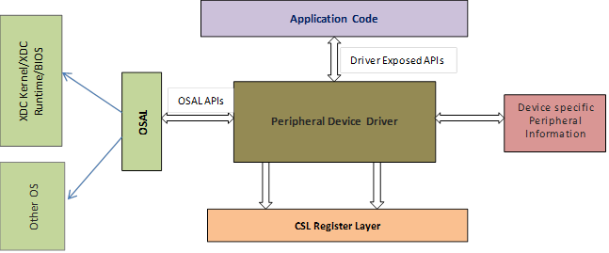

The figure illustrates the following key components:-

Peripheral device driver
This is the core UART device driver. The device driver exposes a set of well-defined APIs which are used by the application layer. The driver also exposes a set of well-defined OS abstraction APIs which will ensure that the driver is OS independent and portable. The driver uses the CSL register layer for MMR accesses.

Device specific module layer
This layer implements a well-defined interface which allows the core UART device driver to be ported to any device which has the same UART IP block. This layer may change for every device.

Application Code
This is the user of the driver and its interface through the well-defined APIs set. Application uses the driver APIs to send and receive data via the UART peripheral.

OSAL
The driver is OS independent and exposes all the operating system callouts via this OSAL layer.

CSL Register Layer
The UART driver uses the CSL UART functional layer to program the device IP by accessing the MMR (Memory Mapped Registers).

Modes of Operation
UART driver provides the following modes of operations.

UART_MODE_BLOCKING
In this mode, read and write operation APIs block on semaphore till the required operation is completed.
By default, the UART driver operates in blocking mode.
In blocking mode, code execution of a task is blocked until UART transaction has completed. This ensures that only one UART transaction operates at a given time. Other tasks requesting UART transactions while a transaction is currently taking place, are also placed into a blocked state and are executed in the order in which they were received.

UART_MODE_NON-BLOCKING
In this mode, read and write operation return immediately. When the transfer by the Hwi
is finished the configured callback function is called.

UART with EDMA
In this mode, UART driver is configured to uses the EDMA and it operates only in blocking mode.

Note:UART stdio example calls UART_scanFmt()requiring the UART driver to inspect the data and return from UART_read() call when a newline character is received. The UART DMA driver does not examine input or output data, so using UART DMA with the UART stdio example causes the call to scanFmt(), which calls UART_read(), to hang waiting for input

API flow

UART_config Structure
The UART-soc .c file also declare the UART_config structure. This structure must be provided to the UART driver. It must be initialized before the UART_init() function is called and cannot be changed afterwards. For details about the individual fields of this structure, see the Doxygen help by opening \docs\doxygen\html\index.html
The board’s UART peripheral and pins must be configured before initializing the UART driver. The application initializes the UART driver by calling UART_init() and is then ready to Open a UART by calling UART_open() and passing in a UART parameters data Structure.

UART_Params_init(&params);
params.baudRate = someNewBaudRate;
params.writeDataMode = UART_DATA_BINARY;
params.readDataMode = UART_DATA_BINARY;
params.readReturnMode = UART_RETURN_FULL;
params.readEcho = UART_ECHO_OFF;
handle = UART_open(someUART_configIndexValue, &params);

On successful creation of handle UART driver is ready for data communication. Application can use the either interrupt based data transfer API or polling mode of data transfer API.
Driver provides the UART_read() and UART_write() API for read and write operation in interrupt mode. And UART_readPolling() and UART_writePolling() function for polled mode of operations.

UART operation using EDMA

UART driver supports the EDMA operations to transfer the data between memory and UART Rx and TX FIFO. Driver uses the separate source files for these operations. The file UART_soc_dma.c is the configuration file for DMA based UART operation.

Driver provides the “UART_BasicExample_AM57X_armDMATestproject” and “UART_BasicExample_AM57X_c66DMATestproject” project files for ARM and C66x respectively.

Application should create the EDMA handle and update the UARTDMA_HwAttrs as below.

uartInitCfg[0].edmaHandle

The procedure and read and write operation s are similar to Non-DMA operations.

API flow path of UART driver is as shown in fig.

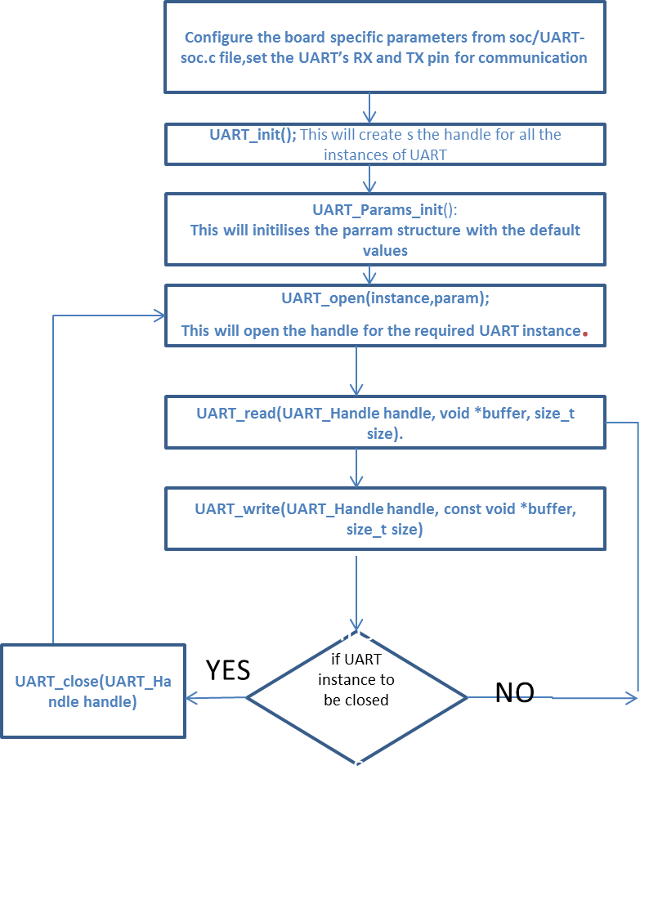

Supported SOCs / EVMs

SOC | Devices
AM571x | AM57X IDK board
AM572x
DRA72x

Benchmarking

Code size for library:
Cycle usage for data path send and receive

