Telogy Software

BIOS MCSDK 2.0

SRIO Benchmarking Example Code User’s Guide

Applies to MCSDK release 02.00.06.18 or greater
Publication Date: November 16, 2011
Version 1.2
Texas Instruments, Incorporated
20450 Century Boulevard
Germantown, MD 20874 USA

Document License

This work is licensed under the Creative Commons Attribution-NoDerivs 3.0 Unported License. To view a copy of this license, visit http://creativecommons.org/licenses/by-nd/3.0/ or send a letter to Creative Commons, 171 Second Street, Suite 300, San Francisco, California, 94105, USA.

Contributors to this document

Copyright (C) 2011 Texas Instruments Incorporated - http://www.ti.com

Contents
1 Overview 1
2 Revision History 1
3 References 1
4 Default test control values 1
5 Test setup diagrams 2
5.1 Single EVM internally looped back 2
5.2 Single EVM externally looped back using a breakout card 2
5.3 Two EVMs connected using breakout cards 2
5.4 Single EVM looped back externally using an external SRIO switch 3
5.5 Two EVMs connected using an external SRIO switch 3
6 How latency measurements are obtained 3
6.1 Type11 latency method: (Round-trip cycles) 4
6.2 NWRITE latency method: (Round-trip cycles) 4
6.3 NREAD latency method: (End to end cycles) 4
7 Latency statistics display explanation 4
7.1 Latency header breakdown 4
8 Throughput statistics display explanation 5
8.1 Throughput header breakdown 5
9 Modifying and compiling the code for the different SRIO connection scenarios 6
9.1 Setting up C-I-C connection mode (core to core, internal loopback) 7
9.2 Setting up C-E-C connection mode (core to core, external loopback) 7
9.3 Setting up C-S-C connection mode (core to core, with a SRIO switch) 7
9.4 Setting up B-E-B connection mode (board to board, external interface) 8
9.5 Setting up B-S-B connection mode (board to board, with a SRIO switch) 8
10 Running the example code 9
10.1 Running the example code for core to core scenarios 9
10.2 Running the example code for board to board scenarios 10
11 Automating runs using the loadti that comes with Code Composer 10
11.1 Copy two enhanced java script files to your CCS loadti directory 11
11.2 Command line usage for loadti in order to run the example code 11
11.3 Workaround for argv/argc in SYS/BIOS 12
12 Sample console output 12
13 Extrapolating other statistics from the displayed output as explained with spreadsheet formulae 15
13.1 Getting the processor loading value from the statistics 15
13.2 Getting the max data rate value from the statistics 15
13.3 Getting the data throughput rate with overhead from the statistics 15
13.4 Getting the bandwidth utilization value from the statistics 15

Overview
The SRIO benchmarking example code is created to allow customers to run benchmarks on their own TI EVMs with code that utilizes the SRIO LLD APIs. The benchmarking example code allows the user to run core to core in loopback mode (internal or external) on a single EVM, or board to board using the external interface between two EVMs. This document’s purpose is to explain how measurements are obtained and how to configure the example code for different test scenarios. SRIO physical connectivity or external SRIO switch configuration is beyond the scope of this document.

Revision History
Revision | Details
1.0 | Initial Version
1.1 | Added test setup diagrams and corrected some wording mistakes.
1.2 | Updated SRIO user’s guide link and directory references for example code.

References
[1] Serial RapidIO (SRIO) for Keystone Devices User's Guide (Literature Number: SPRUGW1A, http://www.ti.com/lit/ug/sprugw1a/sprugw1a.pdf )

Default test control values
The default #defines that control the example code application are located in the benchmarking.h file that is located in the “..\packages\ti\drv\srio\test\tput_benchmarking” directory of the PDK install. The default test control values are located in the section with the heading “Test control default vaules. (User changeable values)”. The benchmarking.h file contains descriptions of the various control values.

Test setup diagrams
These are high level test setup diagrams to illustrate the different test scenarios supported by the example code.

Single EVM internally looped back

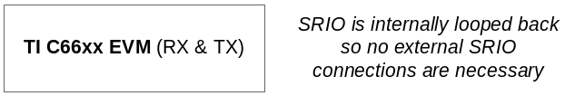

Single EVM externally looped back using a breakout card

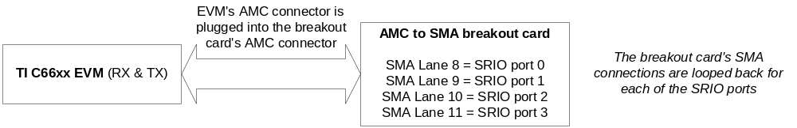

Two EVMs connected using breakout cards

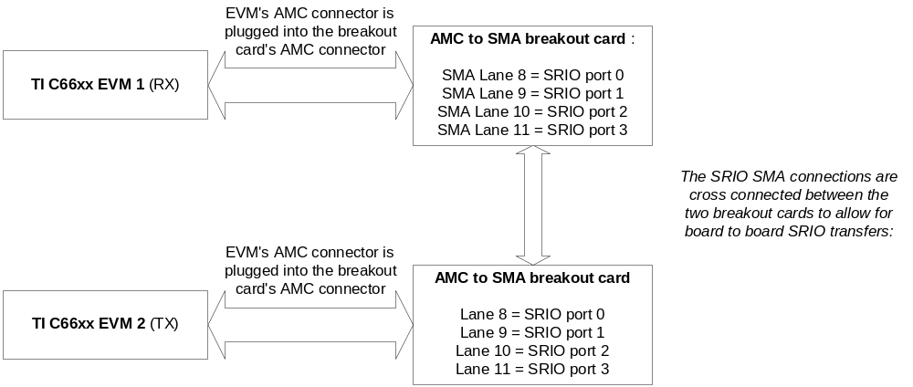

Single EVM looped back externally using an external SRIO switch

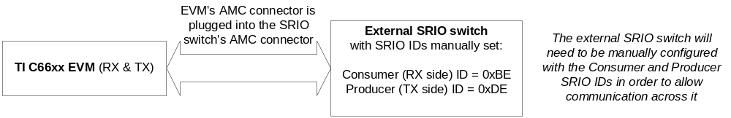

Two EVMs connected using an external SRIO switch

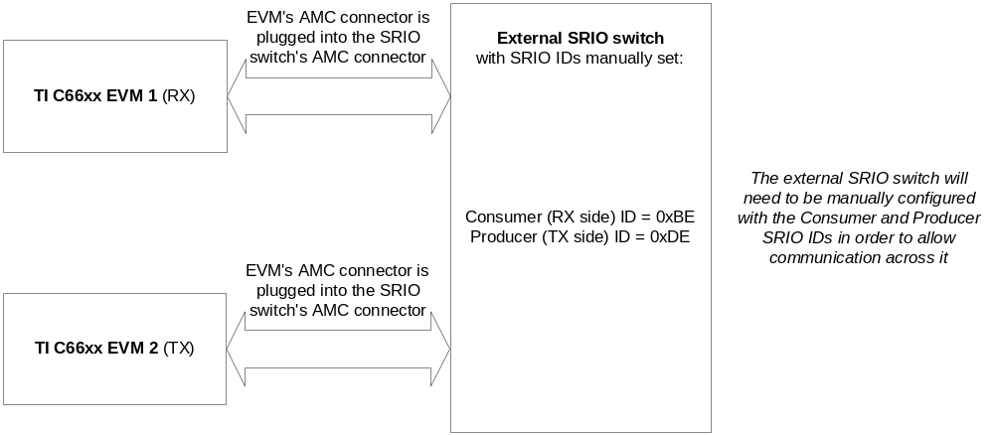

How latency measurements are obtained
For type11 and NWRITE, round-trip cycles are taken and divided by 2. For NREAD the native end-to-end cycles are measured. All measurements are taken from TX side to have the same reference clock used for timestamps. For type11 measurements, the transmit packets are prefabricated and ready to go to eliminate turnaround time. For DIO NWRITE and NREAD, all packet memory bytes are preset before the operation is started. Please note that this example code measures latency from the SRIO LLD API perspective. The example code measures LLD and hardware latency together.

Type11 latency method: (Round-trip cycles)
- Take start timestamp
- Call sRIO LLD’s Srio_sockSend() API (Push to TX queue)
- Call sRIO LLD's Srio_rxCompletionIsr() (Pop RX descriptor if a packet has been received & process the received buffer descriptor)
- Call sRIO LLD's Srio_sockRecv() API (Copy data from the RX buffer)
- Tale end timestamp
- Compute: End to End cycles = (End timestamp - Start timestamp) / 2

NWRITE latency method: (Round-trip cycles)
- Take start timestamp
- Call sRIO LLD's Srio_sockSend() API (Write to LSU registers for memory write over SRIO link)
- Poll memory address of end byte to detect when entire return packet is received.
- Take end timestamp
- Compute: End to End cycles = (End timestamp - Start timestamp) / 2

NREAD latency method: (End to end cycles)
- Take start timestamp
- Call sRIO LLD's Srio_sockSend() API (Write to LSU registers for memory read over SRIO link)
- Poll memory address of end byte to detect when entire packet is received.
- Take end timestamp
- Compute: End to End cycles = End timestamp - Start timestamp

Latency statistics display explanation
The following is a breakdown of the output provided for latency measurements.

Latency header breakdown
- Core (Core that the .out files is being run on)
- Lanes (The number of lanes configured for the port tested also known as port width)
- Speed (The baud rate in gigabits for which each lane is set)
- Conn (The type of SRIO connection used)
  - C-I-C is core to core on the same EVM using internal loopback
  - C-E-C is core to core on the same EVM using external loopback
  - C-S-C is core to core on the same EVM using a external SRIO switch
  - B-E-B is board to board using two separate EVMs using external loopback
  - B-S-B is board to board using two separate EVMs using an External SRIO switch
- MsgType (The type of SRIO operation used)
  - Type-11 is for a SRIO type-11 operation.
  - DIO_NW is for a SRIO directIO NWRITE operation.
  - Type-2_NR is for a SRIO directIO NREAD operation
- PktSize (The size in bytes of the packet being transfered)
- NumPkts (The total number of packets sent/received during the measurement)
- MnLCycs (Minimum end to end cycles measured during latency measurement)
- AgLCycs (Average end to end cycles measured during latency measurement)
- MxLCycs (Maximum end to end cycles measured during latency measurement)

Throughput statistics display explanation
The following is a breakdown of the output provided for throughput measurements.

Throughput header breakdown
- Core (Core that the .out files is being run on)
- Lanes (The number of lanes configured for the port tested also known as port width)
- Speed (The baud rate in gigabits for which each lane is set)
- Conn (The type of SRIO connection used)
  - C-I-C is core to core on the same EVM using internal loopback
  - C-E-C is core to core on the same EVM using external loopback
  - C-S-C is core to core on the same EVM using an external SRIO switch
  - B-E-B is board to board using two separate EVMs using external loopback
  - B-S-B is board to board using two separate EVMs using an external SRIO switch
- MsgType (The type of SRIO operation used)
  - Type-11 is for a SRIO type-11 operation.
  - DIO_NW is for a SRIO directIO NWRITE operation.
  - Type-2_NR is for a SRIO directIO NREAD operation
- OHBytes (The overhead in bytes for the operation)
- PktSize (The size in bytes of the packet being transfered)
- Pacing (The delay cycles added to keep the RX side from getting overruns)
- Thruput (The raw no overhead added throughput in megabits for the packet size)
- PktsSec. (The average number of packets per second measured)
- NumPkts (The total number of packets sent or received during the measurement)
- PktLoss (Always “No” since the test is designed to measure without packet loss.)
- AgPCycs (The average total number of cycles each packet took to transmit or receive)
- AgLCycs (Average cycles the LLD took to complete)
- AgICycs (Average number of idle cycles per packet transaction)
- AgOCycs (Average number of cycles that were not LLD or idle cycles)
- Seconds (The duration in seconds for measuring the packets throughput)

Modifying and compiling the code for the different SRIO connection scenarios
The benchmarking example code allows the user to run core to core on the same EVM or to run board to board using two separate EVMs. There are settings which allow the output to indicate which mode the test is being run in as well. The default settings are contained in the benchmarking.h file. The current defaults are for core to core on the same EVM using internal loopback, the lanes are set for 5.0Gbaud and the port is configured for 4X (all four lanes are used for the port). Each connection mode shown below can be set for different lane rates and port widths.

Setting up C-I-C connection mode (core to core, internal loopback)
- This mode is for core to core transfers on the same EVM using internal loopback. In this mode only one version of the .out file is needed. The .out file will be run on core 0 (the consumer) and core 1 (the producer).
- No modifications to the original version of the benchmarking.h file are needed to use this mode.
- The .out file should be loaded on core 0 and core 1 and run simultaneously to start benchmark measurements.

Setting up C-E-C connection mode (core to core, external loopback)
- This mode is for core to core transfers on the same EVM using external loopback. In this mode only one version of the .out file is needed. The .out file will be run on core 0 (the consumer) and core 1 (the producer). It is assumed that the board is properly looped back over the external interface via a SMA break-out board.
- Modify the benchmarking.h file in the following way:
  - Change the USE_LOOPBACK_MODE define from “TRUE” to “FALSE”
- Recompile the project.
- The .out file should be loaded on core 0 and core 1 and run simultaneously to start benchmark measurements.

Setting up C-S-C connection mode (core to core, with a SRIO switch)
- This mode is for core to core transfers on the same EVM looping back through an external SRIO switch. In this mode only one version of the .out file is needed. The .out file will be run on core 0 (the consumer) and core 1 (the producer). It is assumed that the board is properly connected to the external SRIO switch and that the external SRIO switch is properly configured with the SRIO IDs, port width and lane rate. The consumer side uses 0xBE for the SRIO ID and the producer side uses 0xDE for the SRIO ID.
- Modify the benchmarking.h file in the following way:
  - Change the “IS_OVER_EXTERNAL_SRIO_SWITCH” define from “FALSE to “TRUE”, this will automatically set loopback mode to off and have the output show that the test was run using an external SRIO switch.
- Recompile the project.
- The .out file should be loaded on core 0 and core 1 and run simultaneously to start benchmark measurements.

Setting up B-E-B connection mode (board to board, external interface)
- This mode is for board to board transfers using two separate EVMs. In this mode two different versions of the .out file are needed. The consumer .out file will be run on core 0 of the first EVM and the producer .out file will be run on core 1 of the second EVM. It is assumed that the boards are properly connected over their external interfaces via SMA break-out boards.
- Modify the benchmarking.h file in the following way for the consumer .out file:
  - Change the “IS_BOARD_TO_BOARD” define from “FALSE to “TRUE”, this will automatically set loopback mode to off and have the output show that the test was run board to board.
  - Recompile the project.
  - Save the compiled consumer .out file to a separate directory.
- Modify the benchmarking.h file in the following way for the producer .out file:
  - Change the “IS_BOARD_TO_BOARD” define from “FALSE to “TRUE”, this will automatically set loopback mode to off and have the output show that the test was run board to board.
  - Change the “CORE_TO_INITIALIZE_SRIO” define from “CONSUMER_CORE” to “PRODUCER_CORE”. This will allow the srio initialization routine to be executed for the producer EVM.
  - Recompile the project.
- Load and run the consumer .out file from the saved directory on core 0 of the first EVM. This will be the receive side for the SRIO transfer. The consumer .out file must be loaded and run before the producer .out file is run.
- Load and run the producer .out file on core 1 on the second EVM. This will be the transmit side for the SRIO transfer. This should start the transfer.

Setting up B-S-B connection mode (board to board, with a SRIO switch)
- This mode is for board to board transfers using two separate EVMs over an external SRIO Switch. In this mode two different versions of the .out file are needed. The consumer .out file will be run on core 0 of the first EVM and the producer .out file will be run on core 1 of the second EVM. It is assumed that the boards are properly connected to the external SRIO switch and that the external SRIO switch is properly configured with the SRIO IDs, port width and lane rate. The consumer side uses 0xBE for the SRIO ID and the producer side uses 0xDE for the SRIO ID.
- Modify the benchmarking.h file in the following way for the consumer .out file:
  - Change the “IS_BOARD_TO_BOARD” define from “FALSE to “TRUE”, this will automatically set loopback mode to off and have the output show that the test was run board to board.
  - Change the “IS_OVER_EXTERNAL_SRIO_SWITCH” define from “FALSE to “TRUE”, for this scenario this define is used purely to have the output show that the test was run using an external SRIO switch.
  - Recompile the project.
  - Save the compiled consumer .out file to a separate directory.
- Modify the benchmarking.h file in the following way for the producer .out file:
  - Change the “IS_BOARD_TO_BOARD” define from “FALSE to “TRUE”, this will automatically set loopback mode to off and have the output show that the test was run board to board.
  - Change the “IS_OVER_ EXTERNAL_SRIO_SWITCH” define from “FALSE to “TRUE”, for this scenario this define is used purely used to have the output show that the test was run using an external SRIO switch.
  - Change the “CORE_TO_INITIALIZE_SRIO” define from “CONSUMER_CORE” to “PRODUCER_CORE”. This will allow the srio initialization routine to be executed for the producer EVM.
  - Recompile the project
- Load and run the consumer .out file from the saved directory on core 0 of the first EVM. This will be the receive side for the SRIO transfer. The consumer .out file must be loaded and run before the producer .out file is run.
- On the second EVM connect cores 0 and core 1. Load and run the producer .out file only on core 1 on the second EVM. This will be the transmit side for the SRIO transfer. This should start the transfer. Note: Core 0 is connected in this scenario to have the global default setup function of the GEL file run, since it only runs for core 0.

Running the example code
This section explains how to load and run the example code.

Running the example code for core to core scenarios
This test mode requires a single EVM.
- Power cycle the EVM to start fresh before running the throughput and latency measurements.
- Bring up CCS and connect to the platform.
- On the single EVM load the compiled .out file on both cores 0 and 1. Please see section 7 for creating the proper .out file.
- Select both cores 0 and 1 and run them simultaneously.
- Progress messages should start displaying. It will take approximately 60 minutes for all tests to complete.

Running the example code for board to board scenarios
This test mode requires two EVMS. Two breakout boards or an external SRIO switch can be used for SRIO link connectivity. It is assumed that the physical connections on the breakout boards are correctly made. It is assumed if an external SRIO switch is used that it is correctly configured with SRIO IDs, port width, and lane rate. Please see section 7 for the SRIO IDs used.
- Power cycle EVMs to start fresh before running the throughput and latency measurements.
- Bring up CCS and connect to the receive side platform (consumer).
- Bring up another CCS instance and connect to the transmit side platform (producer).
- On the receive side platform load the consumer .out file on core 0. Please see section 7 for creating the consumer .out file.
- On the producer side platform connect both core 0 and core 1, but only load the producer .out file on core 1. Note: Core 0 is connected in this scenario to have the global default setup function of the GEL file run, since it only runs for core 0. Please see section 7 for creating the producer .out file.
- On the receiver side platform run the consumer .out file on core 0. The consumer needs to be running before starting the producer.
- On the producer side platform run the producer .out file on core 1. The consumer needs to be running before starting the producer.
- Progress messages should start displaying. It will take approximately 60 minutes for all tests to complete.

Automating runs using the loadti that comes with Code Composer
This section will show how to automate running the application using the “loadti” example for the DSS server that comes with Code Composer Studio. Loadti is located under the “ccsv5\ccs_base_x.x.x.xxxxx\scripting\examples\loadti” directory for CCS version 5 and located under the “ccsv4\scripting\examples\loadti” directory for CCS version 4.

Copy two enhanced java script files to your CCS loadti directory
- Copy the java script files located in the “..packages\ti\drv\srio\test\tput_benchmarking\enhanced_loadti_files” directory of your PDK install to the loadti directory of your CCS install. Please see above for location of loadti under the CCS install directory.
- Please see the Readme.txt file in the “enhanced_loadti_files” directory for more information.

Command line usage for loadti in order to run the example code
- Call “C:\Program Files\Texas Instruments\ccsv5\ccs_base_5.0.3.00028\scripting\examples\loadti\loadti" -gtl "C:/workspace/evmc6678l.gel" -gftr "Global_Default_Setup()" -ar -t 3900000 -ctr 2 -c "c:\workspace\C6678_v5_28_mezzanine_no_gel.ccxml" "C:\Program Files\Texas Instruments\pdk_C6678_1_0_0_18\packages\ti\drv\MyexampleProjects\SRIO_TputBenchmarkingTestProject\Debug\SRIO_TputBenchmarkingTestProject.out" 1X 1.250GBaud 60seconds >> throughput.txt"
  - Note: Always power cycle EVM before each run to start fresh.
  - Call is used since Loadti is a batch file. Call is necessary for the batch file to continue on to the next line in the batch file.
  - “C:\Program Files\Texas Instruments\ccsv5\ccs_base_5.0.3.00028\scripting\examples\loadti\loadti" is the command to start loadti.
  - -gtl "C:/workspace/evmc6678l.gel" is the loadti option to load the GEL file. This option is not needed if the .ccxml file was created to automatically load the GEL file.
  - -gftr "Global_Default_Setup()" is the loadti option to load the default setup from the GEL file.
  - –ar is the loadti option to do a system reset on the EVM.
  - -t 3900000 is the loadti option specifying a timeout, in this case after 65 minutes. This is used to give the application enough time to allow all the tests for this run to complete.
  - -ctr 2 is the loadti option specifying the number of core the .out file will be loaded on, in this case two cores.
  - -c "c:\workspace\C6678_v5_28_mezzanine_no_gel.ccxml" is the loadti option specifying the .ccxml file for the EVM being used. The .ccxml file should be created so that the GEL file (e.g. evmc6678l.gel or evmc6670l.gel) is automatically loaded. This can be done by clicking on the “Advanced” tab just after creating the .ccxml file.
  - "C:\Program Files\Texas Instruments\pdk_C6678_1_0_0_18\packages\ti\drv\MyexampleProjects\SRIO_TputBenchmarkingTestProject\Debug\SRIO_TputBenchmarkingTestProject.out" is the loadti option specifying the .out file that you want to load and run.
  - 1X 1.250Gbaud 60seconds are the arguments that loadti will pass to the .out file. The options must be in the order shown. 1X is for a one lane port width (range: 1X, 2X or 4X). 1.250Gbaud is the rate at which the lanes will be set (range: 1.250Gbaud, 2.50Gbaud, 3.125Gbaud or 5.0Gbaud). 60seconds if for the amount of time in seconds to test each packet size.
  - >> throughput.txt is a command line option used to append the console output to a file. Please note that when piping the output to a file you will not see the display. You can periodically do “type througput.txt” to see what has happened so far. You can use WordPad to view the througput.txt file. WordPad can also be used to resave the file so that it is readable with Notepad as well.
  - More information on loadti can be found at the following URL: http://processors.wiki.ti.com/index.php/Loadti

Workaround for argv/argc in SYS/BIOS
- The error message: “SEVERE: ___c_args__ not defined. Use "--args=n" when linking target executable to allocate n bytes for arguments.” when running the command line shown above is an indication that SYS/BIOS is not supporting argument passing. The workaround for this is to download SYS/BIOS package version 6.32.01.38 and recompile the project with this version of SYS/BIOS selected. This is only recommended as a temporary solution to get your automation started.

Sample console output
The console output shown below is from an actual example code run. The sections highlighted in blue below are tab delimited output that can be copied from the CCS console window to a spreadsheet. The column headers were set to bold to easily locate them.

Setting core 0 test parameters to:
One 4X port
5.0Gbaud lane rate
30 seconds test time per packet size

Setting core 1 test parameters to:
One 4X port
5.0Gbaud lane rate
30 seconds test time per packet size

********************************
*********** PRODUCER ***********
********************************
WARNING: Please ensure that the CONSUMER is executing before running the PRODUCER!!
Debug(Core 1): Waiting for SRIO to be initialized.
********************************
*********** CONSUMER ***********
********************************
WARNING: Please ensure that the CONSUMER is executing before running the PRODUCER!!
Debug: Waiting for module reset...
Debug: Waiting for module local reset...
Debug: Waiting for SRIO ports to be operational...
Debug: SRIO port 0 is operational.
Debug: Lanes status shows lanes formed as one 4x port
Debug: AppConfig Tx Queue: 0x2a0 Flow Id: 0
Debug: SRIO Driver Instance 0x@008608c0 has been created
Debug: Running test in polled mode.
Debug: SRIO Driver handle 0x8608c0.

Debug: AppConfig Tx Queue: 0x2a1 Flow Id: 1
Debug: SRIO Driver Instance 0x@008607d0 has been created
Debug: Running test in polled mode.
Debug: SRIO Driver handle 0x8607d0.

Latency: (DIO_NW, 5.000GBaud, 4X, tab delimited)
Core Lanes Speed Conn MsgType PktSize NumPkts MnLCycs AgLCycs MxLCycs
1 4 5.000 C-I-C DIO_NW 4 100 695 695 736
1 4 5.000 C-I-C DIO_NW 8 100 695 695 706
1 4 5.000 C-I-C DIO_NW 16 100 695 697 711
1 4 5.000 C-I-C DIO_NW 32 100 737 740 755
1 4 5.000 C-I-C DIO_NW 64 100 785 799 811
1 4 5.000 C-I-C DIO_NW 128 100 920 922 935
1 4 5.000 C-I-C DIO_NW 256 100 1158 1161 1175
1 4 5.000 C-I-C DIO_NW 512 100 1325 1325 1339
1 4 5.000 C-I-C DIO_NW 1024 100 1623 1625 1640
1 4 5.000 C-I-C DIO_NW 2048 100 2225 2235 2240
1 4 5.000 C-I-C DIO_NW 4096 100 3454 3455 3456
1 4 5.000 C-I-C DIO_NW 8192 100 5885 5885 5899

Throughput: (RX side, DIO_NW, 5.000GBaud, 4X, tab delimited)
Core Lanes Speed Conn MsgType OHBytes PktSize Pacing Thruput PktsSec. NumPkts PktLoss AgPCycs AgLCycs AgICycs AgOCycs Seconds
0 4 5.000 C-I-C DIO_NW 16 4 0 78.43 2450980.50 73600000 No 408 42 337 29 30.03
0 4 5.000 C-I-C DIO_NW 16 8 0 156.86 2450980.50 73600000 No 408 42 336 30 30.03
0 4 5.000 C-I-C DIO_NW 16 16 0 313.73 2450980.50 73600000 No 408 42 336 30 30.03
0 4 5.000 C-I-C DIO_NW 16 32 0 627.45 2450980.50 73600000 No 408 42 336 30 30.03
0 4 5.000 C-I-C DIO_NW 16 64 0 1254.90 2450980.50 73600000 No 408 42 336 30 30.03
0 4 5.000 C-I-C DIO_NW 16 128 0 2509.80 2450980.50 73600000 No 408 42 336 30 30.03
0 4 5.000 C-I-C DIO_NW 16 256 0 5019.61 2450980.50 73600000 No 408 42 337 29 30.03
0 4 5.000 C-I-C DIO_NW 16 512 0 10039.22 2450980.50 73600000 No 408 42 337 29 30.03
0 4 5.000 C-I-C DIO_NW 16 1024 0 12941.55 1579778.88 47400000 No 633 42 561 30 30.00
0 4 5.000 C-I-C DIO_NW 16 2048 0 13159.84 803212.88 24200000 No 1245 42 1173 30 30.13
0 4 5.000 C-I-C DIO_NW 16 4096 0 13271.77 405022.28 12200000 No 2469 42 2397 30 30.12
0 4 5.000 C-I-C DIO_NW 16 8192 0 13282.53 202675.31 6200000 No 4934 42 4863 29 30.60

Throughput: (TX side, DIO_NW, 5.000GBaud, 4X, tab delimited)
Core Lanes Speed Conn MsgType OHBytes PktSize Pacing Thruput PktsSec. NumPkts PktLoss AgPCycs AgLCycs AgICycs AgOCycs Seconds
1 4 5.000 C-I-C DIO_NW 16 4 0 78.43 2450980.50 73600000 No 408 326 25 57 30.03
1 4 5.000 C-I-C DIO_NW 16 8 0 156.86 2450980.50 73600000 No 408 326 25 57 30.03
1 4 5.000 C-I-C DIO_NW 16 16 0 313.73 2450980.50 73600000 No 408 326 25 57 30.03
1 4 5.000 C-I-C DIO_NW 16 32 0 627.45 2450980.50 73600000 No 408 326 25 57 30.03
1 4 5.000 C-I-C DIO_NW 16 64 0 1254.90 2450980.50 73600000 No 408 326 25 57 30.03
1 4 5.000 C-I-C DIO_NW 16 128 0 2509.80 2450980.50 73600000 No 408 326 25 57 30.03
1 4 5.000 C-I-C DIO_NW 16 256 0 5019.61 2450980.50 73600000 No 408 326 25 57 30.03
1 4 5.000 C-I-C DIO_NW 16 512 0 10039.22 2450980.50 73600000 No 408 326 25 57 30.03
1 4 5.000 C-I-C DIO_NW 16 1024 171 12941.55 1579778.88 47400000 No 633 326 248 59 30.00
1 4 5.000 C-I-C DIO_NW 16 2048 784 13159.84 803212.88 24200000 No 1245 326 861 58 30.13
1 4 5.000 C-I-C DIO_NW 16 4096 2009 13271.77 405022.28 12200000 No 2469 326 2085 58 30.12
1 4 5.000 C-I-C DIO_NW 16 8192 4475 13279.84 202634.25 6200000 No 4935 326 4551 58 30.60

Latency: (DIO_NR, 5.000GBaud, 4X, tab delimited)
Core Lanes Speed Conn MsgType PktSize NumPkts MnLCycs AgLCycs MxLCycs
1 4 5.000 C-I-C DIO_NR 4 100 924 953 995
1 4 5.000 C-I-C DIO_NR 8 100 924 953 995
1 4 5.000 C-I-C DIO_NR 16 100 924 956 995
1 4 5.000 C-I-C DIO_NR 32 100 924 990 1017
1 4 5.000 C-I-C DIO_NR 64 100 924 1049 1070
1 4 5.000 C-I-C DIO_NR 128 100 924 1200 1227
1 4 5.000 C-I-C DIO_NR 256 100 924 1420 1428
1 4 5.000 C-I-C DIO_NR 512 100 924 1577 1632
1 4 5.000 C-I-C DIO_NR 1024 100 924 1902 1920
1 4 5.000 C-I-C DIO_NR 2048 100 924 2477 2545
1 4 5.000 C-I-C DIO_NR 4096 100 924 3750 3774
1 4 5.000 C-I-C DIO_NR 8192 100 924 6595 6597

Throughput: (TX side, DIO_NR, 5.000GBaud, 4X, tab delimited)
Core Lanes Speed Conn MsgType OHBytes PktSize Pacing Thruput PktsSec. NumPkts PktLoss AgPCycs AgLCycs AgICycs AgOCycs Seconds
1 4 5.000 C-I-C DIO_NR 28 4 0 46.78 1461988.25 44000000 No 684 339 310 35 30.13
1 4 5.000 C-I-C DIO_NR 28 8 0 93.57 1461988.25 44000000 No 684 339 310 35 30.13
1 4 5.000 C-I-C DIO_NR 28 16 0 184.97 1445086.75 43400000 No 692 331 325 36 30.05
1 4 5.000 C-I-C DIO_NR 28 32 0 351.65 1373626.38 41200000 No 728 336 356 36 30.02
1 4 5.000 C-I-C DIO_NR 28 64 0 647.28 1264222.50 38000000 No 791 338 416 37 30.07
1 4 5.000 C-I-C DIO_NR 28 128 0 1122.81 1096491.25 33000000 No 912 338 538 36 30.12
1 4 5.000 C-I-C DIO_NR 28 256 0 1756.43 857632.94 25800000 No 1166 342 788 36 30.09
1 4 5.000 C-I-C DIO_NR 28 512 0 3119.57 761614.63 23000000 No 1313 339 939 35 30.22
1 4 5.000 C-I-C DIO_NR 28 1024 0 5063.04 618047.00 18600000 No 1618 340 1242 36 30.10
1 4 5.000 C-I-C DIO_NR 28 2048 0 7360.29 449236.31 13600000 No 2226 338 1852 36 30.28
1 4 5.000 C-I-C DIO_NR 28 4096 0 9359.61 285632.69 8600000 No 3501 337 3128 36 30.11
1 4 5.000 C-I-C DIO_NR 28 8192 0 10379.47 158378.20 4800000 No 6314 341 5937 36 30.31

Latency: (Type-11, 5.000GBaud, 4X, tab delimited)
Core Lanes Speed Conn MsgType PktSize NumPkts MnLCycs AgLCycs MxLCycs
1 4 5.000 C-I-C Type-11 16 100 1482 1552 1620
1 4 5.000 C-I-C Type-11 32 100 1542 1564 1585
1 4 5.000 C-I-C Type-11 64 100 1621 1648 1672
1 4 5.000 C-I-C Type-11 128 100 1806 1819 1872
1 4 5.000 C-I-C Type-11 256 100 2109 2153 2161
1 4 5.000 C-I-C Type-11 512 100 2170 2232 2277
1 4 5.000 C-I-C Type-11 1024 100 2422 2498 2589
1 4 5.000 C-I-C Type-11 2048 100 3114 3188 3223
1 4 5.000 C-I-C Type-11 4096 100 4534 4587 4675

Throughput: (RX side, Type-11, 5.000GBaud, 4X, tab delimited)
Core Lanes Speed Conn MsgType OHBytes PktSize Pacing Thruput PktsSec. NumPkts PktLoss AgPCycs AgLCycs AgICycs AgOCycs Seconds
0 4 5.000 C-I-C Type-11 24 16 0 164.10 1282051.25 38600000 No 780 628 0 152 30.11
0 4 5.000 C-I-C Type-11 24 32 0 326.53 1275510.25 38600000 No 784 633 0 151 30.28
0 4 5.000 C-I-C Type-11 24 64 0 652.23 1273885.38 38400000 No 785 634 0 151 30.15
0 4 5.000 C-I-C Type-11 24 128 0 1304.46 1273885.38 38400000 No 785 634 0 151 30.15
0 4 5.000 C-I-C Type-11 24 256 0 2635.78 1287001.25 38600000 No 777 626 0 151 29.99
0 4 5.000 C-I-C Type-11 24 512 0 5211.20 1272264.63 38200000 No 786 635 0 151 30.05
0 4 5.000 C-I-C Type-11 24 1024 0 10422.39 1272264.63 38000000 No 786 635 0 151 29.90
0 4 5.000 C-I-C Type-11 24 2048 0 11636.36 710227.25 21400000 No 1408 632 624 152 30.13
0 4 5.000 C-I-C Type-11 24 4096 0 11640.50 355239.78 10800000 No 2815 631 2033 151 30.41

Throughput: (TX side, Type-11, 5.000GBaud, 4X, tab delimited)
Core Lanes Speed Conn MsgType OHBytes PktSize Pacing Thruput PktsSec. NumPkts PktLoss AgPCycs AgLCycs AgICycs AgOCycs Seconds
1 4 5.000 C-I-C Type-11 24 16 244 164.10 1282051.25 38600000 No 780 108 607 65 30.11
1 4 5.000 C-I-C Type-11 24 32 244 326.53 1275510.25 38600000 No 784 108 612 64 30.28
1 4 5.000 C-I-C Type-11 24 64 246 652.23 1273885.38 38400000 No 785 108 612 65 30.15
1 4 5.000 C-I-C Type-11 24 128 244 1304.46 1273885.38 38400000 No 785 108 613 64 30.15
1 4 5.000 C-I-C Type-11 24 256 234 2635.78 1287001.25 38600000 No 777 108 604 65 29.99
1 4 5.000 C-I-C Type-11 24 512 246 5211.20 1272264.63 38200000 No 786 108 614 64 30.05
1 4 5.000 C-I-C Type-11 24 1024 244 10422.39 1272264.63 38000000 No 786 108 613 65 29.90
1 4 5.000 C-I-C Type-11 24 2048 0 11644.63 710732.06 21400000 No 1407 108 1242 57 30.13
1 4 5.000 C-I-C Type-11 24 4096 0 11640.50 355239.78 10800000 No 2815 108 2650 57 30.41

Extrapolating other statistics from the displayed output as explained with spreadsheet formulae
This section show spreadsheet formulas to get processor loading, max data rate for the links lanes and lane speed combination, throughput data rate with overhead included, and bandwidth utilization from the statistics output by this example code. The formulas would be used for each packet size measured. Items shown below in bold denote that this is a column of the statistics shown in bold blue above. The value within the brackets [] can be copied to the spreadsheet.

Getting the processor loading value from the statistics
- Spreadsheet formula for getting the processor loading percentage: [ = 1 - $O5/$M5 ]
- Cell $O5 is the average idle cycles (AgICycs). Cell $M5 is the average packet cycles (AgPCycs).

Getting the max data rate value from the statistics
- Spreadsheet formula for getting the max data rate in Mbps: [ =$B5 * $C5 * 0.8 * 1000 ]
- Cell $B5 is the number of lanes (Lanes). Cell $C5 is the lane speed in Mbps (Speed). The .8 value in the equation accounts for the 20% overhead taken by the SRIO 8b/10b hardware encoding/decoding method. The 1000 value is to represent result in Mbps.

Getting the data throughput rate with overhead from the statistics
- Spreadsheet formula for getting throughput rate in Mbps with packet overhead included: [ =(((FLOOR((($G5-1)/256)+1,1) * $F5 * 8) + ($G5 * 8)) * $J5) / 1000000 ]
- Cell $G5 is the packet size (PktSize). Cell $F5 is packet overhead in bytes (OHBytes). Cell $J5 is the packets per second (PktsSec.). This formula accounts for the fact that the maximum MTU size for SRIO is 256Bytes. This means that the overhead must be applied to every 256Byte segment transmitted. So for a packet with a size of 1024Bytes, the packet will need to be transmitted in four 256Byte segments and each segment will need to have the overhead applied to it.

Getting the bandwidth utilization value from the statistics
- Spreadsheet formula for getting bandwidth utilization percentage: [ = $T5/$S5 ]
- Cell $T5 is the value derived from the calculation (in section 13.3) to get the throughput with overhead. Cell $S5 is the value derived from the calculation (in section 13.2) to get the max data rate.

