ICSS Cut-Through Switch

Applies to Product Release: 01.00.00.17
Publication Date: October 14, 2019
Document License

This work is licensed under the Creative Commons Attribution-NoDerivs 3.0 Unported License. To view a copy of this license, visit http://creativecommons.org/licenses/by-nd/3.0/ or send a letter to Creative Commons, 171 Second Street, Suite 300, San Francisco, California, 94105, USA.

Contributors to this document

Copyright (C) 2011-2019 Texas Instruments Incorporated - http://www.ti.com/



Texas Instruments, Incorporated
20250 Century Boulevard
Germantown, MD 20874 USA

This document is intended for users who are interested in getting more detailed understanding of the firmware design. It discusses ICSS based Switch firmware implementation details along with any features added on top of the basic Switch firmware. It mentions the memory maps, structures and software design flow of the firmware.

Note: Those who just want to use ICSS Switch firmware may not need to go through this document.

TABLE OF CONTENTS

1 Introduction 6
2 Requirements 7
2.1 Cut-Through Switch High Level Requirements 7
2.2 STP Switch High Level Requirements 7
3 Design Description 8
3.1 System Decomposition Diagram 8
4 Firmware Detailed Design 9
4.1 Firmware Architecture Overview 9
4.1.1 Architecture and Design 9
4.1.2 PRU0/1 DMEM and ICSS Shared RAM memory map for Switch firmware 10
4.1.3 Scratchpad usage design 16
4.1.4 PRU Register Usage Design 18
4.1.5 Receive Task design 23
4.1.6 Buffer Descriptors, Queue Descriptors and Receive Context 31
4.1.7 Quality of Service (QoS) 33
4.1.8 Transmit Task design 34
4.1.9 Queue Contention Task Design 39
4.1.10 Statistics Task 43
4.1.11 Storm Prevention 44
4.1.12 Learning Bridge 45
4.2 STP Switch 46
4.2.1 Memory Map 46
4.2.2 Buffer Descriptor 47
4.2.3 R22 47
4.2.4 STP Support 47
4.2.5 Forwarding Data Base 47
5 Revision History 53

LIST OF FIGURES

Figure 1. Switch Overall Design 8
Figure 2. System Decomposition Diagram 8
Figure 3. Switch Firmware high level architecture 9
Figure 4. Micro Scheduler 21
Figure 5: MS schedules tasks in round robin manner 22
Figure 6: RCV FIRT BLOCK 27
Figure 7: RECEIVE NEXT BLOCK 28
Figure 8 : Transmit First Block 36
Figure 9 : Transmit Next Block 37
Figure 10 : Transmit Last Block 38
Figure 11 : Host Queue Contention Scenario 40
Figure 12 : Port queue contention scenario 41

List of Tables
Table 1. High Level Requirements 7
Table 2. PRU0 DMEM Memory Map 10
Table 3. PRU1 DMEM Memory Map 12
Table 4. ICSS Shared RAM Memory Map 13
Table 5. L3 OCMC RAM Memory Map 14
Table 6. Statistics Offsets 15
Table 7. Scratchpad Register Usage 17
Table 8. PRU Register Usage 18
Table 9. Buffer Descriptor Table 31
Table 10. Queue Descriptor Table 31
Table 11. Firmware Sources Description 52

Introduction
ICSS based Cut-Through Switch is a three port learning Ethernet switch. The development goal of Switch was to apply Ethernet to automation applications which require short cut-through latency and low hardware costs.
Typical automation networks are characterized by chains of slaves connected in a serial manner, thus making it necessary to forward frames at each node as soon as possible. If frame is stored and forwarded on every node then it leads to delays in the propagation of frames and thus poor overall network performance.
With Cut-Through Switch, the Ethernet packet or frame is no longer received and then forwarded at every node. Cut-Through latency depends on when the forwarding decision is made for a frame which is being received. In keeping the requirements of various industrial protocols, the decision point at which cut-through decision is taken can be configured.
In industrial protocols there is Real Time Phase (RT) when process data is exchanged and Non-Real Time Phase (NRT) when TCP/IP frames are transmitted. Switch handles the NRT phase of the protocol cycle.

Requirements

Cut-Through Switch High Level Requirements
Top of Form

Requirements | Remarks
Cut-Through | Supported
Store and Forward | Supported
1 ms buffering per port | Supported
Host IRQ | Supported
Ethernet QoS | Supported but with 4 queues instead of 8. So, it is not a standard Ethernet QoS implementation.
802.1 learning switch | Supported
Statistics | Supported
Queue-Contention Handling on each port | Supported
Three-Port Switch | Supported
Storm Prevention | Supported
Table 1. High Level Requirements
Bottom of Form

STP Switch High Level Requirements
Requirements | Remarks
Cut-Through | Supported
Store and Forward | Supported
1 ms buffering per port | Supported
Host IRQ | Supported
Ethernet QoS | Supported but with 4 queues instead of 8. So, it is not a standard Ethernet QoS implementation.
802.1 learning switch | Supported, learning done in the firmware (see design)
Statistics | Supported
Queue-Contention Handling on each port | Supported
Three-Port Switch | Supported
Storm Prevention | Supported
Per-port STP states | Supported
Multicast/VLAN packet filtering | Supported
PTP | Supported
RX Interrupt Pacing | Supported

Design Description
This section discusses the overall flow & interaction.
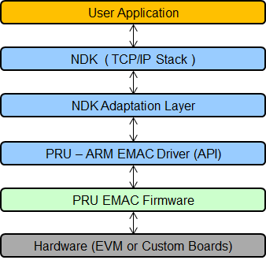
Figure 1. Switch Overall Design

System Decomposition Diagram
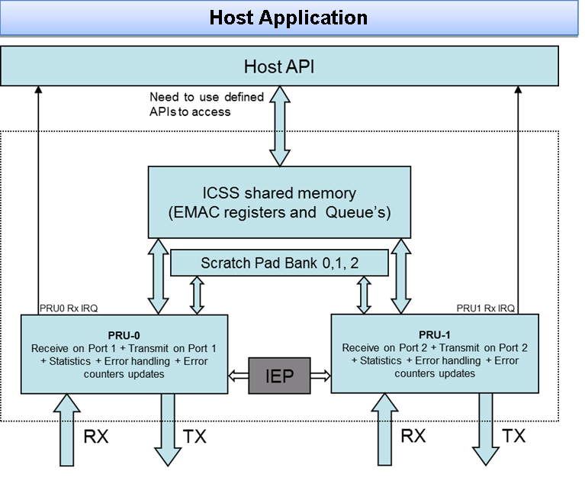
Figure 2. System Decomposition Diagram

Firmware Detailed Design

Firmware Architecture Overview

Architecture and Design

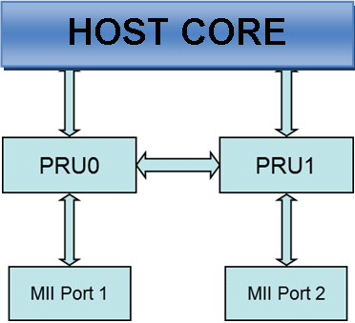
Figure 3. Switch Firmware high level architecture

  - Host Core functions (ARM, DSP)
    - Run NDK Host stack
    - Switch initializations

  - PRU0 functions
    - Receive frames on Port 1
    - Transmit frames on Port 2
    - Statistics for received frames on Port1 and transmit frames on Port 2.
    - Queue contention handling for Host port and Port 2.
    - Cut-Through frames received on Port 1 to Port 2.
    - Store & Forward frames received on Port 1 to Port2.
    - Receive frame in Shadow buffer in case of queue contention on host and Port 2.

  - PRU1 functions are exactly symmetrical to PRU0.

PRU0/1 DMEM and ICSS Shared RAM memory map for Switch firmware

PRU0 DMEM memory map ICSS Shared RAM memory map. Switch doesn’t use PRU0 DMEM memory in general; most of it is free and can be utilized by other tasks. Whatever is used is documented below. Switch Statistics memory layout documented separately.

Definition | Address map | Remarks
Free space | 0x0000-0x00EE | This memory space is free.
ICSS_EMAC_FW_VLAN_FILTER_CTRL_BITMAP_OFFSET | 0x00EF | VLAN Filter Control
ICSS_EMAC_FW_VLAN_FILTER_DROP_CNT_OFFSET | 0x00F0 | VLAN Filter Drop count
ICSS_EMAC_FW_MULTICAST_FILTER_MASK_OFFSET | 0x00F4 | Multicast filter Mask (6 bytes)
ICSS_EMAC_FW_MULTICAST_FILTER_CTRL_OFFSET | 0x00FA | Multicast filter feature control
ICSS_EMAC_FW_MULTICAST_FILTER_OVERRIDE_STATUS | 0x00FB | Multicast filter override for Hash override
ICSS_EMAC_FW_MULTICAST_FILTER_DROP_CNT_OFFSET | 0x00FC | Multicast filter drop count
ICSS_EMAC_FW_MULTICAST_FILTER_TABLE | 0x0100 | Multicast filter table, 256 bytes
ICSS_EMAC_FW_VLAN_FILTER_TABLE_SIZE_BYTES | 0x0200 | Vlan filter table 512 bytes
Protocol Specific | 0x0400-0x1EFF | Available for protocol-specific usage.
Switch Statistics | 0x1F00-0x1F8F | Switch Statistics for PRU1 are stored in this memory space. (See Switch Statistics table below)
STORM_PREVENTION_OFFSET | 0x1F90 | Used to store storm prevention credits and status for Port 0
PHY_SPEED_OFFSET | 0x1F94 | Phy speed status. Indicates to the firmware whether PHY is in 10 or 100 mbps.
PORT_STATUS_OFFSET | 0x1F98 | Contains information about PHY being in half or full duplex.
COLLISION_COUNTER | 0x1F99 | Temporary variable used in Firmware for Half duplex implementation
RX_PKT_SIZE_OFFSET | 0x1F9A | Receive packet size
PORT_CONTROL_ADDR | 0x1F9E | Port enable bit (0 = port disabled, 1 = port enabled)
PORT_MAC_ADDR | 0x1FA2 | MAC address for current port
RX_INT_STATUS_OFFSET | 0x1FA8 | Receive interrupt status bit
STP_INVALID_STATE_OFFSET | 0x1FAC | STP state error counter
Reserved | 0x1FB0-0x1FFF | Reserved for future use.
Table 2. PRU0 DMEM Memory Map

PRU1 DMEM memory map

Definition | Address map | Remarks
Free space. | 0x0000 – 0x00EE | This memory space is free.
ICSS_EMAC_FW_VLAN_FILTER_CTRL_BITMAP_OFFSET | 0x00EF | VLAN Filter Control
ICSS_EMAC_FW_VLAN_FILTER_DROP_CNT_OFFSET | 0x00F0 | VLAN Filter Drop count
ICSS_EMAC_FW_MULTICAST_FILTER_MASK_OFFSET | 0x00F4 | Multicast filter Mask (6 bytes)
ICSS_EMAC_FW_MULTICAST_FILTER_CTRL_OFFSET | 0x00FA | Multicast filter feature control
ICSS_EMAC_FW_MULTICAST_FILTER_OVERRIDE_STATUS | 0x00FB | Multicast filter override for Hash override
ICSS_EMAC_FW_MULTICAST_FILTER_DROP_CNT_OFFSET | 0x00FC | Multicast filter drop count
ICSS_EMAC_FW_MULTICAST_FILTER_TABLE | 0x0100 | Multicast filter table, 256 bytes
ICSS_EMAC_FW_VLAN_FILTER_TABLE_SIZE_BYTES | 0x0200 | Vlan filter table 512 bytes
Protocol Specific | 0x0400-0x1CFF | Available for protocol-specific usage.
P1_Q1_TX_CONTEXT_OFFSET | 0x1D00 | Context for the priority 0 transmit queue on Port 1.
P1_Q2_TX_CONTEXT_OFFSET | 0x1D08 | Context for the priority 1 transmit queue on Port 1.
P1_Q3_TX_CONTEXT_OFFSET | 0x1D10 | Context for the priority 2 transmit queue on Port 1.
P1_Q4_TX_CONTEXT_OFFSET | 0x1D18 | Context for the priority 3 transmit queue on Port 1.
P2_Q1_TX_CONTEXT_OFFSET | 0x1D20 | Context for the priority 0 transmit queue on Port 2.
P2_Q2_TX_CONTEXT_OFFSET | 0x1D28 | Context for the priority 1 transmit queue on Port 2.
P2_Q3_TX_CONTEXT_OFFSET | 0x1D30 | Context for the priority 2 transmit queue on Port 2.
P2_Q4_TX_CONTEXT_OFFSET | 0x1D38 | Context for the priority 3 transmit queue on Port 2.
COL_TX_CONTEXT_P1_Q1_OFFSET_ADDR | 0x1D40 | Context for the transmit collision queue on Port 1.
COL_TX_CONTEXT_P2_Q1_OFFSET_ADDR | 0x1D48 | Context for the transmit collision queue on Port 2.
P1_Q1_RX_CONTEXT_OFFSET | 0x1D70 | Context for the priority 0 receive queue on Port 1.
P1_Q2_RX_CONTEXT_OFFSET | 0x1D78 | Context for the priority 1 receive queue on Port 1.
P1_Q3_RX_CONTEXT_OFFSET | 0x1D80 | Context for the priority 2 receive queue on Port 1.
P1_Q4_RX_CONTEXT_OFFSET | 0x1D88 | Context for the priority 3 receive queue on Port 1.
P2_Q1_RX_CONTEXT_OFFSET | 0x1D90 | Context for the priority 0 receive queue on Port 2.
P2_Q2_RX_CONTEXT_OFFSET | 0x1D98 | Context for the priority 1 receive queue on Port 2.
P3_Q3_RX_CONTEXT_OFFSET | 0x1DA0 | Context for the priority 2 receive queue on Port 2.
P4_Q4_RX_CONTEXT_OFFSET | 0x1DA8 | Context for the priority 3 receive queue on Port 2.
COL_RX_CONTEXT_P0_OFFSET_ADDR | 0x1DB0 | Context for the receive collision queue on the Host port.
COL_RX_CONTEXT_P1_OFFSET_ADDR | 0x1DBC | Context for the receive collision queue on Port 1.
COL_RX_CONTEXT_P2_OFFSET_ADDR | 0x1DC8 | Context for the receive collision queue on Port 2.
QUEUE_DESCRIPTOR_OFFSET_ADDR | 0x1E00 | Table offset for queue descriptors
QUEUE_OFFSET_ADDR | 0x1E18 | Table offset for queue
QUEUE_SIZE_ADDR | 0x1E30 | Table offset for queue size
P1_MAC_ADDR | 0x1E48 | Offset of Port1 MAC address. Reserved
P2_MAC_ADDR | 0x1E50 | Offset of Port2 MAC address. Reserved
INTERFACE_MAC_ADDR | 0x1E58 | Contains the MAC address of switch.
COLLISION_STATUS_ADDR | 0x1E60 | Offset of queue contention status register
P0_COL_QUEUE_DESC_OFFSET | 0x1E64 | Offset of queue contention descriptor of port 0
P1_COL_QUEUE_DESC_OFFSET | 0x1E6C | Offset of queue contention descriptor of port 1
P2_COL_QUEUE_DESC_OFFSET | 0x1E74 | Offset of queue contention descriptor of port 2
P0_QUEUE_DESC_OFFSET | 0x1E7C | 4 host receive queue descriptors for port 0
P1_QUEUE_DESC_OFFSET | 0x1E9C | 4 queue descriptors for port 1
P2_QUEUE_DESC_OFFSET | 0x1EBC | 4 queue descriptors for port 2
Switch Statistics | 0x1F00-0x1F8F | Switch Statistics for PRU1 are stored in this memory space.
STORM_PREVENTION_OFFSET | 0x1F90 | Used to store storm prevention credits and status for Port 1
PHY_SPEED_OFFSET | 0x1F94 | Phy speed status. Indicates to the firmware whether PHY is in 10 or 100 mbps.
PORT_STATUS_OFFSET | 0x1F98 | Contains information about PHY being in half or full duplex.
COLLISION_COUNTER | 0x1F99 | Temporary variable used in Firmware for Half duplex implementation
RX_PKT_SIZE_OFFSET | 0x1F9A | Receive packet size
PORT_CONTROL_ADDR | 0x1F9E | Port enable bit (0 = port disabled, 1 = port enabled)
PORT_MAC_ADDR | 0x1FA2 | MAC address for current port
RX_INT_STATUS_OFFSET | 0x1FA8 | Receive interrupt status bit
STP_INVALID_STATE_OFFSET | 0x1FAC | STP state error counter
Reserved | 0x1FB0-0x1FFF | Reserved for future use.
Table 3. PRU1 DMEM Memory Map

ICSS Shared RAM memory map

Below are offset addresses of the buffer descriptors for the default configuration of queue sizes in “icss_switch.h” file. Since the queue sizes are configurable, offset addresses will automatically change when the size of one or more queue is changed.

Definition | Offset | Remarks
RESERVED | 0x0000 | Reserved for future usage.
PTP Registers | 0x0008-0x011C | PTP API registers
RESERVED | 0x011D-0x03FF | Reserved for future usage
P0_Q1_BD_OFFSET | 0x0400 | Buffer descriptors for the priority 0 host receive queue.
P0_Q2_BD_OFFSET | 0x0708 | Buffer descriptors for the priority 1 host receive queue.
P0_Q3_BD_OFFSET | 0x0A10 | Buffer descriptors for the priority 2 host receive queue.
P0_Q4_BD_OFFSET | 0x0D18 | Buffer descriptors for the priority 3 host receive queue.
P1_Q1_BD_OFFSET | 0x01020 | Buffer descriptors for the priority 0 transmit queue on Port 1.
P1_Q2_BD_OFFSET | 0x11A4 | Buffer descriptors for the priority 1 transmit queue on Port 1.
P1_Q3_BD_OFFSET | 0x1328 | Buffer descriptors for the priority 2 transmit queue on Port 1.
P1_Q4_BD_OFFSET | 0x14AC | Buffer descriptors for the priority 3 transmit queue on Port 1.
P2_Q1_BD_OFFSET | 0x1630 | Buffer descriptors for the priority 0 transmit queue on Port 2.
P2_Q2_BD_OFFSET | 0x17B4 | Buffer descriptors for the priority 0 transmit queue on Port 2.
P2_Q3_BD_OFFSET | 0x1938 | Buffer descriptors for the priority 0 transmit queue on Port 2.
P2_Q4_BD_OFFSET | 0x1ABC | Buffer descriptors for the priority 0 transmit queue on Port 2.
P0_COL_BD_OFFSET | 0x1C40 | 48 Collision buffer descriptors for port 0 send queue
P1_COL_BD_OFFSET | 0x1D00 | 48 Collision buffer descriptors for port 1 send queue
P2_COL_BD_OFFSET | 0x1DC0 | 48 Collision buffer descriptors for port 2 send queue
RESERVED | 0x1E80-0x1FAD | Reserved for future usage
Interrupt Pacing Registers | 0x1FAE-0x1FBF | Interrupt pacing API registers
RESERVED | 0x1FC0-0x1FFF | Reserved for future usage
ICSS_EMAC_FW_FDB__IDX_TBL_OFFSET | 0x2000 | FDB Index Table
ICSS_EMAC_FW_FDB__MAC_TBL_OFFSET | 0x2400 | FDB MAC Table
ICSS_EMAC_FW_FDB__STP_P1_STP_STATE_OFFSET | 0x2E00 | Port 1 STP state
ICSS_EMAC_FW_FDB__STP_P2_STP_STATE_OFFSET | 0x2E01 | Port 2 STP state
ICSS_EMAC_FW_FDB__FLOOD_ENABLE_FLAGS_OFFSET | 0x2E02 | Flood enable flags per-port (bit0 -> Host, bit1 -> Port 1, bit2 → Port 2
ICSS_EMAC_FW_FDB__ARBITRATION_OFFSET | 0x2E03 | FDB locking mechanism
Reserve for protocols. | 0x2E04 -0x2FFF | This memory space is reserved for protocol specific usage. Do not store generic switch control variables here.
Table 4. ICSS Shared RAM Memory Map

L3 OCMC RAM memory map

Below are offset addresses of the queue data buffers for the default configuration of queue sizes in “icss_switch.h” file. Since the queue sizes are configurable, offset addresses will automatically change when the size of one or more queue is changed.

Definition | Offset | Remarks
P0_Q1_BUFFER_OFFSET | 0x0000 | Offset of data buffers of highest priority host queue in L3 RAM
P0_Q2_BUFFER_OFFSET | 0x1840 | Offset of data buffers of second priority host queue in L3 RAM
P0_Q3_BUFFER_OFFSET | 0x3080 | Offset of data buffers of third priority host queue in L3 RAM
P0_Q4_BUFFER_OFFSET | 0x48C0 | Offset of data buffers of least priority host queue in L3 RAM
P1_Q1_BUFFER_OFFSET | 0x6100 | Offset of data buffers of first priority Port1 queue in L3 RAM
P1_Q2_BUFFER_OFFSET | 0x6D20 | Offset of data buffers of second priority Port1 queue in L3 RAM
P1_Q3_BUFFER_OFFSET | 0x7940 | Offset of data buffers of third priority Port1 queue in L3 RAM
P1_Q4_BUFFER_OFFSET | 0x8560 | Offset of data buffers of fourth priority Port1 queue in L3 RAM
P2_Q1_BUFFER_OFFSET | 0x9180 | Offset of data buffers of first priority Port2 queue in L3 RAM
P2_Q2_BUFFER_OFFSET | 0x9DA0 | Offset of data buffers of first priority Port2 queue in L3 RAM
P2_Q3_BUFFER_OFFSET | 0xA9C0 | Offset of data buffers of first priority Port2 queue in L3 RAM
P2_Q4_BUFFER_OFFSET | 0xB5E0 | Offset of data buffers of first priority Port2 queue in L3 RAM
Reserved Space | 0xC200 to 0xEDFF | Since queue sizes are programmable, this space acts as buffer if there is need to increase the queue sizes.
P0_COL_BUFFER_OFFSET | 0xEE00 | Offset of data buffers of host shadow queue in L3 RAM
P1_COL_BUFFER_OFFSET | 0xF400 | Offset of data buffers of Port1 shadow queue in L3 RAM
P2_COL_BUFFER_OFFSET | 0xFA00 | Offset of data buffers of Port2 shadow queue in L3 RAM
Table 5. L3 OCMC RAM Memory Map

Statistics memory map
This is common to both PRU0 and PRU1, DRAM0 stores statistics for PRU0 and DRAM1 for PRU1.

Definition | Offset | Remarks
TX_BC_FRAMES_OFFSET | 0x1F00 | Number of Transmitted Broadcast Frames
TX_MC_FRAMES_OFFSET | 0x1F04 | Number of Transmitted Multicast Frames
TX_UC_FRAMES_OFFSET | 0x1F08 | Number of Transmitted Unicast Frames
TX_BYTE_CNT_OFFSET | 0x1F0C | Total Number of Bytes transmitted
RX_BC_FRAMES_OFFSET | 0x1F10 | Number of Received Broadcast Frames
RX_MC_FRAMES_OFFSET | 0x1F14 | Number of Received Multicast Frames
RX_UC_FRAMES_OFFSET | 0x1F18 | Number of Received Unicast Frames
RX_BYTE_CNT_OFFSET | 0x1F1C | Total Number of Bytes received
LATE_COLLISION_OFFSET | 0x1F50 | Number of packets which suffered late collision
SINGLE_COLLISION_OFFSET | 0x1F54 | Number of bytes which suffered only one collision
MULTIPLE_COLLISION_OFFSET | 0x1F58 | Number of bytes which suffered more than one collision
EXCESS_COLLISION_OFFSET | 0x1F5C | Number of bytes which suffered more than 15 collisions
TX_OVERFLOW_OFFSET | 0x1F88 | Reserved
RX_MISALIGNMENT_COUNT_OFFSET | 0x1F60 | Packets which had an odd number of nibbles
STORM_PREVENTION_COUNTER | 0x1F64 | Multicast and Broadcast Packets which were discarded by Storm prevention
RX_ERROR_OFFSET | 0x1F68 | Number of packets which triggered Rx MAC errors or number of instances where a MAC error was detected.
SFD_ERROR_OFFSET | 0x1F6C | Number of Packets with incorrect preamble.
TX_DEFERRED_OFFSET | 0x1F70 | Packets which were deferred from transmission at least once.
TX_ERROR_OFFSET | 0x1F74 | Reserved
RX_OVERSIZED_FRAME_OFFSET | 0x1F78 | Number of packets with byte size greater than 1522. (Default value. This is a programmable value in MII RT)
RX_UNDERSIZED_FRAME_OFFSET | 0x1F7C | Number of packets with byte size less than 64 (including CRC). Packets with size less than 18 are counted as Rx Error.
RX_CRC_COUNT_OFFSET | 0x1F80 | Number of Packets with CRC/FCS Error.
RX_DROPPED_FRAMES_OFFSET | 0x1F84 | Number of frames dropped due to link loss/same dst as host.
TX_64_BYTE_FRAME_OFFSET | 0x1F20 | Number of transmitted packets of size 64 bytes
TX_65_127_BYTE_FRAME_OFFSET | 0x1F24 | Number of transmitted packets of size between 65-127 bytes.
TX_128_255_BYTE_FRAME_OFFSET | 0x1F28 | Number of transmitted packets of size between 128-255 bytes.
TX_256_511_BYTE_FRAME_OFFSET | 0x1F2C | Number of transmitted packets of size between 256-511 bytes.
TX_512_1023_BYTE_FRAME_OFFSET | 0x1F30 | Number of transmitted packets of size between 512-1023 bytes.
TX_1024_MAX_BYTE_FRAME_OFFSET | 0x1F34 | Number of transmitted packets of size greater than 1023 bytes.
RX_64_BYTE_FRAME_OFFSET | 0x1F38 | Number of received packets of size 64 bytes
RX_65_127_BYTE_FRAME_OFFSET | 0x1F3C | Number of received packets of size between 65-127 bytes.
RX_128_255_BYTE_FRAME_OFFSET | 0x1F40 | Number of received packets of size between 128-255 bytes.
RX_256_511_BYTE_FRAME_OFFSET | 0x1F44 | Number of received packets of size between 256-511 bytes.
RX_512_1023_BYTE_FRAME_OFFSET | 0x1F48 | Number of received packets of size between 512-1023 bytes.
RX_1024_MAX_BYTE_FRAME_OFFSET | 0x1F4C | Number of received packets of size greater than 1023 bytes.
Table 6. Statistics Offsets

Scratchpad usage design
Three shared scratchpads (10, 11 and 12) with 30 registers each between PRU0 and PRU1 is used for keeping Receive Task and Transmit task contexts. Receive Task has two contexts to save, one for host receive and second one is for port receive.
//Structure for MII TX context scratchpad entry
.struct MII_TX_CONTEXT
.u8 flags
.u16 QUEUE_DESC_OFFSET
.u16 BYTE_CNT
.u16 Packet_Length
.u16 BUFFER_DESC_OFFSET
.u16 BUFFER_INDEX
.u16 BUFFER_OFFSET
.u16 TOP_MOST_BUFFER_INDEX
.u16 BASE_BUFFER_DESC_OFFSET
.u16 TOP_MOST_BUFFER_DESC_OFFSET
.ends
//Structure for MII RX context scratchpad entry
.struct MII_RCV_CONTEXT
.u8 rx_flags
.u8 tx_flags
.u8 rx_flags_extended
.u8 qos_queue
.u16 byte_cntr
.u16 wrkng_wr_ptr
.u16 rd_ptr
.u16 buffer_index
.u16 base_buffer_index
.u16 rcv_queue_pointer
.u16 base_buffer_desc_offset
.u16 top_most_buffer_desc_offset
.ends
//Structure for MII Port RX context scratchpad entry
.struct MII_PORT_RCV_CONTEXT
.u16 byte_cntr
u16 wrkng_wr_ptr
.u16 rd_ptr
.u16 buffer_index
.u16 base_buffer_index
.u16 rcv_queue_pointer
.u16 base_buffer_desc_offset
.u16 top_most_buffer_desc_offset
.ends
Below table shows the allocation of above Tx and RCV contexts on the scratchpad:

PRU Core | BANK0 | BANK1 | BANK2
PRU0 Tx Context |  | REG 13 ….. REG 17
PRU1 Tx Context |  |  | REG 13 ….. REG 17
PRU0 Host RCV Context |  | REG 25 ….. RGE 29
PRU1 Host RCV Context |  |  | REG 25 ….. REG 29
PRU0 Port RCV Context | REG 0 ….. REG 3
PRU1 Port RCV Context | REG 4 ….. REG 7
Table 7. Scratchpad Register Usage

Separate registers are need for host receive and port receive on scratchpad because broadcast and possibly a multicast frame is received on host as well as port queue.

Below are defines used for storing and reading context/data from/to the scratchpad and RX L2 Fifo:
#define BANK0 10
#define BANK1 11
#define BANK2 12
#define RX_L2_BANK0_ID 20
#define RX_L2_BANK1_ID 21

PRU Register Usage Design
Each PRU has 32 registers, from REG 0 to REG 31, out of which REG 30 and REG 31 have special use and cannot be used by firmware for storing data. Below is the register allocation table which shows the registers used by various tasks. Since the firmware is symmetrical on both PRU’s , same allocation is true for both PRU’s.
R22 is used as a persistent register on both PRU’s. Bits 16-21 are used by PTP/1588 implementation (details in 4.1.17) while bits 15 and 23-31 are used by switch. Bits 0 to 14 are free for usage by other protocols.
Classification | MII Context | Descriptor Context | Temp Registers | Permanent Registers
RCV Host Queue | MII_RCV(R25..R29)  RCV_DATA(R2..R9)  Length(R18) | RCV_QUEUE_DESC_REG  (R20-R21) | RCV_TEMP_REG_x  (R20,R21,R13) | None
RCV Forward Queue | MII_RCV_PORT(R25..R29)  RCV_DATA(R2..R9)  Length(R18) | RCV_QUEUE_DESC_REG  (R20-R21) | RCV_TEMP_REG_x  (R20,R21,R13) | None
Shadow Queue | Same as RCV Host Queue | Same as Rx Host Queue  QUEUE_DESCRIPTOR_REG (R10,R11)  COLLISION_QUEUE_DESCRIPTOR_REG  (R12,R13) | COLLISION_STATUS_REG  (R21)  Various Uses  (R6..R9) (R15..R18) | None
Cut-Through | Same as RCV Host Queue | Same as RCV Host Queue | Same as RCV Host Queue | CUT_THROUGH_BYTE_CNT  (R23.w2)  PREVIOUS_R18_RCV_BYTEC  OUNT  (R23.b1)
Tx Task | TX_CONTEXT(R13..R17)  TX Data(R2..R9) | QUEUE_DESC_REG(R2..R3) | TEMP_REG_x (R0,R2,R3)  Others (R10,R11) | TX_DATA_POINTER (R1.b3)  TX Flags (R22.b3)
Micro-Scheduler | None | None | TEMP_REG_2  (R4) | TASK_TABLE_ROW0 (R19)  CURRENT_TASK_POINTER  (R1.b2)
Table 8. PRU Register Usage

R22 Usage
As mentioned above, R22 is a persistent register with configuration and status information that would be expensive to read from memory. The R22 bit allocation is as follows:
Bit | Definition | Description
31 | PACKET_TX_ALLOWED | TX is allowed
30 | Entire_Tx_Data_Not_Pushed | Entire TX data was not pushed
29 | RX_LB_PARTIALLY_PROCESSED | RX last byte partially processed
28 | RX_BC_FRAME | Received broadcast frame
27 | RX_MC_FRAME | Received multicast frame
26 | TX_BC_FRAME | Transmit broadcast frame
25 | TX_MC_FRAME | Transmit multicast frame
24 | RX_FWD_FLAG | Rcv packet marked for forwarding
23 | UNUSED | Free for use with other protocols
22 | UNUSED | Free for use with other protocols
21 | UNUSED | Free for use with other protocols
20 | UNUSED | Free for use with other protocols
19 | UNUSED | Free for use with other protocols
18 | UNUSED | Free for use with other protocols
17 | UNUSED | Free for use with other protocols
16 | UNUSED | Free for use with other protocols
15 | UNUSED | Free for use with other protocols
14 | RX_IS_PTP_BIT | (PTP) Indicate a PTP frame on RX
13 | TX_IS_PTP_BIT | (PTP) Indicate a PTP frame on TX
12 | CHECK_SYNC0_BIT | (PTP) Internal book-keeping to generate 1PPS sync0 pulse
11 | DUT_IS_MASTER_BIT | (PTP) DUT is master (not currently used)
10 | OPPOSITE_PORT_LINK_UP | The other port link is up
9 | TX_CALLBACK_INTERRUPT_BIT | (PTP) TX callback interrupt is pending
8 | PTP_RELEASE_HOST_QUEUE_BIT | (PTP) Rcv flag is cleared in the middle (Host queue)
7 | PTP_RELEASE_PORT_QUEUE_BIT | (PTP) Rcv flag is cleared in the middle (Port queue)
6 | UNUSED | Free for use with other protocols
5 | INTR_TO_HOST_PENDING_RX | RX interrupt to host is pending
4 | HOST_QUEUE_EMPTY_STATUS | Host queue is empty
3 | UNUSED | Free for use with other protocols
2 | UNUSED | Free for use with other protocols
1 | UNUSED | Free for use with other protocols
0 | UNUSED | Free for use with other protocols
Micro Scheduler Task design
Micro Scheduler is central to our Switch Design. It schedules various tasks which collectively implement the functionality of Switch. Simultaneous receive and transmit on both the Ethernet ports at the same time is not possible without Micro–Scheduler. It checks various events and schedules appropriate tasks depending on the outcome of those checks.
Micro-Scheduler schedules the tasks in a round-robin manner. Below, tasks are arranged in the decreasing priority:
- Rx Task
- Tx Task
- STAT Task
- Queue Contention Task

Micro-Scheduler starts with scheduling the Rx Task and then executes the other tasks in the round-robin scheme. It also checks for various events between the execution of two tasks and these events can alter the scheduling. MS checks for below events:
- SOF: Start of a new receive packet at Port
- Rx_EOF: Rx packet has been completely received
- Tx_EOF: Tx packet has been completely transmitted
SOF:
Start of Frame signals a new receive packet at the physical port. MS reads data from the RX L2 Fifo in it’s registers and checks the 6th bit of the R10 register. If this bit is clear then MS schedules the next task. If this bit is set then it checks whether 18 bytes have been already been received or not. If 18 bytes have not been received then next task is executed otherwise RCV_FB is called.
Rx_EOF:
End of Frame event signals that a frame has been completely received. MS checks this event only if there is an ongoing receive at the Port. This event is routed through the R31 register to the two PRU’s. If this events has occurred then MS calls the RCV_LB function otherwise it schedules the execution of the next task.
Note: Bit 20 of R31 corresponds to RX_EOF for MII RX Data to PRU R31 ® and RX FIFO. We can’t use this bit for ICSS revision 1 as on AM335x and AM437x, RX_EOF is auto-clear when a new frame arrives in RX L2 mode.
Tx_EoF:
Transmit End of Frame event signals the completion of the transmission of a frame and Tx Fifo is empty. Once this event has come, PRU can start the transmission of the next packet. This event is realized through the underflow event on the Tx Fifo. When the Tx Fifo becomes empty without seeing the TX_EoF command it generates the underflow event. MS checks this event by reading the system event register of the ICSS INTC.
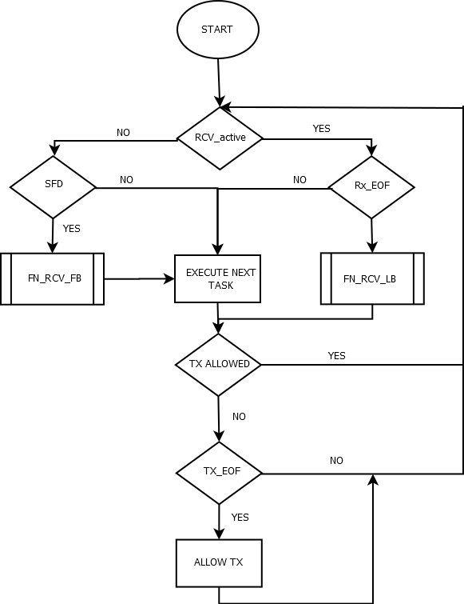
Figure 4. Micro Scheduler

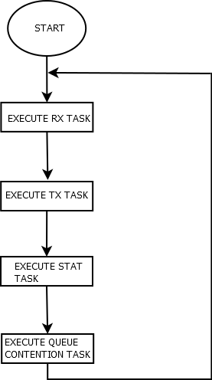

Figure 5: MS schedules tasks in round robin manner

Receive Task design

Quick review of L2 FIFO architecture
The incoming frames are stored in RXL2 FIFO which is composed of 2 banks.
Each bank has 32bytes of data, 16bytes of status and a 5bit write pointer. There is one status entry per two bytes. The write pointer gives the info about data entry being written.
A status can be volatile or static. A volatile status is one which is not yet complete, and hence cannot be parsed.
Note: The frames are packed contiguously. The buffer does not switch on each EOF.

Receive Frame Types
A receive frame can be one of the following types:
- Unicast Frame
- Broadcast Frame
- Multicast Frame
A frame can be classified into one of the above three categories by looking at the destination address (DA) of the frame. If the first bit (LSB) of the first byte of DA is one then it is either multicast or broadcast frame. Further, if the DA is equal to oxffffff then it is broadcast frame otherwise it is multicast frame. If the LSB of the first byte of DA is zero then it is a unicast frame.
Following are actions taken by the Receive Task depending on the type of frame:
Unicast Frame:
If a frame is unicast then it’s destination address is compared against the interface MAC address of the device/slave. If it matches then the frame is received in one of the host queue depending on the priority of the frame. If it doesn’t match then it is either stored & forwarded on the other MII port or it cut’s-through. It cut-through if the other MII port is not already occupied.
Broadcast Frame:
Broadcast frame is received in the host queue as well as forwarded. If the other MII port is not occupied then it cut’s–through otherwise it is stored and forwarded.

Multicast Frame:
If a frame is multicast then a receive table is looked up using the destination address to determine whether the frame is received or not. Similarly, a look up also happens in the forward table to determine whether it is forwarded or not. If the destination address doesn’t fall in the defined group of multicast addresses then it is received and forwarded like a broadcast frame. Firmware expects the multicast filter tables for receive and forward are provided by the application in a specific format. This format is described in the section 4.1.8.

Receive Task Design
Receive (Rx) Task handles the reception of frames. It can store/store & forward/cut-through a frame depending on the destination address of the incoming frame. If a frame is not being received then Micro-scheduler checks for the start of a receive frame before calling the next task. If Micro-scheduler detects start of receive frame and already 18 bytes have been received then it calls the Receive Task.
Rx Task first of all checks whether the port on which frame has arrived is enabled or not. If that port is not enabled then the incoming frame is dropped. Rx Task then checks whether the source address in the incoming frame matches with the interface MAC address of the slave. If it matches then the frame is dropped.
If a incoming frame is not dropped then Rx context is initialized. Following are the main parameters in the Rx context:
- host_rcv_flag: This flag is set when the frame is received for the host port.
- fwd_flag: This flag is set when a frame is stored & forwarded on the other MII port.
- cut_through_flag: This flag is set when a frame cut-through’s.
- qos_queue: This field stores the priority queue as determined by the frame.
- byte_cntr: Number of bytes already received for the frame being received.
- buffer_index: Offset of the data buffer in L3 RAM where the receive frame is stored.
- base_buffer_index: Offset of the data buffer in L3 RAM corresponding to the first buffer descriptor in the queue.
- rcv_queue_pointer: Offset of the receive queue which is selected for the receive frame.
- base_buffer_desc_offset: Offset of the base buffer descriptor for the queue selected.
- top_most_buffer_desc_offset: Offset of the top most buffer descriptor for the queue selected.

Rx context is initialized in the beginning and updated throughout the reception of the frame. When Rx task enters it reads in the Rx context from the scratch pad and saves it back before it exits. Offset’s of the top most buffer descriptor is used to quickly determine if there is a wrap around in the receive queue.

Rx Task is partitioned into following three parts:
- FN_RCV_FB
- FN_RCV_NB
- FN_RCV_LB

FN_RCV_FB: Receive First Block
This block is executed if there is a new receive frame at the port. First it parses the incoming frame to determine whether it is received or forwarded or both. If a frame is to be received then “host_rcv_flag” is set and if the frame is to be forwarded then “fwd_flag” is set. If frame is received as well as forwarded then both the flags are set. Depending on the flags set it initializes the Rx context for the host receive or port receive or both.
When a frame has to be forwarded then first it checks whether the other MII port is free or occupied. It is possible that a host frame might be getting transmitted on the other MII port then the incoming Rx frame cannot cut-through. If the other MII port is not free then the incoming frame is stored and forwarded. Depending on the priority of the frame it is first stored/queued in one of the port queues. Later this stored frame is forwarded when the corresponding MII port becomes free. If the other MII port is free then cut-through of the incoming frame is possible. It set’s the “cut_through_flag” and starts the transmission of frame by pushing the first 18 bytes of the incoming frame to the Tx Fifo.
At the end the Rx context for both the host receive and port receive are saved. If the cut-through is happening then control transfers to FN_RCV_NB otherwise it returns to the Micro-scheduler.
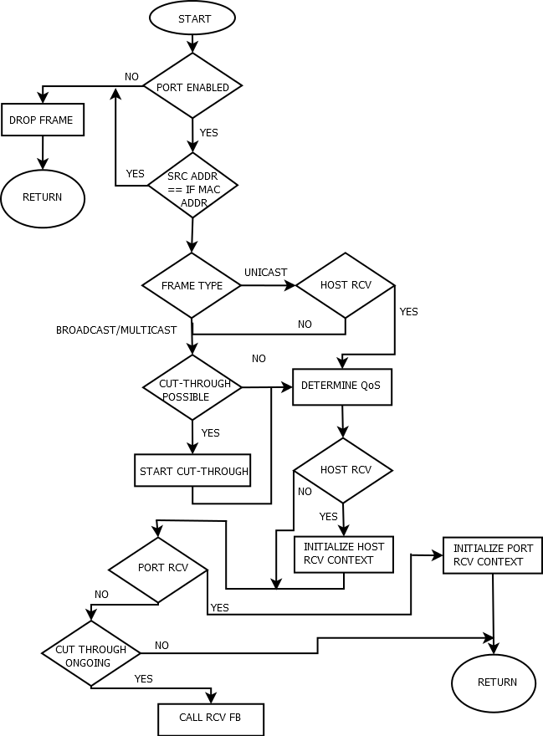
Figure 6: RCV FIRT BLOCK

FN_RCV_NB: Receive Next Block
This block stores the data of the receive frame in the host queue or port queue or both. Maximum it can store a block of 32 bytes per call. If there is a on-going cut-through for the frame being received then it sustains the cut-through by pushing the next available data to the Tx Fifo.
Before it starts storing the frame in the queue, it calls following arbitration function with a parameter which indicates whether is called for host queue or port queue:
- FN_QUEUE_ARBITRATION: called separately for the receive in host queue and port queue
Call to the arbitration function returns the queue where the frame is to be received. Returned queue can be either the main receive queue or shadow queue.
Once a queue is acquired, it starts storing the frame in blocks of 32 bytes. It checks whether new 32 bytes have become available, if yes then stores them otherwise transfers control to Micro-scheduler. If a frame is received as well as forwarded then the 32 byte data is stored in both the queues. After storing the bank index flag, rx_bank_index, is flipped to remember that the next time the data is stored from other bank of RX L2 Fifo.
If cut-through is happening then it doesn’t return the control and stays in till the entire frame has been received and cut-through of the frame is complete.
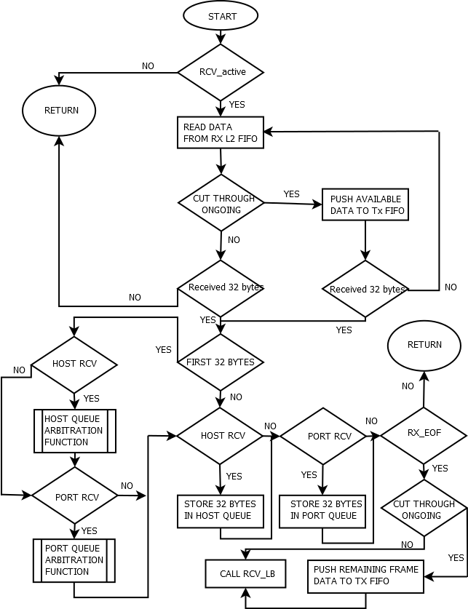

Figure 7: RECEIVE NEXT BLOCK
FN_RCV_LB: Receive Last Block
This block is executed when the RX EOF event has occurred. This block may store less the 32 bytes or exact 32 bytes or more then 32 bytes. In-case where it stores more than 32 bytes of data, it stores from both the bank’s of RX L2 Fifo. After storing the data of the received frame it updates the first buffer descriptor for the Rx frame with the length of frame and port number on which frame was received.
It then updates the queue descriptor to complete the reception of the frame. Only when the queue descriptor is updated the Host comes to know about the received frame. For stored and forwarded frames, the Tx Task comes to know about the received frame only when the queue descriptor for the port queue is updated.
Then it releases the acquired queue and generates an interrupt to host when the frame is received in the host queue. It also sets a flag, RX_STAT_PEND, to signal the STAT’s task. Error handling is discussed in a separate section.
At last it clears the RCV_active bit, clears the RX EOF in ICSS INTC and transfers control back to the Micro-scheduler.
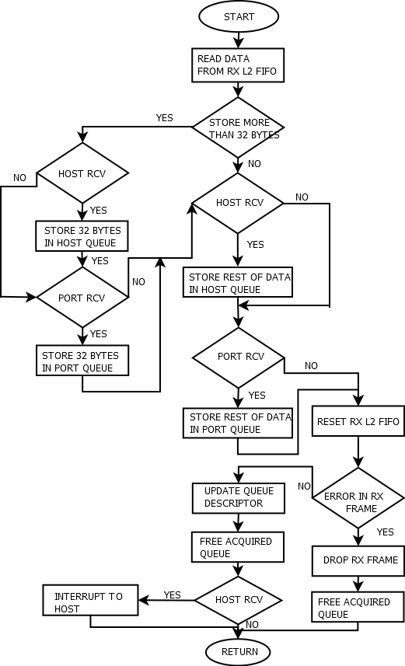

Buffer Descriptors, Queue Descriptors and Receive Context
The way incoming packets are stored in L3 OCMC RAM has a lot to do with the manner in which they are received from FIFO. Incoming data in the form of 32 byte chunks from the Rx FIFO is stored as is by the Firmware to L3 OCMC RAM. These chunks are stored in contiguous manner. So a 64 byte packet would get stored in two blocks.
Each such 32 byte block is in turn pointed to by a buffer descriptor stored in ICSS Shared RAM. Each queue consists of a string of such buffer descriptors kept contiguously on the ICSS Shared RAM.
A description of the Buffer Descriptor is given below
Bit(s) | Name | Meaning
0..13 | Unused | Currently unused, free for use with other protocols
14 | Shadow | inidcates that "index" is pointing into shadow buffer
15 | TimeStamp | indicates that this packet has time stamp in seperate buffer - only needed of PTCP runs on host
16..17 | Port | different meaning for ingress and egress, ingress Port=0 inidcates phy port 1 and Port = 1 inidcates phy port 2. Egress: 0 sends on phy port 1 and 1 sends on phy port 2. Port = 2 goes over MAC table look-up
18..28 | Length | 11 bit of total packet length which is put into first BD only so that host access only one BD
29 | VlanTag | indicates that packet has Length/Type field of 0x08100 with VLAN tag in following byte
30 | Broadcast | inidcates that packet goes out on both physical ports, there will be two bd but only one buffer
31 | Error | indicates there was an error in the packet
Table 9. Buffer Descriptor Table

The first descriptor contains the length of the packet through which the driver knows how many bytes it will have to copy. Since the buffer descriptors are contiguous in memory no additional pointers are required.
0..15 | Rd_ptr | Read pointer. This points to the last buffer descriptor that points to valid data, when Rx tasks puts data it increments the Read pointer
16..31 | Wr_ptr | Write pointer. This points to the bottom of the first buffer descriptor that contains the data, when Rx task on driver reads the data it increments this. When read pointer equals write pointer there is no data in the buffers
32-39 | busy_s | Is just a single bit. The busy bit is set by the driver to indicate to the firmware that there is an ongoing copy, firmware does not use the memory during that time.
40-47 | status
48-55 | max_fill_level | Maximum fill level of the queue. In bytes
56-63 | overflow_cnt | Number of times the queue has overflown
Table 10. Queue Descriptor Table
Using the queue descriptor both firmware and driver know which is the buffer descriptor which points to the current data and combining this with the data from receive context (See section 4.1.3) which tells us where the top and bottom buffer descriptors are located it’s easy to tell if there is a wraparound condition in the queue.

Quality of Service (QoS)
Receive Task implements Quality of Service (QoS) for all the received frames. Firmware uses the VLAN tag to determine the priority of received frame. There are four priority receive queues each for the host and port. A received frame is parsed using quality of service rules to determine in which queue the frame would be received. QoS rules are same for the host and port receive queues. Following QoS rules are implemented by the firmware:
- All the non VLAN tagged frames are stored in the lowest priority queue (queue priority 3).
- VALN tagged frames with “Priority code point (PCP)” value of 6 and 7 are stored in highest priority queue (queue priority 0).
- VALN tagged frames with “Priority code point (PCP)” value of 4 and 5 are stored in second highest priority queue (queue priority 1).
- VALN tagged frames with “Priority code point (PCP)” value of 2 and 3 are stored in third highest priority queue (queue priority 2).
- VALN tagged frames with “Priority code point (PCP)” value of 1 and 2 are stored in lowest priority queue (queue priority 3).
QoS rules are under the “ETHERNET_QOS” define in the “switch_MII_Rcv.p” file.

Transmit Task design

Transmit Task design
Transmit task scans the send queues to determine whether there is a frame to be transmitted. It first looks at the highest priority queue and if it is empty then only checks the lower priority queues. If all the send queues are empty then it returns to the scheduler.
Whenever Tx task is entered then first it checks XMT_active to determine whether there is an ongoing transmission of a frame and if it is set then Tx task fills the next bytes into the Tx Fifo. If XMT_active is clear then send queues are looked up to find whether there is a frame to transmit.
If there is a frame to be transmitted then it initializes the Tx context. Following are the main parameters in the Tx context:
- BUFFER_INDEX : Offset address of the data buffer in L3 RAM which contains first 32 bytes of the frame.
- Packet_Length: Length of the transmit frame in number of bytes.
- BYTE_CNT: Number of bytes already pushed to the Tx Fifo for the transmit frame.
- BUFFER_DESC_OFFSET: Offset of the first buffer descriptor for the transmit frame. First buffer descriptor contains the length of transmit frame.
- BASE_BUFFER_DESC_OFFSET: Offset of the base buffer descriptor of the queue in which transmit frame is queued.
- BUFFER_OFFSET: Offset of the base data buffer in the L3 RAM for the send queue.
- TOP_MOST_BUFFER_INDEX: Offset of the top most data buffer in the L3 RAM for the send queue.
- TOP_MOST_BUFFER_DESC_OFFSET: Offset of the top most buffer descriptor of the send queue.

Tx context is initialized in the beginning and updated throughout the transmission of the frame. When Tx task enters it reads in the Tx context from the scratch pad and saves it back before it exits. Offset’s of the top most buffer descriptor and data buffer are used to quickly determine if there is a wrap around in the send queue.

Tx Task is partitioned into following three parts:
- XMT_FB
- XMT_NB
- XMT_LB

XMT_FB: Transmit First Block
This block of code first checks in the highest priority queue whether there is a frame to be transmitted. If not, then it checks in second highest priority and so on. Once it finds a pending frame then it initializes the Tx context and set’s the XMT_active bit.
It fetches the first 32 bytes of transmit frame from the L3 RAM and pushes this data in the TX Fifo. After pushing first two bytes into the Tx Fifo, it enables transmit of the frame so that frame transmission can start as soon as possible.
After pushing first 32 bytes of data, it checks whether RX EOF event has occurred or not. If this event has not occurred then it fetches next block of data and pushes further 24 bytes into the Tx Fifo. Idea is to start with a completely filled TX Fifo so that there is more time for PRU to come back and fill Tx Fifo.
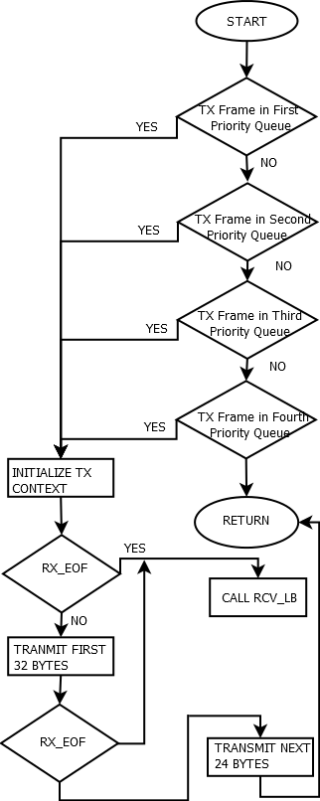

Figure 8 : Transmit First Block

XMT_NB: Transmit Next Block
This block of code fetches and transmit’s rest of the frame apart from the last 32 bytes of data. It computes the Tx Fifo fill level using the IEP counter and fills the available free space in Tx Fifo with the subsequent data of the frame. Maximum it fills 32 bytes of data.
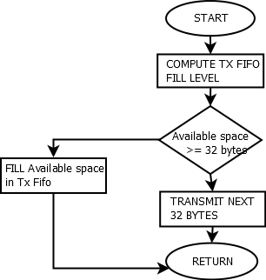

Figure 9 : Transmit Next Block

XMT_LB: Transmit Last Block
This block is executed when there are 32 bytes or less to be transmitted. After pushing the remaining bytes into the Tx Fifo, it also pushes the CRC for the frame. It also updates the read pointer in the queue to indicate that frame has been transmitted.
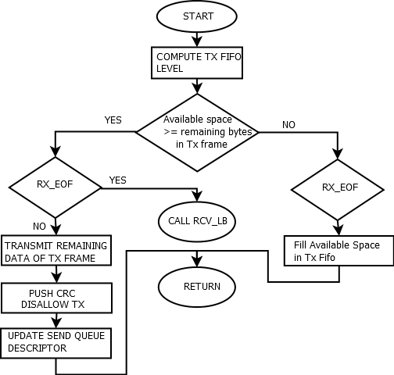

Figure 10 : Transmit Last Block

Queue Contention Task Design
Queue contention happens when two PRU or a PRU and Host want to acquire the same queue at same time. There is a defined queue arbitration scheme according to which ownership of queue is allocated when two PRU or a PRU and host try to acquire same queue.
Queue arbitration scheme defines a Master and a Slave. A core can be Master or Slave depending on the scenario. Below are definitions of Master and Slave:
Master:
Master first checks the slave ownership bit. If this bit is set then it means that slave has already acquired the queue. Master then acquires the Shadow queue and stores the frame in Shadow queue. If the Slave ownership bit is clear then Master sets the master ownership bit and acquires the queue.
Slave:
Slave first checks the master ownership bit. If this bit is set then it means that master has already acquired the queue. It then acquires the Shadow queue and stores the frame in Shadow queue. If Slave finds the master ownership bit as clear then it sets the Slave ownership bit and reads again the master ownership bit to check that master didn’t acquire the queue in-between. If the master has acquired the queue in-between then slave releases the queue by clearing the slave ownership bit. Slave then acquires the shadow queue and stores the packet in it.

In the queue descriptor there is a separate ownership bit for master and slave. These bits are in separate bytes.
As per the scheme, below cores are the defined masters and slave with respect to the queues:
- Host Queues: PRU0 is master and PRU1 is slave.
- Port Queues: PRUx is master and Host is slave.

Queue Contention on Host Queue:
Queue contention happens on a host queue when both the PRU’s try to acquire a queue to store the frame at the same time. Only one PRU can hold the queue at one point of time. Following are possible scenarios:
- PRU0 is already holding the queue then PRU1 stores the frame in shadow queue.
- PRU1 is already holding the queue then PRU0 stores the frame in shadow queue.
- Queue is free and both PRU’s try to acquire it by calling the arbitration function. PRU0 competes as master and PRU1 competes for the queue as slave. Depending on the relative timing between the two PRU’s one will successfully acquire the main queue whereas the other one will acquire the shadow queue.
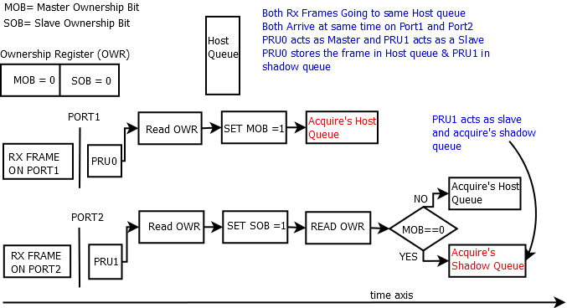

Figure 11 : Host Queue Contention Scenario

Queue Contention on Port Queue:
Queue contention happens on a port queue when Host and PRU try to acquire a queue to store the frame at the same time. This can happen on the queues of both the ports:
- On Port1, contention can happen between Host and PRU1.
- On Port2, contention can happen between Host and PRU0.
As per the scheme, Host is always a slave and PRUx is always a master when competing for a port queue. PRU’s call a separate arbitration function to acquire the port queue. A separate function is needed because with respect to port queues both PRU’s act as master.
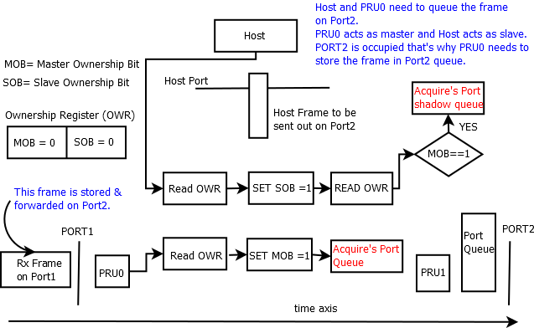

Figure 12 : Port queue contention scenario

Queue Contention Resolution
When queue contention happens then one of the core will store/queue the frame in the shadow buffer. Frame stored in the shadow buffer has to be moved to the main queue. Host always receives the frames through the four host queues and frames are always transmitted from the four send queues on both the ports. There is queue contention task which resolves the queue contention and moves the frame from the shadow buffer to one of the four main queue’s depending on the priority of the frame. Queue contention task runs on both the PRU’s:
- Queue contention task on PRU0 resolves contention for Host port and Port2.
- Queue contention task on PRU1 resolves contention for Port1.
So, if there is frame waiting in shadow buffer of Port1 then it is moved to one of the send queue of Port1 by the PRU1. This distribution of queue contention resolution to two PRU’s helps in resolving the queue contentions quickly.
This task checks the queue contention status register to find whether it has to resolve a queue contention. If there is no contention to resolve then it transfers the control back to the micro scheduler. There is one byte each for the three ports in the queue contention status register. If there is a queue contention then this task clears the contention in status register after it has successfully resolved it.
Shadow buffer can have maximum one frame at a time. If a queue contention happens and new a frame has to be stored in shadow buffer while it is the already holding a frame then the new frame is dropped.
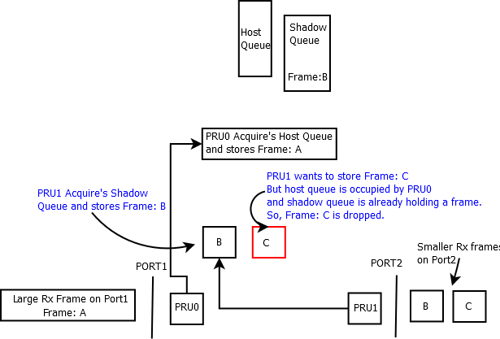
PRU has to acquire the main queue before queue contention can be resolved. As per the scheme, PRU is designated as master while it resolves the queue contention. For example, PRU1 acquires the one of the send queue on Port1 as master when it moves a frame from the shadow buffer to the send queue. At this point of time if host wants to queue a frame in the same send queue then it will have to drop the frame. It can’t store the frame in shadow buffer as well because it is already holding a frame which is being moved to the send queue.

Statistics Task
Statistics on PRU
The statistics task is called by the scheduler periodically in a round robin manner along with RX and TX task. The stat task checks for two flags RX_STAT_PEND and TX_STAT_PEND which are in turn set by the RX and TX task respectively (The flags are only set for non-error frames). Inside the stat task regular counters like multicast/broadcast/unicast counters along with binning counters are updated. Error cases like CRC count, oversize, undersize frames, Rx Error, SFD Error, Dropped frames etc are not part of the stat task. These counters are incremented wherever and wherever the error is detected. In addition to this Half Duplex counters like late collision, excess collision are also not part of the stat task.
The statistics memory map is shown in section 4.1.2.5.
Besides these statistics the firmware does binning (segregating based on size of packet) of Rx and Tx frames.
In the new design firmware does most of the statistics and all counters except one on Host are redundant. They are left there to help in debugging. The one counter exclusive to Host is the rxUnknownProtocol.

Storm Prevention
Storm prevention is primarily done on PRU’s using a credit based scheme. It is
explained below.
- The Host (Cortex A8) writes the number of Multicast+Broadcast packets allowed in a 100ms interval in DRAM of PRU. (STORM_PREVENTION_OFFSET)
- This value (credits) can be configured using the API setCreditValue()
- As soon as the PRU encounters a Multicast/Broadcast packet it decrements the value written in memory by 1 and allows the packet to pass through. If the value goes to 0 the packet is dropped
- At the end of every 100ms interval Cortex A8 writes the value once again. Function resetStormPreventionCounter() in file icss_StormControl.c
- Storm Control can be enabled and disabled on a per port basis.
- List of API’s (Mentioned in switch API doc in section 2.2)

Learning Bridge
- The learning bridge is implemented on the Host (Cortex A8) side. The switch learns source addresses of packets that are either Multicast/Broadcast or directed at the Host (Unicast with Host MAC ID).
- All API’s are contained in the file icss_learning.c. When a packet is received on the Host using the RX Interrupt mechanism explained above in this document the function updateHashTable() is called for that packet with the correct port number. The function adds an entry for the MAC ID and updates the table.
- To retrieve the port number on which that particular MAC ID was present, the API findMAC() is called.
- Ageing is done automatically by the function incrementCounter() and ageingRoutine() (Called inside the driver periodically)
- List of API’s (Mentioned in switch API doc in section 2.2)

STP Switch
In addition to the above features, the source is packaged with an STP-aware switch. This STP-aware switch will be built into its own binaries, but is built directly atop the base ICSS Cut-Through Switch.

Memory Map
Additional memory regions will be used for RSTP as follows

PRU0 DMEM memory map
Definition | Address map | Remarks
ICSS_EMAC_FW_VLAN_FILTER_CTRL_BITMAP_OFFSET | 0x00EF | VLAN Filter Control
ICSS_EMAC_FW_VLAN_FILTER_DROP_CNT_OFFSET | 0x00F0 | VLAN Filter Drop count
ICSS_EMAC_FW_MULTICAST_FILTER_MASK_OFFSET | 0x00F4 | Multicast filter Mask (6 bytes)
ICSS_EMAC_FW_MULTICAST_FILTER_CTRL_OFFSET | 0x00FA | Multicast filter feature control
ICSS_EMAC_FW_MULTICAST_FILTER_OVERRIDE_STATUS | 0x00FB | Multicast filter override for Hash override
ICSS_EMAC_FW_MULTICAST_FILTER_DROP_CNT_OFFSET | 0x00FC | Multicast filter drop count
ICSS_EMAC_FW_MULTICAST_FILTER_TABLE | 0x0100 | Multicast filter table, 256 bytes
ICSS_EMAC_FW_VLAN_FILTER_TABLE_SIZE_BYTES | 0x0200 | Vlan filter table 512 bytes
STP_INVALID_STATE_OFFSET | 0x1FAC | STP state error counter

PRU1 DMEM memory map
Definition | Address map | Remarks
ICSS_EMAC_FW_VLAN_FILTER_CTRL_BITMAP_OFFSET | 0x00EF | VLAN Filter Control
ICSS_EMAC_FW_VLAN_FILTER_DROP_CNT_OFFSET | 0x00F0 | VLAN Filter Drop count
ICSS_EMAC_FW_MULTICAST_FILTER_MASK_OFFSET | 0x00F4 | Multicast filter Mask (6 bytes)
ICSS_EMAC_FW_MULTICAST_FILTER_CTRL_OFFSET | 0x00FA | Multicast filter feature control
ICSS_EMAC_FW_MULTICAST_FILTER_OVERRIDE_STATUS | 0x00FB | Multicast filter override for Hash override
ICSS_EMAC_FW_MULTICAST_FILTER_DROP_CNT_OFFSET | 0x00FC | Multicast filter drop count
ICSS_EMAC_FW_MULTICAST_FILTER_TABLE | 0x0100 | Multicast filter table, 256 bytes
ICSS_EMAC_FW_VLAN_FILTER_TABLE_SIZE_BYTES | 0x0200 | Vlan filter table 512 bytes
STP_INVALID_STATE_OFFSET | 0x1FAC | STP state error counter

ICSS Shared RAM memory map
Definition | Address map | Remarks
ICSS_EMAC_FW_FDB__IDX_TBL_OFFSET | 0x2000 | FDB Index Table
ICSS_EMAC_FW_FDB__MAC_TBL_OFFSET | 0x2400 | FDB MAC Table
ICSS_EMAC_FW_FDB__STP_P1_STP_STATE_OFFSET | 0x2E00 | Port 1 STP state
ICSS_EMAC_FW_FDB__STP_P2_STP_STATE_OFFSET | 0x2E01 | Port 2 STP state
ICSS_EMAC_FW_FDB__FLOOD_ENABLE_FLAGS_OFFSET | 0x2E02 | Flood enable flags per-port (bit0 -> Host, bit1 -> Port 1, bit2 → Port 2
ICSS_EMAC_FW_FDB__ARBITRATION_OFFSET | 0x2E03 | FDB locking mechanism

Buffer Descriptor
Additional bits will be used for RSTP within the Buffer Descriptor as follows
Bit(s) | Name | Meaning
6 | FdbLookupSuccess | FDB lookup was successful (source MAC address found in FDB)
7 | Flood | Packet should be flooded (destination MAC address found in FDB)

R22
Additional bits will be used for RSTP within the Buffer Descriptor as follows
Bit(s) | Name | Meaning
6 | FDB_LOOKUP_SUCCESS | FDB lookup was successful (source MAC address found in FDB)
3 | PKT_FLOODED | Packet should be flooded (destination MAC address found in FDB)
0..2 | STP_STATE | The current STP state for this port

STP Support

Forwarding Data Base
The design of the FDB table is heavily influenced by the NodeTable design in HSR/PRP firmware and the current implementation of the FDB in icss_emacLearning.h. Once an address has sent traffic through the switch, the switch knows that this address is associated with a particular port and will then "learn" the address. In short, the FDB stores learned Unicast MAC addresses to speed up the forwarding of packets to known addresses. This is to be implemented in firmware to avoid overloading the host and to minimize overall latency during high-traffic with known addresses.

Linear Hash Table
This linear hash table is primarily based on the current HSR/PRP linear hash table design for the Node Table. The design handles clashes with expandable buckets, which provides more flexibility but more clashes lead to longer bucket-search times with the worst case resulting in an O(N) linear search in the case where all MACs are hashed to the same id. If bucket-insertions are maintained to be sorted, then binary search can be used to find a value in a bucket. The 8-bit hash limits the total number of buckets to 256, but in theory it is possible to have arbitrary-length buckets.
The design actually consists of two tables: and Index Table and a MAC Table. The MAC Table stores all of the proper MAC addresses and relevant information in buckets, and the Index Table keeps track of the location and size of the buckets within the MAC Table. Each bucket in the MAC Table is a sorted, contiguous group of MACs that share the same hash value.
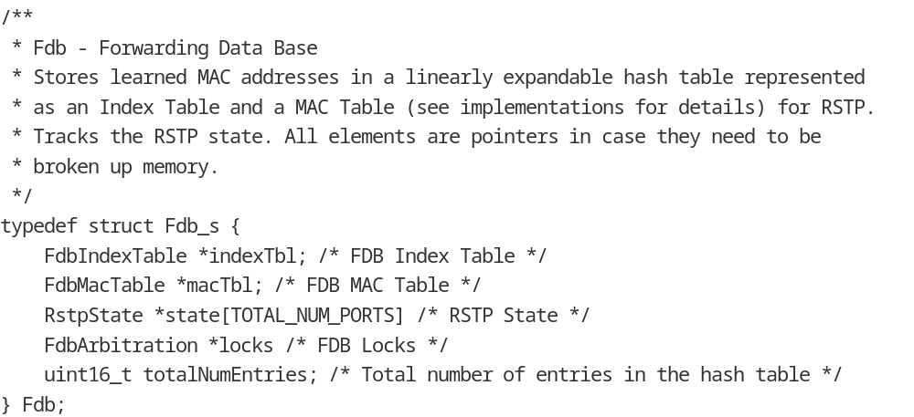

Basic Example
In this basic illustrative example, there are 3 hash buckets in the table associated with the hash values 0x00, 0x02, and 0xFD. The index table tracks the size and starting index of each bucket, and empty buckets have a size of 0 with a dont-care index value.

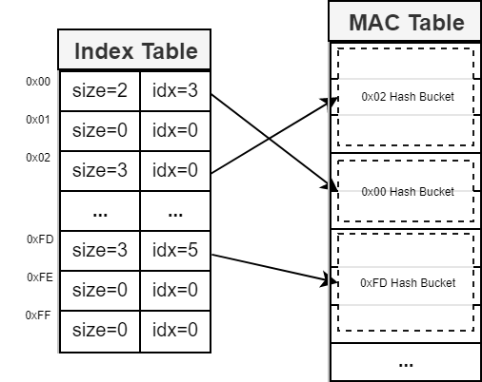

Index Table
As mentioned, the Index Table must be 256 entries to ensure easy indexing with the 8-bit hash. It also keeps track of the current state of each port. The current design uses 16-bit bucket indices and bucket entry counts to support up to a 65,536 entry MAC table.
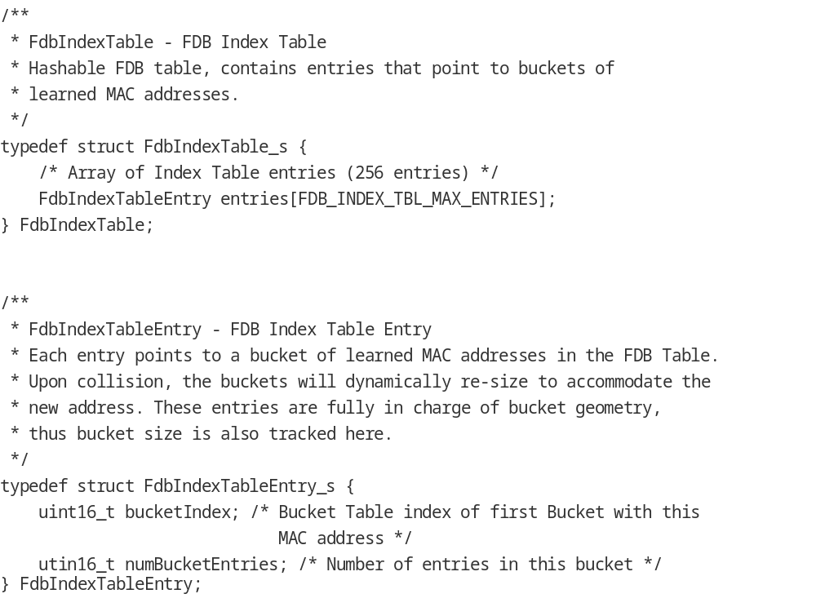

MacTable
The MAC table where the actual FDB entries are stored, hash buckets appear as contiguously linear groups of entries.
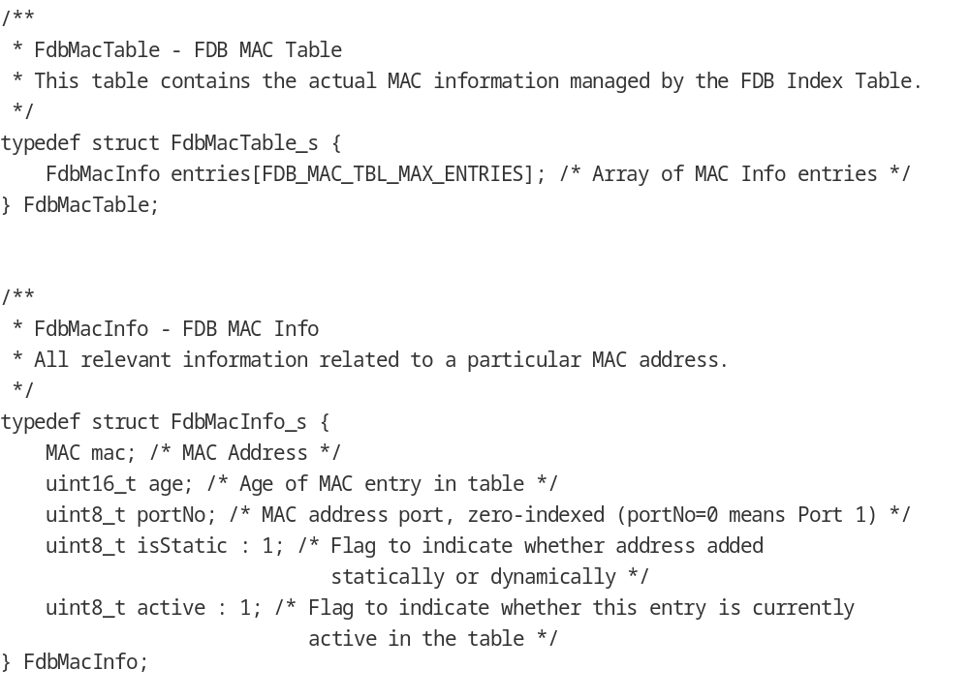

STP Support
The firmware will technically be blindly supporting STP states which are, in effect, a superset of states that include all valid RSTP states. If the host determines it will be running RSTP, it will only configure the firmware in the subset of states that are considered RSTP. If the state is incorrectly configured, the firmware will drop all packets and log error statistics. The functional relationship between STP and RSTP states are as follows:

STP State | RSTP State | Configuration | Receive BPDU | Learn MAC | Forward Packets
Disabled | Discarding | Disable port, state not relevant | No | No | No
Blocking | Discarding | Host sends Blocking | Yes | No | No
Listening | Discarding | Host sends Blocking | Yes | No | No
Learning | Learning | Host sends Learning | Yes | Yes | No
Forwarding | Forwarding | Host sends Forwarding | Yes | Yes | Yes

PTP
The STP switch will support PTP as described in the ICSS-EMAC documentation.

RX Interrupt Pacing
The STP switch will support RX interrupt pacing as described in the ICSS-EMAC documentation.

Multicast/VLAN Filtering
The STP switch will support Multicast and VLAN filtering as described in the ICSS-EMAC documentation.

Firmware sources description
ICSS Switch firmware source includes the following files:
Source File | Remarks
firmware_version.h | ICSS Switch Firmware Version Control
icss_defines.h | ICSS Global Defines
icss_switch_macros.h | ICSS Switch Macros and Defines
switch_collision_task.asm | ICSS Switch collision handling Functions
icss_iep_reg.h | ICSS Industrial Ethernet Peripheral Registers Definition
icss_intc_reg.h | ICSS Interrupt Controller Module Registers Definition
icss_macros.h | Implements Common Macros & Defines
icss_miirt_regs.h | ICSS MII_RT Module Registers Definition
icss_emacSwitch.h | Definitions and Mapping of Ethernet MAC over PRU
micro_scheduler.h | ICSS Defines and Macros used by Micro_Scheduler
micro_scheduler.asm | Round-robin based Micro_Scheduler which controls program flow
emac_MII_Rcv.h | Defines and Macros to be used in Receive Task
emac_MII_Rcv.asm | Receive Task Functions
emac_MII_Xmt.h | Defines and Macros to be used in Transmit Task
emac_MII_Xmt.asm | Transmit Task Functions
emac_statistics.asm | Statistics Task
icss_stp_switch.h | STP Switch memory map and constants definitions
icss_stp_switch_macros.h | STP Switch macros
Table 11. Firmware Sources Description

Revision History

Version # | Date | Author Name | Revision History
0.1 | 11 JUNE 2013 | Robin Singh | First Draft
0.2 | 23rd July 2014 | Robin Singh | Made modifications to align with latest firmware
0.3 | 24th July 2014 | Robin Singh | Incorporated review comments
0.4 | 25th July 2014 | Vineet Roy | Incorporated review comments
1.0 | 25th July 2014 | Robin Singh | Final document which aligns with latest switch firmware.
1.1 | 2nd Jan 2014 | Vineet Roy | 1. Modified the memory map based on recent changes and modified statistics task  2. Modified the statistics task section  3. Added section on half duplex  4. Added section on Link Status Change  5. Added section on PTP
1.2 | 11-Feb-2014 | Vineet Roy | Added section on Buffer and Queue Descriptors
1.3 | 6-September-2017 | Suraj Das | Modified the documentation for Proc SDK release.
1.4 | 16-Apr-2018 | Aravind Batni | Added note for bit 20 of RX_EOF on why it can’t be used for AM335x and AM437x
1.5 | 14-Oct-2019 | Brandon Wetzel | 1. Addition of STP Switch design, memory map, etc.  2. Retroactively fix previously changed memory map  3. Retroactively fix buffer descriptor usage  4. Retroactively fix R22 usage  5. Updated TI Germantown address  6. Preparation for release with PRSDK 6.2

««« § »»»

