Exp 1 Affine Transformation
import java.util.Scanner;
public class AffineCipher
{
public static String encryptionMessage(String Msg)
{
String CTxt = "";
int a = 3;
int b = 6;
for (int i = 0; i < Msg.length(); i++)
{
CTxt = CTxt + (char) ((((a * Msg.charAt(i)) + b) % 26) + 65);
}
return CTxt;
}
public static String decryptionMessage(String CTxt)
{
String Msg = "";
int a = 3;
int b = 6;
int a_inv = 0;
int flag = 0;
for (int i = 0; i < 26; i++)
{
flag = (a * i) % 26;
if (flag == 1)
{
a_inv = i;
System.out.println(i);
} }
for (int i = 0; i < CTxt.length(); i++)
{
Msg = Msg + (char) (((a_inv * ((CTxt.charAt(i) - b)) % 26)) + 65);
}
return Msg;
}
public static void main(String[] args)
{
Scanner sc = new Scanner(System.in);
System.out.println("Enter the message: ");
String message = sc.next();
System.out.println("Message is :" + message);
System.out.println("Encrypted Message is : "
+ encryptionMessage(message));
System.out.println("Decrypted Message is: "
+ decryptionMessage(encryptionMessage(message)));
sc.close();
}}
Exp 2 Transposition Cipher
import java.io.*;
public class An_tans {

public static String enc(String ip,int m_row,int m_col)
{
char op[][]=new char[100][100];
int len = ip.length();
String op2="";
int i1,i2,i;
for(i=0,i1=0,i2=0;i<len;i++)
{
op[i2][i1]=ip.charAt(i);
i2++;
if(i2==m_row)
{
i2=0;
i1++;
}
}

System.out.println("Cipher matrix:");
for(i1=0;i1<m_row;i1++)
{
for(i2=0;i2<m_col;i2++)
{
System.out.print(op[i1][i2]+" ");
}
System.out.println();
}

for(i1=0;i1<m_row;i1++)
{
for(i2=0;i2<m_col;i2++)
{
op2 = op2+op[i1][i2];
}
}
return (op2);
}

public static String dec(String ip,int m_row,int m_col)
{
char op[][]=new char[100][100];
int len = ip.length();
String op2="";
int i1,i2,i;
for(i=0,i1=0,i2=0;i<len;i++)
{
op[i1][i2]=ip.charAt(i);
i2++;
if(i2==m_col)
{
i2=0;
i1++;
}
}

System.out.println("Cipher matrix");
for(i1=0;i1<m_row;i1++)
{
for(i2=0;i2<m_col;i2++)
{
System.out.print(op[i1][i2]+" ");
}
System.out.println();
}
for(i1=0;i1<m_col;i1++)
{
for(i2=0;i2<m_row;i2++)
{
op2 = op2+op[i2][i1];
}
}
return (op2);
}

public static void main(String[] args) throws IOException {
BufferedReader obj = new BufferedReader(new InputStreamReader (System.in));

/* O-P matrix specification */
int m_col;
int m_row;

/* */
String ip;
int len;
String op2;
System.out.println("Enter input:");
ip = obj.readLine();
len = ip.length();
/*Calculate matrix*/
System.out.println("Enter number of rows:");
m_row = Integer.parseInt(obj.readLine());
m_col = (int)Math.ceil((float)len/m_row);

/* Option */
System.out.println("What do you want to perform:\n1.Encryption\n2.Decryption");
int ch;
ch = Integer.parseInt(obj.readLine());
if (ch==1)
{
op2 = enc(ip,m_row,m_col);
op2 = enc(op2,m_row,m_col);
System.out.println("Cipher text:"+ op2);
}
else if (ch==2)
{
op2 = dec(ip,m_row,m_col);
op2 = dec(op2,m_row,m_col);
System.out.println("Plain text:"+ op2);
}
else
{
System.out.println("Invalid Choice");
} }}
Exp 3 RSA public key
import java.math.*;
import java.util.*;
class RSA11
{
public static void main(String args[])
{
Scanner sc=new Scanner(System.in);
int p,q,n,z,d=0,e,i;
System.out.println("Enter the number to be encrypted and decrypted");
int msg=sc.nextInt();
double c;
BigInteger msgback;
System.out.println("Enter 1st prime number p");
p=sc.nextInt();
System.out.println("Enter 2nd prime number q");
q=sc.nextInt();
n=p*q;
z=(p-1)*(q-1);
System.out.println("the value of z = "+z);
for(e=2;e<z;e++)
{
if(gcd(e,z)==1) // e is for public key exponent
{
break;
} }
System.out.println("the value of e = "+e);
for(i=0;i<=9;i++)
{
int x=1+(i*z);
if(x%e==0) //d is for private key exponent
{
d=x/e;
break;
} }
System.out.println("the value of d = "+d);
c=(Math.pow(msg,e))%n;
System.out.println("Encrypted message is : -");
System.out.println(c);
//converting int value of n to BigInteger
BigInteger N = BigInteger.valueOf(n);
//converting float value of c to BigInteger
BigInteger C = BigDecimal.valueOf(c).toBigInteger();
msgback = (C.pow(d)).mod(N);
System.out.println("Derypted message is : -");
System.out.println(msgback);
}
static int gcd(int e, int z)
{
if(e==0)
return z;
else
return gcd(z%e,e);
}}

Exp 4 RSA digital signature
import java.security.KeyPair;
import java.security.KeyPairGenerator;
import java.security.Signature;

import sun.misc.BASE64Encoder;

public class MainClass {
public static void main(String[] args) throws Exception {
KeyPairGenerator kpg = KeyPairGenerator.getInstance("RSA");
kpg.initialize(1024);
KeyPair keyPair = kpg.genKeyPair();

byte[] data = "test".getBytes("UTF8");

Signature sig = Signature.getInstance("MD5WithRSA");
sig.initSign(keyPair.getPrivate());
sig.update(data);
byte[] signatureBytes = sig.sign();
System.out.println("Singature:" + new BASE64Encoder().encode(signatureBytes));

sig.initVerify(keyPair.getPublic());
sig.update(data);

System.out.println(sig.verify(signatureBytes));
}
}

Exp 5 Diffie Hellman
import java.util.*;
class Diffie
{
public static void main(String args[])
{
Scanner sc=new Scanner(System.in);
System.out.println("Enter modulo(p)");
int p=sc.nextInt();
System.out.println("Enter primitive root of "+p);
int g=sc.nextInt();
System.out.println("Choose 1st secret no");
int a=sc.nextInt();
System.out.println("Choose 2nd secret no");
int b=sc.nextInt();

int A = (int)Math.pow(g,a)%p;
int B = (int)Math.pow(g,b)%p;

int S_A = (int)Math.pow(B,a)%p;
int S_B =(int)Math.pow(A,b)%p;

if(S_A==S_B)
{
System.out.println("A and B can communicate with each other!!!");
System.out.println("They share a secret no = "+S_A);
}
else
{
System.out.println("A and B cannot communicate with each other!!!");
}
}
}

Output:
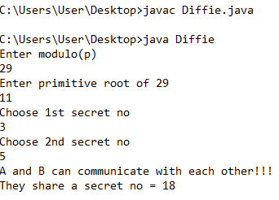
Exp 6 detailed domain and network related information

$ whois domain-name
$ whois -h whois.example.com domain.com
$ whois google.com
neststat

Exp 7 Ports

1) $ sudo netstat –ltnp
2)netstat –atu
3) netstat -a | grep 80

4) # nmap -sP 10.1.1.*
# nmap -O -sV 10.1.1.13
OR
ifconfig -get the IP
sudo nmap -sn 192.168.1.0|24

Exp 8 Command

nslookup google.com
whois google.com
nmap google.com

Exp 9 reconnaissance information from TCP/IP packet

tcpdump -i enp0s3

Or

1) get list of devices
tcpdump -D
then use any device using
tcpdump -i ‘name’

or
tcpdump -n -i ‘name’

2)to capture only TCP/IP packets
tcpdump -i enp0s3 tcp

3)from specific ip
tcpdump -n -i enp0s3 src ‘ip’

Exp 12 Arpwatch
$sudo apt-get install arpwatch
$arpwatch -i eth0
$tail –f/var/log/syslog
$arp –a

Exp 13 Hping3

$cd Desktop
$sudo apt-get install hping3
$sudo hping3 –S --flood –V www.example.com

Exp 14 Iptables

$sudo iptables –A INPUT –i eth0 –j ACCEPT
$sudo iptables –L
$sudo iptables –P FORWARD DROP
$ sudo iptables –L
$ sudo iptables –A INPUT –s 192.168..1.3 –j ACCEPT
$ sudo iptables –L
$ sudo iptables –A INPUT –s 192.168..1.3 –j DROP
$ sudo iptables –L
$sudo iptables –I INPUT –s 192.168.1.3 –p tcp –dport 22 –j ACCEPT
$ sudo iptables –L
$sudo iptables –D INPUT 1
$ sudo iptables –L
$sudo invoke-rc.d iptables-persistent save
$sudo iptables –A INPUT –s 192.168.7.5 –j ACCEPT
$ sudo iptables –L
$ sudo iptables –F
$ sudo iptables –L

Exp 15 Ipsec

Ipsec
Blue server
$sudo apt-get install ipsec-tools strongswan –starter
$sudo gedit/etc/ipsec.conf
$sudo gedit/etc/ipsec.secrets
$sudo ipsec restart

Red server
$sudo apt-get install ipsec-tools strongswan –starter
$sudo gedit/etc/ipsec.conf
$sudo gedit/etc/ipsec.secrets
$sudo ipsec restart
$sudo ipsec statusall
$ping –s 4018 192.168.4.236
$

Exp 16 Cppcheck
Checking Vulnerability
char firstChar1 (/*@null@*/ char *s)
{
return *s;
}

char firstChar2 (/*@null@*/ char *s)
{ if (s == NULL) return ‘\0’;
return *s;
}
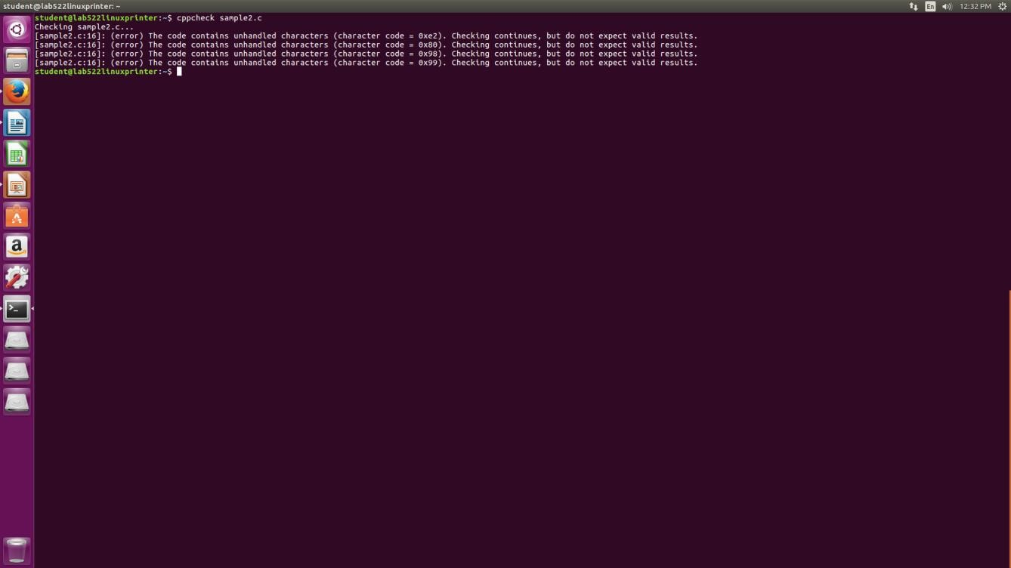
Exp 17 SPLINT:
#include <stdio.h>
#include <string.h>

int main(void)
{ char buff[15];
int pass = 0;

printf("\n Enter the password : \n"); gets(buff);

if(strcmp(buff, "thegeekstuff"))
{
printf ("\n Wrong Password \n");
} else
{
printf ("\n Correct Password \n"); pass = 1;
}

if(pass)
{
/* Now Give root or admin rights to user*/ printf ("\n Root privileges given to the user \n");
}

return 0;
}
