

**GRAPHICS AND DATA VISUALISATION**

**Coursework Two Rationale**

**Rationale**

I decided to present the user with a Main Menu that highlights all the actions before the user ‘Start’s to view the map. The user can also watch a how to video, by clicking the ‘Watch How’ button, for a visual demonstration. The main menu allows the user can be informed before they begin. I included a globe animation to make the main menu a little less monotonous. The window size is the same size as the map (when zoomed out), this is to reduce the excess empty space outside the map.

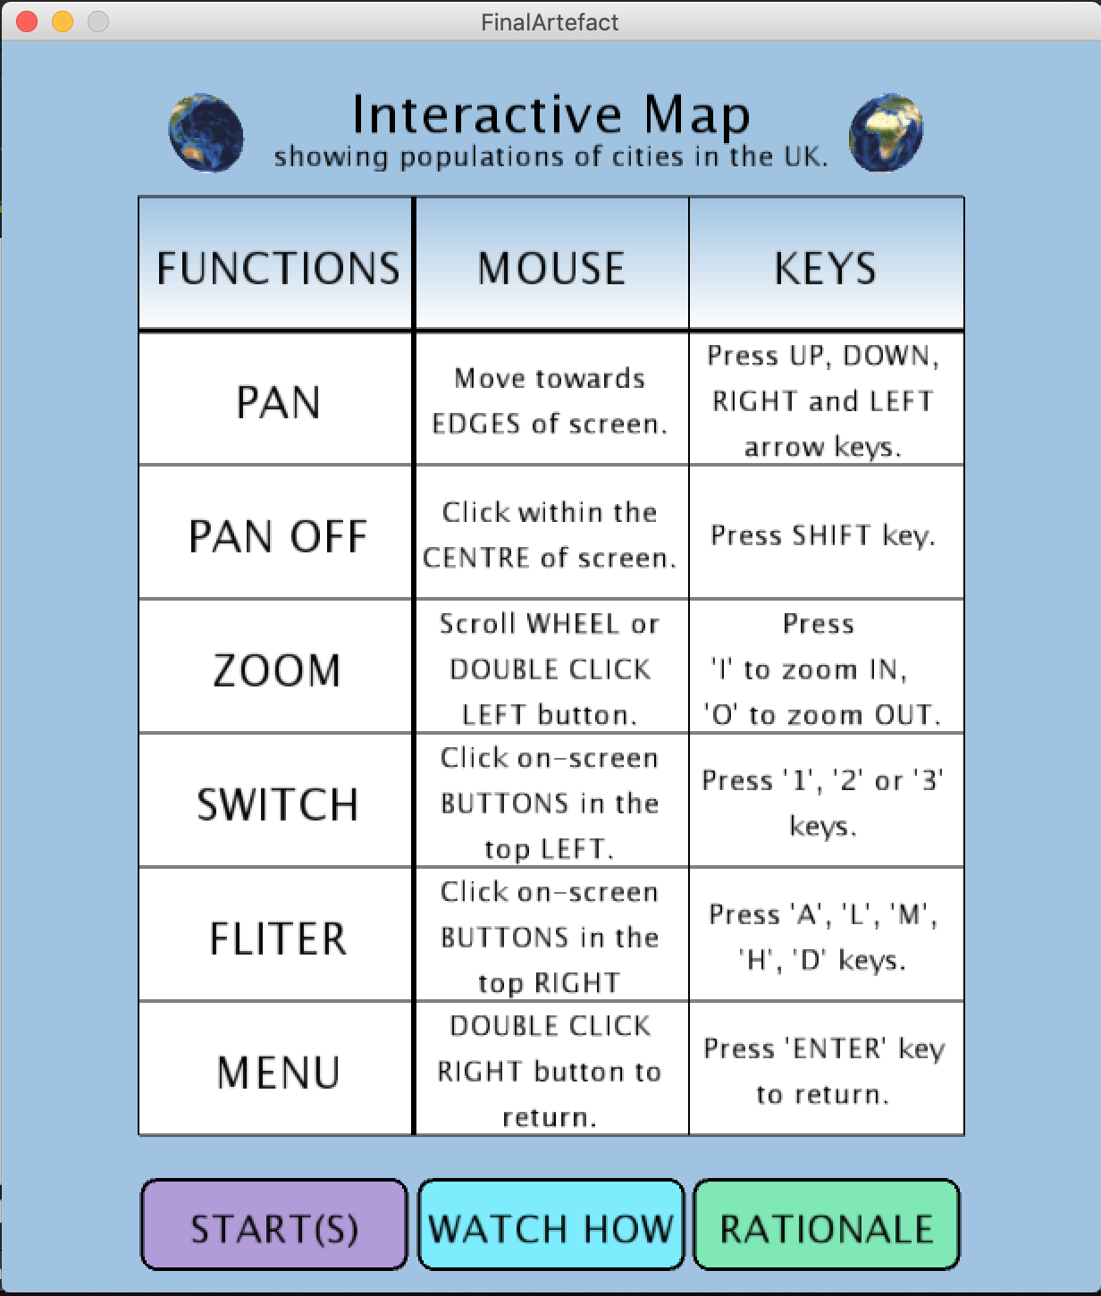

I used the same colours (and shades of those colours) throughout the application. I used light blue to match the map background. I used purple, blue and green to display the populations from the censuses from the years, 1991, 2001 and 2011. I chose these colours because they stand out from the rest of the map contrasting with the colours on the map.

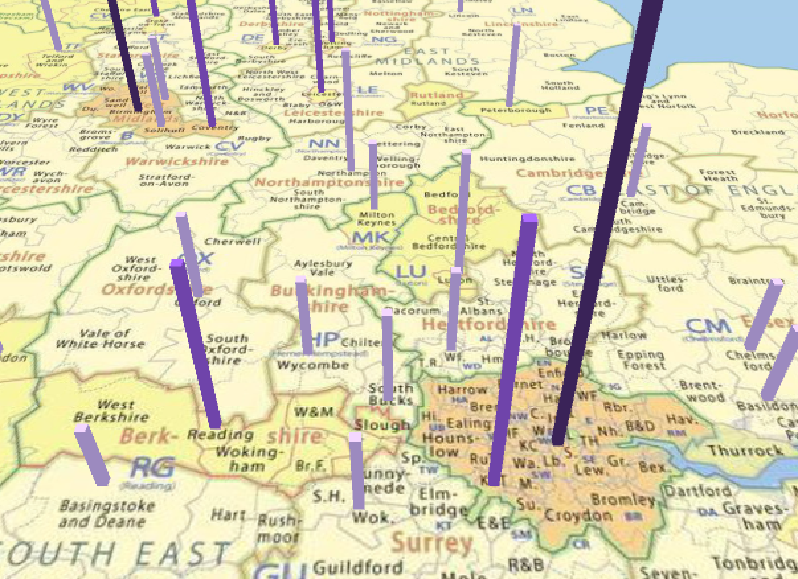

The map is interactive, the user can zoom in and out towards the centre of the map. The user can zoom using the mouse wheel, pinch the track pad (Macbook) or double clicking on the map for snap view zoom. Furthermore, they can use the keys ‘I’ and ‘O’. There is a restriction on how much the user can zoom in and out as zooming until the map is unreadable is unnecessary. Then they can utilise the pan function (by moving arrow keys or mouse towards edges of the screen) to observe all the cities more closely.

The user can also turn this function off (by clicking the centre or ‘SHIFT’ key). I think this is a very useful function because when the user is selecting different years the mouse pan can be irritating, so now the user has the flexibility of turning this on and off as they see fit. The reason I chose the centre was so that clicking the buttons didn’t turn it off/on.

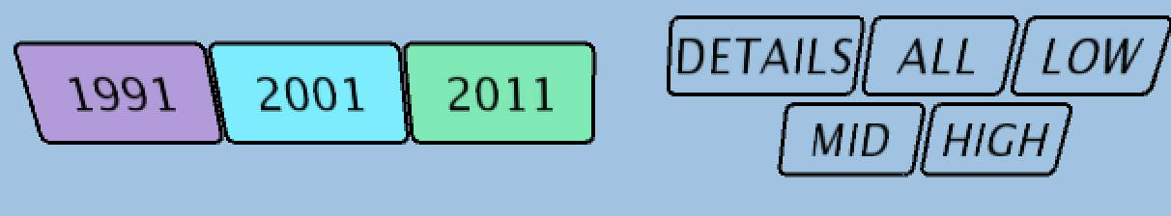

The buttons are positioned at the top left-hand corner and remain there (i.e. they are not affected by zoom or pan), this is for easy access. The text on the buttons is large to increase readability and they also have a black stroke outline to make them stand out. They allow the user to switch between the years. Clicking the buttons will not trigger an other actions, but those of the buttons (e.g. turning mouse pan off). The cubes are placed just above the city’s name on the map, not on top so the user can still read the name of the city. The cube height is proportionate to the population of the city in the year selected. Low populations have a lighter shade and higher populations are darker. The user can filter out information by clicking the ‘DETAILS’, ‘ALL’, ‘HIGH’, ‘MID’ or ‘LOW’ buttons on the top right of the screen or pressing the ‘D’, ‘H’, ‘L’, ‘M’, keys respectively. The user can see the additional details city name and exact population. **Although pressing D on the keyboard works better than** pressing the button.

The user has a lot of control over the map as a result of these actions, with this in mind, the user has the option of returning to the main menu by pressing ‘M’ key or double clicking left button, to refresh their memory on how to use the actions, an improvement on this would be to also trigger a reset function to reset the map if they have lost their bearings.

I chose to move the position of the camera down (along the Y axis) but for the focus to remain in the centre of the map. I think this angle allows the user to see the population of the cities more clearly. I used a subtle ‘lights’ effect to make the population cubes look 3D. I also made sure that all actions could be performed using the keys and the mouse to accommodate user preference and encase the user doesn’t have a standard mouse. Flexibility is further ensured, as the function will perform regardless if the key is uppercase or lowercase.

The image quality of the application on a Apple Macbook is poor compared to compared to an image loaded into an application on Windows. Due to not being able to develop the application in the university labs, the application has been built on a mac and image quality is slightly reduced.