軸 流 風 機
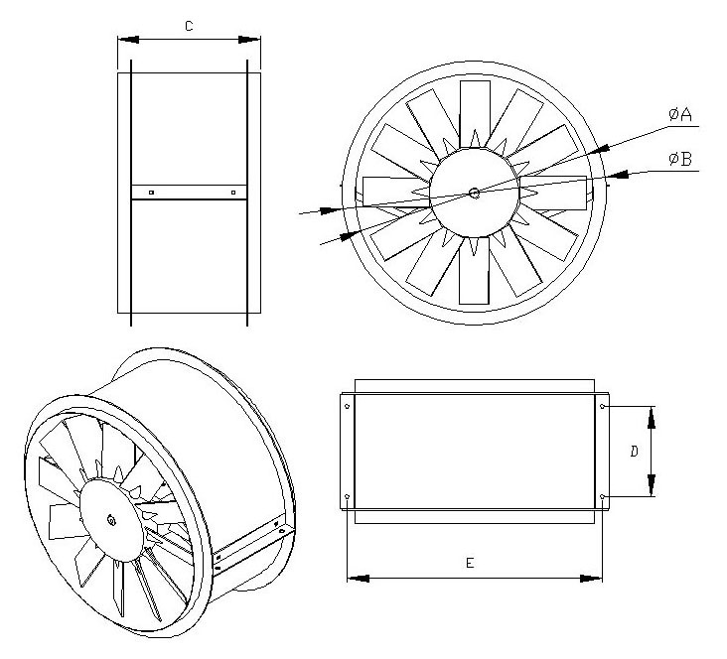
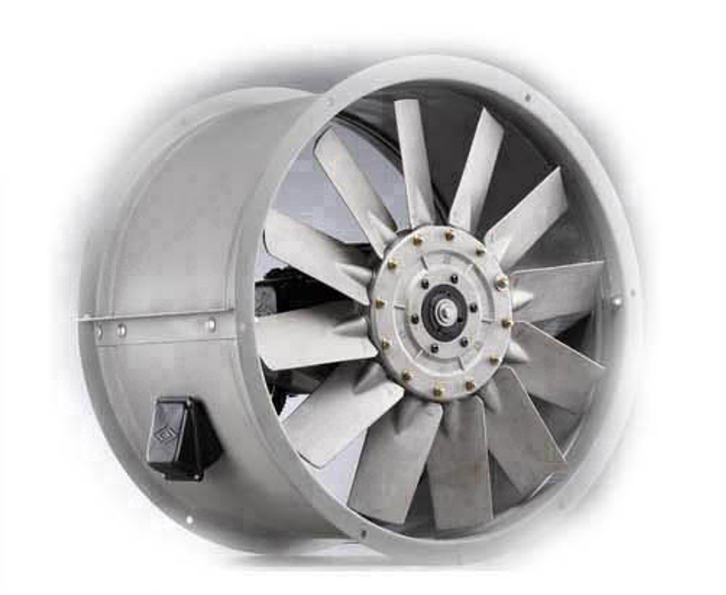


馬力數 | 重量 | 型號 | A | B | C | D | E
3HP(2.2KW) | 60 | FS-D-670-3 | 658 | 728 | 400 | 250 | 698
5HP(3.7KW) | 75 | FS-D-720-5 | 710 | 780 | 400 | 250 | 750
7.5HP(5.5KW) | 100 | FS-D-770-7.5 | 760 | 830 | 400 | 250 | 800
10HP(7.5KW) | 110 | FS-D-770-10 | 760 | 830 | 400 | 250 | 800
15HP(11W) | 160 | FS-D-830-15 | 810 | 880 | 600 | 320 | 850
20HP(15KW) | 185 | FS-D-950-20 | 938 | 1008 | 600 | 320 | 988
25HP(18.5KW) | 240 | FS-D-1100-25 | 1065 | 1135 | 600 | 320 | 1115
30HP(22KW) | 250 | FS-D-1100-30 | 1065 | 1135 | 600 | 320 | 1115
40HP(30KW) | 290 | FS-D-1200-40 | 1185 | 1255 | 600 | 320 | 1235
50HP(37KW) | 360 | FS-D-1200-50 | 1185 | 1255 | 600 | 320 | 1235
75HP(56KW) | 600 | FS-D-1300-75 | 1300 | 1400 | 750 | 500 | 1350
單位:mm

