**Ansible**

# 工作机制

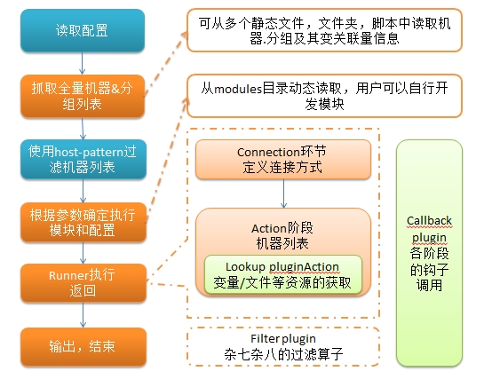

# 安装

两种方式，Linux软件包安装方式，另一种通过PIP安装

安装Ansible管理主机要求：Python2.6或Python2.7

## yum

yum install –y epel

yum install –y ansible #Redhat/CentOS/Fedora

## pip

pip install ansible

# 配置

控制主机：用于控制其它机器的主机

管理主机：被控制主机管理的主机

## 配置管理主机

#yum方式默认在/etc/ansible/hosts

[MHA1]

192.168.100.102

192.168.100.103

192.168.100.104

## 配置控制主机SSH密钥

## 在控制主机中生成ssh密钥对

ssh-keygen –t rsa

## 将公钥拷贝到管理主机中

ssh-copy-id –i ~/.ssh/id_rsa.pub root@192.168.100.102

ssh-copy-id –i ~/.ssh/id_rsa.pub root@192.168.100.103

ssh-copy-id –i ~/.ssh/id_rsa.pub root@192.168.100.104

## ansible配置

/etc/ansible/ansible.cfg

### 禁用每次执行ansible命令检查sshkeyhost

host_key_checking = False

### 开启日志记录

log_path = /var/log/ansible.log

### ansible连接加速配置

accelerate_multi_key = yes?

## 测试

ansible all –m ping

[root@db1 ansible]# ansible all -m ping

192.168.100.102 | SUCCESS => {

"changed": false,

"ping": "pong"

}

192.168.100.103 | SUCCESS => {

"changed": false,

"ping": "pong"

}

192.168.100.104 | SUCCESS => {

"changed": false,

"ping": "pong"

}

# 常用模块

# playbook

# ansible实战

## ansible实战之MySQL(playbooks)

参考：http://docs.ansible.com/ansible/latest/list_of_database_modules.html

https://www.iyunv.com/thread-143695-1-1.html

https://github.com/dl528888/ansible-examples/tree/master/mysql_master_install/roles/mysql_master_install

# 问题

## ansible+django

## ansible+shell

## ansible+MHA

## email/logging

## ansible+backup

## ansible+MHA/replication