Kai Nani Term Project PRD v3
Document version: v3 | Date: May 1, 2026

1. Project Overview
- Project Name: Kai Nani
- Author: Coralia Montalvo
- Location: Maui
- Target Audience: Luxury wellness travelers, honeymooners, and those seeking a restorative Maui stay.
- GitHub Repository: https://github.com/coraliam-dev/ICS385-coraliam-dev-bio
- Live Deployment: [Pending]

2. Problem Statement
Kai Nani requires a polished public experience that allows visitors to quickly understand the property's premium amenities and its suitability for a Maui wellness or romantic getaway. Additionally, the project needs a secure administrative interface where owners or reviewers can access property data, verify the dashboard, and manage future content without exposing internal tools to the public.

3. Target User Personas
- Primary: Travelers planning a high-end Maui stay, focusing on wellness, scenery, and a calm experience.
- Secondary: Property administrators and reviewers who need to manage data and verify site performance.

4. Functional Requirements

Public & User Features
- R1. Public Marketing Page: The home page shall present the Kai Nani brand, high-quality hero imagery, and a concise summary of the property.
- R2. Property Details: The public page shall surface at least three core amenities and a short description of the Maui offering.
- R3. Visitor Analytics Dashboard: The dashboard shall display three Chart.js visualizations with non-empty data for guest or property summaries.

Security & Authentication
- R4. Local Account Creation: The application shall allow a user to register with email and password, storing the password as a bcrypt hash. [New in v3]
- R5. Local Sign-in: The application shall allow existing users to sign in with email/password and create an authenticated session.
- R6. Google Sign-in: The application shall allow sign-in via Google OAuth 2.0 through Passport. [New in v3]
- R7. Protected Admin Access: The admin dashboard and all future admin CRUD routes shall require authentication before rendering.
- R8. Logout: The application shall clear the user session and return the browser to the login page.

Developer Hygiene
- R9. Secret Hygiene: The repository shall keep secrets out of version control by using .env and providing a committed .env.example.

5. Technical Architecture
Stack: Node.js, Express, EJS, MongoDB, Passport, Chart.js

Request Flow
- Browser → Express app / routes
- Authentication → Passport (local or Google OAuth)
- Session Management → express-session + connect-mongo
- Database → MongoDB (users / properties collections)
- View Layer → EJS views + Chart.js dashboards
The public experience uses Express and EJS to render the marketing page and dashboard. Authentication is handled by Passport with session persistence in MongoDB, while the dashboard visualizations are rendered with Chart.js after the authenticated user is loaded from the session.

6. Authentication & Security
- 6.1 Strategies: Supports local authentication (email + bcrypt hashed password) and Google OAuth 2.0 via passport-google-oauth20.
- 6.2 User Model: Includes email (unique), displayName, password (nullable), googleId, provider, role, and createdAt.
- 6.3 Account Linking: Uses a "find-or-link-or-create" rule to prevent duplicate accounts when users switch between local and Google login.
- 6.4 Session Management: Uses express-session with a 14-day TTL. Cookies are secured with httpOnly and sameSite=lax.
- 6.5 Secret Storage: All sensitive keys (like MONGO_URI and GOOGLE_CLIENT_SECRET) are stored in a .env file and excluded from Git.
- 6.6 Protected Routes: The GET /admin/dashboard route and any future admin-specific routes are protected by the ensureAuthenticated middleware. If a user is not logged in, they are automatically redirected to /admin/login .
- 6.7 Threat Mitigation: A01:2021-Broken Access Control: Mitigated by gating /admin routes with session-based middleware. A02:2021-Cryptographic Failures: Mitigated by using bcrypt for password hashing and keeping secrets in a .env file. A07:2021-Identification and Authentication Failures: Mitigated by using Passport.js for session persistence and httpOnly secure cookies.

7.1 Acceptance Criteria
ID | Given | When | Then
AC-1 | Any visitor | Requests GET / | Home page renders successfully (HTTP 200).
AC-2 | Any visitor | Requests GET /dashboard | Three Chart.js visualizations render with data.
AC-6 | Unauthenticated user | Requests /admin/dashboard | App redirects to /admin/login (HTTP 302).
AC-8 | Developer | Checks Repository | .env is absent from Git; .env.example is present.

7.2 Automated Test Scripts
Create tests/auth.test.js using Jest + Supertest. These tests map directly to your Acceptance Criteria (AC-3 through AC-7):
- Test 1 (AC-3 Local Sign-up): POST a valid registration payload; verify redirect, user creation, and bcrypt-hashed password storage.
- Test 2 (AC-4 Local Sign-in): POST a valid login payload; verify redirect to /admin/dashboard and the presence of a session cookie.
- Test 3 (AC-5 Google OAuth): Mock the Google profile callback; verify redirect to /admin/dashboard and confirm the user document includes googleId and provider='google'.
- Test 4 (AC-6 Route Guard): GET /admin/dashboard without authentication; verify a 302 redirect to /admin/login.
- Test 5 (AC-7 Logout): Log in first, then POST /logout; verify the session is cleared on the subsequent request.
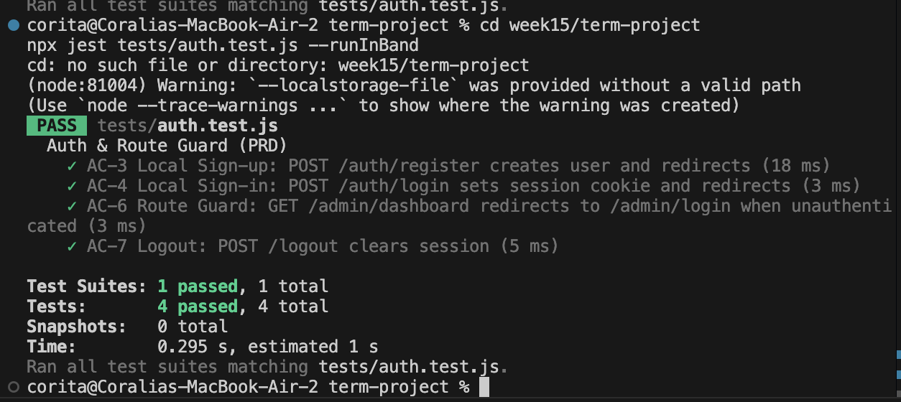

8. AI Attribution
• GitHub Copilot — used for grammar cleanup, formatting, and document organization only.

