4_LER_spad

Lucile regouby

21/11/2022

## Contexte sur l’analyse

We want to answer to this theme of our project weed regulation and competition in the cover, Assing this question : Which species work better in association as a cover crop?

## Importation of data an libraries

### Libraires importation

library(tidyverse)

## ── Attaching packages ─────────────────────────────────────── tidyverse 1.3.1 ──

## ✓ ggplot2 3.3.5 ✓ purrr 0.3.4  
## ✓ tibble 3.1.6 ✓ dplyr 1.0.8  
## ✓ tidyr 1.2.0 ✓ stringr 1.4.0  
## ✓ readr 2.1.2 ✓ forcats 0.5.1

## ── Conflicts ────────────────────────────────────────── tidyverse_conflicts() ──  
## x dplyr::filter() masks stats::filter()  
## x dplyr::lag() masks stats::lag()

library(ggplot2)  
library(agricolae)

### data importation

LER= read.table("4_LER.csv", header = TRUE,sep = ";", dec = ",")  
  
LER%>%  
 mutate(Line = as.integer(Line))

## Line Specie mono_mix zone biomass emergence_rate pre_LERp LERp  
## 1 1 Weed mono Z1 3.27 12 0.27 1.00000000  
## 2 1 Weed mono Z2 6.70 22 0.30 1.00000000  
## 3 1 Weed mono Z3 14.00 33 0.42 1.00000000  
## 4 2 Barley mix Z1 1.20 11 0.11 0.73820915  
## 5 2 Barley mix Z2 16.10 24 0.67 0.73970215  
## 6 2 Barley mix Z3 2.30 29 0.08 0.11404101  
## 7 2 Mustard mix Z1 5.60 9 0.62 1.69696968  
## 8 2 Mustard mix Z2 41.20 12 3.43 17.55681777  
## 9 2 Mustard mix Z3 1.50 12 0.13 0.26315789  
## 10 2 Weed mix Z1 9.90 20 0.50 1.81651376  
## 11 2 Weed mix Z2 1.70 0 Inf NA  
## 12 2 Weed mix Z3 12.40 25 0.50 1.16914287  
## 13 3 Radish mix Z1 2.70 7 0.39 0.11111111  
## 14 3 Radish mix Z2 42.60 9 4.73 0.78687127  
## 15 3 Radish mix Z3 4.60 6 0.77 1.36730360  
## 16 3 Fenugreek mix Z1 0.80 2 0.40 3.46666653  
## 17 3 Fenugreek mix Z2 0.40 11 0.04 0.10000001  
## 18 3 Fenugreek mix Z3 0.00 12 0.00 0.00000000  
## 19 3 Weed mix Z1 3.60 35 0.10 0.37745739  
## 20 3 Weed mix Z2 12.20 5 2.44 8.01194042  
## 21 3 Weed mix Z3 26.20 45 0.58 1.37238096  
## 22 4 Barley mix Z1 0.50 10 0.05 0.33834586  
## 23 4 Barley mix Z2 0.40 20 0.02 0.02205323  
## 24 4 Barley mix Z3 0.00 7 0.00 0.00000000  
## 25 4 Faba bean mix Z1 3.60 3 1.20 0.50000000  
## 26 4 Faba bean mix Z2 13.60 4 3.40 2.40707965  
## 27 4 Faba bean mix Z3 7.24 3 2.41 1.14920635  
## 28 4 Mustard mix Z1 0.01 0 Inf NA  
## 29 4 Mustard mix Z2 0.00 0 NaN NA  
## 30 4 Mustard mix Z3 0.60 8 0.08 0.15789474  
## 31 4 Weed mix Z1 4.10 31 0.13 0.48535068  
## 32 4 Weed mix Z2 2.70 24 0.11 0.36940299  
## 33 4 Weed mix Z3 15.30 31 0.49 1.16336407  
## 34 5 Barley mix Z1 2.40 27 0.09 0.60150376  
## 35 5 Barley mix Z2 19.70 28 0.70 0.77580120  
## 36 5 Barley mix Z3 1.70 12 0.14 0.20370371  
## 37 5 Faba bean mix Z1 2.00 1 2.00 0.83333333  
## 38 5 Faba bean mix Z2 8.40 6 1.40 0.99115044  
## 39 5 Faba bean mix Z3 11.70 5 2.34 1.11428571  
## 40 5 Weed mix Z1 10.20 41 0.25 0.91295593  
## 41 5 Weed mix Z2 3.20 4 0.80 2.62686571  
## 42 5 Weed mix Z3 19.50 33 0.59 1.39285715  
## 43 6 Barley mono Z1 7.98 54 0.15 1.00000000  
## 44 6 Barley mono Z2 26.30 29 0.91 1.00000000  
## 45 6 Barley mono Z3 30.60 44 0.70 1.00000000  
## 46 6 Weed mix Z1 4.50 22 0.20 0.75062550  
## 47 6 Weed mix Z2 5.70 8 0.71 2.33955227  
## 48 6 Weed mix Z3 2.20 6 0.37 0.86428573  
## 49 7 Radish mono Z1 24.30 7 3.47 1.00000000  
## 50 7 Radish mono Z2 78.20 13 6.02 1.00000000  
## 51 7 Radish mono Z3 7.85 14 0.56 1.00000000  
## 52 7 Weed mix Z1 4.30 25 0.17 0.63119266  
## 53 7 Weed mix Z2 0.90 3 0.30 0.98507464  
## 54 7 Weed mix Z3 9.50 38 0.25 0.58928572  
## 55 8 Fenugreek mono Z1 3.00 26 0.12 1.00000000  
## 56 8 Fenugreek mono Z2 4.00 11 0.36 1.00000000  
## 57 8 Fenugreek mono Z3 6.10 25 0.24 1.00000000  
## 58 8 Weed mix Z1 7.90 25 0.32 1.15963303  
## 59 8 Weed mix Z2 20.50 9 2.28 7.47927043  
## 60 8 Weed mix Z3 6.10 19 0.32 0.75676692  
## 61 9 Radish mix Z1 13.70 7 1.96 0.56378601  
## 62 9 Radish mix Z2 33.10 7 4.73 0.78607965  
## 63 9 Radish mix Z3 17.40 17 1.02 1.82540276  
## 64 9 Barley mix Z1 3.20 14 0.23 1.54672394  
## 65 9 Barley mix Z2 10.10 21 0.48 0.53032772  
## 66 9 Barley mix Z3 3.10 27 0.11 0.16509319  
## 67 9 Weed mix Z1 9.30 48 0.19 0.71100917  
## 68 9 Weed mix Z2 0.10 7 0.01 0.04690830  
## 69 9 Weed mix Z3 7.70 74 0.10 0.24527026  
## 70 10 Fenugreek mix Z1 1.70 10 0.17 1.47333327  
## 71 10 Fenugreek mix Z2 1.97 7 0.28 0.77392858  
## 72 10 Fenugreek mix Z3 1.80 8 0.23 0.92213115  
## 73 10 Barley mix Z1 0.40 11 0.04 0.24606974  
## 74 10 Barley mix Z2 13.30 18 0.74 0.81474440  
## 75 10 Barley mix Z3 5.80 19 0.31 0.43894049  
## 76 10 Weed mix Z1 15.60 23 0.68 2.48903072  
## 77 10 Weed mix Z2 3.30 3 1.10 3.61194035  
## 78 10 Weed mix Z3 11.60 16 0.73 1.70892859  
## 79 11 Faba bean mono Z1 9.60 4 2.40 1.00000000  
## 80 11 Faba bean mono Z2 22.60 16 1.41 1.00000000  
## 81 11 Faba bean mono Z3 18.90 9 2.10 1.00000000  
## 82 11 Weed mix Z1 10.50 26 0.40 1.48200422  
## 83 11 Weed mix Z2 0.40 2 0.20 0.65671643  
## 84 11 Weed mix Z3 7.70 18 0.43 1.00833335  
## 85 12 Mustard mix Z1 1.60 9 0.18 0.48484849  
## 86 12 Mustard mix Z2 37.00 7 5.29 27.02922019  
## 87 12 Mustard mix Z3 2.60 6 0.43 0.91228069  
## 88 12 Faba bean mix Z1 4.30 2 2.15 0.89583333  
## 89 12 Faba bean mix Z2 9.80 7 1.40 0.99115044  
## 90 12 Faba bean mix Z3 9.70 5 1.94 0.92380952  
## 91 12 Weed mix Z1 13.00 37 0.35 1.28936275  
## 92 12 Weed mix Z2 1.50 3 0.50 1.64179107  
## 93 12 Weed mix Z3 6.30 26 0.24 0.57115385  
## 94 13 Radish mix Z1 0.00 0 NaN NA  
## 95 13 Radish mix Z2 0.00 0 NaN NA  
## 96 13 Radish mix Z3 0.00 0 NaN NA  
## 97 13 Barley mix Z1 0.10 1 0.10 0.67669172  
## 98 13 Barley mix Z2 0.50 1 0.50 0.55133080  
## 99 13 Barley mix Z3 0.00 1 0.00 0.00000000  
## 100 13 Fenugreek mix Z1 1.70 5 0.34 2.94666655  
## 101 13 Fenugreek mix Z2 4.40 8 0.55 1.51250002  
## 102 13 Fenugreek mix Z3 0.00 8 0.00 0.00000000  
## 103 13 Weed mix Z1 11.60 30 0.39 1.41896026  
## 104 13 Weed mix Z2 11.20 52 0.22 0.70723309  
## 105 13 Weed mix Z3 11.50 31 0.37 0.87442397  
## 106 14 Mustard mono Z1 11.00 30 0.37 1.00000000  
## 107 14 Mustard mono Z2 8.80 45 0.20 1.00000000  
## 108 14 Mustard mono Z3 15.20 32 0.48 1.00000000  
## 109 14 Weed mix Z1 17.90 49 0.37 1.34057292  
## 110 14 Weed mix Z2 9.80 43 0.23 0.74835129  
## 111 14 Weed mix Z3 7.10 21 0.34 0.79693879  
## LER_cc  
## 1 NA  
## 2 NA  
## 3 NA  
## 4 2.4351788  
## 5 18.2965199  
## 6 0.3771989  
## 7 NA  
## 8 NA  
## 9 NA  
## 10 NA  
## 11 NA  
## 12 NA  
## 13 3.5777776  
## 14 0.8868713  
## 15 1.3673036  
## 16 NA  
## 17 NA  
## 18 NA  
## 19 NA  
## 20 NA  
## 21 NA  
## 22 0.8383459  
## 23 2.4291329  
## 24 1.3071011  
## 25 NA  
## 26 NA  
## 27 NA  
## 28 NA  
## 29 NA  
## 30 NA  
## 31 NA  
## 32 NA  
## 33 NA  
## 34 1.4348371  
## 35 1.7669516  
## 36 1.3179894  
## 37 NA  
## 38 NA  
## 39 NA  
## 40 NA  
## 41 NA  
## 42 NA  
## 43 NA  
## 44 NA  
## 45 NA  
## 46 NA  
## 47 NA  
## 48 NA  
## 49 NA  
## 50 NA  
## 51 NA  
## 52 NA  
## 53 NA  
## 54 NA  
## 55 NA  
## 56 NA  
## 57 NA  
## 58 NA  
## 59 NA  
## 60 NA  
## 61 2.1105099  
## 62 1.3164074  
## 63 1.9904959  
## 64 NA  
## 65 NA  
## 66 NA  
## 67 NA  
## 68 NA  
## 69 NA  
## 70 1.7194030  
## 71 1.5886730  
## 72 1.3610716  
## 73 NA  
## 74 NA  
## 75 NA  
## 76 NA  
## 77 NA  
## 78 NA  
## 79 NA  
## 80 NA  
## 81 NA  
## 82 NA  
## 83 NA  
## 84 NA  
## 85 1.3806818  
## 86 28.0203706  
## 87 1.8360902  
## 88 NA  
## 89 NA  
## 90 NA  
## 91 NA  
## 92 NA  
## 93 NA  
## 94 3.6233583  
## 95 2.0638308  
## 96 0.0000000  
## 97 NA  
## 98 NA  
## 99 NA  
## 100 NA  
## 101 NA  
## 102 NA  
## 103 NA  
## 104 NA  
## 105 NA  
## 106 NA  
## 107 NA  
## 108 NA  
## 109 NA  
## 110 NA  
## 111 NA

## 1. – LER Analysis – The mixed cover will be more productive in biomass than the monoculture cover.

### Complete LER analysis between all the treatments

graph of the values of LER in function of the treatment

LER%>%  
 filter( mono_mix == "mix") %>%  
 filter (Specie != "Weed") %>%  
 group_by(Line)%>%  
 summarise(mymean=mean(LER_cc, na.rm=T),  
 mysd=sd(LER_cc, na.rm=T))%>%  
 mutate(ymax=mymean+mysd, ymin=mymean-mysd) %>%  
 ggplot (aes(x = reorder(Line, mymean), y = mymean,  
 ymin=ymin, ymax=ymax, na.rm=T)) +   
 geom_point()+  
 geom_errorbar()+  
 labs(x="Line", y="LER value", title = "LER value in function of the treatment")

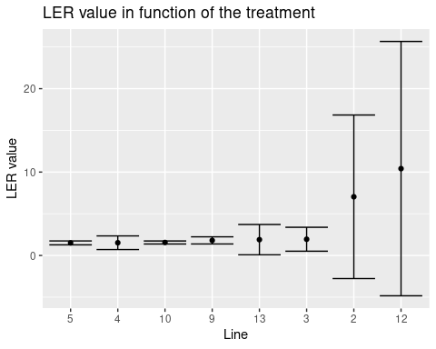

Test anova sur les LER :

anova.LER <-lm(LER_cc~Line, LER)  
anova(anova.LER)

## Analysis of Variance Table  
##   
## Response: LER_cc  
## Df Sum Sq Mean Sq F value Pr(>F)  
## Line 1 4.78 4.779 0.1162 0.7364  
## Residuals 22 904.67 41.121

not significative difference between the treatments

vérification des hypothèses de l’anova :

par(mfrow = c(2,2))  
plot(anova.LER)

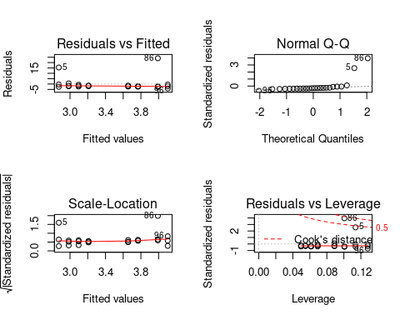

==> les points 5 et 86 sont trop différents des autres valeurs, on va les enlever

nouveau tableau sans les lignes 5 et 86 :

LER_best <- LER %>%  
 rownames_to_column("observation")%>%  
 filter (observation != 86)%>%  
 filter( observation != 5)

nouveau graphique :

LER_best%>%  
 filter( mono_mix == "mix") %>%  
 filter (Specie != "Weed") %>%  
 group_by(Line)%>%  
 summarise(mymean=mean(LER_cc, na.rm=T),  
 mysd=sd(LER_cc, na.rm=T))%>%  
 mutate(ymax=mymean+mysd, ymin=mymean-mysd) %>%  
 ggplot (aes(x = reorder(Line, mymean), y = mymean,  
 ymin=ymin, ymax=ymax, na.rm=T)) +   
 geom_point()+  
 geom_errorbar()+  
 labs(x="Line", y="LER value", title = "LER value in function of the treatment")

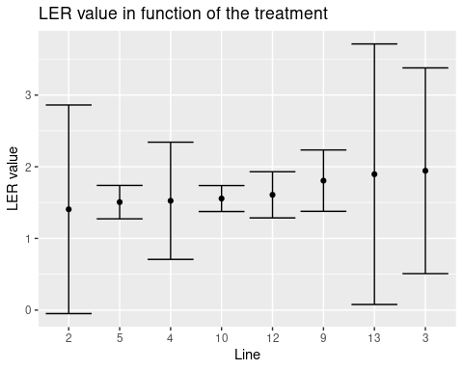

test avec une anova et vérification des hypothèses

anova.LER.best <-lm(LER_cc~Line, LER_best)  
anova(anova.LER.best)

## Analysis of Variance Table  
##   
## Response: LER_cc  
## Df Sum Sq Mean Sq F value Pr(>F)  
## Line 1 0.0716 0.07163 0.0923 0.7644  
## Residuals 20 15.5152 0.77576

par(mfrow = c(2,2))  
plot(anova.LER.best)

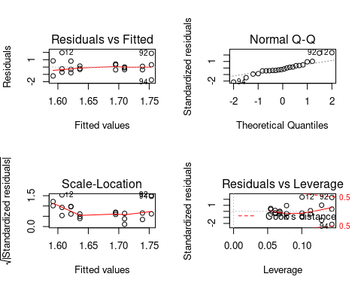 ### Analysis of the LERp for each specie between mix and monoculture

#### Radish

graphique du LERp entre tous les différents treatments où il y a du radis (mono ou mix)

LER%>%  
 filter( Specie == "Radish") %>%  
 group_by(Line)%>%  
 summarise(mymean=mean(LERp, na.rm=T),  
 mysd=sd(LERp, na.rm=T))%>%  
 mutate(ymax=mymean+mysd, ymin=mymean-mysd) %>%  
 ggplot (aes(x = reorder(Line, mymean), y = mymean,  
 ymin=ymin, ymax=ymax, na.rm=T)) +   
 geom_point()+  
 geom_errorbar()+  
 labs(x="Line", y="LERp value", title = "LERp value in function of the radish treatment (monoculture or mix)")

## Warning: Removed 1 rows containing missing values (geom_point).

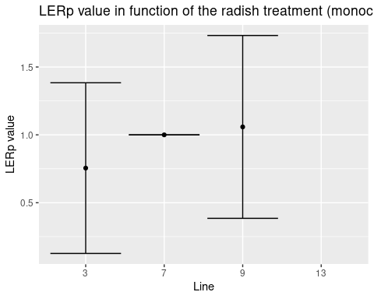 commentaire : la ligne 13 c’est un mélange avec le radis qui n’a pas marché du tout la ligne 7 c’est le radis en monoculture ==> normal qu’il n’y ai pas de variation ==> LERp=1

test avec une anova :

LER.radish <- LER%>%  
 filter( Specie == "Radish")  
anova.LER.radish <-lm(LERp~Line,LER.radish)  
anova(anova.LER.radish)

## Analysis of Variance Table  
##   
## Response: LERp  
## Df Sum Sq Mean Sq F value Pr(>F)  
## Line 1 0.15188 0.15188 0.625 0.4551  
## Residuals 7 1.70113 0.24302

pas de différence significative entre les treatments

vérifier les hypothèses de l’anova :

par(mfrow = c(2,2))  
plot(anova.LER.radish)

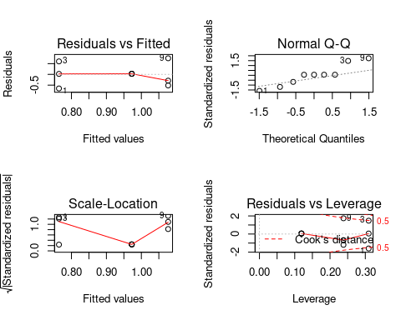 Pas ouff; la normalité est pas du tout respecté, on a vraiment très peu de valeurs pour le coup

test d’un kruskal

kruskal.radish <- kruskal(LER.radish$LERp, LER.radish$Line, console = T)

##   
## Study: LER.radish$LERp ~ LER.radish$Line  
## Kruskal-Wallis test's  
## Ties or no Ties  
##   
## Critical Value: 0.6436782  
## Degrees of freedom: 2  
## Pvalue Chisq : 0.7248148   
##   
## LER.radish$Line, means of the ranks  
##   
## LER.radish.LERp r  
## 3 4.333333 3  
## 7 6.000000 3  
## 9 4.666667 3  
##   
## Post Hoc Analysis  
##   
## t-Student: 2.446912  
## Alpha : 0.05  
## Minimum Significant Difference: 5.956573   
##   
## Treatments with the same letter are not significantly different.  
##   
## LER.radish$LERp groups  
## 7 6.000000 a  
## 9 4.666667 a  
## 3 4.333333 a

ils ne sont pas significativement différents

#### Barley

graphique du LERp de tous les treatment où il y a du barley (mono ou mix)

LER%>%  
 filter( Specie == "Barley") %>%  
 group_by(Line)%>%  
 summarise(mymean=mean(LERp, na.rm=T),  
 mysd=sd(LERp, na.rm=T))%>%  
 mutate(ymax=mymean+mysd, ymin=mymean-mysd) %>%  
 ggplot (aes(x = reorder(Line, mymean), y = mymean,  
 ymin=ymin, ymax=ymax, na.rm=T)) +   
 geom_point()+  
 geom_errorbar()+  
 labs(x="Line", y="LERp value", title = "LERp value in function of the barley treatment (monoculture or mix)")

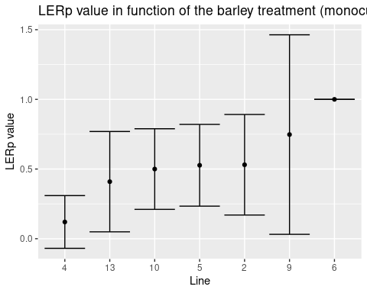 On peut quand même voir que la plus part des treatments ils sont en dessous de 1 / du controle en ligne 6

anova :

LER.B <- LER%>%  
 filter( Specie == "Barley")  
  
anova.LER.B <-lm(LERp~Line,LER.B)  
anova(anova.LER.B)

## Analysis of Variance Table  
##   
## Response: LERp  
## Df Sum Sq Mean Sq F value Pr(>F)  
## Line 1 0.0050 0.004998 0.0288 0.8671  
## Residuals 19 3.2988 0.173621

pas de différence significative entre les treatments

vérification des hypothèses de l’anova :

par(mfrow = c(2,2))  
plot(anova.LER.B)

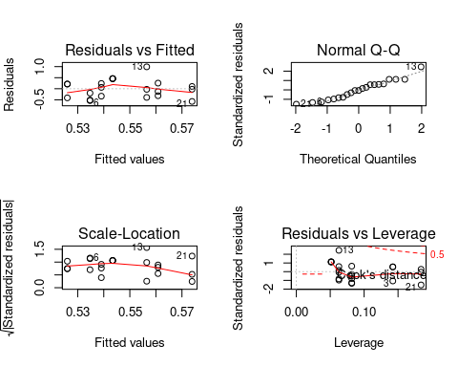 La normalité est pas ouf, le reste ça passe

test d’un kruskal, j’ai pas le droit mais j’en fait un quand même:

kruskal.B <- kruskal(LER.B$LERp, LER.B$Line, console = T)

##   
## Study: LER.B$LERp ~ LER.B$Line  
## Kruskal-Wallis test's  
## Ties or no Ties  
##   
## Critical Value: 9.229099  
## Degrees of freedom: 6  
## Pvalue Chisq : 0.1610977   
##   
## LER.B$Line, means of the ranks  
##   
## LER.B.LERp r  
## 2 11.000000 3  
## 4 4.166667 3  
## 5 11.333333 3  
## 6 19.000000 3  
## 9 12.000000 3  
## 10 11.000000 3  
## 13 8.500000 3  
##   
## Post Hoc Analysis  
##   
## t-Student: 2.144787  
## Alpha : 0.05  
## Minimum Significant Difference: 9.515348   
##   
## Treatments with the same letter are not significantly different.  
##   
## LER.B$LERp groups  
## 6 19.000000 a  
## 9 12.000000 ab  
## 5 11.333333 ab  
## 2 11.000000 ab  
## 10 11.000000 ab  
## 13 8.500000 b  
## 4 4.166667 b

Les lignes 4 et 13 c’est des mix de 3 espèces ==> pour celà qu’ils sont différents. La ligne 6 c’est le barley en monoculture

meilleur graphique :

#### Mustard

LER%>%  
 filter( Specie == "Mustard") %>%  
 group_by(Line)%>%  
 summarise(mymean=mean(LERp, na.rm=T),  
 mysd=sd(LERp, na.rm=T))%>%  
 mutate(ymax=mymean+mysd, ymin=mymean-mysd, ) %>%  
 ggplot (aes(x = reorder(Line, mymean), y = mymean,  
 ymin=ymin, ymax=ymax, na.rm=T)) +   
 geom_point()+  
 geom_errorbar()+  
 labs(x="Line", y="LERp value for mustard", title = "LERp value in function of the mustard treatment (monoculture or mix)")

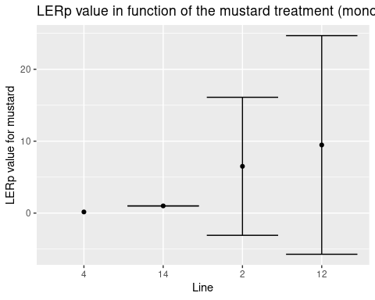 La ligne 14 c’est la moutarde en monoculture La ligne 4 : qu’une seule valeur pour une zone est valables

anova:

LER.m <- LER%>%  
 filter( Specie == "Mustard")  
  
anova.LER.m <-lm(LERp~Line,LER.m)  
anova(anova.LER.m)

## Analysis of Variance Table  
##   
## Response: LERp  
## Df Sum Sq Mean Sq F value Pr(>F)  
## Line 1 2.65 2.647 0.0271 0.8734  
## Residuals 8 782.08 97.760

pas de différence significative vérification des hypothèses

par(mfrow = c(2,2))  
plot(anova.LER.m)

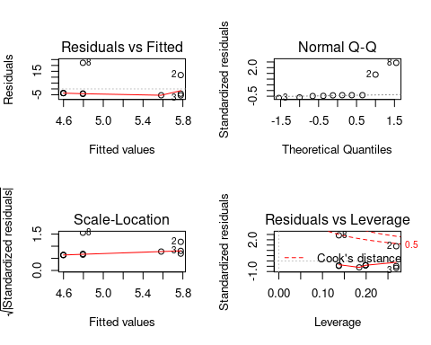 encore une fois on a vraiment très peu de valeurs dont 2 valeurs qui sont pas ouf (la 2 et la 8)

test sans ces 2 valeurs : ==> en vrai flemme de ouf

#### Faba bean

LER%>%  
 filter( Specie == "Faba bean") %>%  
 group_by(Line)%>%  
 summarise(mymean=mean(LERp, na.rm=T),  
 mysd=sd(LERp, na.rm=T))%>%  
 mutate(ymax=mymean+mysd, ymin=mymean-mysd, ) %>%  
 ggplot (aes(x = reorder(Line, mymean), y = mymean,  
 ymin=ymin, ymax=ymax, na.rm=T)) +   
 geom_point()+  
 geom_errorbar()+  
 labs(x="Line", y="LERp value for faba bean", title = "LERp value in function of the faba bean treatment (monoculture or mix)")

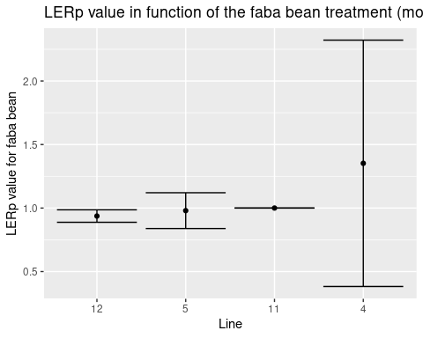 Line 4 : mix of 3 Line 11: Faba bean in monoculture

LER.fb <- LER%>%  
 filter( Specie == "Faba bean")  
  
anova.LER.fb <-lm(LERp~Line,LER.fb)  
anova(anova.LER.fb)

## Analysis of Variance Table  
##   
## Response: LERp  
## Df Sum Sq Mean Sq F value Pr(>F)  
## Line 1 0.15349 0.15349 0.7301 0.4128  
## Residuals 10 2.10218 0.21022

pas de différence significatif

par(mfrow = c(2,2))  
plot(anova.LER.fb)

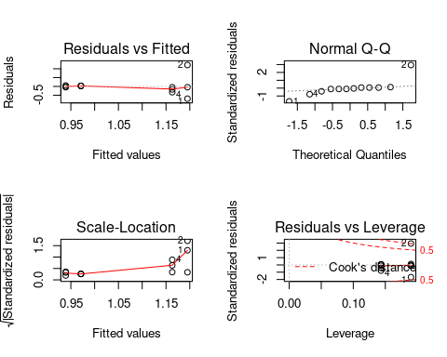

Pas ouf mais de toute façon pas énormément de valeurs

#### Fenugreek

LER%>%  
 filter( Specie == "Fenugreek") %>%  
 group_by(Line)%>%  
 summarise(mymean=mean(LERp, na.rm=T),  
 mysd=sd(LERp, na.rm=T))%>%  
 mutate(ymax=mymean+mysd, ymin=mymean-mysd, ) %>%  
 ggplot (aes(x = reorder(Line, mymean), y = mymean,  
 ymin=ymin, ymax=ymax, na.rm=T)) +   
 geom_point()+  
 geom_errorbar()+  
 labs(x="Line", y="LERp value for fenugreek", title = "LERp value in function of the fenugreek treatment (monoculture or mix)")

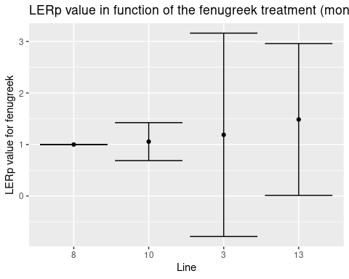 Line 8: monoculture Line 3: mix of 2 Line 13: mix of 3

LER.fn <- LER%>%  
 filter( Specie == "Fenugreek")  
  
anova.LER.fn <-lm(LERp~Line,LER.fn)  
anova(anova.LER.fn)

## Analysis of Variance Table  
##   
## Response: LERp  
## Df Sum Sq Mean Sq F value Pr(>F)  
## Line 1 0.0863 0.08627 0.0677 0.8  
## Residuals 10 12.7400 1.27400

pas de différence significative

par(mfrow = c(2,2))  
plot(anova.LER.fn)

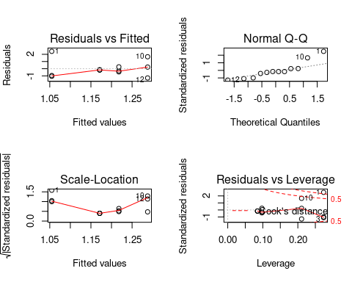 pas ouf

## Spad analysis

### importation of the data and pivot :

spad_ini= read.table("4_spad.csv", header = TRUE,sep = ";", dec = ",")  
  
spad_ini%>%  
 mutate(Line = as.integer(Line), nature=as.factor(nature),  
 legumes=as.factor(legumes), Date=as.factor(Date))

## Date Line Specie nature legumes Z1 Z1.1 Z1.2 Z1.3 Z1.4 Z2 Z2.1  
## 1 17/10 2 Barley mix no 101.4 63.9 97.9 53.4 42.9 63.7 101.0  
## 2 17/10 2 Mustard mix no 35.7 58.3 36.5 36.8 35.6 31.2 29.3  
## 3 17/10 3 Radish mix yes 36.9 36.2 34.7 34.3 33.8 35.1 31.1  
## 4 17/10 3 Fenugreek mix yes 47.4 49.1 54.0 47.4 47.6 46.7 44.4  
## 5 17/10 4 Barley mix yes 34.9 36.6 39.3 NA 39.3 87.3 38.4  
## 6 17/10 4 Faba bean mix yes 42.5 44.9 44.1 44.1 44.8 38.1 52.4  
## 7 17/10 4 Mustard mix yes 41.5 39.3 34.6 34.4 35.4 32.2 36.9  
## 8 17/10 5 Barley mix yes 34.3 44.6 42.3 41.2 36.9 37.9 39.6  
## 9 17/10 5 Faba bean mix yes 41.1 41.6 43.0 41.8 42.0 35.6 47.2  
## 10 17/10 6 Barley mono no 43.0 40.8 41.9 39.4 41.4 52.7 114.3  
## 11 17/10 7 Radish mono no 44.8 39.3 30.0 33.0 28.4 30.9 32.3  
## 12 17/10 8 Fenugreek mono yes 39.8 39.1 41.2 40.6 41.6 46.1 45.4  
## 13 17/10 9 Radish mix no 30.9 29.5 29.0 29.1 29.2 34.5 37.4  
## 14 17/10 9 Barley mix no 39.5 37.6 36.4 38.2 35.8 38.1 39.3  
## 15 17/10 10 Fenugreek mix yes 48.5 53.5 52.5 47.7 54.0 NA NA  
## 16 17/10 10 Barley mix yes 11.9 55.5 41.7 40.3 40.7 27.5 26.2  
## 17 17/10 11 Faba bean mono yes NA 46.7 46.3 45.9 46.4 44.5 51.7  
## 18 17/10 12 Mustard mix yes 34.9 32.8 33.4 34.0 32.8 29.4 NA  
## 19 17/10 12 Faba bean mix yes 43.7 43.8 43.5 43.8 43.9 38.3 38.7  
## 20 17/10 13 Radish mix yes 24.4 24.3 24.0 24.2 24.3 30.1 29.8  
## 21 17/10 13 Barley mix yes 35.9 36.8 37.4 37.2 37.9 39.5 38.8  
## 22 17/10 13 Fenugreek mix yes 45.0 45.2 45.3 47.0 47.5 40.8 38.7  
## 23 17/10 14 Mustard mono no 30.7 31.1 NA 31.7 32.0 31.1 31.7  
## 24 07/11 2 Barley mix no 35.3 35.8 34.2 33.7 33.6 47.5 47.9  
## 25 07/11 2 Mustard mix no 29.8 28.8 29.1 28.9 30.1 30.0 28.7  
## 26 07/11 3 Radish mix yes 30.7 30.5 30.5 30.5 30.7 35.1 35.7  
## 27 07/11 3 Fenugreek mix yes 32.9 29.7 29.5 25.6 27.0 45.8 46.0  
## 28 07/11 4 Barley mix yes 30.8 28.6 27.6 25.9 26.1 46.0 47.5  
## 29 07/11 4 Faba bean mix yes 40.9 40.4 40.1 40.4 40.3 44.2 34.4  
## 30 07/11 4 Mustard mix yes 30.9 30.3 30.5 29.9 29.9 31.3 31.1  
## 31 07/11 5 Barley mix yes 30.8 31.1 31.0 31.0 31.2 48.3 47.6  
## 32 07/11 5 Faba bean mix yes 39.9 38.0 38.2 38.1 38.0 47.1 43.3  
## 33 07/11 6 Barley mono no 39.5 38.7 38.7 38.3 38.9 40.9 40.6  
## 34 07/11 7 Radish mono no 31.1 32.3 32.1 32.4 31.5 36.3 36.4  
## 35 07/11 8 Fenugreek mono yes 42.3 41.8 41.0 40.9 40.9 40.2 40.1  
## 36 07/11 9 Radish mix no 28.8 28.2 28.3 28.2 28.2 32.0 30.8  
## 37 07/11 9 Barley mix no 29.7 28.1 29.0 29.5 26.6 36.7 35.5  
## 38 07/11 10 Fenugreek mix yes 37.1 36.9 37.2 36.9 36.7 44.2 44.1  
## 39 07/11 10 Barley mix yes 33.4 33.4 33.4 33.3 25.6 40.4 41.8  
## 40 07/11 11 Faba bean mono yes 32.9 32.6 33.2 33.3 33.5 43.7 42.6  
## 41 07/11 12 Mustard mix yes 24.9 24.7 24.9 23.3 27.0 23.8 24.2  
## 42 07/11 12 Faba bean mix yes 38.2 38.5 36.3 34.9 34.9 39.0 38.7  
## 43 07/11 13 Radish mix yes 21.3 21.7 22.0 21.9 22.1 37.7 37.4  
## 44 07/11 13 Barley mix yes 34.4 34.6 34.2 35.4 35.8 41.8 46.2  
## 45 07/11 13 Fenugreek mix yes 38.2 37.7 37.2 37.0 36.9 40.7 41.6  
## 46 07/11 14 Mustard mono no 56.7 55.1 54.7 33.3 32.4 27.5 27.1  
## Z2.2 Z2.3 Z2.4 Z3 Z3.1 Z3.2 Z3.3 Z3.4  
## 1 99.4 101.0 95.9 25.2 38.3 47.3 35.7 44.1  
## 2 29.2 28.0 31.6 29.3 28.9 30.3 29.2 28.8  
## 3 33.4 33.5 33.1 27.2 26.4 26.7 31.6 25.6  
## 4 45.3 45.1 45.8 43.1 42.9 37.8 43.5 44.2  
## 5 96.6 82.0 58.6 27.0 29.4 31.6 28.6 30.0  
## 6 40.2 51.5 50.1 66.2 43.3 43.2 45.6 43.4  
## 7 33.3 32.6 34.2 20.1 31.8 31.5 31.5 31.7  
## 8 37.3 37.4 37.4 40.8 41.1 41.0 41.1 41.2  
## 9 37.7 36.3 35.8 43.7 41.0 38.5 41.7 41.8  
## 10 94.4 101.8 92.8 31.5 37.3 35.6 36.5 36.3  
## 11 32.9 29.7 32.5 25.6 26.2 27.1 27.7 26.9  
## 12 45.7 45.2 45.5 40.5 42.9 42.3 61.7 61.1  
## 13 34.1 37.4 36.3 30.9 30.6 30.7 29.5 31.0  
## 14 39.4 38.0 38.5 41.9 40.3 42.3 43.2 44.1  
## 15 NA 40.0 39.8 38.3 42.8 39.9 39.7 79.9  
## 16 19.9 25.9 23.2 38.7 39.0 39.4 38.9 40.1  
## 17 50.4 51.5 52.0 37.5 33.7 36.9 35.4 34.4  
## 18 21.0 20.8 26.9 34.3 34.1 35.6 28.6 29.9  
## 19 37.3 38.8 38.2 41.2 41.0 41.0 40.6 NA  
## 20 30.1 29.9 29.6 28.5 27.7 27.9 28.9 29.0  
## 21 38.8 38.9 39.4 42.7 36.5 37.3 37.1 37.2  
## 22 NA 41.0 38.1 42.7 43.6 44.2 45.6 45.2  
## 23 32.4 31.9 31.3 31.1 30.8 30.7 30.8 39.8  
## 24 47.6 47.2 46.4 41.0 40.6 39.1 38.4 37.5  
## 25 28.4 28.9 28.8 28.7 28.8 28.5 28.6 28.5  
## 26 35.8 36.3 36.4 24.7 24.3 23.8 24.0 23.8  
## 27 44.7 41.3 41.0 32.5 34.1 30.8 30.1 29.9  
## 28 47.3 47.3 47.2 28.3 28.2 28.5 28.4 28.4  
## 29 34.9 34.8 34.7 39.2 39.3 37.9 37.6 37.7  
## 30 30.8 30.8 30.8 30.0 29.8 29.9 30.3 30.0  
## 31 41.6 39.1 38.0 39.4 37.5 40.7 40.0 39.9  
## 32 44.7 44.5 44.7 37.8 37.9 36.1 36.1 35.6  
## 33 40.6 40.5 40.5 24.9 24.8 24.9 24.0 24.0  
## 34 36.5 36.8 35.9 32.8 33.8 32.9 33.1 33.8  
## 35 49.8 64.9 40.4 48.9 49.1 49.1 50.2 50.1  
## 36 29.4 30.3 30.9 24.4 24.6 24.7 24.5 24.6  
## 37 36.1 36.3 36.7 40.8 38.5 39.1 39.7 42.0  
## 38 44.3 45.1 45.5 42.2 42.4 40.3 39.3 40.5  
## 39 41.4 42.4 39.4 40.6 37.3 35.0 2.2 37.2  
## 40 42.7 42.3 42.3 36.7 37.0 38.5 39.8 38.7  
## 41 26.7 23.0 23.0 30.7 30.6 30.7 30.5 30.7  
## 42 38.7 38.9 39.1 42.1 42.4 42.0 42.0 42.0  
## 43 37.5 37.2 35.7 34.8 31.7 29.3 29.2 28.1  
## 44 26.3 39.7 39.6 97.2 69.5 61.1 63.8 67.6  
## 45 41.4 40.0 41.0 43.8 40.9 72.2 81.2 84.1  
## 46 26.8 26.4 26.2 44.4 39.3 43.3 43.6 45.0

spad <- spad_ini %>%  
 pivot_longer(cols = Z1:Z3.4,   
 names_to = "zone", values_to = "spad_value" )

We have a problem for the zones because the zones 1 don’t have the same name

### spad analysis for the first date

#### For all the treatments

spad%>%  
 filter( Date == "17/10") %>%  
 group_by(Line)%>%  
 summarise(mymean=mean(spad_value, na.rm=T),  
 mysd=sd(spad_value, na.rm=T))%>%  
 mutate(ymax=mymean+mysd, ymin=mymean-mysd) %>%  
 ggplot (aes(x = reorder(Line, mymean), y = mymean,  
 ymin=ymin, ymax=ymax, na.rm=T)) +   
 geom_point()+  
 geom_errorbar()+  
 labs(x="Line", y="spad value", title = "Sapad value in function of the treatment")

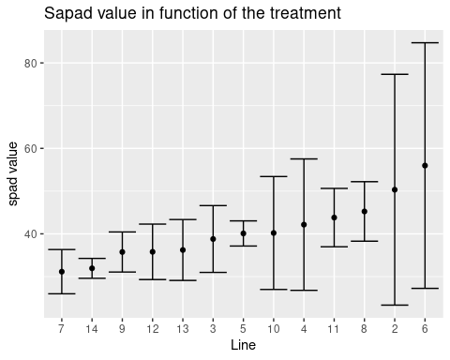

#### For barley

#### For mustard

#### Radish

#### For Faba bean

#### Fenugreek

### Spad analysis for the second date

Note that the echo = FALSE parameter was added to the code chunk to prevent printing of the R code that generated the plot.