Kickstart My Chart

Over two billion dollars have been raised using the massively successful crowdfunding service, Kickstarter, but not every project has found success. Of the over 300,000 projects launched on Kickstarter, only a third have made it through the funding process with a positive outcome.
Since getting funded on Kickstarter requires meeting or exceeding the project's initial goal, many organizations spend months looking through past projects in an attempt to discover some trick to finding success. So, we organized and analyzed a database of four thousand past projects in order to uncover any hidden trends.
The Excel table contains data of four thousand past Kickstarter projects to help uncover some of the market trends.

Outcomes

The `state` column is color coded, depending on whether the associated campaign was "successful," "failed," "cancelled," or is currently "live".

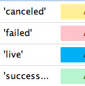

Percent Funded

The `percent funded` column has a three-color scale. The scale starts at 0 with a dark shade of red, transitions to green at 100, and then moving towards blue at 200.
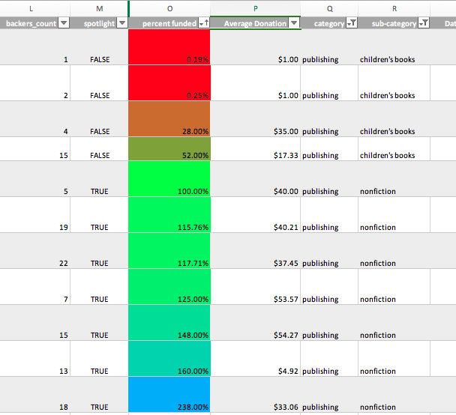

Category Stats

This pivot table analyzes the worksheet to count how many campaigns were "successful," "failed," "cancelled," or are currently "live" per **category**. The stacked column pivot chart can be filtered by `country` based on the table.
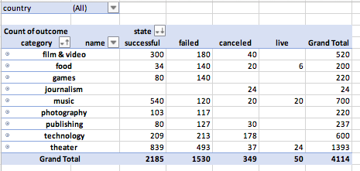
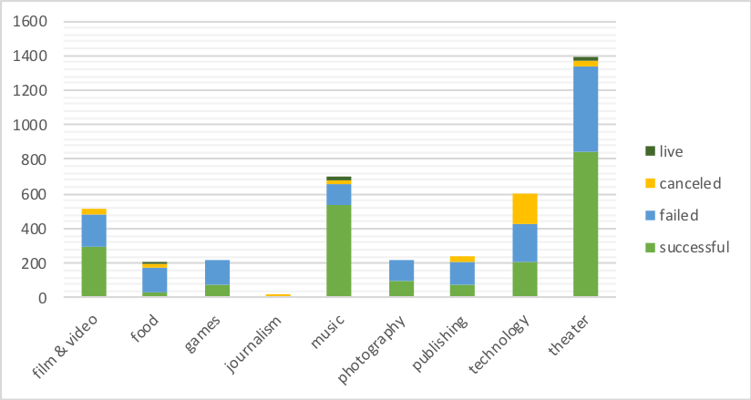
Sub-category Stats
This pivot table analyzes the worksheet to count how many campaigns were "successful," "failed," "cancelled," or are currently "live" per **sub category**. The stacked column pivot chart can be filtered by `country` and ‘parent category’ based on the table.
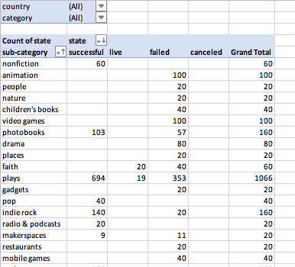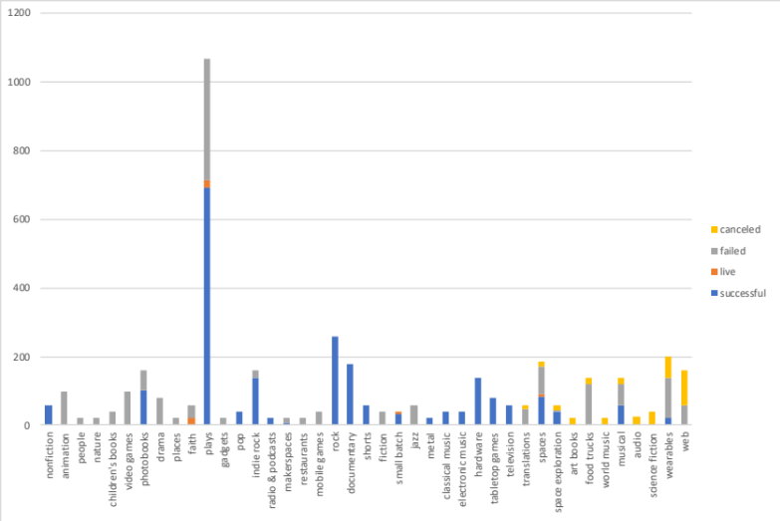
Outcomes Based on Launch Date

This pivot table has a column of `state`, rows of `Date Created Conversion`, values based on the count of `state`, and filters based on `parent category` and `Years`. The pivot chart line graph that visualizes this new table.
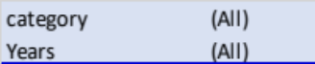
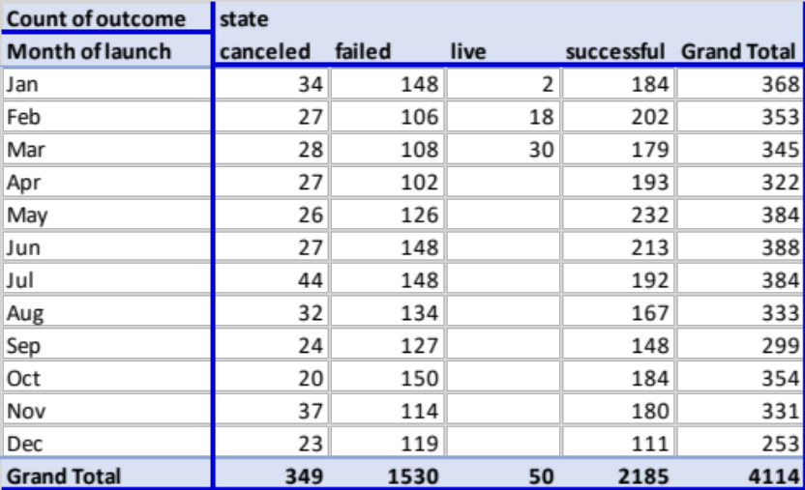
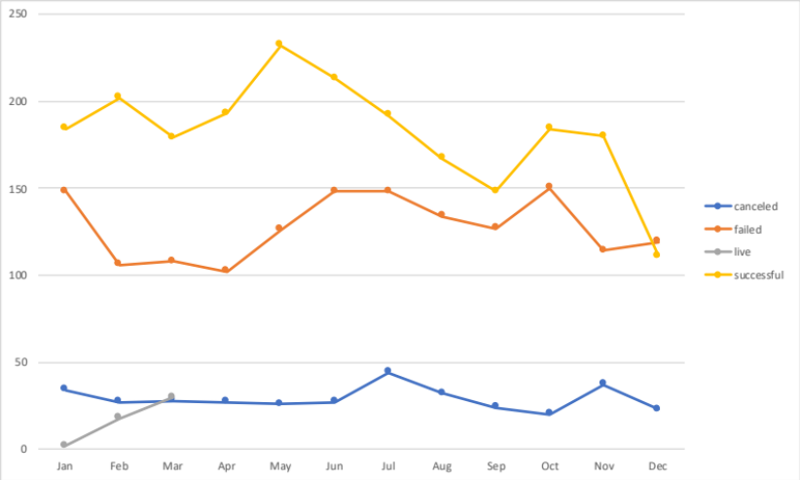

Outcomes based on Goals

The following table and accompanying line chart graph the relationship between a startup’s goal amount and its chances at success, failure, or cancellation.
