Waste Motor Oil / Vegetable Oil Refinery
This SDD Includes Interface and Electrical Design documentation.
Designed and built by: Corbin Probasco
August 2026

Temp sensors (10K NTC3950)
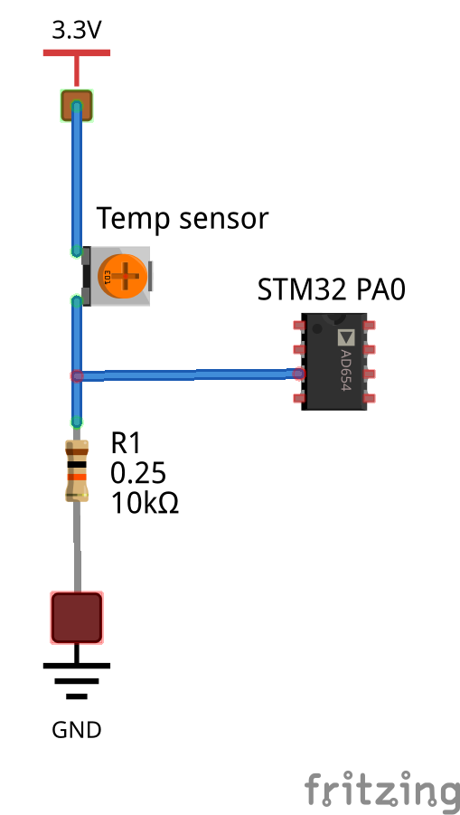
10K NTC3950 thermistor, resistance table computed from the Beta equation (R = R25 x exp(B x (1/T - 1/T25)), R25=10000 ohm, B=3950). ADC raw column assumes the divider 3.3V -> thermistor -> ADC pin -> 10k fixed resistor -> GND, 12-bit ADC (0-4095). Note the 25C row lands at exactly half-scale (2048), confirming the 10k fixed resistor is well matched to this thermistor. ADC reading rises as temperature rises with this wiring orientation, matching the level sender's convention below (higher ADC = more of what's being measured).
Temp (C) | Temp (F) | Resistance (ohm) | ADC raw (12-bit)
-10 | 14 | 58380 | 600
-5 | 23 | 44040 | 757
0 | 32 | 33530 | 940
5 | 41 | 25940 | 1139
10 | 50 | 20176 | 1357
15 | 59 | 15838 | 1585
20 | 68 | 12540 | 1817
25 | 77 | 10000 | 2047
30 | 86 | 8041 | 2270
35 | 95 | 6505 | 2481
40 | 104 | 5301 | 2676
45 | 113 | 4349 | 2854
50 | 122 | 3588 | 3014
55 | 131 | 2979 | 3155
60 | 140 | 2487 | 3279
65 | 149 | 2088 | 3388
70 | 158 | 1762 | 3482
75 | 167 | 1493 | 3563
80 | 176 | 1271 | 3633
85 | 185 | 1087 | 3694
90 | 194 | 934 | 3745
95 | 203 | 805 | 3790
100 | 212 | 698 | 3828

Tank Level Sensors
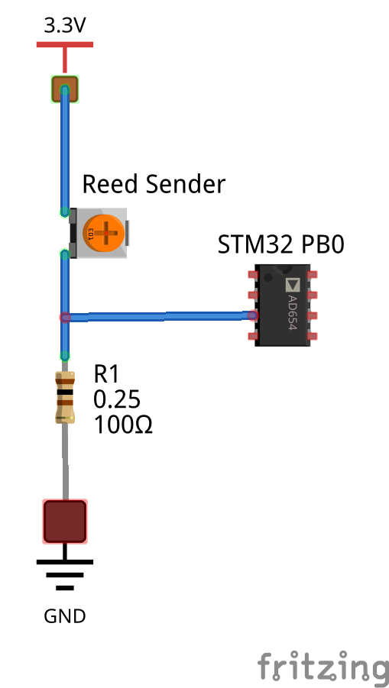
Marine reed/float level sender, American/SAE standard, measured 240 ohm empty (float down) to 33 ohm full (float up). Divider uses a 100 ohm fixed resistor: 3.3V -> sender -> ADC pin -> 100 ohm -> GND. With this wiring orientation ADC reading rises as the tank fills. Table assumes resistance varies linearly with float position across the sender's travel; this is the standard assumption for this type of sender but has not been verified against the physical unit, calibrate against known fill levels before trusting absolute values. 12-bit ADC (0-4095).
Fill (%) | Resistance (ohm) | ADC raw (12-bit)
0 | 240.0 | 1204
10 | 219.3 | 1282
20 | 198.6 | 1371
30 | 177.9 | 1474
40 | 157.2 | 1592
50 | 136.5 | 1732
60 | 115.8 | 1898
70 | 95.1 | 2099
80 | 74.4 | 2348
90 | 53.7 | 2664
100 | 33.0 | 3079

STM32 Pin Assignments
GPIO Outputs - Arduino Header
Signal | Pin | STM32
Tank 1 Solenoid | D2 | PA10
Tank 2 Solenoid | D3 | PB3
Tank 1 Heater | D4 | PB5
Tank 2 Heater | D5 | PB4
Nozzle Heater | D6 | PB10
Fire Ext Extend | D7 | PA8
Fire Ext Retract | D8 | PA9
Centerfuge Motor | D9 | PC7
GPIO Inputs - Morpho Header CN10
Signal | Pin
Flame Sensor 1 | PB1
Flame Sensor 2 | PB2
Flame Sensor 3 | PC5
ADC Inputs - Arduino Header
Signal | Pin | STM32
Tank 1 Temp | A0 | PA0
Tank 2 Temp | A1 | PA1
Nozzle Temp | A2 | PA4
Tank 1 Level | A3 | PB0
Tank 2 Level | A4 | PC1
Serial - USART2
Signal | Pin | STM32
TX | (Arduino)D10 | PB6
RX | (MorphoCN7) | PB7
Raspberry Pi Pin Assignments
Serial USART2
Signal | Pin | STM32 Connection
TX | TXD Pin 8 | PB7
RX | RXD Pin 10 | PB6
Ground | GND Pin 6 | STM32 GND

Pinout Diagrams
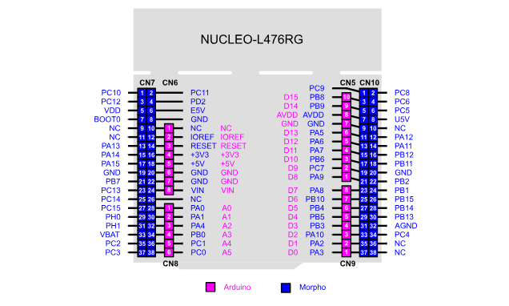
STM32 Nucleo-L476RG

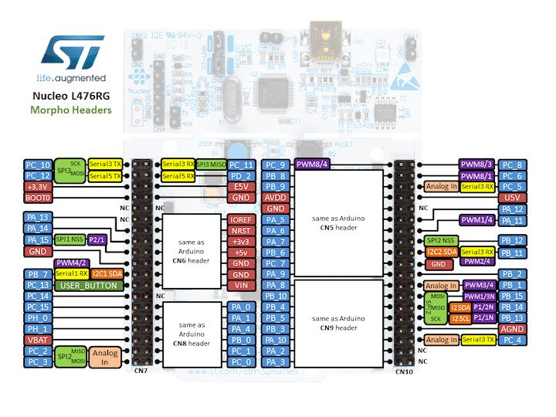

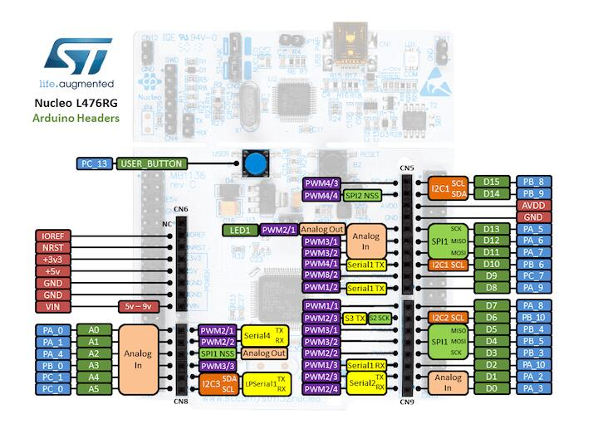
Raspberry Pi 2 Model B
