Project 6: PHP email

Jason Travis

October 24, 2013

CS 212

# Overview

cefns.nau.edu/~jlt256/archive/cs212/contact.php

## Purpose

Use PHP to send an email

## Approach

The script reached a sufficient complexity that it made sense to organize the functions into class and as before I made sure to escape all user input.

There was an issue with the mail function mime type header and gmail displaying newlines. I did not test other mail servers, but when the mime type header was specified as required by the PHP mail function documentation the message newline characters would not display. When the header was omitted, the message displayed as expected. To resolve the issue I commented out the mime type and charset headers with a comment noting their purpose and the error encountered.

In the previous project all the random data files were loaded into memory, but that seemed really inefficient since they were not all needed in all cases. I spent some time thinking about how to organize the script so the files would only be loaded if required, but the solutions I was coming up with were haphazard and increased coupling. I finally settled on the current structure where the insults file was loaded by the isValid method and the rest are loaded by the display method. This made the data available where required, but obscured the dependencies.

There was a software engineering conference presentation on youtube where the speaker had an interesting solution to the hidden dependency problem. As a hard and fast rule, all dependencies should be passed in as parameters. If the parameter list is too long, the method or object probably has too many responsibilities. I don’t like the parameters, but I do like how they make the dependencies clear.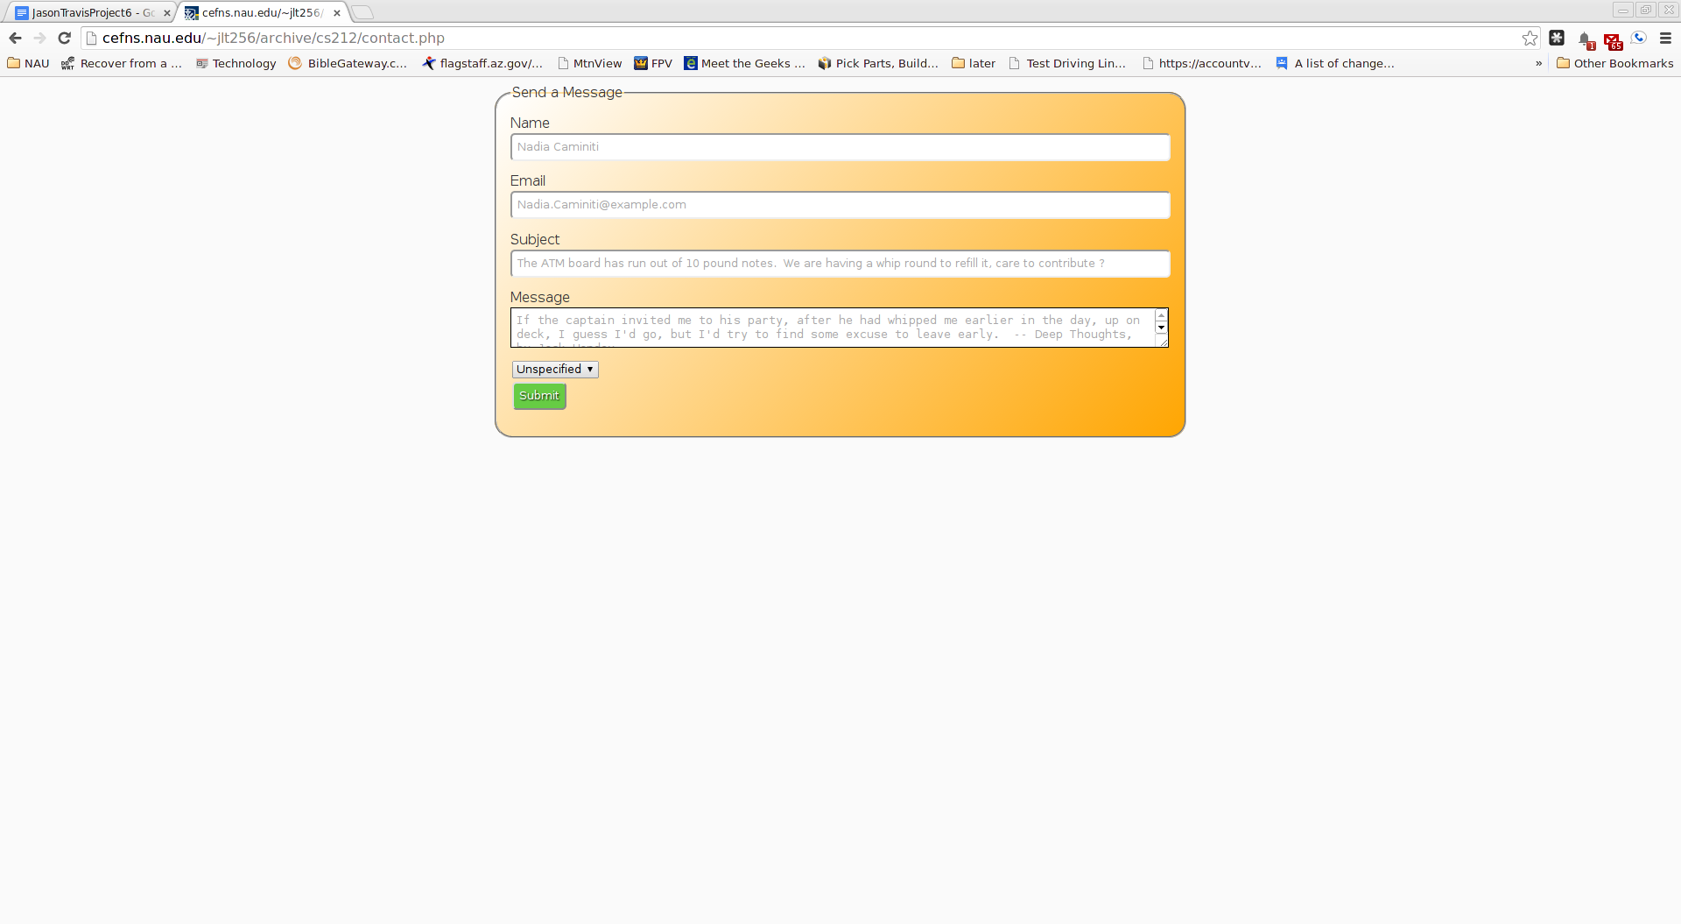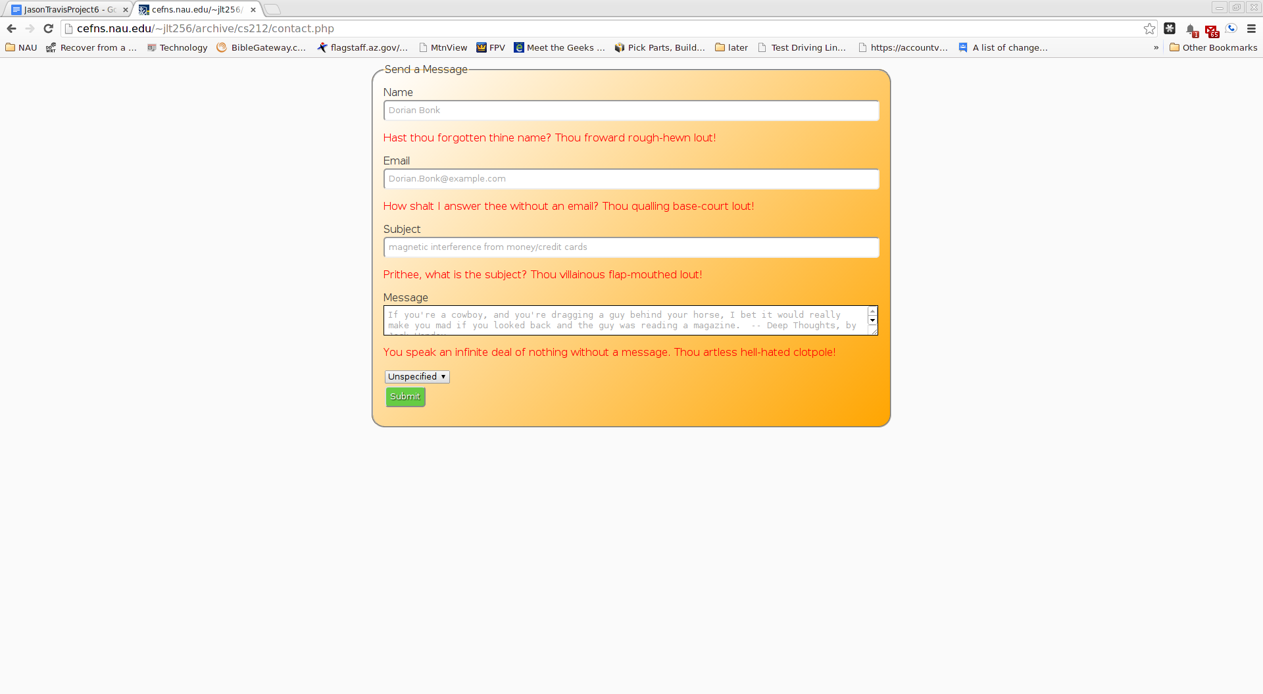

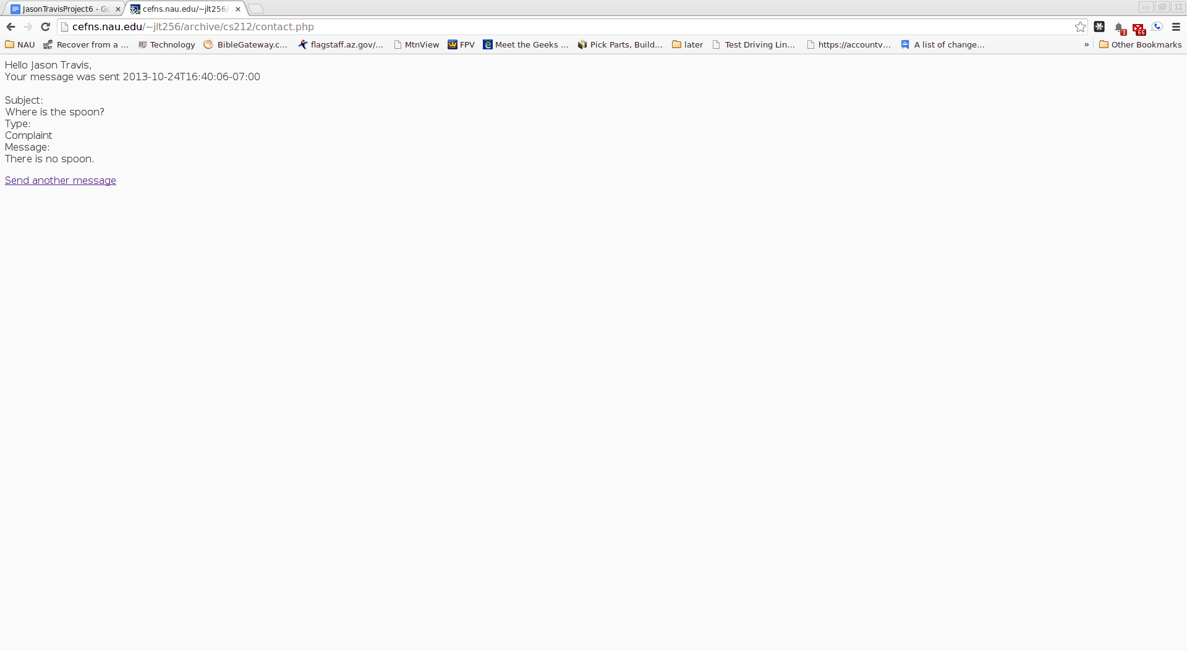

# Conclusion

There are many Schools of Thought regarding PHP best practices. PHP is easy to use, the difficulty is figuring out how to not shoot yourself in the foot because there are so many simple, long-established security holes that are non-obvious. What would be more valuable than a web design course would be a web security course. I would not want to seriously hire someone to build a web application who wasn’t familiar with how to prevent bread and butter attacks such as MySQL injection and cross-site scripting.