Software Requirements Specification
for a
Twitter-like Service
Version 1.0 approved
Prepared by:
Omar Negron
Greg Paris
Lucas Gramlin
Corbin Combs
Chaitali Chaudhari
CSCI 45000 – Software Engineering
October 12, 2014
Table of Contents
Table of Contents ii
Revision History ii
1. Introduction 1
1.1 Purpose 1
1.2 Document Conventions 1
1.3 Intended Audience and Reading Suggestions 1
1.4 Product Scope 1
1.5 References 1
2. Overall Description 2
2.1 Product Perspective 2
2.2 Product Functions 2
2.3 User Classes and Characteristics 2
2.4 Operating Environment 2
2.5 Design and Implementation Constraints 2
2.6 User Documentation 3
2.7 Assumptions and Dependencies 3
3. External Interface Requirements 3
3.1 User Interfaces 3
3.2 Hardware Interfaces 5
3.3 Software Interfaces 5
3.4 Communications Interfaces 5
4. System Features 5
4.1 Posts 5
4.2 Users can only access if logged in 6
4.3 Friends 8
4.4 Password Reset 9

5. Other Nonfunctional Requirements 10
5.1 Performance Requirements 10
5.2 Safety Requirements 10
5.3 Security Requirements 11
5.4 Software Quality Attributes 11
6. Other Requirements 11

Revision History
Name | Date | Reason For Changes | Version

Introduction

Purpose
This document provides all of the requirements for the Twitter-like service. This SRS covers the all of the requirements for the entire system.

Document Conventions
Priorities for higher-level requirements are assumed to be inherited by detailed requirements and every requirement statement is to have its own priority.

Intended Audience and Reading Suggestions
Parts 1 and 2 are intended primarily for customers of the application but will also be of interest to software engineers. Part 1 contains general information such as conventions, scope and references, while part 2 states a high level view of the requirements. Parts 3, 4, and 5 are intended primarily for software engineers, but will also be of interest to customers. Part 3 includes the external interface requirements. Part 4 describes the system features, while part 5 outlines other non-functional requirements such as performance, security, and business rules. Readers are encouraged to read the sections following the numerical ordered in which they are presented.

Product Scope
This product’s goal is to provide a simple social media service similar to Twitter allowing users to communicate through short messages. In addition, it is also a chance for understanding and applying practices of software engineering learned during the course.

References
None.

Overall Description

Product Perspective
This product is a stand-alone product and should be completely self-contained. It may rely on other existing technologies, but it is not a subcomponent of another system. It is being developed solely for the purposes of the class.

Product Functions
This section specifies the overall functionality of the application, without worrying about details. Section 4 provides the requirements in complete detail.

Login Use Case
Actor: Twitter-like service member
Use case:
- User creates an account in the service
- After creating an account in the system, user is required to log in to the website to use the account.

- Users should be able to post “Tweets”
- Users should be able to have “Friends.” Users who are Friends can see one another’s Tweets.

User Classes and Characteristics
<Identify the various user classes that you anticipate will use this product. User classes may be differentiated based on frequency of use, subset of product functions used, technical expertise, security or privilege levels, educational level, or experience. Describe the pertinent characteristics of each user class. Certain requirements may pertain only to certain user classes. Distinguish the most important user classes for this product from those who are less important to satisfy.>

Operating Environment
The software should operate in a standard web browser. It should function properly regardless of the hardware, operating system, or other requirements beyond those needed to run the browser itself.

Design and Implementation Constraints
The major limitations for this project will be the time constraints, as the entire project must be completed and delivered within the course of a semester. There are few or no restrictions on what types of programming technologies or tools are allowed. It is assumed that this design only has English-speaking users in mind, though future iterations could include multi-language support.

User Documentation
No user manuals or help documents are required for this project. However, this may be something to be looked into adding if time constraints allow.

Assumptions and Dependencies
None.

External Interface Requirements

User Interfaces
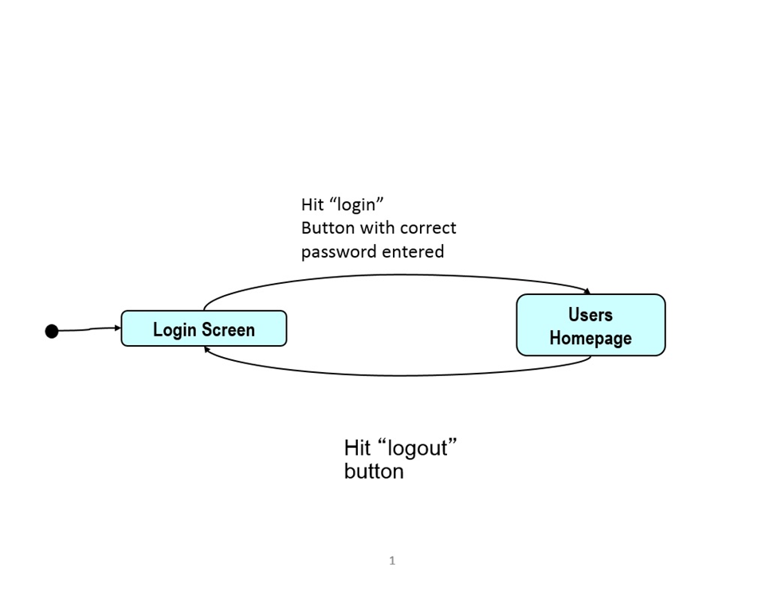

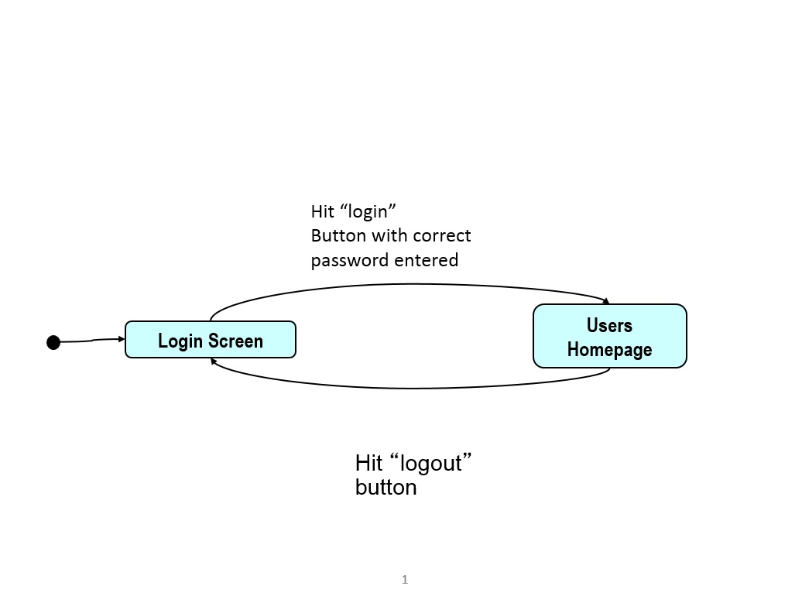

Figure 1.1. GUI transitions diagram for login feature

Figure 1.1 shows a GUI diagram that depicts the interfaces involved with the login feature. The interfaces will take up the entire monitor screen. Initially, the user is present at the login screen which requires entering the username and password correctly and pressing the “Login” button. This immediately directs the user towards the homepage which can lead back to the login screen if the user hits the “logout” button.

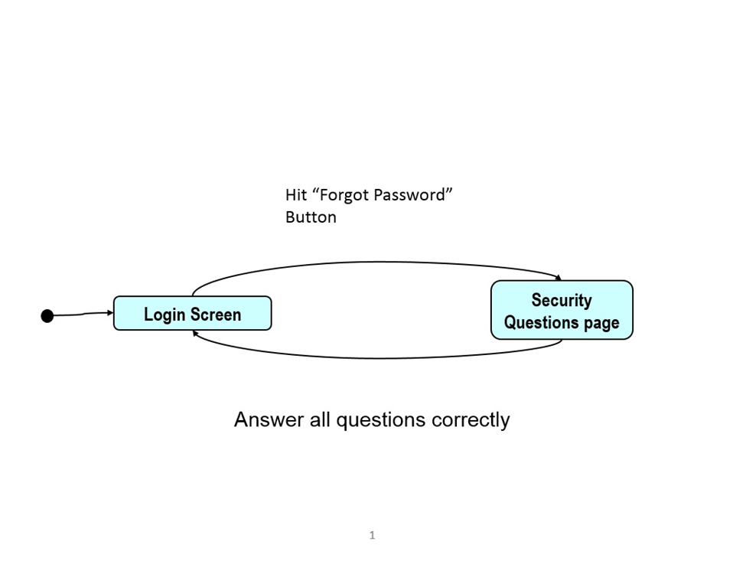

Figure 1.2. GUI transitions diagram for password reset

Figure 1.2 represents the related interfaces for the “Forgot Password” feature. The interfaces will take up the entire monitor screen. In this case, if the user has forgotten the login password in the Login Screen, then the user is directed to the Security Questions page after selecting the “Forgot Password” hyperlink. After answering 3 security questions correctly, in the same page the user is prompted to enter a new password. Once this process is completed, the user is directed back to the login page to provide the new credentials.

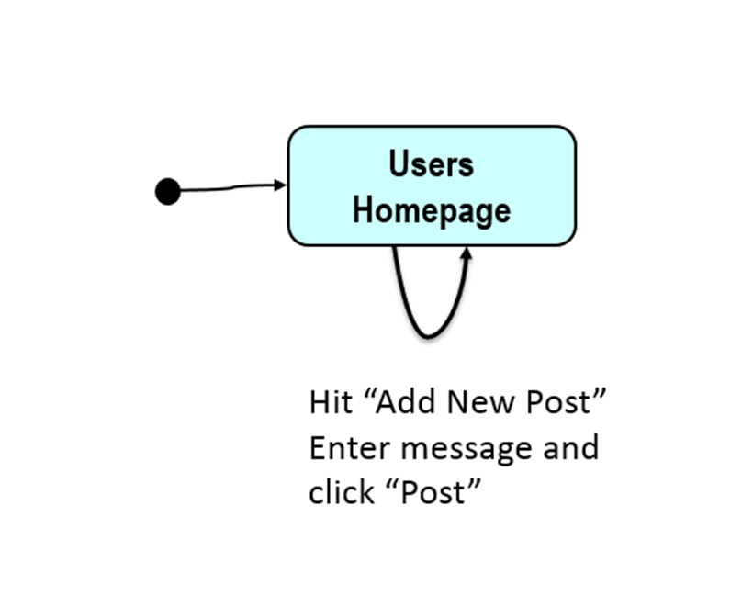

Figure 1.3. GUI transitions diagram for new posts

Figure 1.3 includes only 1 interface. It is on the same homepage where all tweets are included and where the user has the option to add new posts. Once submitted, posts are displayed asynchronously, meaning the page doesn’t need to be reloaded in order to show them. As a result, the user always remains on the same page.

Hardware Interfaces
None.

Software Interfaces

<Describe the connections between this product and other specific software components (name and version), including databases, operating systems, tools, libraries, and integrated commercial components. Identify the data items or messages coming into the system and going out and describe the purpose of each. Describe the services needed and the nature of communications. Refer to documents that describe detailed application programming interface protocols. Identify data that will be shared across software components. If the data sharing mechanism must be implemented in a specific way (for example, use of a global data area in a multitasking operating system), specify this as an implementation constraint.>

Communications Interfaces
None.

System Features

Posts
4.1.1 Description and Priority
The user should be able to post or “Tweet” from the web service. This is a High priority feature.

4.1.2 Stimulus/Response Sequences

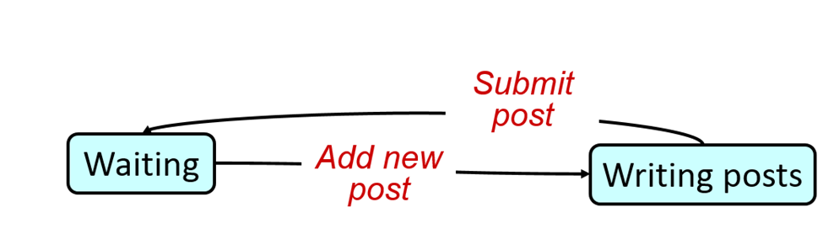
Figure 4.1. Add new posts state transition diagram

4.1.3 Functional Requirements

REQ-1: A user must be able to post short messages called “tweets”. Once logged into the web service and directed to the homepage, the user sees a list of all posted tweets in chronological order starting from the most recent one.

REQ-2: In this page, the user can then add new posts by clicking the “add new post” hyperlink in the same page.

REQ-3: The user types the message which is restricted to 140 characters.

REQ-4: After typing the message, the user clicks the “Post” button to submit the new tweet.

REQ-5: The message must appear on the homepage.

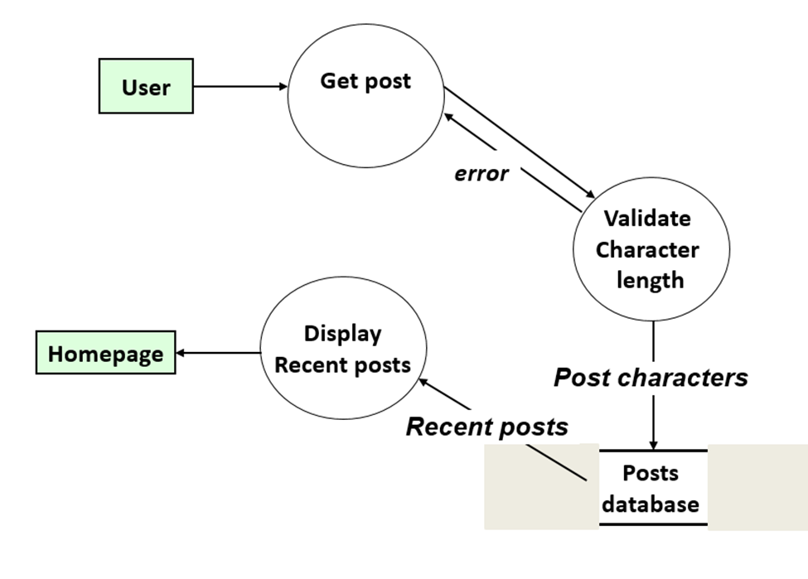

Figure 4.2. Data flow diagram for post submission

User can only access service if logged in.
4.2.1 Description and Priority

The user must only be able to make posts and see posts when logged in to an account. This is a High priority feature.

4.2.2 Stimulus/Response Sequences
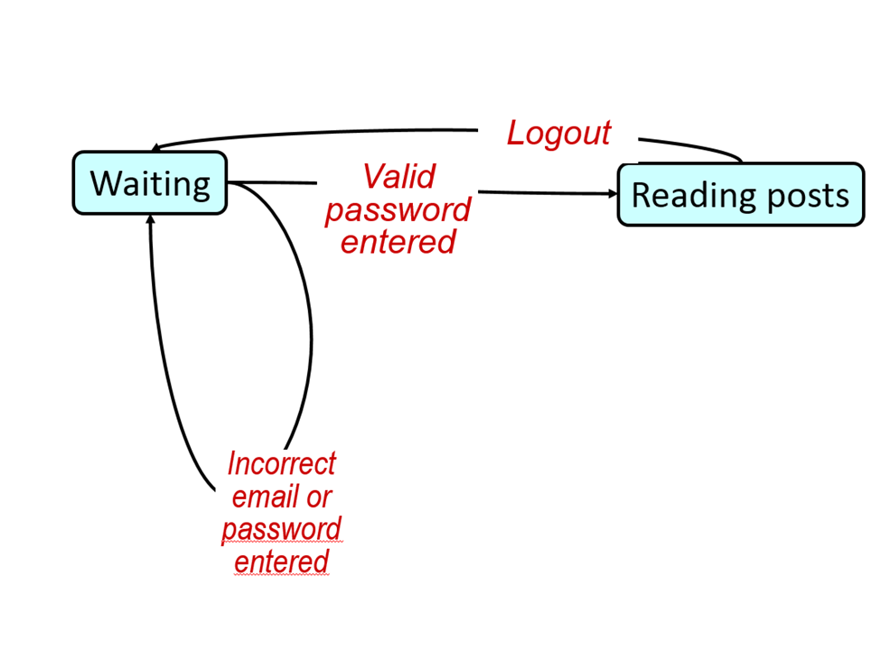

Figure 4.3. Login state transition diagram

4.2.3 Functional Requirements

REQ-1: A user must be logged in in order to see other user’s posts. If you are not logged in to an account you will not be able to see any posts. In order for a user to create a post they must be logged in.

REQ-2: When the site is first accessed it must display a log in page that offers account creation.

REQ-3: After a user logs in to an account or creates and account, the screen must display a list of posts and a way to create a post.

REQ-4: When an account is logged in this must be verified with a database of users and passwords. If an account is created this must be verified with the same database to ensure an account is not duplicated.

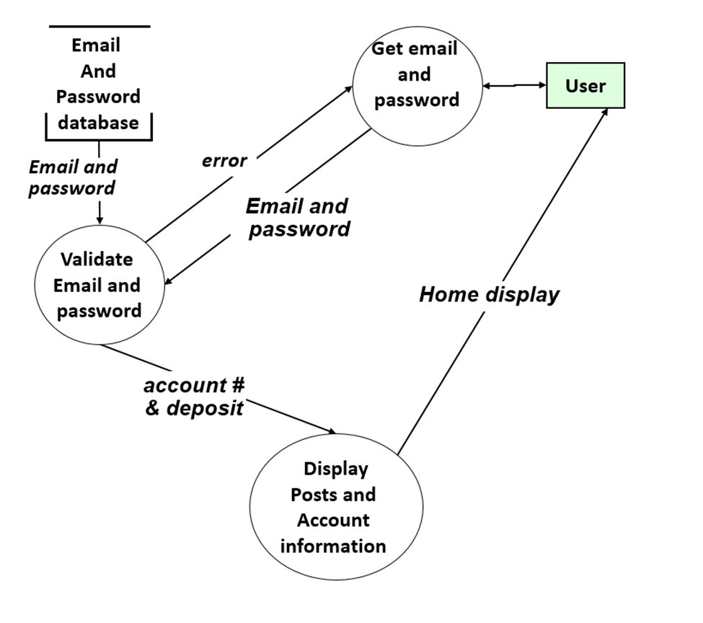

Figure 4.4. Login data flow diagram

Friends
4.3.1 Description and Priority
The user should be able to have friends that see their tweets. This is a High priority feature.

4.3.2 Stimulus/Response Sequences
<List the sequences of user actions and system responses that stimulate the behavior defined for this feature. These will correspond to the dialog elements associated with use cases.>
4.3.3 Functional Requirements
REQ-1: If User A desires to add User B as a Friend, then User A should send a Friend Request to User B.

REQ-2: Upon receiving this request, User B should have the option to Confirm or deny the request.

REQ-2.1: If the request is Denied, then Users A and B remain unaffiliated and cannot view the each other’s Tweets.

REQ-2.1: If the request is Confirmed, then Users A and B become designated as Friends.

REQ-3: If two users are Friends, they gain the ability to view all of each other’s previous Tweets, and will also have the ability to view all new and future Tweets posted by the other person.

Password Reset
4.4.1 Description and Priority
<Provide a short description of the feature and indicate whether it is of High, Medium, or Low priority. You could also include specific priority component ratings, such as benefit, penalty, cost, and risk (each rated on a relative scale from a low of 1 to a high of 9).>

If a user cannot remember their password, they will be able to reset their password.
This is a High priority feature.

4.4.2 Stimulus/Response Sequences

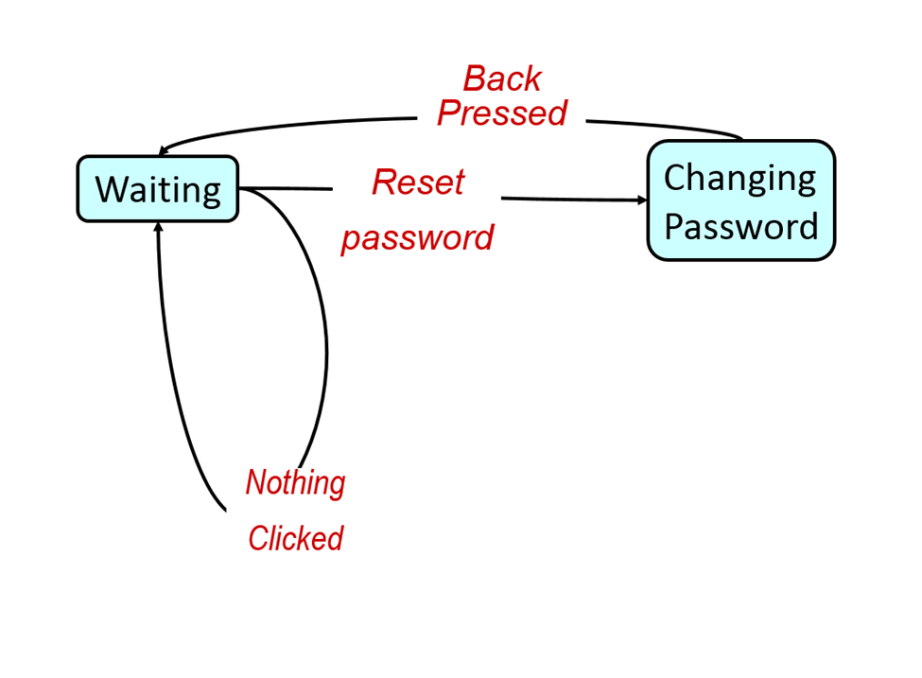

Figure 4.5. Password reset state transition diagram
4.4.3 Functional Requirements

REQ-1: If a user cannot remember their password to login they will be able to reset their password by answering three security questions.

REQ-2: These security questions and answers will be linked to the account upon account creation.

REQ-3: Once all three questions are correctly answered, the user will be able to enter in a new password.

REQ-4: This new password will take effect immediately.

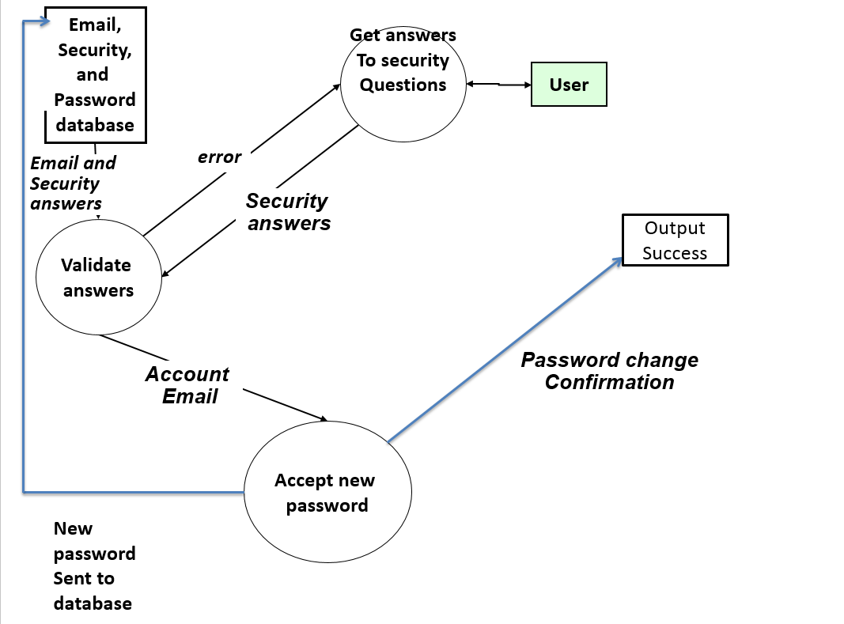

Figure 4.6. Password reset data flow diagram

Other Nonfunctional Requirements

Performance Requirements

As far as performance is concerned, the design should be efficient enough that web pages and site content should be viewable in a reasonable amount of time, preferably no more than 1-3 seconds. However, the main priority is on having functional software and this should be considered a “soft” performance requirement.

Safety Requirements
The main harm that could result from use of this software involves exposure of inappropriate or unpleasant information through a user’s Tweets. The site will not be responsible for censoring, monitoring, or otherwise policing the Tweets posted on the website unless compelled by legal action to do so.

Security Requirement

Users’ email addresses and passwords must be kept secure at all times to ensure the safety and privacy of all users of the program. User email and password databases will only be accessible to site administrators and must be handled with the best interests of the user in mind.

5.4 Software Quality Attributes
The software should be very simple and easy-to-use. The UI and similar interfaces should all be straightforward, intuitive, and well-labeled.

Other Requirements
<Define any other requirements not covered elsewhere in the SRS. This might include database requirements, internationalization requirements, legal requirements, reuse objectives for the project, and so on. Add any new sections that are pertinent to the project.>

None at this moment. However, may be added in the future.

