Description page

Table
Actual value

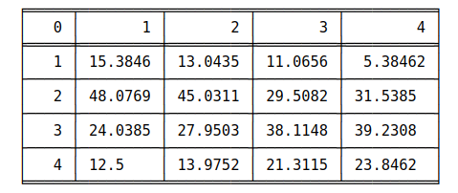
Predicted
value

This column gives the percentage of images with density 1 being categorised as 1 to 4.

Graph
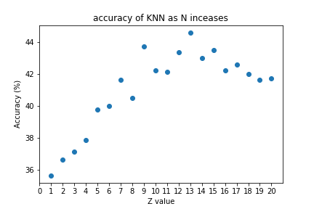

This graph simply shows the overall accuracy for the dataset against Z where Z is the nearest neighbour value

Method 1

Feature detection using nearest pixel (range(-1,1))
sober operator = constant
Gaussian blur only during feature detection
KNN which z denoting number of nearest neighbours
also cross validation is used

z = 1
Truth(%)

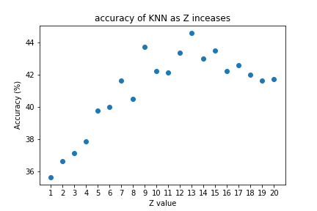

z = 13
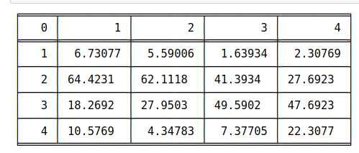
Truth(%)

Method 2

Feature detection using nearest pixel (range(-1,1))
Gaussian blur only during feature detection
KNN which z denoting number of nearest neighbours
also cross validation is used

z = 1
Truth(%)
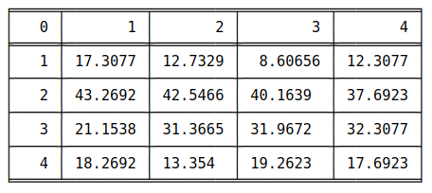

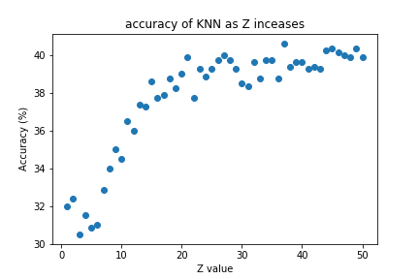

Z = 37
Truth(%)
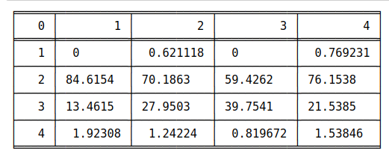

Method 3

Feature detection using nearest pixel (range(-1,1))
sober operator = constant
Gaussian blur initial image with sigma = 1 and during feature detection
KNN which z denoting number of nearest neighbours
also cross validation is used

Z = 1
Truth(%)
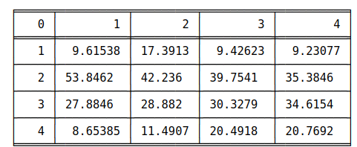

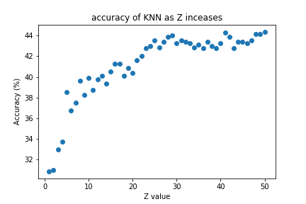
Z=51
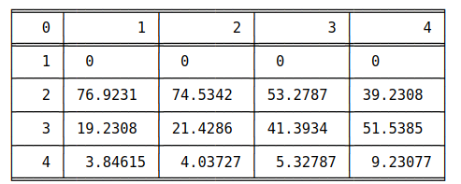
Truth(%)

Method 4

Feature detection using the 2 nearest pixel (range(-2,2))
Gaussian blur only during feature detection
KNN which z denoting number of nearest neighbours
also cross validation is used

Z = 1

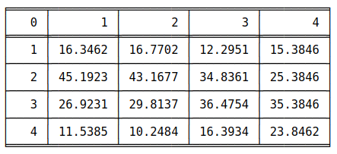

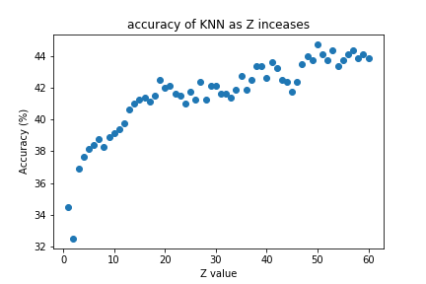
Z = 49
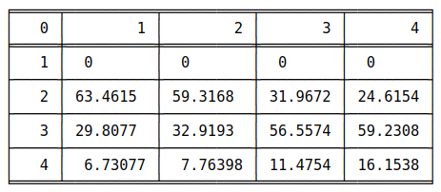

Method 5

Feature detection using the 2 nearest pixel (range(-2,2))
sober operator = constant
Gaussian blur initial image with sigma = 1 and during feature detection
KNN which z denoting number of nearest neighbours
also cross validation is used

Z = 1
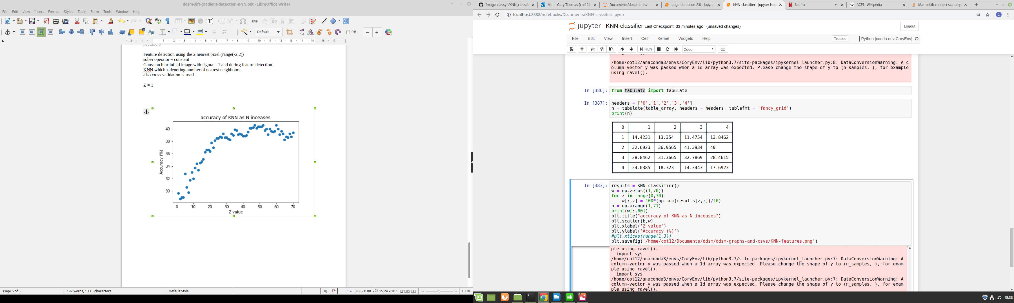

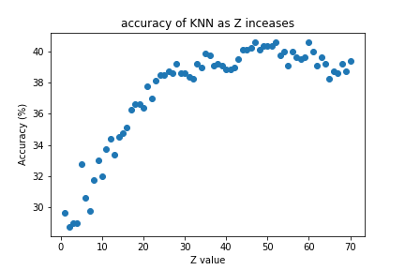

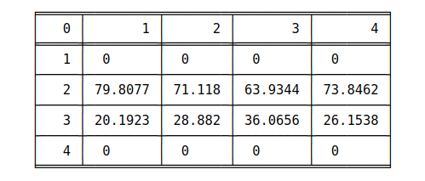
Z = 59

