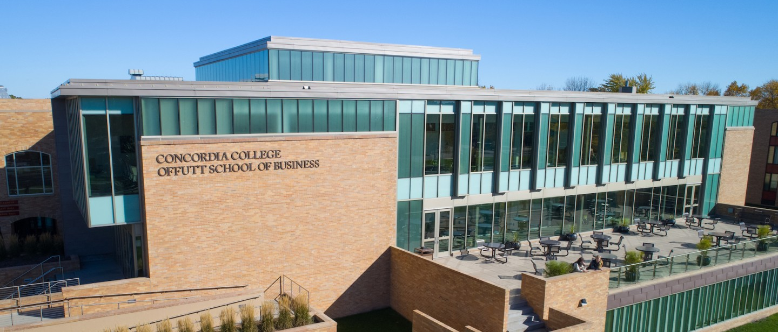

Project Proposal

|  |
| --- |
| Flappy Bird |

|  |  |
| --- | --- |
| Course | **CSC 225 – Fundamental Structures** |
|  | |
| Team Name | **The Coding Cobbers** |
|  |  |
| Team Members | **Matthew Niblock** |
|  | **Huy Vo** |
|  | **Kai Black** |
|  | **Ben Becker** |

|  |
| --- |
| Executive Summary |
| Your executive summary should resemble an elevator pitch: your motivation is to quickly persuade a decision maker to get involved in your project.  What is the purpose of your project? What problem(s) does it address?  The purpose of the project is to create a game that entertains its consumers. This project addresses the problem of a society lacking a game that user can utilize to pass to time.  Why is your project important? Why is it relevant?  This project is important because many games cause users to because bored over expeditive games and then they lose interest. When Flappy Bird first was released it took the world by storm and users from around the world could not get enough. |

|  |
| --- |
| Background and Problem History |
| Explain the problem domain and relevant background information about your project.  The problem first came around when the app store took the app flappy bird off of its store because the creator of the app was very overwhelmed by the amount of hate and interviews, he got from the game.  Provide a brief history of the problem; when did it start? What attempts have been made to solve it?  The problem originated from the developer of the app not wanting to have to deal with the hatred and stress that the game had caused him. The problem started on February 9th, 2014, when the original game was taken off the app store. There have been attempts to solve it but not many have been successful and lots of them have flopped. Many have bad reviews and nobody plays them. |

|  |
| --- |
| Solution |
| How does your team plan to solve the problem?  Our team plans to solve the problem by making a program similar to flappy bird that hopefully would get good reviews and not get taken off the app store if it was available for download.  What makes your approach different from other solutions?  Our approach will be different because the refashioning of the game will provide a happy vibe surrounding the production of the game. In turn, this will hopefully prevent the negativity surround the initial launch of the game. |

|  |
| --- |
| Project Deliverables |
| What will be the “product” of your team’s project? What documents will you create?  The product of our team project will be the recreation of the game “Flappy Bird”. We could potentially rename it. The documents we would create would mainly consist of lines of code and notes. |

|  |
| --- |
| Success Criteria |
| How will your team define success? What aspects of your project can you quantify to objectively measure success?  The best way to define success for our team goal is just to see the project/game actually work. We think we can achieve this by all working together and helping each other out with any questions. I think that one big thing we want to focus on in our project is having our graphics looks good. A visually pleasing game would bring in a lot of attention. We will also measure the success of the project on how much we learn. We should be able to learn a bit because none of us have done this game before. |

|  |
| --- |
| List of Required Project Resources and Materials |
| What resources (books, websites, data sets, problem domain information sources, software, etc.) will be required to complete your project?  We already have had a few websites noted down and will probably add a few more to reference. We will also be using a coding program to complete the project and are planning on using NetBeans. We also have the eBook from CSC 125 to reference if we have any questions. |