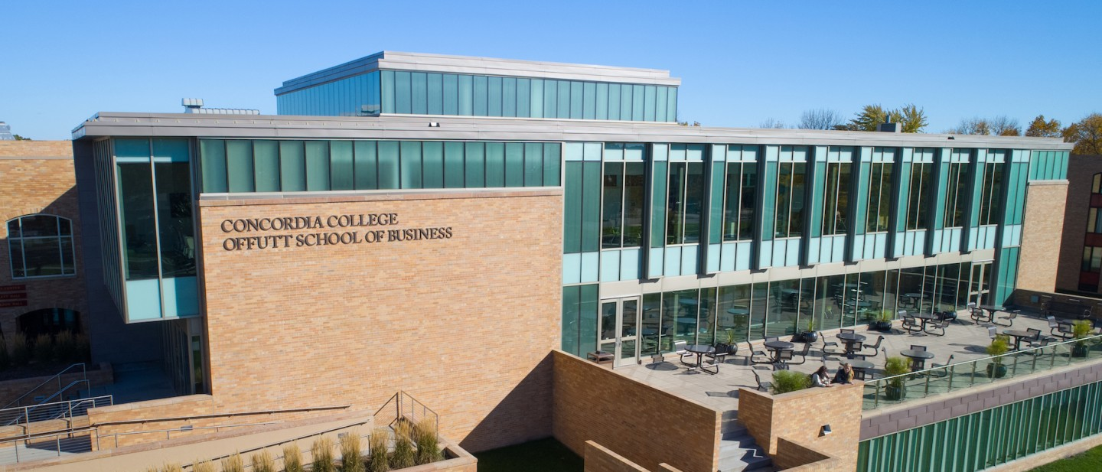

Project Proposal

|  |
| --- |
| Cashier Simulator |

|  |  |
| --- | --- |
| Course | **CSC 225 – Fundamental Structures** |
|  | |
| Team Name | **May We Succeed** |
|  |  |
| Team Members | **Abigail Mueller** |
|  | **Hannah Christensen** |
|  | **Zackery Snyder** |
|  | **Akua Adjei** |

|  |
| --- |
| Executive Summary |
| Your executive summary should resemble an elevator pitch: your motivation is to quickly persuade a decision maker to get involved in your project.  What is the purpose of your project? What problem(s) does it address?  Why is your project important? Why is it relevant?  **The purpose of our project is to create an interactive simulator that conceivably teaches adolescents and adults how to handle currency and card transactions. With a rise in open job positions and a constant influx in adolescents who need a job, understanding this concept is incredibly important. This allows for crucial training in which a job may not supply, or lack to inform, to a new cashier employee who has not dealt with cash registers before or who are experiencing their first ever job. Our project is a safe, stress-free place for these individuals, so they do not have to feel anxious about their new, or first, job position.** |

|  |
| --- |
| Background and Problem History |
| Explain the problem domain and relevant background information about your project.  Provide a brief history of the problem; when did it start? What attempts have been made to solve it?  **Everyone goes through a first job eventually, and for some that can cause high amounts of stress. Specifically with cashiers, dealing with customers constantly and handling their money can be a lot. Employees have been trained to help them do their job, and there are many therapists out there to help these individuals, so we hope that turning it into a game both eases the nerves of a first job, as well as turn it into a fun experience in a simulated game.** |

|  |
| --- |
| Solution |
| How does your team plan to solve the problem?  What makes your approach different from other solutions?  **By creating this program that will be engaging and interactive, people will be able to learn and receive a hands-on experience of how to work as a cashier in different instances. Rather than putting someone in a situation where they need to learn on the spot with real customers (who can be pushy, impatient, or rude when inconvenienced), the user can have a head start experience on how to handle a cash register and manage money.** |

|  |
| --- |
| Project Deliverables |
| What will be the “product” of your team’s project? What documents will you create?  **The product of our project is going to be a simulation game where the user plays as a cashier, therefore dealing with cash and card transactions. Some of the documents that we will create throughout the process of making this game is an ideas document, where we can add or give input to certain features we want in the game. Another document we will make is a workload breakdown document, where we will divide the necessary tasks and actively update the document when a task is completed, if we need additional help from other group members, etc.** |

|  |
| --- |
| Success Criteria |
| How will your team define success? What aspects of your project can you quantify to objectively measure success?  **For our team, our success will be measured by whether or not the program correctly responds to user interaction with currency and cards, and if our program runs without any run-time errors. As it is a simulator that should be able to calculate differences and additions depending on user input, success will be determined by its accuracy in that regard. A question we may ask ourselves in determining this is “Can our program give the user the correct amount of change back?”. We can break down the project to determine success by looking at whether it can give the right amount of change back, whether it can take cash or card correctly, whether it can run without run-time errors, whether the different classes work cohesively with one another, and finally whether the program runs without run-time errors.** |

|  |
| --- |
| List of Required Project Resources and Materials |
| What resources (books, websites, data sets, problem domain information sources, software, etc.) will be required to complete your project?  We will use several resources such as:   * Assistance (Damien, Tutors, Classmate Feedback) * Class Material (Notes, Lectures) * Personal Experiences (All Worked Cashier Jobs) * Websites: * <https://legacycultures.com/five-tips-for-respectful-interaction-in-the-workplace/>  (We used this to the best ways our user would be able to interact well in the workplace.) * <https://www.wikihow.com/Use-a-Cash-Register?amp=1> (We used this to decide the way we would decide to show the user to use the cash register.) * <https://www.themuse.com/amp/advice/interview-questions-and-answers> (This website gave us ideas on how we would ask advice the user before having the interview.) * <https://legacycultures.com/five-tips-for-respectful-interaction-in-the-workplace/>   (The following are 5 tips to help your organization create a culture of respect.) |
|  |