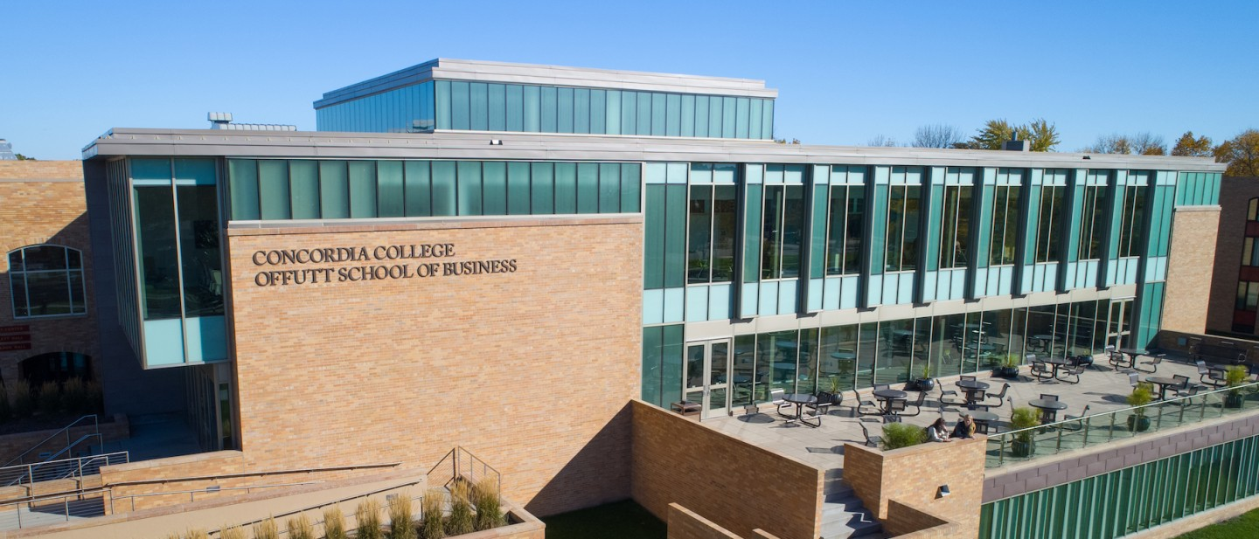

Project Proposal

|  |
| --- |
| Checkers |

|  |  |
| --- | --- |
| Course | **CSC 225 – Fundamental Structures** |
|  | |
| Team Name | **BELLS** |
|  |  |
| Team Members | **Becca Benson** |
|  | **Ella Anderson** |
|  | **Lauryn Schreifels** |
|  | **Losdishen Narayanasawmy** |

|  |
| --- |
| Executive Summary |
| **Your executive summary should resemble an elevator pitch: your motivation is to quickly persuade a decision maker to get involved in your project.** |
| * **What is the purpose of your project; what problem(s) does it address?** * **Why is your project important; why is it relevant? (NOTE: not in terms of the class to get a good grade)** * **Who could your project help; who is your audience or customer?** |
| 1. To create a fun, and engaging, online game that will solve the lack of Concordia board games in existence. The purpose of checkers is to engage players in a strategic board game that challenges their ability to outmaneuver their opponent. Our project stimulates people’s critical thinking skills and 2. Concordia is severely lacking in Cobber themed entertainment, so we plan on solving that problem 1 game of checkers at a time. 3. Bored and lonely college students who want a fun and mind stimulating game. |

|  |
| --- |
| Background and Problem History |
| * Explain the problem domain and relevant background information about your project * Provide a brief history of the problem; when did it start? What attempts have been made to solve it? * NOTE: Think in terms of your PROJECT, not in terms of this class |
| A Concordia themed checkers game doesn’t exist. College kids are lonely and lacking in stimulating cobber themed board (online) games.  No attempts have been made to solve this problem so far (as far as we know) |

|  |
| --- |
| Solution |
| * How does your team plan to solve the problem? * What makes your approach different from other solutions? |
| * By coding the cool cobber themed checkers game. * We haven’t seen other versions of this, we could be the first people to code a cobber themed checkers game. |

|  |
| --- |
| Project Deliverables |
| * What will be the “product” of your team’s project? What documents will you create? |
| * A cobber themed checkers game * Java classes |

|  |
| --- |
| Success Criteria |
| * How will your team define success? What aspects of your project can you quantify to objectively measure success? * NOTE: Think in terms of your PROJECT, not in terms of this class |
| 1. Having a board 2. Creating the pieces 3. Having a game that works |

|  |
| --- |
| List of Required Project Resources and Materials |
| * What resources (books, websites, data sets, problem domain information sources, software, etc.) will be / have been required to complete your project? |
| * GitHub * StackOverflow * VS Code |