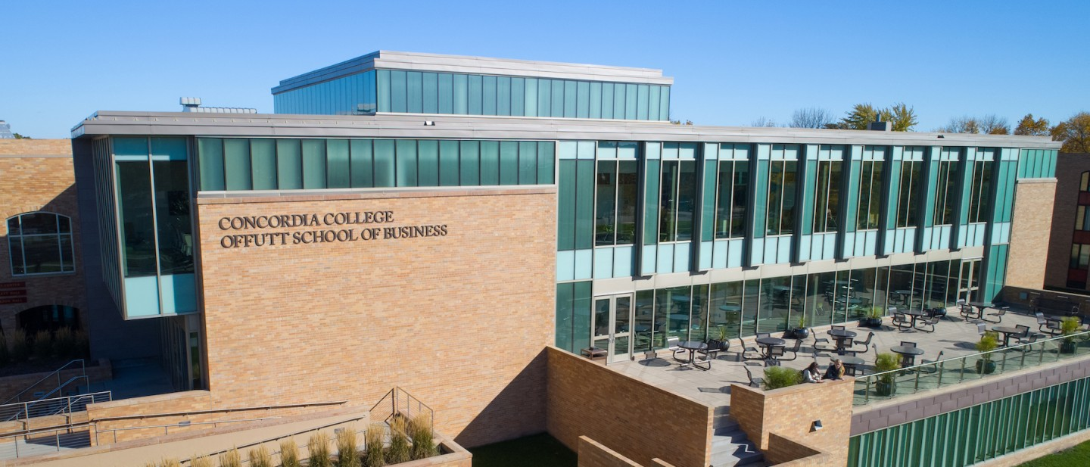

Project Proposal

|  |
| --- |
| Brian Gagnon Landscaping |

|  |  |
| --- | --- |
| Course | **CSC 310 – Web Development** |
|  | |
| Team Name | **Golden Cobbers** |
|  |  |
| Team Members | **Collin Thompson** |
|  | **Hayden Gagnon** |
|  | **Akua Adjei** |
|  |  |

|  |
| --- |
| Executive Summary |
| We are creating a website for Brian Gagnon Landscaping. This is a landscaping company in need of a website to provide information on their services and products. This will be important because it will help them to get more information into the hands of the customer with ease. |

|  |
| --- |
| Background and Problem History |
| They have never had a website or any way to show customers results/products. This will give them a resource to upload and share that information. |

|  |
| --- |
| Solution |
| We will be creating a website that will display the necessary information for both the company and the services it provides. |

|  |
| --- |
| Project Deliverables |
| We want a fully working website that allows customers to access the information with ease. We want to make it visually pleasing and not too confusing for them. We will include links and other navigation tools to simplify their searching process. We will include pictures of finished product as well. |

|  |
| --- |
| Success Criteria |
| If we can meet the goals in our deliverables, then we will be satisfied with out work. If we can get this done and have the customer give us a positive review on our work and be happy with their product. |

|  |
| --- |
| List of Required Project Resources and Materials |
| Class Material  GitHub  Tutors  Internet resources (Stack Overflow, etc) |