**Main Page**

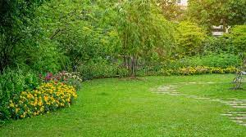

Possibly Add some pictures of the navigations above for a sample of what they will click on.

**About us page**

**FAQ’s Page**

**Frequently Asked Questions (FAQ)**

Question #1 (Dropdown with answer)

Question #2 (Dropdown with answer)

Question #3 (Dropdown with answer)

Repeat for as many as needed

**Products Page**

Continue for as many as needed

**Services Page**

Continue for as many as needed

**Contact Us Page**

His name

Address

Email address

Phone numbers

**Specific Product Page**

**Specific Service Page**