

Habitica Redux

**Principles of Software Engineering**

Course Name

**The 3 Engateers**

**Team Name**

**John Krueger  
Sam Garcia  
Olly Nigaba**

**Team Members**

Habitica can fall under two classifications; it is both a web based interactive transaction based application relying on integration with a webserver and database as well as an entertainment system do to its gamified elements. This software seeks to address some of the problems with current planning and productivity applications. Many physical or digital planners are simple todo lists. This means they fail to incorporate rewards, punishments, and accountability mechanisms. Even amongst tools that include these mechanisms, there are few elements to induce the participant to care about failure. For example, one may lose points for failing to complete a task, but this does not matter if those points do nothing further to punish the plater. Habitica fixes this problem through gamification. The player’s avatar is hurt by failure which offers disincentive. Players are rewarded for doing well by receiving quest rewards like gold for items or pets. The intrinsic motivation of receiving loot or collecting pets serves as a reward. These mechanisms address the primary problem of traditional productivity apps. These features are uniquely key to targeting segments of the population for whom more traditional productivity apps have failed.

**Problem**

Habitica works by gamifying habits and goals into daily quests, TO DOs, and habits. An avatar receives rewards for completing quests, but one is punished via monster attacks or other mechanisms for failure. Habitica can work single player, but one can either create a custom group or simply play publicly to incorporate group accountability or integrate into educational settings. This app targets anyone who wants a more fun style of productivity management. It is particularly useful for people who might have trouble with more conventional planning apps or who otherwise need extra motivation to stay on track. We will help to keep people motivated by enhancing Habitica to better foster engagement and investment.

**Synopsis**

Habitica is a habit building and productivity app that uses gamification elements to motivate people to complete tasks and forge healthy habits. This is useful because conventional habit management apps frequently are not enjoyable to use. Gamification creates psychological rewards for following through on tasks while also inflicting punishments like monster attacks for failure. This app is useful for anyone trying to use their time more productively, but it is particularly useful for those for whom other productivity apps have failed. Our purpose is to enhance Habitica to better serve as a fun gamified productivity app.

**Purpose**

Executive Summary

# Background

Habitica currently incorporates the collection of pets and mounts as a reward for quests. However, pets and mounts are mostly treated as collectables and do not incorporate any gameplay elements. In order to foster greater investment in pet collection and therefore commitment to tasks and habits, a simple multiplayer battling system ought to be implemented. There are three key components to this system:

1. An attribute system similar to games like Pokémon to encourage collecting a wide variety of pets.
2. A consumable based leveling system to encourage continuous investment.
3. The incorporation of chance in the outcome of battles to keep things interesting.

Time estimate: Software Specification and Research: 5hr.

Software Development: 20-30hr.

Software Validation: 5 hr.

Software Improvement: continuous.

Cost Estimate: 0$

Lead: John Krueger

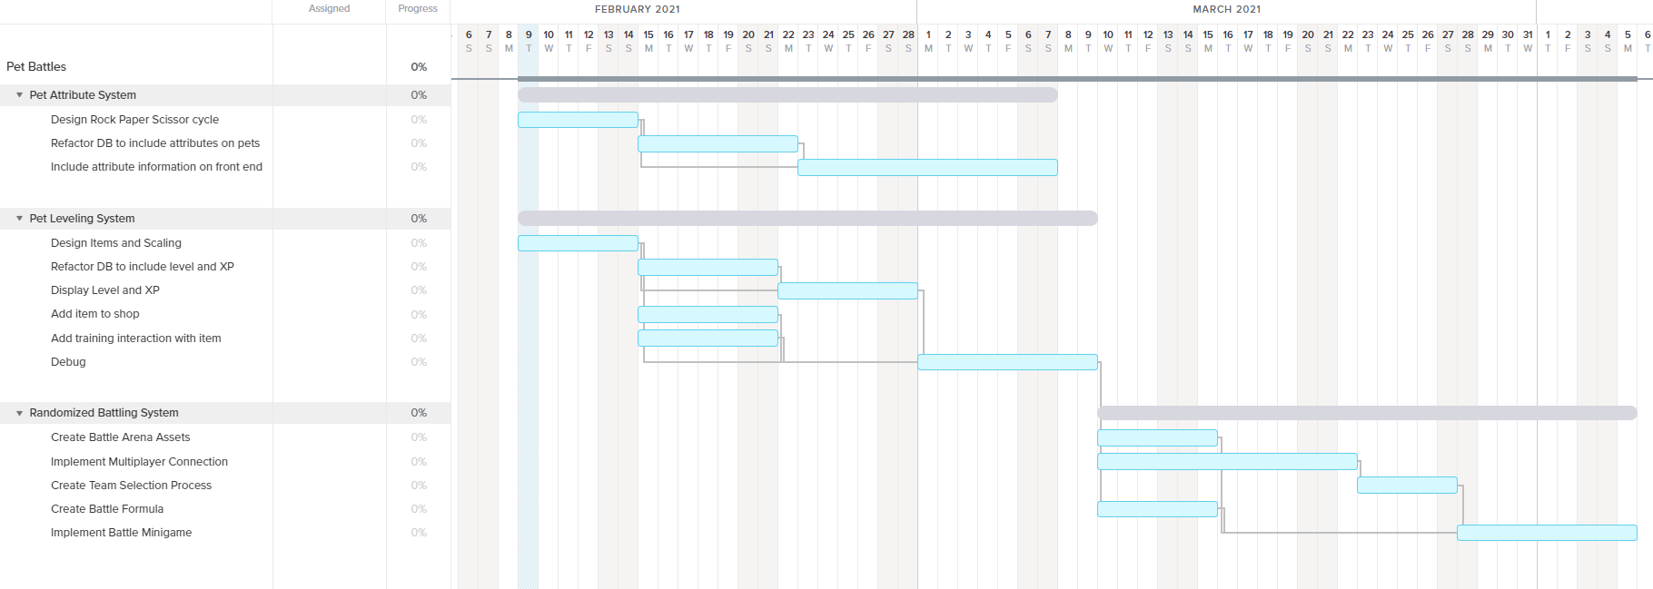

**Feature One: Pet Battles**

My feature is power suits. I want each suit to upgrade as the characters gets better. Also each suite has a limit on how powerful it is based on which suit you have. My estimate cost for this if 0$. Estimated time about 30hr to perfect each suit with its own powers.

Lead: Olly

**Feature Two: Battle Suits**

In Habitica, weapons are available for players to purchase with the gold earned from performing tasks, challenges, and quests. Most weapons increase a player’s stats. Players must start with a weak form of a weapon and work their way to a stronger/better weapon. Once a player decides to upgrade the same type of equipment/weapon replaces its predecessor. Once a weapon has been bought a new item of the same kind from the next set becomes available. If players purchase all the best weapons for their class, they will unlock an achievement. Adding more weapons or a new class of weapons would incentivize players to complete more tasks, challenges, and quests done to unlock the new class of weapons. To obtain achievements for that new weapon class.

Time Estimate: Software Specification and Research:

Software Development:

Software Validation:

Software Improvement:

Cost Estimate: $

Team Member: Sam

**Feature Three: New Weapons**

Completed

**Group Contract 2020-01-21**

# Project Plan

Scheduled

**Final Presentation 2021-04-29**

Scheduled

**Requirements Eng. II 2021-04-13**

Scheduled

**Requirements Eng. I 2021-03-18**

completed

**Proposal Presentation 2021-02-25**

Completed

**Project Plan 2021-02-09**

Sam led the group during this milestone by creating the github repository and the group contract. All members verbally agreed to the contract which was then initialed over the internet.

**Milestone 1 Details**

Krueger led the group during this milestone. They forked a copy of the Habitica repository, as well as creating most of the project planning document. Each group member created the plan for a major feature.

**Milestone 2 Details**

olly led the group during this milestone by creating a PowerPoint by updating on how our project is going and what we have so far. Each member had a topic or slides to explain what exactly has been happing.

**Milestone 3 Details**

# Project Resources

|  |  |  |
| --- | --- | --- |
| Date | Name/URL | Note |
| 2/9/2021 | https://habitica.fandom.com/wiki/Guidance_for_Blacksmiths#Contributor_Tier_Process |  |