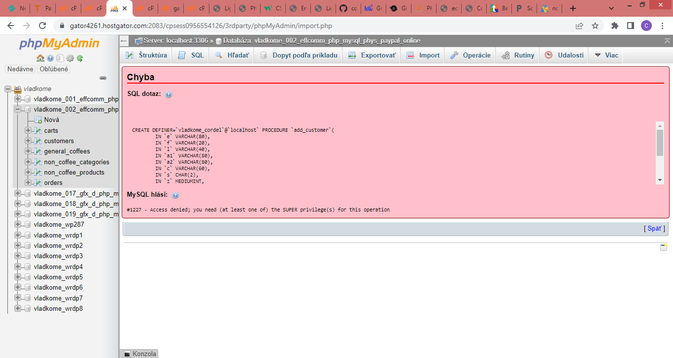
Tech Support: Database Issues case #39943531 4:07 pmVvilma.v joinedWelcome to Chat Support. I'm Vilma and I'll be your Web Advisor today. Please give me a moment while I review your request. 4:07 pmVHi Vilma, yeah, please do 4:07 pmVHello, Vlasko. I understand your concern regarding case updates. I will definitely help you with this. I understand your concern regarding Code Guard. I see that admins have already replied back to the email. I understand that you are receiving 'CodeGuard Resource Sync' error in the CodeGuard dashboard, To address the error we need confirmation to remove the website and re-add the databases through Codeguard. Once we get the confirmation from your end we will go ahead and set up them for you.May I know if you confirm removing the website and re-add the databases through Codeguard? 4:13 pmVVilma, I have no idea what you ar talking about. re you sure, you hve the correct case? The email I received from you said the following: "I have repaired the database and enabled all privileges to that website." There was nothing about any "Code Guard Resource Sync' What is it..? Did you say you need my confirmtion to remove the WEBSITE??? 4:17 pmVI'm sorry, I see that the case number that you have provided is incorrect. Thanks for the information. Let me check on it. Please be on hold for 3-4 minutes while I check few things. 4:18 pmVplease, take your time and get the correct case, no matter how long it takes? 4:19 pmVThanks for the patience. I understand your concern regarding database import. I see that our admins have corrected database privileges. May I know if you have tried importing database? 4:23 pmVyes I did, I am getting the very same error as before. wanna see? 4:23 pmVYes, could you please provide me the screenshot? 4:24 pmVshare your link plz 4:24 pmVHere are the steps to share the screenshot: Click on this link: https://privatebin.support-tools.com/ You can either drag & drop the screenshot or paste the screenshot or click on 'Attach a file'. Please note that the screenshot gets attached without getting displayed on the screen. Click on 'Send' at the top right corner to generate a unique link which will contain the screenshot. Copy the displayed (highlighted) link and paste it here in the chat. It's been a few minutes since I've heard from you. Are we still connected? Just want to keep you posted in advance that our chat system ends a chat when there is inactivity on your end for 5 minutes. Please stick around in the chat window to avoid disconnection. Thanks for understanding! 4:29 pmVhttps://privatebin.support-tools.com/?e3c55d35a7536cfd#vNQuE48y2Fd+xMMCd15RGeMNzvnq9Fx/NwpxHZ9uzI8= 4:30 pmVI'm glad that we are still connected. Thanks for the screenshot. Please be on hold for 3-4 minutes while I check few things. 4:32 pmVplz do 4:33 pmVUnfortunately, it’s taking longer than I expected. I will need 3-4 minutes more. 4:35 pmVsure, easy there 4:36 pmVThanks for the patience. I see that database privileges are set correctly. I have reopened the case and updated case notes with screenshot. Our admins will check the issue further and get back to via email within couple of hours. Please wait for the email from them.4:40 pmVThanks Vilma, bye

