CPSC 1150 - Assignment 2
Cordell Bonnieux

Counting Ones
This program reads a number, and displays it’s binary representation and the number of 1s in that binary representation.

Blueprint:
Inputs: A user inputted integer, I will call it decimal.
Ouputs: A Prompt asking for input from the user, and a prompt which displays the number of ‘1’s in the binary representation of decimal.
Calculations: I will need to create a for loop which repeatedly divides decimal until it reaches 0. On each iteration I need to store the remainder in an array which I will call binary.
Variables: decimal(integer), binary(integer array), remainder(integer), counter(integer), i(integer)
Constants: n/a – none needed

Pseudocode:
Start
Print “Enter an integer between 0 and 99.”
Read int to decimal
If decimal < 0 or decimal > 99
Restart Program (or method/function)
Print decimal + “ in binary is “
While decimal > 0
Compute int remainder = decimal % 2
Compute int decimal = decimal / 2
Compute int array binary += remainder
For (int i = binary.length) as long as ( i >= 0 ) on each iteration (i--)
Print binary[i]
If binary[i] == 1
Compute int counter++
Print “And there are “ + counter + “, 1s in the binary representation.“
End

Trace Tables:
Step # | Input | decimal | remainder | binary | counter | i | Output
0 | -5
1 |  | -5

Step # | Input | decimal | remainder | binary | counter | i | Output
0 | 14
1 |  | 14
2 |  |  |  |  |  |  | “14 in binary is “
3 |  | 7 | 0 | [0]
4 |  | 3 | 1 | [0],[1]
5 |  | 1 | 1 | [0],[1],[1]
6 |  | 0 | 1 | [0],[1],[1],[1]
7 |  |  |  |  | 1 | 4 | “1”
8 |  |  |  |  | 2 | 3 | “1”
9 |  |  |  |  | 3 | 2 | “1”
10 |  |  |  |  | 4 | 1 | “0”
11 |  |  |  |  |  |  | “And there are 4 1s in that binary representation”

Step # | Input | Decimal | remainder | binary | counter | i | Ouput
1 | 100
2 |  | 100

Step # | Input | Decimal | remainder | binary | counter | i | Ouput
1 | 0
2 |  | 0

Trace Table Notes:
- The algorithm loops if an invalid integer is entered
binary – This is an array of integers, that is used to hold the binary representation of decimal. However since this algorithm prints it backwards, the values in binary will also be stored backwards.

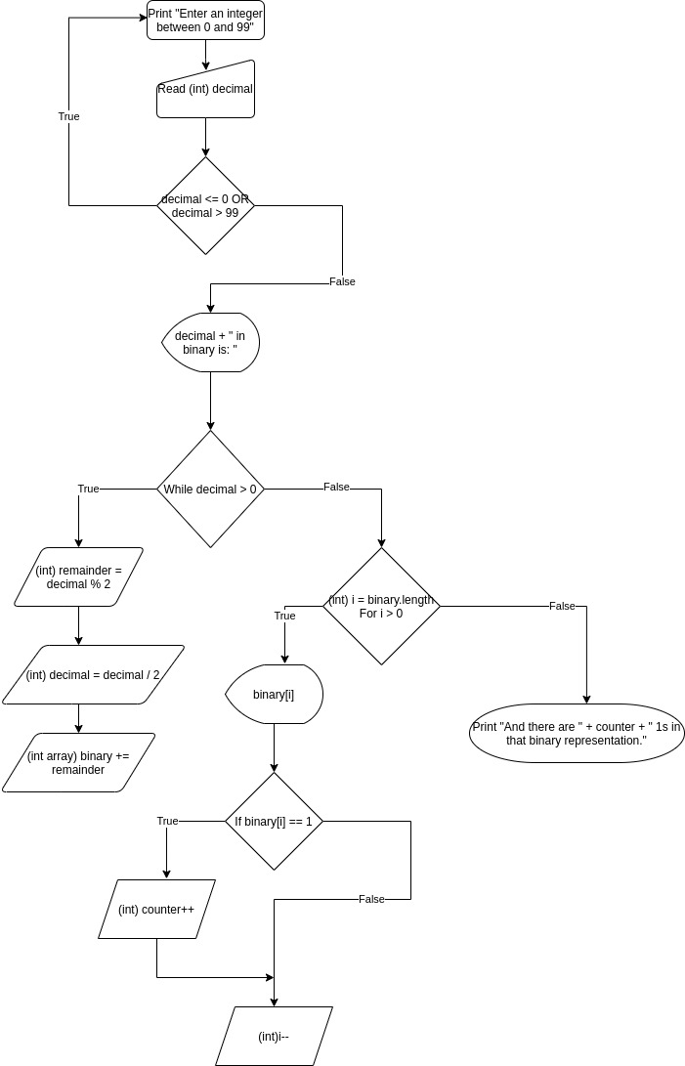

Palindrome
This program randomly generates a number and determines whether or not it is a plaindrome.

Pseudocode:
Start
Compute int num1 (random int between/including 1 – 9)
Compute int num3 (random int between/including 0 – 9)
If num1 == num3
Compute boolean palindrome = true
Compute int num2 (random int between/including 0 – 9)
Print num1 + num2 + num3
If palindrome
Print “ is a palindrome.”
else
Print “ is not a palindrome.”
End

Trace Tables:
Step # | num1 | num3 | num2 | palindrome | Output
1 | 4
2 |  | 4
3 |  |  |  | true
4 |  |  | 7
5 |  |  |  |  | “474 is a palindrome”

Step # | num1 | num3 | num2 | palindrome | Output
1 | 8
2 |  | 5
3 |  |  |  | false
4 |  |  | 1
5 |  |  |  |  | “815 is not a palindrome”

Card Game
This program generates a random number from 1 to 52. It then uses that number to determine which card from a deck of cards it represents.

Pseudocode
Start
Print “The card that has been picked is “
Compute int card (random int between/including 1-52)
If card == 1 or 14 or 27 or 40
Print “Ace”
Else if card == 2 or 15 or 28 or 41
Print “2”
Else if card == 3 or 16 or 29 or 42
Print “3”
Else if card == 4 or 17 or 30 or 43
Print “4”
Else if card == 5 or 18 or 31 or 44
Print “5”
Else if card == 6 or 19 or 32 or 45
Print “6”
Else if card == 7 or 20 or 33 or 46
Print “7”
Else if card == 8 or 21 or 34 or 47
Print “8”
Else if card == 9 or 22 or 35 or 48
Print “9”
Else if card == 10 or 23 or 36 or 49
Print “10”
Else if card == 11 or 24 or 37 or 50
Print “Jack”
Else if card == 12 or 25 or 38 or 51
Print “Queen”
Else if card == 13 or 26 or 39 or 52
Print “King”
If card % 4 == 0
Print “ of Clubs.”
Else if card % 4 == 1
Print “ of Diamonds.”
Else if card % 4 == 2
Print “ of Hearts.”
Else if card % 4 == 3
Print “ of Spades.”

