Lab 10

**Student:** Cordell Bonnieux 100372192

**Instructor:** Dr. Bita Shadgar

**Class:** CPSC 1150 W01

**Date:** July 27, 2021

# Compare.java

This program compares arrays of random integers, of various sizes using linear and binary searches. The results from the searches are then displayed in the console.

## Pseudocode

* Start
* Print “Average Number Of Comparrisons”
* Print in tabular format “n Linear Search Binary Search”
* For int size = 10 as long as size < 1000000 then, size *= 10
  + Compute array of random integers list, of size size
  + Compute doubles linear =0 and binary = 0
  + For int i = 0 as long as i < length of list then, i++
    - Compute linear += number of comparrisons to find i using linear search
    - Compute binary += number of comparisons to find i using binary search
  + Compute double avgLnS = linear / length of list
  + Compute double avgBS = binary / length of list
  + Print in tabular format size + avgLnS + avgBS
* End

## **Testcases**

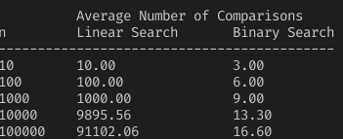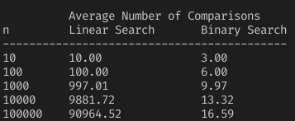

**B:** Binary search needs less comparisons than linear search does, and thus is more efficient.

**C:**

* **Linear Search:** O(n)
* **Binary Search:** O(log n)

**D:** I would always opt to use Binary search, as it is vastly superior to linear search. By searching every item (n), linear search proves to be extremely time consuming for large sets of data.

# **MergeSort.java**