CPSC 1150 – Lab 4

**Cordell Bonnieux**

# Assignment Description

This Lab includes three programs, their associated documentation is in this file.

# Program Descriptions

## Sort3.java

The first program takes in three integers from the user, sorts them in ascending order and prints them to the console.

### Pseudocode:

**Start**

**Print** “Enter your first integer”

**Read** int to **a**

**Print** “Enter your second integer”

**Read** int to **b**

**If a** > **b**

int **largest** = **a**

int **middle** = **b**

**else**

int **largest** = **b**

int **middle** = **a**

**Print** “Enter your third integer”

**Read** int to **c**

**If c** > **middle**

**If c** > **largest**

int **smallest** =  **middle**

int **middle** = **largest**

int **largest** = **c**

**else**

int **smallest** = **middle**

int **middle** = **c**

**else**

int **smallest** = **c**

**Print smallest** **middle largest**

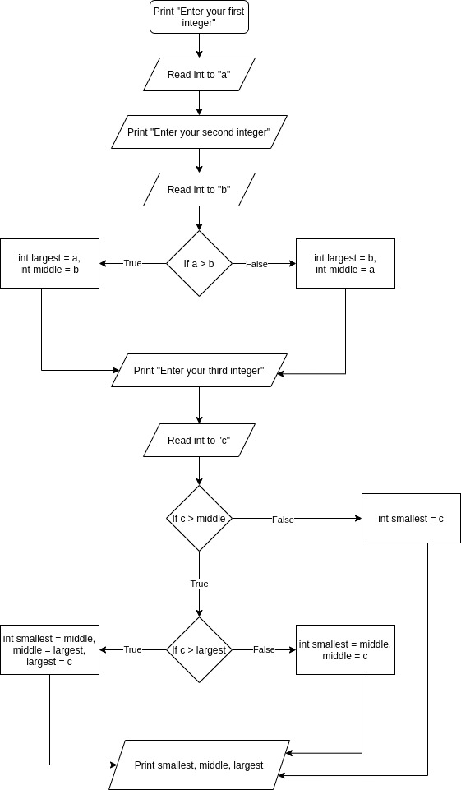

## LogicalOps.java

The second program takes in an integer from the user, then prints whether or not it is divisible by:

* 5 and 6
* 5 or 6
* 5 or 6, but not both

### Pseudocode:

**Start**

**Print** “Please enter an integer”

**Read** int to **num**

**If num** % 5 == 0

int **modBy5** = **true**

**If num** % 6 == 0

int **modBy6** = **true**

**If modBy5** *and* **modBy6**

int **modByBoth** = **true**

**If modBy5** *or* **modBy6**

int **modByOne** = **true**

**Print** “Is “ + **num** + “ divisible by 5 and 6? “ + **modByBoth**

**Print** “Is “ + **num** + “ divisible by 5 or 6? “ + **modByOne**

**Print** “Is “ + **num** + “ divisible by 5 or 6, but not both? “

**If**  **modByOne** *and* !**modByBoth**

**Print modByOne**

**else**

**Print false**

## RSPGame.java

The third program is a rock paper scissors game. The user is asked to input one of three integers:

* 0 for rock
* 1 for scissors
* 2 for paper

The program then randomly selects one of the three same integers. The two are then compared to determine if the computer or user wins or if there is a draw.

### Pseudocode:

**Start**

**Print** “Select: rock (0), scissors(1), paper(2)”

**Read** int to **user**

**Compute** int **computer** (random number between and including 0 and 2)

**Print** “The computer played:” **computer**

**Print** “You played:” **user**

**If** (**user** = 0 *and* **computer** = 1) *or* (**user** = 1 *and* **computer** = 2) *or* (**user** = 2 *and* **computer** = 0)

**Print** “You win!”

**else if** ( **computer** = 0 *and* **user** = 1) *or* ( **computer** = 1 *and* **user** = 2) *or* ( **computer** = 2 *and* **user** = 0)

**Print** “You Loose!”

**else**

**Print** “It’s a draw!”