White Water Rafting Site Plan
Cordell Winward
WDD 130

Overview
Purpose
Display content from my web development class

Branding

Website Logo

Style Guide
Color Palette
Primary colors
#06419B #1A3842
Accent Colors
#1E1E1E #0B89D9 #1A3842

Typography
Heading Font: Conthrax
Paragraph Font: Times San Serif

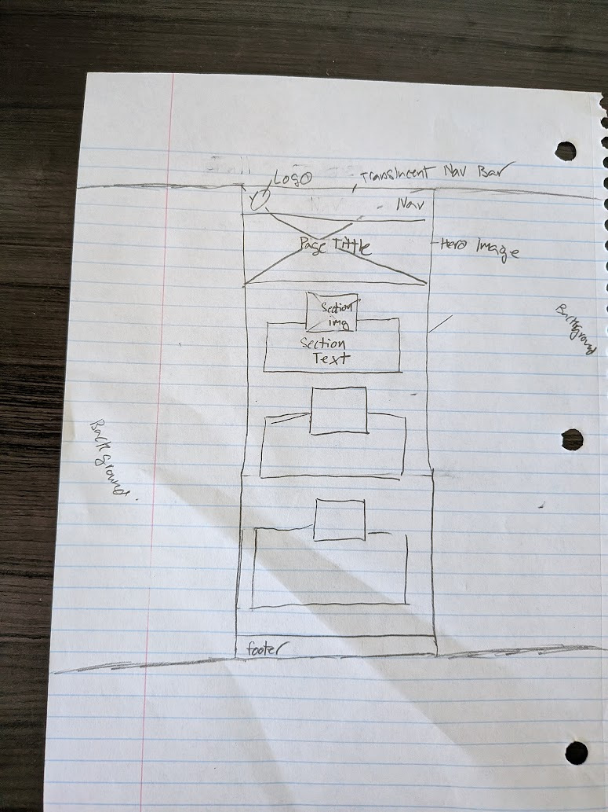
Wireframes
Nav links
Home Wwr Ice About me

