**3. Edit Business**

EditBusiness($buid, $userid, $business_name, $pan, $email_address, $primary_contact_person, $primary_contact_personph);

Name: editbusiness

*: buid, userid, business_name, pan

Method: PUT

[http://172.17.1.140/programming/hbgstapi/api/](http://172.17.1.140/programming/hbgstapi/api/loginvalidate)editbusiness

**Body:**

**{**

**"buid":"100",**

**"userid":"42",**

**"business_name":"Gc buss to GK Buss",**

**"pan":"BGAPP6736B",**

**"email_address":"gyan.chandra@kapspro.com",**

**"$primary_contact_person":"GYAN CONTACT",**

**"$primary_contact_personph":"9898989898"**

**}**

**Response:**

**{"status":"success","message":"You have successfully updated the business type."}**

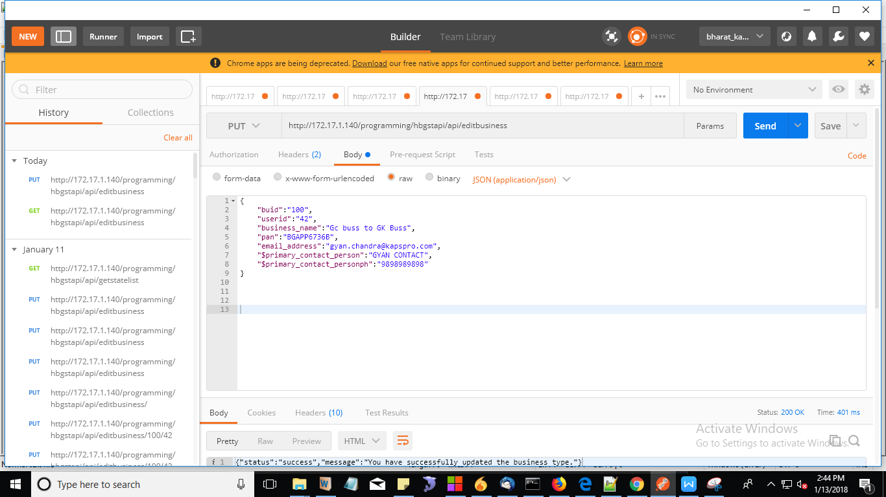

Missing PAN, NAme, emai, phone.

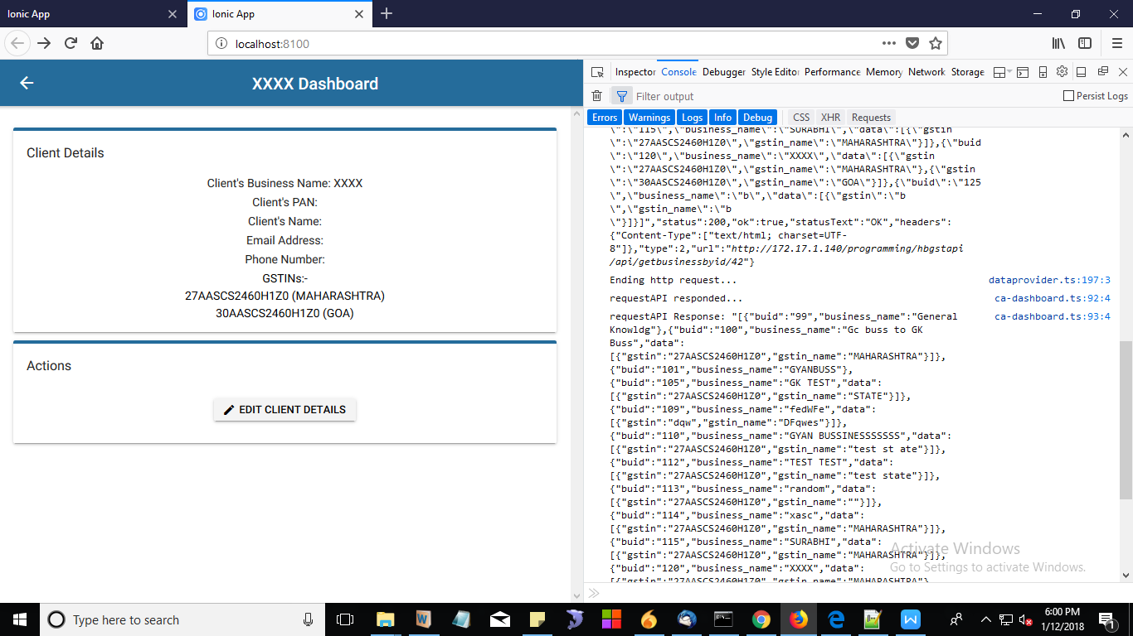

In edit we’re receiving details

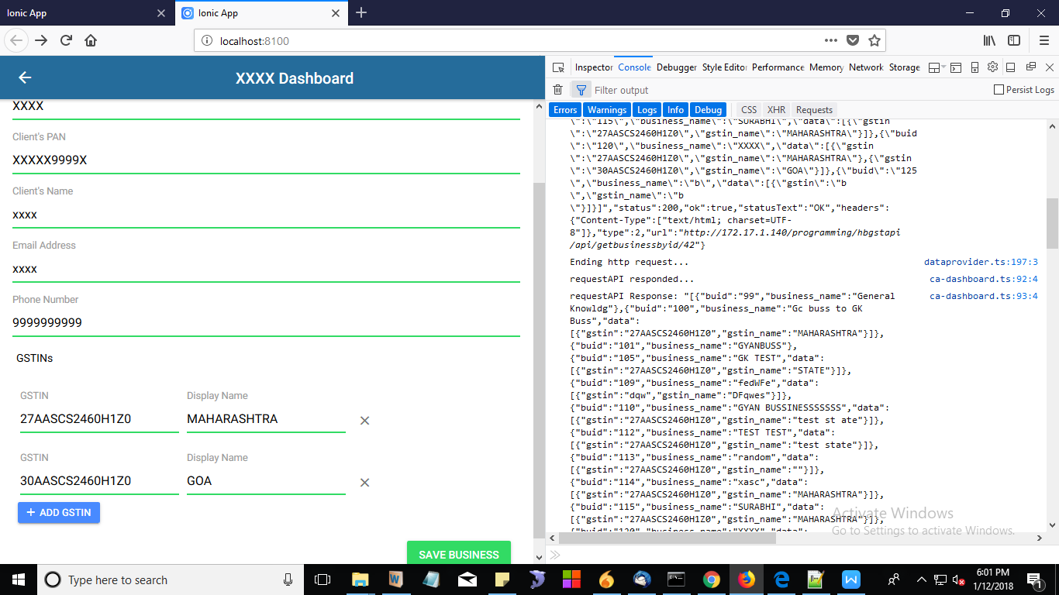

But when we “save Business” error page open

