The cell layout abstract view is used in auto-place-and-route. APR needs to know the size of the cells (width, height), the locations of pins for connections, and where the blockages are.
In such a layout abstract view, the base layer data (e.g., poly, diffusion) are ignored. The popular LEF files basically contain those abstract data. In Synopsys, this step is called BPV (blockage, pin and vias). It produces more info than LEF, since “V” in BPV can tell routers where to drop vias safely to connect to pins.
We design this assignment to let you practice how to create an abstract view. Welcome to use Boost’s package in your program. You may need to play around Boost’s APIs first to get a feeling about it. Any question, simply ask.

Project-1 (10%)
  - Welcome using Boost to exercise its Boolean geometry APIs
  - Display the results

For Blockage-Pin-Via (BPV), first let’s define a simple language to describe shapes.

# (first char # means that line is for comments)
# defining layers and the associated colors
# number_of_layers (total # of layers)
# layer_name layer_number
number_of_layers 3
M1 1
M2 2
M3 3
end_of_layer

# descriptions of polygon
# layer_number x1 y1, x2 y2, x3 y3, x4 y4, x1 y1 (enclosed. Use “,” to separate two points)
number_of_polygons 2
1 0 0, 0 10, 5 10, 5 -2, 0 0
2 1 1, 1 8, 7 8, 5 5, 1 1
end_of_polygon

# description of rectangles
# layer_number x1 y1, x2 y2
number_of_rectangles 1
3 2 4, 14 8
end_of_rectangle

# description of texts (which is placed at a location. For now, we do not define the font size)
# layer_number text location (x y)
number_of_texts 1
1 A 4 5
end_of_text

Now this assignment is to merge several M1 shapes and produce M1 blockages as big as possible. Then, there are shapes defining pins (i.e., the shapes touched by the pin texts.) We need to carve out those pin-shapes for connection.
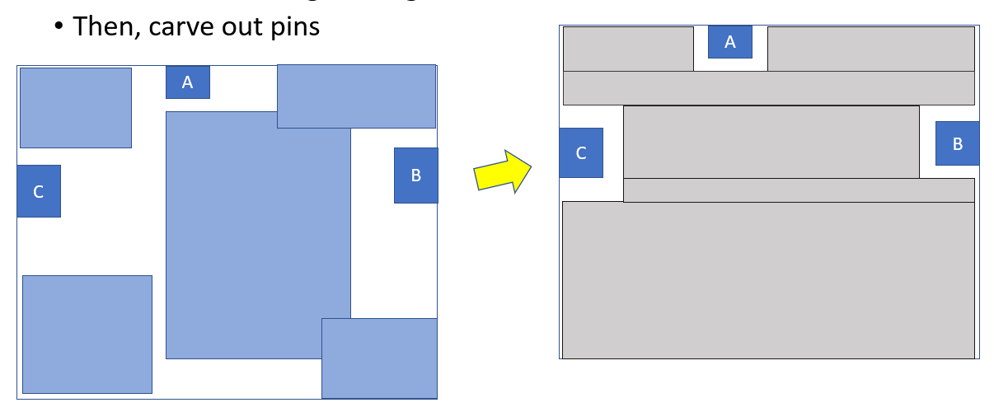
Below are the descriptions of the above picture.

number_of_layers 1
M1 1
end_of_layer
number_of_polygons 5
1 0 0, 0 10, 10 10, 10 0, 0 0
1 12 3, 12 30, 32 30, 32 3, 12 3
1 30 0, 30 5, 40 5, 40 0, 30 0
1 0 40, 0 50, 6 50, 6 40, 0 40
1 30 42, 30 50, 40 50, 40 42, 30 42

end_of_polygon
number_of_rectangles 3
1 0 20, 3 24
1 13 46, 17 50
1 38 10, 40 13
end_of_rectangle
number_of_texts 3
1 C 1 21
1 A 14 47
1 B 39 12
end_of_text

Please write a parser to read in all the polygons, rectangles and texts.
- Find the smallest enclosing rectangle of all these objects. This rectangle serves as a big blockage.

- From the texts and their locations, please identify which shapes are touched by them. Those shapes will become pins for future connections.

- Then, carve out pin shapes from the big blockage obtained in (1). In this exercise, please use 0.5 as min spacing for M1 (in other words, you need to leave 0.5 spacing around the pin shapes.)

Please show a layout right after your parsing those shapes – (A)
Then, display the result of (3) and the resulting polygons/rectangles. Please slice the blockages into rectangles – (B). A reason is if you don’t slice a polygon to rectangles, APR tools will do that internally.

For display, one way is to use .svg file. A sample code is below:
std::ofstream svg("diff.svg");
boost::geometry::svg_mapper<point> mapper(svg, 200, 200);
mapper.add(green);
mapper.add(blue);
mapper.map(green, "fill-opacity:0.5;fill:rgb(0,153,0);stroke:rgb(0,200,0);stroke-width:2");
mapper.map(blue, "fill-opacity:0.5;fill:rgb(0,0,153);stroke:rgb(0,0,200);stroke-width:2");

Welcome to refer to some .cpp in this folder: /disk1/for_jtli/test/boost_test
(Soon I will create accounts for you in my CentOS7 machine. Besides that, welcome to use other ways to create your results for viewing – just teach me how to view.)

Note: BPV is used to create abstract views of all the library cells used in place-and-route. If interested, welcome to browse these
https://www.ispd.cc/contests/18/lefdefref.pdf
https://coriolis.lip6.fr/doc/lefdef/lefdefref/LEFSyntax.html

