Project-2 (end-of-line rule) (10%)
Please see a picture below, which describes this EOL rule. Let’s say
EOL spacing between objects 1 and 2 is at least 1 (um).
Length of end is 0.6 (um) (i.e., if the width of object-1 is smaller & equal than 0.6, need to consider this rule.)
Parallel length from the top of edge 1 is 0.7 (um).
Parallel halo away from object-1 is 0.4 (um)
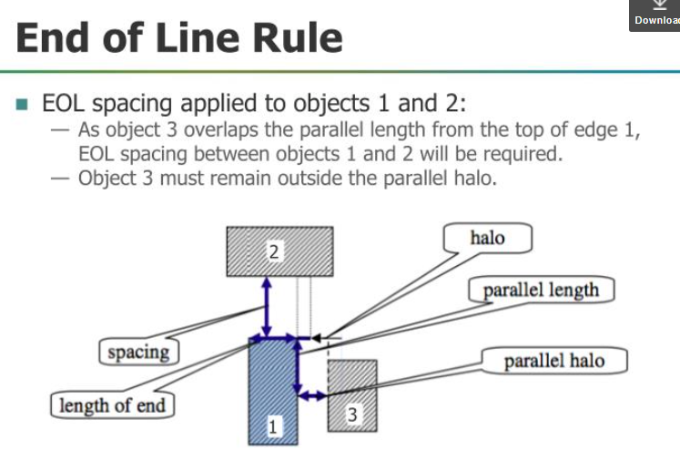

Another simpler picture for EOL is below:
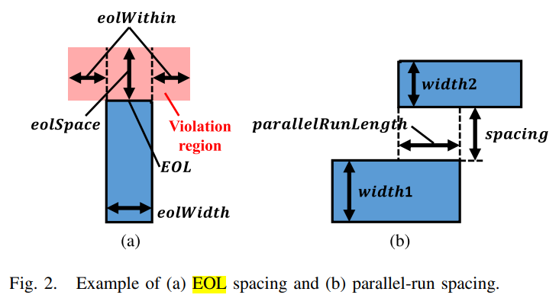
EOL Spacing: A metal end is an EOL if its width is shorter than or equal to eolWidth. EOL is required to preserve a spacing greater than or equal to eolSpace; and no shape touching the two side areas defined by the eolWithin distance, as Fig. 2(a) shows

Below is a layout sample which has an end-of-line error.
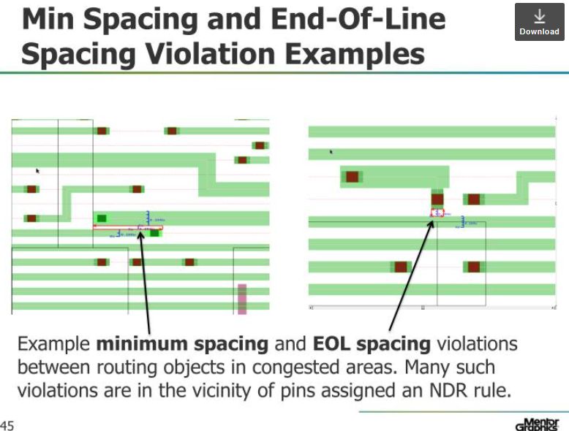

In this project, please write down your algorithms for this checking. Then, implement it to read the following layout patterns (using the format defined in project-1) to see if there are EOL errors. In this exercise, it is totally up to you if you want to use Boost APIs. If you want to code this checking using Calibre rule deck, it is also welcome.

Layout patterns are described below. The unit used below is um.
number_of_layers 1
M1 1
end_of_layer
number_of_rectangles 6
1 4.0 0, 7.8 0.6
1 0 1.0, 6.1 1.6
1 2.0 2.0, 4.0 2.6
1 7.0 1.0, 14 1.6
1 10.4 0.8, 11 1.8
1 8.6 2.2, 14 2.8
end_of_rectangle

Please read in this file to build your data structure, then, check if there is/are end-of-line DRC errors. In the report, please write down the steps of your algorithm and show the locations of violations, if any.
Also tell me where your program is and we will login to exercise it. In that directory, please create a README file for us to study, to compile, to run. Thanks.

The layout looks like below:
Y
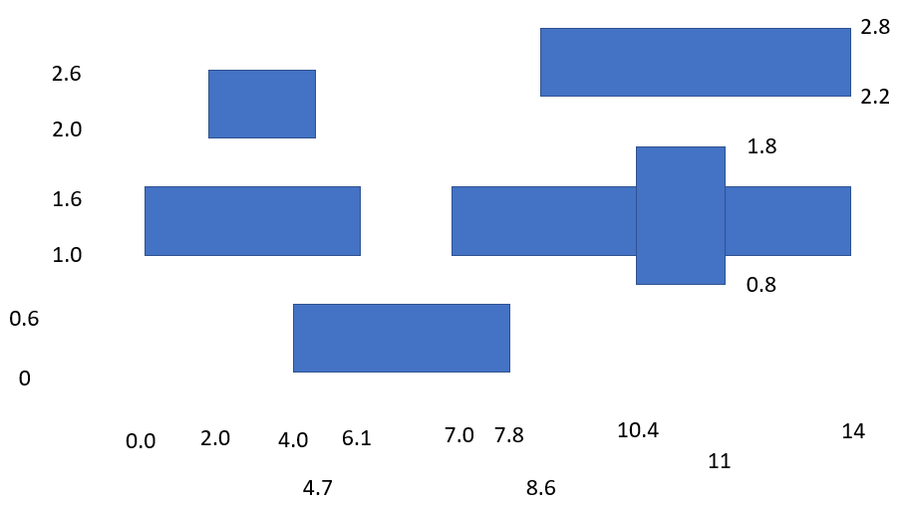

The EOL rule is important in recent technology nodes (TSMC, Intel, Samsung). Routers need to obey such a rule in their router-DRC-checker and find new routing paths to avoid this violation. UCSD talked about this in their TritonRoute router. (A link to that paper is below.)
https://vlsicad.ucsd.edu/Publications/Journals/j133.pdf

