Project-3 GDS & QT (15 points):
An intent of this project is to guide you
- To understand GDS (its format and its parser); then, create some GDS objects; how to traverse those objects; and very importantly how to query those objects?
(Note: from there, we can extend to learn how to write out GDS. But we don’t need to go there).

- How to render layout objects through QT? how to query an object in a QT window? In the query, a cursor location (x, y) is obtained. Then, collect the objects underneath that location. When the program is run, an event queue is being run and waiting for any actions to be issued. So when the mouse is clicked to do “query”, some functions will be called and some shapes will be selected and printed out in a dialog window.

First, please study GDS format (a link to a good GDS introduction is in the .ppt.) Then, browse the parser codes (a link to a parser in GitHub is in the .ppt).
Here is a suggested way to do this project.
One is to “cp -rp ~jtli/test/gds_QT/object_viewer_02102023 .” into your working directory. (I believe the read permission is ready.)
- Build object_viewer; then, run it. You can see a menu bar with “File” at the left side. When you click it, you can see a pull-down menu and select “Open”. If you have a GDS file, then, you can provide it. Otherwise, you can simply “Cancel” it.
If a GDS file exists, when the program parses it, the records in this GDS file will be printed on the screen one record per line.
(Note: in the working directory, you can see some GDS examples are in
~jtli/test/gds_QT/object_viewer_02102023/gdsFileParser/testData )
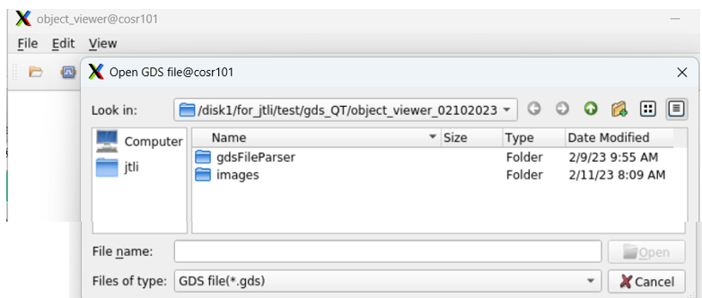

- An important exercise is to learn how to use this asynchronous programming (i.e., an event queue is created to wait for any mouse event to happen, and then, process.)

How to compile the codes?
If you are on my CentOS-7 machine, please read file ~jtli/test/gds_QT/how_to_compile”. I installed a QT version at /opt/qt5.12.12

Please run
export LD_LIBRARY_PATH=/opt/qt5.12.12/5.12.12/gcc_64/lib:$LD_LIBRARY_PATH
export QT_QPA_FONTDIR=/usr/share/fonts/dejavu

/opt/qt5.12.12/5.12.12/gcc_64/bin/qmake -o Makefile object_viewer.pro
make
./object_viewer

If you are on EE machine, such as ws26, whose OS was recently upgraded to CentOS-8, IT helped to installed Qt 5.15.3
# /usr/lib64/qt5/bin
# /usr/include/qt5/
# /usr/share/qt5
Please run
setenv QT_QPA_FONTDIR /usr/share/fonts/dejavu
/usr/lib64/qt5/bin/qmake -o Makefile object_viewer.pro
make
./object_viewer

After you can compile, link successfully, you can play round the executable. A few things you can try:
- We hard codes some shapes. Please find out which files have those codes. Then, please add two more shapes in your program (or adding new shapes in QT window.) Please trace the codes to see how objects are added and which key is used to terminate the job.

- In display window, please do several queries and get the snapshots. Then, find out which functions are doing the “query” work.

- Can you try to parse in a GDS file you will create in project-4: creating layout cellviews for differential pairs. (Or trying to import /home/user/jtli/test/gds_QT/object_viewer_02102023/gdsFileParser/testData/two_stage/two_stage.gds. Such GDS was dumped from a 14nm layout for a two-stage amplifier using Synopsys 14nm university PDK.)

(In fact, a symbolic link is ready for you to parse two_stage.gds) /home/course/jtli/pdk/Synopsys/SNPS/Ccompiler/synopsys_custom/two_stage.gds

Then, submit your reports.
Welcome to compile with “-g”; then, use gdb to trace the codes to learn. These are excellent examples for you to study. Or to follow Karl’s suggestions to learn QT. He wrote
A better way is to get the students to enhance the code rather than trace it. QT is event driven and hard to understand without trying to modify it for some purpose. There are numerous enhancements which could be added to the code via a sequence of exercises with increasing levels of difficulty. Each new task would build in some knowledge in QT. For example a possible task could be to save the current drawing as an image file, select a 2 or more paths are merge into a single path … trace overlapping shapes on specific layers (e.g., building the connectivity, or doing color propagation) … things like that.

This entire package is for you to study. They are well written. Welcome to save a copy for your future usage.

