Standards
Variable Names
- Camel userName, isDarkMode
- Constants in UPPER_CASE API_BASE_URL
- Boolean variables start with (is,has,should) isOpen,hasError
Functions
- camelCase, descriptive specifically, only 1 purpose handleSubmit, fetchUserData
Components
- PascalCase LoginForm, UserCard
- Component files must match the component name LoginForm.jsx

CSS/ Classes
- kebab-case .main-container

Component Design
- Keep components small (as much as we can), single-responsibillity.
- Avoid prop drilling use Redux as much as we can.

Hooks
- Always prefix sustom hooks with use useAuth, useFormValidation
- Keep hooks small and reusable
State Management
- Local state useState, useReducer…
- Global state redux

Project Structure
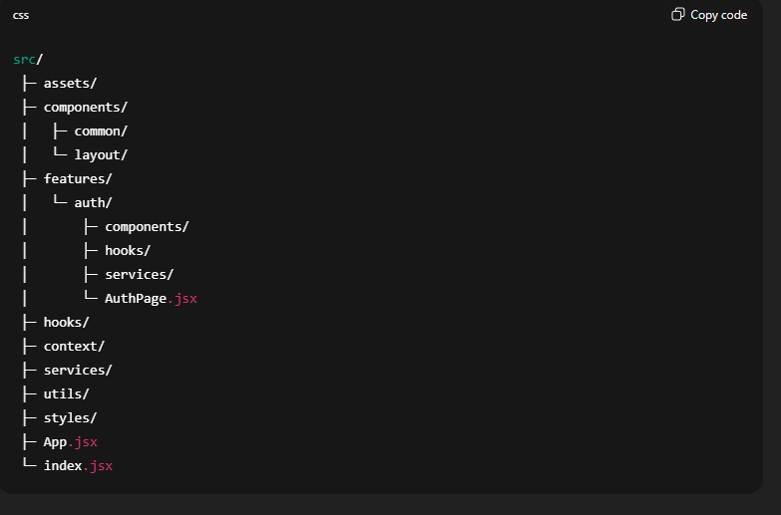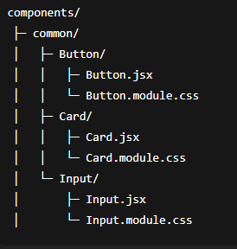

Imports & File Organization
- React & core libraries
- Third-party livraries
- Context / hooks
- Components
- Styles

Git & Workflow
- Branch Naming Conventions
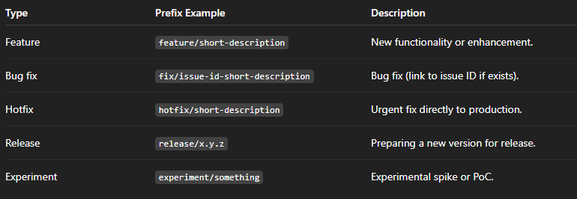
Examples:
feature/login-endpoint
fix/123-null-pointer
hotfix/payment-bug

- Commit Message Conventions
- Feat – new feature
- Fix – bug fix
- Docs - documentation change
- Style – formatting / styling
- Refactor – code change without new feature
- Test – adding or changing tests
- Core – maintenance (deps, config)

Examples
feat(auth): add JWT authentication
fix(api): handle null response
docs(readme): update installation instructions

