PLAIN PACKAGING OF TOBACCO:

Legal Issues

Tobacco companies say plain packaging is unlawful – is this true?

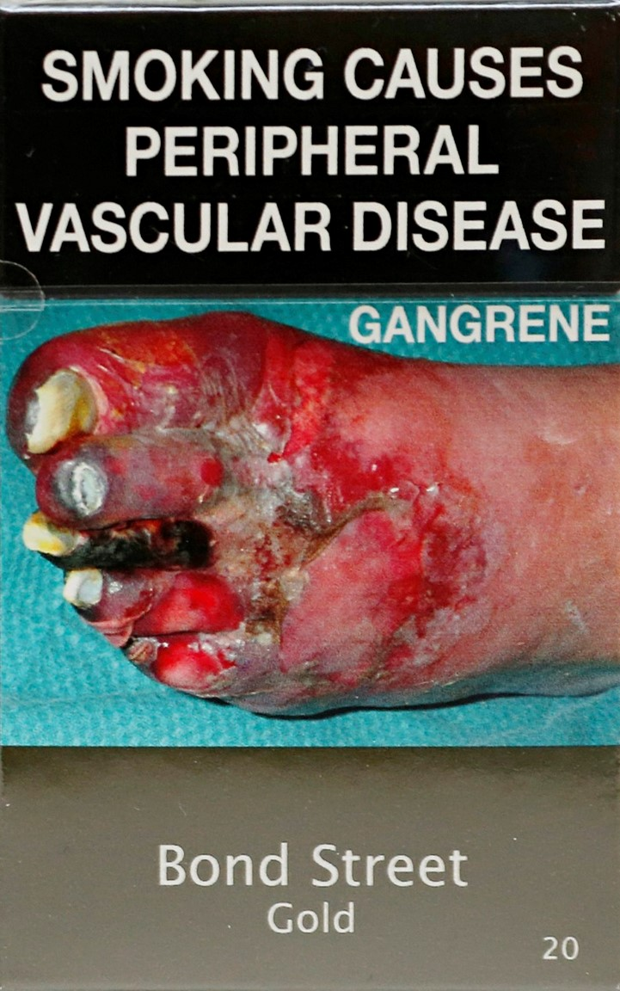

**Plain packaging laws have been upheld as lawful by national, regional and international courts and tribunals** which have found the arguments put forward by the tobacco companies to be flawed.

Plain packaging is recommended in the implementation guidelines to Article 11 and 13 the Framework Convention on Tobacco Control – one of the most widely ratified international treaties in the world.

If adopted using appropriate national administrative, constitutional and legislative arrangements then there is no inherent reason why plain packaging should be found unlawful.

Legal challenges to plain packaging laws in other countries:

All the legal challenges decided, as of the end of 2016, have upheld the legality of plain packaging of tobacco products:

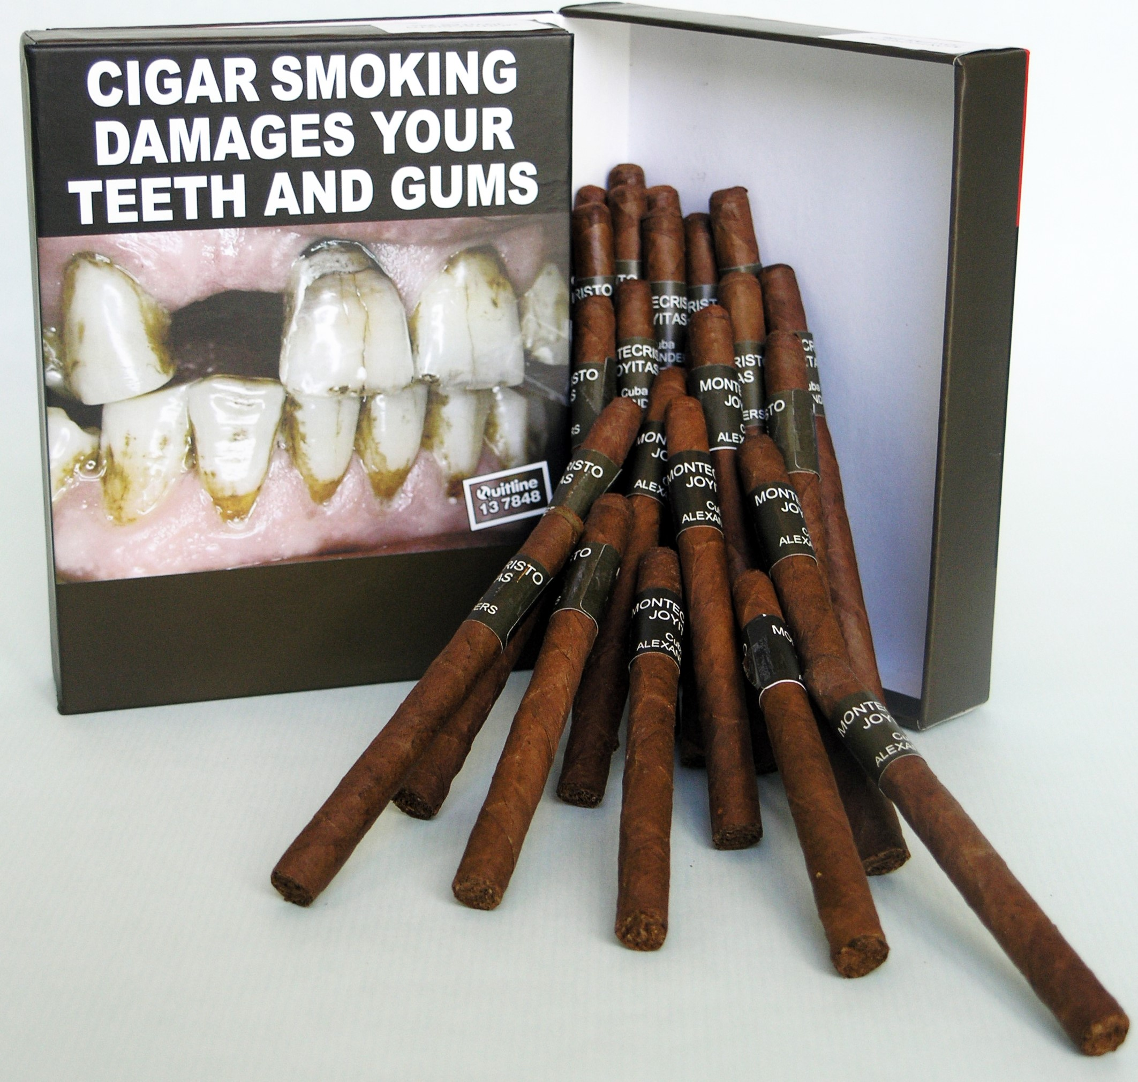

AUSTRALIA

Constitutional challenge in Australia High Court[1] – **dismissed** August 2012

International investment arbitration claim[2] – **dismissed** December 2015

Complaint before the WTO dispute panel - ruling due May 2017.

UNITED KINGDOM

5 claims in the High Court of England and Wales[3] – **dismissed** in May 2016.

Ruling upheld by Court of Appeal in December 2016.

FRANCE

Constitutional Court referral[4] – **dismissed** January 2016

6 challenges in the Conseil d’Etat[5] – **dismissed** December 2016.

IRELAND

Challenge in the High Court[6] – **struck out** November 2016.

EUROPEAN UNION

Challenge to the EU Tobacco Products Directive in the EU Court of Justice[7] – **dismissed** in May 2016

Will the tobacco companies try to sue every government that introduces plain packaging?

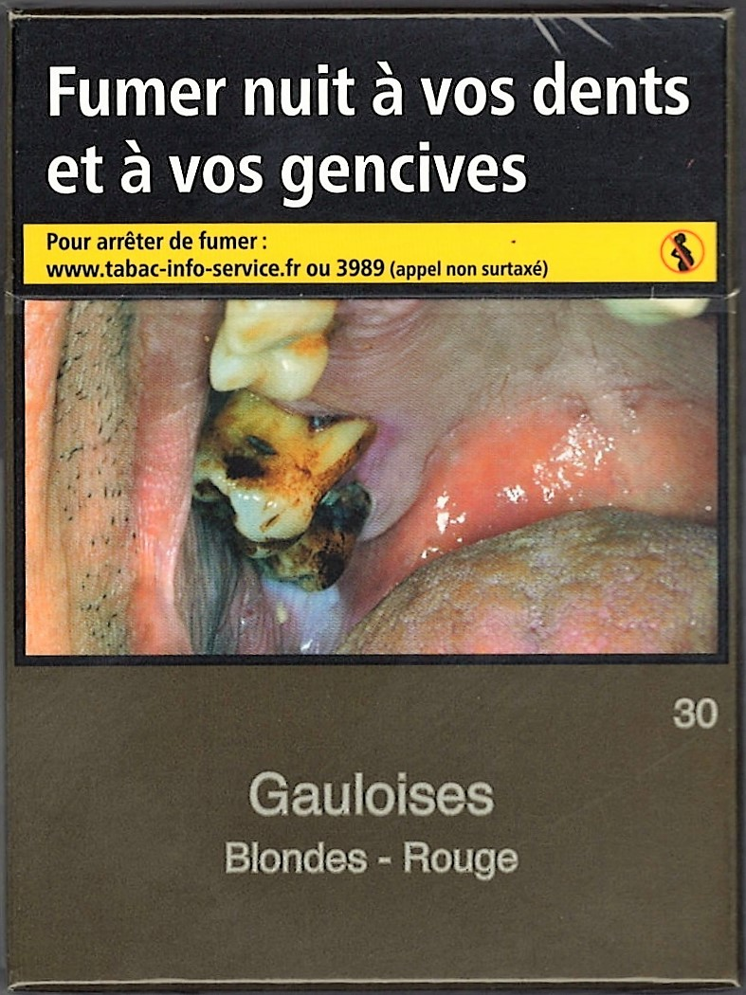

Litigation, and the threat of legal suit, is one of the strategies used by the tobacco industry to try to delay or prevent governments from introducing effective tobacco control polies. But each country has a different legal system and not every government introducing plain packaging has faced a legal challenge.

Hungary, Norway and New Zealand have adopted plain packaging laws but there has been no legal challenge in those countries to date.

The tobacco industry continues to aggressively assert that plain packaging is unlawful in countries considering the policy, even though every industry legal challenges has so far been defeated. Governments should therefore be prepared.

Does plain packaging of tobacco products breach intellectual property laws?

The court rulings dismissing the legal challenges in Australia, France and the United Kingdom have all been clear - plain packaging does not breach either domestic or international intellectual property laws and obligations.

As the High Court in Australia pointed out, plain packaging is no different in kind from other packaging or labelling requirement. If tobacco plain packaging breached IP laws, then governments could not regulate other packaging and labelling of other products.

The tobacco companies argue that once they have registered their trademarks they have a ‘right to use’ those trademarks. But no international IP treaty requires that owners of registered trademarks have a ‘right to use’ them that overrides a states’ powers to regulate for the public good.

As far back as 1994, disclosed internal industry documents show that the tobacco companies had advice from their own lawyers and from the World Intellectual Property Organisation (WIPO), that plain packaging would not contravene the international IP rules[8].

The Director General of WIPO wrote to the Director General of WHO in 1995 to state “*countries party to the Paris Convention remain free to regulate the sale of certain types of goods and the fact that a mark has been registered for such goods does not give the right to the holder of the registration to be exempted from any limitation of using the mark which may be decided by the competent authority of the country where the mark is registered*”[9].

The case being considered by the WTO

A World Trade Organisation (WTO) dispute settlement panel is adjudicating complaints by Honduras; Dominican Republic; Cuba; and Indonesia against Australia’s plain packaging, claiming that it breaches the TRIPS and TBT agreements.[10] (Ukraine also initiated a dispute but later withdrew the complaint).

The panel’s decision is due to be given in May 2017. 34 member states together with the EU have made 3rd party submissions – more than any previous WTO dispute. This is an important and highly anticipated ruling.

However, governments in many countries have considered their WTO obligations and decided to proceed before the ruling is given and, as stated above, many courts and tribunals have considered the WTO agreements and found that plain packaging laws do not breach them.

What do the tobacco companies claim; and what have the courts in other countries ruled?

Below are just some examples of what the courts have said in dismissing the tobacco companies’ legal claims against plain packaging. More detailed summaries and analysis are available [paragraph numbers from judgments given in square brackets].

1. Plain packaging is not ‘justified’, ‘necessary’ or ‘proportionate’ because the evidence does not support that the policy will work to reduce smoking rates.

**UK High Court**: “*In my judgment the qualitative evidence relied upon by the [Government] is cogent, substantial and overwhelmingly one-directional in its conclusion*” that plain packaging will be effective. [¶592]

**Australia High Court**: plain packaging requirements “*are no different in kind from any legislation that requires labels that warn against the use or misuse of a product*.” [¶181]

1. Plain packaging is an ‘expropriation’, ‘deprivation’ or ‘acquisition’ of the property rights in their trademarks.

**France Constitutional Court**: “*Thus an expropriation is not at issue here … but a limitation of the rights of property justified by the objective of protecting public health*” [¶20 translated]

**Australia High Court**: “*neither the Commonwealth nor any other person acquired any property*” [Official court summary]

1. Plain packaging is incompatible with intellectual property laws and the ‘right to use’ a trademark.

**UK High Court**: “*It is no part of international, EU or domestic common law on intellectual property that the legitimate function of a trade mark (i.e. its essence or substance) should be defined to include a right to use the mark to harm public health*.” [¶40]

1. Plain packaging breaches World Trade Organisation rules and international treaties

**France Conseil d’Etat**: The provisions in the WTO TRIPS and the Paris Convection “*do not in any event prohibit States parties from exercising the option, which is always open to them, to adopt measures necessary to protect public health, which can be applied, where appropriate depending on the objective, to certain categories of products.*” [¶22 translated]

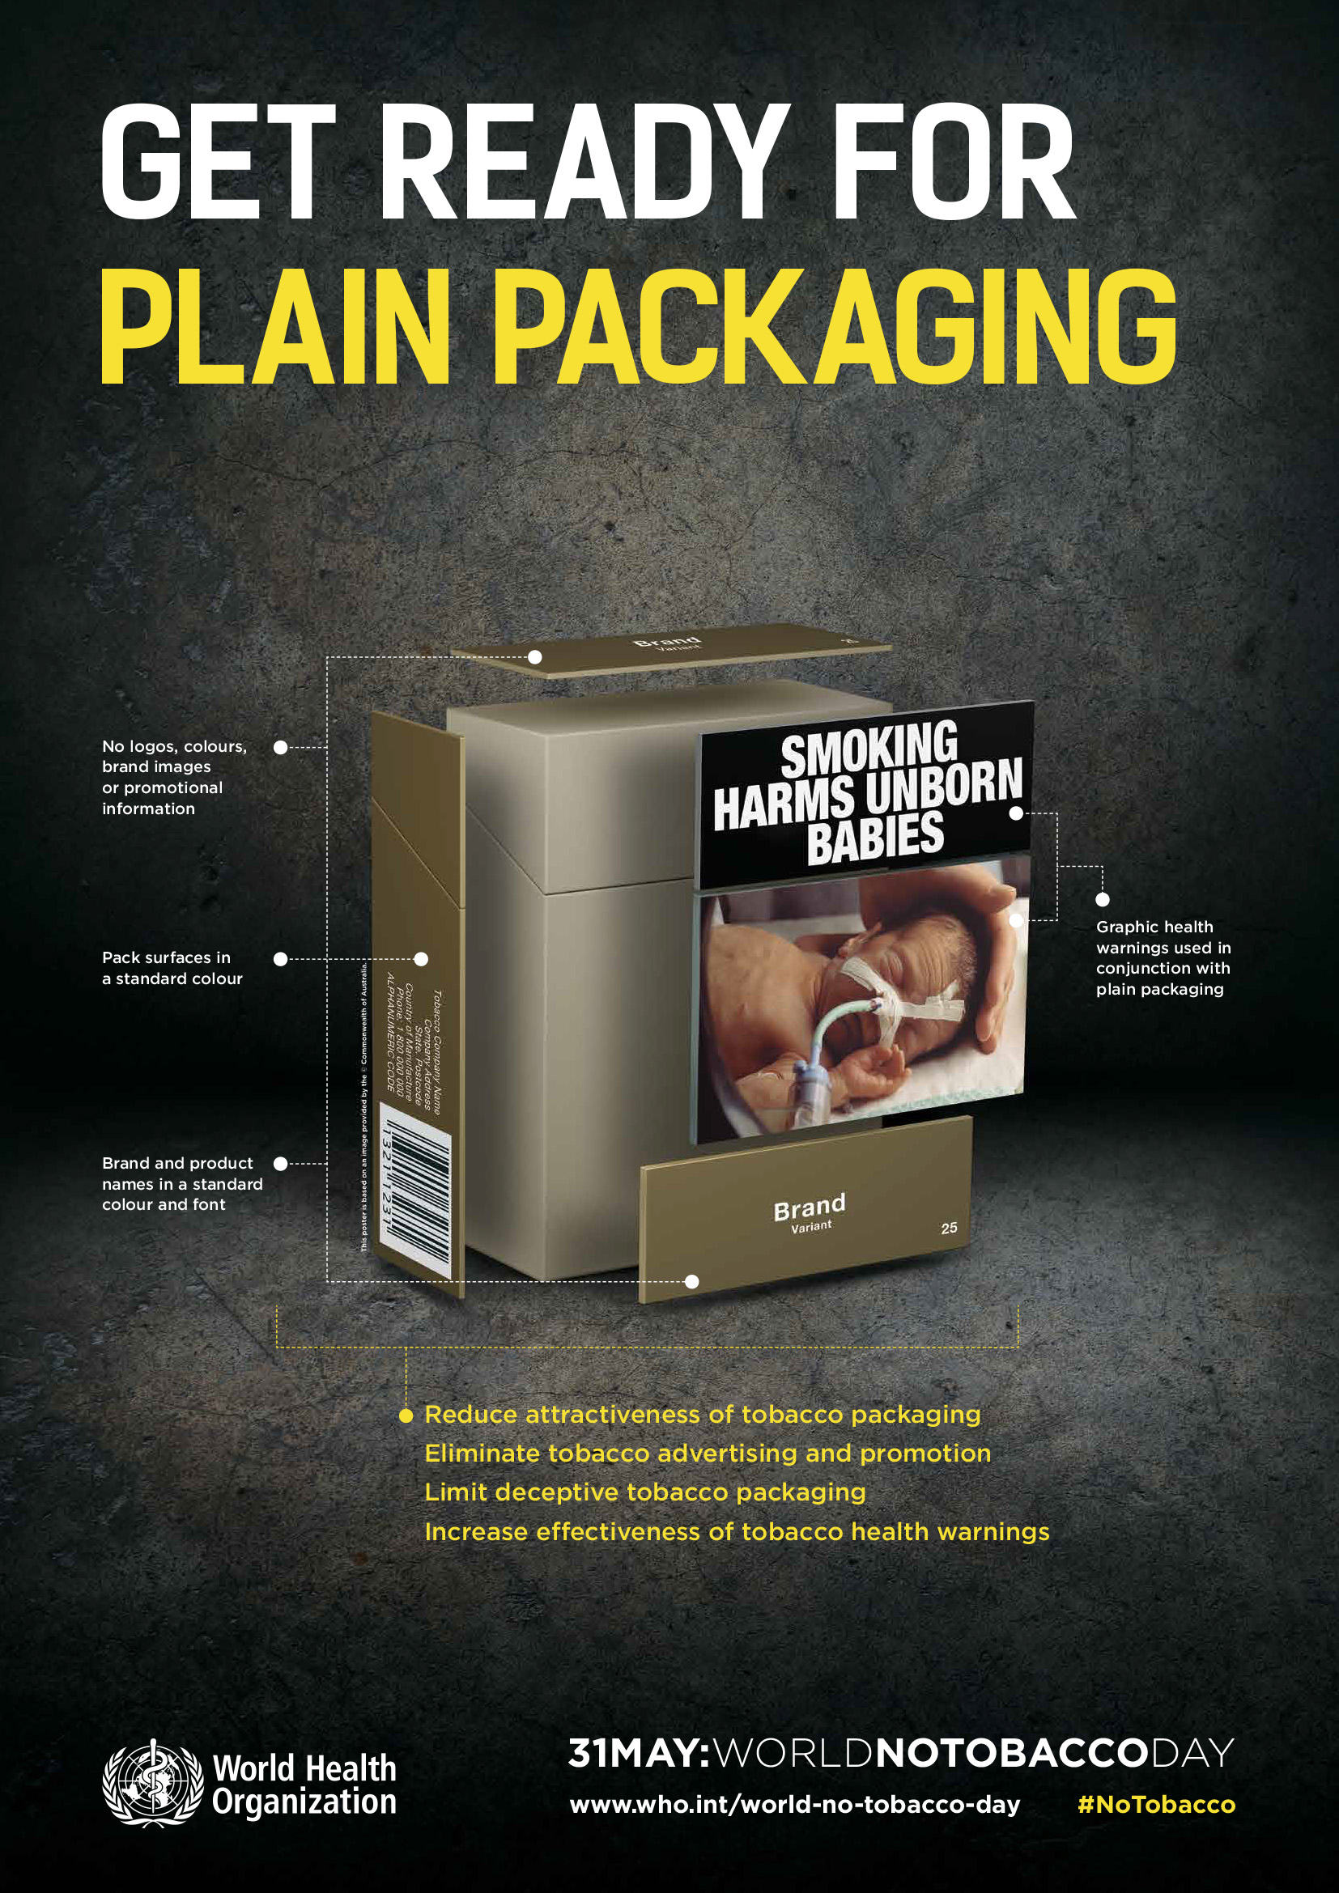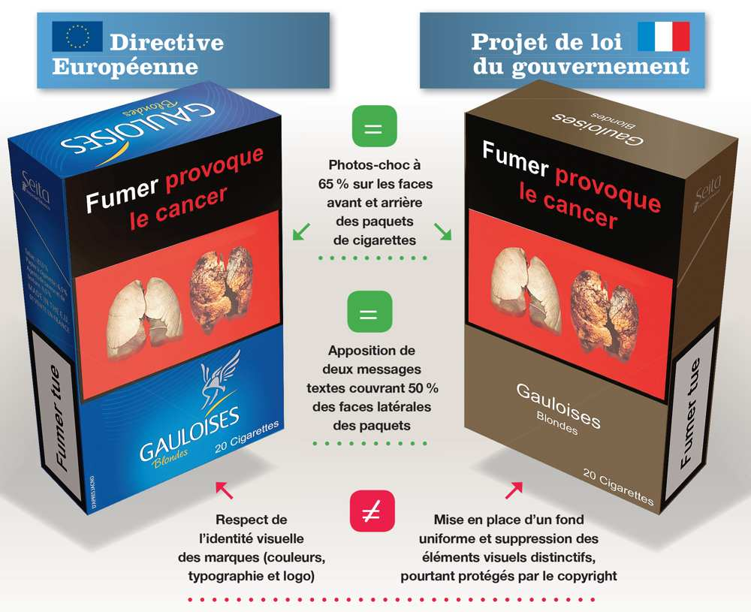

1. JT International SA v Commonwealth of Australia [2012] HCA 43, High Court of Australia, Order August 15, 2012, Reasons October 5, 2012
2. Philip Morris Asia Limited v. The Commonwealth of Australia. PCA Case No. 2012-12
3. R (British American Tobacco & Ors) v Secretary of State for Health [2016] EWHC 1169 (Admin)
4. LE CONSEIL CONSTITUTIONNEL Décision n° 2015-727 DC
5. CE, 23 décembre 2016, société JT International SA, Société d'exploitation industrielle des tabacs et des allumettes, société Philip Morris France SA et autres
6. JTI v Minister for Health, Ireland and the Attorney General is 2015/2530P
7. Philip Morris Brands SARL and Others v Secretary of State for Health C-547/14
8. A full history and explanation of the disclosed documents relating to plain packaging is produced by Smoke-Free Canada and can be found here: <http://www.smoke-free.ca/pdf_1/plotagainstplainpackaging-apr1'.pdf>
9. Published in, Tobacco control and the Paris Convention for the Protection of Industrial Property. Tobacco Control 1996; 5: 165 Collishaw NE
10. WTO Dispute numbers [DS435](https://www.wto.org/english/tratop_e/dispu_e/cases_e/ds435_e.htm), [DS441](https://www.wto.org/english/tratop_e/dispu_e/cases_e/ds441_e.htm), [DS458](https://www.wto.org/english/tratop_e/dispu_e/cases_e/ds458_e.htm) and [DS467](https://www.wto.org/english/tratop_e/dispu_e/cases_e/ds467_e.htm)