- Introduction
  - What is CRM?
  - About CoreBOS
    - What is the difference between CoreBOS Vtiger 6.x?
    - Advantages of CoreBOS
    - Who is CoreBOS for?
    - How is CoreBOS evolving?
  - Pc Setup & Other Requirements
    - Loginor
  - CRM Home Page
    - Home Page Content
  - Navigation
    - Login Area
      - My Preferences
    - Navigation Area
    - Quick Create
    - Search
    - Tools
  - Access privileges
- Marketing
- Sales
  - How to implement your sales process with CRM?
  - Lead Management
    - Creating Leads
    - Qualify Leads
      - Creating Filters
      - Scheduling Events
      - Sending Emails
      - Receiving Emails
    - Convert Leads
    - Mapping Fields
  - Opportunities Management
  - Organisations Management
  - Contacts Management
  - Quotes
  - Sales Orders
  - Purchase Orders
  - Invoices
- Support
  - Support Tickets
  - Create New Tickets
  - Work with Tickets
  - FAQ
  - Customer Portal
- Inventory
  - Organize Products
  - Price Books
  - Vendors
- Tools
  - RSS
  - Our Sites
  - Notes
  - SMS Notifier
  - Recycle Bin
  - Mail Manager
  - Global Variables
  - Business Maps
  - Business Actions
  - View Permissions
  - Comments
  - Generate Documents
- Reporting & Analysis
  - Reports
  - Dashboards
- Settings
  - CoreBOS Updater
  - Translations
  - Menu Editor
- CoreBOS CRM Settings
  - Users & Access Management
    - Role Security
    - Users
    - Profiles
    - Roles
    - Groups
    - Field Access
    - Sharing Access
  - Studio
    - Module Manager
    - Picklist Editor
    - Picklist Dependency Editor
  - Business Process Management
    - Mail Converter
    - Workflows
      - Workflow Launch Conditions
      - Workflow Tasks
        - Update Workflow Tasks
        - Add/Delete Tags Workflow Tasks
        - Related Product/Service Workflow Task
        - Invoke Custom Functions Workflow Tasks
        - SMS Workflow Tasks
    - Scheduler
  - Other Settings
    - Currencies
    - Tax Calculations
    - Outgoing Server
    - Customize Record Numbering
- Mobile Access
  - Two Factor Authentication

1.Introduction
User Manual
Administration Manual
1.1. What is CRM?
CRM(Customer Relationship Management) is a computer system to basically do two things:
- Contact management
- Programming of commercial activities, ie track and schedule actions to achieve sales over time.
A CRM system essentially provides a central place where businesses can store customer and prospect data, track customer interactions, and share this information with colleagues. It allows businesses to manage relationships with customers, helping the business to grow.
With a CRM system in place, every question, every service request, every preference and every past contact details about every customer is instantly available, which means that every new interaction with them should always be personalized, relevant and up to date.
As well as tracking every phone call, email sent, meeting held and presentation delivered, CRM systems can also be used to add notes, schedule follow-ups and organize the next steps that need to be taken. This ensures that opportunities to close deals or grow customer accounts won’t be missed.
By understanding customers better, opportunities become clearer too, giving organizations a much better chance to win new business from existing customers.
1.2. About CoreBOS
It is an IT platform for service companies of any size. As an evolution of SugarCRM and vtigerCRM, it comes from the world of CRM but has evolved into the model of ERP to consider issues that fall outside the world of CRM, such as: billing, collection management, supplier management, financial management, data analysis, reporting and Big data.
What is the difference between coreBOS CRM and Vtiger 6.x?
The vtiger crm 5.4 project bifurcated into two branches, namely:
coreBOS which is the natural evolution of vtiger 5.4, following on the basis of existing and tested code. The name has changed for copyright issues but really it is version 6 of vtiger crm.
Vtiger 6.x: a focused solution to a proprietary SaaS and On Demand which provides an open source version that is different from the commercial version.
This version has really been a complete re-writing of the code, that means:
- VERY DIFFICULT UPDATE: any custom code you have needs to be rebuilt,
- A LOT OF BUGS: new code, new bugs.
- LOST FEATURES: Many features have disappeared because they were not implemented.
- BACK TO THE START: in many cases, because it is a rebuilt system, we must re-learn how to build and how to use the system. In other words: a new program but with the same name.
Advantages of coreBOS:
- SIMPLE AND NATURAL UPDATE: continuity on a stable and tested code base.
- FULL FUNCTIONALITY: Authentic Open source. Only one flavor.
- SUPPORT: Freedom to dispose of most of the vtiger community partners 5.x
- EVOLUTION: There are plenty of new features right now by not having to rewrite all the existing code.
- IN THE MAINSTREAM: Easy migration to coreBOS platform.
- AUTONOMY AND SPEED: Autonomy and quick incorporation of features, optimizations and correction of bugs detected.
- RELIABILITY: Ensuring reliability to be based on a model of truly open collaboration
Who is coreBOS for?
- Service companies of any size that want to computerize their business: where services are the main product to be sold.
- Companies wishing to professionally manage their sales department: calendar, tracking, sales funnel, sales targets.
- Companies that want to manage their sales service (tickets, job reports, incidences, projects)
- Companies who want or need to automate processes to achieve cost reduction.
- Companies who want to start using Online marketing and automate it: capturing leads through their website, autoresponders, automated management of publications, sending a series of training and education material for raising potential opportunities, lead nurturing.
- Companies that want to unify all their information in a single system and eliminate the spread of information they currently have.
- Entrepreneurs who want to get more visibility for their business by: dashboards, reporting, Business Intelligence, Big Data, reports and graphic display of data.
How is coreBOS evolving?
Currently the most vivid and exciting trends of development are:
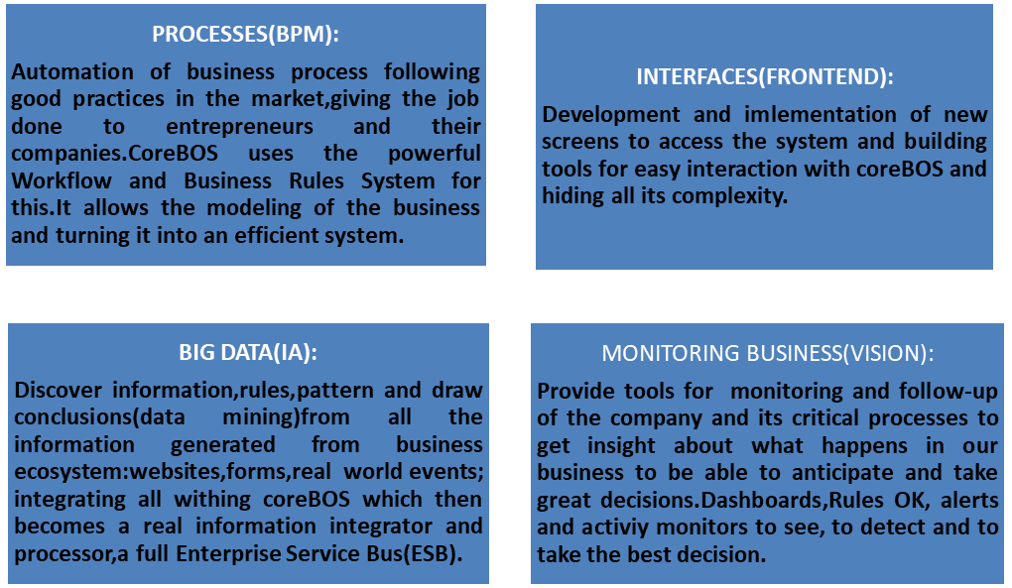
1.3.PC Setup and other Requirements
For a simple use of the CRM system you do not need to install any software on your computer system. You operate the CRM system by your favorite browser only.
Please note the following minimum requirements and follow the browser setup instructions.
Hardware requirements: PC or Thin Client with Browser and minimum screen resolution of 1024 * 768 pixels.
Browser: Firefox or Google Chrome
Your browser configuration must meet the following requirements:
Cookies
You must allow cookies.
Javascript
You must have JavaScript enabled in the security settings of your browser.
Login

Your CRM system administrator will provide you an URL to be used as the access address to the CRM system at you browser. You will also need the Username and the Password of your CRM account.

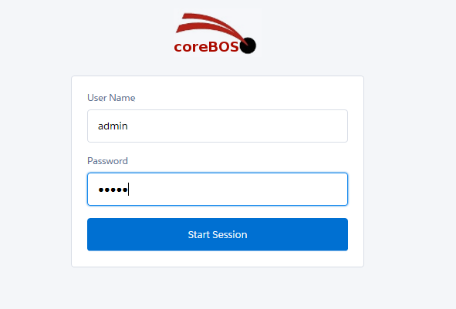
Figure 1.1. Login screen
Upon starting the CRM software, the Login screen will appear as shown in Figure: Login Screen. The user must type an Username and Password into the available edit fields in order to continue on the program.
Caution:Most browsers are able to store your Username and Password to simplify the usage. However, this may be a security risk if you can not make sure that nobody else has access to your computer. Unauthorized persons may get access to your confidential data. This is especially true if you are using a notebook that can get lost.

1.4.CRM Home Page
After login, you will be presented a Home page screen as shown in Figure: CRM Home page.
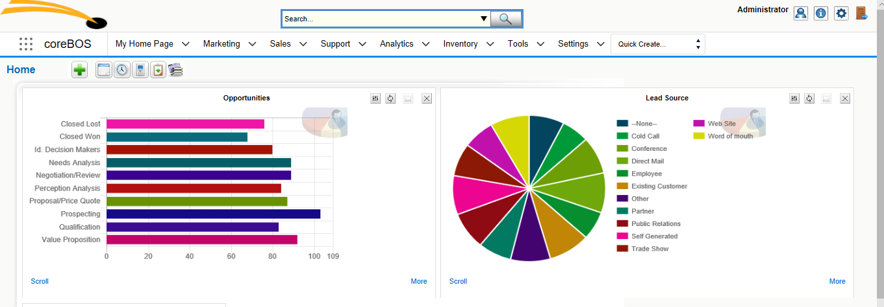
Figure 1.2.CRM Home Page

The following chapters will explain how you can customize the Home page and how you can use the CRM functions.
1.4.1. Home Page Content
The main area of the Home page, as illustrated in the center of Figure: CRM Home page, displays a block summary of the most important CRM information. You may change the order of theses blocks by "drag and drop" with your mouse.
Table 1.1. Home Page Content
 | Type | Content
1 | Homepage Dashboard: | This dashboard displays the data stored at the CRM system as a graphic. This graphic summarizes all information that are related to the user logged in.
2 | My Top Accounts: | Here you can see a list of your top accounts. The content of this list is generated by adding all amounts listed at potentials related to individual accounts.
3 | My Top Open Potentials: | This is a list of your top potentials
4 | My Group Allocations: | This a list of CRM entries that have been assigned to a group where you are a member
5 | My Trouble Tickets: | This is a list of tickets assigned to you or to a group where you are a member.
6 | My Trouble Tickets: | This is a list of tickets assigned to you or to a group where you are a member.
7 | Key Metrics: | The key metrics is a powerful tool. Its function depends on your list view settings. For the data displayed in each CRM module you may create list views based on criteria that meet your special needs. These criteria can be met for instance by using the filter functions. The key metrics will add up the number of CRM entries that meet these criteria. For instance, you build a list view of all Quotes which has been drafted. Then the key metrics will show you the total number of these Quotes.
8 | My Top Open Quotes: | Here are the top open quotes listed. All entries are sorted by the amount.
9 | My Top Open Sales Orders: | Here are the top open sales orders listed. All entries are sorted by the amount.
10 | My Top Open Purchase Orders: | Here are the top open purchase orders listed. All entries are sorted by the amount.
11 | My Top Open Invoice: | Here are the top open invoices listed. All entries are sorted by the amount
12 | My New Leads: | Here are the new Leads displayed. Note, that you may configure the settings for this block at your My Settings menue.
13 | Upcoming & Pending Activities: | This lists the upcoming and pending activities from your calendar. Pending activities are overdue and not closed.
14 | My Recent FAQs: | This is a list of your entries at the knowledge base

Please note:All data stored at the CRM system have an owner. The owner is marked by an "[assigned to:]" entry. If you make a new entry, the data will be assigned to you automatically unless you change it intentionally. At the Home page only data assigned to you will be presented.

1.5.Navigation
The smart design of the CRM system will allow you to get most information quickly. You may navigate within the CRM as you know it from browsing websites.
Caution: It is not recommended to use the back and forward buttons of the browser. These buttons can cause problems when browsing through pages with dynamic generated content.
It is recommended to use the icons and links provided by the CRM system. Advanced users may switch to tabbed browsing to speed up the handling process. You may reach each CRM page by a few clicks. All CRM pages are in hierarchical order. You may switch between pages at the same hierarchical level or you may access a page directly. Based on the content of each individual page you may use the following keyboard shortcuts:
- [Alt+E:] Edit
- [Alt+S:] Save
- [Alt+Q:] Search
- [Alt+C:] Empty
- [Alt+G: ]Select
- [Alt+D: ]Delete
- [Alt+U:] Copy
At the Top of the CRM system, as illustrated at Figure: Screen Top Area you have access to different area types and functions to navigate and to work with the CRM.
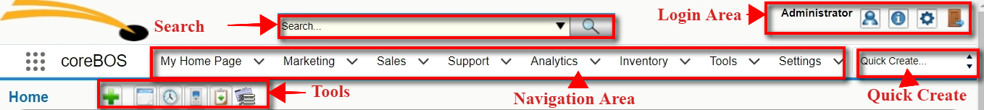
Figure 1.3. Screen Top Area
1.5.1.Login area:
In this area you may access your preference data, get help or release information, or leave the CRM system.
My Preferences
When you click on My Preferences a new window opens as displayed in Figure: My Preferences. This allows you to view and to edit user information and to set your own preferences.
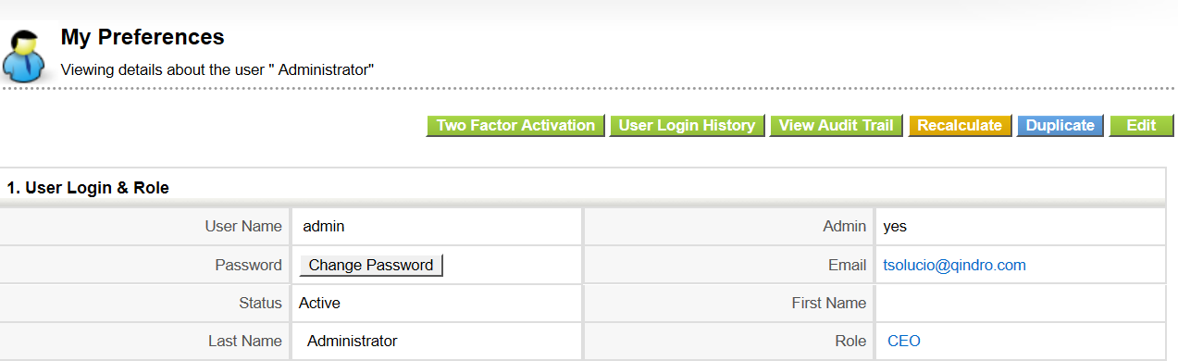
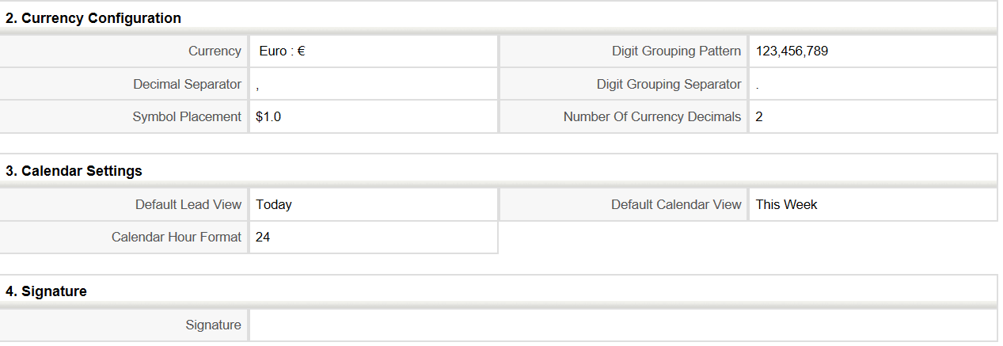
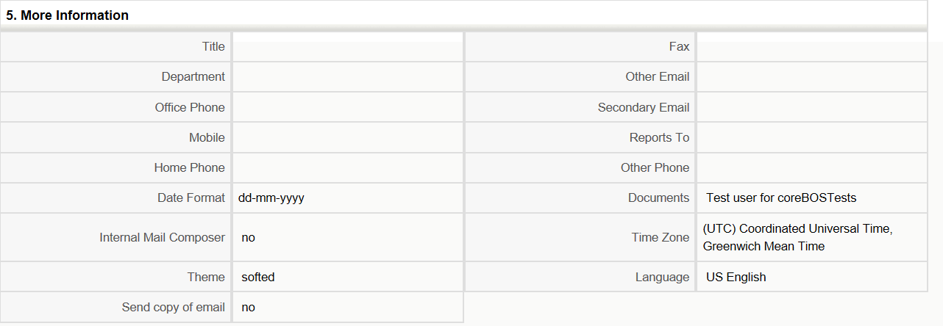
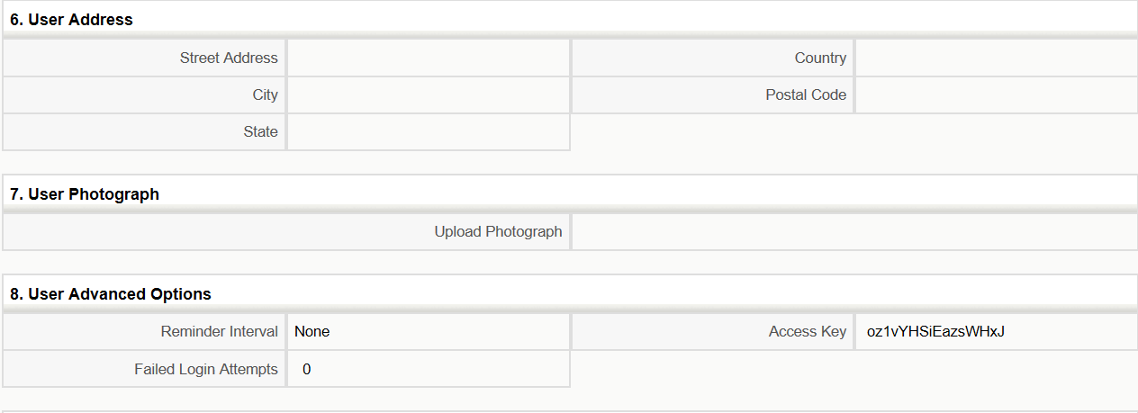
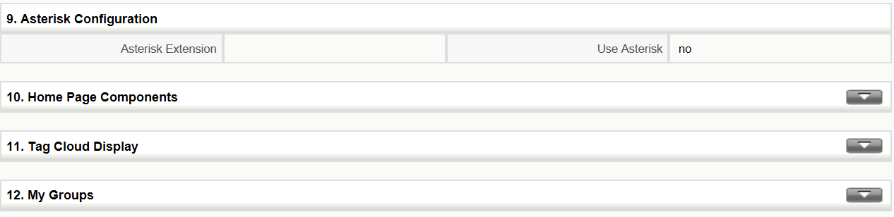
Figure 1.4. My Preferences
Most of these fields are self-explanatory. The highlighted fields in Figure: My Preferences are fields that serve special purposes and are explained in the following table:
Table 1.2. List of special fields at My Preferences
 | Type | Content
1 | User Login & Role - Admin: | If the checkbox is marked the user has administrator privileges. This field can not be edited by a user but can be changed by the administrator.
2 | User Login & Role - Role: | This field displays the role assigned to the user. This field can not be edited by a user but can be changed by the administrator.
3 | User Login & Role - Status: | This field shows whether a user is active (only important for administrators). Inactive users are not allowed to access the CRM system. This field can not be edited by a user but can be changed by the administrator.
4 | More Information - Signature: | This defines the signature as it is added to outgoing emails automatically. The signature should be entered by each individual users
5 | More Information - Reports To: | Here the supervisor of a particular user is defined. This is for information only and does not influence the security settings at all
6 | User Photograph: | Here an image or photo of an user can be stored
7 | Home Page Components: | Here is displayed which CRM information are displayed at the users home page.
8 | My Groups: | If a user is a member of a group a list of the membership is shown
9 | Login History: | That displays the login history of each individual user

Every user can define and change the own password. It is recommended to change the password frequently.
Important : Username and passwords have to be a combination of small or capital letters and numbers. It is recommended that you use at least 8 digits. As more digits you have and as more secure is the CRM access. The use of special characters such as %, / or umlaut (such as ä, ö, ü or ß), as they are used in other languages, is not allowed. A good password for example looks like "Dhe4K39b". Usernames once created can not be changed. However, you might create a new user and transfer all data to the new user.
Click on the [Edit] button to make changes. Alternatively you may move your mouse pointer on top of an entry. Then an edit function is offered, that you can use to change one particular entry.
The [View Audit Trail] button is only functional, if the CRM system administrator enables this function. You may want to know what a particular user has been done at the CRM system. For this type of audit open the Audit Trail Information menu.
The order and the content of the blocks shown at Home can be modified for each individual user. You may change the display order of these blocks at home by drag and drop. You may change the content by clicking on [My Preferences] and the [Edit] button. Mark the information blocks you would like to see at your home page display.
Two-Factor Authentication. coreBOS supports Two-Factor Authentication as of June 2017.
In addition, you may define the conditions of displaying entries such as the "Default Lead View" and "Default Calendar View".
1.5.2. Navigation area:
Here you may switch between the functions and data lists offered by the CRM system.
Figure 1.3.Navigation Area
1.5.3. Quick-Create:
The Quick-Create at Home allows you to jump quickly to an entry page. At the drop down menu select the new entry you would like to make.
Please Note: The Quick-Create has only limited capabilities for entering data.
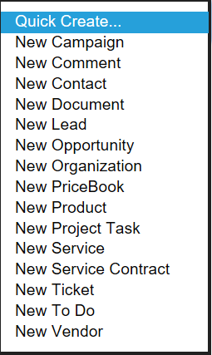
Figure 1.4.Quick-Create

1.5.4. Search:
The Home pages provides a powerful search function that allows you to search the entire database. You may search for any terms.
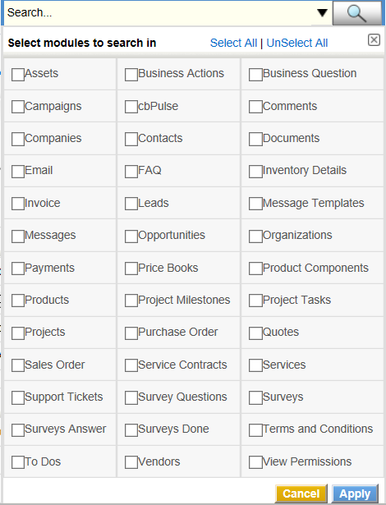
Figure 1.5. Search Menu

Tip: The % character can be used as wild cart for the search function. For example, if you have two contacts spelled "Meyer" and "Mayer" you may search for both by entering "M%yer" as the search term

1.5.5. Tools:
By clicking on these icons you get a quick access to the calendar, the clock, the calculator and other functions. In addition, you may use the Open Selection Menu icon for a quick access to all CRM modules. These icons are available at all CRM menus if appropriate.

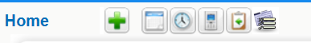
Figure 1.6.Tools

1.6. Access Privileges
Your access privileges to the CRM system are set by the administrator when configuring the CRM system. Thereby the following privilege types are available:
- The permission to use certain CRM modules.
- The permission to view data in certain CRM modules.
- The permission to edit or to change data in certain CRM modules.
- The permission to delete data in certain CRM modules. The permission to export or import data from certain CRM modules.
The CRM system makes sure that you can only exercise certain operations if you have proper privileges.

Marketing
3. Sales
3.1.How to implement your sales process with CRM?
Any company can use CoreBOS , whether it has a well defined sales process that wants to duplicate in the CRM or it wants to build the process from scratch.
The sales process supported by the CRM has been divided into the following steps:
- Lead
- Potential
- Quote
- Sales and Purchase Order
- Invoice
- Service
A typical sales procedure follows these steps:
- Based on a first contact to a prospect customer a Lead will be created. As this sales stage it is not clear whether there will be a business opportunity. This Lead will contain all the information about the contact or the organization available at this sales stage.
- The Lead status of this contact will be maintained until it is clear whether there is a business opportunity. All activities related to this Lead will be listed within the CRM.
- If there is a business opportunity, the Lead will get converted to a Potential. At the same time contacts and accounts are being created automatically and the Lead will be deleted. All the information collected for the Lead are still available but now presented based on their content in contacts, accounts or potentials.
By using this procedure, only those contacts and accounts are being created that have a chance to become a business. The CRM system will not be overloaded with useless data.
In addition, you may enter new accounts or contacts directly if they do not fit to the procedure described. This might be true for your own employees, partner of your company, personal contacts etc.
This procedure will be described in more detail in the following sections.
3.2. Lead Management
Leads are the first phase in establishing a customer relationship. Your company may get leads from marketing activities such as trade shows, advertisements or press releases. At this phase you do not know whether this first contact will lead to a business opportunity.
Important:Usually or unfortunately most of your Leads will not generate any businesses. The CRM system considers that by treating Leads different from all other contact information stored in the CRM. It is meaningful to avoid that useless Leads load the CRM system unnecessarily. For this reason Leads are not linked to other accounts or contact information.
The responsibility of sales agents is to introduce Leads into the system, organize, filter and qualify the prospects. In the B2B model, lead represents a company whereas in B2C model, lead represents a person.

3.2.1. Creating Leads
There are different ways how leads can be generated. Based on your needs you can choose one of the below.
Quick Create
Quick create helps you to create lead records with basic details. This might be helpful if you are running out of time.
If you click on [New Lead] at the Quick-Create menu you are offered a quick entry menu for leads, but only for name, company, phone and email entries.
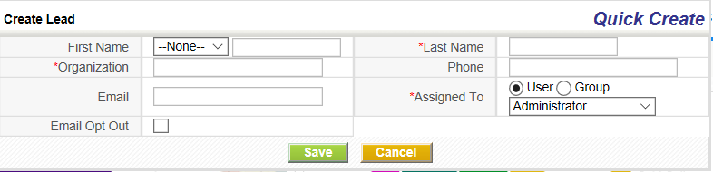
Figure 3.1. Quick-Create Leads
Entering Leads Manually
You can enter lead details manually from Leads Module. If you want to collect more detailed lead information you may click on the [Sales] tab at the navigation area shown in Figure: Navigation Area. Use the plus icon to open the edit view for a new lead as shown in Figure: New Lead. Now you can enter all the lead information you have.
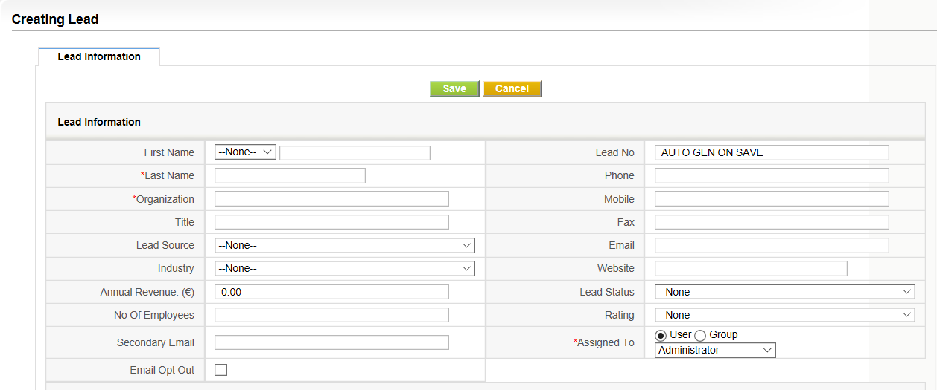
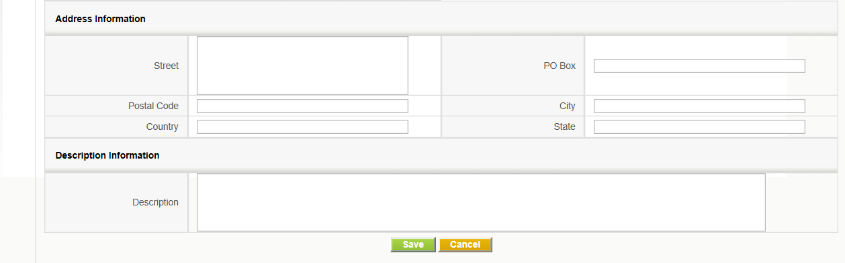
Figure 3.2. New Lead
Click on [Save] to save your entries at the CRM system.
Note: Entry field marked by a "*" are mandatory.
Importing Leads From Existing Files
The import feature enables users to import data or records from various sources into coreBOS. Currently, CSV format and VCF (Vcard) format are allowed to import. (Exceptionally iCal import is supported for Calendar module).
Export/Import feature is enabled on almost all modules. There are a few that are still not supported like price books or FAQ and Documents whose import process is more complex and is supported by an external tool which is not free (ask us if you need it).
While we demonstrate using it through Leads ,you can use the same process form within any other module to achieve the same result.
Firstly, the following conditions should be completed.
- Mandatory Fields. Make sure your file addresses all mandatory fields. For instance, Last Name and Company fields are mandatory in Leads module. You cannot proceed with importing until or unless you have a value within these fields of your .csv file. If the value of mandatory fields is empty, they will be set to '????'.
- File Size. Make sure the file to be imported do not exceed 3 MB size
- Permissions. Administrator users can disable import access to non-administrator users from Profile level. If you can't find the Import option, you should contact your Administrator to enable import permission for your profile

Steps to Import

Step 1: Select File
After clicking on the Import icon, the first step is to select the file. Click on the Browse button to select a file from your local system and upload it to the server for Import. Currently, csv and vcf formats are accepted.
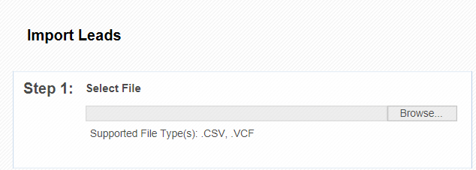

Step 2: Specify Format

In the second step of the importing process, you'll need to specify import file properties. The details of each property are explained below.
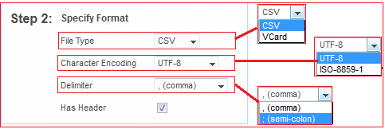

File Type

CSV and VCF(vcard) are the 2 file types, currently supported. Select the appropriate value from the File Type dropdown that describes the format of the file you've selected in Step:1. For instance, if you've uploaded .csv file, select .csv from File Type field.
Character Encoding

Make sure you select the right character set in which your import file has been encoded. Just because file has UTF-8 characters in it, do not expect the tool to import the UTF-8 characters in right format, by selecting UTF-8 encoding. You need to ensure you select the right encoding of the file irrespective of the file contents.

Following 2 sections, apply only for csv file import:

Delimiter

Currently comma(,) and semi-colon(;) are supported as field delimiters. This delimiter indicates the character separator used to separate field values from each other within a row. In the case that you need to use the same character in your data and do not want the tool to read it as delimiter, enclose the string in double quotes (“). Then, only delimiter characters, outside the double quotes, will be treated as actual delimiter.

Has Header
The 'Has Header' property is to indicate whether the csv file has a header row or not. If you indicate that the csv file has a header, then the first row from the csv file is treated to be header and skipped from importing into the csv file. Having a header in the csv file, makes it easier for the user to map the csv columns to right CRM fields.
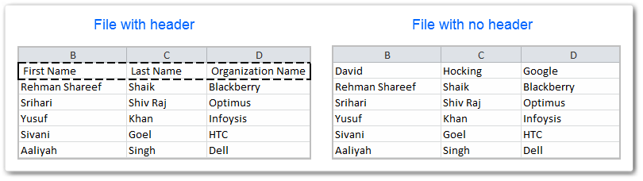

Step 3: Duplicate Record Handling
This is an optional step, which allows you to configure duplicate record handling during Import. You can configure the criteria, for duplicate records look up and can also configure the action to be taken when duplicate records are found.
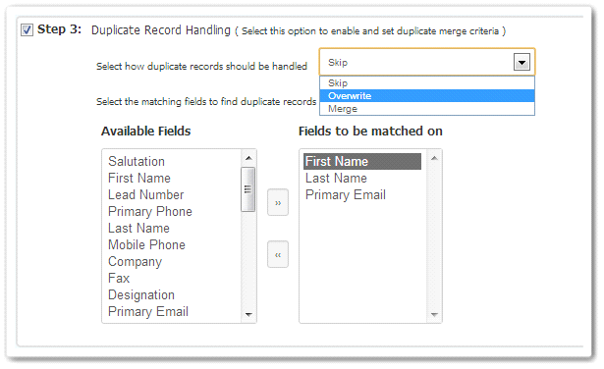
Select the action to be taken on duplicate records. Actions allowed are:

Skip : When a record from the import file is a duplicate of already existing record in the CRM, then that record is skipped from importing into the system.
Overwrite: When a record from the import file has duplicate records in the CRM, all the existing duplicate records in the CRM are deleted except for the last one. Last duplicate record is overwritten by the newly imported record from the file.
Merge : When a record from the import file has duplicate records in the CRM, all the existing duplicate records in the CRM are deleted except for the last one. Only the non-empty values from the newly imported record from the file, are overwritten on the last duplicate record of the system.

Select the fields for duplicate records look up: Configure the combination of fields, based on which the duplicate records need to be searched for. All the records which have the same values for the combination of the selected fields, will be considered as duplicate records.

Here's a sample image that depicts how all these properties work. Can use this part in the Appendix.

Step 4: Map Columns to Module Fields
The last step is to configure the mapping between the import file columns/headers to the Module fields.
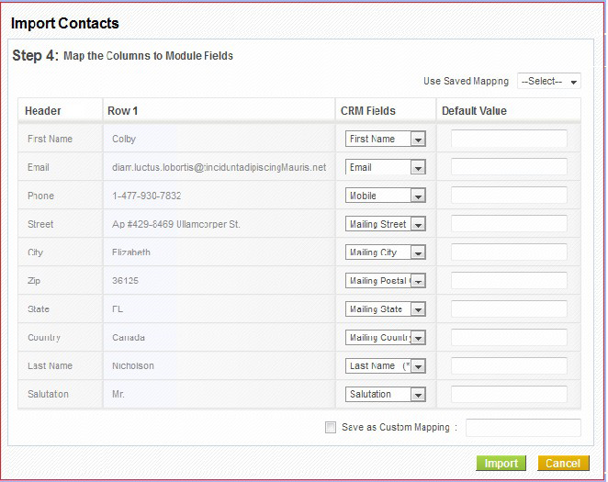
When importing CSV file, if the csv file has header, and the header name matches with the Field label, then those columns are automatically mapped.
Default values can be provided for the mapped fields, which will be picked up, in case the value for the field in the file is empty.
Mandatory fields need to be compulsorily mapped.
A particular field cannot be mapped more than once.

Saved Maps
- Commonly used mapping can be saved and re-used.
- Saved maps are accessible across all users.
- When a particular map is picked up from the selected list, the save mapping information reflects by mapping the fields configured for the map.
- Saved maps can also be deleted.
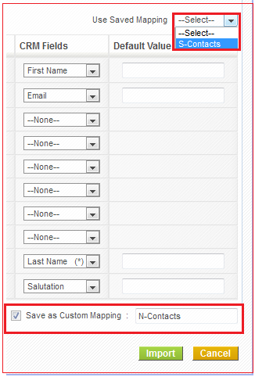

Understanding error messages

Data Corruption Error
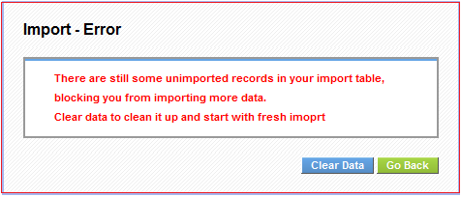
This error shows up when the import has been interrupted for various reasons like crashed in between or canceled by a user etc. This error indicates that the import table still has records to be imported into the system, but all the information related to the import (like mapping, default values, merge criteria) are all lost. So these records can not be imported and the user needs to clear this data before starting any other import.

Import Locked Error
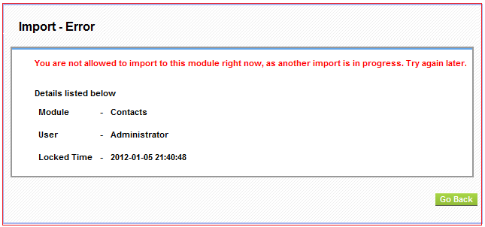
This error indicates that the Import on the module that user is trying to import, has been locked by another user's import. The details of the module, user and the time at which the Import has been locked, are exposed in the error message itself.

Import Interrupted Error
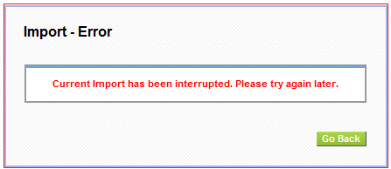
When a non-admin user triggers an import, and admin user tries to import to the same module, at the same time, admin user will not get Import locked error. Instead, admin user will be able to see the current status of the Import triggered by the non-admin user and will also be able to Cancel the import. In this case, when non-admin user is in the middle of the import and the admin user cancels the import, the error message above is shown to the non-admin user.
Export
Click on the [Export icon] at any list view menu if this function is available. A new window for uploading data to your computer opens.
If you click on [Export Leads] all data will be exported to your computer,depending on the checkboxes selected. The data are provided as ASCII file with comma separated values, also called CSV format.
Please Note:Since the format of the exported data is different than the data format required for an import you can not use exported data for an import directly.
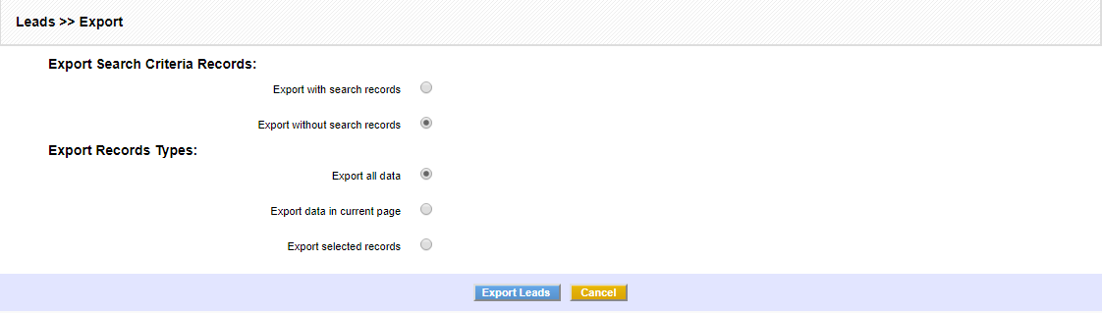
Figure. Export Leads
3.2.2.Qualify Leads
CoreBOS CRM provides an intuitive platform to track and manage leads. Not all Leads will bring in revenues. Classify leads, distinguish leads that hold potential to become sales, and follow up accordingly. This will enormously reduce efforts and saves the time of your Sales team. As a result, they can spend time only on the set of leads that are very likely to purchase your product.
Creating Filters
Filters are an effective search tool that can rapidly group records in a module. You can limit your search to selected columns and search criteria. This helps your sales team members to filter lead records with desired criteria. You can also perform operations on the filtered records like mass edit, delete, sending emails etc.
Select a module and click Create Filter link (highlighted below) in the list view of a module. In our example,will be shown the Leads Module.
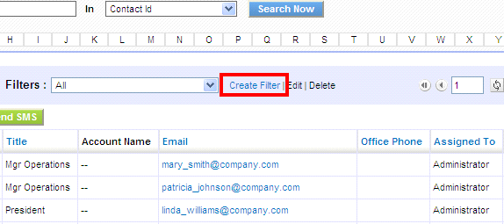

Provide a name to your filter in View Name and select the columns that you want to be displayed in list view, when filter is selected.
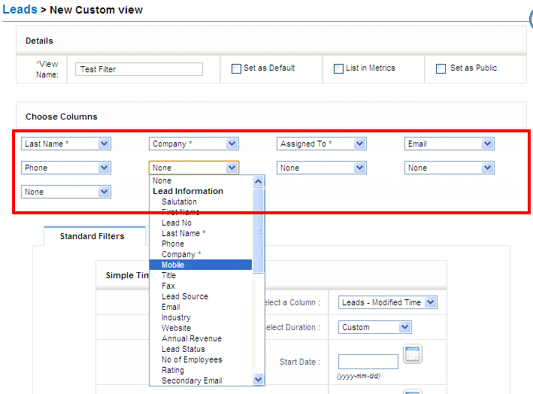

On save you will be able to see filter in action. At this point you can see the list of records in selected columns.
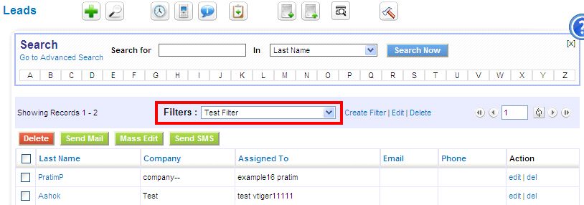

Both Standard Filters and Advanced Filters are used to enhance and refine your filter.
Standard Filters refine the search depending upon date intervals or particular period. You can find these options available:
 | Type | Content
1 | Select a Column | This picklist allows users to refine search depending upon record Date fields.
2 | Select Duration | This picklist allows users to select time duration in accordance with the Select a Column option above.
3 | Start Date and End Date | You can fill these fields manually or if you select the duration, these fields will be automatically

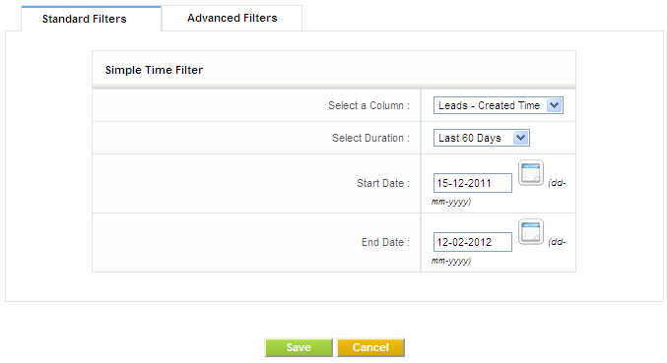
Advanced Filters refine the search depending upon field values conditions specified.
This block contains three columns. Select the desired field name from the picklist in the first column, set the desired condition from picklist in second column and enter one or multiple items in third column manually. Items you enter in third column should be separated with commas.
For example:
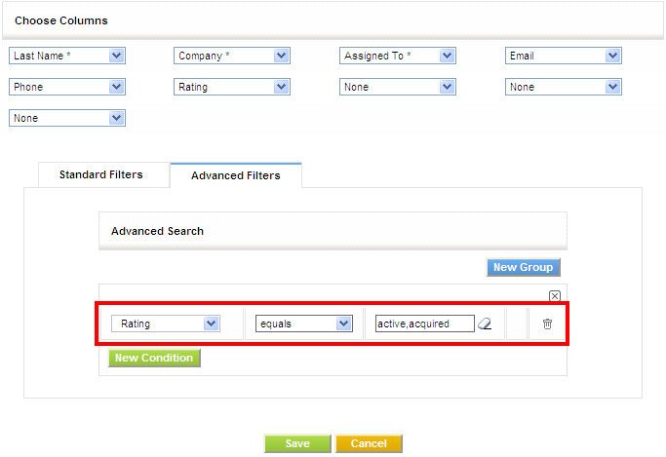
After saving you will see the list of records the fulfill the conditions in the list view.
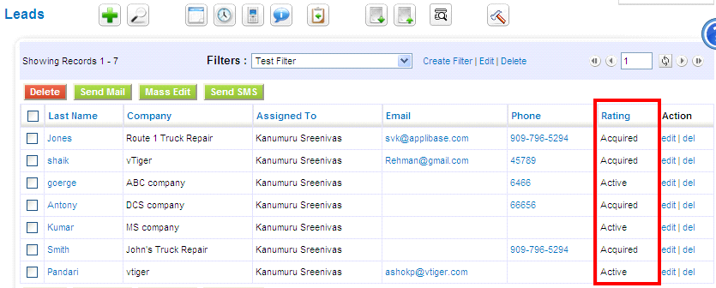

 | Type | Content
1 | List in Metrics | This option if enabled will show the count and details of the filter in the Key Metrics widget on the Home Page.
2 | Set as Default | If this option is enabled, then this filter will be the default view loaded when you first access the module. Once you have selected another filter that selection will prevail until you exit the system
3 | Set as public | If this option is enabled, every user of the application, irrespective of role/position can view it. When a user marks a custom filter as public, it should be first approved by the admin user. It remains in pending state until an administrator approves it. Administrators can see the request in the Pending section. The rule is: When a user makes a filter, only he and administrator users can select/edit it. If the filter is marked as Public AND approved, all users can select it, but only he, administrator users and users in a superior role can edit it.

Blank Dates
You can search on blank dates using the dollar sign $
Blank Fields
You can use the word null to search for empty values on related and text fields
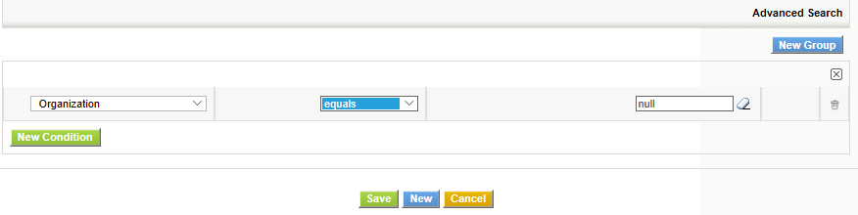

View/Filter Management
The View Management module permits us to fine tune the sharing rules of filters on each module and a view itself.
The record has two “modes”, one for the settings of a filter and another for the default permissions of the module. This dual mode is defined by the value of the “Default Setting” checkbox.
To set the permission for a view, we uncheck the “Default Setting” checkbox which puts the record in View permission mode. Then we can select the User, Group or Role for which we want to set the permissions. Finally, we set the CRUD-A permissions and the Default status. We can make this the mandatory setting for the selected User/Group/Role.
If the “Default Setting” is checked then you must select the module for which you want to set the permissions and mark the permission set you want. This will define the default permissions on all views for the selected modules if no other record with specific settings is found.
So, for any view we can select that view in the initial picklist and then select the user and set the Retrieve, Update, Delete and Approve permissions that user will have over the filter.
With the “Default Setting” set to true, we can define the Create, Retrieve, Update, Delete and Approve permissions that all users will have over in the module.
From a developer point of view, the module gives a set of services:
- getDefaultView(module, user): which returns the default view for a module and user
- getAllViews(module, user): will return all the views a user has access to on the module
- getPermission(CustomViewID, user): CRUD-A permissions on the filter or Module if the filter is ALL
The getAllViews service can be retrieved via the getAllViewsByModule web service method.
When a new filter is created on a module, the application will automatically create a cbCVManagement record with these settings:
- User set to the user creating the filter
- SubRoles of the user will be set
- C = F
- R = T
- U = T
- D = T
- A = F
- Default View = F
- Mandatory = F
- Default Setting = F
- Module List = Empty
- Set Public = T
This will permit you to create a workflow that detects the “Set Public” checkbox and send an email to any user who needs to Approve the filter for other users.

Scheduling Events and Tasks
Customers, they really like timely follow ups. This could be the best way to capture attention or to create an impression. You can schedule meetings, calls, and tasks to follow up prospects. Follow ups will bridge the gap between your sales team and Customers. With CoreBOS CRM, hopefully, you will not miss one.
If you would like use the calendar to schedule an event or task you have to click either on the calendar icon at any list view or at the [Calendar] at the navigation area. A new window will open that will display based on your system setup either the calendars list or the hour view. The hour view the is shown in Figure: Calendar - Hourly View.

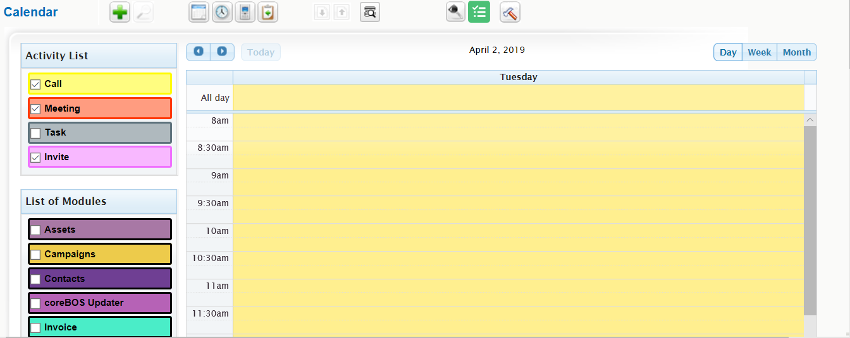
Figure . Calendar - Hourly View
You may switch to a weekly, monthly or yearly view by clicking on the appropriate icon at the top of the daily calendar. You may also switch to a list view.
Adding an Event to the Calendar
To enter the schedule of a meeting or call click on the button and select your event type. A pop up window within the calendar will open as shown in Figure: New Event
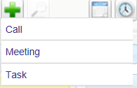

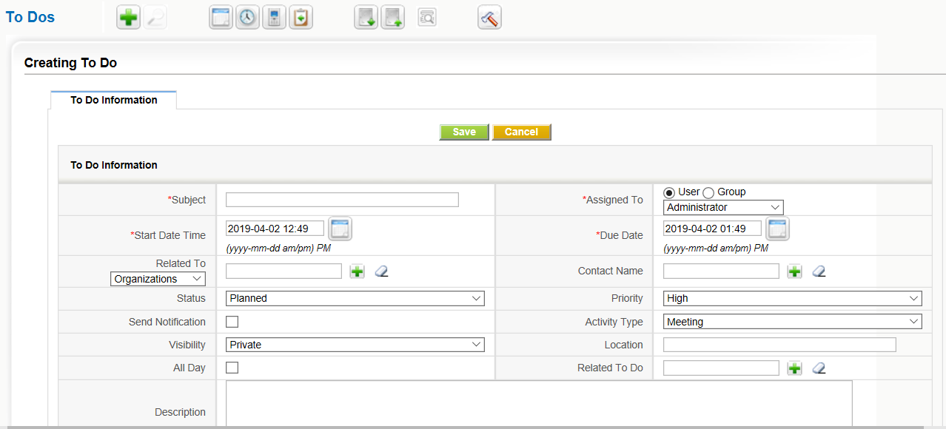
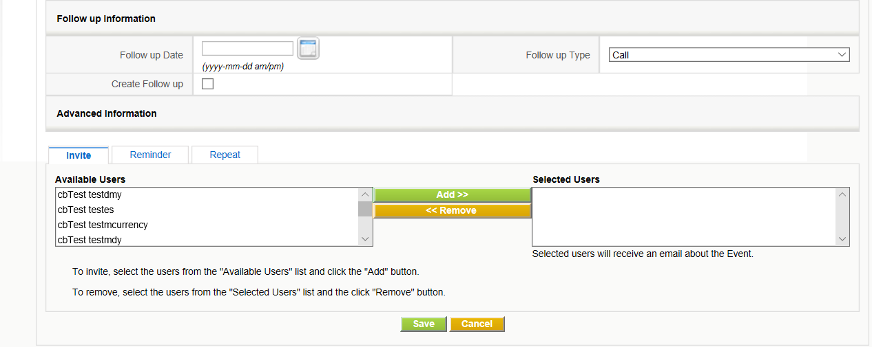
Figure 2.13. New Event Meeting
Here you may enter your Meeting information.
-------------
You may click on the [Reminder] tab, to schedule an automatic reminder email to be send by the CRM as shown in Figure: Event Reminder.
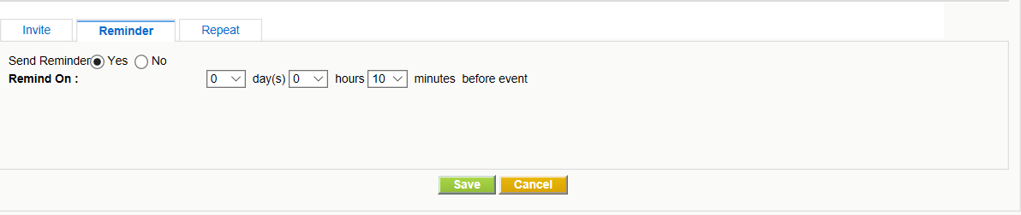
In addition, the CRM allows you to schedule events that repeat on regular basis. Click on the [Repeat] tab, to make your settings. The dialog is shown in Figure: Repeating Events.
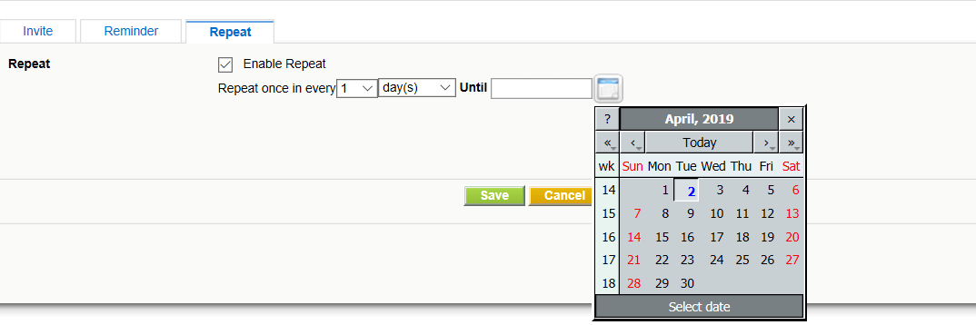
Finally, click on [Save] to transfer the event schedule to the CRM. As a result you will see the event listed in your calendar.
Note:Each individual user has its own calendar. However, you may invite other CRM users to calls or meetings and/or share your calendar with other users as explained in Section: Calendar Sharing. The calendar is displayed in the browser defined language. If you see the calendar in a wrong language you may check your browser settings.

Tasks and ToDos
The CRM system helps you to schedule tasks which are also sometimes called ToDos. Tasks are always assigned to one CRM user or Group and do not have an end date. You can not invite other users to tasks nor can you link more than one contact to tasks. However, you may transfer tasks to others by changing the owner.
Important:Tasks are separated from your calendar as ToDos. They are also displayed at the Upcoming and Pending Activities list at the users Home page.
There are many places at the CRM where you can enter tasks. You may enter tasks at any detail view of steps in your sales process or in the calendar. The edit view window as shown in Figure: New Task / ToDo will open and you may enter your task information. Please note the mandatory fields.
When you are finished click on [Save] to store the task at the CRM system.
Calendar Sharing
You may share your calendar or specific event entries with other CRM system users. Thereby, the following sharing types are possible:
- Sharing with any CRM user defined by the calendar settings:
Select [Calendar View]--> Click on [Calendar Settings] icon -->In Calendar Settings pop-up, select the list of users with whom one would like to share your calendar as displayed in Figure: Calendar Settings.
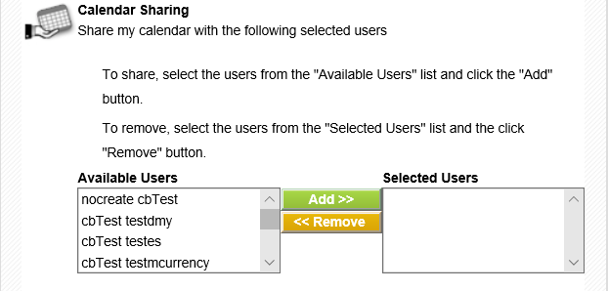

Event related sharing with users in the Role based hierarchy:
Irrespective of sharing events settings at your calendar, other users in the role-based hierarchy can view specific events at other users' calendar if these events have been made public. To make a particular event public, mark the [Public] check box as displayed in Figure: Sharing Event Settings when you create a new event
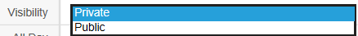

Calendar Settings
In Section: Calendar Sharing is already explained how you can access the calendar settings in order to configure the sharing functions. In addition to the calendar sharing function you may configure the time your calendar starts and the time format. Please look at Figure: Calendar Settings for further reference.
If you would like to see all activities in one list you may click on the [ToDos] tab at the Calendar menu as exemplary shown in Figure: All Events and ToDos View - List View.
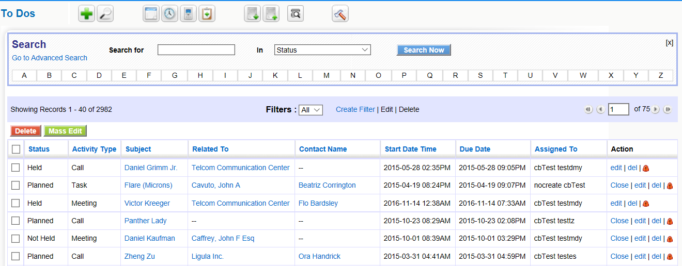
Figure 2.21. All Events and ToDos - List View

You may change the list based on your own criteria. Please refer to Section: Working with Lists for further instruction on how to modify the list view. You may also mark an activity as closed by clicking on the [X] sign.
At the list view you may click on the name of a activity to enter the detail view as shown in Figure: All Events and ToDos - Detail View. At the detail view you may change details by editing, add an entry to the tag cloud, or duplicate the activity for a new entry.
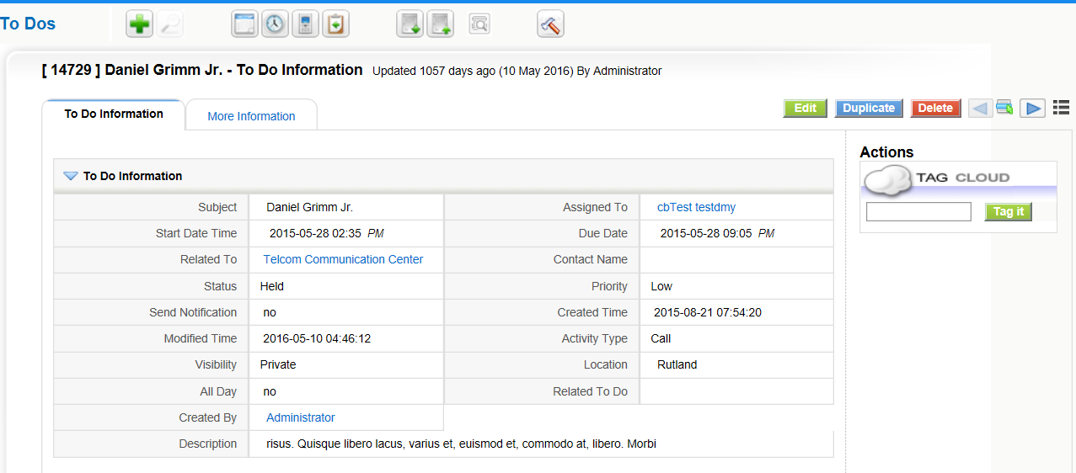
Figure 2.21. All Events and ToDos - Detail View
3.2.4. Send Emails
If you want to use the CRM system for outgoing emails you have three choices:
You may create an email from the detail view of one of you leads, contacts or accounts. By using the contact details already stored at your CRM system, the system makes sure that the emails sent will be stored in reference to the existing contact entries. You may see such emails at the contacts detail view
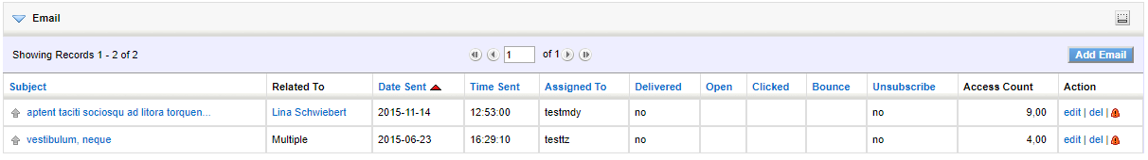
Figure. Email listing at Contact Detail View

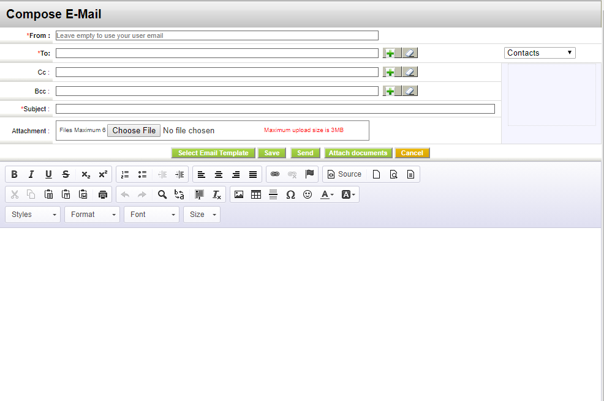
Important

To be able to send an email, the CRM system needs to access your outgoing email server. The setup of the server connectivity is explained in Section: Outgoing Server.

At the composing menu you may use the entry fields based on the following description:

 | Type | Content
1 | To: | Here you may enter the email addresses of the receivers
2 | CC: | "CC" stands for Carbon Copy. You may enter receiver email addresses which get email copies.
3 | BCC: | "BCC" stands for Blind Carbon Copy. You may enter additional email receivers. These receivers will not be visible to the other email receivers.
4 | Subject: | You should enter a subject for this email.
5 | Attachment: | You may add an attachment to your email.  Note  At the current release the maximum size of an attachment might be limited to a file size of 1 Mb.
6 | Description: | You may enter your email message here. Note that the email will be sent as an HTML mail by default. You may use the design tools to enhance the email representation.

Tip The CRM system can store your standard email signature and adds it to your message automatically. The signature is set by the My Settings menu at the CRMs Login Area.
Beneath the description field the buttons serve the following purposes:

 | Type | Content
1 | Select Email Template: | The CRM offers you to work with email templates. These templates must be designed and stored at the CRM system
2 | Send: | The email will be send. A signature will be added automatically if defined before.  Note  The emails sent will be assigned to the sending user. A copy of the email will be send by the CRM system to the assigned user automatically
3 | Save: | You may save this email without sending it. The email will be stored and get listed when you click on the My Home Page > Emails menu.
4 | Cancel: | You may cancel the email operation. All changes will be lost.

Email Mass Mailing

You can send a common email from the CRM to several persons at the same time. You may use this function for mass mailings to your customers or to other contacts stored in your CRM. For mass mailing it is recommended to create a mail from the list view.

- Create a custom view of your leads, contacts, or accounts. Use the filter operations to select the desired contacts.
- Save the custom view.
- Display the custom view. Select the contacts you want have as the receiver of your mass mailing. Click on the [Send Mail] button at the bottom of the list as shown in Figure: Mass Mailing Selection.

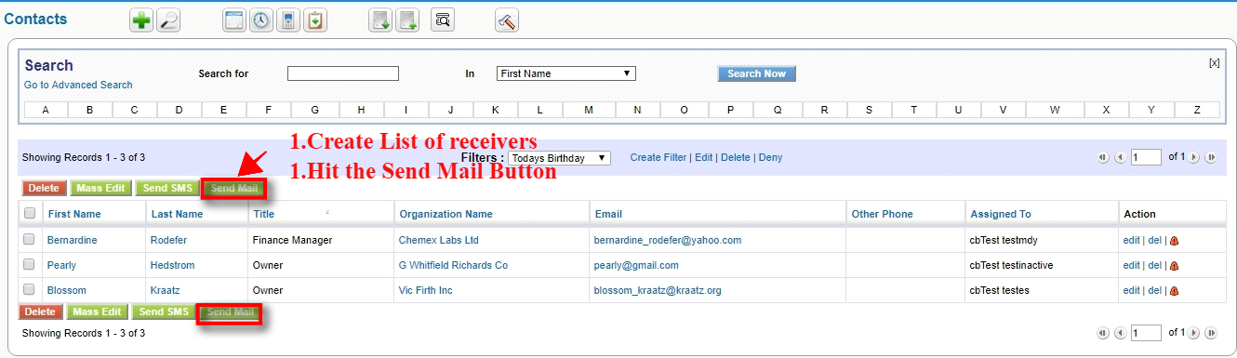
Figure. Mass Mailing Selection

The email creation window will open as shown in Figure: Create Mass Mailing Email.
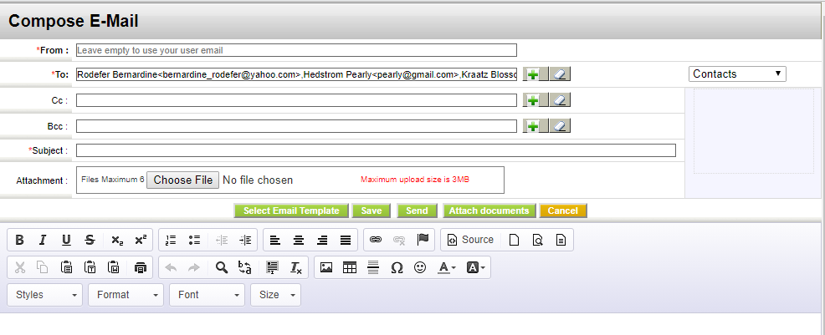
Figure . Create Mass Mailing Email

Edit your email. You may also add further email addresses which you have not selected before.

- Click on the [Send] button to send your email immediately.
- Use the [Save] button, to store the email at the CRM without sending it. With the Select Email Template button you

A reference to a copy of the email sent, will be stored at each individual contact and is displayed at the detail view.

3.2.5 Receiving Emails
3.2.6. Convert Leads
Once a Lead is qualified and determined to be a potential sale, the Lead can be converted to an Opportunity. A Contact record and Organization record will be created simultaneously to store the personal information and company information.
Steps to convert a Lead

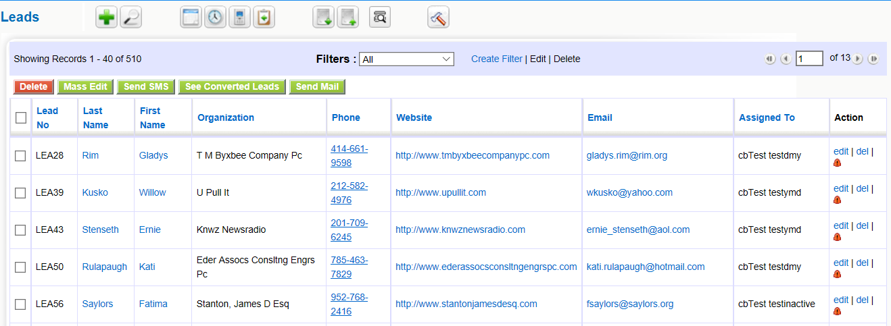
Figure.Lead List View
- Click on the Lead record you intend to convert,from the List View of Lead Module.
- In the detail view, Click Convert Lead Button.
- In the convert Lead pop-up, you can modify the existing values and transfer related records.
- If there is a chance of an immediate sale, un-check Opportunity check-box.
- Click [Save].
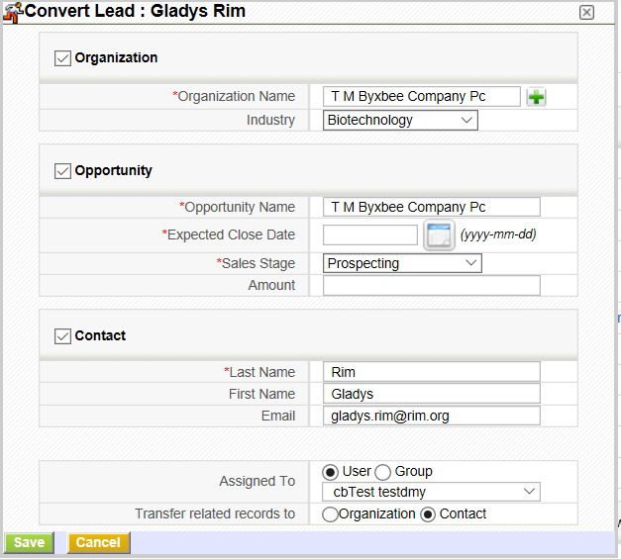
Figure .Convert Lead
During Lead Conversion, if Contact already exists with same field values you can either link the Lead or create a new Contact record.

Field Mapping

Create field on Contacts
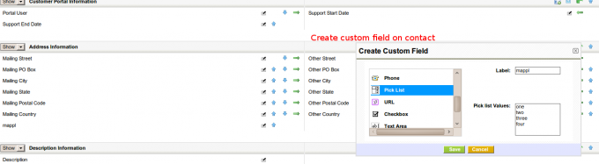

Create field on Leads, with the exact same name and value
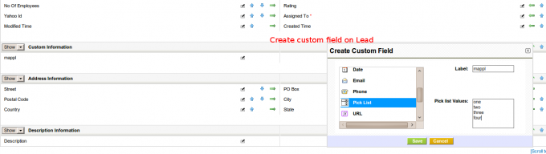

Access the mapping link in Settings
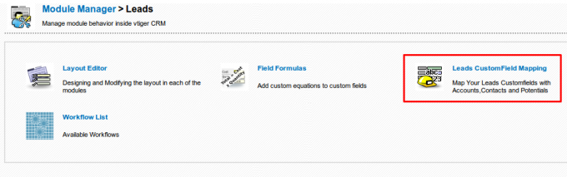

Establish the relation between the fields
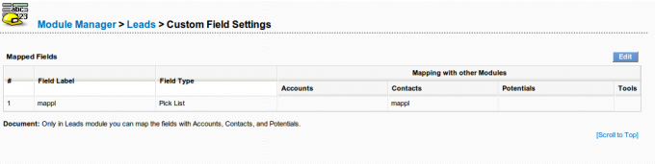

Lead Field Mapping
In general, the assignment of copying one field from the Lead to another field on another module will be restricted to fields of the same type and smaller length. So you will only be able to map an email field on the Lead to an email field on Accounts, Contacts or Potentials.
There are two exceptions:
- text fields: you will be able to map a text field on Leads to a text field on another module ONLY if the length of the field on Leads is SMALLER than the length of the destination field. If we permitted the contrary you could potentially lose information.
- picklists: you will be able to map a picklist to another picklist or a text field and there will be NO validation done. It will be your responsibility to assure that:
  - both picklists have the same values or
  - the destination text field has enough characters to hold the longest picklist value

How to change the length of a text field
It is a typical situation to have created two custom fields, one on the Leads module and the other on another module and then want to assign values from one to the other, but it turns out that both fields were created with different sizes and the smaller one is on the destination module, so the application won't permit the mapping.
To solve this situation we have two options.
- Eliminate the destination custom field and create it again with the correct size. The problem with this option is that ALL data in the field you are deleting WILL BE LOST. So you can only do this if you still haven't saved any information in that field.
- Change the size of the destination field directly in the database. Let's look at how that would be done.
The size of a custom field is saved in two places, the vtiger_field table and the destination module's custom field table, so we have to change it in both places.
First we need to know the name of the field. If you are on a coreBOS release after September 2016 you can go to the field's property box in the layout editor. You will see the name of the column in the title. If not, go to the edit form of the module, right click on the field's input box and look for the “name” property. Let's suppose the field we want to change is called cf_891
Open phpmyadmin or adminer to access the coreBOS database. Navigate to the vtiger_field table and search the columnname for the field name we found, cf_891 in our case.
Navigate to the typeofdata column. You will see that there is a number there reflecting the size of the field. Let's suppose that our custom text field cf_891 has a length of 10 characters. We will see that the column has this value:
V~O~LE~10
or
V~M~LE~10
depending on if the field is mandatory or not. That 10 is the first change we need to make. Let's suppose we want to have a length of 20. We will edit the column and set it to:
V~O~LE~20
The row that is found contains the information we need to make the second change. Look in the column tablename, there is the name of the table that holds the real value of the field. Let's suppose that our cf_891 custom field belongs to the Accounts module. We will see that the column tablename has a value of vtiger_accountscf. So we navigate to the vtiger_accountscf table and go to the structure of the table. We will see that the cf_891 has been defined as VARCHAR(10), we must ALTER that definition to VARCHAR(20)
Both phpmyadmin and adminer will permit you to do that change in the graphical interface but in the end the necessary SQL will look something like this:
ALTER TABLE vtiger_accountscf CHANGE cf_891 cf_891 VARCHAR(20) NULL
After those two changes you should be able reload the Lead mapping screen and do the assignment you need.
3.3. Opportunities Management
An opportunity represents a potential sale. Customers who are very likely to purchase your product can be termed as Opportunities. They hold a lots of importance as they present complete information of sales process from beginning to the end.
The journey of sales process may begin at different stages:
Creating an Opportunity from a Lead
A Lead can also be converted to an Opportunity to track the Sales process from Lead Qualification to End of sale (Deal won or Deal Lost).
Creating an Opportunity for an Existing Customer
Existing customer is the one that is already dealing business with you. Details of customer are stored in your vtiger CRM as Contact or an Organization record. If you have gotten the same customer as a new lead to deal a new business, you can create an Opportunity record and associate with existing Contact/Organization.
Creating an Opportunity for a New Customer
New customer is the one that doesn't have any records history in your vtiger CRM. If you will have to deal business with new person or a company, you can create related Contact/Organization record in vtiger CRM and associate it with new opportunity record.
Creating Opportunities Manually
You can enter Opportunity details manually from Opportunities Module. This might come handy if you will have to enter Opportunity details individually.
Steps to create Opportunity records manually
- In Opportunities tab, click on Add Opportunity button
- In the Create Opportunity view, fill in the Opportunity details
- Click Save
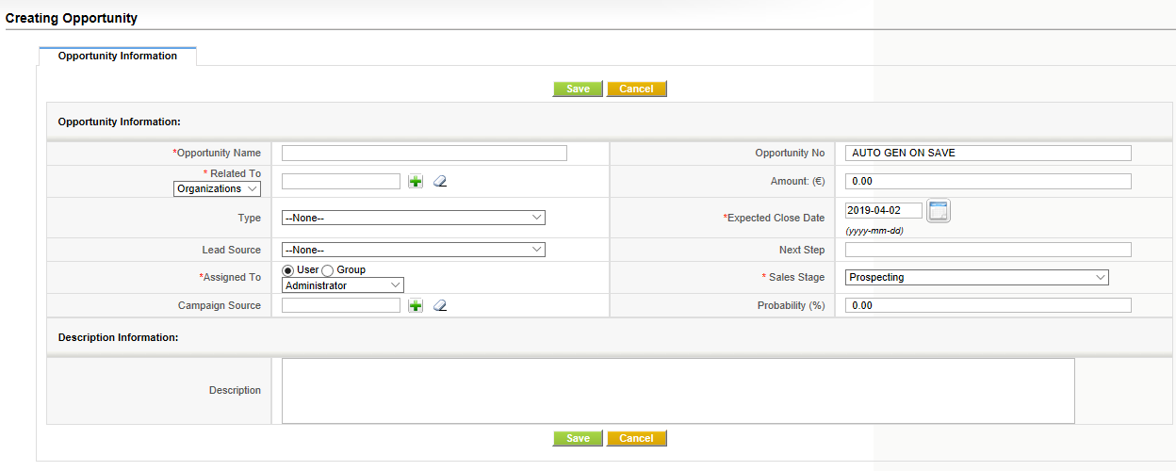
Quick Create
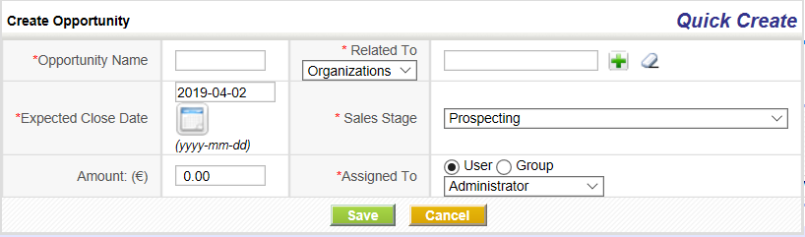

You can enter basic details of Opportunity record through Quick create. This might be helpful if you are running out of time.
Importing Opportunities from Existing files.
For more information refer to Lead Import Section.

The list of Operations you can perform on records in Opportunities Home page.
Create Custom filters to classify records as per your requirements. You can be able to limit your search to selected columns and search criteria.
Click on Mass Actions button and perform actions on desired records like: Edit, Delete and Add comments.
Click Settings button > Edit Fields to configure fields and customize the layout of fields through Layout Editor.
Click > Edit Workflows to view / create new Workflows on Opportunities.
Click > Edit Picklist values to modify picklist values through Picklist Editor.
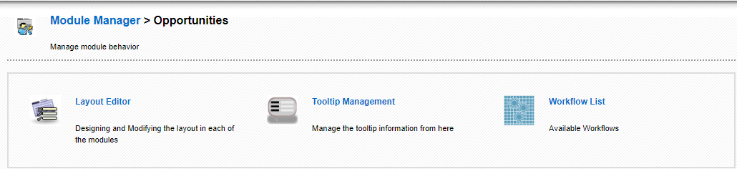
Organizations Management
Organization represents a company or an institution that has multiple employees associated with it. Contacts, as in employees, can be directly related to an Organization record. Organization need not always be an existing customer. You will track the business deal through Opportunities. If the deal is won, Organization will represent existing customer. If the deal is lost, you can always have archive of dead Organizations in your vtiger CRM with an intention of having business with them some time in the future.
Creating Organizations Manually
You can enter Organization details manually from Organizations Module. This might come handy if you will have to enter Organization details individually.
Steps to create Organization records manually
- In Organizations tab, click on Add Organization button
- In the Create Organization view, fill in the Organization details
- Click [Save]
Quick Create
You can enter basic details of Organization record through Quick create. This might be helpful if you are running out of time.
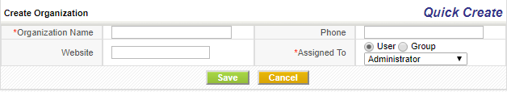
Importing Organizations from Existing files
CoreBOS CRM supports importing Organizations from external sources such as .csv and vcf files. As it saves lots of time and efforts, it might come in really helpful for your Sales Team to import thousands of records instantly.
Converting a Lead
Once a Lead is qualified and determined to be a potential sale, the Lead can be converted to an Opportunity. A Contact record and Organization record will be created simultaneously to store personal information and company information.
List of operations you can perform on records in Organizations Home page
- Create Custom filters to classify records as per your requirements. You can be able to limit your search to selected columns and search criteria
- Search desired records
- Click on Actions drop-down to perform following operations
- Select Edit to modify selected record(s)
- Select Delete to delete selected record(s)
- Select Add Comment to add a comment on selected record(s)
- Select Send email to send out emails to selected record(s)
- Select Send SMS to send out SMS to selected record(s)
Click Settings button to perform following operations
- Select Edit Fields to configure fields and customize the layout of fields through Layout Editor
- Select Edit Workflows to view / create new Workflows on Organizations module
- Select Edit Picklist values to modify picklist values through Picklist Editor.
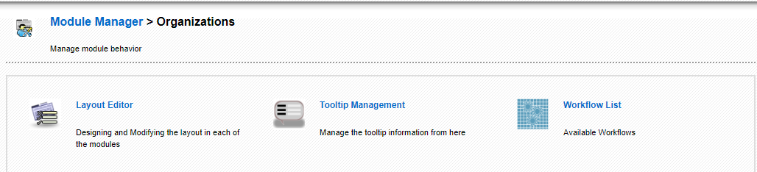
List of operations you can perform on detail view of Organization record
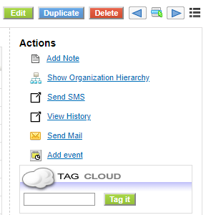
- Click Edit to modify existing content
- Click Send Email to send email to existing Organization record
- Select Delete to delete the existing Organization record
- Select Duplicate to clone existing Organization record
- Select Add Note to attach a note to existing Organization record
- Select Organization Hierarchy to view administrative body with each Organization subordinate to the one above
- Select Send SMS to send out SMS to existing Organization record
- Select Add Event to schedule a Call or Meeting and Select Add Task to schedule a Todo

Fields Information
Most fields are self-explanatory
 | Type | Content
1 | Organization Name | Specify the name of the Organization
2 | Website | Specify company's website URL
3 | Member Of | Select or create parent company for existing Organization record
4 | Ticker Symbol | Specify company's ticker symbol
5 | Primary Email | Specify email address of the Organization
6 | Ownership | Specify the ownership type of the company
7 | Employees | Specify the number of employees working in the company
8 | Industry | Specify the type of industry from the pick-list
9 | Assigned to | Select any user(s) to make him/her the owner of Organization record
10 | Description Details | Specify additional details about the Organization

Contacts Management
Contact can be represented as a qualified sales lead. Contacts differentiate qualified customers from the huge list of unqualified customers. Contacts also represent the people that are conducting business with you. They could be acting individually or representing an Organization.
Creating Contacts Manually
You can enter Contact details manually from Contacts Module. This might come handy if you will have to enter Contact details individually.
Steps to create Contact records manually
- In Contacts tab, click on the Add Contact button
- In the Create Contact view, fill in the Contact details
- Click Save
Quick Create
You can enter basic details of Contact record through Quick create. This might be helpful if you are running out of time.
Steps to create Contact records through Quick create
- On the Quick Create Menu click Create Contact
- In the Create Contact view, fill in the Contact details
- Click Save
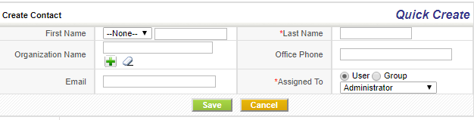
Importing Contacts from Existing files
Refer to Lead Import Section.
Converting a Lead
Once a Lead is qualified and determined to be a potential sale, the Lead can be converted to an Opportunity. A Contact record and Organization record will be created simultaneously to store personal information and company information.
List of operations you can perform on records in Contacts Home page
- Create Custom filters to classify records as per your requirements. You can be able to limit your search to selected columns and search criteria
- Search desired records
- Select Edit to modify selected record(s)
- Select Delete to delete selected record(s)
- Select Add Comment to add a comment on selected record(s)
- Select Send email to send out emails to selected record(s)
- Select Send SMS to send out SMS to selected record(s)
Click Settings button to perform following operations
- Select Edit Fields to configure fields and customize the layout of fields through Layout Editor
- Select Edit Workflows to view / create new Workflows on Contacts module
- Select Edit Picklist values to modify picklist values through Picklist Editor
List of operations you can perform on detail view of Contact record
- Click Edit to modify existing content
- Click Send Email to send email to existing contact record
- Click on More drop-down to perform following operations on Contact record
- Select Delete to delete the existing contact record
- Select Duplicate to clone existing contact record
- Select Add Document to attach a document to existing contact record
- Select Send SMS to send out SMS to existing contact record
- Select Add Event to schedule a Call or Meeting and Select Add Task to schedule a Todo
Information of fields in the Contacts module.
 | Type | Content
1 | First Name | Provide the first name of the Contact
2 | Last Name | Provide the Last name of the Contact. This is a mandatory field
3 | Organization Name | Select the Organization that is related to the Contact
4 | Primary Email | Provide email address of the Contact
5 | Date of Birth | Provide date of birth of the Contact
6 | Reports to | Select from the list of Contacts to whom the Contact reports
7 | Email opt out | Select the check-box to remove the contact from mailing list. That means the contact will not be able to receive emails from vtiger CRM anymore
8 | Assigned to | Select any user(s) to make him/her the owner of Contact record
9 | Portal User | Enable the check-box to grant customer portal access to Contact record
10 | Support Start Date | Customer can log into Customer portal from this date
11 | Support End Date | Customer can log into Customer portal until this date

Quotes
Quote is a formal statement issued by a seller to the prospective buyer; basically, upon inquiry or request for a quotation. It contains the detailed list of Products and Services, Prices and Taxes, Dates, Parties involved, Address information, Terms and Discounts etc.
Operations you can perform in list view of Quotes module
List view of Quotes module enables you to perform mass actions like editing, deleting and filtering records in bulk. In addition, you can also edit fields, workflows and picklist values.
Operations you can perform in detail view of quote record
Detail view of quote record enables you to perform actions like editing, deleting, cloning, exporting the existing record in PDF format, etc as shown on figure.
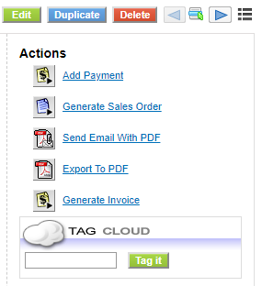
Sales Orders
Sales Order is an Internal document generated within the company after the Purchase Order is received. It helps your sales team track all the Products or Services that should be manufactured, shipped etc according to the agreed prices and dates. Sales Order comprise Sales Order number, Purchase Order, Recurring Invoice, Billing and Shipping Address, Products or Services, Prices and Taxes etc.
Creating Sales Order individually
You can easily create a sales order by entering information in the fields provided.
Follow few simple steps to create an sales order
- Click Sales Module
- Click Sales Orders
- In the list view of sales order module, click Add Sales Order
- Provide necessary information the fields, and click Save
Creating Sales Order from a Quote
After the quote is approved, you can create sales order record out of it. Automatically, the information in quote record is transferred to sales order record.

Follow a few simple steps to create sales order from quote record
- Click Sales
- Click Quotes
- In the list view of Quotes module, click on desired quote record
- In the detail view of that quote record, click More drop-down and click Generate Sales Order
- Modify details, if necessary, and click [Save]
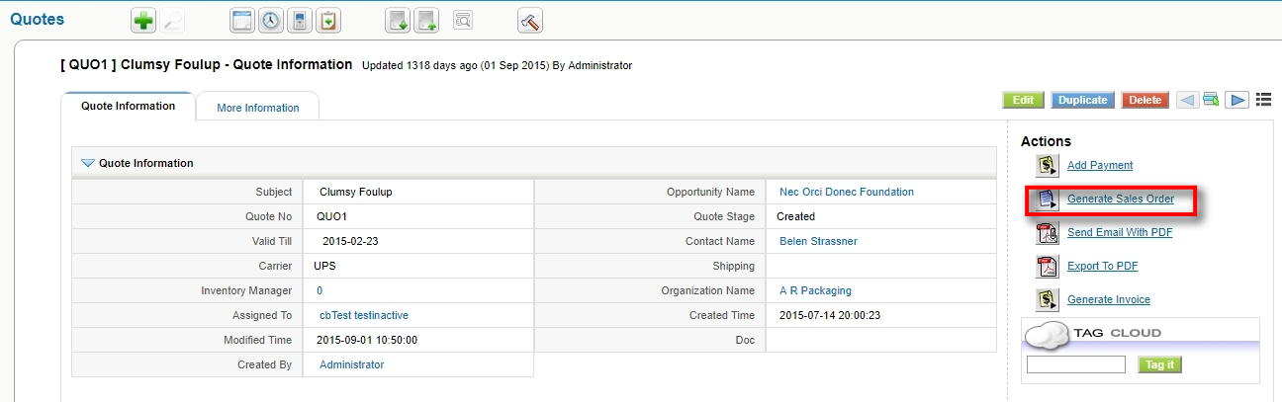
Operations you can perform in list view of Sales Orders module
List view of Sales Orders module enables you to perform mass actions like editing, deleting and filtering records in bulk. In addition, you can also edit fields, workflows and picklist values.
Operations you can perform in detail view of sales order record
Detail view of sales order record enables you to perform actions like editing, deleting, cloning, exporting the existing record in PDF format, etc
Purchase Orders
A purchase order is a legal document handled over to a vendor to purchase Products or Services. It offers you a channel to explain your requirements and intentions explicitly. Purchase Orders comprise the purchase order number, vendor details, product or service details, terms and conditions, prices, etc.
Creating Purchase Order individually
You can easily create a purchase order by entering information in the fields provided.
Follow few simple steps to create a purchase order
- Click All drop-down
- Click Purchase Orders
- In the list view of the purchase order module, click Add Purchase Order
- Provide necessary information the fields, and click Save
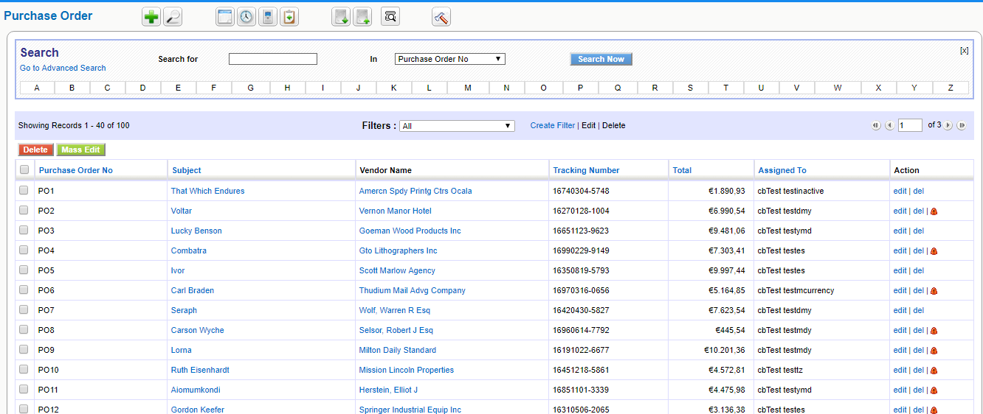
Figure. Purchase Order List View
Operations you can perform in list view of Purchase Orders module
Purchase Orders module enables you to perform mass actions like editing, deleting and filtering records in bulk. In addition, you can also edit fields, workflows and picklist values.
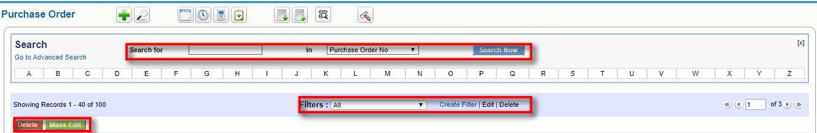
Operations you can perform in detail view of purchase order record
Detail view of the purchase order record enables you to perform actions like editing, deleting, cloning, exporting the existing record in PDF format, etc
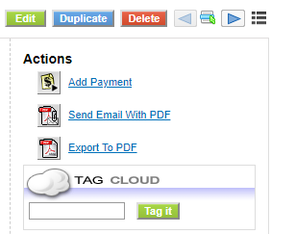
Invoices
An invoice, or a bill, is a non negotiable itemized statement issued for the Products and Services rendered to the customer. It usually contains the Products or Services details, Prices and Taxes, Dates, Parties involved, Address information, Terms and Discounts, and payment methods.
Creating an Invoice individually
You can easily create an Invoice by entering information in the fields provided.
Follow a few simple steps to create an Invoice:
- Click Sales Module
- Click Invoice
- In the list view of Invoices module, click Add Invoice
- Provide necessary information the fields, and click Save
Creating Invoice from a Quote
After the Quote is approved, you can create an Invoice record out of it. Automatically, the information in Quote record is transferred to Invoice record.
Follow a few simple steps to create an Invoice from Quote record:
- Click All drop-down
- Click Quotes
- In the list view of Quotes module, click on desired quote record
- In the detail view of that quote record, click Generate Invoice on the right corner
- Modify details, if necessary, and click Save
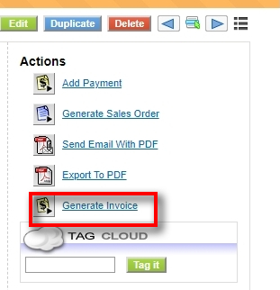

Creating Invoice from a Sales Order
After the Sales Order is successfully created, you can create an Invoice record out of it. Automatically, the information in Sales Order record is transferred to Invoice record.
Follow a few simple steps to create an Invoice from Sales Order record :
- Click Sales Module
- Click Sales Order
- In the list view of Sales Orders module, click on desired sales order record
- In the detail view of that sales order record, click Create Invoice
- Modify details, if necessary, and click Save
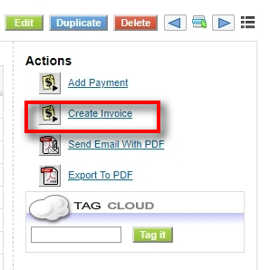
Creating Invoice from an Opportunity
After winning a deal, you can create an Invoice record out of an opportunity record. Automatically, the information in Opportunity record is transferred to Invoice record.
Follow a few simple steps to create an Invoice from Sales Order record :
- Click Sales Module
- Click Opportunities
- In the list view of Opportunities module, click on desired opportunity record
- In the detail view of that opportunity record, click Create Invoice
- Modify details, if necessary, and click Save
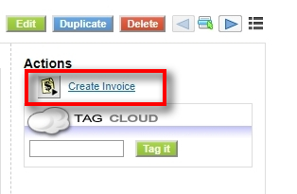
Operations you can perform in list view of Invoices module
List view of the Invoices module enables you to perform mass actions like editing, deleting and filtering records in bulk. In addition, you can also edit fields, workflows and picklist values.
Operations you can perform in detail view of Invoice record
Detail view of Invoice record enables you to perform actions like editing, deleting, cloning, exporting the existing record in PDF format, etc
Support
The CRM system offers comfortable possibilities to maintain the valuable customer relationships after the conclusion of a business by offering support functions. Why should you use the support functions?
- Above all the support functions helps you to collect and sort customer requests, inquiries, disturbances, problems or others related to the goods or services sold.
- The support functions keep CRM users and customers informed about the status reached in terms of the response to customers messages.
- Support staff get a very effective tool to keep track of customer complaints or requirements related to customers or products or both.
- Sales staff and management can get a quick overview about support activities related to customers or products or both.
- CRM user or customer get convenient access to frequently asked questions (FAQ). That might help you company to keep the service requests low and to maintain standard procedures in responding to customer requests.
The CRMs capabilities of providing FAQ as well as Tickets are extended by the Customer Portal functions as explained at Customer Portal manual.
Support Tickets
The CRM considers tickets as any kind of customer service requests as they occur after sales. Tickets are listed at the Support > Support Tickets menu.
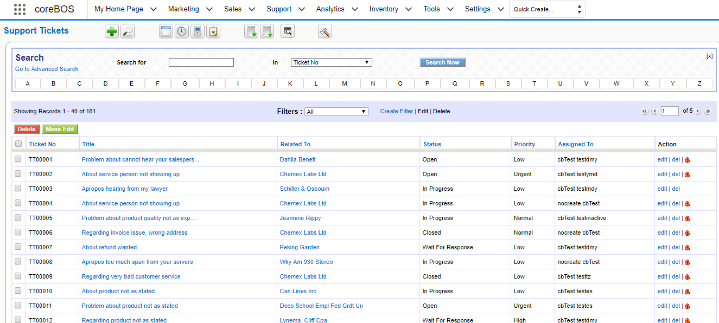
Figure. Support Tickets List View
Create New Tickets
You can create a new ticket:
Quick Create
- Click on Create New Ticket on Quick Create Menu.
- Fill the necessary fields
- Click Save
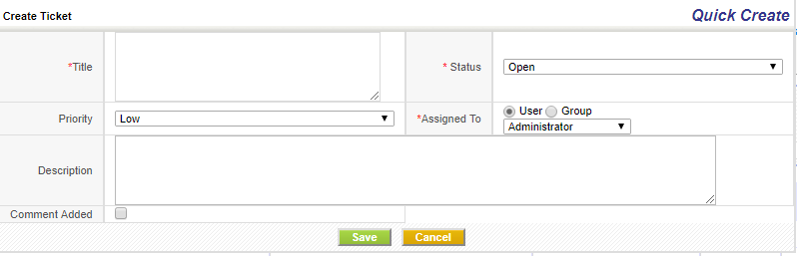
Create Manually
- Click on the plus icon
- Fill the necessary fields
- Click Save
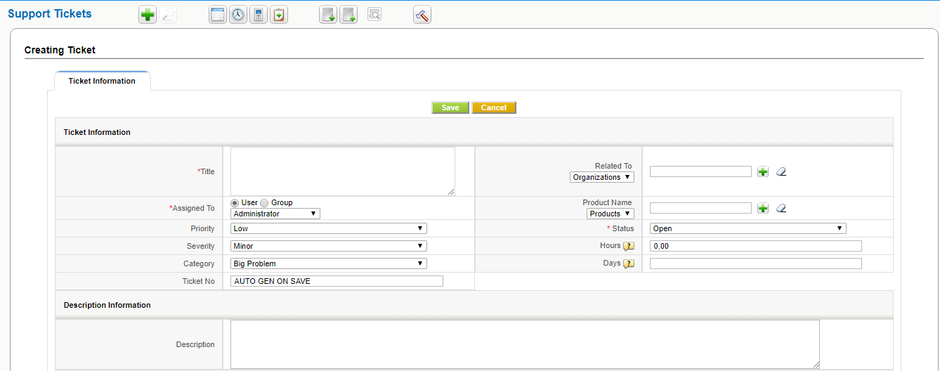
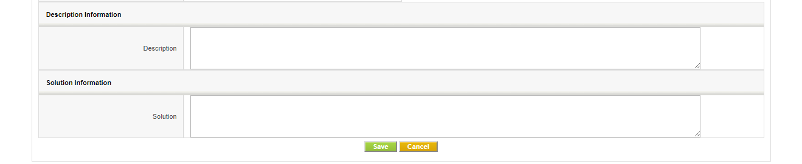

List of default entry fields for tickets

 | Type | Content
1 | Assigned To: | You may assign the ticket to a person that is listed as CRM user or to a user group. This person or group will be in charge to answer to the customers request.
2 | Priority, Severity and Category: | You may select the appropriate entries based on their importance. That might help your service staff to schedule their work and the management to be informed.
3 | Title: | You should give each ticket a unique name.
4 | Contacts, Accounts: | You should link this ticket to a specific contact or account
5 | Product Name: | You may link this ticket with goods or services your company has sold.
6 | Status: | You should set the actual status of the ticket
7 | Attachment: | You may add an attachment to a ticket.
8 | Description: | You should enter a brief description about the issue that is the cause for this ticket

Working with Tickets
You can:
- Edit, Duplicate or Delete a ticket: The Edit function allows you and your coworkers to change the entries and to make comments before or after a solution is found. Note that you may enter data without opening the edit view. Just move the mouse button at the detail view to the appropriate fields to make your entries. With the Duplicate function you may copy a ticket. This function might be useful to split ticket. Use the delete function carefully. It might be better to keep a ticket in the list and changing the status.
- Convert as FAQ: You may get customer requests to a same topic frequently. This function allows you to convert a ticket to a FAQ as explained in the next section.
- Add a Tag: You may use this function to set your own priorities as explained in Section: Tag Cloud.
- Merge the ticket information with a template: You may use this function to merge ticket information with a email template.
Each ticket may go through different working stages and will be closed soon or later. The CRM helps you to keep track on the working progress and is logging the changes.
At comments any CRM user may post a comment. The comments will be sorted by the time and will indicate the CRM user who did the comment.
At the end of the "live cycle" of a ticket you may present the solution. All changes to a ticket are displayed at the ticket history. The information provided allow you to find out:
Who changed ticket information?
- What changes has been made?
- What was the time of a change?
Click on the More Information tab to view or to add ticket related activities, notes or attachments.
Frequently Asked Questions (FAQ)
The CRM system offers you to have a FAQ list. FAQ refer to listed questions and answers, all supposed to be frequently asked in some context, and pertaining to a particular topic.
You may use this for instance
- as a knowledge base to inform your customer about your product, services or procedures,
- for your employees to inform about internal business procedures,
- for your service staff to discuss procedures for helping customers,
and much more.
You may reach the FAQ list at the Support > FAQ menu. Click on the on top of the list to enter a new FAQ.
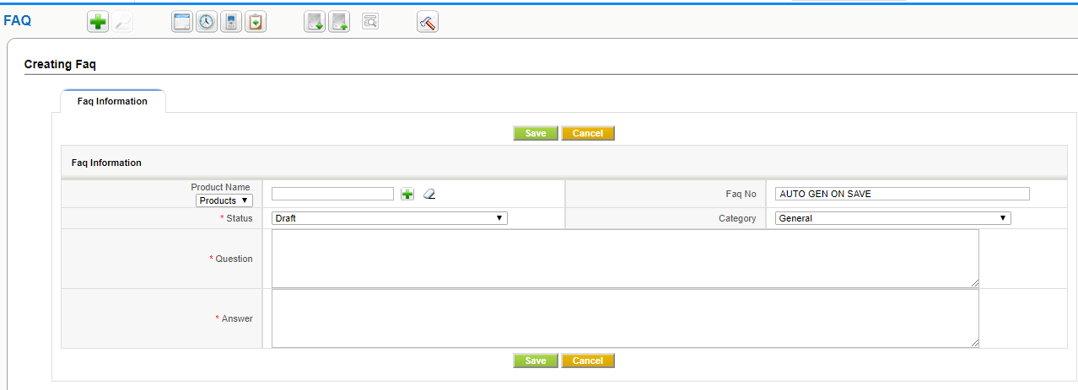
Figure. Create New FAQ
In addition, you may
- link this entry to a product or service your company offers,
- assign a category for this entry,
- set a status for the entry.
Caution
FAQ are also displayed at the Customer Portal. You may control the FAQ entries that will published at the Customer Portal. Only entries with the status "published" will be visible there.
Inventory
Organize Products
Products represent stock of goods in your Inventory. Products can be either procured from your suppliers or rendered to your customers depending upon nature of your Organization. Interestingly, if your company manages both selling and purchasing goods, Products module will act as a bridge between Sales and Purchase departments.
Create Products Manually
You can enter Product details manually from Products Module. This might come handy if you will have to enter Product details individually.
Steps to create Product records manually
- In Products tab, click on Add Product button
- In the Create Product view, fill in the Product details
- Click [Save]
Quick Create
You can enter basic details of Product record through Quick create. This might be helpful if you are running out of time.
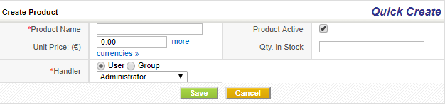
Importing Products from Existing files
Price Books
Price Books gives you the ability to attribute different prices for products. As it gives control over the pricing, you can vary prices at any time; As a result, you can always offer best price to delight your customers.
Create Price Books Manually
You can enter Price Book details manually from Price Books Module. This might come handy if you will have to enter Price Book details individually.
Steps to create Price Book records manually
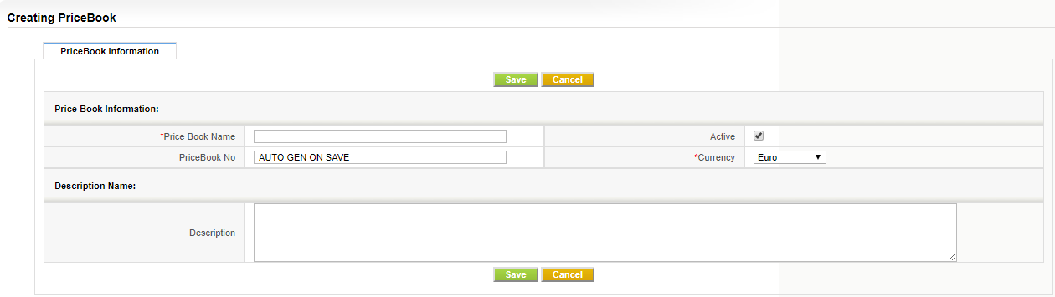
- In Price Books tab, click on Add Price Book button
- In the Create Price Book view, fill in the details
- Click [Save]

Adding Products to Price Books
You can add any number of products under the price book by marking the prices manually.
Steps to add products to Price Book manually

- After adding the Price book manually,there would be a list of secondary modules that can be linked for the created price book.
- Select "Products" under it,it will redirect to the page from where the products can be added.
- Under it,click on the "Select Products" button,it redirects to a new tab which shows the list of products.
- Select any number of products by enabling the check mark,once the check mark gets enabled,it gives the access to list out the desired "List Price" for the selected product where the price can be entered manually.

- After selecting the product(s) ,click on the "Add to PriceBooks" button.It gets added in the selected price book. It gets added.
Quick Create
You can enter basic details of Price Book record through Quick create. This might be helpful if you are running out of time.
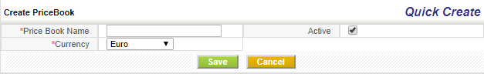
List of operations you can perform on records in Price Books Home page:
- Create Custom filters to classify records as per your requirements. You can be able to limit your search to selected columns and search criteria.
- Click on Mass Actions button and perform actions on desired records like: Edit and Delete
- Click Settings button > Edit Fields to configure fields and customize the layout of fields through Layout Editor
- Click > Edit Workflows to view / create new Workflows on Price Books
- Click > Edit Picklist values to modify picklist values through Picklist Editor
- Search desired records

Working with Price Books
You can modify the list price of Product or a Service to suite different customer groups.
Unit Price : Predefined price fixed by manufacturer.
List Price : Price that can be varied by the Seller.
Vendors
Vendor is a person or organization that supplies Products or Services to your company. Vendor can also be a manufacturer or a re-seller.
Creating vendors individually
You can easily create a vendor record by entering information in the fields provided.
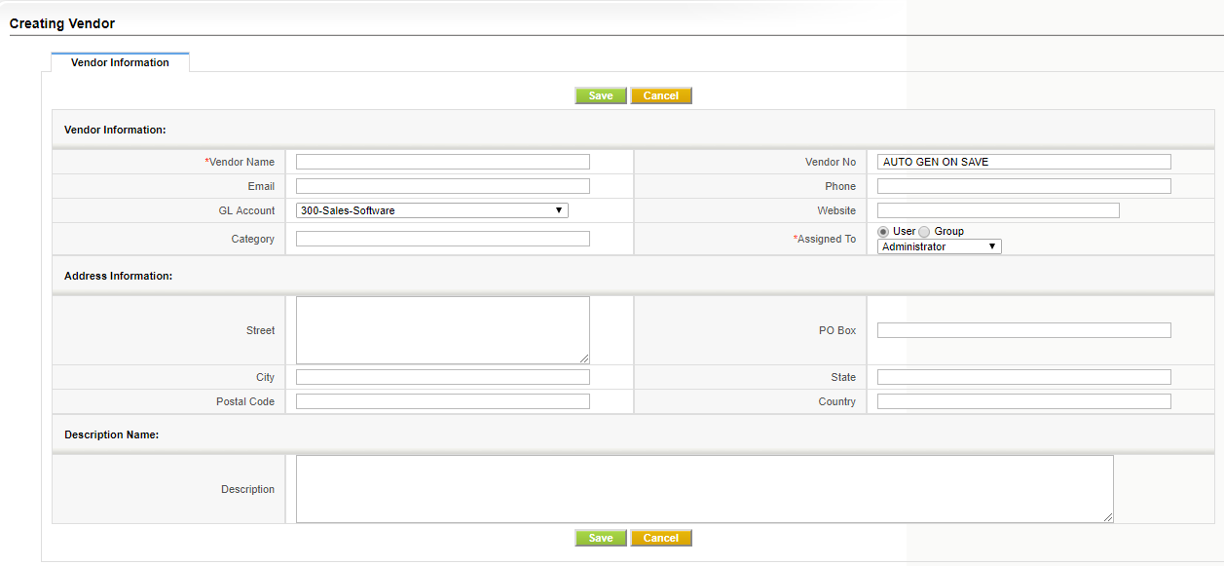

Quick Create
You can enter basic details of Vendor record through Quick create. This might be helpful if you are running out of time.
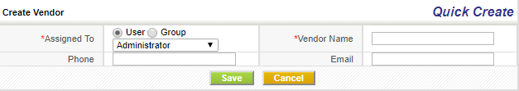

Importing vendors
Operations you can perform in list view of Vendors module
List view of Vendors module enables you to perform mass actions like editing, deleting, importing and filtering records in bulk. In addition, you can also edit fields, workflows and picklist values
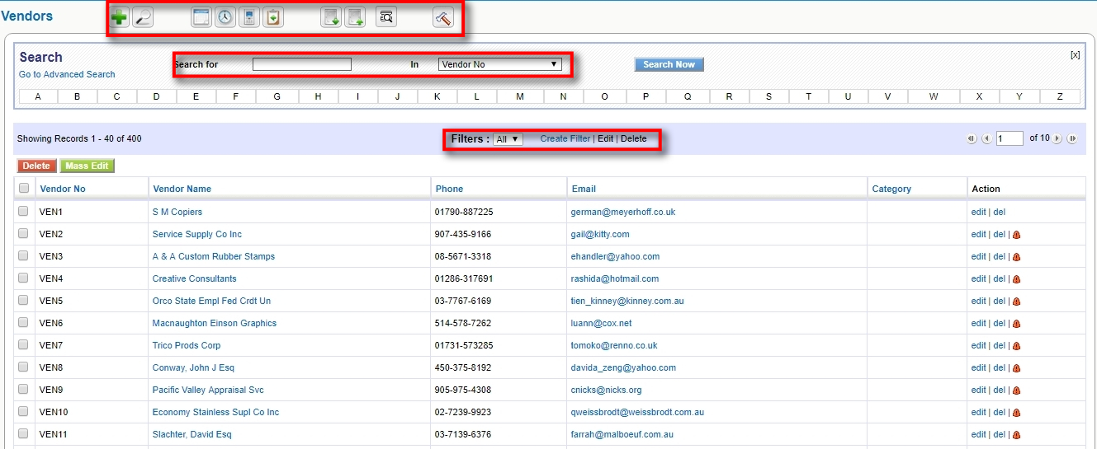

Operations you can perform in detail view of Vendor record
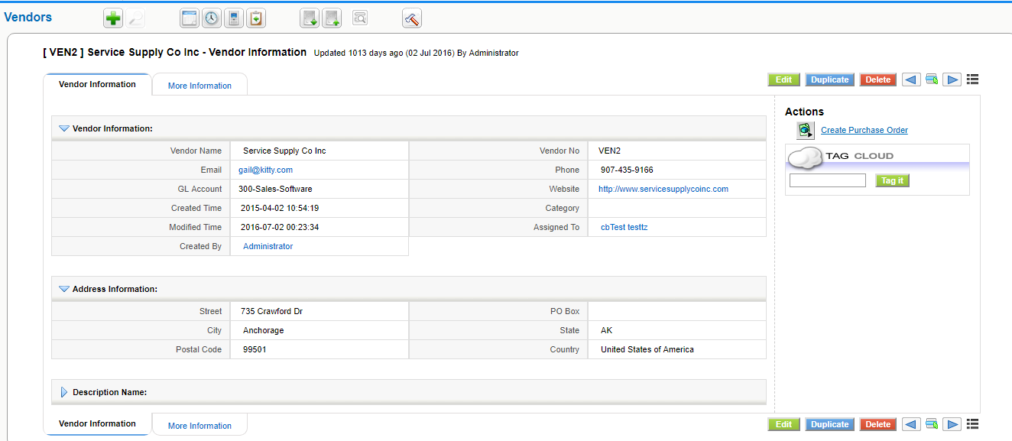

Tools
The CRM offers a set of additional tools which are useful for the daily work with customers.
RSS
RSS is a Web feed format, used for Web syndication and stands for Really Simple Syndication. Web feeds are widely used by the weblog community to share the latest entries' headlines or their full text, and even attach multimedia files. Some providers allow other websites to incorporate their "syndicated" headline or headline and-short-summary feeds.
RSS is used for many purposes, including marketing, bug-reports, or any other activity involving periodic updates or publications. Many corporations are turning to RSS for delivery of their news, replacing email and fax distribution. The news media is also utilizing RSS by bypassing traditional news sources.
CRM users are able to have news constantly fed to them instead of searching for it. The CRM system provides at the Tools > RSS menu an RSS reader, can check a list of feeds on behalf of the users and displays any updated articles that it finds. You may search the Web for RSS feeds you are interested in. Every RSS feed has a unique address similar to Web URLs. To watch an RSS feed you have to enter these addresses into the CRM system.
Our Sites
You may link the CRM with other websites which are of any interest for your business. Users don't need to leave the CRM system to access third party web sites or other Intranet or Internet sites. You may use this function for instance to watch important customers, your own website, or the websites of your competitors. It is also very useful for tracking shipments, or communicate with vendors web based.
Before you can see any website at the Tools > My Site menu you need to bookmark a site. Click on [Manage Sites] to enter a new website. Click on the [My Sites] to see the bookmarked websites.
Notes
Notes are a practical tool to add further information to Contacts, Accounts, Leads, Potentials, Products, Invoices,as well as Sales and Purchase Orders. You may enter a note by using the Quick-Menu or the Plus Icon at the list view of the Tools > Notes menu. You may also add notes directly at the detail views of certain CRM modules. As displayed in Figure: Note - Edit View you may also attach files to notes.
You may use this function for instance to collect documents important to your companies operation.

Business Mappings and Conditions
The Business Mappings and Conditions module permits implementers to define high-level configuration options for the execution of the application.
Using different types of structured XML, JSON or direct SQL, this module will define conditions, field mappings, and other advanced logic to modify the functionality of the application without the need to get into programming details.
This module also serves another purpose: separating the programmers from the implementors. In other words, it permits the programmers to create functionality in the application while giving to the implementer total control on how that functionality should act in different cases for different installations.
With this module, we achieve a much more configurable application without the need to depend on specific programming knowledge.
Note that in the end, many of these mappings or conditions are actually a washed down configuration screen. Many times, from a programmers point of view, creating certain functionality is easy, the problem is creating a GUI for the user to be able to configure the different options that are present in the code. Usually, we spend more time programming the interface than the actual solution. With Business Mappings and Conditions we create a spartan, manual but generic interface to many features without getting to complicated nor repeating work over and over.

Business Mappings Store
We have a relation of different Business Mappings we use where you can find a whole set of different Business Mappings which can be used in your application directly or with easy modifications to adapt them to your needs.

Fields of Business Mappings
- Map Name: this is a textual identifier of the mapping. It is very important to use the exact name that each feature requires as that is what the code looks for. These names are constantly evolving as we add new features that use the mappings module
- Map Number: autonumeric reference field
- Map Type: the type of mapping that is required, Depending on the type, the structure of the contents field is different
- Map Contents: the actual definition of the mappings, normally this will be an XML structure

How it works

How an implementer can use a Business Mapping
Once a programmer has established the code changes to use a Business Mapping, the implementer has to create, one or more, records in the module with that type of Business Mapping.
Usually, the programmer will have created some examples and documentation on the exact formatting and options supported by the business mapping type.
Once created and configured the code will use the mapping.
Optionally, the implementer can create more than one mapping of this type with different configurations and then associate each one to different users, with the help of the Global Variable module.

How a programmer can use a Business Mapping
The idea is to get the mapping to apply and then pass in the parameters so the mapping can be processed.
The correct way to do this is using the global variable module so that the mappings are dependent on the users and pass in the default mapping which you should have created.
$cbMapid = GlobalVariable::getVariable('BusinessMapping_SalesOrder2Invoice', cbMap::getMapIdByName('SalesOrder2Invoice'));
if ($cbMapid) {
$cbMap = cbMap::getMapByID($cbMapid);
$focus->column_fields = $cbMap->Mapping($so_focus->column_fields,$focus->column_fields);
} else {
...
All global variable whose name starts with 'BusinessMapping_' will return the associated mapping.
In the code above, the Mapping called 'SalesOrder2Invoice' is the default mapping.If the mapping is found we apply it by calling the type of mapping and passing the required parameters for each type. You should consider implementing the 'else' part in case no mapping is found.

How a programmer can add a Business Mapping Type
Adding a new process is rather simple:
- Add your mapping type to the changeset file so it gets added in the business mapping picklist
  - build/changeSets/cbMapAddMapTypes.php
  - see the code
- Add the translation of the mapping type to the modules/cbMap/language files
- Copy the file modules/cbMap/processmap/processMap.php to a file named as your mapping inside this same directory
- Now modify this file to process your mapping. Basically you will need a convert method that will convert the XML into a PHP array and then add methods that read the array and return answers, values or parts of that array
Once you have done that you will be able to launch your mapping by loading the CRMID and calling the mapping name.
As you can see in the commit, we add the ListColumns type to the picklist and translation files. Then we add a new script that, first documents the required XML structure, then converts the XML to an array for easier processing and then defines a set of helper methods to extract information from the mapping.
Once we have a Mapping ID, we load it:
$cbMap = cbMap::getMapByID($cbMapid);
and then call the ListColumns mapping type to initialize the internals (call processMap) and from there we call the helper methods to get the information we need:
$focus->search_fields = $cbMap->ListColumns()->getSearchFields();

Types of Business Mappings
There are currently these different types of mappings:
- Condition Query
The accepted format is a direct SQL OR a QueryGenerator specification.
If it contains both, the SQL part will be used and the other ignored
You MUST specify the return value which can be:
- a field from the query, the value of the first row found will be returned
- the string COUNT which will return the number of rows of the query
- the string RECORDSET which will return all the results. Be careful!!
In QueryGenerator:
- you can specify the fields to be returned in the SQL by a comma separated string of field names
- if no fields are specified the ID of the records will be used
- the conditions are a JSON encoded string as generated by the conditions editor of the application

2. Condition Expression Business Mapping
This mapping accepts two formats, one is a direct expression from the workflow expression engine and the other is a function expression that can be called from inside the system. The function parameters will be changed to the current record values if they exist.
<map>
<expression>uppercase('this string')</expression>
</map>
<map>
<expression>accountname</expression>
</map>
<map>
<expression>employees + 10</expression>
</map>
<map>
<expression>if employees > 10 then 'true' else 'false' end</expression>
</map>
<map>
<function>
<name>isPermitted</name>
<parameters>
<parameter>Accounts</parameter>
<parameter>CreateView</parameter>
<parameter>record_id</parameter>
</parameters>
</function>
</map>
the isPermitted mapping above will be converted into:
isPermitted('Accounts','CreateView','74');

3. (Field) Mapping Business Mapping
This business rule serves the purpose of filling in fields of a new record when coming from another module's record or setting default values for the module you are creating. For example, when creating an Invoice from a SalesOrder or an Opportunity from a Contact.
When creating a new record you always have access to all the fields of the current user using the FIELD or TEMPLATE types. For example:
$(assigned_user_id : (Users) first_name)
It will permit you to define what values you want to copy from the origin module or simply what values you want to set by default when creating in the way. The user must have the possibility to choose:
- Origin Module
- Target Module
- FieldName (choose a field from the list of field of the Target Module)
- FieldValue (choose a field from the list of field of the Origin Module)
- Value (add a default value )
- RelfieldName (choose a field from a related module)
4. Record Access Control
This type of map is used to specify the permission such as Add, Edit, View, Delete, Duplicate for ListView mode, DetailView mode and Related Lists of a specific module.

5. Master Detail Mapping
The purpose of this mapping is to define the structure of a master-detail module so it can be used to construct a special module editor. With this mapping we are able to specify the relation between parent and child modules and also the fields that we should show in the list and detail view of the dependent module.
First of all we choose the Target Module (dependent module) and Origin Module (parent module). Then, we specify the fields we want to show in the list view and detail view of the Target Module. We use <editable>0 or 1</editable> , <mandatory>0 or 1</mandatory>, <hidden>0 or 1</hidden> to specify if the fields shown in Target Module are going to be editable, mandatory or hidden.
6. IOMap
This type of map is a developer tool. It permits you to define the input and output parameters of different processes that can be programmed. It has no visual effect nor functionality inside the application. The inputs and outputs can be fields from modules or values(default or not) used during different programmed processes such as a module id, record id etc.

7. Field Dependency
This type of map permits you to define dependencies between fields in edit mode.It will permit you to make a field mandatory or not, hidden or not, readonly or not, depending on the value selected in a given field (responsible field), or to change the available values in a picklist depending on the value.
8. Global Search Autocomplete
This business map is really a configuration setting. Most business maps are generic, whereas you can use them on many modules or for various purposes. This mapping is, specifically, to define the set of modules and fields you want to launch a reduced global search on.
As of the creation and implementation of this map, if it exists, you will be able to start writing in the global search text box to get an autocomplete dropdown with values that it finds in the modules and fields defined in the mapping
9. Extended Field Information Mapping
The purpose of this mapping is to define a set of additional features on fields. Instead of adding columns to the vtiger_field table and creating different UI settings options we add this mapping where you can configure the extra information for each field.

10. Record Set Mapping
The purpose of this mapping is to define an heterogeneous set of module names. Simply a bunch of modules. This could be used to define a set of modules to launch a mass operation upon or a set of modules which must be excluded from some global process. You will be able to get the set of modules using the getFullModuleSet() method.
11. Related Panes
The purpose of this mapping is to define additional panes or tabs on a modules' detail view. The additional panes work exactly as the “More Information” pane with a drop down menu that contains the different blocks contained in the pane.

A pane can contain any combination of 4 types of blocks:
- RelatedList: a related list of records with actions, this is the current content of the default “More Information” tab

- Widget: this is a block that must be constructed following the DetailViewWidget specification. You have full control of the space designate to this block

- CodeWithoutHeader: this will open a “div” and directly include your code inside

- CodeWithHeader: this will add a header following the look and feel of the default related list blocks and the open a “div” and directly include your code inside

12. Module Set Mapping
The purpose of this mapping is to define an heterogeneous set of module names. Simply a bunch of modules. This could be used to define a set of modules to launch a mass operation upon or a set of modules which must be excluded from some global process. You will be able to get the set of modules using the getFullModuleSet() method.
The format:
<map>
<modules>
<module>ModuleName</module>
<module>ModuleName2</module>
...
</modules>
</map>

13. Duplicate Records
This is a workflow configuration map. It permits you to define the related modules that will be duplicated when launching a Duplicate Records workflow task.

The coreBOS application supports mass duplication of records by means of the Duplicate Records workflow task. The idea is that you can duplicate a record and all its related information in one step.

14. Import
This type of map is a developer tool. It permits you to define the relation of fields between two system in order to import and sync the information.

15. Field Set Mapping
The purpose of this mapping is to define a heterogeneous set of fields that belong to some modules. Simply a bunch of fields. This could be used to define a set of fields to launch a mass operation upon or a set of fields which must be excluded/included from some global process.
The format:
<map>
<module>
<name>ModuleName</name>
<fields>
<field>
<name>fieldname</name>
<info>anything you need</info>
</field>
.....
</fields>
</module>
....
</map>

The two most typical business map errors are:
- giving the record the wrong name: most business maps are launched depending on their name, so you must set it correctly
- invalid XML: https://www.xmlvalidation.com

Business Actions
Most of the parts of scripts are executed by actions. In coreBOS we have different types of actions. A business action is the definition that something graphical has to appear on the screen or not. After choosing the type of the action you want (button, link). Then you link the action to a business rule, and the condition is based on a map which may be a SQL query. Most of the script is executed using actions (launcher actions). Business actions are written just once they can be used every time and are built inside the module.

A business action is the definition that something graphical has to appear on the screen or not. After choosing the type of the action you want (button, link). Then you link the action to a business rule, and the condition is based on a map which may be a SQL query. Most of the script is executed using launcher actions. Business actions are written just once they can be used every time and are built inside the module.

The usage of a considerable number of Business actions and script weakens the system performance , you lose control of the system. It must be done in different infrastructure.
The Launcher Actions
These actions are usually used when a user builds an action based on a script designed by a programmer in a certain language.
When designing a Launcher Type Action is important to define the name of the action, the type of the action that we are creating. The type of a business action may be script launcher Create/Update Entity, Alert etc. In business actions is also required to assign a user that this action is dedicated.
In creating business actions each action is important to create maps in order to define the input and output for performing actions. Also this action contains business rules that include all the roles and groups of user that is action is dedicated to.

Send Mail Actions
The map is important in business action because you can put the main parameters of the script (Subject, record id, assigned to…). When you use the type of action Send Mail another step that is going to be taken Message Setting. In message setting we put the address of the person who is going to receive the email, the variables you have to be fulfilled they take values from CRM fields and they also have values from the actual module and the related modules . Normally we create actions using workflows. You put at the workflow the condition of how and when the action is going to be executed. In this way you can make the operations automatic. Causale field is used as a logical identifier of an action.

Create Entity Action
The create Entity Actions build actions of two related modules the origin module and the target module. In this type of actions is important to define the related fields on modules in the map that takes the input and output parameters.

Sequencer Action
These types of actions are related with the sequencer module. Sequence actions execute each action one by one. The sequence action don’t execute if we don’t connect it with a primary actions. The field business rules in sequencer actions is important because defines the users when this action will be performed. When we execute the sequence actions all the actions that contain the sequencer will be executed.

Global Variables
The Global Variables module permits us to customize the functionality of the application in a very easy way. The basic idea is that when we are programming something and need to establish a value or a decision, we create a global variable with a default value and use the result. So now any user can set the global variable to another value and effectively modify the program logic without having to modify the code. A really powerful and easy extension.

The order Global Variables use to return a value is:
- First it looks for a GV marked as 'mandatory'.
- If none is found, it'll look for one assigned to the role of the current user.
- If none is found, it'll look for one assigned to the current user.
- If none is found, it'll look for one assigned to the group of the current user.
- Finally, it'll look for one that's marked as 'default'.
- If no GV was set, the default system behavior will take place.
- Additionally the previous searches will take into consideration the checkbox 'In Module List'

Fields
Global Variable Name: This is a list of existing variables. It is a select box with the accepted values.
Value: Is a string field that holds the actual value to be used for this variable. Each variable has its own possible values which are documented in the module. There is a special value accepted by all variables which is [Use Description]. Some variables have very long values, for example Application_UserLoginIPs can be a long string of values. To make maintaining these long values easier you can put the value in the description field instead of the value field by setting the value to [Use Description].
User: the user this variable is for.
Default: This check box is the contrary to Mandatory. It permits the administrator to set a default value for all users but it can be overridden by any user who wants to have a different value. The record marked as Default will only be used if no other record is found.
Mandatory: This check box forces the value of the variable for all users. If it is checked no other record for this variable will be used. It is designed for the administrator to be able to set a variable globally for all users. To accomplish this you must set the module to private sharing and assign the record to the admin user so it can't be modified by any user.
Blocked: This field is simply for grouping certain variables together, it has no logic nor process associated. The use case this field was created for was for the admin user to be able to hide it in all profiles or not permit editing of the field so he can use it to group certain important variables together. Once those variables are ticked we can easily create a filter or search on the field so we can find them quickly.

Module and In Module List: Variable values can be applied per module with these two fields. If the in module list field is checked then the defined value will be applied only to the modules selected in the module multi-picklist field.

Role: Select the roles you want to apply this variable to.

Business Map: When we look for business maps in the code we do that through the global variable module instead of going directly to the business map module. This way we permit any user to override the default selection and set a specific mapping for any case.

Category: simply for organization purposes, so you can group and filter your variable records.

Create a new variable
Creating a new variable is a three step process:
- Call the global variable method with the new variable in your code
- Add the new variable to the DefineGlobalVariables.php continuous changeset so it gets added to the picklist of valid variables
- Add the definition of the new variable in the language file

Reporting and Analysis
Dashboard:
The dashboard gives you a graphical representation of your sales and service data.

Reports
You may summarize your data stored in the CRM by reports. You have a set of predefined reports available which you can customize based on your needs. You should use these report and analytic CRM features to get an overview about customer related activities and to draw conclusions as how to improve your sales process.

Dashboard
You may reach the Dashboard function at the Analytics > Dashboard menu. The dashboard includes a graphical representation of sales and services related data as partly displayed in 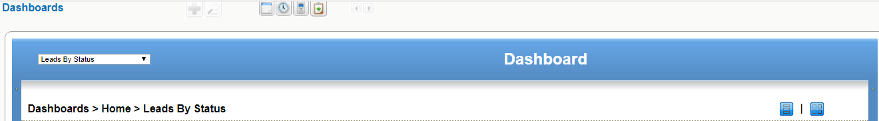
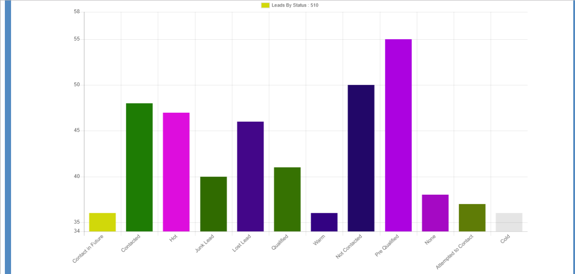
Figure 3.23. Dashboard

You may switch between different reports and views. Some reports, such as Dashboard Home, allow to modify the period as well as the type of data included. Click on [Edit] to modify the settings. Use the "Strg" button on your keyboard to select multiple data sets to be displayed.

Note The time period used at the dashboard does not update automatically when time passes by. You have to set the required period and you should click on [Refresh] to make sure the actual data are shown.
The sales stages, status as well as the other source information used may get changed by your CRM system administrator.

Reports

You may get a report of almost any data you have stored in your CRM at the Analytics > Reports menu as shown in Figure: Reports Home.
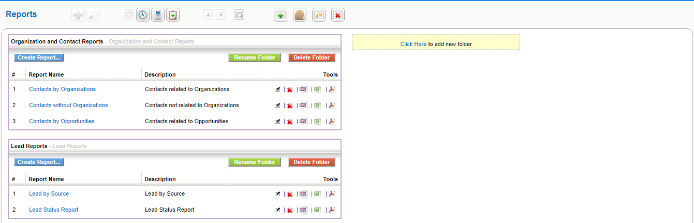
Figure 3.24. Reports Home

The CRM offers you a report generator as well as a report designer.
Report Generator:
The report generator provides you with reports which you can see at the screen or export as PDF or Excel files.
The CRM comes with a rich selection of standard reports as illustrated in the previous figure. Each of these reports comes as two types:
Tabular Report:
Tabular reports are the simplest and fastest way to get a listing of your data.
Summary Report:
Summary reports allow you to view your data along with subtotals and other summary information.
In the following we will explain how you can modify reports or even setup your own report folders.

Edit Reports

To change an existing report click on the click on the Report Name. An new window will open that lists the selected report and allows you to customize the report.
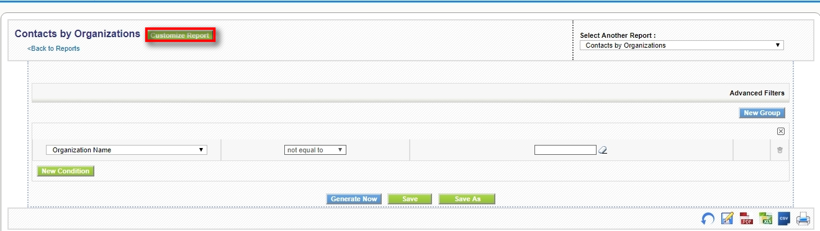
Figure 3.25. Report Detail View

To open the report editor to change an existing report click on Customize Report as indicated in Figure: Report Detail View. Follow the instructions.

To create a new report click on the New Reports icon shown at Figure: Reports Home. First you are ask for the CRM module that provides the data for the report. Based on this selection the fields available for the reports are selected by the CRM system.

The opening pop up window displays the next steps for report creation as shown in Figure: New Report Detail.
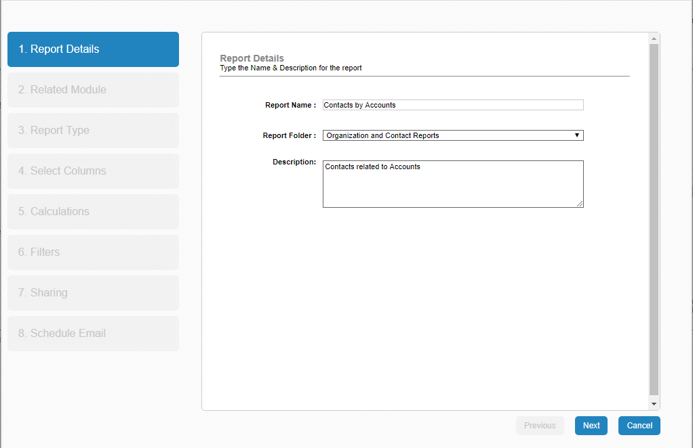
Figure 3.26. New Report Detail

Follow the instructions.

Caution At the current release the CRM does not control whether there is enough site space for a proper PDF output available. If you chose too many columns you might not get a useful PDF export.

Note
Designing a report can be a very complex task. You should start with a very simple report and control your results frequently before you begin to use filter functions.

If your report design is finished, click on [Next] to save your settings and to start the report generator.

Immediately, you

• can see the report at your screen,
• may export the report as PDF or Excel file, and
• may print the report.

Customized Report Folders

To create your own report folder click on the [Create New Folder] icon as shown in Figure: Reports Home.
At the new pop up window, you may give this folder a name and a description.

Click on [Save] to create this folder. You could use this self created folder to store your own or modified reports. The new folder will be listed at the [Analytics > Reports] menu.

At the [Analytics > Reports] menu you may also move or delete reports by clicking at the appropriate buttons or icons.

Note
You may create any report to be listed at your own folders. Make your folder selection in step 1 of the new report creation process.

Settings
CoreBOS Updater
coreBOS 5.5 has brought a new tool to our powerful business operating system: coreBOS Updater.
Since we have a very stable and tested code base, and thanks to the powerful code administration and distribution system that GitHub gives us, it just seems natural to put your coreBOS install under code versioning with git (be that private or open) and point a remote to the public, open source coreBOS project.
Once you have that setup, updating your code with our (constant) changes is fairly easy, as git carries all the heavy weight during merge, leaving us to fix the minor details.
So with the approach above and the fact that the majority of changes we make are also tested and stable, you really don't have to wait for us to release an official download to get the new features, you just update your code and apply the database changes the new code may require.
Wait! Apply database changes? How do you do that? git doesn't do that, how do I know what changes I need to apply?
Enter coreBOS Updater.
coreBOS Updater is a tool that will control the state of our database with respect to the code and will be able to automatically apply the pending changes that are needed. This way the upgrade process is converted into these steps:
- update your code with git (or manually if you are brave )
- log into the application and go to the coreBOS Updater module
- click on the “Load Updates” button
- click on the “Apply All” button
You are finished! That easy! coreBOS updater has taken care of all the pending database changes and your code and database are in sync and ready for you to start working.
Going forward all future releases of coreBOS will follow this procedure to apply database changes for the upgrades.
If you have a look at the module you will see that each changeset is created as a record in the module. You can see the details of the change and also undo some of them, all those that are not pure system updates. The system type changesets are mandatory for the application to work correctly.

How to prepare and distribute system changes
From a developers point of view, the coreBOS Updater tool is a clean way of recording database changes in code. This permits us to control (to some extent) the set of database changes that are needed in our version control system.
Since we are really programming the changes in files, we then version those changes along with the rest of file changes that define the new feature or bug fix and it all gets registered in the versioning system.
To help us prepare the database changes coreBOS updater is going to take care of all the dirty work it can for us, so we basically just have to write the changes that are needed.

Step 1: Define the change and the file that contains the work to be done
Edit the file modules/cbupdater/cbupdater.xml and add your definition to the list of changes.
The file modules/cbupdater/cbupdater.xml is the main change file of the coreBOS application. Although you can use this file to register your changes the correct way to distribute them is by creating your own changeset XML file inside the modules/cbupdater/cbupdates directory. When coreBOS Updater looks for changes it reads them from the base modules/cbupdater/cbupdater.xml file and then looks for any .xml file inside modules/cbupdater/cbupdates to pickup those changes also. That way each programmer can easily distribute changes without overwriting the base application changesets.
The XML changeSet element contains various entries of which only two are mandatory, but all recommended:
author | optional | Name of the person or company adding this changeset
description | optional | Explanation of the goals of this changeset
filename | mandatory | Name of the file which contains the changes. This file can be anywhere on the file system as long as it is accessible by coreBOS. We propose and recommend that these changesets be saved all together in build/changeSets directory
classname | mandatory | Name of the class that implements the changes (explained next)
systemupdate | optional | True if the changeset is mandatory, false if it can be undone
perspective | optional | True if the changeset is a perspective (see below)
continuous | optional | True if the changeset must/can be executed always. Certain changeset are very general and can be (or must be) applied many times.
An example:
<changeSet>
<author>joebordes</author>
<description>Custom field support on FAQ module</description>
<filename>build/changeSets/cffaq.php</filename>
<classname>cffaq</classname>
<systemupdate>true</systemupdate>
<perspective>false</perspective>
<continuous>false</continuous>
</changeSet>
The file modules/cbupdater/cbupdater.xsd defines the official schema accepted for the XML changeset file and it is used by coreBOS Updater to validate the XML format.
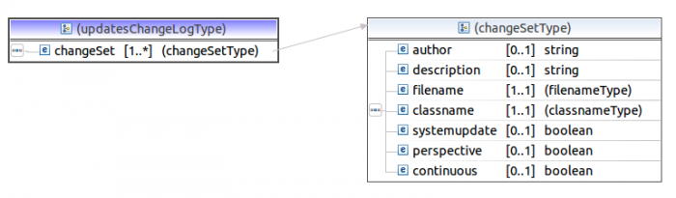

Step 2: Implement your change
- copy build/changeSets/cbupdate_template.php to the name you used in the XML <filename> element
- edit your script
- change the license
- change the name of the class to the name you used in the XML <classname> element
- edit the applyChange() function: locate the line that contains “do your magic here” and start adding your changes
- edit the undoChange() function: locate the line that contains “undo your magic here” and start adding code to undo the change
- test and validate
If your change cannot be undone you can eliminate the undo function completely and coreBOS Updater will take care of it.
You can find a whole bunch of real examples of different types in the build/changeSets directory.

Step 3: Test, validate and version the change
Really! Test, validate and version the change.
Menu Editor
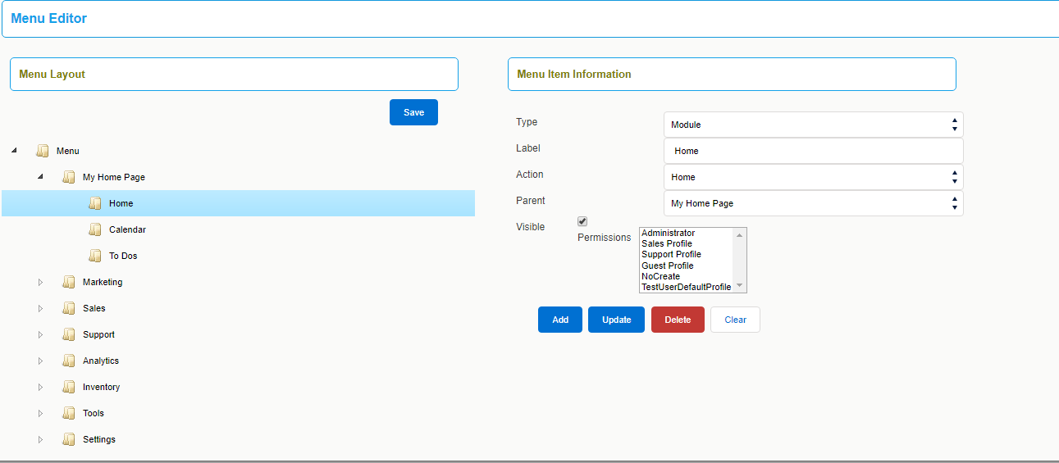
With the help of Menu Editor, you can have most frequently accessed CoreBOS CRM modules on your menu bar.
This will ensure easy navigation, and switching between different modules is easy.
Also, you can shuffle their positions according to your requirements.
However, the list of all available modules in CoreBOS CRM are displayed under All dropdown.
For instance, Sales reps frequently access sales related modules : Contacts, Leads, Invoices, etc. They can have frequently visited modules on menu bar to save time.
Follow few simple steps to configure desired modules on menu bar
- Click CRM Settings
- Click Menu Editor. You can click on pin icon next to it to add a shortcut to your settings home page
- All active modules in CoreBOS CRM are available for selection. Select desired modules from list of modules
Notes! You can only select up to 7 modules to have on menu bar
- Change the arrangement of the modules by dragging them among the other modules
- Click Save
- Refresh your page to see desired items on your menu bar

coreBOS Translation Module
Thanks to the team at OpenCubed, CoreBOS has the functionality to translate the labels from within the application.
This is especially important for custom fields, because we cannot use special characters that are so important in many languages either in the labels or the picklist values. Due to that restriction we have to use plain text and then translate the values. Before having this functionality that translation had to be done directly editing the language files, now the admin user can easily do the change without needing access to the files.
To access the translator you must login as an admin user and go to the Module Manager. On the Custom Modules tab we will find the language files and next to each one the hammer icon will take us to the translation screen.
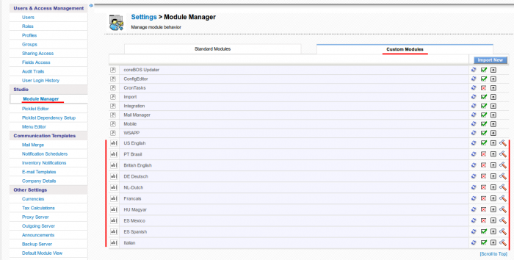
The translator permits us to select from among the different modules and base language files to translate and shows us the full list of labels with their value in the base application language followed by the translation which you can modify accordingly.
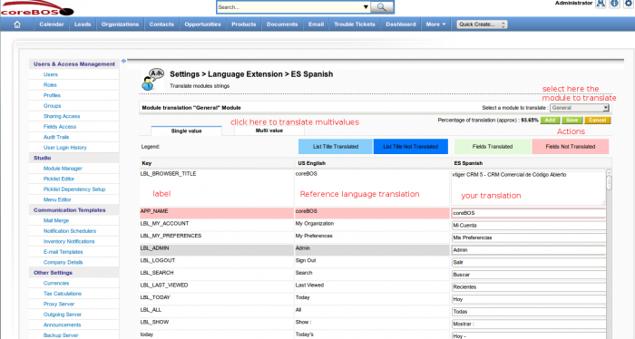

Administration Manual
CoreBOS CRM Settings
The CoreBOS CRM Settings page lists the various settings and configurations that you can change to tailor CoreBOS to your business’s specific needs.
This chapter explains how to start working with CoreBOS CRM's Settings. It's an overview of all types of considerations an administrator should go through before starting to setup the CRM system.
Please note:The access to the Settings area is restricted to CRM administrators only.The settings area won’t be shown to standard users in the Log in Area.
To reach the Settings Page click on the [Settings] button from the top right corner of any page and then in the CRM Settings menu that appears.
The main Settings Page in divided into four sections:Users and Access Management ,Studio, Business Process Management, Other Settings, as shown in Figure CRM Settings Page. This chapter will explain each section in detail.
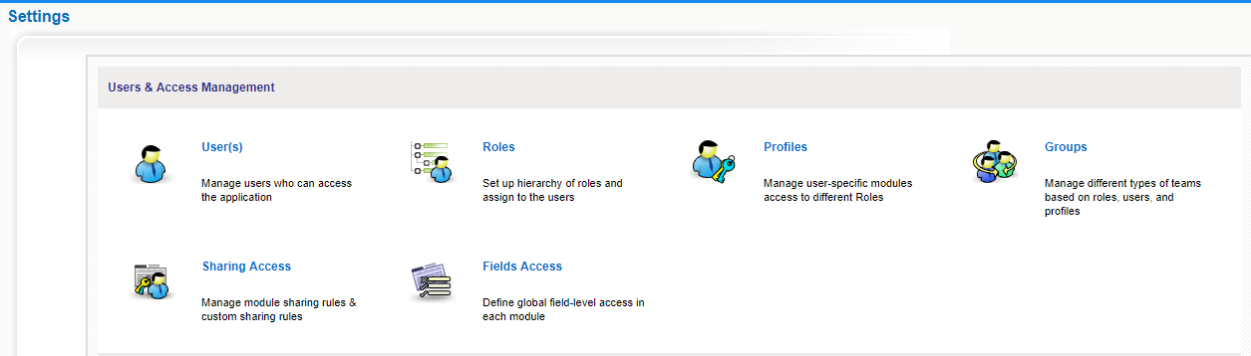
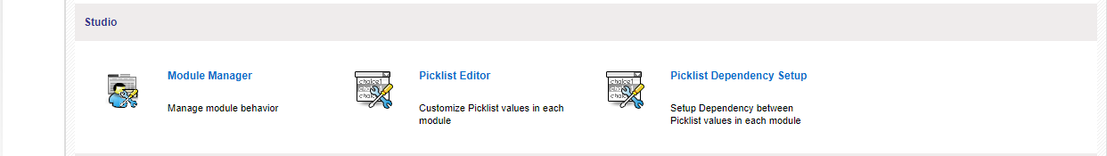
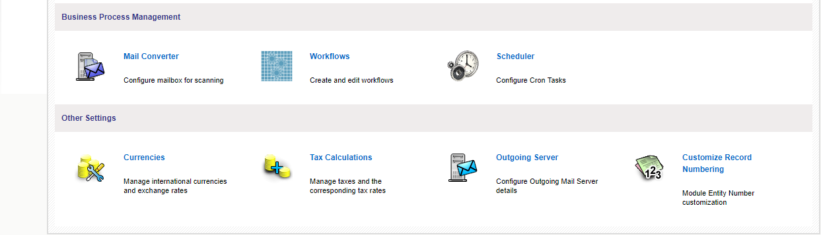
Figure x.1. CRM Settings Page

Users and Access Management
From the organisation point of view user administration means administration of privileges. Essentially, the use of privileges depends on the number of users and the company structure. Few users in small enterprises have few requirements to a privilege administration. With an increasing number of users the complexity of the relations between the users increases and usually it develops the need to assign and administer privileges.
The CRM system offers a privilege system that is based on the following simple looking rules:
- Who can see certain data?
- Who can change certain data?
- Who can delete certain data?
- Who can create certain data?
In the practical work with the CRM this is most helpful and necessary as the following examples illustrate:
- A selling coworker would feel it surely as unpleasant, if somebody else changes the data of customers.
- Personal information remains confidential only if other coworkers are not allowed to see those.
- The company management does not want that everybody can see the revenue numbers.
- Only one person is allowed to change the product or service catalog.
Therefore, it is necessary that the user privilege assignment is truly based on business requirements as described in the following examples:
- Only the sales staff is allowed to change customer related data.
- The secretary does not get any access to revenue numbers.
- Only the product manager is allowed to change prices of services or goods offered by the company.
- Only the management is allowed to see all CRM data.
- Nobody is allowed to export any contacts.
Considering the current CRM capabilities of managing user privileges you should configure your system in the following order:
- Set the Default Organisation Wide Privileges: Organisation Wide Privileges should be created first. They are the basis for the privilege assignment valid for all users.
- Create Profiles: To control what modules and fields each user can see and modify,CRM administrators can create and customize user access profiles that are applied to users through their hierarchical roles. In any organization there are usually different users with different tasks, like sales, service, secretariat or CRM administrator. Depending of the user type the privileges for accessing data and using CRM modules and functions can be assigned.
- Define Roles: Roles is where you define you organizational hierarchy,which determines who can see what records in CoreBOS,when record sharing in the Sharing Rules Settings area is set to private. Roles are based on profiles. They define the overall privileges for each individual user.
Please note: Private records mean that users assigned to a role in the hierarchy cannot see records assigned to individuals or groups at the same level or higher up within the role hierarchy.For example, a manager can see all of his assigned employees contacts but employees can’t see each other’s assigned contacts.
- Define Groups: Larger organizations may define groups to improve the usability of the CRM system.Groups allow you to group various CRM users together to assign group responsibilities and tasks as well as to assign group access to specific records.
- Create Users: The privileges of individual users are defined by roles. You have to assign a role to a user.
Tip: Never use the "admin" role for your daily work with CRM system. It is advised to create individual users instead. Later, if you want to delete a user, you can assign all data to a new user.
Single users do not need any privilege management. They have and need all privileges to access and to change all data stored at the CRM.
Nevertheless it is helpful to know the basics of privilege assignment. This might be needed if additional users will be required in the future. A small number of users, who use the CRM system together, should be familiar with the simple solutions offered by the privilege assignment. That includes especially:
- To prohibit that other CRM users see confidential data.
- To prohibit that other users can delete or modify data. In a small organization there is usually no pronounced hierarchy between coworkers.
A complex privilege administration does not have to be developed. However, if it should be necessary to granulate the privileges more finely, you should begin with the use of different profiles. Each individual user may get its own profile with certain privileges. To provide a larger number of users within an organization with different user privileges, a clear structure of the privilege assignment is necessary.
It is meaningful to connect user privileges with the position or tasks of each individual user or user groups. The current CRM version supports a fine grained privilege management.
Role Based Security
CoreBOS CRM implements a state of the art role based security management which utilizes the concepts of roles, similar to the implementation of security in many current computer operating systems. Role based security (also called role based access control) is built on the premise that users are authenticated, which is the process of identifying the user. Once identified, the user can be authorized or, assigned roles and permissions.
The security management includes the configuration of the following CRM modules:
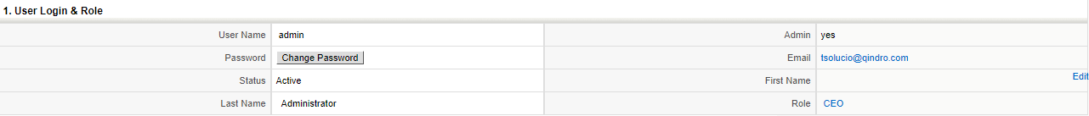

Figure x.2 User Login and Role

Users & access management

Users

Users are employees in your organization who can log into their CoreBOS CRM accounts, access information, and perform tasks according to permissions that have been defined to them.

There are two types of users for the CRM software:
- Standard user
- Administrator user

Standard users have a limited access to the CRM system to perform CRUD (Create, Retrieve, Update, and Delete) and limited user specific customization operations only.

Administrator users are capable to manage the complete software that includes:

- managing users and groups and their access privileges,
- customizing the CRM user interface,
- creating communications templates,
- configuring all organization wide settings,
- changing passwords, deactivate users, and view the login history, and
- exercise CRUD operations for all data.

To create or to manage users click on the Users menu to open the users list as exemplary shown in Figure: User List View.
This user list includes the user name, the role, the email address and other details for each individual user.

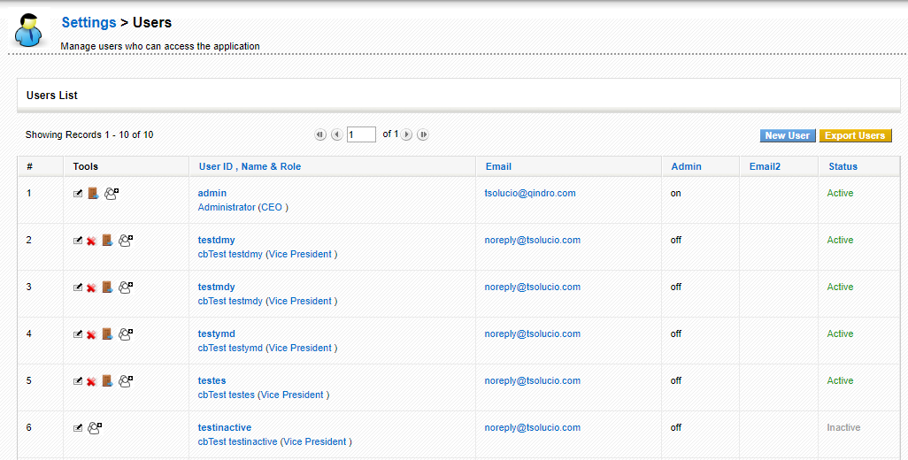
Figure: User List View

You may edit, delete or sign out users at this view.
Deleting Users
You can delete user accounts to terminate their access to CoreBOS CRM. After delete, users will not be able to log into CoreBOS CRM anymore.
Here's how to delete users:
- In the list view of users, click on icon to delete corresponding user
- Before deleting the user, you'll be prompted to transfer records to selected user in your CoreBOS CRM account
- Select desired user from the dropdown to transfer records
- Click [Save]

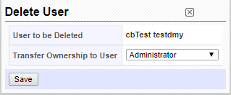
Figure.Delete User

Note:You can not delete default users provided by the CRM system.
Click on the users name (User ID) to open the detail view of a particular user.This view includes user master data related to the login and to the users role and other user information. User privileges are not shown. These privileges are defined by the user profiles and organisation wide settings as it will be explained later.

Adding New Users

Users with administrator rights have the ability to add new users.

Here's how to add new users in CoreBOS CRM:
- Click New User.
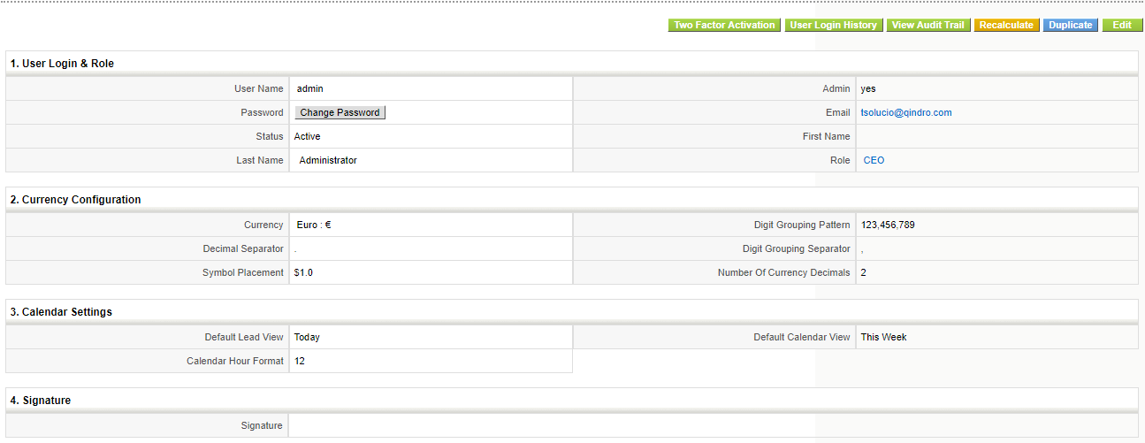
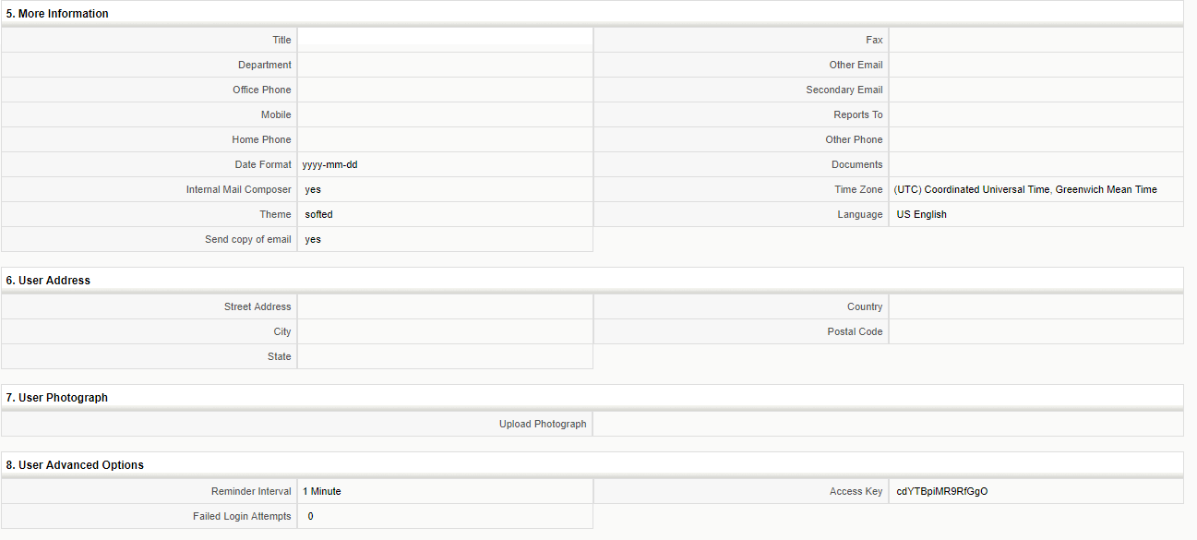

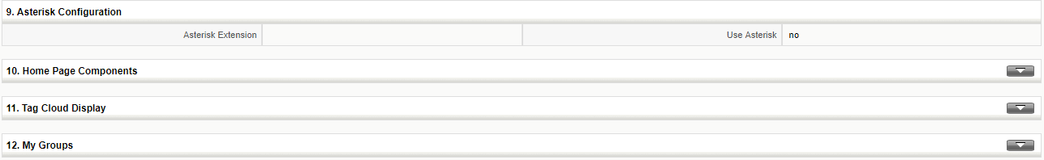
Figure.User Detail View

With the help of the buttons displayed at this view you may perform the following operations:

View Audit Trail: This button opens a new window that provides detailed information about the login history. Note that this function needs to be permitted by the CRM system administrator.

Duplicate: This button allows you to copy user data. This is helpful if you have to configure several users with equal settings.

Edit: This button allows you to edit the user master data.

The entry fields at "User Login & Role" displayed at Figure: User Detail View have the following meanings:

Table . List of default entry fields for User Login and Role

 | Type | Content
1 | User Name: | Each user must get an unique and secure user name. Use at least 8 digits. User names once created can not be changed in the edit view. Every user has the privilege to change its own password.
2 | Admin Checkbox | Check this box only if you want to create a user with administrator privileges, independent from the role.  Warning Users with administration privileges can see and modify the settings and all user data.
3 | Password | You should give each ticket a unique name
4 | First and Last Name: | Enter the users name. The first name will be used for the welcome message. If you do not enter a first name, the last name will be used for the welcome message.
5 | Role: | As explained before, roles define the privileges for a user. A role must be assigned to each individual user and must be created before
6 | Email: | Enter the email address of this user. This address will be used by the CRM for outgoing emails.
7 | Status: | You may set a user as active or inactive. Inactive users are not allowed to login
8 | Default Activity View: | Here you can set the default activity view and decide how activities are presented to the user at the home page.
9 | Default Lead View: | Here you can set the default lead view and decide how leads are presented to the user at the home page.
10 | Currency: | You may set the currency for this user here. Note that the currencies used by the CRM system are defined by the currency settings menu.

Note: User information are not visible to other users.

After filling up the fields, click Save.

Roles

You can mimic your organization-wide hierarchy in CoreBOS CRM with the help of Roles. You can assign identical designations to your employees like Sales Manager, Receptionist, etc. User's position in the hierarchy will decide which of the records he/she can access.

Notes! When Sharing Rules are set to Private, users can always view their own records and their subordinates' records, whereas non-admin users can not view records of their superiors and peers

Creating Roles
Roles like CEO and Sales Manager are provided by default along with CoreBOS CRM package. You can now define access privileges while you create a role. The idea is to reduce clicks and navigation. Having privileges defined on a role eliminates the necessity to create a different profile and associate it to a role. Additionally, you need not have to visit individual profiles to view or modify privileges you've defined earlier.

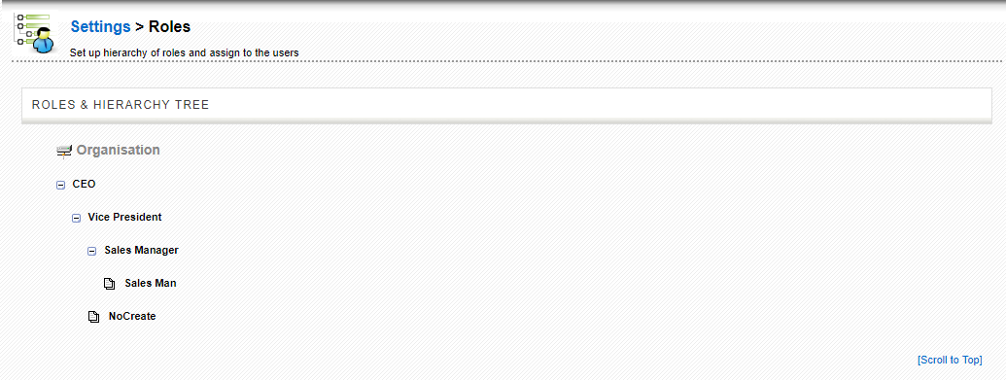
Figure .Roles List View

Users at any given role can always view, edit, delete all data owned by users below in the hierarchy.
Follow a few simple steps to create roles:
- Click CRM Settings
- Click 'User and Access Control'
- Hover mouse over the existing roles and click on New User icon to create a new role. The page as shown in Figure Create New Role will be shown.
- There you can create a new role and assign it to an existing profile.
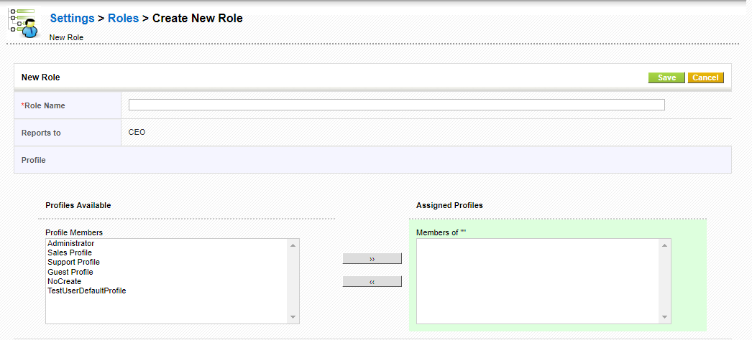
Figure.Create New Role

Important: Each user created in the CRM system must be associated with a role. A role must be associated with at least one profile.
Follow few steps to delete roles.
- Hover mouse over the existing roles and click on (Bin) icon to delete a role.
Please note:When you delete a role,the users assigned with that role will have to be assigned to another role,as shown in Figure Delete Role.
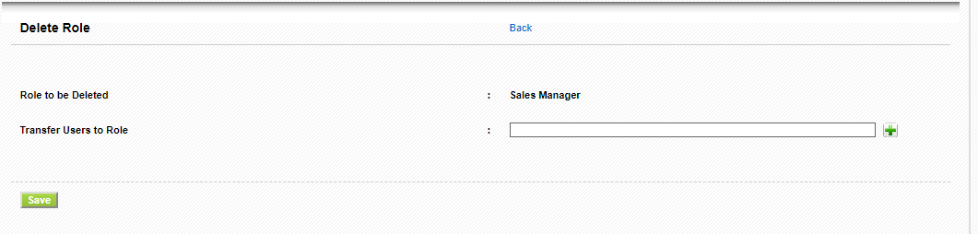
Figure Delete Role

Assigning Roles to users

Notes!
- You can associate multiple users and profiles for the same role.
- When you associate multiple users for same role, the users under the role will not be able to see each others' records.
- A role always work with respect to Profiles and Sharing Access.
Profiles

Profiles are used to control actions that users can perform on records. In addition, the profiles can be used to restrict access to specific fields, modules, and features such as import, export, etc. When a profile is associated with a role, the access rights defined in the profile will be applied across all users in that role.

Click on the Profiles menu to open the list view of your profiles as shown in Figure: Profiles - List View. Here you see a list of all profiles that have been defined at your CRM system.

The CRM systems comes with a set of predefined profiles which you can use and change but not delete.
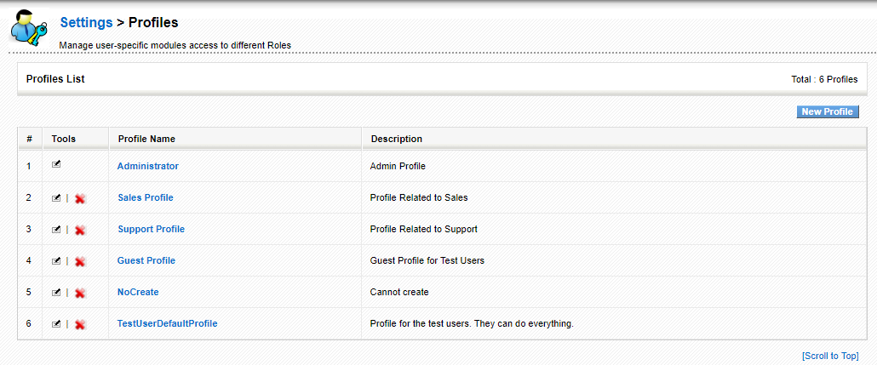
Figure 4.13. Profiles - List View

You may change the profile by clicking on the [ ] button.
You can create different profiles and associate with roles in CoreBOS CRM. For instance, you can create different profiles for your Sales team, Support team, etc

Follow a few simple steps to create a profile

To create a new profile click on the [New Profile] button at the list view. Follow the instructions provided:

Step 1 : Creating Profiles
Give the profile a unique name and a description. Select whether you would like to use an existing profile as a template. It is recommended to use this option.
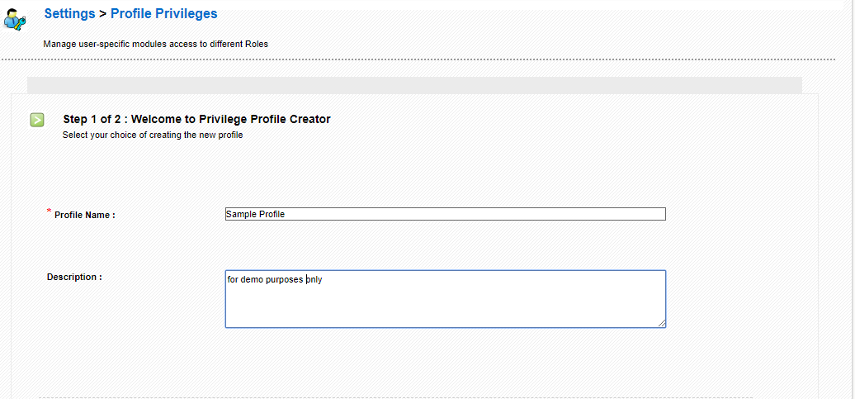
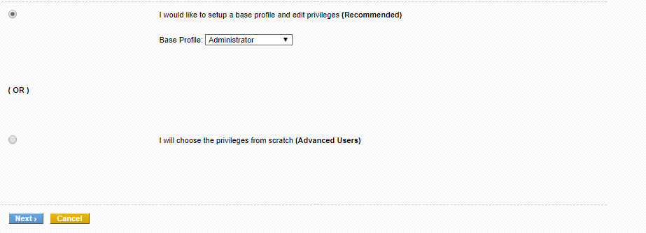
Figure. New Profile - Step 1

Click on [Next] to continue

Step 2 : Defining Permissions
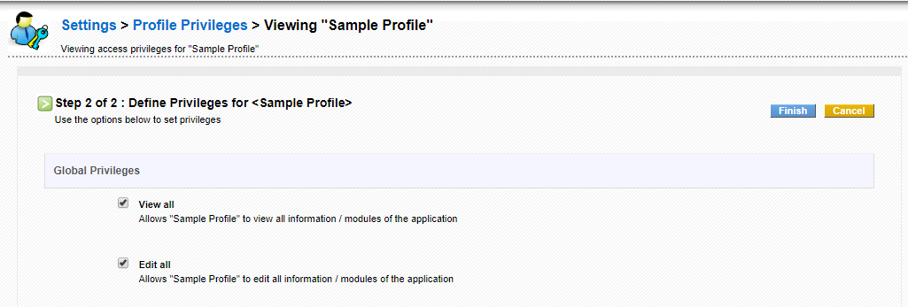

Figure . New Profile - Step 2

The menu for step two is displayed at Figure: New Profile - Step 2. At this step you configure the access privileges for all modules. First you might select at the Global Privileges entry fields whether the profile allows to view or to edit all data.

Then you can configure the profile related access privileges for each individual CRM module. You may select Create/Edit, View and Delete privileges as well as the fields to be displayed in each module.
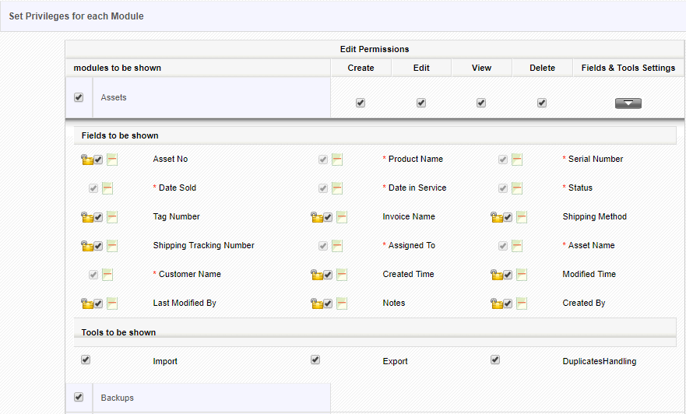

Figure. Defining permissions on fields and tools

To disable a specific module, you'll need to uncheck the checkbox corresponding to that module
To disable permissions on a specific module, you'll need to uncheck the checkbox under corresponding tab. For instance, if you don't want your support team to Create/Edit Contacts, you'll need to uncheck the checkbox next to Contacts and under Create/Edit tab.

Click on [Finish] to save your profile at the CRM system.

Please note: The settings of the Global Privileges are always superior to the other privilege settings.

Deleting Profiles

If existing profiles doesn't meet your requirements, you can delete them right away. Before deleting, responsibilities of that profile should be transferred to another existing profile.
Follow a few simple steps to delete an existing profile
- In the list view of Profiles, click trash icon to the right of your desired profile
- In the popup, transfer responsibilities to another existing profile
- Click Save
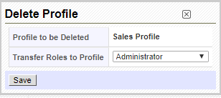
Figure Delete Profile

Step 3 : Assigning users to a profile
Profile cannot be directly linked with users. You'll need to associate a profile with a role; as a result, privileges are affected to all users across that role.

Notes!
- You can associate multiple users and profiles for the same role.
- When you associate multiple users for the same role, the users under the role will not be able to see each others' records.
- A role always work with respect to Profiles and Sharing Access.

Groups
Groups can be combination on different users, roles, roles and subordinates and groups within an organization. Groups will help you to build teams to share common set of records.
When records are assigned to a group, all members associated with the group can perform operations on the record. This will help your users to work together as a team.
For instance, If a support team member is on leave for the day, there is a chance that trouble ticket(case) assigned to him will not be resolved in time. Should the ticket be assigned to a group, all members associated to the group will get email notification and any one can handle the issue.
A group supports following combinations
- Users : Selected users will be part of the group
- Roles: All users associated with a role will be part of the group
- Roles and subordinates : All users associated with the role, and its subordinates will be part of the group
- Group: All users associated with selected group will be part of the group

Notes! Groups will also help you to define custom sharing rules. You can define data sharing rules to make a certain role, role and subordinates, or a group view records of another role, role and subordinates, or a group.

Groups are a very effective tool in order to summarize users and privileges.
Any type of relationship can be used to form a group, such as:
• users at the same location
• users with a common task
• user at the same department
• users with the same working history
• users with the same interests

Click on the Groups menu to open the list view as shown in Figure: Groups - List View. You see a list of all existing groups.
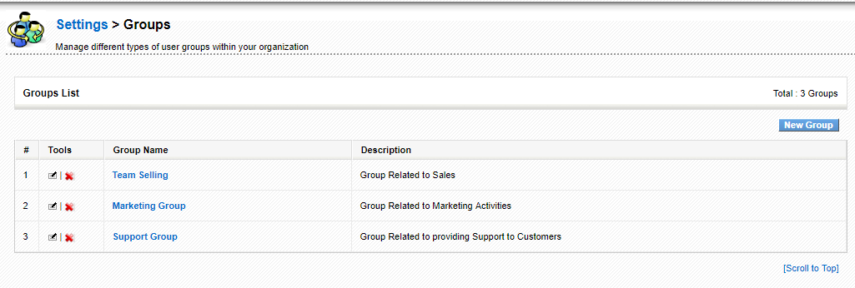
Figure. Groups - List View

Editing Group

Click on the name of a group to get the details as shown exemplary in Figure: Group - Detail View. The detail view lists the name, the description and the current users who are members of this group. You may change the group settings by clicking on the [Edit] button.
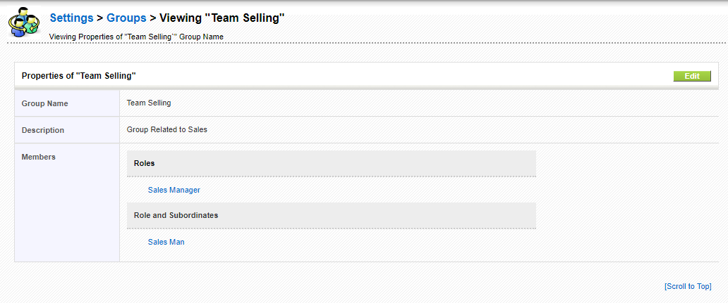
Figure . Group - Detail View

Creating New Group

To create a new group click on the [Create New Group] button at the list view. The new entry window as shown in Figure: Group - Edit View allows you to define the conditions for a group.
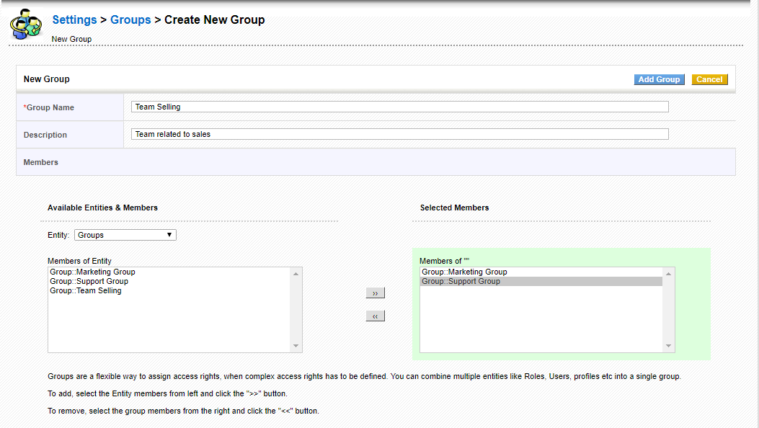
Figure . Group - Edit View

First, give the group a name and provide a short description. Then select the criteria for membership of this group. The filter function as well as the search function allows you to select members quickly. You may choose users, roles, roles and subordinates as well as other groups as group members.
Click on [Save] to store you new group at the CRM system. The assignment of a user to a group will also be displayed at the users detail view as shown in Figure: User Detail View.

Deleting Groups
This feature enables you to delete existing group if it doesn't meet your requirements.
Follow a few simple steps to delete an existing group
- In the list view of groups, click on pencil icon to the left of desired group
- Transfer responsibilities to another existing group
- Click Save
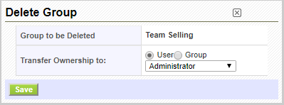

Sharing Access

Sharing Rules are used to configure data sharing rules across users in role hierarchy. In CoreBOS CRM, the default access for CRM records is set to public, which enables everyone to see all records. When sharing rules are set to private, users can only view records assigned to them and records of users below them in role hierarchy.
Sharing Rules also help you to set custom sharing rules to share data with specific role, role and subordinate, and group.

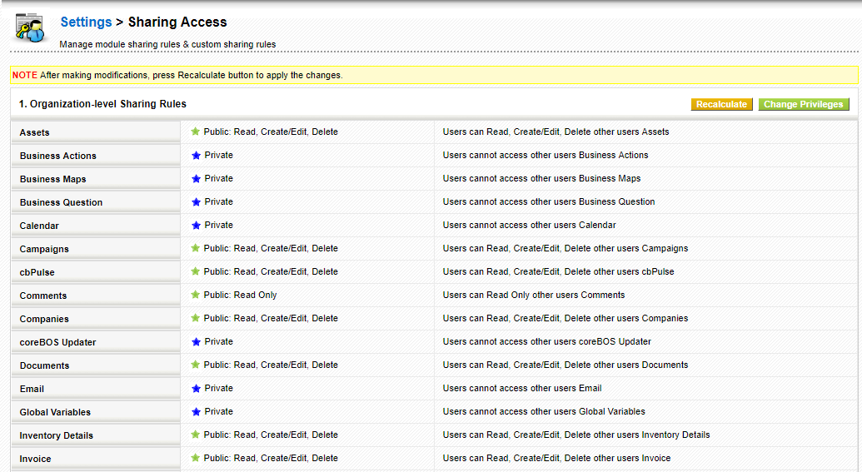
Figure.Sharing Access

Notes! Admin users can view all records irrespective of roles, profiles and sharing rules

Features
Sharing Rules enables you to configure following permissions across users in CoreBOS CRM.

1 | Private | Users can only view records assigned to them, and records that are assigned to users with a role below them.
2 | Public Read only | Everyone can view all records but cannot modify and delete the records.
3 | Public Read, Create/Edit | Everyone can view and modify all records but cannot delete the records.
4 | Public: Read, Create/Edit, Delete | Everyone can view, modify and delete every one else's records.

Configuring organization-level sharing rules
This feature enables you to configure sharing rules across your organization. The default sharing rules offered by CoreBOS CRM are set to Public. However, you can change the sharing rules according to your requirements.
Follow a few simple steps to configure sharing rules
- Click Change Privileges
- Click Save Permissions to update changes
Notes! Please make sure you click on the Recalculate button after making modifications. If not, your changes will not be affected.
Setting up custom sharing rules
Custom sharing rules are used to allow subordinates to perform operations on superiors' records. In other words, you, as a user on the upper hierarchy, can grant access to your subordinates to view your records. This can also be achieved by setting up Sharing Rules to Public, but the intention here is to only grant access to selected group, role and role and subordinates that are below you in role hierarchy.
For instance, Sales Manager is on a role hierarchy above SalesPerson. As sharing rules are set to private, Sales Manager can view Sales Person's records but not the other way around. Sales Manager wants to give access on his records to his Sales Person. Now setting sharing rules to Public will let everyone view Sales Manager's records. Setting up custom sharing rules gives Sales Manager the flexibility to exclusively grant access to Sales Person role.
Follow a few simple steps to define custom sharing rule:
- In the Custom Sharing Rules view, Click Add Privileges button,for the module you want to set Custom Rules.
- In the popup, define custom sharing rules
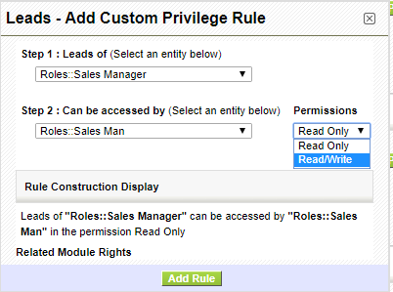
Figure.Add Custom Privilege Rule
- Select a value to specify whose records should be accessed (Superior)
- Select a value to specify who will be accessing the records of superior (Subordinate)
- Select permissions that users have on records
- Click Add Rule to update changes
Similarly, you can configure custom sharing rules to share data with role, roles and subordinates and group.
Notes! You will have to define custom sharing rules for every module individually.

Fields Access
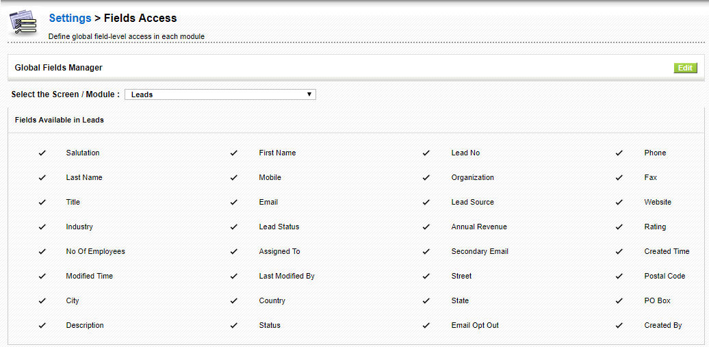
Figure. Fields Access

CoreBOS CRM allows you to determine which fields will be shown for each module.As shown in Figure: Fields Access After you click on your desired module,in this case Leads, you then can click in the Edit button to edit the appearance of Fields or not in the Lead Module.

- Studio

Module Manager

Module Manager gives you the flexibility to enable, disable and configure settings of
different modules available in CoreBOS CRM.
Deactivating Module(s)
Module Manager displays the list of all modules available in your CoreBOS CRM account. You can disable the modules that doesn't meet your business requirements by unchecking the checkboxes beside them. Unlike Profiles, if modules are disabled in Module Manager, they will not be available for use for all users across your CoreBOS CRM account. However, you can easily enable the modules to bring them back in action by clicking on the checkbox beside that module.
Steps to disable modules in CoreBOS CRM
Activating Modules

Note! If you want to limit users' access to modules, you can use Profiles in the 'Users Management' section under Settings

Configuring Modules

 | Type | Content
1 | Edit Fields | Navigates you to Fields and Layout Editor where you can configure fields of selected module
2 | Module Sequence Numbering | Navigates you to Customize Record Numbering feature where you can modify default record numbering of selected module
3 | Edit Workflows | Navigates you to Workflows feature where you can set up new workflows on selected module
4 | Edit Picklist Values | Navigates you to Picklist Editor where you can customize picklist fields of selected module
5 | Edit Field Mapping | Exclusively for Leads. Navigates you to Lead Mappping feature where you can map fields before converting leads

Picklist Editor

As the name itself says, Picklist is a drop-down field with list of options available, within which, only one option can be selected.

For instance, Lead status in Leads module.

Picklist Editor is used to configure picklist values in different modules.
It enables you to add a new values, rename, delete or rearrange existing picklist values.

Picklist values vary across roles — users under a role can only access picklist values assigned to that role.

Working with Picklist Fields
You can perform a wide variety of operations on picklist fields like adding new values to existing picklist field, modifying, deleting, rearranging existing values of a picklist field. Additionally, you can also assign roles on selected picklist values.

Follow a few simple steps to configure picklist fields

To customize picklist fields, you'll need to select desired [Module] from Select Module dropdown (ex:Leads, Contacts, etc).
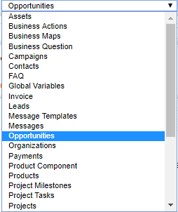

Consequently, Select Picklist in [Module] dropdown will display all picklist fields available for that module. This drop-down can be used to select the desired picklist field to perform global actions.
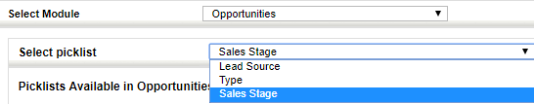

Adding New Value(s)

CoreBOS CRM enables you to create new picklist values in addition to existing values. After the custom picklist value(s) are created, they will be available for selection in respective module.
Follow a few simple steps to add new picklist values:
- Select a module and desired picklist field
- Click Add Item to add a custom picklist value
- In the popup, provide desired name in Item Value field
- Select desired role(s) from Select Roles drop-down to grant them access to new picklist value
- Click Save
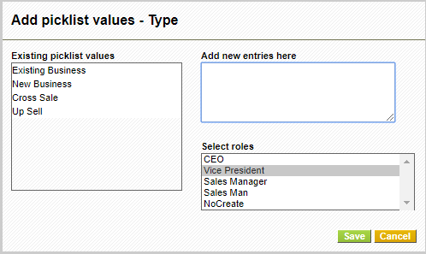

Notes! Roles are not available for selection for non-role based picklist fields as values are displayed across all users in Vtiger CRM

Editing Existing Values
This feature helps you to edit existing picklist values in the selected picklist field.
Follow a few simple steps to edit existing values:
- Select a module and desired picklist field
- Select desired picklist value you wish to edit
- Click Rename Item
- In the popup, provide new label in Enter New Name field
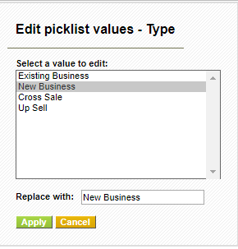

- Click Apply

Deleting Existing Values
This feature helps you to delete existing picklist values in the selected picklist field. It also helps you to select multiple values and delete them all in one shot.
Follow a few simple steps to delete picklist values:
- Select a module and desired picklist field
- Select desired picklist values you wish to delete.
- Click Delete Value to delete selected values
- Select a value in Replace it with field to transfer responsibilities. The selected field will show up in place of deleted value(s).
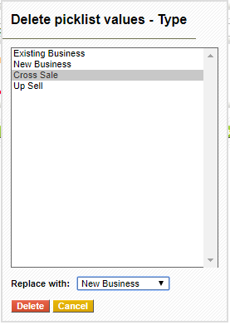
Figure.Delete Picklist

Assigning Values to selected role(s)
This feature enables you to assign multiple picklist values to multiple roles in one shot. When you assign values to a role, all users under that role will be able to access the picklist values.

Notes! Neither Assign Value button nor Values assigned to a role tab are available for non role based picklist fields

Follow a few simple steps to assign values to role(s):
- Select a module and desired picklist field
- Select desired picklist values you wish to assign to selected role(s).
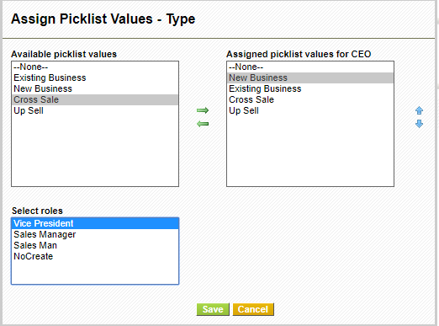
Figure .Add to other Roles

Picklist dependency Setup

Dependent picklists enable you to filter what values are shown in one picklist based on the value selected in other picklist.

Note: Only mapped picklist of the source field will be shown.

You'll need to set-up dependency between two picklist fields (source and target picklist fields).
By selecting a value in source picklist field, you'll have complete control over the target picklist fields.
For instance, we will consider a real time example. I have two different fields in Contacts Module. Football Team - source field, and Football Players- target field. When a value is selected in Football Team field, only players related to the selected team should be displayed in Football Players field. Now let's begin.

Configuring Picklist Dependency
Before we set up picklist dependency, we'll have to specify module, source field, and target field. Entire process is made simple and straightforward.
Follow a few simple steps to setup picklist dependency:
- Select the Module you want to Configure the Picklist Dependency
- Select the source and target field for that Module
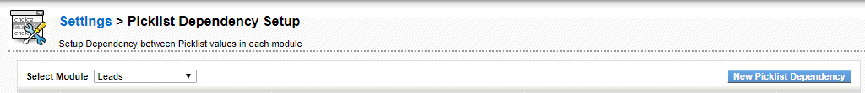
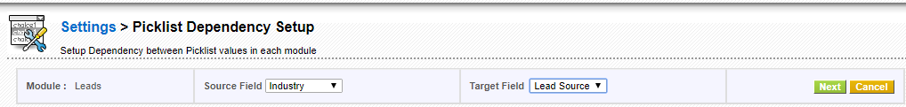
Figure. Picklist Dependency Setup
By clicking the Select Source Values Button a pop window will be shown for you to choose the source field values,as shown in Figure:Select Source Picklist Values to configure mapping.
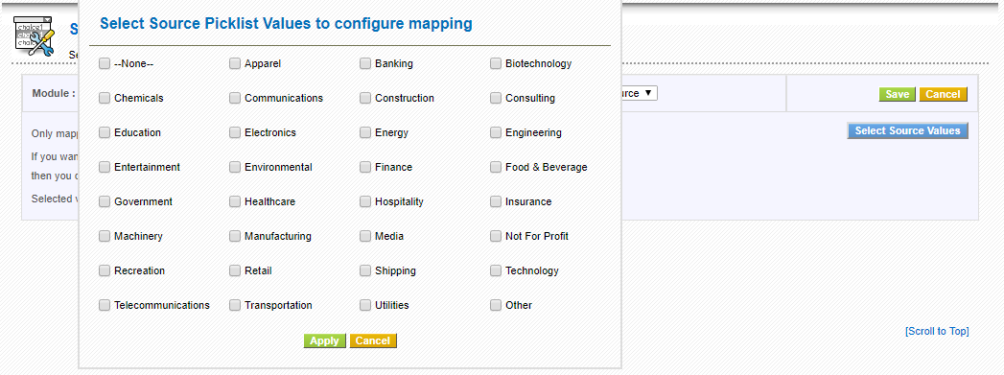

All available values in source picklist field and target field are displayed. You can view all source picklist values in header section.

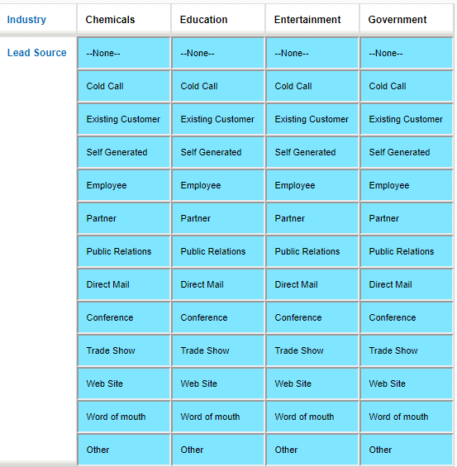
7. Now pick desired target field values under corresponding source field values(headers).
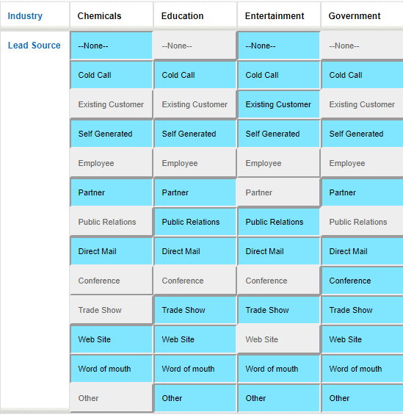

Notes! Values in blue are selected and values in gray are unselected.
8. Click Save

Working
After successfully setting up picklist dependency, you can select a value in source field to view only corresponding values in target field.

Business Process Management

Mail Converter

You send and receive thousands of emails every day. You interact with your leads, clients, peers, etc. through emails and all these are pile up. Your mail converter is intelligent enough to manage your mailbox efficiently . Mail Converter makes your task easier by managing your mails in an organized way which enables you to configure your mailbox to scan your emails and create appropriate entities in CoreBOS CRM. You can also define rules to specify what actions should be performed on your emails. Your emails are scanned automatically, unless you've disabled Mail Scanner task in Scheduler.

This feature permits Configuring an IMAP mailbox to scan for messages and convert them to appropriate entities in the application.
Mail Converter adds the capability to scan your mailbox and take actions on messages that matches the established criteria.
The main functionality it was created for is to manage the Help Desk workflow with the logic that can be seen in the next image:
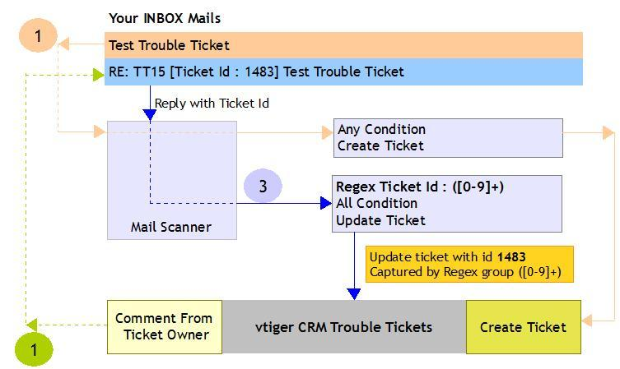
The Regular expression to process tickets correctly is:
Re: TT[0-9]+ \[ Ticket Id : [0-9]+ \] (.+)
What we put in the last block of parenthesis is what the application uses to match the ticket, if it is a number it will look for the CRMID if not it will look for the subject of the ticket.

Configure Mailbox
You can access the Converter in Settings → Mail Converter
You need to provide the mailbox information on which the scan needs to be performed. By default the mailbox will be disabled as no information is available.
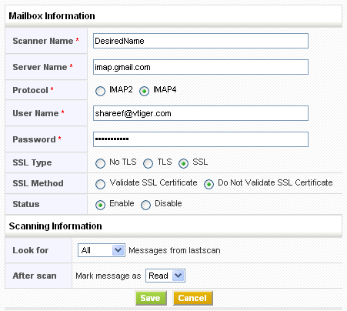
Make sure that the status is Enable before saving the mailbox information. Scan will not be performed if the status is Disable
Provide configuration details to establish connection with your mail server and click on the Save button; As a result, all the available folder names will be fetched. If the connection fails the information will not be saved.

Select Folders
After mailbox setup you can select the folders which should be considered for scanning the mails. Click on the Select Folders button.
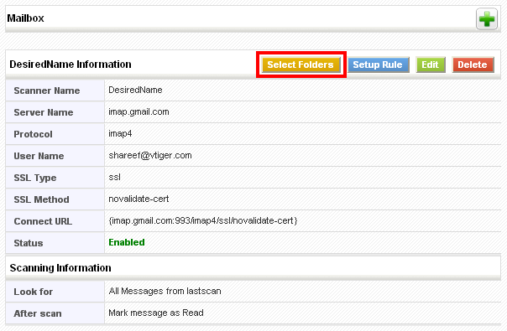
You can exclude or include the folders by selecting/de-selecting the checkbox as shown here:
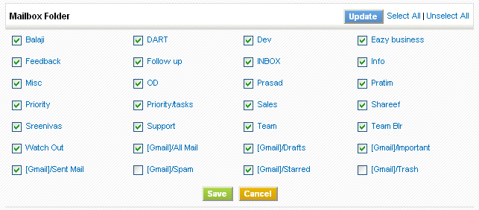

Rules
You can setup one or multiple rules on a mailbox which permit you to perform actions on a mail based on the criteria.
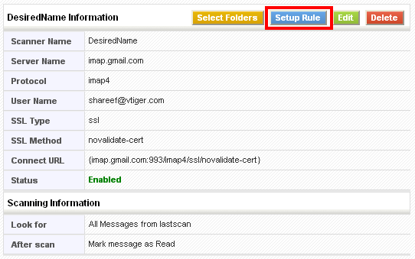
Click on the Add Rule button and set up the actions that you would like to perform on a mail.
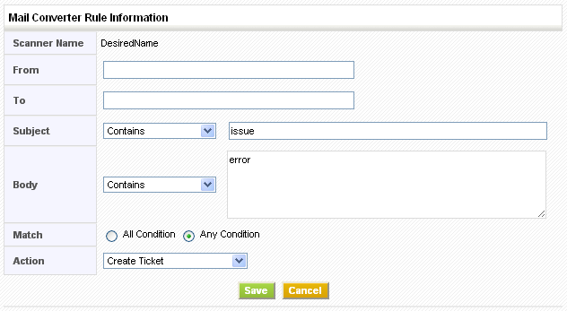

Rule criteria
Rule criteria are evaluated as follows:
From | Check for the input occurrence in the FROM field of the email
To | Check for the input occurrence in the TO field of the email
Subject | Compare the input with SUBJECT of email using one of the condition selected (Contains, Not Contains, Equals, Not Equals, Begins With, Not Begins With, Regex)
Body | Compare the input with BODY of email using one of the condition selected (Contains, Not Contains, Equals, Not Equals, Begins With, Not Begins With)
Match | All Condition – All the input conditions should evaluate as true to take Action
 | Any Condition – At least one condition should evaluate as true to take Action

Once a successful matching on an email occurs, the action will be applied on it as follows:
Create Ticket | Creates a new trouble ticket record with the following:  Title = SUBJECT of email  Description = BODY of email  Attachments of email will be linked to the trouble ticket record
 | Lookup is made for existing Contact/Account based on FROM field of email and ticket is associated to matching record (if found)
Update Ticket | Updates existing trouble ticket record with the following:  Comment = BODY of email
Lookup is made on existing trouble ticket based on FROM field of email and title or CRMID match. Preferable to select Regex as Subject and paste the following code in the text area
Ticket Id[^:]?: ([0-9]+)
Add to Contact[FROM] | Lookup is made for existing Contact based on FROM field of email. On success a new email record is created and is associated to matching record.
Add to Contact[TO] | Lookup is made for existing Contact based on TO field of email. On success a new email record is created and is associated to matching record.
Add to Account[FROM] | Lookup is made for existing Account based on FROM field of email. On success a new email record is created and is associated to matching record.
Add to Account[TO] | Lookup is made for existing Account based on TO field of email. On success a new email record is created and is associated to matching record.

Example: Rule to create trouble ticket from any email is shown below:
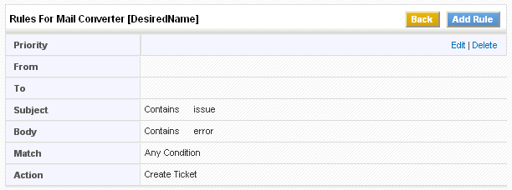

Rule Priority
One or more rules for the mailbox which are applied in sequence while Scanning. You can change the order (Priority) by clicking the arrow marks.
If the email matches the conditions defined for a given rule, the remaining rules are not applied.

Manual Scanning
Click the Back button after setting rule or rules.
After setting up at least one rule you can scan the mailbox.
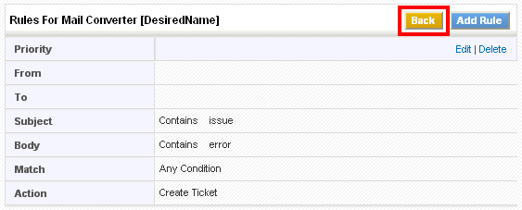
Now click on the Scan Now button. It might take long time based on the amount of emails that will be present in the mailbox (configured folders)
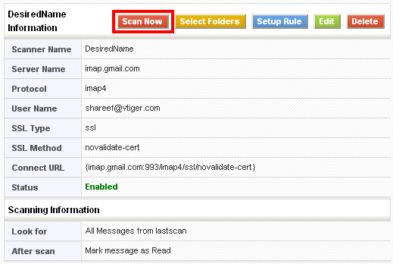
As soon as scanning is finished you will get changes according to the rules you have set for creating and updating Trouble Ticket or adding an e-mail to Organizations or Contacts

Workflows
Workflows are a very powerful part of the application. They permit us to automate our business logic to some extent making it possible to standardize process and have the application do some of the repetitive tasks our business requires.
It is necessary to execute four steps to configure and setup a workflow:
- Select a module against which the workflow will be executed and give it a name
- Select when the workflow will be triggered
- Select any conditions that restrict for what records the workflow must take it's actions
- Define and configure the different tasks that the workflow will perform

In the next sections you will be able to find more information on these steps.
Workflow launch conditions

Launch conditions specify when the workflow must be executed.
All workflows except scheduled are “save” event based, which means that they will be evaluated ONLY when a record is saved from within the application. That save event will usually be some user creating or editing a record, but it could also be triggered from a webservice call or by some specially crafted code.
Since workflows are triggered when we save a record the different launch options that we have are related to this event:
- Only on the first save: Triggers the workflow when you create a new record. For example a welcome email would have this launch condition so it gets sent ONLY when the new contact is created.
- Until the first time the condition is true: Triggers the workflow only once for a record that complies with the defined conditions. Once executed, your workflow will not trigger on the same record again. However, it will trigger actions on other records in the selected module when they fulfill the conditions. For example, when an invoice enters status paid we send a “thank you” email to the client. If we edit the invoice again and save it we don't want that email going out again for this record.
- Every time the record is saved: Triggers the workflow every time you save a record, including the first creation save. This is ideal for calculated fields. For example the forecast amount field on opportunities uses this launch condition to calculate the forecast each time the record is saved.
- Every time the record is modified: Triggers the workflow every time you edit and save your record, EXCEPT on the first creation save. For example, if we want to get an email each time a ticket is closed, we would use this launch condition so that even when a ticket is reopened and saved again we would get that email.
Scheduled Workflows are time based, not event based, so they are triggered on a certain date/time.
Workflow step by step explanation

The Workflow module provides a number of options to trigger actions based on events in the application or time based events.
To configure a workflow for a module enter the application as an admin user, go to the Settings page and click on the Workflows link (this can be found under the Other Settings Block)
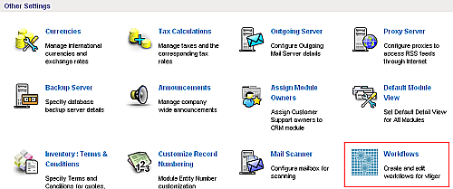
This will bring up the list of all defined workflows (by default all workflows are listed).
You can see all the available workflow for any particular module using the Select Module dropdown on the page.
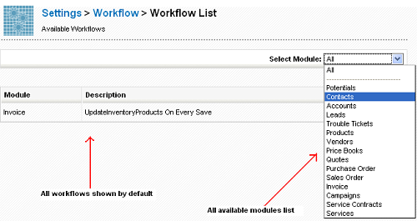
The Workflow extension provides options to
- create a new workflow
- edit an existing workflow
- delete an existing workflow

Create Workflow
Click on the New Workflow button. A popup will appear listing the available modules.
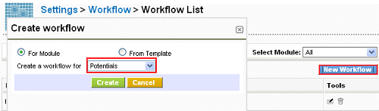
Select a module and click Create. You will be taken to an edit page for the workflow.
Add a Description for the workflow. You can specify here when the workflow should run.
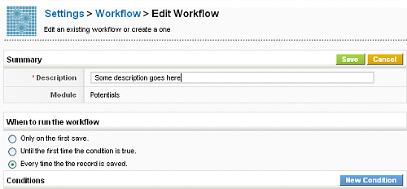
You can add more conditions by clicking the New Condition button.
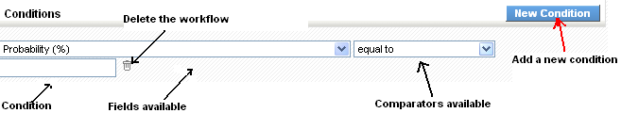
Click the 'Save' Button to save the new workflow.
Once you have saved the workflow, you will be presented with a screen where you can add the tasks for the workflow. These task(s) will be executed once the workflow conditions are satisfied.
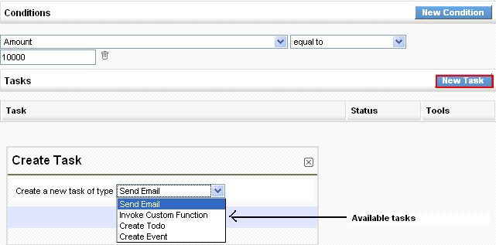

Create tasks
Click on the New Task button to add a new task. You will get a popup to select the type of task you can create. There are multiple types of tasks, among which you may find:
- Send Email task which can be used to send emails
- Invoke custom function task which will call certain specific methods on the entity objects.
- Create Todo task which will create a todo when the workflow condition is met.
- Create Event task, which will create an event.
Select a task type from the dropdown and click on the create button to create the task.

Configuring tasks

Common Fields
The following fields are common for all workflow tasks
- Task Title - This is the title of the task used in the task list to identify the task.
- Status - This is a selection box which should be set to active if the task is to be executed when the workflow executes.
- Execute the task after some delay - If this is checked you will be provided with additional fields to specify a time delay for when the task will be executed. You can specify when the task is executed relative to the time in a date field on the record.
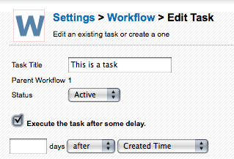

Email Task
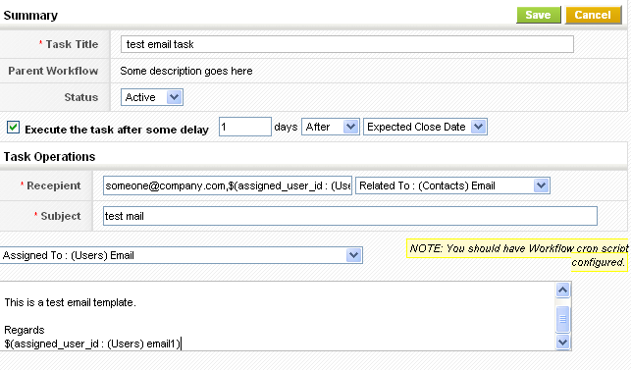

Invoke custom function
This option provides a way for developers to add module specific actions to workflows. To define a task, you need to define a method to be called. This method should be defined as a function in it's own file.
<?php
function demo($entity){
$entity->focus->called = true;
}
?>
The method then needs to be registered, for example if the method was defined in the file modules/demo/Demo.inc for the Contacts module and given the name method.
require_once 'include/utils/utils.php';
require 'modules/com_vtiger_workflow/VTEntityMethodManager.inc';
$emm = new VTEntityMethodManager($adb);
$emm->addEntityMethod("PurchaseOrder", "method", "modules/Workflow/Demo.inc", "demo");
The method will appear in the list of methods available for the Contacts module.
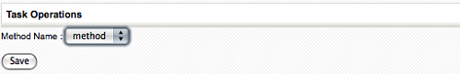

Todo Task
Using this option, you can setup a workflow to create a new calendar Todo when a condition is matched. The following fields are provided in the create view of this option
- Todo - The title of the todo.
- Description - Of the todo.
- Status - The status of the todo, can be selected from the dropdown
- Priority - The priority of the todo, can be selected from the dropdown.
- Time - The start time of the todo, in 24 hours time.
- Due Date - The due date for the todo, the start date is also set using this.
- Send Notification - Set the send notification flag.
If the module which triggers the workflow is Contacts then the Contact Name field will be bound to the contact. If the module is one of the acceptable modules for the Related To field then the module Related To field will be bound to the module.
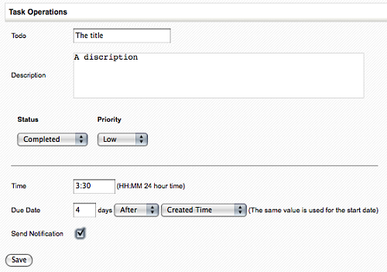

Event Task
This is same as Todo task other than that it creates an event instead of a task.
Scheduled Time based Workflows

Scheduled Workflows are time based, not event based, so they are triggered on a certain date/time. That totally defines and limits the way they work and the way they must be constructed, which is slightly different than the save event based workflows.
Scheduled Workflows enable you to run periodic tasks to automate your business. You can program the tasks to be executed when a certain time arrives so you can dedicate your attention to other business operations.

Scheduled Workflow Launch Times
The Scheduled Workflow feature offers you a wide variety of launch times to run your workflow. These options are:
- Hourly: Workflow is executed every hour
- Daily: Workflow is executed every day at the specified time
- Weekly: Workflow is executed on the selected days of every week
- On Specific Date: Workflow is executed on the selected date
- Monthly by Date: Workflow is executed on the selected days of every month
- Yearly: Workflow is executed on the selected day of every year

Scheduled Workflow Conditions Restrictions
Scheduled Workflows are different than event based workflows and their conditions also have a set of restrictions that the other workflows do not have. Most restrictions stem from the fact that we do not have a unique record to execute expressions against. So we cannot use formulas like
concat(field1,field2)
because there are no field values to concatenate.
To be honest, this type of expression could be supported, but it would need a big rewrite of the query engine so that the application could convert that into a valid SQL statement and do the concatenation in the database. Currently, the application's expression engine expects to have a valid active record that is being saved, so it can concatenate or, in general, operate with the field values of that record. Since Scheduled Workflows do not have one record to send into the formulas, these cannot be used.
Scheduled Workflows work by constructing an SQL statement that asks the database for records that fulfill the conditions. It gets back a whole set of records, not just one.
So, in short: only a very limited set of formula expressions are supported, basically only those that do not use fields.
Another restriction that stems from this is the use of related entity fields. It is difficult to access fields on related entities in the SQL command that is being constructed, so accessing the fields of an Account from a contact requires some coding that we currently do not have in place.
In general:
- stick with conditions on fields that belong to the entity you are creating the workflow for
- avoid fields and expressions/formulas in the conditions, use the given operators with static raw text values

Finally some operators have no meaning in scheduled workflows, mostly the “has changed” type operators which require a specific action of saving to detect the change between the “before” and “after” values. With scheduled workflows there is no “before” value, we are directly selecting records from the database and they have had no change whatsoever.

Scheduled Workflow Conditions
As with all other workflow types, you can set conditions on any field type as long as:
- the field belongs to the entity the workflow is related with
- you use static/raw text values
You cannot currently use fields from other modules nor use formulas of any type.
To overcome the above restrictions, date fields have some special operators and some special functionality that will permit us to select records based on time which is what this type of workflows is all about.
For date fields we can choose from the next set of operators:
- Is/Is not
- Between
- Before/After
For these operators we can:
- set a fixed value
- use one of the functions:
  - add_days(x): adds x days to today, where today is the day of execution
  - sub_days(x): subtracts x days from today, where today is the day of execution
  - Days ago: accepts a number and will subtract that number of days from today
  - Days later: accepts a number and will add that number of days to today
  - today
  - tomorrow
  - yesterday

Then we have a set of special operators which will take a number of hours or days and calculate a range of dates for the record selection. These are:
- Less than hours before
- Less than hours later
- More than hours before
- More than hours later
- Less than days ago
- Less than days later
- More than days ago
- More than days later
These divide time in four ranges and permits us to set our target date/time in any one of them. The next image depicts the four ranges and you can get a better understanding by looking at the examples below.
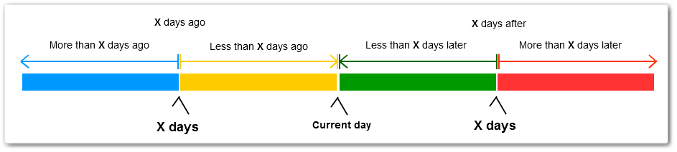

Workflow Tasks

Update Workflow Tasks
When you want to update a field from a workflow (even on a related module), you have the option to use a function expression. There are many options here, two of which are the 'aggregation' and 'aggregation_fields_operation' functions. The default output, once you select one of these is:
aggregation(operation,relatedmodules,relatedFieldToAggregate,conditions)
or
aggregation_fields_operation(operation,RelatedModule,relatedFieldsToAggregateWithOperation,conditions)
Use this small guide to get you going:
- For the 'operation' parameter, you have the following choices (I think they speak for themselves):
  - sum
  - min
  - max
  - avg
  - count
  - std
  - variance
The related module is the module you want to aggregate from. This can be the same module as you're creating the workflow on. You would use this if you want to update a field on a related record by summing up (for instance) all the 'siblings' of the record you are editing. For instance, you could update a field in Accounts with the sum of all payments made to that account, whenever you edit or save one of those payments, without having to save the Account in question first.
The related field(s) should be field names of the module you specified in the previous parameter. Again, this can be one the same module you're creating the workflow on.
The conditions should be an array-like formatted string with 4 parameters (example: [relatedto2,e,$(relatedto2 : (LitigationMatter) matter_name),or])
The first parameter tells the workflow which field to look for on the 'sibling' records.
The second is the operator. In the example, there is an 'e', which stands for 'equals'.
The third parameter tells you what the fields in the 'relatedto2' field on the sibling should match. In this case, a nested expression is used to get the name of the related LitigationMatter, so basically you want all 'siblings' that have the same name in that field
The last parameter tells the workflow how to 'glue' conditions together if you have multiple (yes, you can have multiple condition arrays).
Important Note: Do not use spaces in the condition array-string between the arguments.

Add/Delete Tags Workflow Tasks
This workflow task permits you to add or delete tags on the object being saved. Either associated to the current user doing the operation or massively to all users.
This is very useful for filtering and segmenting your clients that are coming in through the webform, for example.
The workflow task in itself is simple; you select:
- the action to do: add or delete
- for whom to do it: all users or only current user
- list of space-separated tags to work with
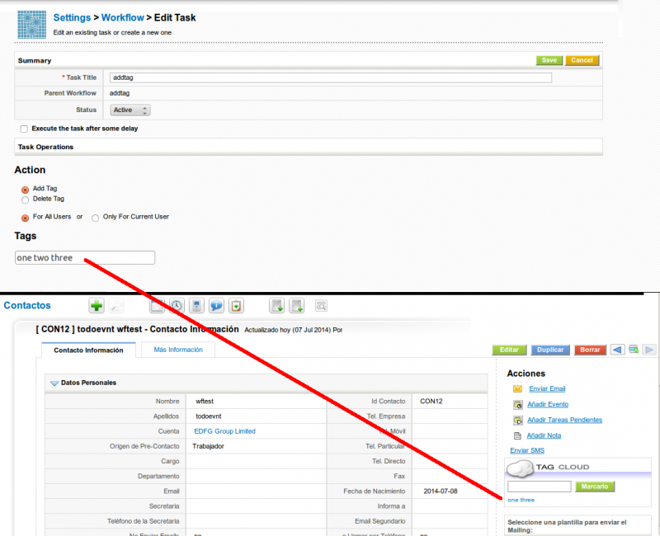

Related Product/Service Workflow Task
The Relate Products and/or Services to Accounts/Vendor and/or Contacts workflow will implement a frequently demanded functionality which consists of automatically relating the products and services sold on an invoice or bought on a purchase order to the account or vendor selected on the record. This makes a lot of sense in many businesses where we want to be able to see a list of products that our client has bought directly on their “Products” related list.
This workflow is associated to Quotes, Sales Orders, Invoices and Purchase Orders and permits the automatic relation of the products and services on each of these modules with the Account, Vendor and/or Contact selected on the record.
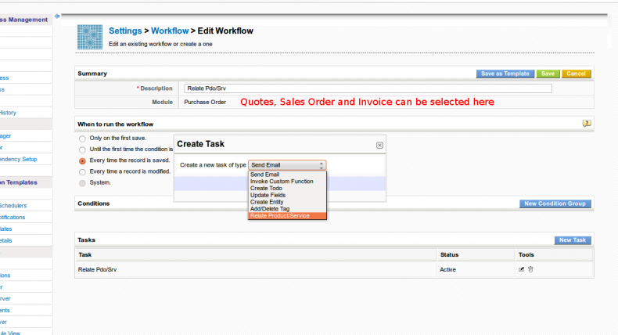
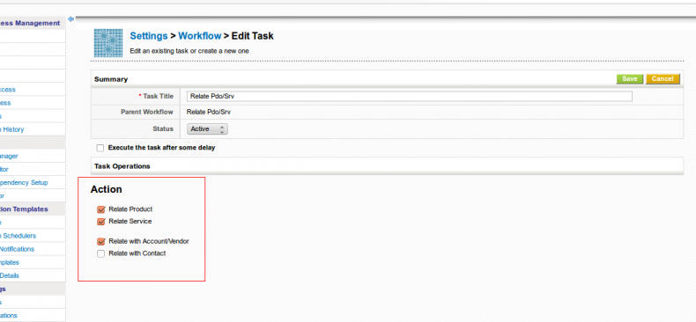
As can be seen in the screen shots above, this workflow permits us to select which elements we want to relate and with which entities:
- Relate Product: if it should relate products or not
- Related Service: if it should relate services or not
- Relate with Account/Vendor: if it should relate the element(s) selected above to the Account or Vendor in case of Purchase Order.
- Relate with Contact: if it should relate the element(s) selected above to the Contact
This was implemented in issue ~~issue:191~~
Invoke Custom Functions Workflow Tasks
This type of workflows is like an open set of functionality that can implement many different actions. In reality it is a simple and defined way of enhancing the workflow system without going through the trouble of adding a new screen (not that that is very complicated but this is easier).
So with custom functions we can find a lot of different options and operations to activate on our records.
The steps are:
- create a new workflow and select the main module
- give it a name and set the conditions
- create a new task and select the “Invoke Custom Function” task
- On the configuration screen we will find a drop down select box with the available functions for that module
- Simply select the function and save
that is it, there is nothing to configure as these are atomic action functions, everything they need to know is given to them by the save context.

Available Custom Functions

UpdateInventory
Modules | Invoice, SalesOrder
Functionality | when creating will subtract all stock from the products associated to the record\ when editing will restore all the stock of the previous record and subtract all the stock of the new record

NotifyOwnerOnTicketChange
Modules | HelpDesk
Functionality | Sends email to the user assigned to the ticket when the ticket changes

NotifyParentOnTicketChange
Modules | HelpDesk
Functionality | Sends email to the account/contact assigned to the ticket when the ticket changes

NotifyOnPortalTicketCreation and NotifyOnPortalTicketComment
Modules | HelpDesk
Functionality | Sends email when ticket is created pr commented on in portal

Update Contact Assigned To
Modules | Accounts and Contacts
Functionality | changes the user assigned to all contacts associated to an account when the account is saved OR changes the user assigned to the Contact being saved when it is related to an Account

SMS Workflow Tasks
Create a Workflow and save it with the desired conditions. Click on the New Task button and select SMS Task to automate the process of sending SMS.
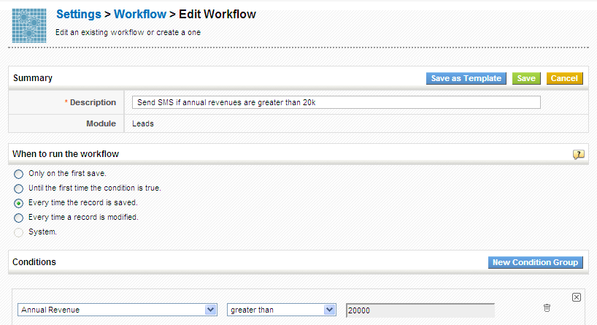
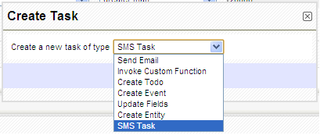
Provide a label to the task and set the Status of the workflow. From the Recipients field, select the number of users to whom the message should be sent. While composing the message, Select the field values from the dropdown to fill the values in the text area below.
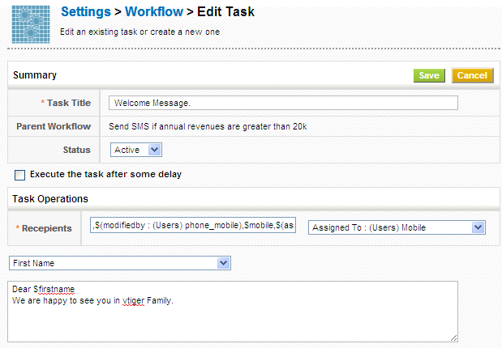

Scheduler

- Other Settings
Currencies
This feature enables you to configure national and international currencies to help you in dealing business operations with your customers around the globe. You'll be asked to select your base currency at your first login, in start up page. The base currency is the currency against which exchange rates are generally quoted in a given country. For instance, INR in India, and USD in USA. The foreign currencies you'd set up in your CoreBOS CRM account will be converted according to the exchange rates of base currency
Adding new currencies
Besides base currency which is automatically added, you can also add new foreign currencies in CoreBOS CRM. While the exchange rate of base currency is set to 1, you'll have to manually provide exchange rates for newly added currencies in accordance with your base currency.
Follow a few simple steps to add new currencies
- Click Currencies. You can click on pin icon next to it to add a shortcut to your settings home page
- Click New Currency
In the create view of new currency, you'll need to fill up the following fields
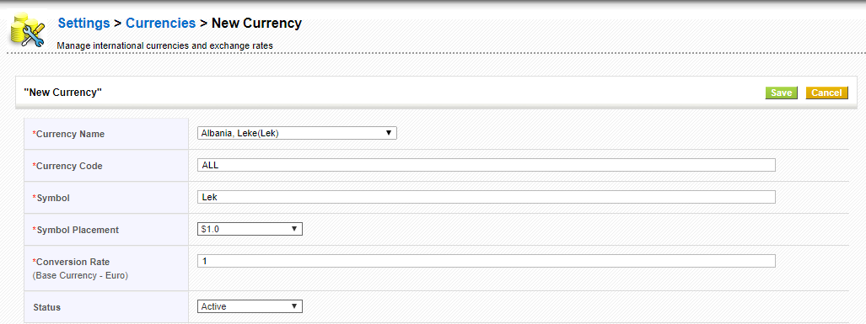
Figure.New Currency

Type | Content
Currency Name: | The name of the currency, e.g. "US Dollar".
Currency Code: | The short name of the currency, e.g. "Dollar"
Currency Symbol: | Enter the symbol of the currency. This symbol will be used at the CRM for all price information, e.g. "$".
Conversion Rate: | Enter the currency conversion rate in relation to the CRM basic currency. The basic currency is the first currency at your currency list.
Status: | You may set a currency as active or inactive. Inactive currencies can not get assigned to users

Modifying Product Price
Products are sold across different countries with different price tags i.e, if product of US is to be sold in India, price of that product may or may not be decided on the basis of conversion rates. CoreBOS CRM gives you the flexibility to configure product prices manually or populate prices according to conversion rates.
In the edit view or create view of desired product, click more currencies link under Unit Price field
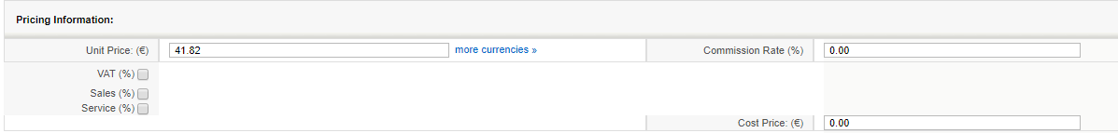
Figure.Pricing Information
In the Product Price popup, you can see, values are all updated according to conversion rates. However, you can modify them and have custom values in place by entering desired price values under Price tab.
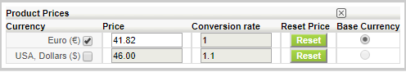
Figure.Product Prices
Now when you select this product while generating Invoice, Sales Order, Purchase Order or Quotes, you'll see the prices that are updated by you - not conversion rates.

Tax calculations

Tax is a fee charged ("levied") by a government on a product, income, or activity.
CoreBOS CRM gives you the flexibility to manage local and international tax rates through Tax Calculations. After the tax rates are defined, they will be available for selection in Invoices, Purchase Orders, Sales Orders and Quotes.
Taxes defines in Tax Calculations are global, not product specific.
TAXES

CoreBOS CRM supports Product and Service Taxes ,Shipping and Handling Taxes.
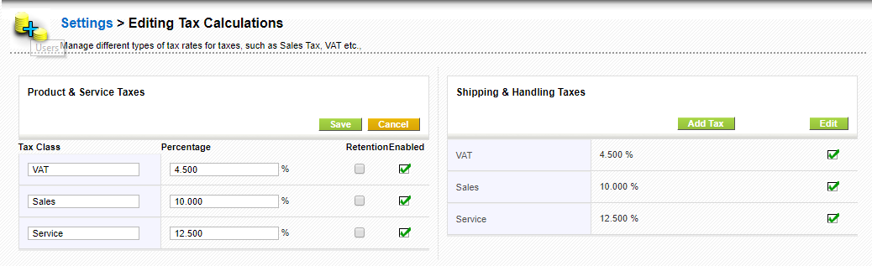
Figure:Types of Taxes
You can edit the current Taxes or Create New taxes for each category of taxes,by adding the Tax Name and Tax value,as shown on Figure:Create Tax.
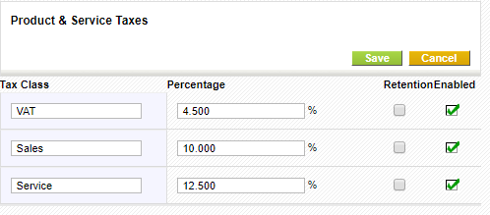
Figure:Edit Taxes
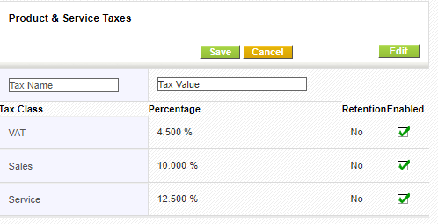
Figure:Create Tax

Outgoing server

This feature helps you to configure Outgoing Server with SMTP (Simple Mail Transfer Protocol) settings of your
email server to manage sending out emails from Vtiger CRM.
You can view default settings provided by CoreBOS CRM. To modify, click Edit button in the top right.
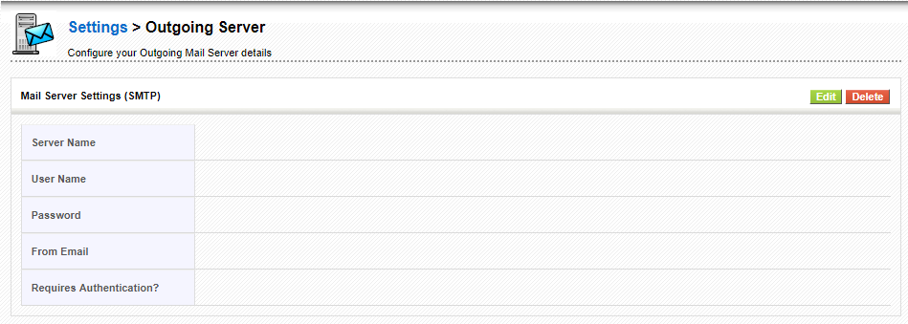
Figure .Outgoing Server

Table.Outgoing Server Content
 | Type | Content
1 | Server Name | Provide mail.yourdomain.com where yourdomain.com is the actual domain name. For instance, gmail accepts ssl://smtp.gmail.com:465
2 | User Name | Provide you user name.
3 | Password | Provide you password
4 | From Email | Emails will be sent from the email id you would specify in this field; else, emails will be sent via the email id of the current user
5 | Requires Authentication? | Click on the check-box to enable authentication before sending an email.

After configuring details, click Save

Heads up!
- By default, the outgoing server is configured with vtiger CRM settings. You can manage sending out emails with these settings. However, we will recommend you to configure Outgoing Server with your own SMTP settings.
- If you prefer to retain vtiger server as the outgoing server, we recommend you to configure your domain's SPF record to include the vtiger server as a valid sender for your domain.
- You can click on Reset to Default in edit view to populate default set of values provided by Vtiger CRM

Customize record numbering

This feature helps you to customize numbering of records according to your requirements.
CoreBOS CRM offers default numbering corresponding to every module in CoreBOS CRM. We recommend you to customize your record numbering prior to inputting data in your CoreBOS CRM account - because this feature doesn't affect the numbering of existing records.
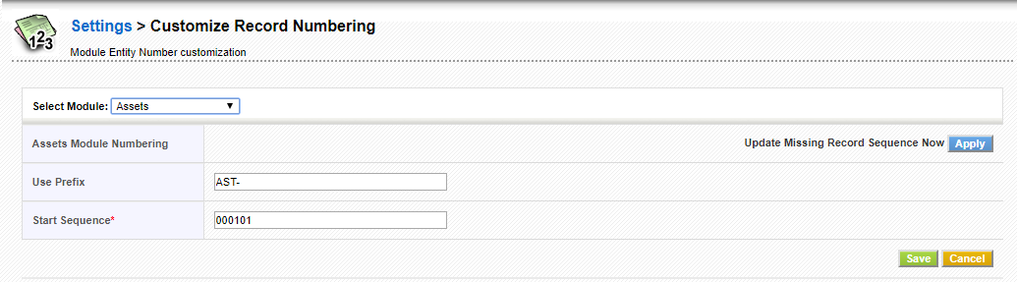
Figure.Customize Record Numbering

Table .Customize Record Numbering Content

 | Type | Content
1 | Select Module | Select desired module to customize numbering of records in it.
2 | Use Prefix | Provide desired prefix. This will be automatically populated in the detail view of selected module > [Module] number field. Module can be Contacts, Leads, etc.,
3 | Start Sequence | Provide the sequence where numbering should be started. This record numbering chronological order beginning form you start sequence number.

After successfully customizing record numbering, you can see that the records that are imported or created after the customization will automatically populate prefix and sequence number is updated chronologically.

Mobile Interface Introduction

What is CoreBOS Mobile?
It is a module created by CRM-NOW, which has been integrated into coreBOS by default, to support it and add new functionality.
This module allows us to have a mobile interface to access a large part of the coreBOS data.

What is it for?
It serves to access coreBOS with a mobile interface and thus be able to consult our data in a simpler way. Especially to be able to consult the agenda and customer data when we are out of the office.
What can it do?
We can quickly consult our agenda, create events, consult and create clients, contacts, opportunities.
It is also a good tool for technicians since they can consult the open support requests, add the time and material that they dedicate to it, if they have the module of Time/Material Control active, and be able to close the incident, even with the signature of the client.
Who can use it?
Any user of coreBOS who needs to consult or manage their agenda, consult customer data, contacts or opportunities.
An ideal profile could be the technical and commercial ones that have to make visits to clients.

Since when is it available?
The first version that we integrated from CRM-NOW was on May 10, 2016.

A little bit of history
This module already existed before the version of CRM-NOW, the one that came from vtigerCRM was used, but it was not practical to use.
That's why when we learned that Frank Piepiorra, from CRM-NOW, had a new version of this module shared with the community and saw that it had a much more pleasant and practical aspect, we decided to integrate it.
We spent some time on this first version to make it work correctly on coreBOS, plus some fixes and small features that we added, but after a few months they released another version, which is the one we started from, that looked better, not only the exterior, but the interior was better structured to be able to maintain it and improve it little by little.
This second version was incorporated on December 2, 2016, with our changes already included and since then we have not stopped supporting it and adding new things, as our clients have been testing it and requesting fixes and functionalities.

How can coreBOS Mobile be used?
Very easy. If the URL of our coreBOS is: http://mi.coreboscrm.com we should add to the end /Mobile.php so it would look like this: http://mi.coreboscrm.com/Mobile.php
We will see a login screen where we can enter our username and password of coreBOS and get to work!

How is it configured?
In order to use coreBOS Mobile, you do not need to do anything, but you can configure certain parts.

Global Variables
We have in the Global Variables module, two variables for the coreBOS Mobile interface.
- Mobile_Module_by_default: Set the default module to show when entering the Mobile module.
- Mobile_Related_Modules: Activate the modules that we want to have related lists. The name of each module must be indicated separated by commas. The default value that exists is: Contacts, Potentials, HelpDesk, Documents, Timecontrol. So it is recommended to keep these values ​​and add the new modules you want after these. For example: Contacts, Potentials, HelpDesk, Documents, Timecontrol ,Assets
Mobile Profile
Another thing we can do from coreBOS is to create a specific profile for when you enter coreBOS Mobile.
The user of coreBOS belongs to a particular role and this role has a profile. If you do not have any Mobile profile, the user will see the same modules and fields in both coreBOS and coreBOS Mobile, but if we want to differentiate this we must add a profile to this role as follows.
We create a profile as always, but the name MUST start with Mobile :: in front and then the rest of the profile name, the system already knows that this profile is only used when entering coreBOS Mobile.
How is it used?

User and password
As in the application, we must authenticate with our username and password.
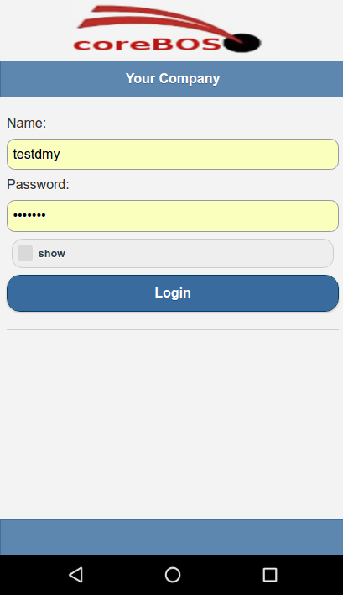

Home Page
By default, it shows us the calendar and the events we have for today if there are any.
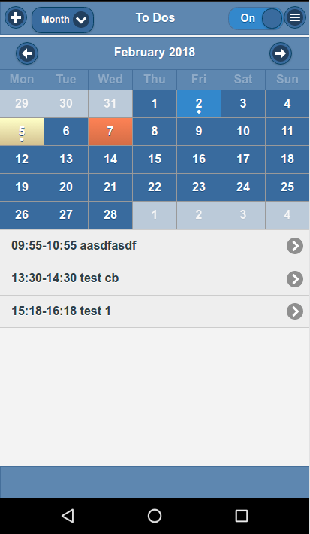

List View
If we do not want to see the calendar, but show the list of all the events and use the filters as in any module, we just have to move the widget from the top right to Off
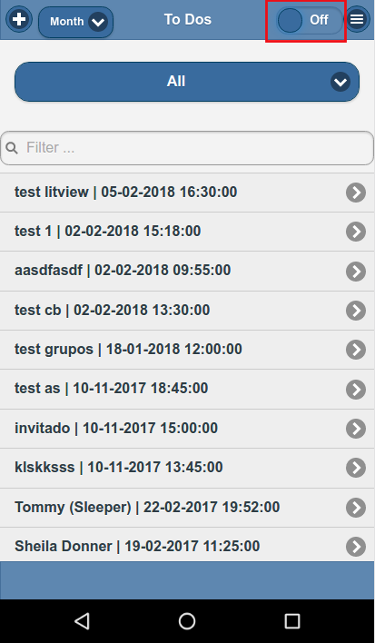

Create New Record
To create a new record, we must press the cross, which we will always see in the list view.


Detail View
In the detail view we have 3 icons that serve for the following:
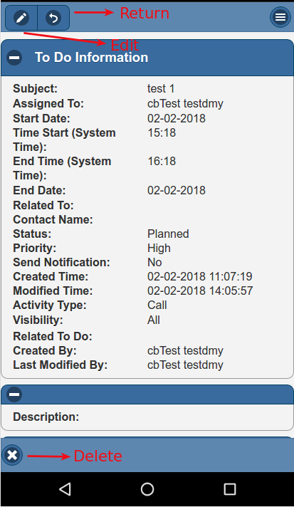

Edit View
In the edit view, we enter the data we need and to save we must press the following icon.
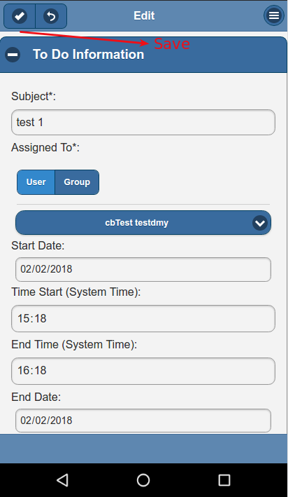

Search Related Records
A difference we have with coreBOS is in the fields of type relationship, instead of opening a new window, we have the functionality of autocomplete. As we write, we will suggest options to select.
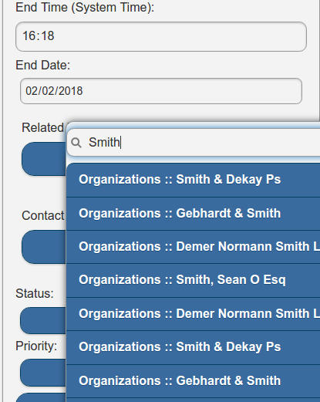

Menu
If we open the menu we can navigate through the different modules, quick create, global search, and log out.


